REVISED STAFF REPORT

Agenda Item: | 11 | Name: | Jake Tracy
Proposed No.: | 2022-0294 | Date: | August 23, 2022

COMMITTEE ACTION

Proposed Substitute Motion 2022-0294.2, which would approve a Repetitive Loss Area Analysis Report for transmittal to the Federal Emergency Management Agency to meet Community Rating System requirements, passed out of committee on August 23, 2022 with a “Do Pass” recommendation. The Motion was amended in committee with Amendment 1 to attach the final report.

SUBJECT

Proposed Motion (PM) 2022-0294 would approve a Repetitive Loss Area Analysis Report for transmittal to the Federal Emergency Management Agency to meet Community Rating System requirements.

SUMMARY

The National Flood Insurance Program (NFIP) is a program administered by the Federal Emergency Management Agency (FEMA) that provides flood insurance to property owners and renters. This insurance helps financially protect homes and businesses from flood damage. As part of the NFIP, FEMA operates the Community Rating System (CRS), which helps flood insurance policyholders receive discounts on their premiums. The CRS gives local governments credit for activities and programs that exceed federal minimum standards. King County has been a member of the CRS since 1991, and is classified as a Class 2 community, which provides residents and businesses with a 40% discount on a standard flood insurance policy.

A core requirement of the CRS program is for the local government to have a current adopted repetitive loss area analysis (RLAA) report. According to FEMA, a repetitive loss property is any insurable building for which two or more claims of more than $1,000 were paid by the National Flood Insurance Program (NFIP) within any rolling ten-year period since 1978. A property can be removed from the list of repetitive loss properties if the flooding problem has been mitigated for that property.

The RLAA report is required to:
- Describe the repetitive loss problem within unincorporated King County;
- Contain a map showing the showing the location of all repetitive loss properties;
- Undertake a prescribed five-step planning process.

PM 2022-0294 would approve an RLAA Report for unincorporated King County for transmittal to the Federal Emergency Management Agency to meet Community Rating System requirements. FEMA has indicated that the final version of the report (the subject of Amendment 1) meets the requirements for approval.

There is an amendment, Amendment 1, which would attach the final version of the RLAA Report.

BACKGROUND

The NFIP is a program administered by the FEMA that provides flood insurance to property owners and renters. This insurance helps financially protect homes and businesses from flood damage. The NFIP was created in 1968, and the County has participated in the NFIP since September 1978. By participating in the NFIP, the County gains access to federal flood insurance for all properties in the unincorporated areas of King County. All properties may purchase flood insurance coverage, though only ones in FEMA-mapped flood hazard areas are required to carry coverage. According to the transmittal, as of January 2, 2022, there are currently 1,541 NFIP policies in force in King County with a total annual premium of $1.5 million and coverage of $429 million. The NFTIP has paid 1,327 losses totaling more than $21.8 million in unincorporated King County

To gain access to flood insurance for residents and businesses, King County must adopt and enforce floodplain regulations that meet minimum criteria. King County's floodplain regulations were most recently updated in 2020 through Ordinance 19128.

As part of the NFIP, FEMA operates the Community Rating System (CRS), which helps flood insurance policyholders receive discounts on their premiums. The CRS gives local governments credit for activities and programs that exceed federal minimum standards. King County has been a member of the CRS since 1991, and is classified as a Class 2 community, which provides residents and businesses with a 40% discount on a standard flood insurance policy.

A core requirement of the CRS program is for the local government to have a current adopted repetitive loss area analysis (RLAA) report. According to FEMA, a repetitive loss property is any insurable building for which two or more claims of more than $1,000 were paid by the National Flood Insurance Program (NFIP) within any rolling ten-year period since 1978. A property can be removed from the list of repetitive loss properties if the flooding problem has been mitigated for that property.

The RLAA report is required to:
- Describe the repetitive loss problem within unincorporated King County;
- Contain a map showing the showing the location of all repetitive loss properties;
- Undertake the following five-step planning process:
  - Step 1: Advise all the properties in the repetitive loss areas that the analysis will be conducted and request their input on the hazard and recommended actions.
  - Step 2: Contact agencies or organizations that may have plans or studies that could affect the cause or impacts of the flooding. The agencies and organizations must be identified in the analysis report.
  - Step 3: Visit each building in the repetitive loss area and collect basic data.
  - Step 4: Review alternative approaches and determine whether any property protection measures or drainage improvements are feasible.
  - Step 5: Document the findings. A separate analysis report must be conducted for each area.

FEMA further requires the legislative body (i.e., the King County Council) to adopt the RLAA at least every five years. Without an adopted RLAA Report, Executive staff state that King County would be demoted to a Class 10 rating and a zero percent discount on flood insurance premiums, effectively increasing insurance costs by approximately $1,000,000 for policyholders in unincorporated King County.

ANALYSIS

PM 2022-0294 would approve an RLAA Report for transmittal to the Federal Emergency Management Agency to meet Community Rating System requirements. The draft RLAA Report is Attachment A to the PM. Executive staff have noted that a FEMA-approved final version will need to be attached by amendment – this is included in Amendment 1.

Identification of Repetitive Loss Areas. The draft RLAA Report details the process King County, FEMA, and a consultant used to identify repetitive loss areas in King County. Through this process, the County identified 88 unmitigated repetitive loss properties in unincorporated King County, and a number of other properties in repetitive loss areas that have been mitigated or built to higher standards, or that do not have repetitive claims against the NFIP. Table 1 below shows these properties by watershed/drainage basin, and Figure 1 shows the location of the 41 repetitive loss areas that encompass these properties.

Table 1.
Properties in Repetitive Loss Areas in Unincorporated King County, by Drainage Basin
Drainage Basin | Unmitigated Repetitive Loss Properties | Other Properties
Sammamish River Basin | 3 | 0
Skykomish River Basin | 6 | 26
Green River Basin | 5 | 16
Vashon Island | 3 | 28
Cedar River Basin | 6 | 45
Snoqualmie River Basin | 65 | 332
White River Basin | 0 | 0
Total | 88 | 447

Figure 1.
Repetitive Loss Areas in King County

Compliance with FEMA Five-step Process. As noted in the background section of this report, FEMA requires a five-step planning process for completion of an RLAA Report. Compliance with each of these steps is discussed below.

Step 1: Advise all the properties in the repetitive loss areas that the analysis will be conducted and request their input on the hazard and recommended actions. According to the draft RLAA Report, the County mailed letters to all property owners and residents within the 41 repetitive loss areas identified through the process described in the previous section. The letter was provided in English and Spanish and requested the recipient to complete a survey relating to flooding on their property. Forty-seven survey responses were received at the time the draft RLAA Report was completed; the final version, which is the attachment to Amendment 1, updates this number to 51. The letter can be found on pages 13 and 14 of the final RLAA Report, the summary of survey responses begins on page 15 of that same document, and the full survey results are contained in Appendix B of the final RLAA Report.

100% of respondents were owners of the property in question, and 60% of them had owned the property for ten years or more. More than 60% of respondents reported flooding or water problems in the past, with 2009 being the most common response for year of flooding.

Step 2: Contact agencies or organizations that may have plans or studies that could affect the cause or impacts of the flooding. The agencies and organizations must be identified in the analysis report. In addition to reviewing plans and reports internal to King County, the draft RLAA Report states that the following agencies were contacted to comply with this requirement:
- American Rivers
- Army Corps of Engineers Seattle District
- Washington Department of Ecology, NFIP Coordinator
- FEMA

Step 3: Visit each building in the repetitive loss area and collect basic data. The draft RLAA states that basin teams conducted on-site field research in June 2022 and used a mobile application and photography to collect data. The following information was recorded for each property in a repetitive loss area:

- Primary land use
- Presence of basement
- First floor elevation compared to other structures in repetitive loss area
- Foundation type
- Foundation condition
- Structure condition
- Type of effective mitigation measures
- Notes about drainage patterns around the building, observations, or comments
- Photos

Step 4: Review alternative approaches and determine whether any property protection measures or drainage improvements are feasible. The draft RLAA Report discusses several approaches to reduce the impacts of flooding in repetitive loss areas. These include the following:

- Preventive activities, namely better mapping and regulation. The draft RLAA Report notes that 30% of claims paid to repetitive loss properties are outside the FEMA-defined 100-year floodplain;
- Property protection activities, such as:
  - Land Acquisition and Structure Demolition;
  - Elevation (of whole home or damage-prone components);
  - Relocation;
  - Floodproofing (dry or wet);
  - Drainage Maintenance; and
  - Temporary Barriers;
- Natural resource protection activities, such as providing or restoring floodplain habitat and/or improving function;
- Emergency services, such as flood warning notifications and response activities;
- Structural projects, such as levees, reservoirs, or other flood control measures such as elevating roads; and
- Public information activities.

The draft RLAA Report states that, while some of the above activities can be taken by individual property owners without financial support, many of the most effective actions will require support from entities such as King County. It lists the following as potential sources of funding:

- Local funding from King County Flood Control District for home elevations and acquisitions.
- FEMA Hazard Mitigation Assistance program, which includes the Hazard Mitigation Grant Program (HMGP), Flood Mitigation Assistance (FMA) program, Severe Repetitive Loss (SRL) program, and Building Resilient Infrastructure and Capacity (BRIC) program. These grants require support from King County to apply.
- Increased Cost of Compliance (ICC) coverage which is part of the flood insurance program. The program provides funding to offset the costs of bringing a substantially damaged home into compliance with floodplain regulations.
- Small Business Administration (SBA) loans for disaster recovery provides low-interest loan to help property owners repair structures after a flood.
Though not listed in the draft RLAA Report, King County also administers an Open Space – River Corridors grant program intended to reduce flooding through natural resource protection activities.
Step 5: Document the findings. A separate analysis report must be conducted for each area. For each repetitive loss area, the report contains a description of the area, flooding characteristics, potential solutions to flooding in that particular area with estimated costs (if identified), and possible mitigation options for each individual property. The analysis for each repetitive loss area also includes maps and sample photos of structures in that area.

Figure 2 gives an example of the data shown for a repetitive loss area (maps and photos excluded).

Figure 2.
Repetitive Loss Property Analysis Example
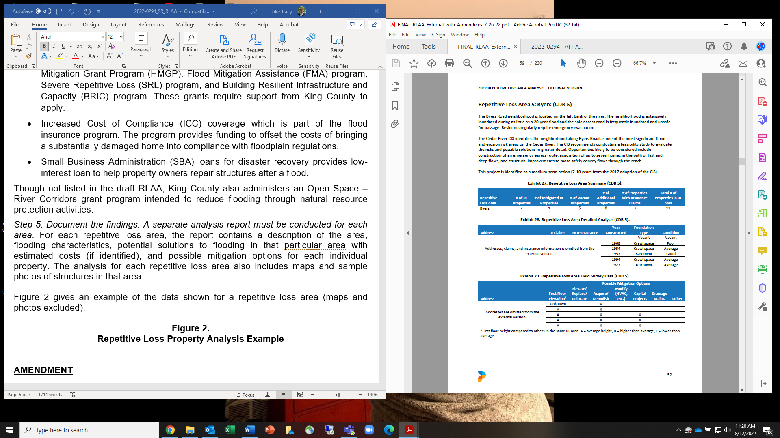

Future RLAA Reports. FEMA requires that each community subject to the RLAA requirement update its analysis in time for each CRS verification visit. King County's next visit is scheduled for 2024 and, if approved, this RLAA would be effective for that visit. The RLAA Report would need to be updated and approved by the Council again by 2027 to be in compliance for the following verification visit.

AMENDMENT

Amendment 1 would attach the final version of the RLAA Report to the PM for adoption. Changes between the transmitted version and the final version included in this amendment include updates to how the flood insurance claims data is organized and entered into the exhibits, an update to total number of survey responses, and incorporation of the one comment on the draft RLAA Report received from a property owner.

FEMA has indicated that the final version of the report meets the requirements for approval.

https://crsresources.org/files/500/rlaa-guide-2017.pdf pg. 2
July 15th email from John Graves, Floodplain Management and Insurance Branch Chief, Mitigation Division, FEMA Region 10.
https://www.fema.gov/sites/default/files/documents/fema-480_floodplain-management-study-guide_local-officials.pdf
https://crsresources.org/files/500/rlaa-guide-2017.pdf pg. 2
Pages 7 and 8 of Attachment A.
These are properties within repetitive loss areas that are mitigated or have the same or similar flood conditions to repetitive loss properties but do not have repetitive claims paid against the NFIP.
July 15th email from John Graves, Floodplain Management and Insurance Branch Chief, Mitigation Division, FEMA Region 10.

