

IT Service Center Verification Report

Prepared By: Sharon Glein,
Office of Information Resource Management

Date: March 3, 2011

This report verifies that the following actions regarding the IT service center were completed by each executive branch department and the office of information resource management as required by the 2011 budget provisos in Ordinance 16984 sections 24, 56, 93, and 108. Although the provisos affected budgets in only four executive branch departments, each proviso stated that “it is the intent of the council that tasks 1) through 5) listed in this proviso will be completed by all executive agencies with service centers.” See Appendix A for a full description of each budget proviso. The status for each department with regards to the proviso is identified in Table 1.
Table 1 - Completion Status by Department
Proviso Element | DAJD | DCHS | DDES | DES | DNRP | DOT | DPH | OIRM
1) the director has signed a letter committing the director's department to working to accomplish the vision, mission and goals statement for the IT service center as signed by all executive branch service delivery managers on 10/18/2010  2) the director has committed that the departmental budget will hold open any vacant help desk, desktop and LAN administrative staff positions to facilitate the consolidation of positions within OIRM  See Appendix B for details | ✓ | ✓ | ✓ | ✓ | ✓ | ✓ | ✓ | ✓
3) all help desk, desktop and LAN admin staff positions budgeted within department and OIRM has been identified  4) the body of work for each help desk, desktop and LAN admin position has been reviewed showing the percentage of the work that is tier one or tier two work for each position, where "tier one" work is considered the first level of support and initial trouble shooting provided to all basic service requests and "tier two" work resolves technology issues that require deeper knowledge and narrower expertise  See Appendix C for details | ✓ | ✓ | ✓ | ✓ | ✓ | ✓ | ✓ | ✓
5) the department has installed and implemented the service center tracking software used to record all departmental requests for service such that the department can report the number, type, staffing and outcome, for all service center requests  See Appendix D for details | ✓ | ✓ | ✓ | ✓ | ✓ | ✓ | ✓ | ✓
Legend: ✓ means completed

This report is also required to be “accompanied by an ordinance developed in consultation with the office of labor relations, amending KCC chapter 2.16 to move to the OIRM the functions and responsibilities of all tier one service staff that provide help desk, desktop and LAN admin support for all executive departments.” This requirement is being addressed in the proposed ordinance required in response to an office of performance, strategy and budget proviso to consolidate some or all of the functions and responsibility for all IT services provided to executive branch departments.

Appendix A – 2011 Budget Provisos, Ordinance 16984
Section 24, P1: Department of Executive Services - Administration
Of this appropriation, $200,000 shall not be expended or encumbered until the executive has transmitted a report verifying that the following actions have been completed by DES: 1) the director has signed a letter committing the director's department to working to accomplish the vision, mission and goals statement for the IT service center as signed by all executive branch service delivery managers on 10/18/2010, 2) the director of the department of executive services has committed that the departmental budget will hold open any vacant help desk, desktop and LAN administrative staff positions to facilitate the consolidation of positions within OIRM, 3) all help desk, desktop and LAN admin staff positions budgeted within DES has been identified, 4) the body of work for each help desk, desktop and LAN admin position has been reviewed showing the percentage of the work that is tier one or tier two work for each position, where "tier one" work is considered the first level of support and initial trouble shooting provided to all basic service requests and "tier two" work resolves technology issues that require deeper knowledge and narrower expertise, and 5) the department has installed and implemented the service center tracking software used to record all departmental requests for service such that the department can report the number, type, staffing and outcome, for all service center requests. The report required by this proviso must be accompanied by an ordinance developed in consultation with the office of labor relations, amending KCC chapter 2.16 to move to the OIRM the functions and responsibilities of all tier one service staff that provide help desk, desktop and LAN admin support for all executive departments. It is the intent of the council that tasks 1) through 5) listed in this proviso will be completed by all executive agencies with service centers. The executive must file the report and ordinance required to be submitted by this proviso by April 10, 2011, in the form of a paper original and an electronic copy with the clerk of the council, who shall retain the original and provide an electronic copy to all councilmembers, the council chief of staff and the lead staff for the government accountability and oversight committee or its successor. Upon receipt of the required report, the clerk shall provide a proof of receipt to the director of the office of performance, strategy and budget.

Section 56 P3: Department of Community and Human Services - Administration
Of this appropriation, $200,000 shall not be expended or encumbered until the executive has transmitted a report verifying that the following actions have been completed by DCHS: 1) the director has signed a letter committing the director's department to working to accomplish the vision, mission and goals statement for the IT service center as signed by all executive branch service delivery managers on 10/18/2010, 2) the director of DCHS has committed that the departmental budget will hold open any vacant help desk, desktop and LAN administrative staff positions to facilitate the consolidation of positions within OIRM, 3) all help desk, desktop and LAN admin staff positions budgeted within DCHS has been identified, 4) the body of work for each help desk, desktop and LAN admin position has been reviewed showing the percentage of the work that is tier one or tier two work for each position, where "tier one" work is considered the first level of support and initial trouble shooting provided to all basic service requests and "tier two" work resolves technology issues that require deeper knowledge and narrower expertise, and 5) the department has installed and implemented the service center tracking software used to record all departmental requests for service such that the department can report the number, type, staffing and outcome, for all service center requests. The report required by this proviso must be accompanied by an ordinance developed in consultation with the office of labor relations, amending KCC chapter 2.16 to move to the OIRM the functions and responsibilities of all tier one service staff that provide help desk, desktop and LAN admin support for all executive departments. It is the intent of the council that tasks 1) through 5) listed in this proviso will be completed by all executive agencies with service centers. The executive must file the report and ordinance required to be submitted by this proviso by April 10, 2011, in the form of a paper original and an electronic copy with the clerk of the council, who shall retain the original and provide an electronic copy to all councilmembers, the council chief of staff and the lead staff for the government accountability and oversight committee or its successor. Upon receipt of the required report, the clerk shall provide a proof of receipt to the director of the office of performance, strategy and budget.

Section 93, P2: Department of Public Health
Of this appropriation, $600,000 shall not be expended or encumbered until the executive has transmitted a report verifying that the following actions have been completed by DPH: 1) the director has signed a letter committing the director's department to working to accomplish the vision, mission and goals statement for the IT service center as signed by all executive branch service delivery managers on 10/18/2010, 2) the director of DPH has committed that the departmental budget will hold open any vacant help desk, desktop and LAN administrative staff positions to facilitate the consolidation of positions within OIRM, 3) all help desk, desktop and LAN admin staff positions budgeted within DPH has been identified, 4) the body of work for each help desk, desktop and LAN admin position has been reviewed showing the percentage of the work that is tier one or tier two work for each position, where "tier one" work is considered the first level of support and initial trouble shooting provided to all basic service requests and "tier two" work resolves technology issues that require deeper knowledge and narrower expertise, and 5) the department has installed and implemented the service center tracking software used to record all departmental requests for service such that the department can report the number, type, staffing and outcome, for all service center requests. The report required by this proviso must be accompanied by an ordinance developed in consultation with the office of labor relations, amending KCC chapter 2.16 to move to the OIRM the functions and responsibilities of all tier one service staff that provide help desk, desktop and LAN admin support for all executive departments. It is the intent of the council that tasks 1) through 5) listed in this proviso will be completed by all executive agencies with service centers. The executive must file the report and ordinance required to be submitted by this proviso by April 10, 2011, in the form of a paper original and an electronic copy with the clerk of the council, who shall retain the original and provide an electronic copy to all councilmembers, the council chief of staff and the lead staff for the government accountability and oversight committee or its successor. Upon receipt of the required report, the clerk shall provide a proof of receipt to the director of the office of performance, strategy and budget.

Section 108, P2: Office of Information Resource Management
Of this appropriation, $300,000 shall not be expended or encumbered until the executive has transmitted a report verifying that the following actions have been completed by OIRM: 1) CIO has signed a letter committing OIRM to working to accomplish the vision, mission and goals statement for the IT service center as signed by all executive branch service delivery managers on 10/18/2010, 2) CIO has committed that OIRM budget will hold open any vacant help desk, desktop and LAN administrative staff positions to facilitate the consolidation of positions within OIRM, 3) all help desk, desktop and LAN admin staff positions budgeted within OIRM has been identified, 4) the body of work for each help desk, desktop and LAN admin position has been reviewed showing the percentage of the work that is tier one or tier two work for each position, where "tier one" work is considered the first level of support and initial trouble shooting provided to all basic service requests and "tier two" work resolves technology issues that require deeper knowledge and narrower expertise, and 5) OIRM has installed and implemented the service center tracking software used to record all requests for service such that OIRM can report the number, type, staffing and outcome, for all service center requests. The report required by this proviso must be accompanied by an ordinance developed in consultation with the office of labor relations, amending KCC chapter 2.16 to move to the OIRM the functions and responsibilities of all tier one service staff that provide help desk, desktop and LAN admin support for all executive departments. It is the intent of the council that tasks 1) through 5) listed in this proviso will be completed by all executive agencies with service centers. The executive must file the report and ordinance required to be submitted by this proviso by April 10, 2011, in the form of a paper original and an electronic copy with the clerk of the council, who shall retain the original and provide an electronic copy to all councilmembers, the council chief of staff and the lead staff for the government accountability and oversight committee or its successor. Upon receipt of the required report, the clerk shall provide a proof of receipt to the director of the office of performance, strategy and budget.

Appendix B – Department Director Letters

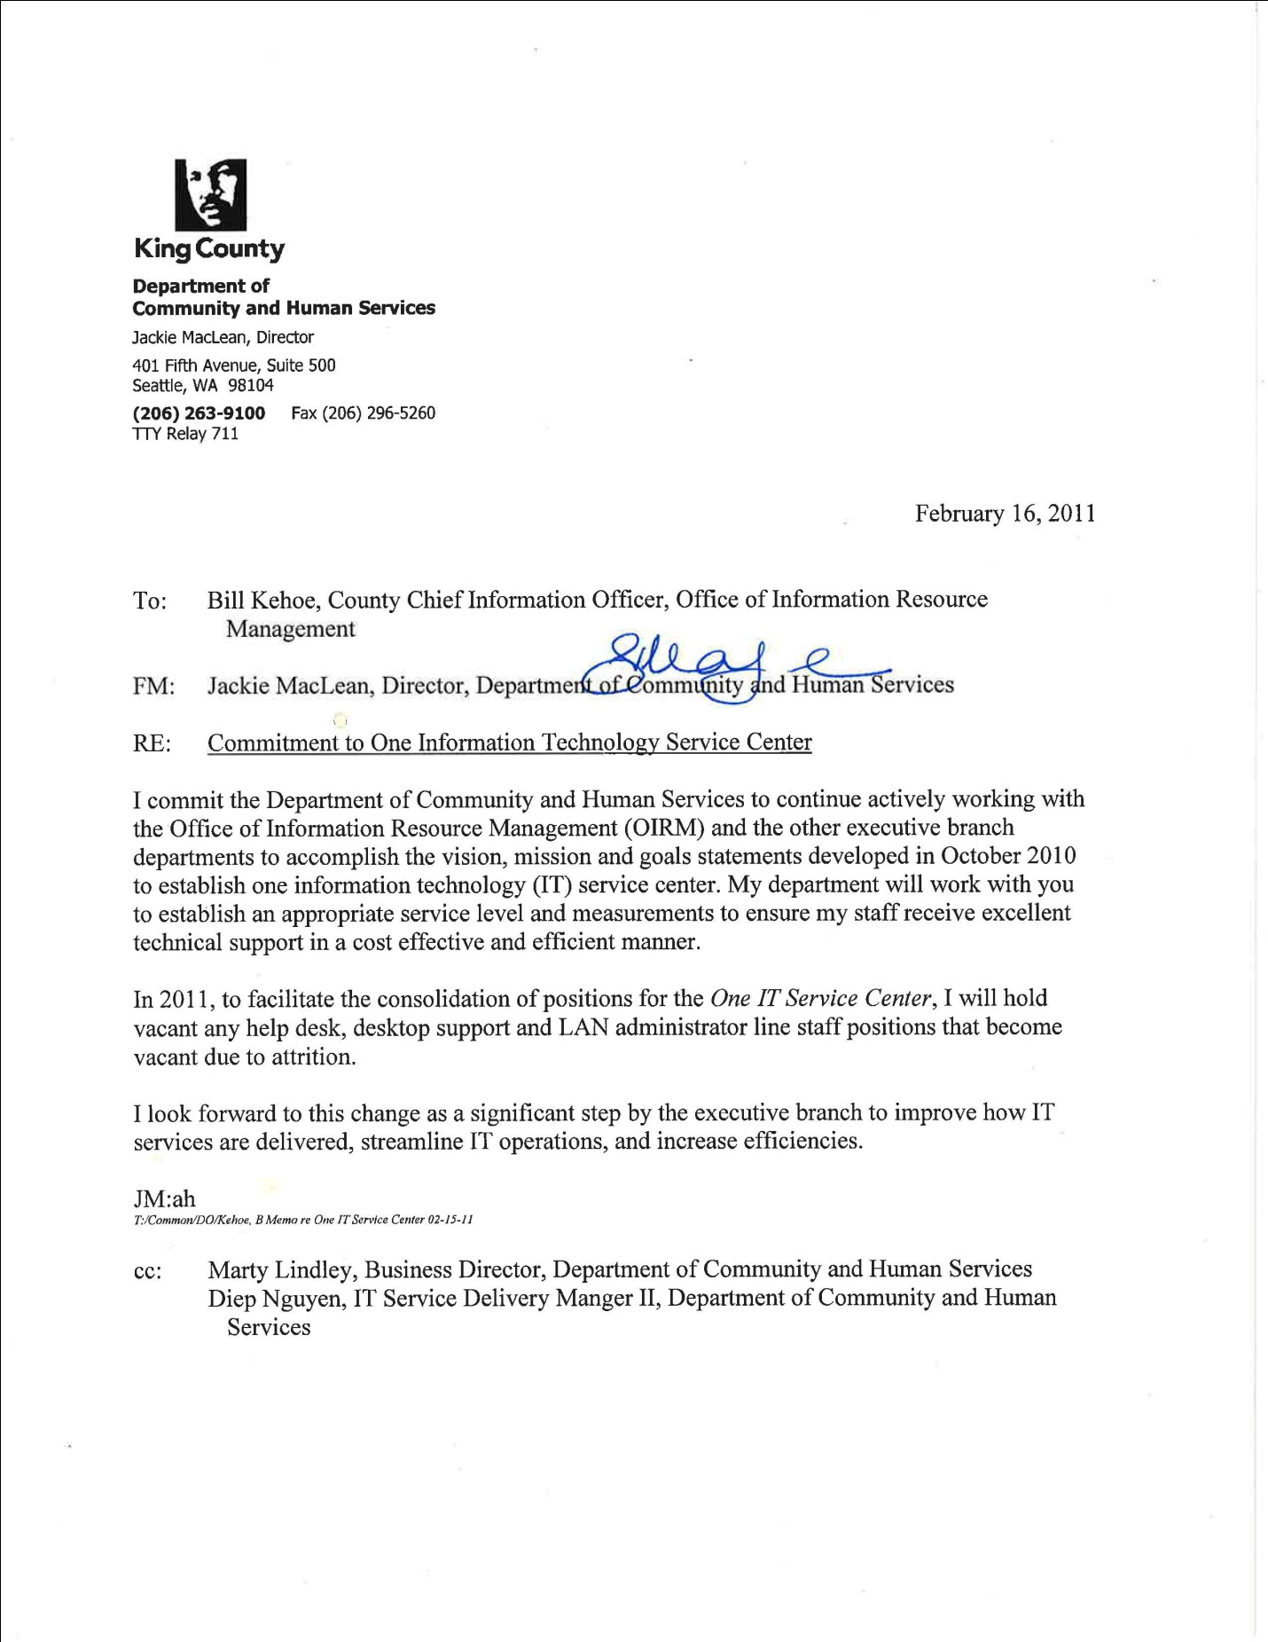

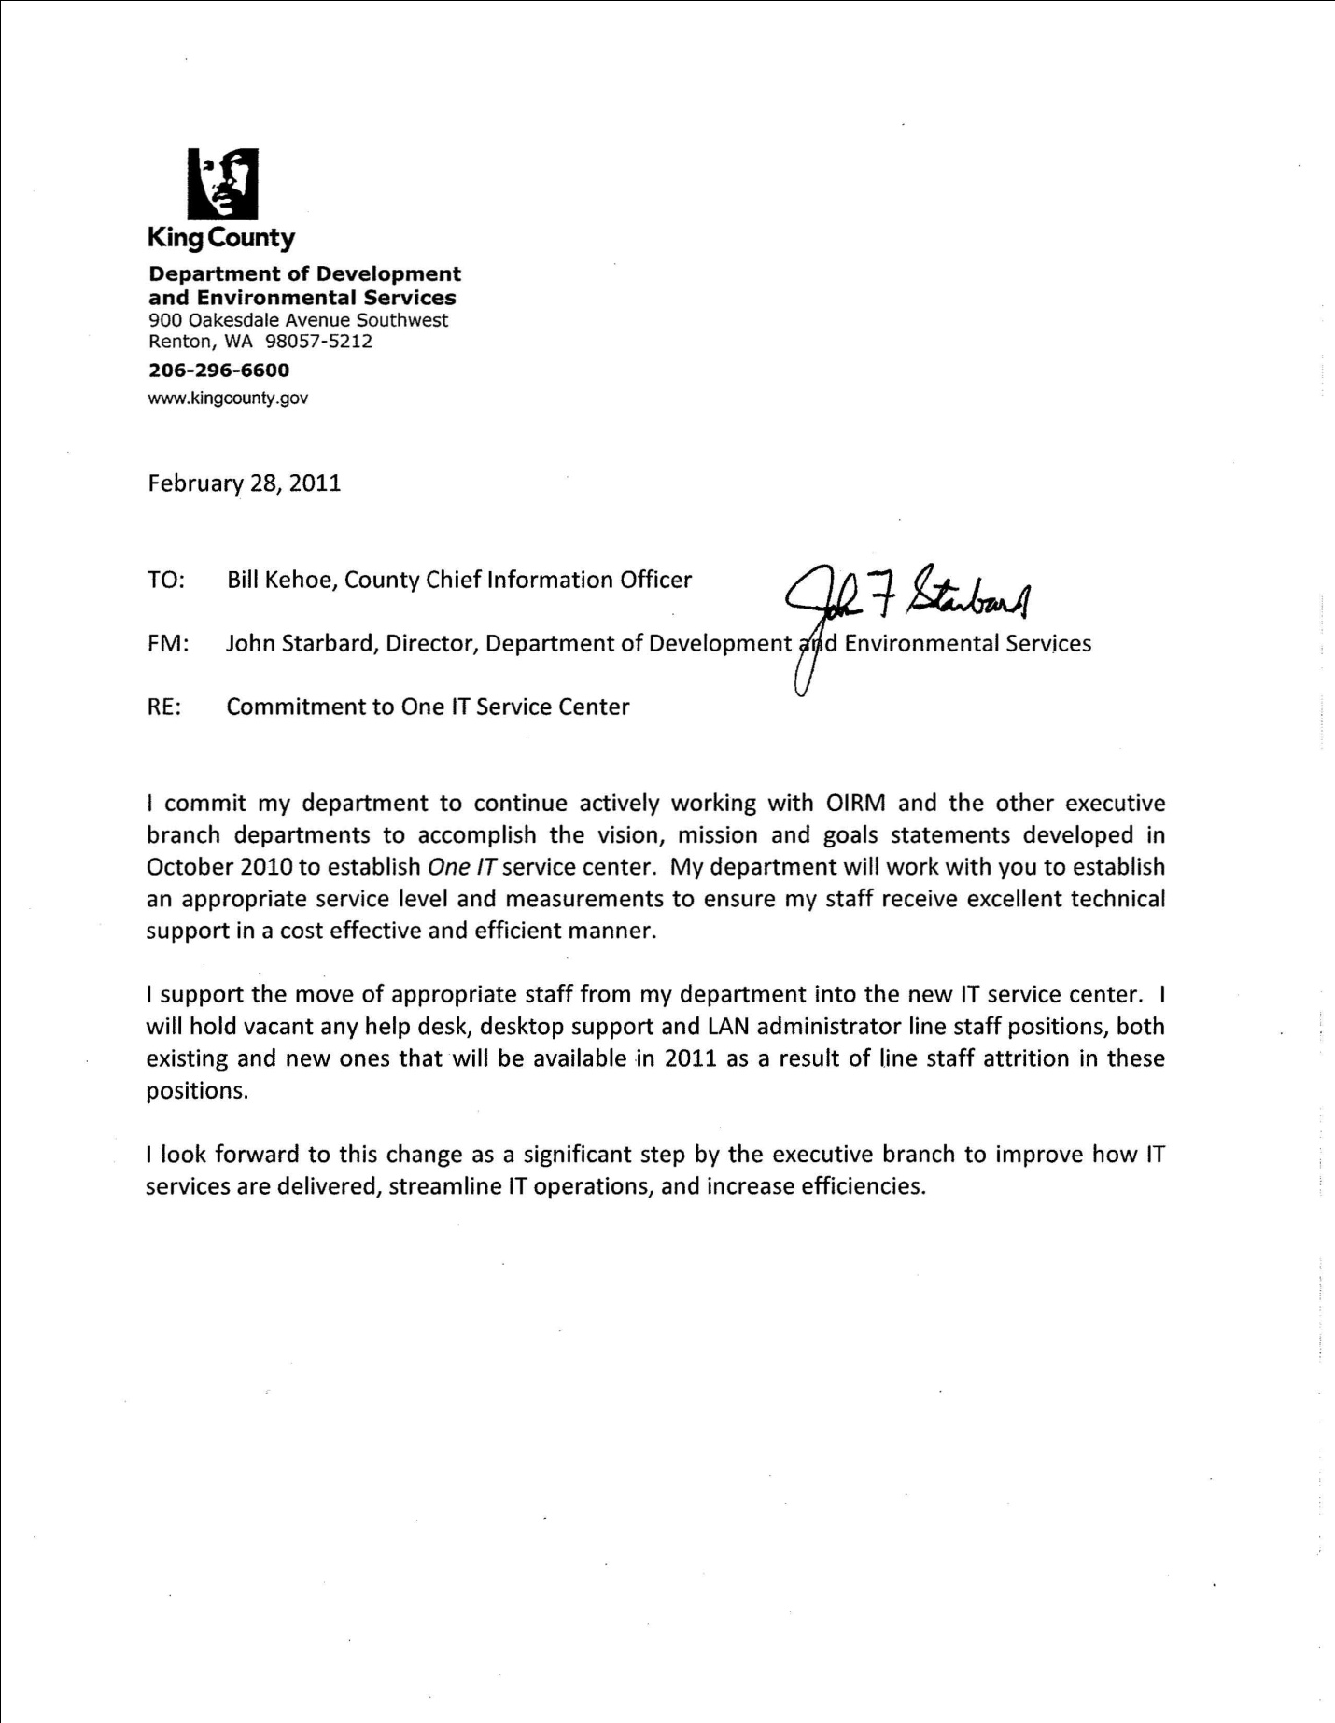

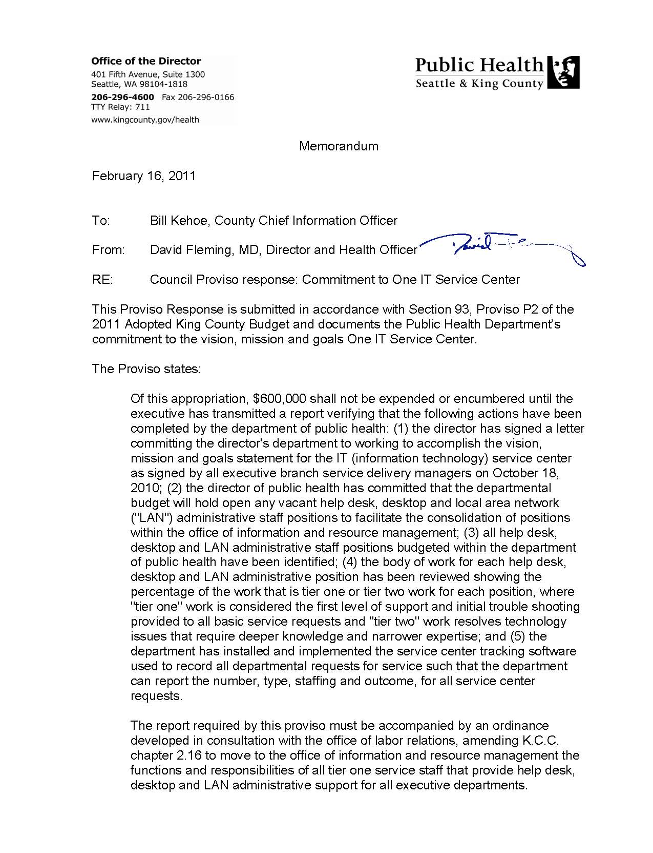
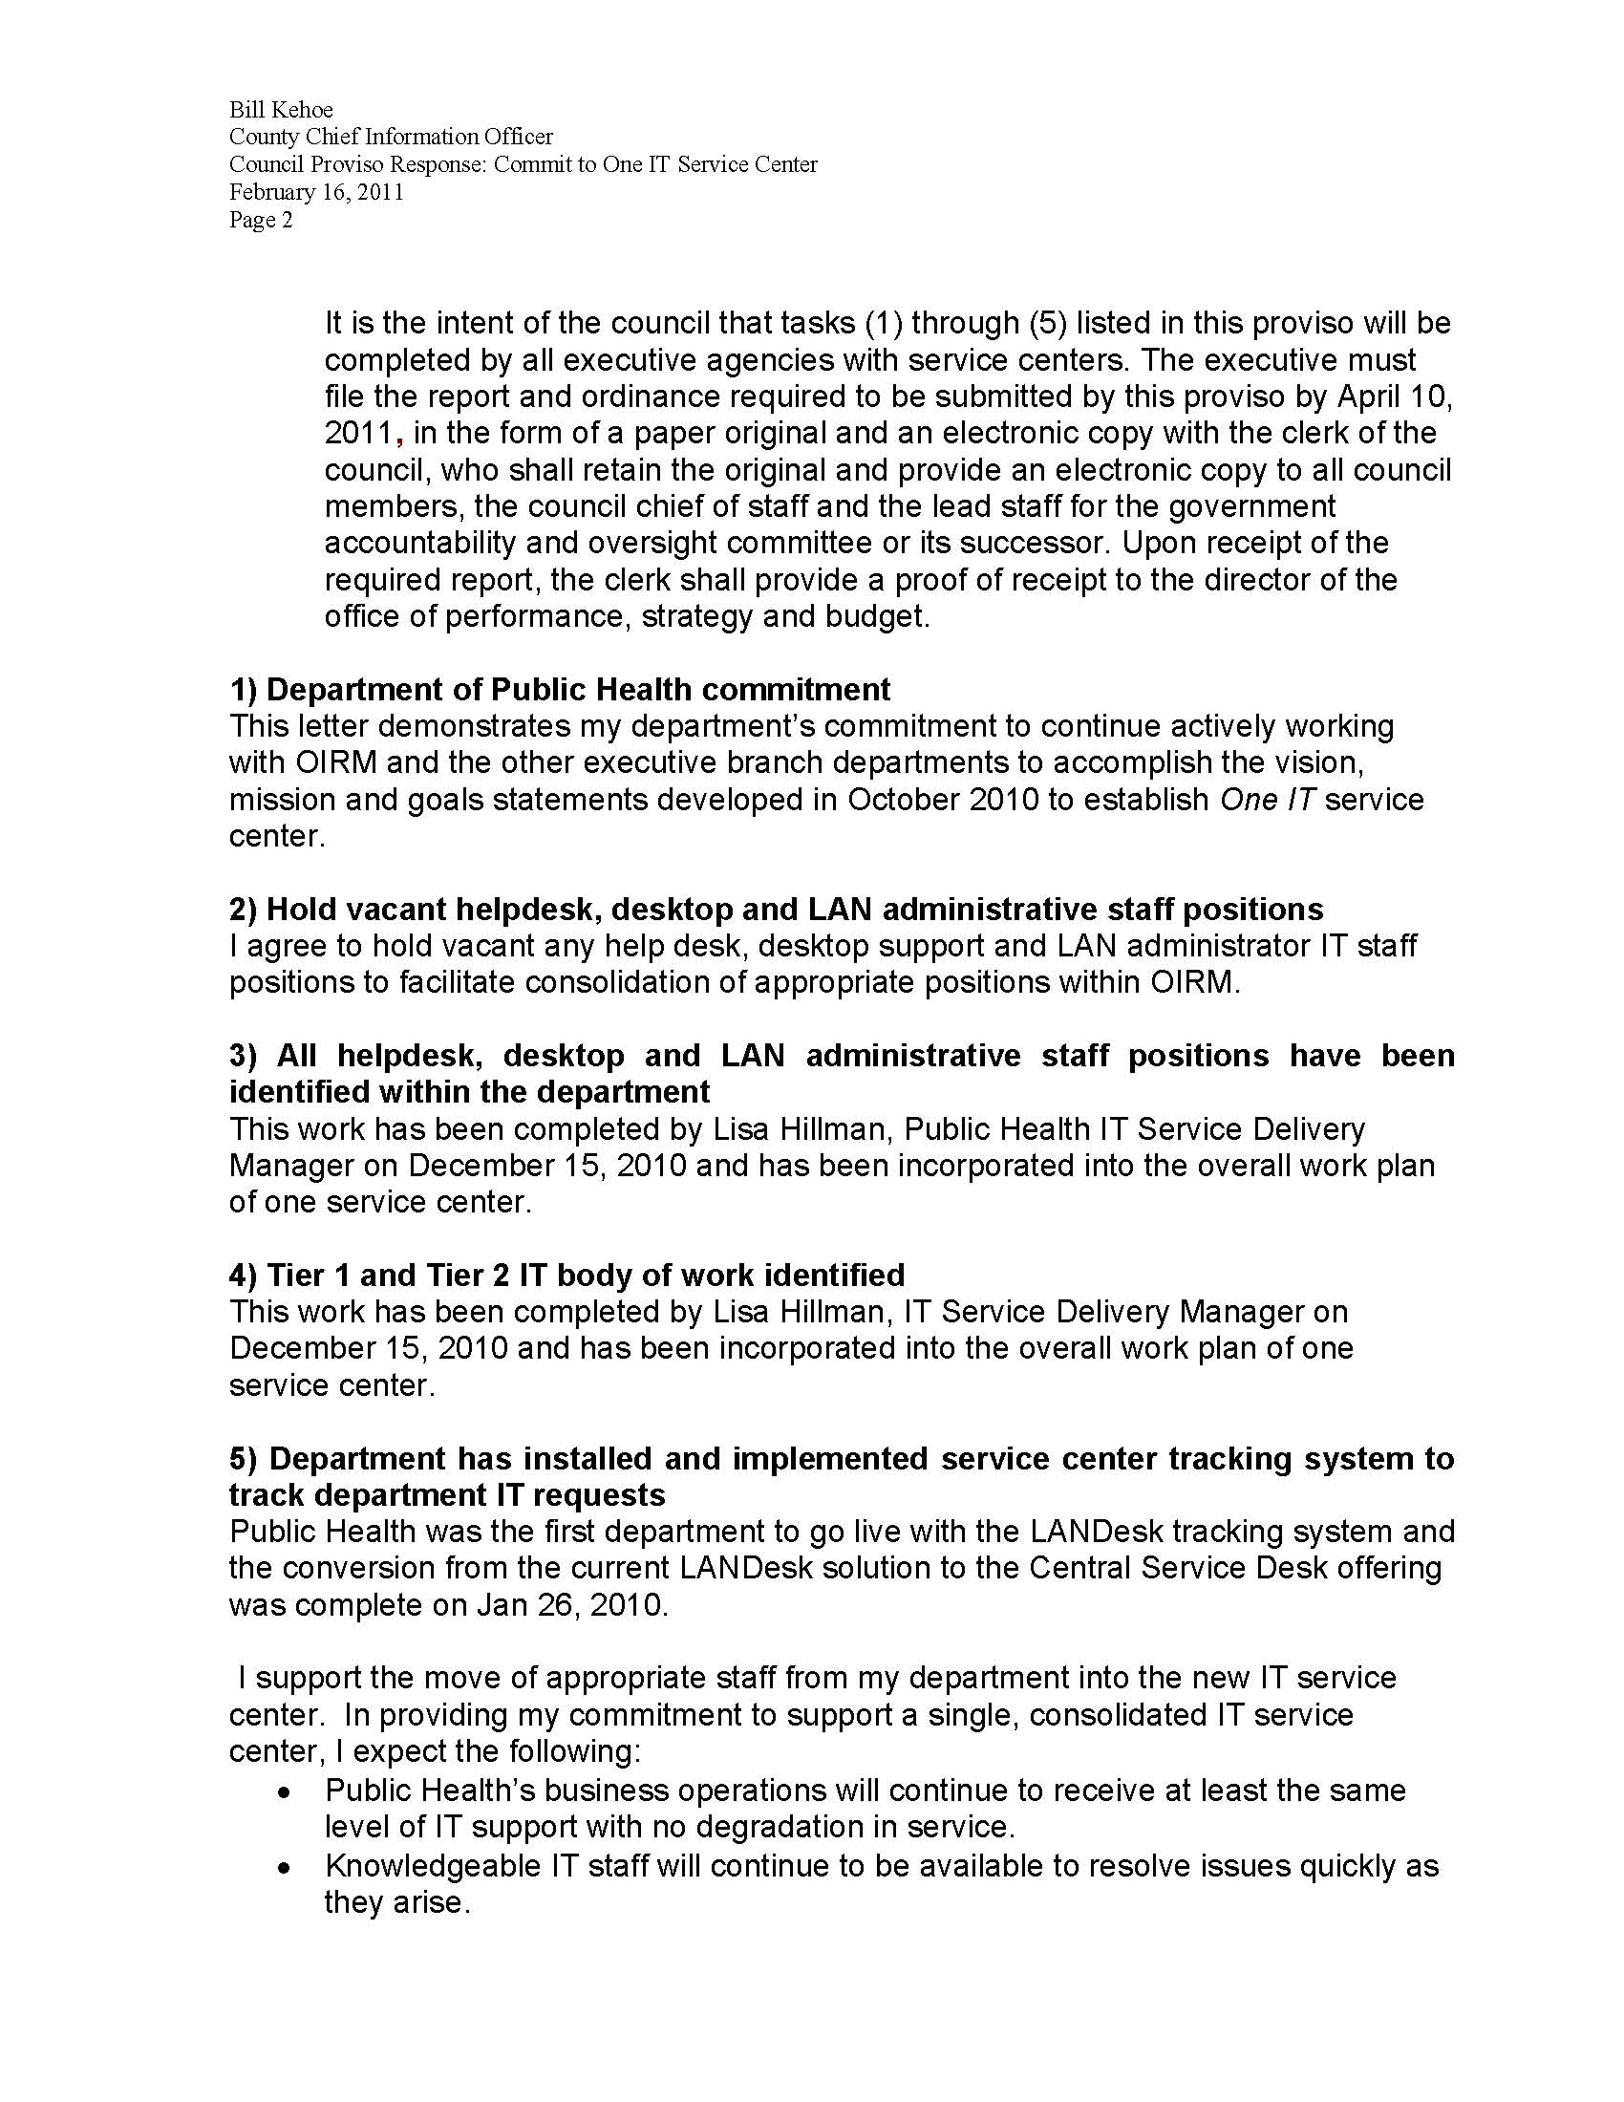

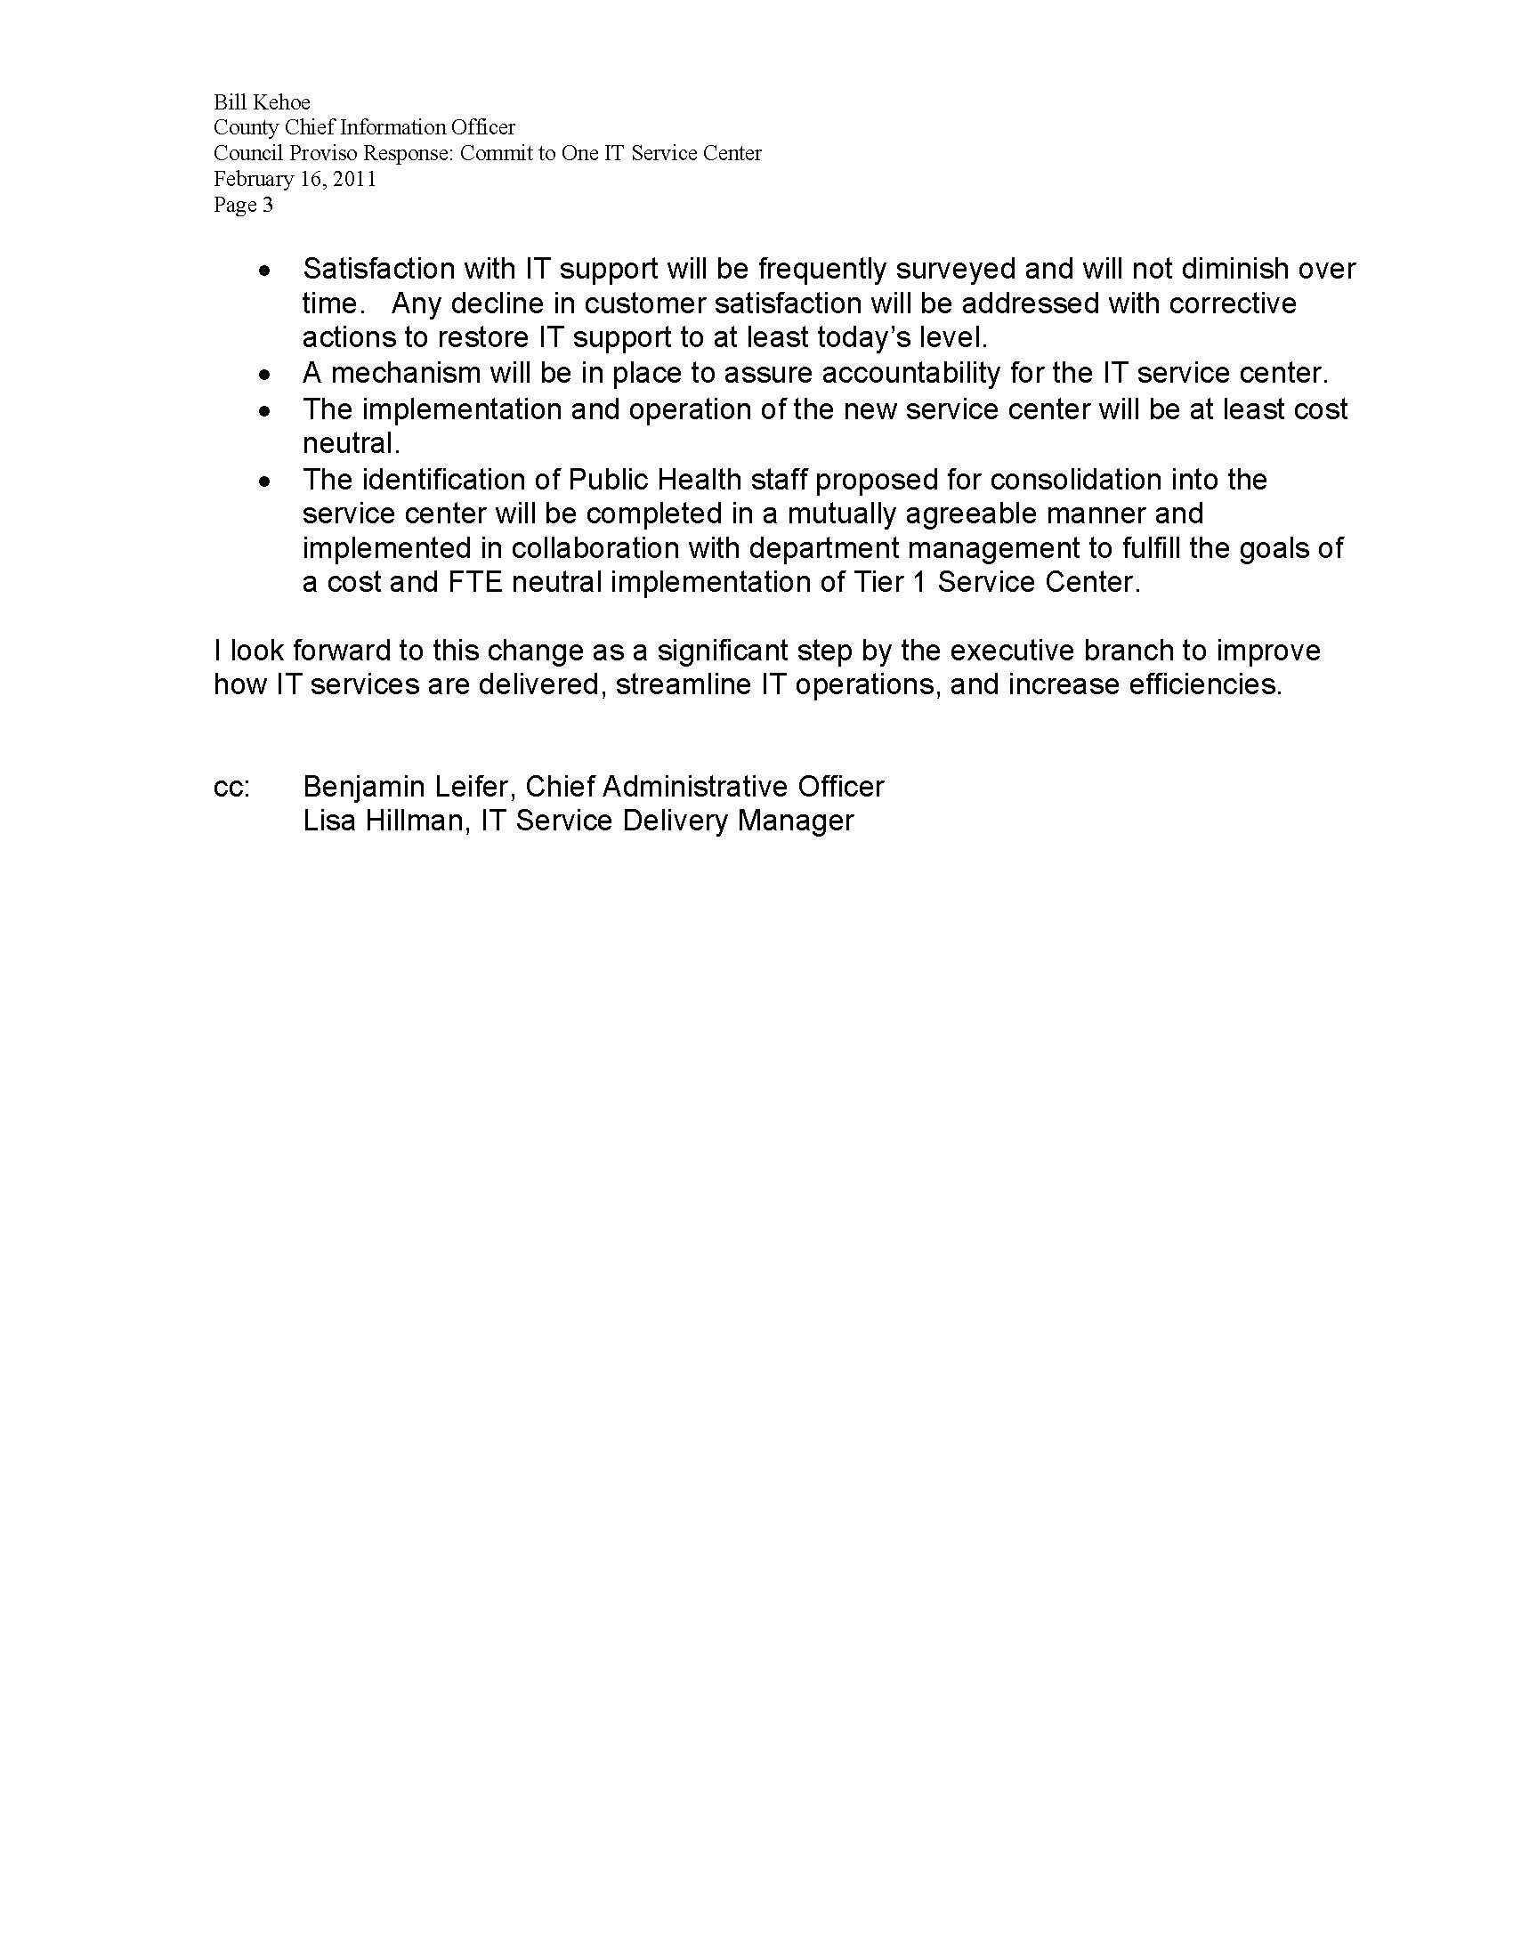

Appendix C – Staff Positions and Body of Work (December 31, 2010)

Appendix D – LANDesk Service Desk System Go-Live Dates
Department | Go-Live Date
Adult & Juvenile Detention | 4/14/10
Community and Human Services | 6/30/10
Development & Environmental Services | 5/17/10
Elections | 2/23/10
Executive Services | 3/8 /10
Public Health | 1/26/10
Office of Information Resource Management | 2/17/10
Natural Resources and Parks | 8/11/10
Transportation | 3/3/10

