East Link Connections Transit Gap Service Analysis Report
April 22, 2026

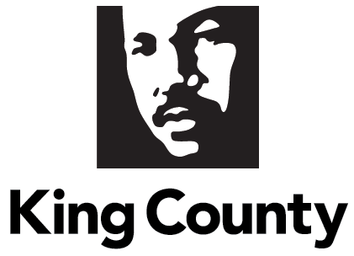

Contents
I. Proviso Text 3
II. Executive Summary 4
III. Background 6
IV. Report Requirements 8
A. Summary of potential changes to routes 226 or 240 that could restore services to Richards Road 8
B. A description of flexible service pilots that could be implemented or expanded in the Bel-Red, Crossroads and Woodridge neighborhoods in Bellevue to provide connections to frequent transit service 14
V. Conclusion 21
VI. Appendices 23

Figures
Figure 1. Woodridge transit service access with potential Route 240 revision 9
Figure 2. Woodridge East Link Connections transit service gaps with Route 226 revision 12
Figure 3. Bel-Red and Crossroads East Link Connections transit service gaps 17
Figure 4. Potential pilot Overlake Metro Flex expansion areas 18
Figure 5. Potential pilot Woodridge Metro Flex area 20

Tables
Table 1. Woodridge neighborhood transit access impacts 9
Table 2. Comparing travel times for Route 240 Eastgate Park and Ride to light rail 11
Table 3. Comparing travel times for Route 240 Eastgate Park and Ride to Bellevue Transit Center 11

Proviso Text

Ordinance 20023, Section 116, Proviso P14

P14 PROVIDED FURTHER THAT:
Of this appropriation, $100,000 shall not be expended or encumbered until the executive transmits an East Link Connections transit gap service analysis report and a motion acknowledging receipt of the report, and a motion acknowledging receipt of the report is passed by the council. The motion should reference the subject matter, the proviso's ordinance number, ordinance section and proviso number in both the title and body of the motion.
The East Link Connections transit gap service analysis report shall use the extensive analysis and community outreach information collected by the Metro transit department as part of its East Link Connections Mobility Project, as well as additional information as needed, to identify potential solutions to the transit service gaps in the Woodridge, Bel-Red, and Crossroads neighborhoods of Bellevue that were created by the East Link Connections Mobility Project approved by Ordinance 19899, specifically by the changes that were made to routes 226 and 240 and by the elimination of route 246, by including:
A. A summary of potential changes to routes 226 or 240 that could restore services to Richards Road, such as infrastructure investments, routing changes, speed and reliability improvements, bus stop consolidation, and changed route terminus locations; and
B. A description of flexible service pilots that could be implemented or expanded in the Woodridge, Bel-Red, and Crossroads neighborhoods in Bellevue to provide connections to frequent transit service.
The executive should electronically file the report and motion required by this proviso no later than February 19, 2026, with the clerk of the council, who shall retain an electronic copy and provide an electronic copy to all councilmembers, the council chief of staff and the lead staff for the transportation, economy, and environment committee or its successor.

Executive Summary

In response to the Proviso in Ordinance 20023, Section 116, Transit, P14, this report summarizes transit service gaps resulting from implementation of the East Link Connections Mobility Project (ELC) as approved by Ordinance 19899, specifically in the Bellevue neighborhoods of Bel-Red, Crossroads and Woodridge from changes in routes 226 and 240, and deletion of Route 246. This report identifies potential solutions and associated trade-offs for filling gaps in these neighborhoods, including an alternative pathway through Woodridge to restore service on Richards Road, which would remove the pathway serving South Bellevue Station between Eastgate Park-and-Ride and East Main Station, and potential Metro Flex on-demand pilot service options.

Potential changes to Route 240 to restore transit service to Richards Road
To restore transit service to Richards Road, Route 240 could revert to its pathway prior to the August 30, 2025, changes. The prior pathway leaves Eastgate Park-and-Ride via 139th Avenue Southeast to Southeast 26th Street to Richards Road and continues to downtown Bellevue via Lake Hills Connector, Southeast 8th Street and 112th Avenue Southeast. This would allow all of Richards Road and adjacent areas to be within a quarter mile of a bus stop. Figure 1 on page nine shows the current Route 240 and a revised Route 240 with potential changes described above.

In Woodridge and adjacent areas near Eastgate Park-and-Ride, 12 stops lost service due to Route 240 pathway changes to connect to South Bellevue Station. In fall 2024, these stops had an average weekday daily total of 65 boardings at a time when this area was already connected to the East Main Station. If this alternative pathway for Route 240 to serve Richards Road is implemented, service at the 12 stops would be restored. However, since August 30, 2025, Route 240 has been serving South Bellevue Station, with an average weekday daily total of 80 boardings, with more boardings expected after light rail connects to Seattle in March 2026. This demonstrates higher demand at the current Link station stops than the previous demand at stops that lost coverage.

The Route 240 potential change to serve Richards Road would increase transit travel times between key destinations and connections. Overall, the current Route 240 provides faster service to the nearest light rail station. Travel time to Bellevue Transit Center is similar with Route 240 via Richards Road, often a few minutes faster than the current Route 240.

Potential Metro Flex pilots connecting to frequent transit connections in Bel-Red, Crossroads and Woodridge
Metro Flex is an app-enabled, on-demand mobility service where customers can book a ride from one place to another within a defined service area. Metro Flex functions as a way to strategically fill gaps in the fixed-route network and connect customers to transit hubs. To use funding efficiently, Metro used its learnings from implementing previous service areas and created standards for Metro Flex, including a maximum cost per ride and minimum number of rides per hour by a vehicle. A description of these standards is available in Metro’s System Evaluation.

To achieve the ridership needed to meet these standards and encourage productivity and efficiency, the following best practices based on Metro’s learnings are applied in designing Metro Flex Service areas:
- Ensure desirable destinations are relatively close together mixed with residential density to allow shorter journeys, increasing the number of trips that can be delivered, including more shared trips.
- Include frequent transit hubs to drive ridership because they are an attractive destination that provides broader access beyond the Metro Flex service area to jobs, attractions, and community resources.
- Center key destinations, like frequent transit hubs, in the service area to increase efficiency by minimizing trip distances and maximizing the number of people able to reach destinations using Metro Flex.
- Assess service area size. Large service areas decrease efficiency because trips are longer, occupying vehicles and reducing their availability to other customers.
- Analyze street network characteristics as to how they impact efficiency because some types of streets, such as residential areas with cul-de-sacs or freeway interchanges, create bottlenecks slowing travel time, while free flowing street grids can make it easier to serve an area.
Figure 4 on page 18 shows a map of East Link Connections-related transit service gaps in the Bel-Red, Crossroads, and Northeast neighborhoods of Bellevue. It also shows how potential extensions of the existing grant-funded, pilot Overlake Metro Flex area could provide connections to frequent transit.

Based on the best practice principles summarized above expansions of the grant-funded, pilot Overlake Metro Flex zone shown in Figure 4 could reduce efficiency due to longer trip times. Longer trip times may result because the added destinations are separated from population, few new residents are covered by the expansions, and the service area is larger. This may result in vehicles carrying fewer riders per hour at a higher cost per ride with longer wait times. This outcome is not aligned with Metro’s Strategic Plan goals to be responsible stewards of public funds and deliver quality service. For these reasons, Metro would not recommend these Metro Flex expansions. An additional vehicle would be needed to cover these expansions at an estimated cost of 4,160 vehicle hours and $310,300 per year, increasing year-over-year for inflation and other operational factors. Metro’s adopted budget does not include funding for this service.

Figure 5 on page 20 shows a map of East Link Connections-related transit service gaps in the Woodridge neighborhood of Bellevue. It also shows how a potential pilot Metro Flex area could provide connections between Woodridge and frequent transit at Eastgate Park and Ride.

Based on the best practice design principles summarized above, Metro would not recommend Metro Flex in Woodridge because a pilot in this neighborhood is likely to have low-ridership and high cost. The Woodridge area is largely residential and isolated from transit hubs and other destinations with limited road network connectivity. This environment can lead to increased travel time and vehicles in use longer while unable to pick up other passengers. This reduced vehicle availability results in longer wait times for customers. Woodridge is not near the high density of destinations needed to encourage ridership. Operating a Metro Flex pilot in the Woodridge neighborhood would require a minimum of two vehicles at an estimated cost of 8,700 vehicle hours and $648,800 per year, increasing year-over-year for inflation and other operational factors. Metro’s adopted budget does not include funding for this service.

Background

Department Overview: King County Metro is the Puget Sound region’s largest public transportation agency. Metro provides bus, paratransit, Vanpool, and water taxi services, and operates Seattle Streetcar, Sound Transit Link light rail, and Sound Transit Express bus service. Metro is committed to providing safe, equitable, and sustainable mobility, and prioritizing service where needs are greatest.

Key Historical Context: This report is related to Metro’s East Link Connections Mobility Project, which was adopted by the King County Council via Ordinance 19899 on March 7, 2025.

The East Link Connections project is a large-scale transit restructure to align bus service with the new 2 Line, restore bus service suspended during the pandemic period, and update the transit network to reflect changing travel and land use patterns on the Eastside. The project area encompasses 21 jurisdictions and hundreds of thousands of people. To understand and balance the priorities of residents in the broad and diverse project area Metro conducted an extensive public engagement process involving thousands of public comments, virtual open houses, a resident advisory board, a board of jurisdictions, businesses, and community organizations, partnerships with community organizations, advertising, and other strategies. Community priorities heard during engagement informed the decisions made as part of this project which often involve trade-offs, such as removing transit coverage in low-ridership areas to add frequency or increase span of service in high-ridership areas. Metro recognizes the challenges these trade-offs present to riders and endeavors to create the least number of negative impacts. The trade-offs also resulted in benefits such as increased frequency along key corridors, more service at night and on weekends, new and improved connections with key destinations, and connections to Link light rail.

Implementation of this updated transit network began on March 29, 2025, and continued in June of that year. A significant amount of service was added on August 30, 2025, and major changes took place to continue implementing the new transit network. Additional phases of implementation are planned in 2026 and 2027 to complete the changes and levels of service shown in Ordinance 19899. During and after this implementation period Metro will be monitoring performance and listening to community feedback about the changes to the network.

Key Current Conditions: Since August 30, 2025, Metro has received many comments from residents in areas with transit network changes, particularly the Woodridge and Northeast neighborhoods of Bellevue. These comments are focused on the closure of bus stops in these neighborhoods and reduced access to service. Metro service planning and community engagement staff have directly reached out to a number of these residents to help them understand changes and flexible service alternatives for mobility that may exist, such as Access paratransit service, the Hyde Shuttle (a shuttle for seniors and those with disabilities), and Vanpool.

By August 2027, the King County Executive will submit a letter to the Council summarizing Metro’s review of performance of the East Link Connections network changes to date. Due to the large amount of service investments and phased Link station openings, 2027 will be the first year during which full implementation is complete. This summary evaluation will consider how the full set of changes are performing with all 2 Line stations operating.
Report Methodology: This report was created by Metro’s Service Development section in the Mobility Division. It includes input and analysis from service planners and schedulers, as well as Metro community engagement staff. It is informed by the previous body of work and public engagement to develop and implement the East Link Connections Mobility Project. The report significantly leverages work associated with the East Link Connections Mobility Project revised transit network. It also includes recent public comments received, ridership data to the stop level, scheduling information, operating costs and hours, and demographics. Data from the City of Bellevue Open Data Portal was used to define the neighborhoods requested for analysis by this proviso.

Over time, flexible service pilots at Metro have taken many forms and iterated on technology and operations approaches. These pilots have included both services driven by professional drivers and vans operated by volunteers performing trips requested by riders, and have been open to a range of riders, including the general public, people with disabilities, seniors, and customers associated with supportive community organizations. For the purposes of this report the focus will be on describing and assessing flexible service options using the current public, professionally-operated, on-demand, pilot Metro Flex services. This is the flexible service profile most consistent with the needs of customers who provided comments about these changes. There are other flexible services that could potentially support mobility in these neighborhoods, including meeting the needs of those who have expressed concern about the loss of service in their neighborhoods. These services include Access, Hyde Shuttle, and Vanpool.

The King County Metro Mobility Framework directs the agency to provide additional transit service in areas with unmet need, prioritizing areas with a high density of priority populations among other criteria. Using this direction, the description of alternative service scenarios in this report includes impacts on priority populations, defined by the Mobility Framework as Black, Indigenous, and other people of color, low-income people, people with disabilities, refugees, immigrants, and diverse language speakers.

This report presents potential changes to address transit service gaps and the benefits and impacts. This work will also be included in a broader post-implementation assessment Metro undertakes following large restructures. It includes monitoring and assessing the performance of the network changes across all neighborhoods and routes in the project area, listening to feedback from the community, and over time, and with additional public engagement considering changes as needed.

Report Requirements

Summary of potential changes to routes 226 or 240 that could restore services to Richards Road

East Link Connections implementation included Route 240 changes and deletion of Route 246 that removed fixed-route transit access in the Woodridge neighborhood in an area along Richards Road, Southeast 27th Street, and 123rd Avenue Southeast. This area includes 4,123 residents, including 1,800 living in equity priority areas, and 474 jobs. Fixed-route transit access is defined as living within a quarter mile of a bus stop.

To restore transit service to Richards Road, Route 240 could be revised to follow its pathway prior to August 30, 2025, changes. Doing so would require moving a stop more than a half mile, exceeding Metro’s administrative authority for making changes. Therefore, such a change would require Council approval of an ordinance. Metro’s practice is to conduct public engagement to garner and consider feedback from residents who may be affected by changes to the network prior to submitting a proposed ordinance to King County Council.

To serve Richards Road a revised Route 240 would leave Eastgate Park-and-Ride inbound to downtown Bellevue via 139th Avenue Southeast to Southeast 26th Street to Richards Road and continue to downtown Bellevue via Lake Hills Connector, Southeast 8th Street and 112th Avenue Southeast. This would not restore fixed-route transit access to areas along the former Route 246 pathway in Woodridge. Figure 1 shows the existing Route 240 and a revised Route 240 with potential changes described above. For a larger view of this map, see Appendix A.

Figure 1. Woodridge transit service access with potential Route 240 revision
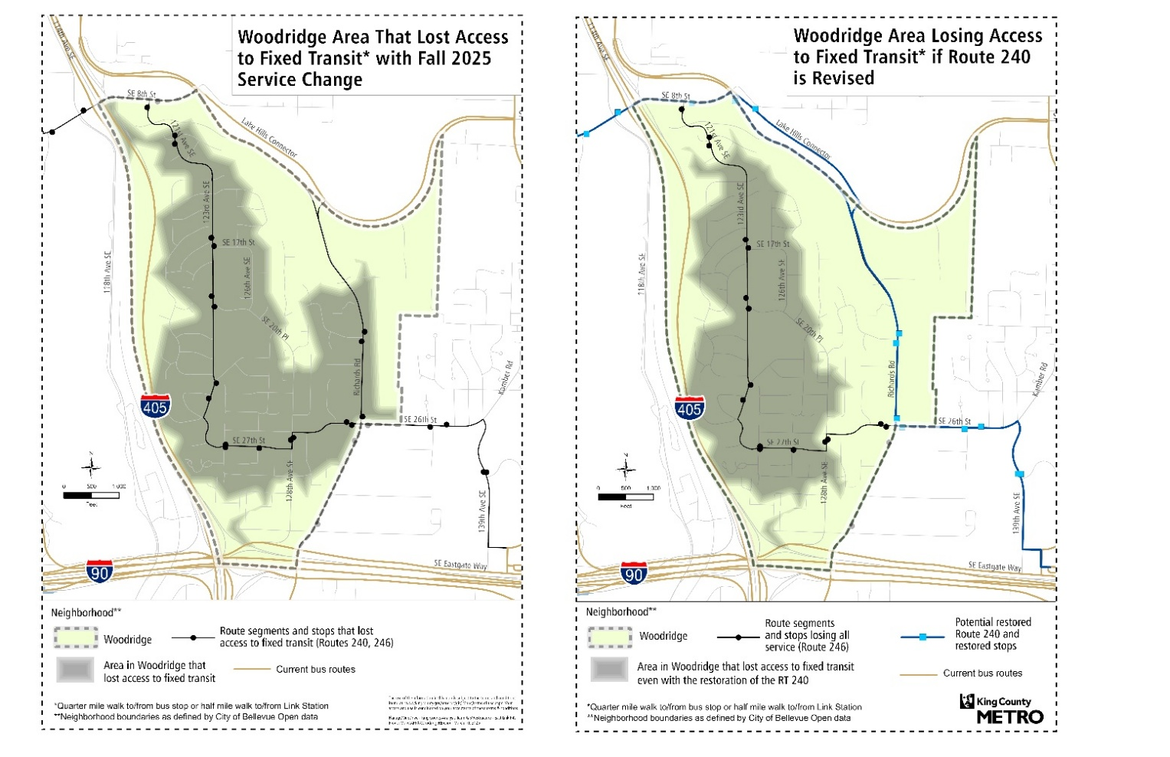

Table 1 below summarizes the population without access to fixed-route transit within a quarter mile of their location currently and with potential changes to serve Richards Road. While service to Richards Road restores fixed-route transit access to 42 percent of Woodridge residents currently without it, it would restore service to 59 percent of Woodridge residents living in equity priority areas who are currently without it.

Table 1. Woodridge neighborhood transit access impacts
Variant | Population without transit access | Priority population without transit access | Community Assets losing transit access | Loss of transit access to jobs | Average weekday boardings at stops that lost service
Current  Route 240 | 4,123 | 1,800 | 1 | 474 | 97
Revised Route 240 via Richards Road | 2,400 | 735 | 1 | 287 | 32

The potential changes to Route 240 to serve Richards Road would not restore service to 18 stops associated with the deleted Route 246. These stops had very low ridership. The total average weekday daily boardings in fall 2024 for these stops was 32. According to the 2024 System Evaluation, Route 246 was consistently one of the lowest ridership routes among all urban and suburban routes in Metro’s system, carrying an average of 245 riders per day for the entire route. The 2024 System Evaluation also showed Route 246 in the bottom 25 percent of all suburban and urban routes for riders per hour. Stops on Route 246 in Woodridge had very low ridership with 7 of 17 stops averaging less than one rider per day.

During community engagement Metro heard a preference for less coverage routes with low frequency in favor of more frequency on higher ridership routes, with a majority of survey responses supporting deleting Route 246 and subsequent reallocation of resources to routes with more frequent service. Metro worked to limit areas losing coverage while better aligning bus service levels with rider demand, consistent with Metro’s Service Guidelines. Metro’s Service Guidelines direct evaluation, design, and modification of service, as directed by Ordinance 19367.

A1. Ridership at South Bellevue Station Compared to Woodridge
In Woodridge and adjacent areas near Eastgate Park-and-Ride, 12 stops lost service due to Route 240 pathway changes to connect to South Bellevue Station. In fall 2024, these stops had an average weekday daily total of 65 boardings. If potential changes to Route 240 were implemented to serve Richards Road, service at these stops would be restored. However, since August 30, 2025, Route 240 has been serving South Bellevue Station. There are two stops at the station serving Route 240. Those stops currently have an average weekday daily total of 80 Route 240 boardings, with more boardings expected after light rail connects to Seattle in March 2026. This demonstrates there is currently more demand for boardings at the current Link station stops than the previous demand at stops that lost coverage.

A2. Travel time impacts
Potential Route 240 changes to serve Richards Road would impact transit travel times between key destinations and connections. Specifically, the most significant impact of restoring Route 240 service to Richards Road is an increase in travel time to Link light rail by 5-12 minutes. The increase would effect riders starting their trips at or south of Eastgate Park-and-Ride in areas such as Factoria, Newcastle, and Renton. Travel time for this analysis is measured using scheduled runtimes that are used by Metro to schedule bus service between designated points.

Travel time impact of the potential Route 240 Richards Road pathway will be compared between:
- Eastgate Park-and-Ride and the nearest light rail station
- Eastgate Park-and-Ride and downtown Bellevue
While some riders are coming to and from downtown Bellevue, some will be seeking to travel to and from light rail because of the high quality of the service and the wide range of destinations it serves, such as downtown Seattle, Microsoft campus, and downtown Redmond. As noted earlier, good connections to Link stations was a strong theme of need noted during public engagement.

The current Route 240 provides faster travel times to reach light rail than the potential changes to serve Richards Road. The current route connects Eastgate Park-and-Ride and the nearest light rail station, which is South Bellevue Station. The nearest station for the potential change to Route 240 via Richards Road is East Main Station further north on the edge of downtown Bellevue (this is measured from Northeast 4th Street and 108th Avenue Northeast, which is the nearest designated point to East Main Station used for estimating runtime). Table 2 below summarizes the differences in travel time. For each Route 240 alignment there are different estimated travel times for each hour of the day and thus a unique difference for each hour. The table shows the range across all hours for each column. Changing the route to serve Richards Road would increase the time it takes riders to reach light rail. This would impact all potential riders on Route 240 at or south of Eastgate Park-and-Ride in areas such as Factoria, Newcastle, and Renton. Factoria, Newcastle, and Renton all contain significant numbers of priority populations who may seek direct connections to light rail.

Table 2. Comparing travel times for Route 240 Eastgate Park-and-Ride to light rail
Travel direction | Current Route 240 to/from South Bellevue Station | Route 240 via Richards Road to/from East Main Station | Difference if changed to Route 240 via Richards Road
Northbound | 5-8 minutes | 12-19 minutes | +5 to +12 minutes
Southbound | 5-7 minutes | 11-15 minutes | +6 to +8 minutes

Between Eastgate Park-and-Ride and Bellevue Transit Center travel times for the current Route 240 and the potential change to Route 240 via Richards Road are similar. Northbound the current Route 240 via South Bellevue Station is a few minutes faster during peak periods, while in the off-peak periods Richards Road is faster. Southbound trends are clearer with the Richard Road pathway being consistently a few minutes faster throughout the day. Table 3 below summarizes the differences in travel time by hour of the day. For each Route 240 alignment there are different estimated travel times for each hour of the day and thus a unique difference for each hour. The table shows the range across all hours for each column.

Table 3. Comparing travel times for Route 240 Eastgate Park-and-Ride to Bellevue Transit Center
Travel direction | Current Route 240 | Route 240 via Richards Road | Difference if changed to Route 240 via Richards Road
Northbound | 15-21 minutes | 14-23 minutes | -5 to +3 minutes
Southbound | 14-21 minutes | 14-16 minutes | -2 to -5 minutes

Overall, the current Route 240 is faster for reaching light rail, while travel time is similar to Bellevue Transit Center with the Route 240 Richards Road pathway often a few minutes faster.

A3. Route 226
Route 226 could be revised to serve Richards Road. Doing so would require moving a stop more than a half mile, exceeding Metro’s administrative authority for making changes. Therefore, such a change would require Council approval of an ordinance. Metro’s practice is to conduct public engagement to garner and consider feedback from residents who may be affected by changes to the network prior to submitting a proposed ordinance to King County Council.

To serve Richards Road, a revised Route 226 would leave Eastgate Park-and-Ride inbound to downtown Bellevue via Southeast Eastgate Way to Richards Road and continue to downtown Bellevue via Lake Hills Connector, Southeast 8th Street, and 112th Avenue Southeast. Figure 2 shows the existing Route 226 and a revised Route 226 with potential changes described above, including areas without transit service, which are defined as areas beyond a quarter-mile walk to a bus stop or a half-mile walk to a rail station. For a larger view of this map, see Appendix B.

Figure 2. Woodridge East Link Connections transit service gaps with Route 226 revision
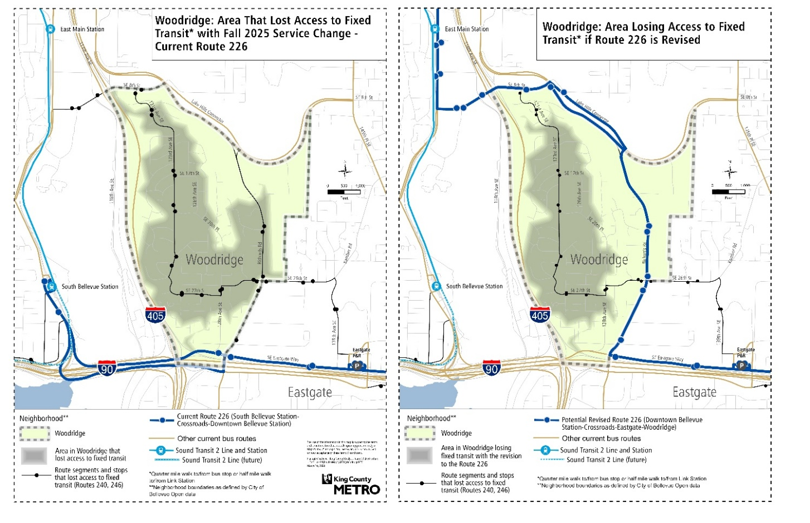

There are significant negative impacts of this change.

- Route 226 currently provides the only two-way service on Southeast Eastgate Way, including service to/from Porchlight Emergency Men’s Shelter and the adjacent permanent supportive housing, so Metro would revise routing in a way that ensures this connection remains. Therefore, Route 226 rerouting would not serve the 139th Avenue Southeast to Southeast 26th Street areas that Route 240 could serve if rerouted. At least four stop pairs east of Richards Road on 139th Avenue Southeast to Southeast 26th Street would not have service restored.

- With this change, residents east of Eastgate Park-and-Ride in the Robinswood and Phantom Lake areas would have a slower connection to light rail. If revised to serve Richards Road, the closest and most direct light rail connection would be the East Main Station near downtown Bellevue. Like the case for a Route 240 revision, getting to East Main Station takes longer than getting to South Bellevue Station.

- If Route 226 served Richards Road, a new terminal and layover location proximate to downtown Bellevue would need to be identified. Route 226 currently terminates and lays over at South Bellevue Station. Curbspace for a new layover in and near downtown Bellevue is limited and subject to many competing needs such as loading zones and driveways, and would require approval by City of Bellevue.

- Extending Route 226 further north than its current terminus would increase the cost of operating the route. Because it takes longer to get to East Main Station and there would also be added time needed to get to the unidentified layover location, this change would add substantial travel time and cost to the route.

A4. Infrastructure investments, speed and reliability improvements, and bus stop consolidation
The proviso requests information about additional interventions that could facilitate restoring coverage on Richards Road. Infrastructure investments, speed and reliability improvements, and bus stop consolidation are all additional approaches that could facilitate restoring coverage by reducing runtime for buses, which could lead to more comparable travel times.

Given the nature of the Richards Road corridor and the frequency of Route 240, the most appropriate speed and reliability treatment would likely be Transit Signal Priority (TSP). TSP would cost approximately $10,000 per traffic signal (assuming these signals already have communication with Bellevue City Hall) and would provide an estimated five to 10 percent savings in bus travel time, a time savings of about 45-90 seconds, for the potential Route 240 pathway via Richards Road between Eastgate Park-and-Ride and East Main Station. The City of Bellevue would need to agree on the TSP strategies, on the signal timing necessary for bus travel time savings, and to operate TSP at these signals. Currently in the City of Bellevue, TSP is used only along the RapidRide B Line. This would entail a multi-year planning and design process with City of Bellevue, and identification and securement of funding for the capital improvements. Other speed and reliability infrastructure such as bus lanes would also entail significant capital investment, permission from City of Bellevue, and a long study process.

Bus stop consolidation can also reduce travel time by reducing the number of bus stops on a route. Closing a bus stop removes access to transit at that location, reducing the overall population with access to transit. The stops along the Richards Road segment already meet Metro’s stop spacing standard of at least a quarter mile between stops, so there are no candidates for removal that could save time in the corridor. Removing or changing transit access involves further public engagement to assess the full impacts of removing stops.

If Metro pursued the type of improvements noted above it could shorten travel times, but there are trade-offs to this work. Metro and the City of Bellevue would have to invest staff time and design work to carefully assess feasibility and time savings. Investing in this corridor would also affect Metro’s ability to invest in other areas where there may be greater impact benefiting more riders. Metro’s speed and reliability program assesses and prioritizes countywide, on all routes, the potential for time savings and return on investment and partners with jurisdictions to make those investments. Similarly, Metro periodically assesses bus stop spacing and access to determine alignment with bus stop placement policies, which can result in bus stop consolidation in some areas.

A description of flexible service pilots that could be implemented or expanded in the Bel-Red, Crossroads and Woodridge neighborhoods in Bellevue to provide connections to frequent transit service

There are several flexible service options currently available that can provide mobility for limited audiences. For customers who meet Metro’s qualifications for Access paratransit, pre-booked trips are available in Bel-Red, Crossroads, and Woodridge. Sound Generations offers a Metro-supported service called Hyde Shuttle, which provides free on-demand van service within Bellevue, Redmond, and Kirkland for adults 55 and older and people with permanent disabilities. Hyde Shuttle operates 8:00 a.m. to 4:00 p.m. on weekdays. Reservations should be made at least three days, or up to 30 days, before the ride, and are available on a first-come, first-served basis. Another option for employees traveling between these neighborhoods and jobs is Vanpool, where five or more people can form a group to travel to and from work together on their own schedule. These services can be a good option for some, but because of limited eligibility and the volunteer nature of Vanpool they do not work for most people living in these neighborhoods. They are available to all who meet eligibility standards or are willing and able to voluntarily join a Vanpool.

Therefore, as noted in the methodology, for the purposes of this report “flexible service pilots” will only include Metro Flex pilot service. This is the flexible service profile that Metro considers most consistent with customer comments received about these changes because it is a professionally-operated service that is open to the general public.

This section will be divided into three parts. The first part will discuss how Metro Flex works, resource trade-offs, and service design best practices to attain efficient cost per ride and overall ridership. The second and third parts describe potential Metro Flex services in Bel-Red/ Crossroads and Woodridge respectively, including expected performance dynamics and why Metro does not recommend service in these areas.

B1. Metro Flex Design Best Practices
Metro Flex is an app-enabled, on-demand mobility service where customers can book a ride from one place to another within a defined service area. These rides bring passengers from and to nearby pick-up locations and their ride may be shared with others. If there is a fixed-route bus available within a quarter mile to make the trip with a similar travel time with no transfers, the service directs customers to take the bus. The fare is the same as riding Metro using an ORCA card and ADA accessible rides are available. Metro Flex functions as a way to strategically supplement the fixed-route network by bringing customers to transit hubs or destinations not accessible by bus, particularly in areas that are difficult to serve efficiently with fixed-route bus service.

Metro Service Guidelines prioritize adding Metro Flex in areas where Metro Flex can increase accessibility for medium density areas. While Metro Flex could be deployed almost anywhere, Metro considers efficiency and best use of limited County resources from the perspective of cost-per-ride and productivity of how many riders are being carried. Fixed-route is almost always more cost-efficient and can carry more people. This is why Metro’s approach is to use Metro Flex where the greatest increases in access to jobs and community assets can be achieved and provide transit connections for a reasonable cost relative to a fixed-route option.

Metro Flex operates in 10 service areas across the county. To maximize cost efficiency and keep the cost per ride lower, Metro created standards for Metro Flex including a maximum cost per ride and minimum number of rides per hour by a vehicle. A description of these standards is available in Metro’s System Evaluation. To achieve the ridership needed to meet these standards and encourage productivity and efficiency the following principles are applied in designing Metro Flex Service areas:

- Destination density is near or mixed with residential density. While population density is important for most types of transit, on-demand service is non-linear and constrained within a geographic area. Therefore, if the area is primarily or completely residential there is little market for the service, resulting in very few rides. Limited choices for where to go limits demand for the service. An ideal zone has a variety of residential densities and a range of desirable destinations throughout the area. This profile also increases the potential for trips to be shared, further increasing efficiency and ridership.

- Frequent transit hubs drive ridership. In most Metro Flex zones transit hubs are the top destination. Frequent transit hubs provide access to a wider range of destinations such as jobs beyond the boundaries of a Metro Flex zone. In this way, Metro Flex serves as a first- and last-mile bridge. Metro Flex specifically focuses on first- and last-mile connections in areas with less fixed-route service, where flexible service can most significantly increase access to desired destinations. Areas with great fixed-route connections to frequent transit already provide residents with broad access across the region, so the gain in access by adding Metro Flex is smaller. This is why Metro’s prioritization for Metro Flex focuses on filling gaps where there are fewer fixed-route connections.

- Centering key destinations increases efficiency. If the places people want to go are closer to the middle of zones, this will typically make trips shorter on average, allowing vehicles to be available more of the time for more riders. Conversely, destinations at the edge of a service area create longer trips, which occupy vehicles for a longer time and make them less available for other customers. The higher demand a destination is, the more important this principle becomes. For this reason, it is optimal when geography allows frequent transit hubs to be centered in a service area.

- Large service areas decrease efficiency. The larger an area becomes the greater the potential for longer trips, which occupies vehicles longer and makes them less available for other customers. The larger the area the greater this problem becomes. Therefore, service areas should be designed to balance the need to serve a large enough market with a range of desired destinations, but not so large that vehicles are occupied with long trips and the service is not available to customers who want to use it. While large areas can be served, more vehicles are needed to do so while maintaining reasonable wait times and vehicle availability, at a much higher cost.

- Street network characteristics impact efficiency. Some street networks, like grids with few barriers and dead ends, are more efficient to travel and access a particular area than others. In many cases, road networks can create local bottlenecks or barriers that can limit travel options for vehicles, which leads to vehicles with longer travel times when they are serving these parts of a zone. Examples include large areas of twisting roads, dead ends, or cul-de-sacs, large freeway interchanges, extreme hillsides, wetlands, and parks, and places where the street grid is limited or fragmented. Difficult to serve areas must be considered carefully as they can hinder the efficiency of the overall service area.

B2. Metro Flex in Bel-Red and Crossroads
Figure 3 shows a map of East Link Connections transit service access gaps in the Bel-Red and Crossroads neighborhoods. For a larger view of this map, see Appendix C. East Link Connections implementation included Route 249 changes that removed transit access in the Bel-Red neighborhood in an area north and south of Northeast 20th Street between 148th Avenue Northeast and 120th Avenue Northeast. This area includes 21 residents and 2,799 jobs, and no priority populations.

East Link Connections implementation included Route 221 and 226 changes that removed transit access in the Crossroads and Northeast neighborhoods in a small area north of Northeast 8th Street between 156th Avenue Northeast and 164th Avenue Northeast, and a larger area east of 164th Avenue Northeast. These areas include 4,612 residents, including 2,270 living in equity priority areas, and 1,291 jobs.

Figure 3. Bel-Red and Crossroads East Link Connections transit service gaps
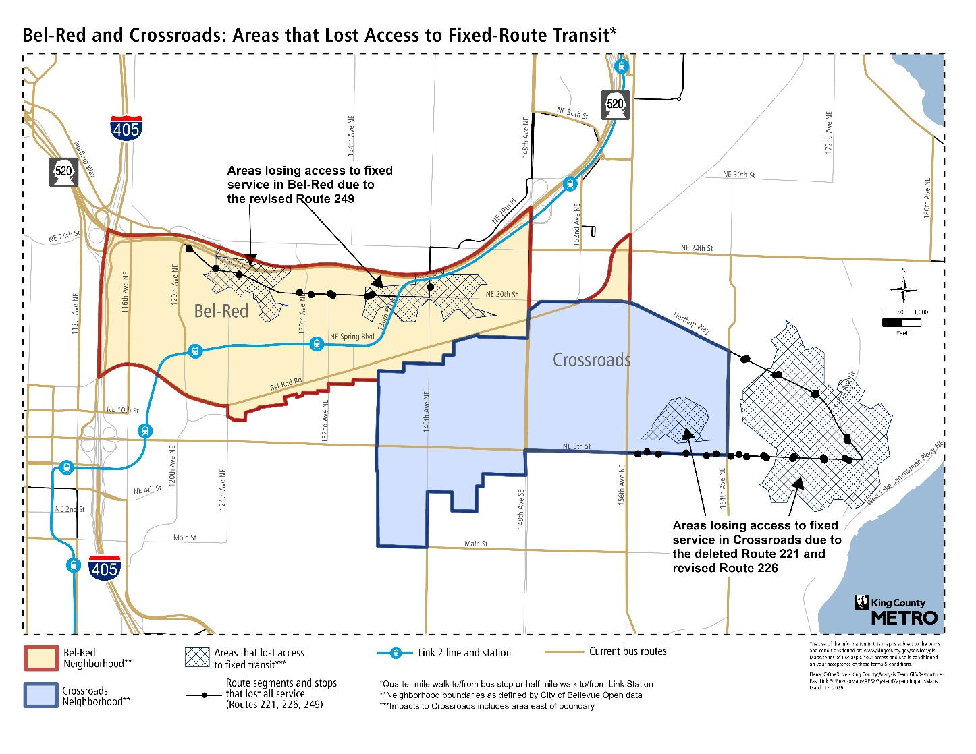

The grant-funded, pilot Overlake Metro Flex zone currently serves most areas in the Crossroads and Northeast Bellevue neighborhoods that lost fixed-route transit access described above. This pilot will run between September 2025 and September 2027 at which time it will be evaluated to determine if it will become sustained service by meeting Metro’s minimum performance standards and pending funding approval in Metro’s 2028-2029 biennium budget.

An area south of Northeast 8th Street in the Northeast neighborhood is not covered by the current pilot Overlake zone. This area includes 588 people, including 195 living in equity priority areas, and 93 jobs.

Expansion of the pilot Overlake zone could serve both transit service gaps by including areas west and south of the existing zone. Figure 4 shows a map of the existing pilot Overlake zone in gray with tan areas depicting expansions. For a larger view of this map, see Appendix D.

Figure 4. Potential pilot Overlake Metro Flex expansion areas
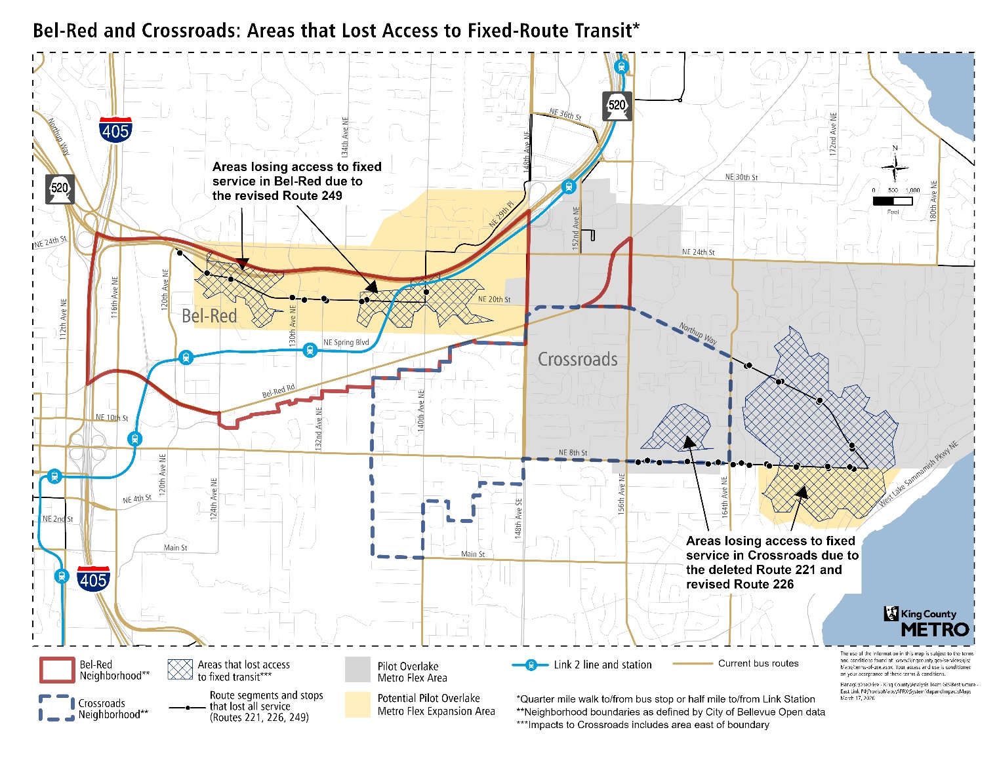

Overall, the impact of expanding the grant-funded, pilot Overlake zone would be to reduce its efficiency and productivity while significantly increasing resources needed to operate, and is therefore not recommended by Metro. Below is a summary of the reasons.

- Expanding to the west into Bel-Red would not provide new transit access for many households, and therefore provide little potential for new ridership.
- The expansion area also does not have many destinations near households in the area, which is key to creating an efficient, well-used service area.
- Operating efficiency would be reduced due to the increase in zone size resulting in longer trips. Efficiency would also be reduced because new destinations (restaurants, coffee shops, and food markets) and jobs are at the edge of the zone separated from population centers to the east resulting in longer trips.
- The expansion in the Northeast neighborhood south of Northeast 8th Street would have fewer impacts on operations because it is a small area being added, though the twisting, all-residential streets in this area could slow travel times, reducing how many riders could be served with a given vehicle.
The one benefit of a western expansion into Bel-Red is the large number of jobs and destinations such as restaurants, coffee shops, and food markets. This could increase ridership to and from these destinations, though the trip distances could be long because population and transit connections are mainly separated further east.

The pilot Overlake zone is currently served by two vehicles on a typical day that are about 80 percent grant funded. If the pilot zone were expanded as described above an additional vehicle would be needed. The Overlake pilot operates 12 hours a day on weekdays and 10 hours a day on weekends for a total of 80 hours a week, or about 4,160 hours a year. Funding an additional 4,160 hours per year for the additional vehicle at the current 2026 rate of $74.58 per hour would cost about $310,300 per year, increasing year-over-year for inflation and other operational factors.

B3. Metro Flex in Woodridge
East Link Connections implementation included Route 240 changes and deletion of Route 246 that removed transit access in the Woodridge neighborhood in an area along Richards Road, Southeast 27th Street, and 123rd Avenue Southeast. This area includes 4,123 residents, including 1,800 living in equity priority areas, and 474 jobs. To provide transit access to this area with Metro Flex, a new zone would need to be created. This potential pilot Metro Flex zone could be bound by I-405 to the west, Lake Hills Connector, Southeast 8th Street and Lake Hills Boulevard to the north, I-90 to the south and 156th Avenue Southeast to the east. Figure 5 below is a map showing this potential zone in the Woodridge neighborhood. For a larger view of this map, see Appendix E.

Figure 5. Potential Woodridge pilot Metro Flex area
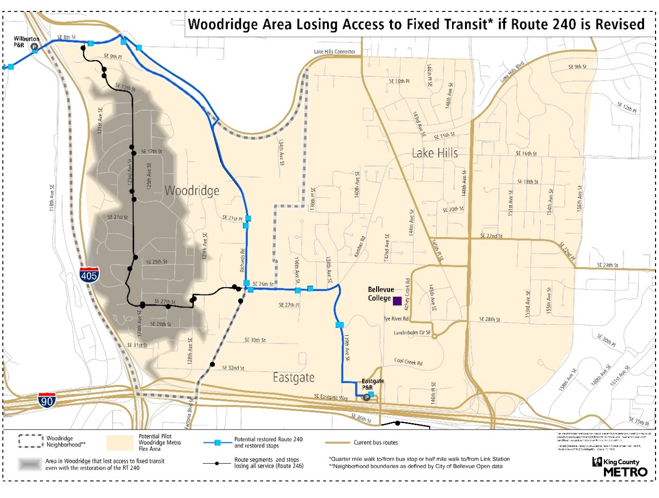

Applying the best practice design principles above indicates such a Woodridge Metro Flex pilot zone is likely to perform poorly at a high cost and is therefore not recommended by Metro. Below is a summary of the reasons.

- The Woodridge neighborhood covering almost half of the zone is primarily residential resulting in no proximity to destination density and longer trips for those who seek to connect to the eastern or northeast parts of the zone. The population of this area is also relatively small, resulting in a small market for potential riders.
- The road network connectivity east of Richards Road is limited to Lake Hills Connector, Southeast 26th Street to Kamber Road and Southeast Eastgate Way. This creates travel bottlenecks that will further increase travel time and occupy vehicles longer, leading to less vehicle availability and longer wait times.
- Without creating a very large zone including high acreage green spaces, it would not be possible to center destinations, especially transit hubs. In particular, connecting to Link would be challenging because the distance to the nearest light rail stations is significant, and there are geographic and road network barriers to those connections, including I-90, I-405/Mercer Slough, Lake Hills Connector, and Southeast 8th Street pinch points. Eastgate Park-and-Ride is the only high-frequency transit hub proximate to Woodridge.
- In 2018 and 2019 Metro operated an on-demand service called Ride2 serving Eastgate Park-and-Ride and surrounding areas east and south of Woodridge. This pilot was ultimately cancelled because cost per ride was too high to support the overall cost. Though Ride2 used a different operator and did not serve Woodridge, it demonstrates the challenging conditions for on-demand service in the general area.
- Another weakness of this potential pilot Metro Flex zone is that the areas to the east around Lake Hills and Bellevue College are well served by frequent fixed-route services (routes 223, 245, 270, 226, future K Line). Metro Flex denies trips well-served by fixed-route transit, so a relatively high proportion of intending riders in these areas would likely be referred to nearby bus stops. However, not including these areas in a pilot would leave the potential zone without any destinations except Eastgate Park-and-Ride, which would further depress ridership.
Using Metro’s prioritization criteria for Metro Flex, the Eastgate Park-and-Ride transit hub would not rank in the top 20 transit hubs in the county to serve with Metro Flex because the priority populations, defined as Black, Indigenous, and other people of color, low-income people, people with disabilities, refugees, immigrants, and diverse language speakers, living in this area are not high relative to other transit hub areas across the county. If only increased access to jobs and community assets were considered, Eastgate Park-and-Ride would rank 36 for priority to invest in Metro Flex.

Overall, Woodridge is small, residential, and isolated, making it a challenge to efficiently serve with Metro Flex, and the areas east of Woodridge are well served by fixed-route transit. For the reasons described earlier, Metro does not recommend Metro Flex for coverage in these areas. Metro estimates that a minimum of two vehicles would be needed to operate a zone covering Woodridge about 90 percent of the time with average wait times of 20-30 minutes. Operating two vehicles 12 hours a day, 7:00 a.m. to 7:00 p.m., seven days a week would require about 168 service hours a week, or about 8,700 hours a year. At Metro Flex’s current operating cost per hour of $74.58 the total annual cost would be $648,800, increasing year-over-year for inflation and other operational factors.

Conclusion

The East Link Connections project is a large-scale transit restructure to align service with the new Link light rail 2 Line, restore service suspended during the pandemic period, and update the network to reflect changing travel and land use patterns on the Eastside. The project area encompasses 21 jurisdictions and hundreds of thousands of people. To understand and balance the priorities of residents in the broad and diverse project area Metro conducted an extensive public engagement process involving thousands of public comments, virtual open houses, a resident advisory board, a board of jurisdictions, businesses, and community organizations, partnerships with community organizations, advertising, and other strategies. Community priorities heard during engagement informed the decisions made as part of this project which always involve trade-offs. Metro recognizes the challenges these trade-offs present to riders and endeavors to create the least number of negative impacts. The trade-offs also resulted in benefits such as increased frequency along key corridors, more service at night and on weekends, new and improved connections with key destinations, and connections to Link light rail. This report closely examines gaps created by the changes made to routes 226 and 240 and by the elimination of route 246 and presents alternatives for closing those gaps.

In addition to this report, Metro is undertaking a broader analysis of the effect of implemented changes. It includes monitoring and assessing the performance of the network changes across all neighborhoods and routes in the project area and beyond, listening to feedback from the community, and identifying potential changes to be considered with additional public engagement. By August 2027, the King County Executive will submit a letter to the Council summarizing Metro’s review of performance of the East Link Connections network changes to date. Due to the large amount of service investments and phased Link station openings, 2027 will be the first year during which full implementation is complete. This summary evaluation will consider how the full set of changes are performing with all 2 Line stations operating.

Potential changes such as those identified in this report are typically subject to public engagement to evaluate trade-offs and community support. From a technical perspective and efficient use of Metro transit funding, these Metro Flex options are not recommended. As this work continues Metro plans to consider not only community feedback and analysis of performance, but Metro’s guiding policy documents including the Service Guidelines, Metro Connects, Strategic Plan, and Mobility Framework.

Appendices
The following appendices provide larger version of the figures included in this report. The title of each corresponds to the figure titles.

Woodridge transit service access with potential Route 240 revision
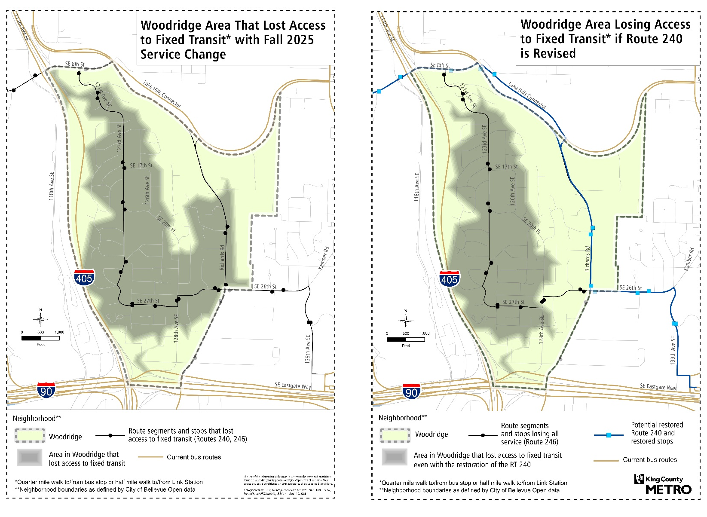

Woodridge East Link Connections transit service gaps with Route 226 revision
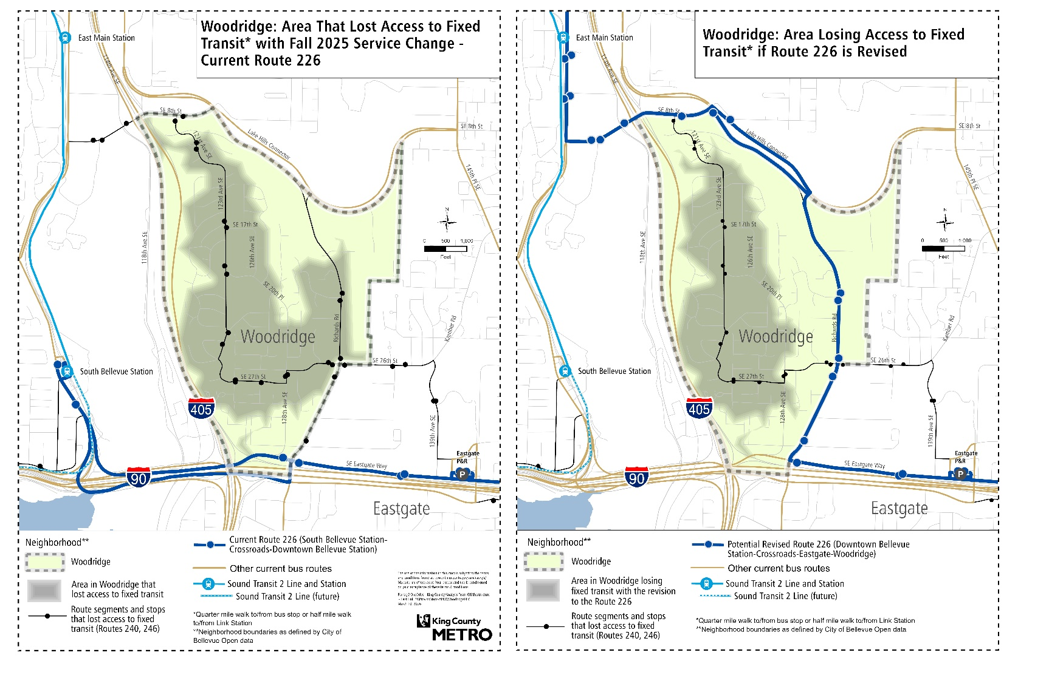

Bel-Red and Crossroads East Link Connections transit service gaps
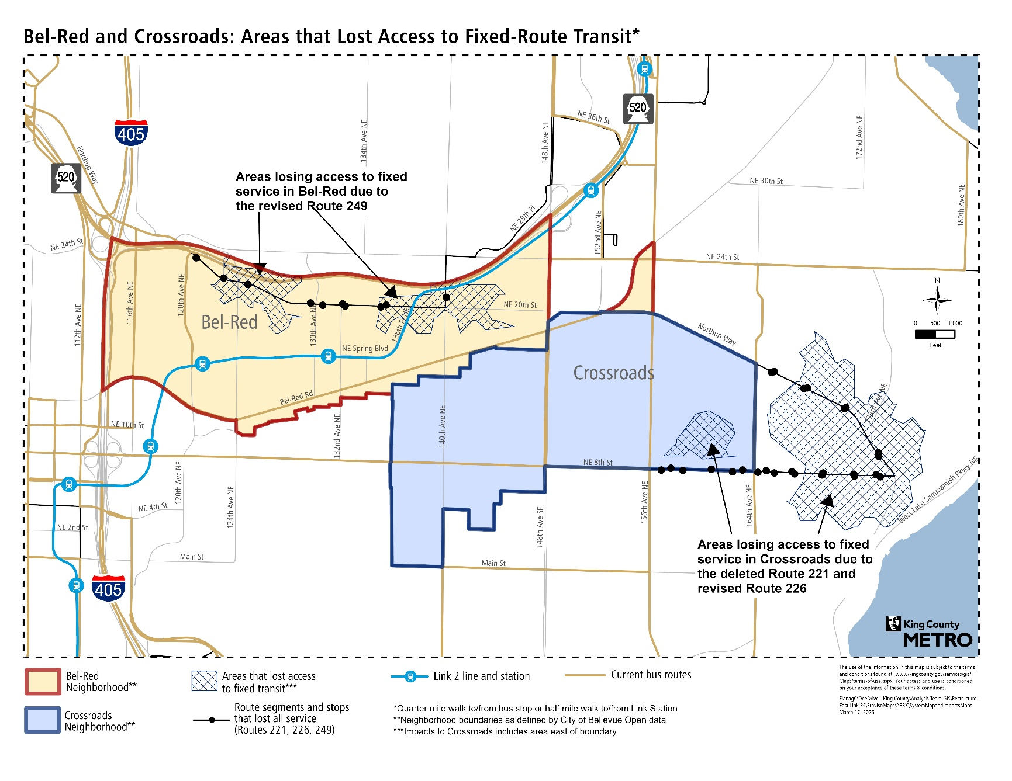

Potential pilot Overlake Metro Flex expansion areas
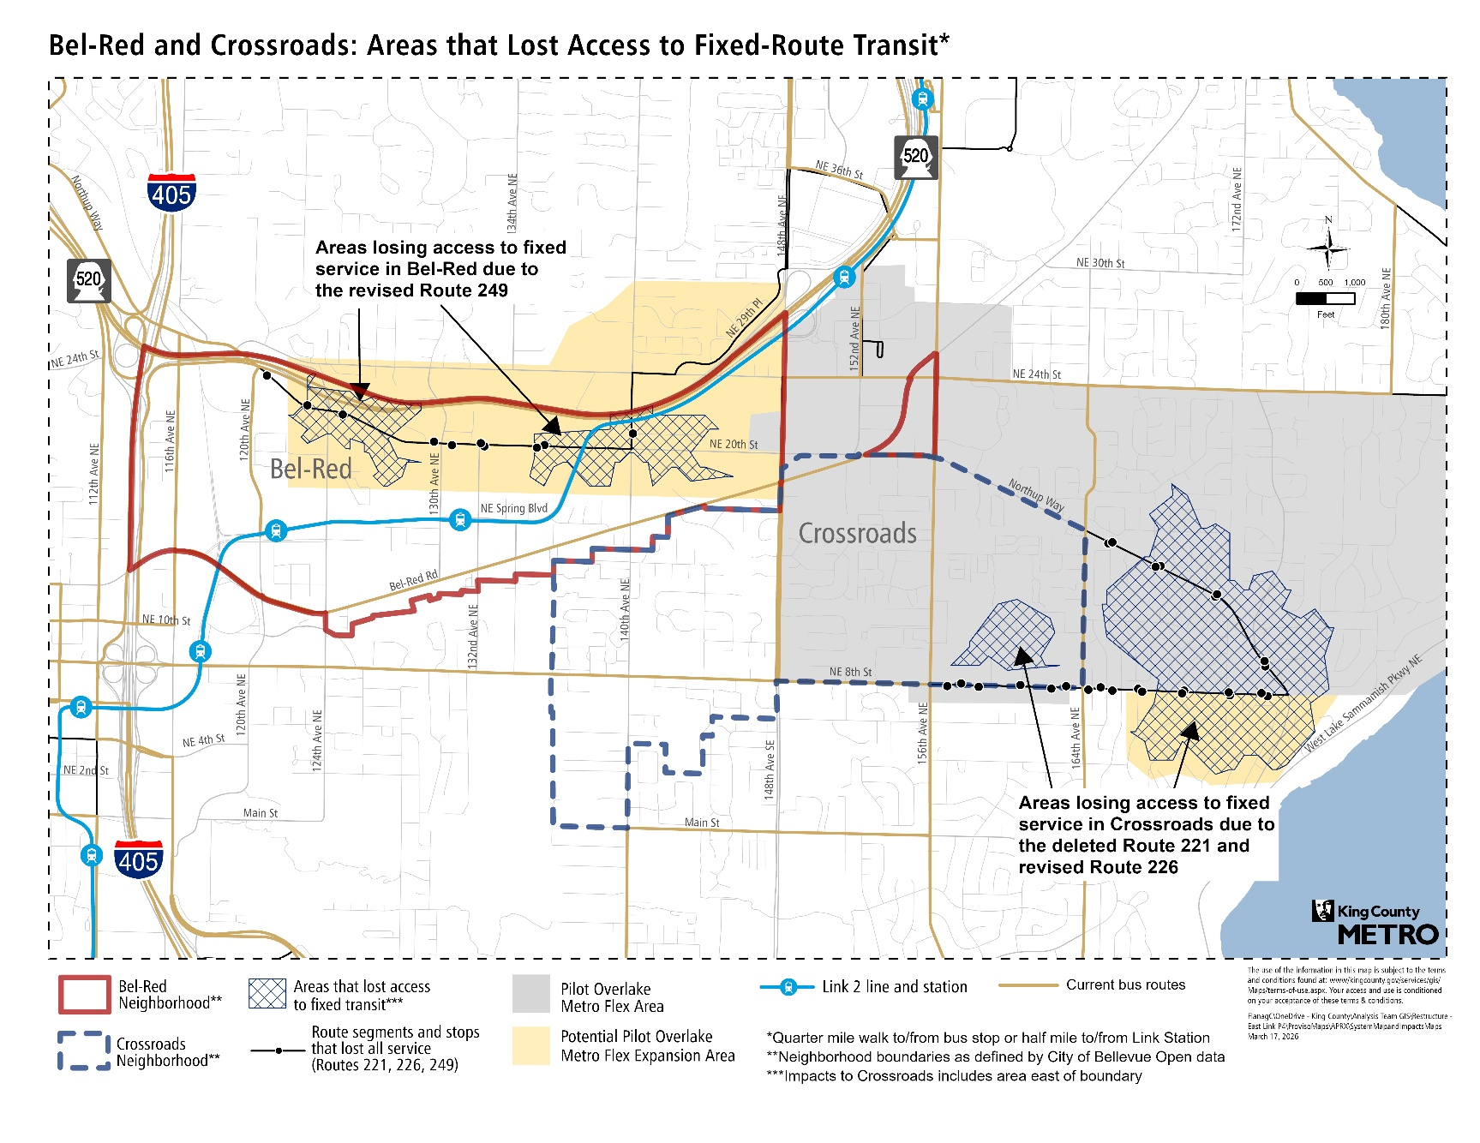

Potential Woodridge pilot Metro Flex area
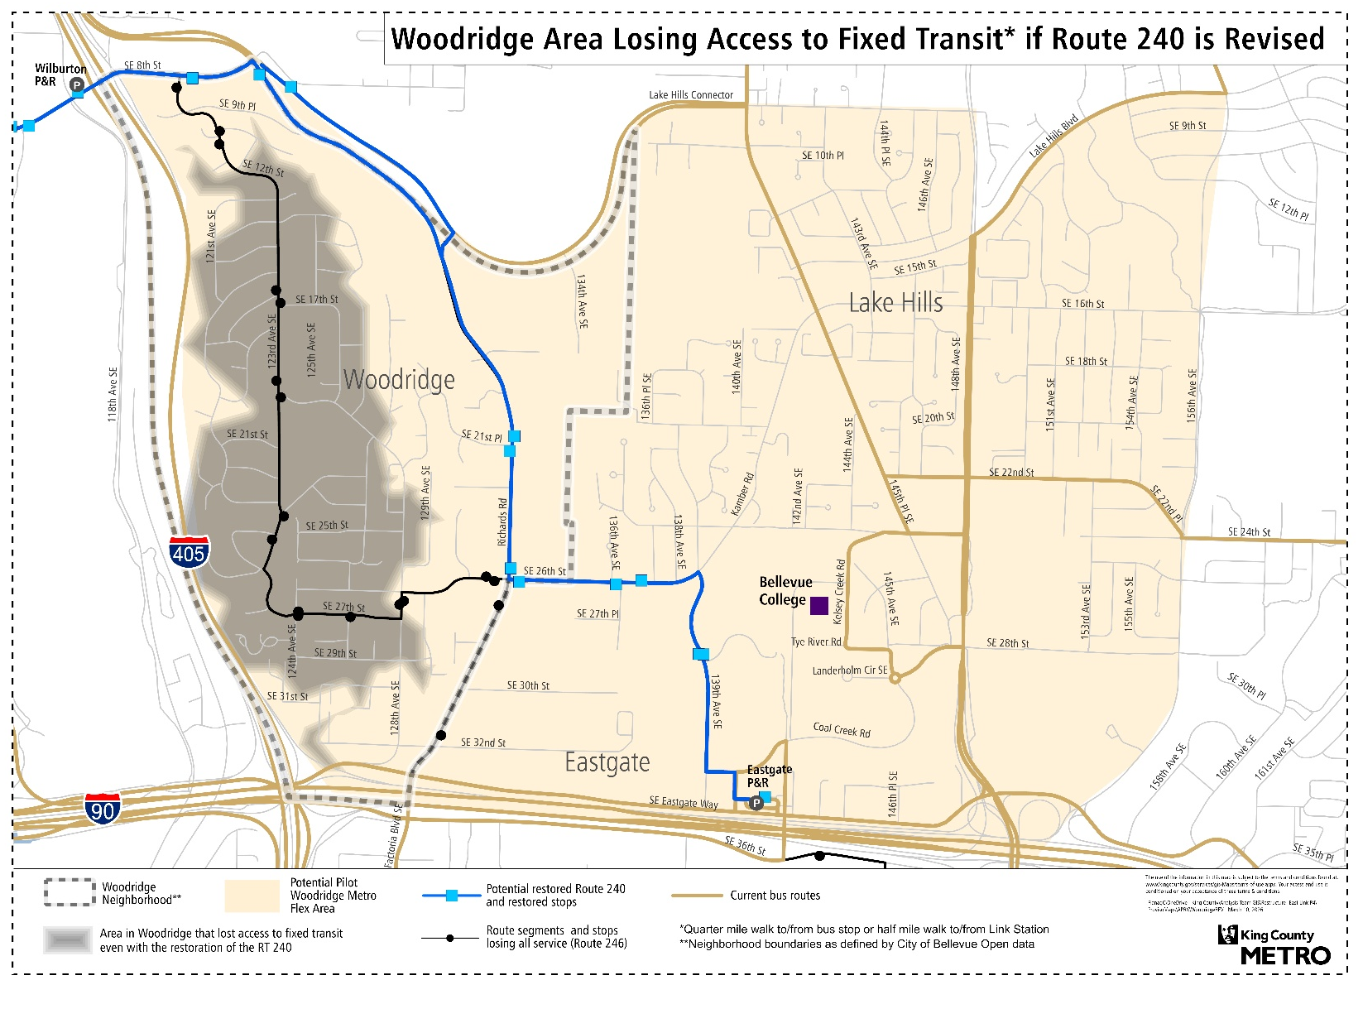

Ordinance 20023, Section 116, Metro Transit Department, P172 [LINK]
2024 System Evaluation [LINK], P33
Ordinance 19899 [LINK]
Ordinance 19899 [LINK]
City of Bellevue Open Data [LINK]
King County Metro Mobility Framework [LINK]
2024 System Evaluation [LINK], P47
2024 System Evaluation [LINK], P53
Equity Impact Review and Recommendation Development Report [LINK], P48
King County Metro Service Guidelines [LINK], P18-19
Layover is a critical facility at the end of a route where the bus parks to provide the operator with legally required break time and access to restroom facilities. There are limited areas suitable for laying over because of the need for a restroom and well-lit and paved pathway in close proximity to the parked bus. On-street layover also must be approved by City of Bellevue.
King County Metro Transit Route Facilities Guidelines [LINK], P4-6-7
2024 System Evaluation [LINK], P33
2024 System Evaluation [LINK], P33

