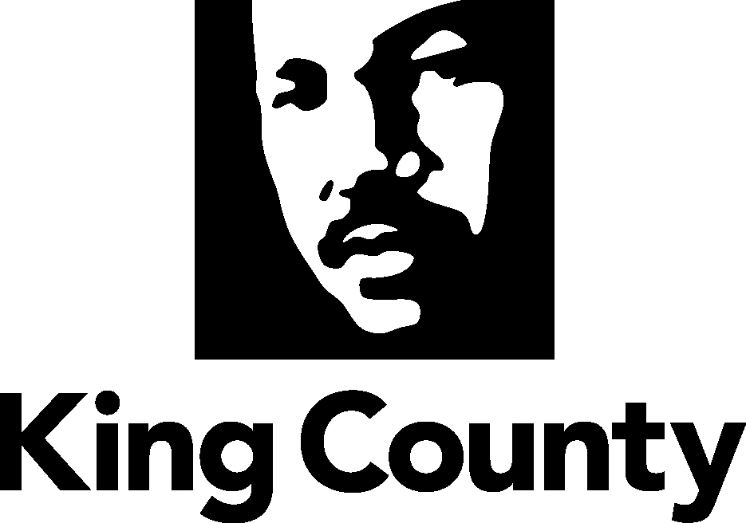

King County Department of Transportation
Strategic Plan for Road Services
2014 Update

Note to reviewers
This 2014 update of the Strategic Plan for Road Services is based on the adopted 2010 plan. A version showing the updates in Microsoft Word “track changes” is available upon request. A summary of changes is also available.
Following approval of the contents by the King County Council, the 2014 plan update will be printed in a similar format to the 2010 plan, complete with the photographs and other graphic elements.
For more information:
Brenda Bauer, Director
Road Services Division
King County Department of Transportation
King Street Center, KSC-TR-0313
201 S Jackson St
Seattle, WA 98104
206-477-3580 TTY Relay: 711
www.kingcounty.gov/roads

Acknowledgements

This 2014 Strategic Plan for Road Services (SPRS) update would not have been possible without the insights, guidance and support provided by numerous individuals.
The SPRS Executive Committee met throughout this process to guide and oversee the Steering Committee in updating this plan. The Roads Work Group provided staff support and analysis. We sincerely thank each and every committee and work group member for their thoughtful insights and willingness to come to the table ready for an open and honest discussion.
Executive Committee members
Fred Jarrett, Deputy County Executive, King County Executive’s Office
Dwight Dively, Director, King County Office of Performance, Strategy and Budget (PSB)
The Honorable Kathy Lambert, Councilmember, Metropolitan King County Council, District 3
The Honorable Joe McDermott, Councilmember, Metropolitan King County Council, District 8
The Honorable Reagan Dunn, Councilmember, Metropolitan King County Council, District 9
Harold S. Taniguchi, Director, King County Department of Transportation
Christie True, Director, King County Department of Natural Resources and Parks
Brenda Bauer, Director, Road Services Division (RSD), King County Department of Transportation
Kathy Brown, Director, Facilities Management Division, Department of Executive Services
Ed Conyers, Local Programs Engineer, Washington State Department of Transportation

The Steering Committee provided input, data and documentation used in preparing the SPRS. The Steering Committee also reviewed and discussed all policies and analyses before they were presented to the Executive Committee for approval. We thank them for their support, guidance and their time.
Steering Committee members
Debbie Arima, Road Maintenance Operations Manager, RSD
Chris Arkills, Government Relations Officer, King County Executive’s Office
Rick Brater, County Road Engineer, RSD
Paul Carlson, Principal Legislative Analyst, King County Council
Tricia Davis, Budget Supervisor, PSB
Jennifer Hills, Director, Office of Risk Management
Jennifer Lindwall, Director, Fleet Administration Division
Jay Osborne, Strategic Business Operations Manager, RSD
John Resha, Supervising Senior Principal Legislative Analyst, King County Council

Road Services Division Work Group
Mark Foote, Business and Finance Officer
Yvette Franz, Program Manager
Ruth Harvey, Policy & Performance Management Lead, RSD (SPRS project manager)
Lindy Jenson, Maintenance Superintendent
Fatin Kara, Engineer
Lydia Reynolds-Jones, Managing Engineer

This plan truly was a collaborative process and everyone involved played an important role in the development of policy recommendations. We sincerely thank all of you for your support.

Table of Contents
Executive Summary 3
Introduction 7
About the Road Services Division 10
Customers 13
Road Services Funding 16
Change Drivers 18
Service Area Asset Inventory, Condition and Needs 19
Strategic Policy Framework 22
Goals and Strategies 25
Future Service Level Analysis 31
Performance Measures - How Will We Know This Plan is Making a Difference? 38
Facilities Master Planning (New chapter) 39
Next Steps 45
Appendix A: Division Functions 49
Appendix B: Contract Services Framework and Proviso Response 51
Appendix C: Customer Outreach 56
Appendix D: Summary of Road Funding Options 57
Appendix E: Change Drivers Identified in the ROMP Phase I (Details) 58
Appendix F: Map of Arterials and Lifeline Routes 61
Appendix G: Facilities Master Plan Attachments (New appendix) 62
Appendix G-1: Property/Site Inventory 63
Appendix G-2: Condition Assessment Summary 67
Appendix G-3: Functional Criteria 69
Appendix G-4: Location Criteria 75
Appendix G-5: Location and Functional Needs Evaluation Summary of Existing Facilities 79
Appendix G-6: Regional Maintenance Shops Key Issues and Deficiencies 88
Appendix H: Glossary of Terms 91

Chapter 1
Executive Summary
Executive Summary
King County maintains 1,500 miles of roads and 180 bridges in the county’s unincorporated areas, outside of cities. This road system supports more than 1 million trips every day—people traveling to work, school, and recreation; businesses and farmers delivering goods and services; and emergency responders reaching people who need assistance. The system also provides pathways for essential public utilities. Unincorporated-area roads are part of a larger transportation network, and people from all parts of the county—and beyond—use them; about half the trips on the high-volume roads originate in cities and other counties.
Built over many generations, county roads and bridges are in increasingly poor condition, while annexations, lower property valuations and a decline in gas tax revenue have caused a decrease in funding for maintenance and improvements. The amount of revenue available for the county road system is projected to be an average of $90 million per year over the 10-year period of this plan, while the annual investment necessary to maintain the current condition of the existing road system is about $200 million per year.
This Strategic Plan for Road Services (SPRS) provides policy guidance for managing the current situation and presents information about the county road system needs, associated costs, and alternative service levels to inform the public and policymakers as future service and funding options are considered.
Why this plan was prepared
This plan covers the years 2014 through 2024. It replaces the 2010 strategic plan earlier than originally planned, mainly because key assumptions made in 2010 were not borne out in the following years. The 2010 plan assumed that cities would complete annexations of urban growth areas served by Road Services by 2015, affecting the division’s service area and the revenue it would receive. While annexations of three areas were approved, voters in two areas rejected annexation proposals.
The 2010 plan also assumed that the county road fund would decline to a low point of $102 million after annexations. Revenues have actually been lower, declining to a projected $85 million dollar level for 2017—even with the retention of the property tax base in the areas where annexations were rejected. Major factors in the ongoing revenue decline include decreasing receipts from property and gas taxes—major sources of funding for Road Services. The total assessed property value in unincorporated King County has fallen by more than 40 percent over the past three years, and future growth in revenues is limited by state law. Since 1991, the gas tax rate for counties has only been increased by one half of a cent. With vehicles becoming ever more fuel-efficient, King County’s gas tax revenue is expected to continue its downward trend. Annexations and declines in grant funding are also factors.
Another development since 2010 that drives an update to the plan is the division’s adoption of an asset management operational model. Road Services is developing an asset management model designed to guide the most cost-effective operating and capital investments—from maintenance through preservation and replacement. This approach has enabled the division to prepare a more accurate inventory of the maintenance, preservation and replacement needs of the road system as well as the estimated costs of meeting those needs. The division also separately analyzed the condition and location of its work facilities and identified short- and long-term facility needs.
A key finding of the division’s needs analysis is that the County’s roadway infrastructure will deteriorate and fail at a faster rate than estimated during the development of the 2010 plan. The discrepancy is in part due to an improved asset management approach to the estimates than was in place from 2008-2010. Additionally, the current analysis assumes less investment in preservation and replacement, and therefore higher lifecycle costs. (Using best industry practices for preventive repair, replacement and maintenance would reduce unplanned failures and annual costs.)
The division’s current estimate is that it would cost $350 million annually—for a period that is longer than the life of this strategic plan—to fully address the current backlog of needs, embark on an asset management program that produces the lowest life cycle costs, address the division’s future maintenance facility needs, and systematically accomplish the road capacity, mobility and non-motorized needs identified in the Transportation Needs Report. The estimated cost in the 2010 plan was $240 million.
Based on the recent developments and improved information about service needs and costs, this 2014 plan adjusts goals, strategies and policies developed in 2008-2009 and adopted in 2010. The 2014 plan focuses clearly on immediate operational safety needs, compliance, and maintenance and preservation of the road system.
Goals
The plan contains two sets of goals. The first set, about “what we deliver,” articulates what Road Services aspires to accomplish. These goals are listed in priority order below. Current revenues are insufficient to fully address the first three, top-priority goals. No resources are currently available to pursue goals 4 and 5; they would be addressed only if additional resources become available.
Goal 1: Prevent and respond to immediate operational life safety and property damage hazards.
Goal 2: Meet regulatory requirements and standards in cooperation with regulatory agencies.
Goal 3: Maintain and preserve the existing roadway facilities network.
Goal 4: Enhance mobility (movement of people and goods) by facilitating more efficient use of the existing road system.
Goal 5: Address roadway capacity.
The second set of goals is about “how we deliver.” Achievement of these goals is less dependent on funding, and they are all given equal importance. These goals are:
Goal 1: Exercise responsible financial stewardship.
Goal 2: Provide responsive customer service and public engagement.
Goal 3: Enhance the use of risk assessment in decision-making.
Goal 4: Support the effectiveness of our workforce in a rapidly changing environment.
The plan outlines three alternative service level scenarios for working toward the goals. None of these scenarios includes capacity improvements since those are the lowest priority and beyond the current funding capability.
Scenario 1, “Maximize asset lifecycle,” would fully implement an asset management methodology and address the backlog of preservation and maintenance needs, but would not have sufficient funding to accomplish any road capacity, non-motorized or other road enhancement needs. This scenario would improve the current condition of roads and bridges, allow a cost-effective planned maintenance approach, and improve emergency response capability. This approach would require an estimated $330 million annually.
Scenario 2, “Moderate the decline of asset condition,” would maintain current asset condition in the short term and make modest investments in road and bridge replacement, but would not optimize the lifecycle of assets. The condition of roads and bridges would remain similar to 2014 levels in the near term, and major deterioration would be delayed. However, deterioration inevitably would occur over time and eventually would have to be addressed. Pavement condition and drainage systems would experience the most noticeable impacts; pavement condition scores would trend downward and more localized flooding could occur due to deferred maintenance and preservation of drainage infrastructure. The public would likely experience more temporary road closures due to unscheduled repairs. Staff and equipment would remain adequate to maintain the current level of emergency response. This approach would require an estimated $200 million annually.
Scenario 3, “Manage risk in a declining system,” would not provide sufficient infrastructure maintenance and preservation to sustain the current condition of the system. This approach would pose difficult choices since the system would eventually deteriorate to failure conditions. Some bridges and roads would eventually have to be load-limited to prevent damage. Speed reductions on some roadways, more lane closures for emergency repairs, and increased congestion would eventually occur. Some complete closures of roads and bridges might be necessary. Maintenance would be primarily reactive in nature, and the associated needs and costs would accelerate as infrastructure conditions deteriorated. Emergency and storm response capability would be limited due to lack of resources. This approach would require an estimated $110 million annually.
Annual road revenues are currently forecast to be about $90 million on average, or $20 million less than the estimated $110 million needed annually even for the least costly scenario, 3. This means that failures will happen at an accelerated rate and the division will not have the resources to even appropriately manage the decline of the system. As a result, over the next 25 years, 35 bridges may have to be closed, 72 miles of roadway will deteriorate to the point of significant restrictions or closures (speed reductions or closures of lanes or full roads), and 65 percent of the stormwater system will be at risk of failure, causing sinkholes, local flooding, and washouts that can keep roads closed for weeks, months or years.
New guidance
In light of the insufficient funding, the 2014 plan provides new guidance for managing the decline of the road system. Key changes are:
- Safety goal changed to first priority – The 2010 plan established “meet regulatory requirements and standards” as priority one and “meet core safety needs” as priority two, with the assumption that the division would have adequate resources to accomplish both. With resources now more limited than expected, the updated plan changes safety to first priority and recognizes that the County may need to work with regulatory agencies to seek modifications, exceptions, or deferrals to optimize regulatory outcomes within available resources. Maintenance and preservation remain the third priority. Although the goals of enhancing mobility and addressing roadway capacity represent core functions of the Road Services Division, they are the lowest priorities and are unfunded in the current environment.
- Utility contributions – The road right-of-way serves as a pathway for delivery of water, sewer, stormwater control, energy, and communication utilities. A new policy states that all providers of these services should pay for their use of the right-of-way, and their appropriate share of any repairs, to help preserve these vital corridors. Currently only water, energy and communication utilities have agreements with the County to make repairs.
- Road failure guidance – New policies have been added to provide guidance when the division is faced with road failures. These include direction for development of a process to consider long-term closures and potential sharing of restoration costs with other agencies or property owners when their infrastructure has contributed to a road failure or they would benefit from the repair.
- Reduce “orphaned” urban roads – The plan contains new guidance about transferring responsibility for isolated urban roads to the adjacent city. These include half-streets (i.e., one side owned by a city and the other by the County), roads completely surrounded by city territory, and roads located on the urban growth boundary where consistent urban services are most appropriate.
- Elevate risk management – Since a significant portion of the short- and long-term decisions facing Road Services will focus on risk management, the division will continue working with the County’s Risk Management office to develop a plan that evaluates the risks associated with maintenance and engineering activities. The plan will be integrated with the asset management strategy, and initially used at the policy level. Additionally, the goal is to further refine the strategy to guide decision making on a day-to-day basis by field personnel and engineering staff.
Next steps
To address the policies and goals in this plan, the County should at a minimum deliver the level of service described in Scenario 2: Moderate the decline in asset condition. While not optimal, the County would continue to provide a basic level of road services in the unincorporated area, preventing rapidly escalating repair costs and infrastructure failures.
Road Services should also continue to pursue efficiencies, improve the organization of service delivery, and seek funding solutions. Specific steps include the following:
- Continue using performance management business practices to achieve efficiencies.
- Continue using a data-driven asset management approach, employing new information technology to analyze asset conditions and make data-driven decisions about service and investment priorities.
- Continue to streamline the division’s organization as annexations occur, shifting away from programs designed to serve urban areas and from large capacity projects, and moving toward a greater emphasis on rural safety and preservation services and investments.
- Continue city contract work when it involves specialty work that small jurisdictions need. Limit commitments to cities to perform general maintenance work that would detract from the County’s ability to perform basic work on county roads.
- Identify potential funding choices that are consistent with County and regional plans, and coordinate with others to help resolve the structural transportation funding problem.
- Ensure that the agency is right-sized and has a flexible, efficient organization that enables us to meet the changing demands of the road system and respond to emergencies.
Conclusion
County roads and state highways are critical for the movement of people, utilities, goods and services throughout the most urban and dense county in the state. These roads, built generations ago, are failing, and there is insufficient funding to keep the system functioning at current levels. In response to a loss of one-third of the revenue for county roads and bridges, the County has cut costs and achieved new efficiencies, but revenue reductions of this magnitude ultimately require cuts in services. This plan will help guide County employees to provide the most critical services and make difficult decisions should the funding shortfall continue. If additional revenue becomes available to support roads, this plan will help the County prioritize and organize the delivery of services.
Chapter 2
Introduction
Purpose
The Strategic Plan for Road Services lays out the division’s mission, vision, and focused direction for the next 10 years. It aligns the division’s employees, services, and programs with the overarching goals of King County; informs decisions of the King County Executive and Metropolitan King County Council on matters of policy, operations, and budget; and provides a framework to ensure oversight and management of the division’s programs and services.
This plan was developed in response to a critical structural funding problem coupled with a backlog of road system maintenance and preservation needs. Road Services recognizes that it may not be able to fully accomplish all of the goals and strategies in this plan. The plan prioritizes goals to guide division staff so their work meets the most critical needs with available funding and resources. It places high priority on immediate operational safety and regulatory compliance.
Background
Up until 2005, Road Services had a robust capital improvement program (CIP) and had begun to program debt-supported capacity projects in order to accelerate their construction. The division funded asset preservation work through both the operations budget and capital projects such as the pavement overlay, bridge seismic retrofit, and priority maintenance programs.
Revenue sources, including the road levy and shares of the vehicle license fee and state gas tax, were relatively stable. With its mix of capital projects and local revenue for matching funds, Road Services was well-positioned to compete for grant funding. Its mission, vision, and goals reflected an agency that was aware of its challenges and confident in its ability to meet them.
In 2004, the division adopted a strategic plan that helped clarify and focus its decisions and priorities. Since that time, the environment has changed. The division has been facing a steep decline in revenue, uncertainties about the timing of annexations, issues concerning current and future maintenance facilities, and other challenges.
In light of these developments, the County Council approved the Strategic Plan for Road Services (SPRS) in December 2010 to provide guidance on making the best use of available funding. The 2010 plan concluded that Road Services would not be able to sustain its budgeted level of operations and capital investments due to reduced revenue; increases in costs for labor, materials, and equipment; a statutory limit of the growth in property tax revenue; and growing demand for services.
The 2010 plan laid out goals for what the division will deliver, in the following priority order:
- Regulatory compliance
- Core safety
- Preservation and maintenance
- Mobility improvements
- Capacity improvements
The plan also identified roads and structures by location and level of service with policy that led to the creation of a tiered system. This system gives priority to service to the roadways that provide life safety connections and have the highest volume of users.
The 2010 plan was used to develop subsequent budgets and guide investment decisions. Having used this plan extensively over the past three years, the Road Services Division has refined its policies, goals, and strategies. Those refinements are incorporated into this 2014 update to the strategic plan.
How was the plan developed?
The 2010 plan was intended to be a five-year plan. It assumed, based on the County’s planning assumptions at the time, that all urban areas would be annexed by 2015. It also included a forecast that revenue for the road fund would hit a low point of $102 million after the annexations. In both cases, actual experience was different. While annexations of Juanita/Finn Hill to Kirkland and the urban islands to Bothell were successful, voters in North Highline and West Hill rejected calls for annexation. And as a result of the Great Recession, revenue forecasts dipped as low as $85 million. These factors contributed to an escalating funding crisis for road services that has made this 2014 strategic plan even more critical to decisions about which services to provide at which locations, and which needs to leave unfunded.
The County Council-approved 2010 plan directed the Road Services Division to perform the analysis necessary for an asset lifecycle management approach to providing services. Optimal lifecycle management involves making the right investment at the right time to ensure that the asset delivers the requisite level of service over its full expected life, at the minimum cost. The completed analysis outlined in this 2014 plan quantifies the gap between current revenues and the funding necessary to minimize lifecycle costs. It also describes alternative service levels and the backlog of work, as well as the costs of providing those services and performing the backlogged work.
Development of this strategic plan was guided and overseen by an Executive Committee made up of elected officials and other King County representatives. The committee included the Deputy County Executive; King County Council members from districts with significant unincorporated area; the directors of the Department of Transportation, Department of Natural Resources and Parks, Road Services Division, Facilities Management Division, and the Office of Performance, Strategy and Budget; and the Washington State Department of Transportation’s Local Government Liaison.
The committee agreed on recommendations by consensus with an understanding that if consensus was not reached, alternate views would be provided in the final report.
An interdepartmental, inter-branch Steering Committee provided input, data and documentation used in preparing the SPRS. The Steering Committee also reviewed and discussed all policies and analyses before they were presented to the Executive Committee for approval. A Road Services Division work group provided staff support and analysis.
Surveys and discussions with user groups and contract city customers informed the development of the 2010 plan, and this update also considered user and customer feedback that has been received since 2010. The goals and strategies presented in this plan are in alignment with the King County Strategic Plan.
How will the plan be used?
Strategic planning is a process by which an organization assesses how it is doing, identifies where it wants to go, and charts a path to get there. Strategic plans help define important goals, set specific directions, and clarify policy and budget priorities. This strategic plan:
- Focuses on the delivery of road facilities and services
- Provides direction for prioritizing road projects
- Provides guidance for decisions on spending road-system dollars
- Provides a practical, action-oriented guide for widely varied users, including County staff members, elected officials, and the public.
This is a challenging time for the Road Services Division. This plan is designed to guide the division through an uncertain and rapidly changing environment in the near term and to provide a prioritized framework for making sound decisions over the long term.
Chapter 3
About the Road Services Division
Road Services’ mission and vision were updated for the 2014 plan to be consistent with the current and forecast business environment.
Mission
Manage the unincorporated King County road system through focused investment of available resources to facilitate the movement of people, goods and services, and respond to emergencies.
Vision
A resilient, sustainably funded, unincorporated urban and rural road system that supports our communities and the economy by connecting people to employment, education, commerce and recreation, and is well-integrated with the regional transportation network. This is achieved through a lowest-lifecycle-cost approach to effective infrastructure maintenance, preservation, and improvement.
Road system and service area
Road Services is one of five divisions in the King County Department of Transportation. It is responsible for all County-owned roads, bridges, and related infrastructure in the unincorporated areas of the county, and must meet the road-related transportation needs of a very large and diverse service area. The county’s many bridges are an integral part of the road system, as are other components such as sidewalks and pathways, bike lanes, guardrails, drainage and water quality facilities, traffic control equipment, and traffic cameras.
The unincorporated-area road system owned and managed by Road Services includes the following inventory (numbers are approximate):
- 1,450 miles of paved roads
- 50 miles of unpaved roads
- 180 bridges, including several jointly owned with cities
- Over 44,000 traffic control signs
- 85 traffic signals
- 110 miles of protective guardrail
- 57 traffic cameras (viewable on the division’s website)
- 5.7 million feet of drainage ditch
- 2.9 million feet of drainage pipe
King County is home to nearly two million people; the population has increased more than 30 percent since 1990. More than 250,000 county residents live outside of incorporated cities.
Even after all urban unincorporated areas of the county have been annexed into cities, the population of the unincorporated area is forecast to be more than 150,000—larger than the current population of Bellevue. Unincorporated King County will likely remain the second largest local jurisdiction after Seattle and will have by far the largest land area.
The total land area of King County is 2,130 square miles (see Fig. 1). Approximately 79 percent, or 1,676 square miles of that land, is designated as either a “rural” or “resource” area by the King County Comprehensive Plan. These areas cannot be annexed into cities, meaning the County will forever have responsibility to serve them.
This service area is not only large, it also is geographically diverse. It includes a wide variety of landforms and many environmentally sensitive areas such as saltwater coastline, river floodplains, plateaus, slopes, and mountains—punctuated with lakes and salmon streams.
Most travel in the county uses a system of interconnected roads that includes interstate highways, state highways, arterials, local access roads, private roads and forest/logging roads. The majority of paved arterial and local roads in unincorporated King County are the direct responsibility of the Road Services Division. Interstate highways, state highways and private or logging roads are the responsibility of other agencies or property owners.
Division functions
Road Services’ functions fall into two primary categories: capital project delivery, and operations and maintenance. Every section in the division is involved in capital project work. Major work products and services include planning and programming; project delivery; and design and implementation services. Road Services is also responsible for maintaining and operating all assets within the right-of-way. These include the traveled roadway; roadside assets such as pedestrian and bicycle pathways, drainage systems and shoulders; and traffic control and management features such as signs, striping, and signals. Emergency response activities that keep the road system safe and operational during severe weather or other emergencies are an important area of service.
Road Services also provides additional products and services as part of managing a large and complex road system. Some are not directly related to providing road and bridge infrastructure to the public. Many are required by federal, state or local laws; others are essential aspects of the division’s commitment to customer service. More information on all of the division’s functions can be found in Appendix A.
Road Services operates within a legal, policy, and planning framework that includes the following:
Federal law and policy
Federal road and bridge standards
State and federal grant fund requirements
Washington laws
Washington State Growth Management Act
WSDOT Local Agency Guidelines Manual
Puget Sound Regional Council’s Transportation 2040 (metropolitan transportation plan)
King County Charter and Code
King County Countywide Planning Policies
King County Comprehensive Plan
King County Strategic Plan 2010-2014
King County Equity and Social Justice Ordinance
King County Transportation Needs Report
King County Transportation Concurrency Management Program
King County Mitigation Payment System
King County Road Design and Construction Standards
King County Green Building Ordinance
King County Climate Plan
King County Energy Plan
County Road Administration Board requirements
King County Executive Policies and Procedures
Chapter 4
Customers
Fig. 1
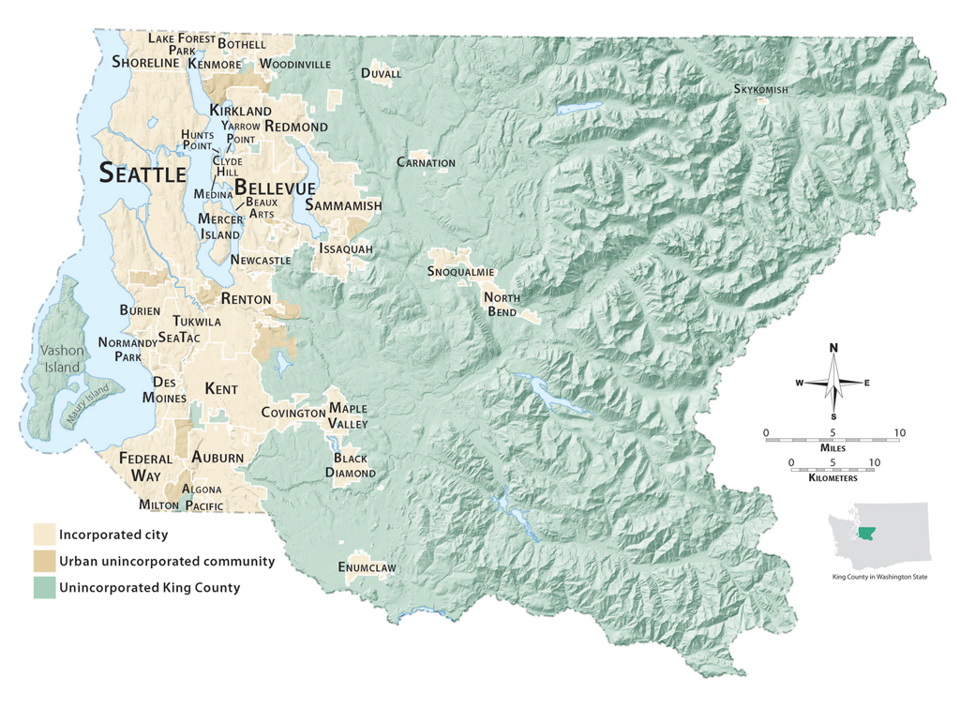

With nearly two million people, King County is the largest metropolitan county in Washington in terms of population, number of cities, and employment, and is the state’s growth and economic engine with more than 40 percent of the state’s jobs. It contains nearly one-third of the state’s population, is the 14th most populous county in the United States, and also has more residents than 10 states. The population is forecast to surpass 2.2 million by 2030.
As reflected in the division’s mission and vision statements, Road Services’ primary customers are the users of King County’s unincorporated-area road system. They may travel on foot or by car, public transit, truck, bicycle, or even on horseback. They may live and pay property taxes in an unincorporated area, in one of the region’s 39 cities, or in another county. The unincorporated road system supports local trips close to home, commuter trips, and regional travel between jurisdictions. All of these users expect and deserve a safe and efficient road system.
More than 250,000 county residents of the unincorporated area depend on the county road system daily and are directly served by Road Services. Unincorporated communities are spread geographically throughout the county and range from highly urban areas, such as West Hill and North Highline in the west, to rural farming and suburban areas in the east.
Unincorporated residents are by no means the only users of the unincorporated road system. More than a quarter of a million other people also use the same roads and bridges to commute to work or school, travel to retail and other services or to recreational and leisure destinations, transport freight and goods, or conduct their businesses.
Many of the growing cities in eastern King County are highly dependent on the unincorporated road network. For example, the years between 2000 and 2010 saw significant population growth in the cities of Snoqualmie (554 percent), Maple Valley (60 percent), Duvall (45 percent), Covington (28 percent), Sammamish (34 percent), and Redmond (20 percent). Residents of these communities and other eastern-county cities are major users of the unincorporated road network for commuting to employment and commercial centers. Some rural arterial roads serve as critical connectors to urban areas.
Residents of neighboring Pierce and Snohomish counties also use major arterials in the unincorporated area as commute routes to employment centers in King County. A 2010 analysis showed that for several of King County’s rural arterial roads, 50 percent or more of commuters are from local cities or neighboring counties. For example, 60 percent of P.M. peak hour trips (i.e., the afternoon commute) on Woodinville-Duvall Road are headed to destinations in various eastside cities or Snohomish County. Likewise, 59 percent of such trips on Novelty Hill Road are to cities and Snohomish County and 56 percent of such trips on Issaquah-Hobart Road are going to destinations within cities or Pierce County.
In total, more than one million daily trips are taken on King County’s unincorporated road network each day.
In addition to growing, the customer base is also becoming increasingly diverse. About 65 percent of King County’s population is non-Hispanic white, 15 percent is Asian or Pacific Islander, 9 percent is Latino, 6 percent is African-American, and 1 percent is Native American. The county’s population is aging, with a median age near 38 and 11 percent of the population over age 65. Consistent with County policy and administrative procedures, Road Services is increasing efforts to provide information about projects and services in multiple languages to meet the needs of diverse communities.
The unincorporated road network also provides access to outdoor recreational activities in King County, which has one of the largest concentrations of outdoor recreation enthusiasts in the state. Residents from all over the county—and beyond—enjoy the biking, camping, hiking, climbing, and skiing opportunities that are abundant in this region. Many of the state’s largest outdoor recreational organizations are based in, and serve, King County. These include the Mountaineers, Washington Kayak Club, and Cascade Bicycle Club.
Public service providers, such as police, fire, emergency medical responders and Metro Transit, are also key customers of the county’s unincorporated-area road system. In addition, the road right-of-way serves as a pathway for delivery of water, sewer, stormwater control, energy, and communication utilities.
Another important group of Road Services customers are the jurisdictions and government agencies that purchase road-related services such as paving, repair, safety improvements and construction. The division currently provides an ongoing level of contract services to 10 cities. It also provides project-specific or as-needed services to over two dozen other cities and agencies and to several nonprofit organizations implementing projects funded by federal or state transportation grants.
Road Services typically provides reimbursable services through a contractual relationship with these customers. These arrangements are mutually beneficial to both the jurisdiction or agency and King County; the benefits include:

- Economies of scale that allow sharing of the capital cost of equipment and other resources
- Shared management and support costs that result in lower project overhead
- Support for specialized technical expertise and flexibility in staffing levels
- Coordination of emergency services, including those provided during snow and ice storms, flooding, and earthquakes, to keep lifeline routes open.
In response to a 2013 budget proviso from the County Council, and in light of the resource limitations the division is currently experiencing, the division and staff from the Executive Office reviewed and evaluated the contact agreements and services provided to city customers. That analysis and evaluation, along with a summary of the contract framework, is in Appendix B.
The division involved its customers in the process of developing the 2010 strategic plan. A summary of those public involvement efforts can be found in Appendix C. Input received from customers since 2010 was also considered in this 2014 plan update.
Chapter 5
Road Services Funding
Resources to provide road services in unincorporated King County are subject to a tax structure that limits revenue growth to a pace slower than the ongoing growth in the cost of delivering services. The costs of labor, benefits, material and equipment are expected to grow at or above the general rate of inflation, while major revenue sources are expected to grow more slowly or decline over the next 10 years covered by this strategic plan.
In addition to structural constraints, the total unincorporated area assessed property value fell by more than 40 percent since 2009. King County gas tax revenue declined as population and road miles were annexed to cities and fewer miles were driven during the recession and as more fuel-efficient vehicles replaced—and continue to replace—older, less fuel-efficient vehicles. Gas tax receipts will decline further as annexations reduce the population of the unincorporated and the number of miles in the road system. Elimination of the Local Option Vehicle License Fee and the exhaustion of banked property tax levy capacity have also contributed to the growing gap between resources and the cost of providing services.
Fig. 2
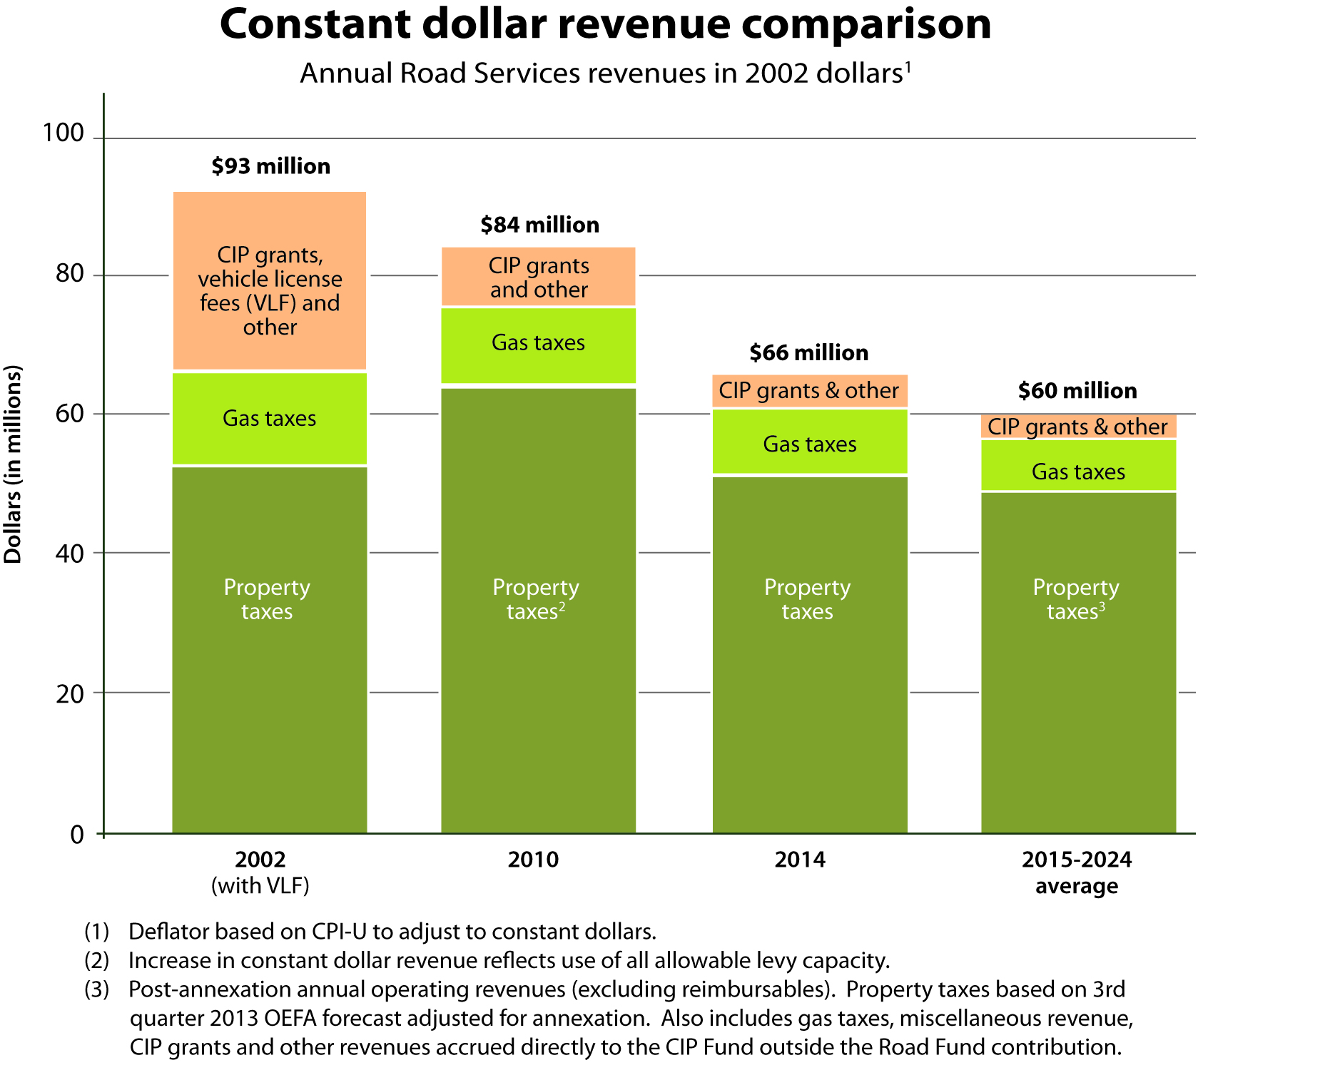

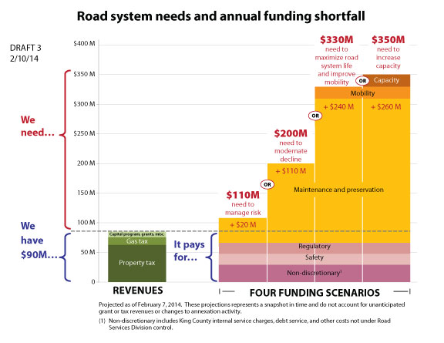
Available revenues have declined more rapidly than the 2010 plan projected they would. At the time the County Council adopted the 2010 plan, annual revenues were expected to hit a low of $102 million. Projected revenue for the coming 10 years now averages about $90 million annually, dipping close to $85 million in 2017. The approximately $90 million revenue available annually for services and capital comes from property taxes ($71 million), gas taxes ($11 million), CIP grants ($4 million), and interest, rents, and other small sources ($3 million).
As the cost of providing the current level of road services continues to outpace future growth in resources, the Road Services Division is shifting its focus from maintenance, preservation and construction to managing road system decline. Since 2009, the division has reduced its staffing levels from 615 to 350 FTEs—more than 40 percent. The division has consolidated facilities and has reduced pothole repairs by 65 percent. Overlay work performed in 2013 was limited to that funded by federal grants—seven miles compared to the 40 miles treated in 2010. Current projections point to additional reductions in services delivered in 2017.
There is a growing gap between the cost of maintaining the system at an acceptable level and the resources available. While average expected revenues have declined since the 2010 plan (from $102 million to about $90 million), the cost of the expected total annual service needs has grown (from $240 million in 2010 to $350 million in 2014). As preventive maintenance is replaced by reactive management, the cost of individual responses increases—much as the cost of deferring oil changes can lead to expensive automobile repairs. Fig. 3 illustrates this growing gap.
Fig. 3
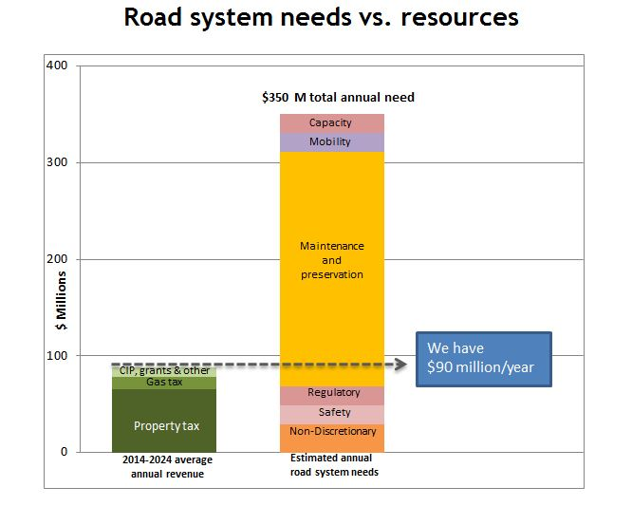
Chapter 6
Change Drivers
The 2010 plan identified five important challenges, or change drivers, facing the county road system. These challenges will persist—and in most cases will intensify—over the next 10 years.
- Annexations will leave the County with less revenue and with the rural roadways that are most difficult to support because of their location, age and condition, and susceptibility to flooding and snow and ice events.
- The population will continue to grow in both rural areas and adjacent cities, adding traffic to the rural road system and creating expectations for urban levels of service.
- Aging county roads will fail or be at risk of failure because Road Services does not have enough funds to perform all needed safety, maintenance and preservation work—and deferral of this work will lead to higher repair and replacement costs in the future.
- New environmental and safety regulations and engineering standards will continue adding to the complexity and cost of supporting the road system.
- Climate change could lead to an increase in the number and severity of winter storms and their impact on roads, and climate change policies could have wide-ranging effects on roadway management.
In addition, since 2010 the following new change drivers have emerged as significant challenges.
- Road budget cuts have resulted in a 40 percent reduction in staff. Fewer staff and smaller budgets have reduced the services Road Services can provide, including emergency response capabilities.
- Staff reductions due to layoffs, as well as voluntary staff turnover, have also created new challenges to maintaining the division’s workforce skills, knowledge, and experience.
More detailed information on change drivers can be found in Appendix E.
Chapter 7
Service Area Asset Inventory, Condition and Needs
Annexations are a key element of the State of Washington’s Growth Management Act, and King County has been a leader in the state in implementing growth management. However, urban areas remain throughout the county that have not yet been annexed or incorporated, and while some may do so over the next 10 years, some may remain within the county inventory for the foreseeable future. As the remaining urban areas are annexed into cities, Road Services’ inventory of road assets will be reduced, but not as significantly as one might expect: inventory in some asset categories will be reduced, while considerable inventory will remain in other categories. For example, after annexation of the remaining urban areas, the division will retain responsibility for the following percentages of current assets:
- 90 percent of bridges
- 73 percent of arterial mile pavement
- 87 percent of open drainage ditches
- 85 percent of gravel shoulders
- 80 percent of guardrail
- 57 percent of local access road pavement
- 32 percent of signals
- 45 percent of pipes
- 39 percent of stormwater catch basins.
The effects of annexation on several key inventory categories are illustrated in Fig. 4.
Fig. 4
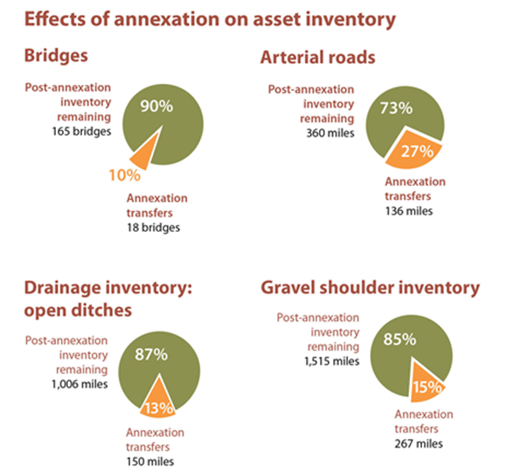
The division also faces some challenges left over from historic annexations, such as orphan roads – roads that are fully surrounded by other jurisdictions but are wholly or partially the County’s responsibility. The division is proactively working to remove these orphan roads from the County’s inventory by working with adjacent cities on transferring ownership. Eliminating the division’s responsibility for these roads will be key to providing better service, as many require attentive service due to their use by transit, but their distance from the division’s maintenance sites absorbs considerable resources.
Asset condition and needs
The amount of work and associated costs of maintaining and preserving different types of asset inventory varies considerably. For analysis purposes, Road Services is classifying specific assets as their “product” inventory in order to estimate overall infrastructure needs. The products include roadways, bridges, drainage (catch basins, pipes, and open ditches), traffic control infrastructure (markings, signs, signals), and roadside features (such as guardrail and pedestrian walkways). These products account for the largest investment in infrastructure, have an ongoing need to be preserved, are subject to regulation, and are interdependent and critical to the functioning of the road system.
The available data on the condition of the inventory varies greatly. For example, the division has historical, current, and location-specific data on the condition, cost, and performance of pavement and bridges. However, drainage and roadside condition ratings exist only by random sample, and the division has limited information on the condition of individual traffic control assets.
Despite the variation in data availability, it is clear from the division’s limited analysis that the road system is deteriorating at a faster rate than initially thought. Road Services must take a long-term perspective and increase our efforts to preserve roads and bridges. For example:
- Pavement testing performed in 2012 indicated that 70 percent of the approximately 450-mile arterial roadway system is in need of reconstruction or rehabilitation. To reduce this backlog of work by one-tenth in the next six years (the span of the capital improvement plan) would require an investment of over $14 million per year. To reduce the backlog by a quarter over the next six years would require a $70 million annual investment.
- More than 30 percent of the County’s 180 bridges are structurally deficient or functionally obsolete. Five bridges currently have load or height limits. The County has closed the old South Park Bridge, Alvord T Bridge, and Miller River Bridge in recent years when these bridges could no longer be safely kept open.
- About $20 million per year for 75 years is needed for lifecycle replacement of long-span bridges (over 20 feet). This figure does not take into account that many of the bridges in the inventory have already reached the end of their design life. When this is taken into account, the required investment increases to $29 million per year for the replacement of three bridges per year.
- A $2.3 million annual investment (over a five-year period) is needed to reduce a backlog of 10 short-span bridges that should be replaced because of their age and condition.
Drainage system and other asset categories show similar deterioration and a growing backlog of work. For example:
- There is currently a $90 million backlog of drainage project needs, and more projects are added to the backlog every year. At the current investment level of $6 million per year, that backlog will grow to $118 million by 2020. An annual investment of $15 million per year would reduce the backlog of needs in 2020 by 80 percent, to $24 million.
- Catch basins are currently cleaned on average once every three years. Increasing this frequency to once per year in order to meet permit and proper maintenance requirements would require an additional $1 million per year.
- The system of roadside ditches is currently cleaned on a cycle of every 30 years. To keep roadside ditches in proper working order would require bucket-ditching the system every five years at an additional cost of $7 million per year.
- The division maintains more than 850 miles of gravel shoulders that need grading to ensure proper drainage, a function that directly impacts the physical condition of the travelled way. Gravel shoulders are currently graded on a cycle of every 17 years. Ensuring properly functioning shoulders would require the system to be graded every 16 months at an additional cost of
$1 million per year.
Chapter 8
Strategic Policy Framework
The King County road network serves the 250,000 residents of the unincorporated area by providing access to their homes and properties, travel routes to work, school, recreation, businesses and other services. An equally large number of people who live outside the unincorporated area also use the network for their transportation needs. County roads link cities, counties and rural destinations together, to the greater regional transportation system, and to other vital services.
Based on the analyses done for this plan, the following policy framework was developed to guide the future direction of Road Services.
Composition of the county road network –The unincorporated area road network should:
- Consist of roads outside the Urban Growth Area (per Growth Management Act guidance that urban services are best provided by cities).
- Provide connections between cities and to rural destinations.
- Form an integrated system free of isolated service areas.
- Emphasize interconnected routes allowing through travel.
The County should add new roads to the network only if they are consistent with these purposes and if the County has the financial ability to maintain and preserve additional infrastructure. The County will work to reduce responsibility for “orphan” road segments in the urban areas that are difficult to serve, and will identify options for the management of less-used roadways in the absence of adequate resources to address critical road operational and safety concerns.
Prioritization of responsibilities – Road Services will strive for the following outcomes for program areas and deliverables, in the listed order of priority:
- Addressing safety needs and complying with legal mandates.
- Preservation of the existing roadway facilities network.
- Managing and enhancing mobility through system efficiencies.
- Addressing concurrency-driven roadway capacity needs.
Safety and legal mandates – Enhancing the safety of the users of King County’s roadway network while meeting local, state, and federal standards is inherent in all of the Road Services Division’s program areas and deliverables. We strive to enhance safety as we design, build, maintain, and manage roadways. Although funding and resources are limited, the division will consider safety, standards, and legal requirements as the highest priorities for all program areas and deliverables. Currently this means that mobility and capacity improvements will be unfunded. Road Services will continue to develop a plan for systematically addressing the prioritized road-related safety issues that exceed its current financial capacity.
Operational model – Road Services will give high priority to asset management in the Rural Area to make data-driven decisions about service delivery and to minimize infrastructure lifecycle cost to the extent feasible with available funding. This approach recognizes that the Rural Area roads will be the County’s long-term assets, and places a priority on maintenance and preservation of the rural roadway system. Critical safety and regulatory needs, as defined in this plan, will be addressed independent of urban/rural location.
Contract services provided to other jurisdictions/agencies – Road Services will pursue contracting opportunities when those services provide mutual benefit to King County and the contracting jurisdiction, and do not materially reduce the capacity of the division to provide services to the County’s network. A full discussion of this topic is in Appendix B.
Roads hierarchy – Road Services will prioritize the road hierarchy as follows in order to keep the most vital components of the road system operational for customers:
- Lifeline routes
- Arterial roads
- Sole-access local roads
- Other local access roads.
Risk management approach – Road Services will allocate resources using a risk management approach that balances the likelihood, consequences, and costs of infrastructure failure and potential solutions to achieve the following desired outcomes (in priority order):
- Protecting life safety
- Preventing private property damage
- Preventing asset damage
- Preventing environmental damage
- Preserving mobility.
In addition to these operational risks, Road Services should also assess and mitigate regulatory, compliance, reputational, and other business risks.
Road system failures and potential long-term closures – Given the increasing gap between infrastructure needs and available funding, Road Services will be facing road system failure scenarios beyond the division’s financial capacity to address. Road Services shall develop a process for long-term closures that includes the following:
- First, evaluate the failure to determine whether it is caused by County-owned road infrastructure, utilities in the right-of-way, or a natural or man-made incident.
- Second, evaluate the options for repair, restriction, or full/partial closure of the road in accordance with the roads hierarchy and risk management policies established in this plan, the impacts on the community, and the available funding resources.
- Communicate with affected stakeholders (residents, businesses, utility companies, other government agencies, etc.) to keep them informed and seek input on potential response alternatives.
- Work with agencies or private property owners to recover costs associated with repairs or replacement when their infrastructure, within or adjacent to the road right-of-way, has caused or contributed to the failure or they would benefit from the repair.
Use of the road network by other public/private entities – The road right-of-way serves a vital function, not just for transportation, but also as a pathway for delivery of other important community services such as water, sewer, stormwater control, energy, and communications. Other service providers should continue to be required to accommodate modifications to the right-of-way, and should pay for their use and their appropriate share of repairs related to their use, in order to help preserve these vital corridors.
Management of work facilities and properties – The Road Services Divisions work complexes, facilities and properties are essential to support the delivery of services to the public. They should:
- Be located so that services can be delivered in a timely and cost-effective way.
- Contain the appropriate facilities to meet work requirements and regulatory mandates and provide safe, healthy work space for employees.
- Be maintained, preserved, and replaced according to asset management principles.
Chapter 9
Goals and Strategies
The following goals and strategies grew out of the analyses for this plan concerning challenges, road system assets, funding, and alternative service delivery scenarios as well as the policies outlined in the previous section. They also respond to views expressed by Road Services customers. These goals and strategies will guide the Road Services Division for the next 10 years.
There are two types of goals. “What we deliver” goals articulate what the division intends to accomplish, and “how we deliver” goals articulate how the division intends to conduct its work. In general, “what” goals relate to the products and services provided to the public, and “how” goals speak to the internal aspects of services (such as cost-efficiency).
The “what we deliver” goals are:
Goal 1: Prevent and respond to immediate operational life safety and property damage hazards.
Goal 2: Meet regulatory requirements and standards in cooperation with regulatory agencies.
Goal 3: Preserve the existing roadway facilities network.
Goal 4: Enhance mobility (movement of people and goods) by facilitating more efficient use of the existing road system.
Goal 5: Address roadway capacity when necessary to support growth targets in the urban area.
The “how we deliver” goals are:
Goal 1: Exercise responsible financial stewardship.
Goal 2: Provide responsive customer service and public engagement.
Goal 3: Enhance the use of risk assessment in decision making.
Goal 4: Support the effectiveness of our workforce in a rapidly changing environment.
“What we deliver” goals
(Note: These goals are in priority order)
Due to the structural funding challenge and the absence of additional funding to address the backlog of critical infrastructure preservation and maintenance needs, over the next 10 years the Road Services Division will focus on immediate operational safety needs, regulatory compliance, and maintenance and preservation of the road system. Consistent with the policy direction outlined previously, the five goals below are listed in priority order. These priorities will serve as an important guide for future resource investment. Road Services will focus on the goals shown on the following pages, in priority order:
Goal 1: Prevent and respond to immediate operational life safety and property damage hazards.
Immediate operational life safety hazards are situations or road conditions that, if not addressed, have the direct potential to result imminently in injuries or death. Property damage hazards involve road conditions or defects that may result in substantial damage to road system assets and public or private property. Some examples of prevention and response could include, but are not limited to, the following:
1) removing obstructions in the traveled roadway; 2) mowing hazardous vegetation that significantly diminishes visibility at intersections; 3) plowing or de-icing lifeline routes that serve hospitals and public safety facilities; 4) addressing demonstrated high accident locations through traffic control or road design improvements; 5) repairing significant pavement defects in heavily traveled locations; 6) replacing a damaged stop sign or repairing a malfunctioning traffic signal; 7) cleaning a blocked stream culvert; or
8) inspecting infrastructure after an earthquake or flood.
Strategies
- Although the funding for roads is limited, immediate operational life safety and property damage hazard prevention/response is fundamental and we will address them first in all Road Services program areas and deliverables.
- When resources are insufficient for corrective action, response to hazards may include temporary or permanent closure of road/bridge facilities or other usage restrictions.
- Continue to evaluate and prioritize road-related safety needs that currently exceed the Road Services Division’s financial capacity.
- Address conditions or situations that are not immediate operational life safety or property hazards through maintenance and preservation activities informed by the risk-management framework described in “How we deliver” goal number three later in this plan.
Goal 2: Meet regulatory requirements and standards in cooperation with regulatory agencies.
Regulatory requirements and standards are aspects of the division’s business that are mandated by law. Failure to comply with such mandates can result in significant fines, potential harm to citizens, property, or the environment; potential for third-party lawsuits; and ineligibility for certain types of grant funding.
Strategies
- Concentrate efforts on requirements and standards related to safe design, construction, and maintenance of roadway infrastructure.
- Focus on compliance activities that best minimize risks and consequences.
- Identify efficiencies to help streamline compliance.
- When appropriate, engage regulatory agencies, including King County, to seek modifications, exceptions, or deferrals with appropriate compliance schedules that optimize outcomes within available resources.
Goal 3: Maintain and preserve the existing roadway facilities network.
Strategies
- Continue to develop a roads asset management program to guide capital and operating investment and resource deployment decisions. The division has long-standing programs for pavement and bridge condition; this new system looks at all of the assets owned and operated by the division. The program should identify what needs to be done to minimize infrastructure lifecycle costs, what actually can be done given available resources, and the backlog of needs and the consequences of not addressing them.
- Assess and document the condition of key road system assets; regularly update this data and share with the public and policymakers to inform discussions on funding and service levels.
- Actively develop a range of options that outline the funding necessary to assess, maintain, and preserve the existing road system, prevent degradation of asset condition and service levels, and address the backlog of deficient and obsolete facilities. Provide options describing the impact on the road and bridge assets at different funding levels to local, state, and regional bodies that play a role in funding decisions. Options should be available as a resource for public consideration and debate on levels of funding and service.
- Focus efforts on keeping the most vital components of the road system—as defined by function, traffic volume, and access options—open and operational for customers in the following priority order:
1) lifeline routes
2) arterial roads
3) sole-access local roads
4) other local roads.
Note that at the time this plan is being written, revenues are insufficient to adequately address Goal 1, to prevent and respond to safety hazards; Goal 2, to meet regulatory mandates; and Goal 3, to maintain and preserve the roadway network. No resources are available to address Goal 4, to enhance mobility or Goal 5, to address capacity needs; however, these goals are included here because they would be addressed if sufficient resources were to become available.
Goal 4: Enhance mobility (movement of people and goods) by facilitating more efficient use of the existing road system.
Strategies
- Preserve existing mobility by keeping the road system in a state of good repair to minimize service disruptions resulting from structural degradation and safety-related road or bridge closures.
- Implement mobility improvements in conjunction with preservation and maintenance projects when it is cost-effective to do both at the same time, and/or when distinct funding sources can be used for the mobility enhancement components.
- Maximize the efficient use of existing roads through operational improvements, including things such as signal timing, intelligent transportation systems (ITS), turn lanes or roundabouts, transit signal priority, and speed limit modifications.
- Seek funding sources such as user-based fees, grants, and regional funding mechanisms, in addition to the unincorporated area levy and other current revenue sources, to pay for road improvements whose sole purpose is to enhance or improve the movement of people and goods.
Goal 5: Address roadway capacity when necessary to support adopted growth targets.
Strategies
- Consistent with the King County Comprehensive Plan, capacity improvements to support urban growth will only be considered on:
  - Roads in the urban unincorporated area.
  - Rural regional corridors where the added capacity will not increase new growth inconsistent with growth targets in the rural unincorporated area.
- Seek regional funding contributions, city cost sharing, and/or user-based fees when capacity improvements or road maintenance is primarily needed to serve city residents (or facilitate achievement of city growth targets) or residents of other counties rather than residents of King County’s unincorporated area.
- Encourage the state to improve state facilities that affect transportation concurrency in unincorporated King County, and seek grant funds to offset the cost of design and construction of necessary improvements.
- Seek distinct funding sources such as user-based fees, developer funds to mitigate impacts, grants, and regional funding mechanisms separate from the road fund, to pay for road capacity improvements and growth-related maintenance needs.
“How we deliver” goals
(Note: These goals are not prioritized.)
Goal 1: Exercise responsible financial stewardship.
Strategies
- Deliver projects and services on time and within budget in the quickest and most effective manner.
- Seek the most efficient organizational structure and core staff competencies to deliver Road Services Division programs and services.
- Utilize performance measures and best practices to continually identify and implement operational efficiencies that bring down the costs of providing services and track the effectiveness of improvements.
- Utilize partnerships and provision of contract services to cities and other agencies to achieve efficiencies and economies of scale, where such affiliations do not materially reduce the capacity of the division to provide services to the county’s network.
- Use asset management practices to support:
  - Effective everyday resource allocation decisions that better meet desired operating and maintenance service levels.
  - Strategic capital investment decisions to meet identified needs and goals
- Articulate to the public and elected officials the consequences of deferring capital projects and maintenance work, both in terms of accelerated deterioration of infrastructure assets and inflationary cost increases over time.
- Identify potential stable funding source(s) to resolve the structural funding problem associated with the current outdated funding mechanisms for roads and bridges.
- Identify potential regional or user-based funding mechanisms when improvements are needed to support regional/cross-jurisdictional trips on unincorporated King County roads. When possible, select projects that provide multiple benefits (for example, meet both preservation and mobility enhancement goals).
- Consistent with the Growth Management Act and King County and regional policies, work actively with cities and the state to transfer responsibility for isolated urban roads to the adjacent city. These include half-streets (i.e., one side owned by a city and the other by the County), roads completely surrounded by city territory, and roads located on the urban growth boundary where consistent urban services are most appropriate.
Goal 2: Provide responsive customer service and public engagement.
Strategies
- Proactively inform road users about the level and frequency of service available in the unincorporated area under existing funding.
- Provide timely, consistent, and clear two-way communication with customers.
- Use information technology to enhance communication and promote widespread sharing of information (such as road closures and emergency notifications) and improve access to services and their ease of use.
- Foster collaboration with road users to identify for elected officials potential solutions to roads funding and service delivery challenges.
- Provide a variety of opportunities for public input on projects and decisions (such as community advisory groups, websites, etc.). Communicate in multiple languages when necessary to meet community needs.
- Provide timely information about emergency situations and life safety hazards (such as response to snow or ice conditions, road hazards, etc.).
Goal 3: Enhance the use of risk assessment in decision-making.
Strategies
- Use a risk-management approach to direct limited financial resources. The approach will be based on the following priorities:
  - Protecting life safety
  - Preventing private property damage
  - Preventing asset damage
  - Preventing environmental damage
  - Preserving mobility
- Develop and implement a risk evaluation tool to address both asset management-related risks, and risks related to other business practices and decisions.
- To protect life safety, consider both engineered (capital and operational improvements) and behavioral (education and enforcement activities) approaches to decreasing dangerous behaviors and reducing collisions, injuries, and fatalities. Evaluate the costs and benefits of these approaches when considering funding levels.
- Explore the use of Practical Design, a strategy currently being implemented at the state level to deliver focused benefits for a transportation system while working with the realities of a fiscally constrained funding environment.

Goal 4: Support the effectiveness of our workforce in a rapidly changing environment.
Strategies
- During times of significant transition and challenges, continue striving to attract, retain, and support a skilled, diverse, and productive workforce.
- Provide available career development services to employees, including career transition support when staff reductions are necessary.
- Manage change and further develop employee adaptation skills through communication and training.
- Engage employees in identification and implementation of workplace improvements and efficiencies.
- Encourage teamwork, collaboration, and creative problem solving.
- Acknowledge exceptional performance.
- Seek opportunities to partner with labor unions to improve services and promote workforce effectiveness.
- Develop and implement a succession plan to identify and develop people with the potential to fill key leadership positions in the division.
Chapter 10
Future Service Level Analysis
Given the needs for road system improvement and maintenance, and the shortfall in funding, how can Road Services achieve the goals in this plan?
As directed in the 2010 plan, the division has adopted an asset management operational model based on industry best practices with an ultimate goal of minimizing capital and operating costs over the entire asset life cycle. While the division does not currently have adequate resources to optimize asset life cycles, we have employed asset management principles to sharpen our ability to forecast maintenance, preservation and replacement needs; to estimate corresponding costs based on inventory quantities and unit prices; and to predict the resulting condition and risk profiles associated with various levels of funding.
Roads Asset Management Program
The purpose of the roads asset management program is to make the most cost-effective operating and capital investments—from maintenance through preservation and replacement—at whatever funding level is available—in accordance with this strategic plan, other County policy, and FHWA/WSDOT guidance. Since the 2010 plan was published, Road Services has established a robust framework for asset management. We have defined asset data requirements; specified standards of care; migrated asset data from separate sources into a single GIS-based inventory; and are in the final stages of implementing a computerized maintenance and asset management system. Over the next decade the division will leverage the information and tools of this framework to assess and manage its assets – from needs identification through replacement or decommissioning.
The analysis of future service needs summarized in the following section has been informed by the division’s progress in asset management over the past few years and new systems developed since 2010. It encompasses a more detailed understanding of the needs of individual asset components of the system, including roadway, bridge, drainage, traffic control, and roadside infrastructure. In addition, several assumptions and methodologies have been revised since the 2010 plan and are outlined below.
- Annexations – The 2010 plan assumed, per County policy and forecasts at the time, that the entire urban area would be annexed or incorporated by 2015, so the needs and cost analysis in the 2010 included only the rural area. Those annexations have not materialized and the County has since revised its annexation forecasts. Therefore, this plan update assumes that annexations will take place slowly over the next 10 years and that Road Services will continue to serve both the rural area and a diminishing portion of the unincorporated urban area during that timeframe.
- Planning horizon – The 2010 plan covered a five-year timeframe, whereas this plan covers 10 years (2014–2024). During this period a certain amount of asset inventory will be lost due to annexations, as noted above. The County will also gain some new asset inventory as a result of new development, and the costs of caring for infrastructure will grow because of inflation and other factors; these changes this will likely offset any cost savings from annexation of roads. The road levy growth limits will have a continuing detrimental impact on the road fund as inflation for labor and other costs outpaces revenue growth.
- Proxy analysis vs. more robust system analysis – The 2010 plan used a proxy methodology, extrapolating from a subset of assets, to estimate needs and costs. This updated analysis uses a more comprehensive and detailed service level model methodology based on more robust information about asset inventories, standards of care, and task unit costs. With this more comprehensive method, we have identified a larger number of system needs and therefore a higher cost than the 2010 estimates.
- New standards and needs – The analysis estimates needs and costs associated with reconstructing County-owned arterial roadways in accordance with current standards, including new standards for water quality. These new standards, together with a deeper understanding of the extent of road reconstruction needs, results in added costs since the 2010 plan.
- New regulatory requirements – The analysis recognizes the increased costs associated with new regulatory requirements such as stormwater treatment.
- Maintenance facility needs – Based on the division’s concurrent work on facilities master planning, the analysis includes the estimated costs associated with maintaining, repairing, reconstructing and potentially relocating road maintenance facility complexes.
- Aging and deteriorating infrastructure – The King County road system is the oldest in the state—some roads are over 100 years old, and portions of the drainage infrastructure we still depend on are more than 70 years old. Infrastructure is deteriorating and failing at an escalating rate because we are no longer able to do needed preventive repair, replacement and even maintenance. Therefore, since roads have continued to deteriorate, the baseline condition of the road system that we used to determine needs and cost estimates is lower than it was when the 2010 plan was developed, resulting in a higher need.
The changes incorporated in this updated analysis have resulted not only in better estimating abilities, but also in the identification of a larger set of infrastructure needs and associated costs.
Service level scenarios
The division currently estimates that it would cost $350 million annually—for a period that is longer than the life of this strategic plan—to fully address the current backlog of needs, embark on an asset management program that produces the lowest life cycle costs, address the division’s future maintenance facility needs, and systematically accomplish the road capacity, mobility and non-motorized needs identified in the Transportation Needs Report. The estimated cost in the 2010 plan was $240 million.
In comparison, from 2014 through 2024 the forecast available road fund will average about $90 million annually. Given current financial constraints, the division will face difficult decisions about which assets will be allowed to deteriorate, which will be subject to load limits or other restrictions, and which will be closed.
The division used a new service level modeling tool to generate three scenarios for this update, each characterized by varying work programs, expenditures, condition outcomes, and risk profiles. The scenarios are the same as those presented in the 2010 plan except for the addition of maintenance facility needs in the analysis. The scenarios are as follows:
- Maximize asset lifecycles
- Moderate the decline in asset condition
- Manage risk in a declining system

An estimated $350 million would be required to accomplish all of the identified road system needs. For purposes of this plan, we are describing three scenarios that do not include capacity improvements since those are the lowest priority.

Scenario 1: Maximize asset lifecycles
In this scenario, Road Services would significantly reduce the backlog of maintenance and preservation needs and continue to maintain the system’s assets at the lowest life-cycle cost. The asset management plan would be informed by infrastructure conditions and risks, and both factors would play an equal role in the development of preservation projects to reconstruct roads, bridges, and drainage systems and bring the overall system up to optimum conditions.
In order to maximize asset lifecycles, Road Services would have to improve the condition of the entire roadway system (including bridges, pavement, drainages, shoulders, etc.) to a point that allows for cost-effective planned maintenance and timely reconstruction or replacement. While this approach would be very costly up front because of the large number of existing deficient assets, it would reduce long-term costs and minimize liability. This scenario also includes investment in ongoing mobility and safety upgrades to existing infrastructure.
The annual revenue needed to accomplish this scenario is estimated at $330 million.
Scenario 2: Moderate the decline in asset condition
In this scenario, Road Services would maintain the road system in its current (albeit deteriorated) condition in the short term; however, we would delay additional deterioration through aggressive maintenance and repair. The asset management plan would be informed by infrastructure conditions and risks, but the risk component would be more likely to drive the development of projects.
Road Services would make modest targeted investments in roadway and bridge replacement or reconstruction to avoid cumulative future deterioration. The division would use a cost-effective planned maintenance approach as opposed to reactive maintenance, but would not be able to improve the asset enough to achieve the lowest lifecycle cost. Instead, the division would attempt to maintain the existing functionality of the system for as long as possible and slow the current decline. However, deterioration would inevitably occur over time and would ultimately have to be addressed.
Pavement condition and drainage systems would experience the most noticeable impacts; pavement condition scores would trend downward and more localized flooding might occur as a result of deferred maintenance and preservation of drainage infrastructure. The public would likely experience more temporary road closures as unscheduled repairs were done.
The annual revenue needed to accomplish this scenario is estimated at $200 million.
Scenario 3: Manage risk in a declining system
In this scenario Road Services faces a number of difficult choices as the system deteriorates to failure conditions, and the division is forced to selectively maintain the current condition of portions of the system, while in other portions deterioration continues largely unabated. The asset management plan would be informed by infrastructure conditions and risks, but the risk component is less likely to drive the development of projects and more likely to determine decisions regarding incremental closures of the system and lowering levels of service.
The division would provide basic levels of maintenance and snow removal services, but maintenance needs and costs would accelerate steeply as infrastructure conditions deteriorate. Only a limited number of roads, bridges, or drainage pipes would be reconstructed or replaced. Therefore, more bridges would have to be load-limited to prevent further damage. Arterial roadways would receive some level of surface treatment, but overall pavement conditions would worsen, and some would need to be posted for reduced speeds. The situation would also lead to additional lane closures for emergency repairs, increased congestion, diminished useful life of pavement overlays, more flooding of roads and private property, and potential closures of certain “redundant” roads (i.e., roads with alternative routes) because of poor condition and safety issues.
The annual revenue needed to accomplish this scenario is estimated at $110 million.
Table 1, shown on the following pages, summarizes the characteristics and impacts of the three service scenarios analyzed.

Table 1. Alternative Scenarios for Service Delivery

 | Scenario 1 | Scenario2 | Scenario 3
Description | Maximize life cycles | Moderate the decline in asset condition | Manage risk in declining system
Annual Revenue Needed | $330 million | $200 million | $110 million
Capacity/System Enhancement Projects | None | None | None
Maintenance | Maintain lowest life cycle condition ratings, eliminated or highly reduced backlogs and risks | Reasonable conditions and moderately reduced backlogs/risks | Substandard and declining asset condition with growing backlogs and increasing risk
Bridges  (Inventory = 180 ) | - Improves current condition—keeps up with the replacement -rehabilitation backlog  - 4 short span and 3 long span replacements per year | - Condition similar to current levels, but deterioration is slowed over time  - 2 short span and 2 long span replacements | - Eventual load limits, proactive load limiting to prevent damage, potential closure of “redundant” facilities  - 1 short span replacement per year  - No long span replacements
Drainage | - 16 fish culverts/year  - Reduces other drainage backlog over 2/3 by 2024 | - 8 fish culverts/year  - Reduces other drainage backlog over 1/3 by 2024 | - 4 fish culverts/year  - Reduces other drainage backlog ¼ by 2024
Roadway  Reconstruction -arterials only  (Inventory =  450 miles) | Backlog down 25% by 2024 | Backlog down 5% by 2024 | No reconstruction
Roadway Surface  (Inventory =  1,500 miles) | Maintain weighted pavement condition score (WPCS) of 70 for arterial and local system | Maintain WPCS of 70 for arterials and 60 for locals | Maintain WPCS of 55 for arterials and 40 for locals
Maintenance facilities | Fully implement Facilities Master Plan (FMP) recommendations, including asset lifecycle management, repairs, functional upgrades, and long-term investment in rehabilitation or replacement | Implement most FMP recommendations, including repairs, functional upgrades, and long-term investment in rehabilitation or replacement | Address urgent, high-priority repairs and replacements identified in the FMP
Proactive vs. Reactive | Allows cost-effective planned vs. reactive maintenance | Facilitates more cost-effective planned vs. reactive maintenance; unscheduled repairs and associated temporary road closures will still be likely to occur | Reactive—little planned maintenance; needs/costs accelerate as infrastructure condition deteriorates
Regulatory Compliance | Met over time | Met over time | Met over time
Emergency and Storm Response | High capacity | Improved capacity | Limited capacity
Grant Funding | Avoids loss of federal storm reimbursement and bridge grants | Avoids loss of federal storm reimbursement and bridge grants | Limited
Mobility Improvements | Reduces backlog of intelligent transportation system (ITS) projects and non-motorized (pedestrian/bike) improvements by 2/3 by 2020 | Limited mobility improvements provided in conjunction with maintenance and preservation projects | May include limited grant-funded non-motorized improvements
Claims | Reduced | Stabilized | Escalate as risk increases
Where we are today (2014)
With no change in existing revenue sources, road revenues are forecast to be $90 million on average annually for the life of this plan. At this funding level the division will primarily function as a reactive organization with little to no proactive maintenance or preservation investment and growing emergency repairs and closures. In addition, inflation will continue to reduce the division’s capacity to respond to infrastructure needs. Over the next 25 years 35 bridges will need to be closed, 72 miles of roadway will deteriorate to the point of significant restrictions or closures (speed reductions, lane or full road closures), and 65 percent of the stormwater system will likely fail causing sinkholes, local flooding, and washouts that can keep roads closed for weeks or in some cases indefinitely.
The county will work to reduce responsibility for “orphan” road segments in the urban areas that are difficult to serve, and will identify options for the management of lower tier roadways in the absence of adequate resources to address critical road operational and safety concerns.
Risk management
Given that a significant portion of the short- and long-term decisions facing Road Services will focus on risk management, the division is working with the County’s Risk Management office to develop a plan that evaluates the risks associated with maintenance and engineering activities. The plan will be integrated with the asset management strategy, and initially used at the policy level, but further refined in the future to guide decision making on a day-to-day basis by field personnel and engineering staff. The risk management plan will use the County’s current standard format, a five-by-five heat chart that plots the likelihood of a risk against the potential consequences. Two examples of a heat chart are presented in figures 5 and 6.
Fig. 5
Shoulder Maintenance Task
Shoulder maintenance is performed to smooth and reshape gravel shoulders to fix and prevent rutting and drainage problems. Too much material on the shoulder can prevent proper drainage, causing cracking and rutting problems. Too little material can cause big drop-offs from the roadway to the shoulder.

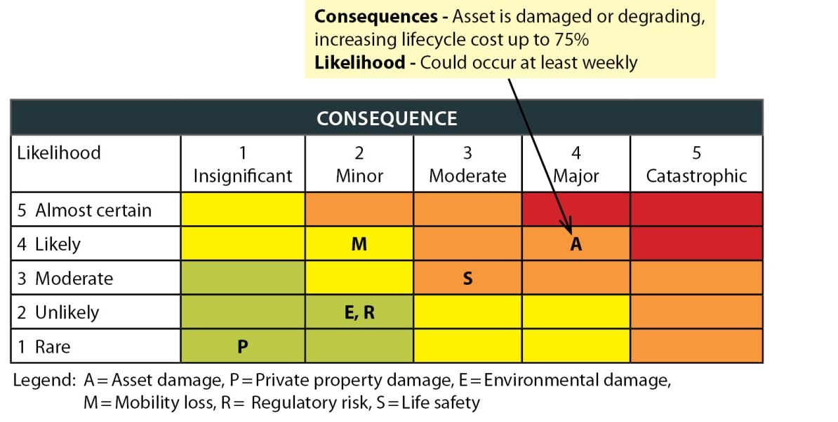
Fig. 6
Vegetation Maintenance Task
This task includes shoulder mowing and hand brushing to remove significant sight-distance obstructions due to overgrown vegetation. This provides safer driving conditions for motorists and safer shoulders for pedestrians, bicyclists and equestrians. The more mowing is performed, the less hand brushing is needed, since mowing can keep small seedlings from growing into trees that become too large in diameter to mow. 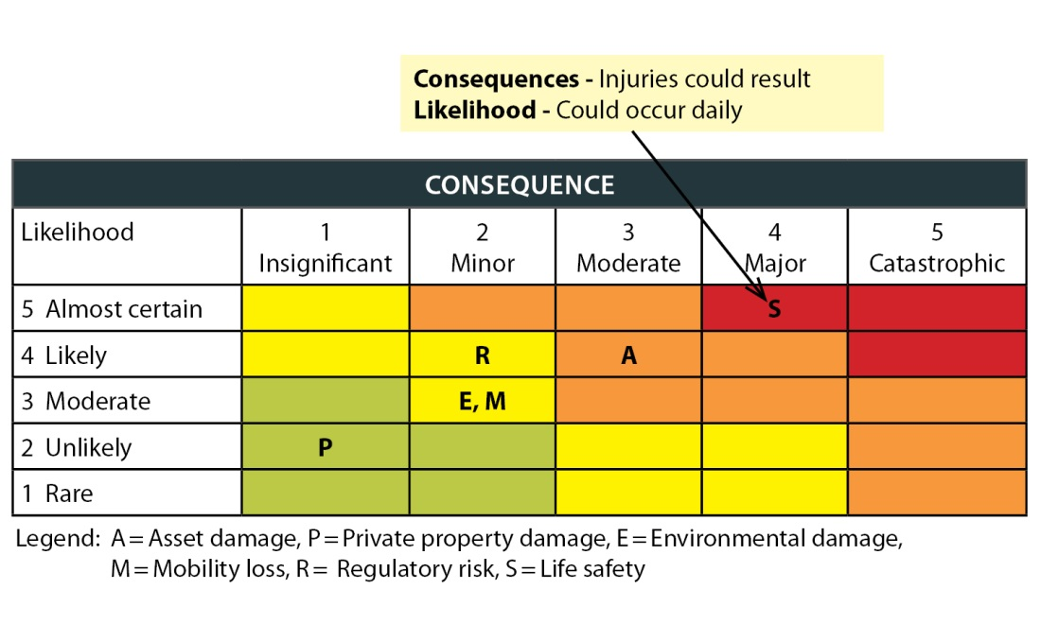
Shoulder maintenance and vegetation management were chosen for these examples because they highlight how the decision to perform certain tasks over others may have unintended consequences. For example, the public may wish to understand why the division spends a significant amount of resources trimming vegetation, when maintaining shoulders more regularly would better preserve the roadway asset and prevent the need for costly reconstruction. In this case, the risk management analysis indicates that while not maintaining shoulders degrades the overall asset condition, vegetation management (in particular maintaining sight distances at intersections) carries a much greater life safety risk and therefore should be a priority.
The risk management plan will be an important tool for prioritizing work, creating transparency in the decision-making process, and for understanding and communicating the impacts of unmitigated risks. For example, if catch basins are not cleaned, the risk of regulatory-related fines might be high, but the risk of the basins becoming safety hazards is low. For this reason, the division might choose to delay some of this work in order to complete other work that corrects a high safety risk, such as replacement of road striping. In this case, the use of the risk management plan would not eliminate or reduce the regulatory risk, but it will help County leadership make well-informed decisions.
Needs vs. revenues
Funding will be the key factor determining which service level scenario is achievable, as shown in Fig. 7. This figure compares the needs and available revenues associated with the prioritized roads “what we deliver” goals described in Chapter 9 (immediate operational life safety hazards, regulatory compliance, maintenance and preservation, mobility, and capacity improvements).
It's also important to recognize that the same types of work may be categorized as different priorities given a proactive or reactive environment. For the purposes of this needs analysis, each task was categorized as safety, regulatory, etc. based upon its core function in a proactive environment. For example, filling potholes is typically considered a maintenance or preservation activity at its core. However, when that pothole reaches a certain size or depth, its priority may become one of safety.
Fig. 7
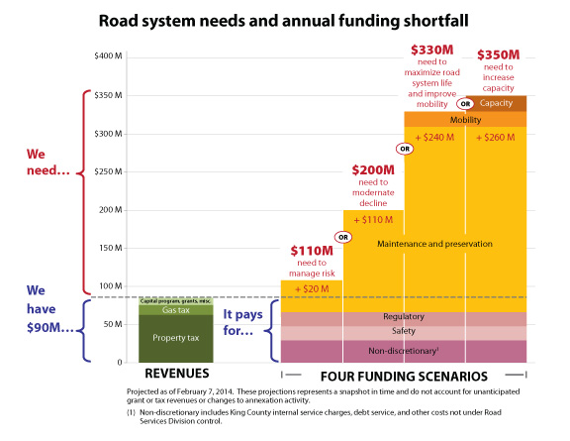
Chapter 11
Performance Measures – How Will We Know This Plan is Making a Difference?
Road Services tracks many performance metrics and uses them in internal program management, management decision support, and public communications and reporting. These include basic output measures such as number of miles of pavement overlay constructed or bridges replaced, outcome measures such as percent of structurally deficient bridges, customer service measures such as average number of days to complete requests for pothole repair, and high level community indicators (that the division has only partial influence over) such as the vehicle related fatality rate on unincorporated roads.
Given the current financial situation and the accelerating rate of decline of the system condition, data will be an important tool to inform management decisions... The division is beginning to use a work order tracking system that is tied to a GIS system. This will allow us to generate a full work history, as well as condition ratings for specific assets that can be used to develop corridor indicators of system health. The work order system will be fully implemented in 2014, and the combined condition ratings and work order system will grow into a robust management tool over the coming years.
Road Services will be preparing a Line of Business Plan for submittal with the 2015-2016 biennial budget. This plan will establish enhanced performance metrics grounded in the County's performance management framework and informed by the Lean approach to process improvement. The metrics will include quantity, quality, cost, and customer service components and include information such as the following:
- Collision, injury and fatality rates for motorists, bicyclists and pedestrians
- Pavement, bridge, drainage and road shoulder infrastructure condition ratings—eventually a corridor indicator will be possible
- System condition and asset failure indicators
- Financial indicators of the growing backlog and need will be updated as part of each budget process.
Further details of these measures and metrics will be laid out in the 2015-2016 Line of Business Plan.
Chapter 12
Facilities Master Planning
In conjunction with this 2014 plan update, the division also engaged in a facilities master planning effort to align the division’s facilities management with its policies and strategic goals. As stated in the Strategic Policy Framework chapter, the following SPRS policy provides overarching direction for facilities management:
The Road Services Division’s work complexes, facilities and properties are essential to support the delivery of services to the public. They should:

- Be located so that services can be delivered in a timely and cost-effective way.
- Contain the appropriate facilities to meet work requirements, regulatory mandates, and provide safe, healthy work space for employees.
- Be maintained, preserved, and replaced according to asset management principles.
The following section outlines the facilities challenges facing the division, the condition and deficiencies of existing facilities, and key short- and long-term needs and issues. It also provides guiding principles to help ensure that Road Services has the right facilities, in good condition, sited in the right locations to effectively and efficiently support the needs of our customers.
More detailed facilities information and analyses can be found in Appendix G. Additional facilities planning documentation is available from the division upon request.
Background
Road maintenance and operations facilities are critical to support the division’s mission. Maintenance activities keep the County’s road-related assets in working condition to maximize the public’s investment and provide for the safety of users. Some common activities include routine maintenance and repair of pavement, bridge components, ditches, culverts, shoulders, and guardrail, as well as vegetation management, debris removal, maintenance of traffic control devices and road striping. A significant number of environmental and regulatory compliance activities are also associated with road maintenance. Adequate maintenance facilities located in the right places and in good condition are necessary to support the efficient provision of vital services to the traveling public.
The ability to respond to incidents and emergencies 24 hours a day, seven days a week is an important part of operating a road network. Emergency response capability also helps keep the road system safe and operational during severe weather and after earthquakes or other events. Examples of emergency response activities include responding to significant accidents that impede travel; sanding, plowing and ice prevention on snowy or icy roads; removing downed trees and clearing other debris caused by landslides, storms or flooding; managing flood-related or other types of emergency road closures; and completing storm-related repairs to roadways and other assets such as drainage systems, shoulders, and adjacent slopes. Inspecting bridges and other infrastructure after earthquakes or other events is another critical emergency response function.
Current facilities
The division currently has eight regional maintenance shops located around the county, including remote facilities on Vashon Island and in the Skykomish area near Stevens Pass. In addition, a maintenance headquarters campus in Renton serves as the primary location for central administration; specialty functions like materials lab, traffic sign and signal shops; and other specialty services and equipment used throughout the system. Regional maintenance shops need adequate space for crews, vehicles, multiple pieces of equipment and materials, and functions such as waste disposal, truck washing and other similar activities. A fully functional regional shop site typically needs 35 to 40 acres for all of the storage and operating functions required to provide maintenance services for a wide geographic area.
Another 11 sites located throughout King County are used for supplementary materials and equipment stockpiling and storage, snow and ice or other emergency response, and project staging. A list and map of the division’s facilities can be found in Appendix G-1.
Many of the County’s existing road maintenance facilities are old and require significant capital improvements or have exceeded their useful lives and require replacement. Most are between 40 and 60 years old, with a few dating back to the early 1900s. These facilities were built or modified before the wave of annexations and incorporations that began in 1990 changed the geography of our service area. The division has already sold some facilities, such as Bruggers Bog, that are in the now-annexed/incorporated area. As the annexation/incorporation trend continues, other facilities, like the Issaquah and Star Lake regional maintenance shops, will have to be sold and the staff relocated.
Many facilities were not originally built as maintenance sites but have been adapted for that use. For instance, the original jail on Vashon Island now serves as a maintenance storage and office facility. Some do not meet current building standards or do not readily accommodate the needs of a modern workforce and equipment inventory. Some facilities have inadequate heat, insufficient restrooms, or failing septic systems. Some facilities have been plagued by leaking roofs, mold, or rodent infestations.
Other facilities may be in adequate physical condition, but do not meet necessary functional or operational criteria – for example, they don’t have adequate office space, or covered materials and equipment storage, or a place to process road waste materials. An important purpose of the facilities planning effort was to assess these issues and develop a plan for the future in order to provide appropriate facilities to safely house staff and adequately serve the public.
Facilities guiding principles
The following principles are recommended to guide the management of road maintenance facilities and properties.
- Manage facilities and real estate properties to maximize service to the public, minimize costs, limit liability, and protect property assets.
- Design and maintain facilities so they are functional, efficient, and resilient during the normal course of work and emergency events.
- Seek to minimize travel time from facilities to service areas in order to maintain efficiency and enable timely emergency response. Division analysis indicates an average travel time of 45 minutes or less is desirable and cost-efficient.
- Pursue co-location opportunities with other agencies when feasible, operationally beneficial, cost-effective, and/or cost-neutral to the division.
- In order to meet future property needs, the division may land-bank existing properties when the potential has been demonstrated to meet specific, identified future operational needs of the agency, especially when the property may be difficult or impossible to replace in the future.
- Consider the most cost-effective and efficient way to meet system wide needs like vehicle fueling, storage of materials and supplies, disposal or remediation of street wastes, and vactor/decant waste processing and services.
- Surplus excess properties to generate revenues following consideration of market conditions and the costs of continued ownership.
- Retain resource properties (gravel, timber, etc.) for the division’s own operational needs when such use is likely to represent the most cost-effective option. The division may also choose to generate revenue from resource extraction, such as mining or forestry, on its properties when it is financially beneficial and does not adversely impact road maintenance operations. However, the division should not retain or manage properties specifically for long-term commercial resource extraction purposes not related to road management.
- Pursue potential alternatives and options for securing funds to support facility needs, upgrades, and/or construction.
- Whenever possible, allocate surplus operating property sales proceeds to facility maintenance and/or construction needs after the division’s financial reserve requirements are met.
Key service delivery considerations
The division’s facilities analysis identified three key service delivery issues that must be considered when planning maintenance facilities: travel time, satellite facilities, and geography/topography as described below.
Travel time
Travel time costs money and affects efficiency of service delivery. Time spent traveling to and from job sites or making round-trips to haul materials or wastes long distances during the work day is unproductive time. Using Lean process improvement terminology, this would be considered a type of “transportation waste.” In addition to being unproductive, long travel times can also waste fuel and create excess vehicle emissions. When locating facilities, travel time should be minimized to the extent feasible. The analysis conducted for this plan indicates that the division should seek to keep travel time from facilities to the work site to 45 minutes or less on average. Actual travel time will vary based on traffic and other conditions, but this is a good frame of reference for planning purposes. In addition to cost and productivity concerns, travel time can also be critically important when responding to road-related emergency conditions.
Satellite sites for materials, equipment, and staff support
One way to reduce travel time and increase work efficiency and response time to incidents and emergencies is to have “satellite” maintenance sites dispersed at strategic locations throughout the service area. Such sites allow maintenance crews to more quickly access materials, supplies or equipment without having to travel all the way back to a primary maintenance facility. These satellite sites can take the form of basic materials storage depots for stockpiling sand, gravel or road salt, or more developed emergency facilities that may house special equipment (such as snow plows) and provide crews with temporary shelter from the weather, as well as restrooms and other staff health and safety functions.
Topography considerations
Topographic constraints can make it difficult to serve certain areas of the county during severe weather or flooding. King County is large and geographically diverse. Many portions of the division’s service area are bifurcated by major rivers and subject to flooding. There is a wide variety of terrain, and a large portion of the rural area is at higher elevations and significantly affected by snow and ice conditions. All of this must be considered when siting primary or satellite maintenance facilities to ensure that portions of the county do not become cut off from road services during severe weather conditions or other emergencies. For example, when the Snoqualmie River floods, the communities to the east can become isolated during flood events. A satellite emergency facility on the east side of the river would help to provide continuity of services.
Assessment of current facilities
The division’s existing facilities were assessed from three perspectives: physical condition and repair needs, location suitability, and functional/operational deficiencies.
Physical condition and repair needs
To get a current and comprehensive understanding of the condition of its existing maintenance facilities, the County engaged facilities consultant DLR Group in July 2013 to conduct a facilities condition assessment. DLR Group assessed and documented various components of the buildings and properties at 11 different maintenance sites. The study included the cost estimates for capital needs of each facility and projected costs associated with future use for each facility. The report identified, as a conservative estimate, over $250 million in capital needs over a 30-year period. Appendix G-2 describes the types of needs that have been identified. The capital and repair needs will be incorporated in the division’s next Transportation Needs Report update.
The DLR condition report and analysis will help Road Services prioritize needed maintenance repairs and will also help inform future cost-benefit analysis and decisions regarding whether to invest in expensive repairs or rehabilitation of facilities, or to relocate or rebuild facilities. Road Services will also be able to use the resulting facilities condition database as an asset management tool to track future improvements and changes in building component condition. A summary of the DLR report can be found in Appendix G-2 and a copy of the full report is available upon request.
Location suitability
As the unincorporated service area has changed significantly with annexations and incorporations over the past two decades, a number of facilities are no longer sited in the best locations to serve the core unincorporated service areas. In addition, facilities sites have certain size, land use, zoning, environmental and other requirements. Because the division’s facilities have been sited, acquired, and developed ad hoc over a very long period of time, many current facilities have issues related to their location. For example, the Summit site is now located within a city and surrounded by residential development. The division assessed each facility according to a set of criteria that considered travel time, size, land use issues, and many other factors. The criteria and a summary of evaluation results are in Appendix G-4 and G-5.
Functional/operational deficiencies
The division’s facilities were also assessed against a set of functional criteria to identify deficiencies from an operational perspective. The criteria and results of the analysis are in Appendix G-3 along with the results of the analysis in Appendix G-5.
Short-Term Recommendations
Facility Consolidations
We recommend two facility closures and consolidations within the next few years. The Star Lake regional maintenance shop (north of Federal Way) is underutilized as a result of annexations of the urban area and is located too far west to meet future service area needs. Similarly, the Issaquah regional maintenance shop is no longer in a suitable location to efficiently serve the remaining unincorporated area. It is also in poor condition requiring significant repairs and upgrades to remain operational.
The functions of these regional shops can be relocated to other facilities and the properties surplused. It may be desirable to retain use of a small portion of the Star Lake site for materials storage and emergency response and to also retain access to the existing vactor decant facility to support services to the remaining unincorporated urban pockets until they annex to cities.
Enhanced satellite facilities
We identified two needs for new or enhanced emergency response facilities as short term priorities. In the north, the service area east of Snoqualmie River can become isolated from service in the event of flooding. Developing an existing Road Services Division property east of the river (such as the Stillwater property) as an emergency facility would be beneficial.
The Enumclaw Plateau area is separated from the rest of the southern service area by the Green River and could become isolated following an event such as earthquake or major flooding. These concerns need to be assessed further. Based on the conclusions of that assessment, the division may consider developing an existing Road Services Division property (such as Krain or Cumberland) as a satellite emergency facility.
Other satellite facility needs also exist, but the two above are high priorities because of the degree of isolation from existing service facilities.
Urgent, high-priority maintenance and repair needs
In addition to the two facility closures, the DLR condition assessment report identified urgent, high priority maintenance and repair projects that would cost approximately $5 million. These needs will be addressed as part of the 2015-2016 biennium budget process. A summary is in Appendix G-2.
Medium and long-term issues
Longer term issues facing the division’s facilities include the following:
- The Renton Headquarters currently serves as the division’s main maintenance facility. The County has a significant investment in this facility, which houses many special centralized roads functions (such as survey, materials lab, environmental unit, vactor decant, etc.). It is also home to other compatible support services agencies such as fleet stores, where Road Services purchases tools and supplies, and the fleet vehicle maintenance facilities that provide countywide service for the division’s vehicles and equipment. The facility is conveniently located and supports a full-range of functions (except for fill capacity), but it needs over $2 million in repairs and upgrades.
- The Cadman regional maintenance shop is located on the western edge of its long-term service area, which is not optimal for travel time. The facility also faces urban land use and development pressures because of its location inside the growing City of Redmond. In addition, it is subject to city permitting and regulatory requirements. For these reasons, it would be worthwhile to explore other options, including co-location partnership opportunities with other agencies at an alternate location. If alternative arrangements for north-end division regional functions are implemented in the future, Cadman could be retained as satellite site.
- The Fall City regional maintenance shop is located in a flood zone and is very old, too small (2.5 acres) to adequately support necessary operations, and the building is outdated and inadequate. It would be worthwhile to explore other options, including co-location partnership opportunities with other agencies at alternative locations. A location with reliable access during flood conditions would be a high priority.
- The Summit regional maintenance shop is in an area that was annexed by the City of Maple Valley in December 2013. Escalating urban land use and development pressures, city zoning, and a proposed school on a likely soon-to-be-sold portion of the property will all impact long-term use as a regional maintenance shop. For these reasons, we recommending continuing to plan for replacing the functions currently provided by Summit. The road waste processing functions will be particularly difficult to replace at another site because of size requirements, permitting, and other issues.
- The Black Diamond regional maintenance shop does not currently support all needed functions and is not large enough to absorb all staff and functions from Summit, if Summit is closed. Major upgrades and repair work are needed to meet current needs. A nearby fish hatchery and environmental issues may limit further development at this site. If a new south end regional maintenance shop was to be developed in the future, Black Diamond could be retained as a satellite site.
- The Vashon regional maintenance shop is very old and inadequate for the full array of needs of a regional shop, and the property is too small. Because of its age and condition, some or all of the facility will need to be upgraded, repaired and/or rebuilt eventually. It would be worthwhile to explore the potential for collaboration with other public agencies serving Vashon Island (e.g. parks, police etc.) for a shared facility complex. The RSD-owned Mileta property could be evaluated as one potential future siting option.
- The Skykomish regional maintenance shop is isolated from the remainder of the County’s service area, but the facility is appropriately located for its area. It is currently in good condition with some minor, immediate maintenance and repair work needed. The facilities are old, however, and some will need repairs and upgrades eventually.
Overall, all of the division’s facilities that are retained for the long term will need significant repairs and preventive maintenance. The DLR report estimates approximately $55 million in needs for the period 2015-2024 and almost $200 million in additional needs through 2044.
The division continues to evaluate future road maintenance facility needs. As better information about co-location or relocation opportunities becomes available, and as potential new funding sources for Road Services are explored, the division will continue to assess its maintenance service delivery configuration to determine the appropriate number and type of facilities needed for the long term.
Other planning considerations
A planning level property analysis conducted by the division using GIS data and the facilities siting criteria included in Appendix G-4 determined that there are few locations in the county potentially suitable for siting new, fully-functional regional maintenance facilities. Less than three dozen properties countywide, most of which are not currently for sale, appear to meet the key criteria. Since feasible locations for new facilities are quite scarce, the division should be prepared to seriously consider any opportunities to partner with other agencies to co-locate facilities and/or to acquire the rare suitable property that may become available in locations that would meet the division’s future needs. We should continue to explore in more detail opportunities for co-location and/or potential feasible relocation sites over the next few years.
Chapter 13
Next Steps
As described in this plan, Road Services has a continuing and growing gap between available funding and system need. The recession led to a decrease in property tax revenues, other revenues have been declining or growing too slowly to match inflation, and the cost of doing business has been continuing to increase. The funding situation, coupled with an aging road system, has resulted in a decline in the overall condition and sustainability of the county’s road infrastructure, creating a growing backlog of unaddressed preservation and maintenance needs. We are starting to restrict and close road and bridge facilities as funding to repair or replace them is no longer available.
At the same time, the County’s responsibilities for providing road services and infrastructure will remain substantial. The twin challenges of reduced revenue and deteriorating infrastructure mean it is necessary to focus our resources on the most critical priorities of safety, maintenance, and extending the life of existing facilities while doing our best to comply with a wide range of regulations and other legal mandates.
In order to address the fundamental intent of the policies and goals described in this plan, the County would at minimum, need to achieve future service delivery scenario B: Moderate the decline in asset condition. While this scenario is not optimal in terms of infrastructure lifecycle management and does not prevent the long-term decline of the system, it is a more realistic interim option to strive for given current economic realities. By moderating the decline of asset conditions, the County would continue to provide a basic level of service to users of the unincorporated-area road system in the near term, and will prevent rapidly escalating repair costs and potential infrastructure failures that would result from deferred maintenance and preservation.
Road Services should continue to pursue efficiencies and take action to better organize service delivery.
Efficiency
- Continue to use performance management business practices to identify, evaluate and implement efficiencies that help reduce the cost of services.
- Continue to pursue efficiencies through the more timely use of new information technology as Road Services moves to a data-driven asset management approach. This approach will rely on GIS data that provide detailed and complete information about asset conditions by location, allowing us to analyze the condition of a singular asset, a class of assets, or corridor or road networks. When fully implemented, this approach will increase our efficiency in identifying, inventorying, and monitoring maintenance and preservation of the County’s road network assets. It will allow the County to make data-driven decisions in the selection and prioritization of investments as we strive to minimize life cycle cost and maximize asset life within available funding.
- Continue to streamline the organization of the division as areas annex and the division’s work shifts to a more rural nature. For example, the division already has cut or reduced those programs that serve primarily urban populations—such as the neighborhood, pedestrian, and school traffic safety programs; signal design and engineering; development review of traffic impacts; traffic data modeling; transportation concurrency management; mitigation payment system planning; and non-motorized planning. Some maintenance and special operations programs will continue to provide services, but with a reduced workload as a result of annexations. As the capital program shifts away from larger capacity and other more urban improvements and moves toward a higher volume of rural safety and preservation investments, Road Services also expects to see some workload reductions in civil design, roads project management, bridge project management, and environmental studies and design.
- Continue city contract work when it involves specialty skilled work that smaller agencies across the county could not support on their own or easily acquire in the private sector. The city work helps the County by funding a more stable team of experts to serve both county roads and cities. The centralized nature of the traffic and engineering work groups, the relatively discrete nature of their work products, and the less seasonal nature of the work makes the planning and delivery of those services more consistent.
- Limit commitments to cities to perform general maintenance work when it poses a conflict with basic work on county roads. At times, general maintenance work on county roads has been delayed or deferred in order to accommodate seasonal or peak demands of cities. As funding shortfalls lead to more significant road failures, it will be more difficult to respond to both emerging county road issues and scheduled city general maintenance work. This type of less specialized general maintenance work can be undertaken by cities or external contractors.
Funding
- Identify potential funding choices that are consistent with this plan, the Puget Sound region’s transportation plan (Transportation 2040), and the King County Strategic Plan and would support adopted service-level goals.
- Participate in an integrated and coordinated approach to resolving the problems with the region’s transportation funding structure that considers both the road and transit needs of the County.
- Since projected revenues are insufficient to adequately manage the decline of the system, explore with grant funding agencies ways to place a greater emphasis on maintenance and preservation funding instead of the traditional focus on capital improvements.
Staffing and organizational structure
- Ensure that the agency is right-sized to meet the demands of managing the road system and responding to emergencies. Road Services will examine staffing in each budget cycle using the following factors:
  - Changes in service area due to annexation
  - Changes in regulatory requirements
  - Changes in revenues and County priorities
  - Changes due to shifts in CIP workload
  - Changes in workload from contract cities, agencies and jurisdictions
  - Changes in technology.
- Strive for a nimble and efficient organizational structure and staffing that provides for delivery of services as prioritized in this plan.
Facility planning
- Implement the recommendations of the facilities master planning chapter of this plan and continue to evaluate opportunities to relocate or co-locate regional maintenance shops to meet the future needs of the service area.
Conclusion
The County right-of-way and road and bridge network provide pathways between cities and other counties. County roads and state highways are necessary links for the movement of people, utilities and goods throughout the most urban and dense county in the state. These roads—built generations ago—are failing, and there is insufficient funding to maintain and replace them. Our connectedness hinges not just on high-profile bridges and tunnels, but on thousands of miles of ordinary and unremarkable streets, culverts and bridges that travelers mostly take for granted.
In King County, 13 percent of the total population pays for the roads that one million cars drive on every day. This is because we are the only county to have so completely implemented the state’s Growth Management Act, which calls for small, dense, urban areas of high-value properties to be annexed into cities. The old system for funding county roads didn’t contemplate growth management, and it doesn’t leave sufficient revenues to keep the system functioning even at current levels.
The County has worked to respond to the decline of more than one-third of the revenue available to care for roads and bridges. However, despite many efforts to cut costs and achieve efficiencies, revenue reductions of this magnitude ultimately require cuts in services. County roads outside of cities could see the closure of 35 bridges as they become unsafe, restrictions on an estimated 72 miles of failing roadways, more slides and flooding from clogged and aging drainage, a two-thirds reduction in snow and ice plowing, which will mean more communities that are isolated and delays in restoring utilities.
This plan will help guide County employees to provide the most critical services and make difficult decisions should funding gaps continue. And if additional revenues are identified to support roads, the strategies in this plan will allow the County to best prioritize the management of the system and the organization of the work.

Appendices

Appendix A: Division Functions
Road Services’ functions fall into two primary categories: capital project delivery, and operations and maintenance.

Capital project delivery
Every section in the division is involved in capital project work. Major work products and services include the following:
- Planning and programming sets priorities for preservation and improvement projects, identifying improvements that will contribute most effectively to the goals set for King County roadways. Various prioritization processes are used to rank project needs related to capacity, high accident locations/high accident road segments, long- and short-span bridges, guardrail, traffic signals, pedestrians, intelligent transportation systems, vulnerable road segments, small-scale operational improvements, and intersections. Products and services include the CIP, the Transportation Needs Report (TNR), the Annual Bridge Report, travel demand forecasting, and division-wide performance measures.
- Project delivery is the process of designing and building projects in the adopted capital improvement program. This includes developing and controlling project budgets, identifying and obtaining grant revenues, determining the best project scope, and coordinating with outside agencies and stakeholders. Major work products and services include project management and coordination, contract management, and environmental permitting, compliance, and mitigation.
- Design and implementation services include design engineering and other professional services to develop plans, specifications, and estimates as well as the construction administration to manage road and bridge contractors. Major work products and services include biddable and buildable plans; design and construction specifications; professional engineering, survey, and right-of-way services; environmental engineering and analysis; construction management; and materials and geotechnical testing.

Operations and maintenance
Road Services is responsible for maintaining and operating all assets within the right-of-way. These include the traveled roadway; roadside assets such as pedestrian and bicycle pathways, drainage systems and shoulders; and traffic control and management features such as signs, striping, and signals. Emergency response activities that keep the road system safe and operational during severe weather or other emergencies are an important area of service.
The following are the major work products and services:
- Road system maintenance and operations involves routine and major maintenance, repair, and restoration of roads, drainage systems, shoulders, and other assets in the King County right-of-way; removal of trees, vegetation, and debris that impacts roads; maintenance of signs, signals, guardrails, road striping, and other traffic control devices; bridge maintenance; and environmental and regulatory compliance for division activities and facilities.
- Specialized engineering services support optimal operation of the transportation system. Specific products and services include traffic engineering, intelligent transportation systems support, and bridge and pavement inspections.
- Emergency response encompasses activities such as sanding, plowing and ice prevention on snowy or icy roads; removing downed trees and clearing other debris from heavy rains, flooding, and windstorms; managing flood-related or other types of emergency road closures; and completing storm repairs to roadways and roadside assets such as drainage systems, shoulders, and adjacent slopes.

Other responsibilities
Road Services provides additional products and services as part of managing a large and complex road system. Some are not directly related to providing road and bridge infrastructure to the public. Many are required by federal, state or local laws; others are essential aspects of the division’s commitment to customer service. Some examples:
- Providing public access to maps and records
- Reviewing public and private development proposals for potential impacts on transportation
- Operating a 24-hour road help line
- Keeping the public informed about major construction projects, road or bridge closures and repairs, and other road services and activities
- Handling public inquiries and complaints
- Administering state and federal transportation grants for smaller cities and nonprofit agencies
- Issuing permits for special uses of the road right-of-way
- Processing road vacations for property owners
- Developing the transportation element of the King County Comprehensive Plan and other transportation policies
- Managing transportation concurrency and other requirements of the state Growth Management Act
- Operating regional stormwater disposal stations.

Appendix B: Contract Services Framework and Proviso Response
The following framework was developed in the 2010 plan to guide implementation of Road Services contract services agreements.
The Road Services Division will pursue contracting opportunities when the provision of contract services provides mutual benefit to King County and the customer agency/jurisdiction. The following guidelines provide the framework for the Road Services Division’s contract services agreements.
- Meet full cost recovery requirements consistent with:
- State Accountancy Act
- Federal guidelines
- Generally accepted accounting principles

- Balance King County and customer agency/jurisdiction needs according to the following priorities:
- Priority 1- Maintenance and preservation of King County’s unincorporated area road network
- Priority 2 - Services to customer agencies/ jurisdictions having an established, ongoing maintenance program with the Road Services Division
- Priority 3 - Services to other customer agencies/ jurisdictions based on the amount of lead time the requesting entity provides

- Develop procedures for the delivery of contract services that address:
- Customer level of service expectations that reflect the priorities listed above
- Clear prioritization of work
- Process for handling work request changes
- Contracting options including a variety of service level options
- Available services and the associated costs and benefits of specific service packages
- Method to address emergency and other response protocols
- Process for resolution of non-standard customer work requests
- Process for dispute resolution, including billing disputes
- Method to address customer-invoicing issues related to billing formats

While this framework continues to provide guidance for contract service agreements, Road Services was required to take a closer look at its “regional road services delivery models” in response to Proviso P1 to Section 65 of the 2013 King County Budget Ordinance 17476. The proviso required a work plan be developed which was transmitted to the council in March 2013 and included the following work tasks:

- Report on historical Road Services Division contract services and identify trends;
- Work with jurisdictions in a regional engagement process to shape potential changes to contracting processes and services; and,
- Use historical trends in service and input from outreach to develop a comprehensive regional road services contracting approach to inform the 2015-2016 budget and update the Strategic Plan for Road Services.
The materials in the remainder of this appendix comprise the products of this work effort.

Report on historical Road Services Division contract services and trends

The County provides three general types of service to cities: road maintenance; traffic maintenance, and engineering services. Within each service types are various tasks like pothole patching, signal maintenance and bridge inspections. While routine maintenance services are usually budgeted annually in a single amount, the specific work orders may not be defined by the cities until the service is needed. Since some work is heavily seasonal, like street sweeping in late fall, which the County and the cities want to do at the same time, requests for service can conflict between customers and either require deferral of services to unincorporated county roads or telling a customer we are unable to provide service.

Generally speaking, the amount of road maintenance service provided to cities has been trending down over the last five years, because many of the cities that once relied solely on the County now have public works departments of their own that are fully capable of providing these services in-house. Additionally, cities have cut-back general maintenance services during the recession.

In contrast, traffic maintenance services have been steady, which is partially due to the fact that the County is one of the few traffic and signal control design and maintenance providers in the region and this work is mandatory in nature. Engineering service trends are more sporadic due to the variability of staffing required for large capital projects, but bridge inspection and materials lab services provided by the engineering group have remained relatively stable.

Charts outlining the trends and historical types of services provided by Road Services during 2008 - 2012 are provided in figures B-1 to B-3.

Fig. B-1

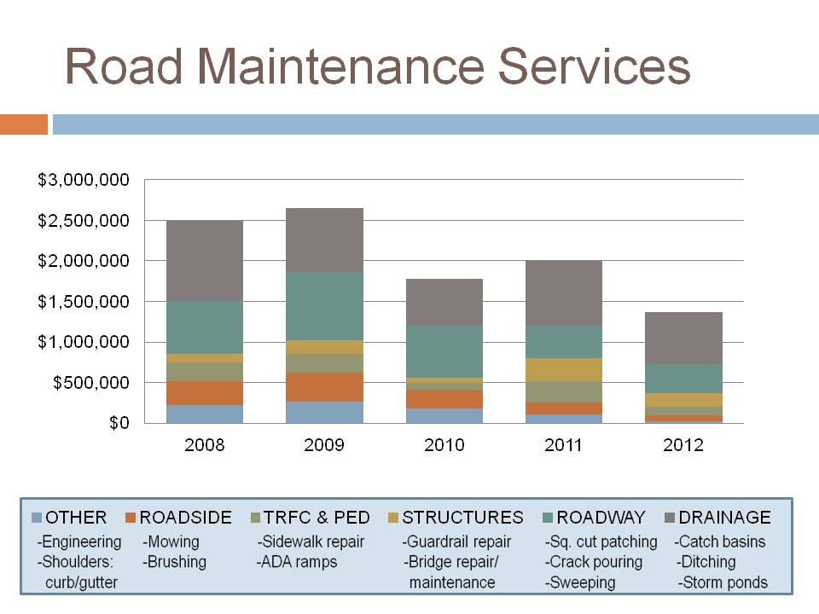

Fig. B-2
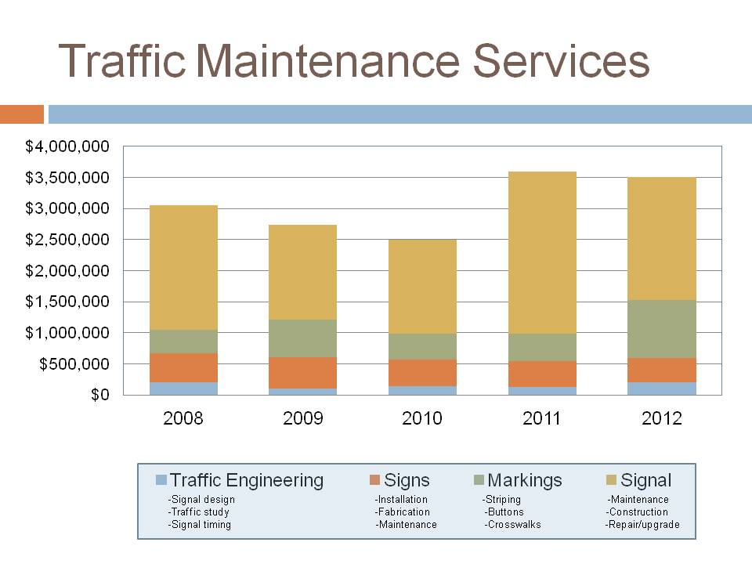

Fig. B-3
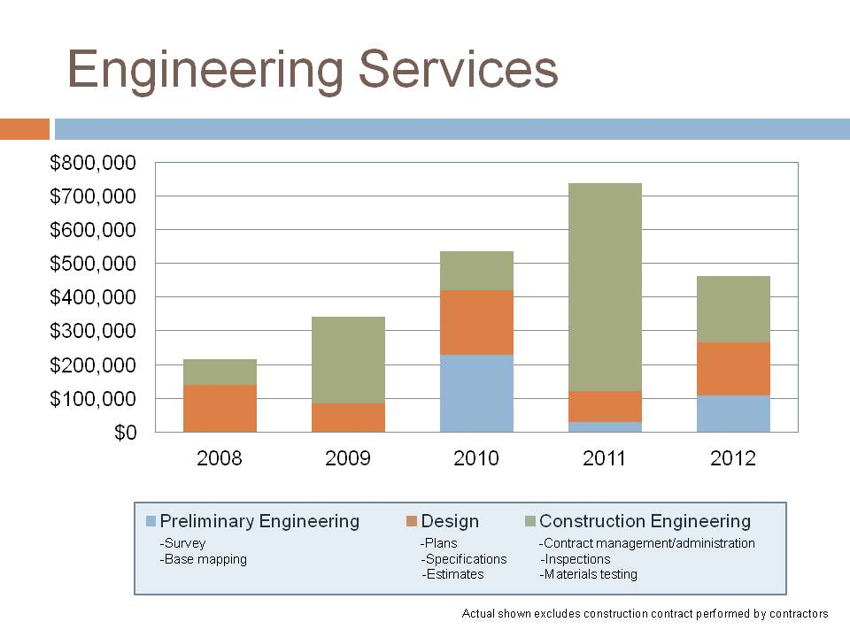

Regional Engagement Process
During September 2013, staff from Road Services and the Executive Office met with city contract customers to discuss and evaluate how the provision of services was going. Feedback consistently expressed by cities included the following:

- The traffic maintenance crews (striping, signals, sign shop etc.) are very responsive and the work product is well-received. The cities that purchase this service are pleased with it and have no intention of looking for alternative service providers at this time.
- The bridge inspection and materials lab services are also very good, and cities that purchase this service are pleased with it and have no intention of looking for alternative service providers at this time.
- In some instances, cities stated that road general maintenance crews could not reliably meet schedules or budgets, and as a result, several cities were now contracting out the work to other agencies or performing the work themselves. Of all the road maintenance work, stormwater pond maintenance and road sweeping were the most widely valued. General maintenance services is an area the division will evaluate as part of its 2015/2016 budget process.
- Cities expressed concerns that the County’s invoicing process is problematic. Vague and delayed invoices have resulted in less work being purchased by cities since remaining budget is uncertain.
Conclusions

- City contract work is most successful with specialty skilled work groups like traffic and bridge services that cities may not have the inventory that requires full time staff (if a city has four or five traffic signals it doesn’t make sense to have a full time signal technician for example). The city work helps the County by funding a more stable team of experts to serve both county roads and cities.

- Inconsistencies in budget to actuals over the last five years are due at least in part to the differing budget cycles between the County and the individual cities (annual versus biennial), and challenges small cities experience that require budget adjustments. During the recession, reductions from planned city budgets for general maintenance work were significant. Before the recession, there was enough demand that the County could find other work to address any cancelled city work. However, in recent years the shortfalls in planned city work and the general lack of demand has required some unanticipated layoffs of County staff.

Billing reports issued to cities require more detail regarding when and what types of work were performed by county forces. Providing this clarity will encourage prompt payments, and builds trust with city customers.
- The centralized nature of the traffic and engineering work groups, the relatively discreet nature of their work products, and the less seasonal nature of the work makes the planning and delivery of those services more consistent.

- At times, general maintenance work on county roads has been delayed or deferred in order to accommodate seasonal or peak demands of cities. As funding shortfalls lead to more significant road failures, it will be more difficult to respond to both emerging county road issues and scheduled city general maintenance work. This type of less specialized work can be undertaken by cities or more easily contracted and is work the County should have limited, if any engagement in.
Recommendations
Based on these discussions and subsequent evaluation, we recommend the following guidelines for development of the 2015-2016 budget:

- Consider how unanticipated failures will impact the availability of road maintenance crews.
In the foreseeable future, road maintenance crews are likely to be dedicating more time responding to unanticipated failures. As a result, less crew time will be available to perform scheduled contract work for cities and other agencies, as well as meet the basic maintenance needs of unincorporated county roads. The County should consider limiting commitments to cities to perform general maintenance work.

- Specialized services should continue to be provided regionally by the County, where feasible.
Focus efforts with cities on contracts for more technically complex work like bridge inspection, materials lab, traffic signals and controls, and pond management.

- Address any remaining billing system and estimating issues.
Address concerns about billing detail for city projects, and put in place agreed processes to address budget issues.

- Clarify service expectations with cities.
Set available timeframes for work and priorities for on-call work. State when county road work will take priority, and provide clear timing expectations for accomplishing planned city work programs.

These recommendations have also informed the preparation of this 2014 strategic plan update. A discussion of these efforts will be included in the 2015-2016 budget submittal.

Appendix C: Customer Outreach
The division involved its customers in the process of developing the 2010 strategic plan. It conducted a resident survey in December of 2008 for the Roads Operational Master Plan Phase I. An independent consultant surveyed 400 unincorporated-area residents to gauge public opinion about Road Services’ priorities and service levels. When asked about the condition of county roadways, two-thirds of survey respondents reported they were “generally satisfied.” Survey respondents also identified priorities for the county road system in the context of limited funds and the potential for decreasing services and service level outcomes.
Overall, respondents reported their asset priorities as:
- Paved roadway surfaces
- Storm-water drainage
- Bridge repair or replacement.
Service priorities included:
- Making road safety improvements to help reduce accidents
- Improving intersections and signals to speed traffic control and congestion
- Adding new lanes to existing roads.
The 2009 King County Community survey, conducted by ETC Institute, asked residents of unincorporated King County to rate the quality, satisfaction and importance of “construction and maintenance of roads / bridges.” Based on ETC Institute’s Importance Satisfaction Analysis, construction and maintenance of roads and bridges is the highest priority for improvement of local services to unincorporated area residents. Subsequent community surveys conducted by the County have continued to demonstrate that road-related services are a very high priority for the public.
The 2010 plan also included outreach to inform stakeholders of the process and to obtain feedback on the analysis and direction of the plan. Members of the stakeholders group represented a diversity of interests and the varied geographic areas of the county. Four broad themes emerged from the discussion with stakeholders: 1) Road Services must clearly identify who it sees as its customers; 2) Reduced service levels are not considered an acceptable option -- stakeholders want Road Services to make sure assets do not continue to deteriorate; 3) Before requesting any revenues increases, the County must identify efficiencies and develop trust; and 4) Equitability was felt to be important and stakeholders placed a strong emphasis on user fees and using money where it is raised.
The 2014 plan update also considered input received from customers since the 2010 plan was published. Following the approval of the 2010 plan, the Road Services Division embarked on extensive public outreach activities and communications to share information about priorities, goals, its funding situation, and service cuts. Over the period 2011-2013, substantial input was received from residents and other stakeholders though meetings and extensive correspondence.

Appendix D: Summary of Road Funding Options
The following funding ideas have been generated from a variety of sources, including the 2008 Roads Operational Master Plan Phase I and subsequent discussions. This list includes some potential mechanisms that are not currently authorized by state or local law. The ideas below are offered for further thought or research and do not constitute a recommendation.
Table 3

Taxes | User Fees | Transfers
Countywide sales tax on auto parts and service | Congestion fees (area tolls) | Portion of utility tax for electric vehicles or bio fuels
Increase in county sales taxes | Container fees at the Port of Seattle | Revenue distribution of state highway tolls to support roads network system
Increase in General Fund property tax levy | Local arterial tolling | Revenue distribution of truck licensing fee
Increase in Real Estate Excise Tax | New development mitigation fees
Local option motor fuel tax | Vehicle license and registration fees
Increase road levy component of property tax | Vehicle-miles-traveled fee
Tax on commercial parking operations | Surcharge on land used for non-residential parking
State gas tax increase | Auto insurance surcharge
Motor vehicle excise tax | Street utility fee
Excess levy for road capital projects | Road Improvement Districts (RID) or Local Improvement Districts (LID)
Employee tax | Taxi cab fee

Appendix E: Change Drivers Identified in the ROMP Phase I (Details)
Phase I of the Roads Operational Master Plan (ROMP) identified five key challenges, or change drivers, which are reviewed below.

Incorporations and annexations
King County’s goal is that by 2015 cities will annex all land within the Urban Growth Area as mandated by the state Growth Management Act. The County can encourage annexations and incorporations, but they are largely beyond its direct control. The timing of these events is uncertain and dependent on the desires of the cities and residents involved. For Road Services, annexation will result in a decreased road inventory with the following characteristics and effects:
- The bulk of the unincorporated service area will shift progressively to the eastern, rural part of the county, while rural Vashon-Maury Island will remain as unincorporated territory in the western portion of the county.
- Road Services will also retain long-term responsibility for two large urban planned communities (Trilogy and Redmond Ridge) east of the City of Redmond in northeast King County. These urban “islands,” which currently have about 8,000 residents, are situated in the midst of the county’s rural area yet have an expectation of urban levels of road service that are more costly to provide.
- During the transition to a fully annexed/incorporated urban area, Road Services will continue to be responsible for numerous small unincorporated “in-holdings” that are widely dispersed throughout the county. These remnant urban territories were skipped over by past annexations and incorporations and are inefficient to serve since they are surrounded by city territory.
- Two rural Green River Agricultural Production Districts, completely surrounded by the cities of Kent and Auburn, will remain unincorporated and are inefficient to serve.
- The rural area includes numerous stream crossings, requires more environmental considerations, and also encompasses terrain that is more prone to flooding and snow and ice emergencies than urban and suburban areas of the county.
- Although there are will be fewer road miles overall, due to the age of the rural system as well as the topography and flood zone locations Road Services, the volume of work that will remain does not decrease proportionally.
- Road Services will be responsible for an older, deteriorating roadway system. When that system needs improvements, it will take more work to bring it up to current engineering and environmental standards.
- There will be a smaller road network over which to apply the fixed costs of owning and operating a road system, resulting in the loss of some economies of scale. For example, specialized equipment may not be as fully utilized. Higher fixed costs might be mitigated if the division is able to increase the volume of contracted services it provides to other jurisdictions and share the cost of specialized resources among more users.

Development and population growth
Development and its associated growth in population, vehicle miles traveled, and new road miles will increase Road Services’ workload in unincorporated King County in the future, despite reductions in total road miles in the county’s road system due to annexation. Travel demand is directly linked to growth in population, the economy, and employment. After all urban areas have been annexed or incorporated into cities, the population of King County’s unincorporated areas is projected to grow at a rate of 1,000 to 2,000 people per year. Vehicle miles traveled in King County as a whole are projected to increase by 1.3-1.4 percent per year. The effects of this increased travel demand will include:
- Increased traffic on roads and degradation of operational performance, resulting in increased congestion.
- Increased use of county roads for commuting from eastern unincorporated King County, cities, and adjacent counties to population and employment centers in King County.
- An increased need for safety and traffic operational improvements, congestion relief, and road reconstruction, as well as increased road maintenance needs due to more wear and tear on the infrastructure.
Rural roads built as farm-to-market routes in the 19th century are increasingly being expected to perform as highways for residents of unincorporated areas and rural cities as they travel to employment centers during the week, and as recreational routes for cyclists, equestrians, and hikers on weekends. User expectations for convenience and service on rural roadways are ever increasing. Technology enhancements such as e-mail and the Internet have increased expectations that service requests will be attended to immediately. Changing demographics in the rural area have also led to expectations on the part of some rural residents for more urban or suburban levels of service, including amenities like sidewalks, street lighting, or enclosed drainage systems, some of which are inconsistent with King County Comprehensive Plan policies for rural areas.

Aging infrastructure and underinvestment
Road Services has a large, unfunded backlog of high-priority safety, maintenance, and preservation needs. Over time, underinvestment in the preservation and maintenance of roads increases the cost of ownership. Continued underinvestment can lead county road infrastructure to be at risk of failure. The following are some of the consequences of these deteriorating conditions:
- The failure of at-risk assets, resulting in road closures, expensive rehabilitation, and eventually a need for reconstruction or replacement.
- A significant escalation in maintenance costs for at-risk assets if action is not taken to remedy deficiencies and optimize asset lifecycles.
- The risk of more costly emergency repairs, wholesale loss of the road and related closures and detours, and increased probability of damage to persons and property due to flooding and other failures.
- A rapidly escalating backlog of failing and at-risk assets.

Complexity of projects and regulatory requirements
Recent years have seen a large increase in the cost of transportation projects and maintenance and preservation activities due to variable commodity costs and new regulatory requirements. For example, statutory greenhouse gas reduction goals and water quality compliance requirements are changing how roads are designed, built, maintained, and used by adding more mitigation and maintenance responsibility. New projects and activities will have to meet new evolving standards, and this will increase the cost of owning and operating the county’s roads.
- A constrained ability to meet needs, combined with fluctuating commodity costs, creates a backlog of capital, preservation, and maintenance work that is increasingly expensive to complete.
- New environmental and safety regulations, coupled with changing pavement, bridge, signal, and sign standards, increase costs and backlogs and require increased investment to meet mandates.
- If investment in the road system is not increased, service levels will decrease.

Climate change
Climate change could affect Road Services in two areas: the requirements of County, state and national climate change policies, and the impacts of a changing climate. The effects are likely to include:
- An increase in the number and severity of winter storms, resulting in an increased need for storm- and weather-related emergency response, maintenance, and repair work.
- An increase in roadway lifecycle management costs (due to increased weather related impacts on infrastructure).
- Wide-ranging effects on the division’s management of travel demand, service delivery, and business costs resulting from policy and regulatory responses to climate change.
- The need to change roadway design, maintenance, and construction practice to adapt to climate change.

Appendix F: Map of Arterials and Lifeline Routes

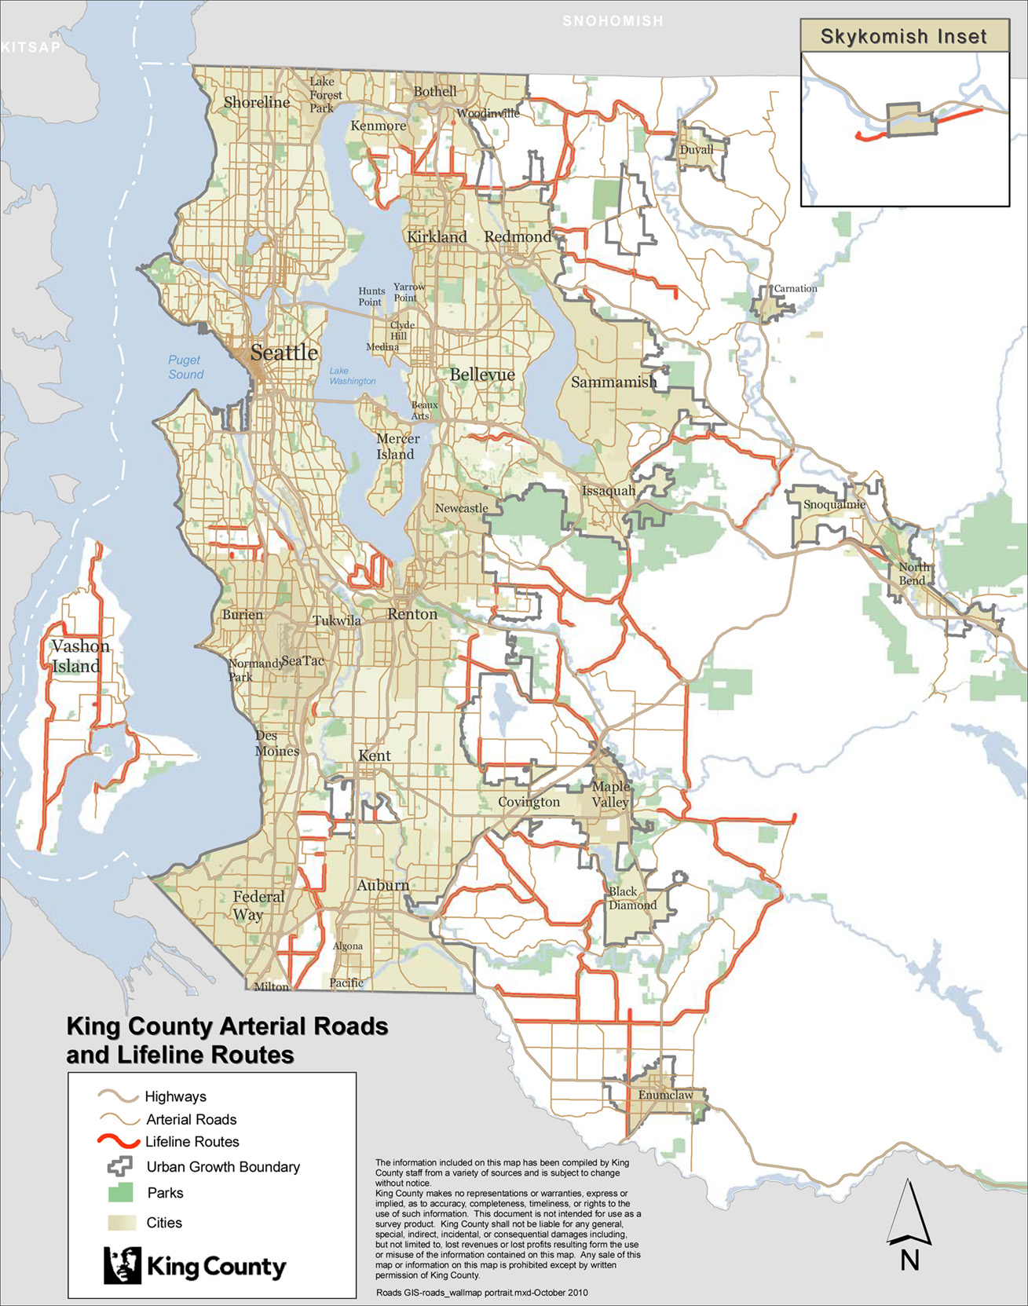

Appendix G: Facilities Master Plan Attachments (New appendix)

This appendix includes the following:
G-1: Property/Site Inventory and Map
G-2: Condition Assessment Summary
- High Priority Maintenance Repair
- 30-Year Estimated End of Useful Life Costs
G-3: Functional Criteria
G-4: Location Criteria
G-5: Location and Functional Needs Evaluation Summary of Existing Facilities
G-6: Regional Maintenance Shops Key Issues and Deficiencies

Appendix G-1: Property/Site Inventory
 |  | Current Use
 | Property/Site | Regional Maintenance Shops | Materials Storage | Snow & Ice | Emergency | Size (Acres) | In Urban Growth Area | Jurisdiction/General Location
1. | Cadman | X | X | X | X | 23.68 | Yes | Redmond (just inside the SE city limits)
2. | Diamond | X | X | X | X | 39.71 | No | KC (west of Black Diamond)
3. | Fall City | X | X | X | X | 1.72 | No | KC (NW of Snoqualmie, adjacent to Raging R.)
4. | Issaquah | X | X | X | X | 18.19 | Yes | KC (unincorporated island, eastern part of Issaquah)
5. | Renton Headquarters | X | X | X | X | 101.05 | Yes | Renton
6. | Skykomish | X | X | X | X | 3.07 | No | KC (just east of the city of Skykomish)
7. | Star Lake | X | X | X | X | 10.72 | Yes | Kent (west part of the city)
8. | Summit | X | X | X | X | 156.48* | Yes | Maple Valley
9. | Vashon | X | X | X | X | 2.00 | No | KC (Vashon Island)
10. | Cedarhurst |  | X |  |  | 5.00 | No | KC (north part of Vashon Island)
11. | Hoover |  | X |  |  | 40.00 | No | KC (west of Fall City, south of SE Issaquah-Fall City Rd.)
12. | Krain |  | X | X |  | 29.39 | No | KC (south of Black Diamond)
13. | Lake Youngs |  |  | X |  | 5.55 | Yes | KC (Fairwood area adjacent to Petrovitsky Rd.)
14. | Mileta |  | X | X |  | 39.35 | No | KC (Maury Island)
15. | North Bend |  | X | X |  | 12.63 | No | KC (just outside the SE city limits of North Bend)
16. | North Bend Shed |  |  |  | X | 0.23 | Yes | North Bend
17. | Pohl |  | X |  |  | 7.69 | No | KC (south part of Vashon Island)
18. | Stillwater |  | X | X |  | 6.80 | No | KC (north of Carnation, Snoqualmie valley)
19. | Tjomsland |  | X |  |  | 4.81 | No | KC (north-central part of Vashon Island)
20. | Woodinville |  | X | X |  | 10.05 | No | KC (south of city on Hollywood Hills)

 | Inactive Operating Properties
21. | Cumberland | Inactive | 53.33 | No | KC (east of Black Diamond)
22. | Wynaco Annex | Inactive | 27.93 | No | KC (east of Auburn)
23. | Kummer | Inactive | 22.00 | No | KC (south of Black Diamond)

- *Includes 35 acres sold to Tahoma School District
- For current use, some facilities have multiple uses. For example regional maintenance shops generally include materials storage, snow & ice and emergency functions.
- Description of use
- Regional Maintenance Shop
- Serves as the base for dispatching crews; and storing roadway vehicles, equipment, supplies, and materials.
- Provides the following functions: CROW (Consolidated Recycling of Waste) pad; covered and heated vehicle storage; hazardous waste storage building; uncovered raw materials storage; vehicle wash; decant; supply storage; traffic material storage; truck scales; covered sand storage; liquid anti-ice storage tank; small tools storage; sign storage; fill capacity; covered erosion and sediment control materials storage space; emergency power system; and office space. With all these functions, regional maintenance shop fulfills the functions of materials storage, snow and ice, and emergency facilities as well.
- Provides the primary functions of materials storage location as they provide the most efficient use of the stored materials due to equipment storage and crew muster areas are also located here. For this reason regional maintenance shops have the largest quantities of materials stored including those materials that are small and attractive requiring better security to prevent against loss due to theft.
- Provides the primary storage for snow sand, salt, and de-icing materials needed for the snow and ice program.

- Materials Storage
- Provides the following functions: CROW pad; uncovered vehicle storage; covered bulk salt storage; covered sand storage; bathroom or port-a-potty; lights for night operations; and fill capacity.
- Although regional maintenance shop serves as the main materials storage site, a network of materials storage sites should be located throughout the service areas to improve operation efficiency by reducing travel times between the work site and the storage site.
- Provides for temporary storage of waste materials. Operation efficiency is increased by having the ability to temporarily store waste materials at these strategically located materials storage sites throughout the service area without having to travel all the way back to the regional maintenance shop.
- Since limited space is available in the roadway area for staging of materials and equipment, materials storage site can also serve as staging area for larger repair or preservation projects.

- Snow and Ice
- Provides the following functions: CROW pad; uncovered vehicle storage; covered bulk salt storage; covered sand storage; bathroom or port-a-potty; and lights for night operations. Covered salt storage protects the salt from rain to prevent groundwater contamination and premature loss of salt. Covered sand storage protects the sand from moisture to minimize freezing in cold weather since frozen sand is unusable during sanding operations.
- Snow and ice sites located strategically throughout the service area help reduce travel time and increase work efficiency and response time by having the ability to access sand and salt materials without having to travel all the way back to the regional maintenance shop.
- Since materials storage facility shares all the site criteria and the functions required for a snow and ice facility, all materials storage facilities can also serve as snow and ice facilities on as needed basis.
- These snow and ice sites will be used mainly during major snow events when staffs are working 24 hours per day plowing and sanding the county roads. During these events crews may start and end there day at these remote locations to improve operation efficiency and reduce downtime.

- Emergency
- An emergency site has the function to house staff on a temporary basis that can accommodate a small crew and some equipment and materials such as barricades, cones, chain saws and fuel. This provides the necessary resources for the crew while assigned to outlying areas to respond more efficiently and timely to emergency conditions when it becomes difficult or impossible to access equipment and materials from the regional maintenance shop.
- A remote service area that may become isolated and difficult to serve under emergency conditions is an operation concern. The Duvall area east of the Snoqualmie River is an example of a remote service area that occasionally becomes isolated due to road closures during flood conditions. An emergency facility located in this area would allow the crew to respond timely to conditions when accessibility to the area is limited or eliminated by a flooding event.

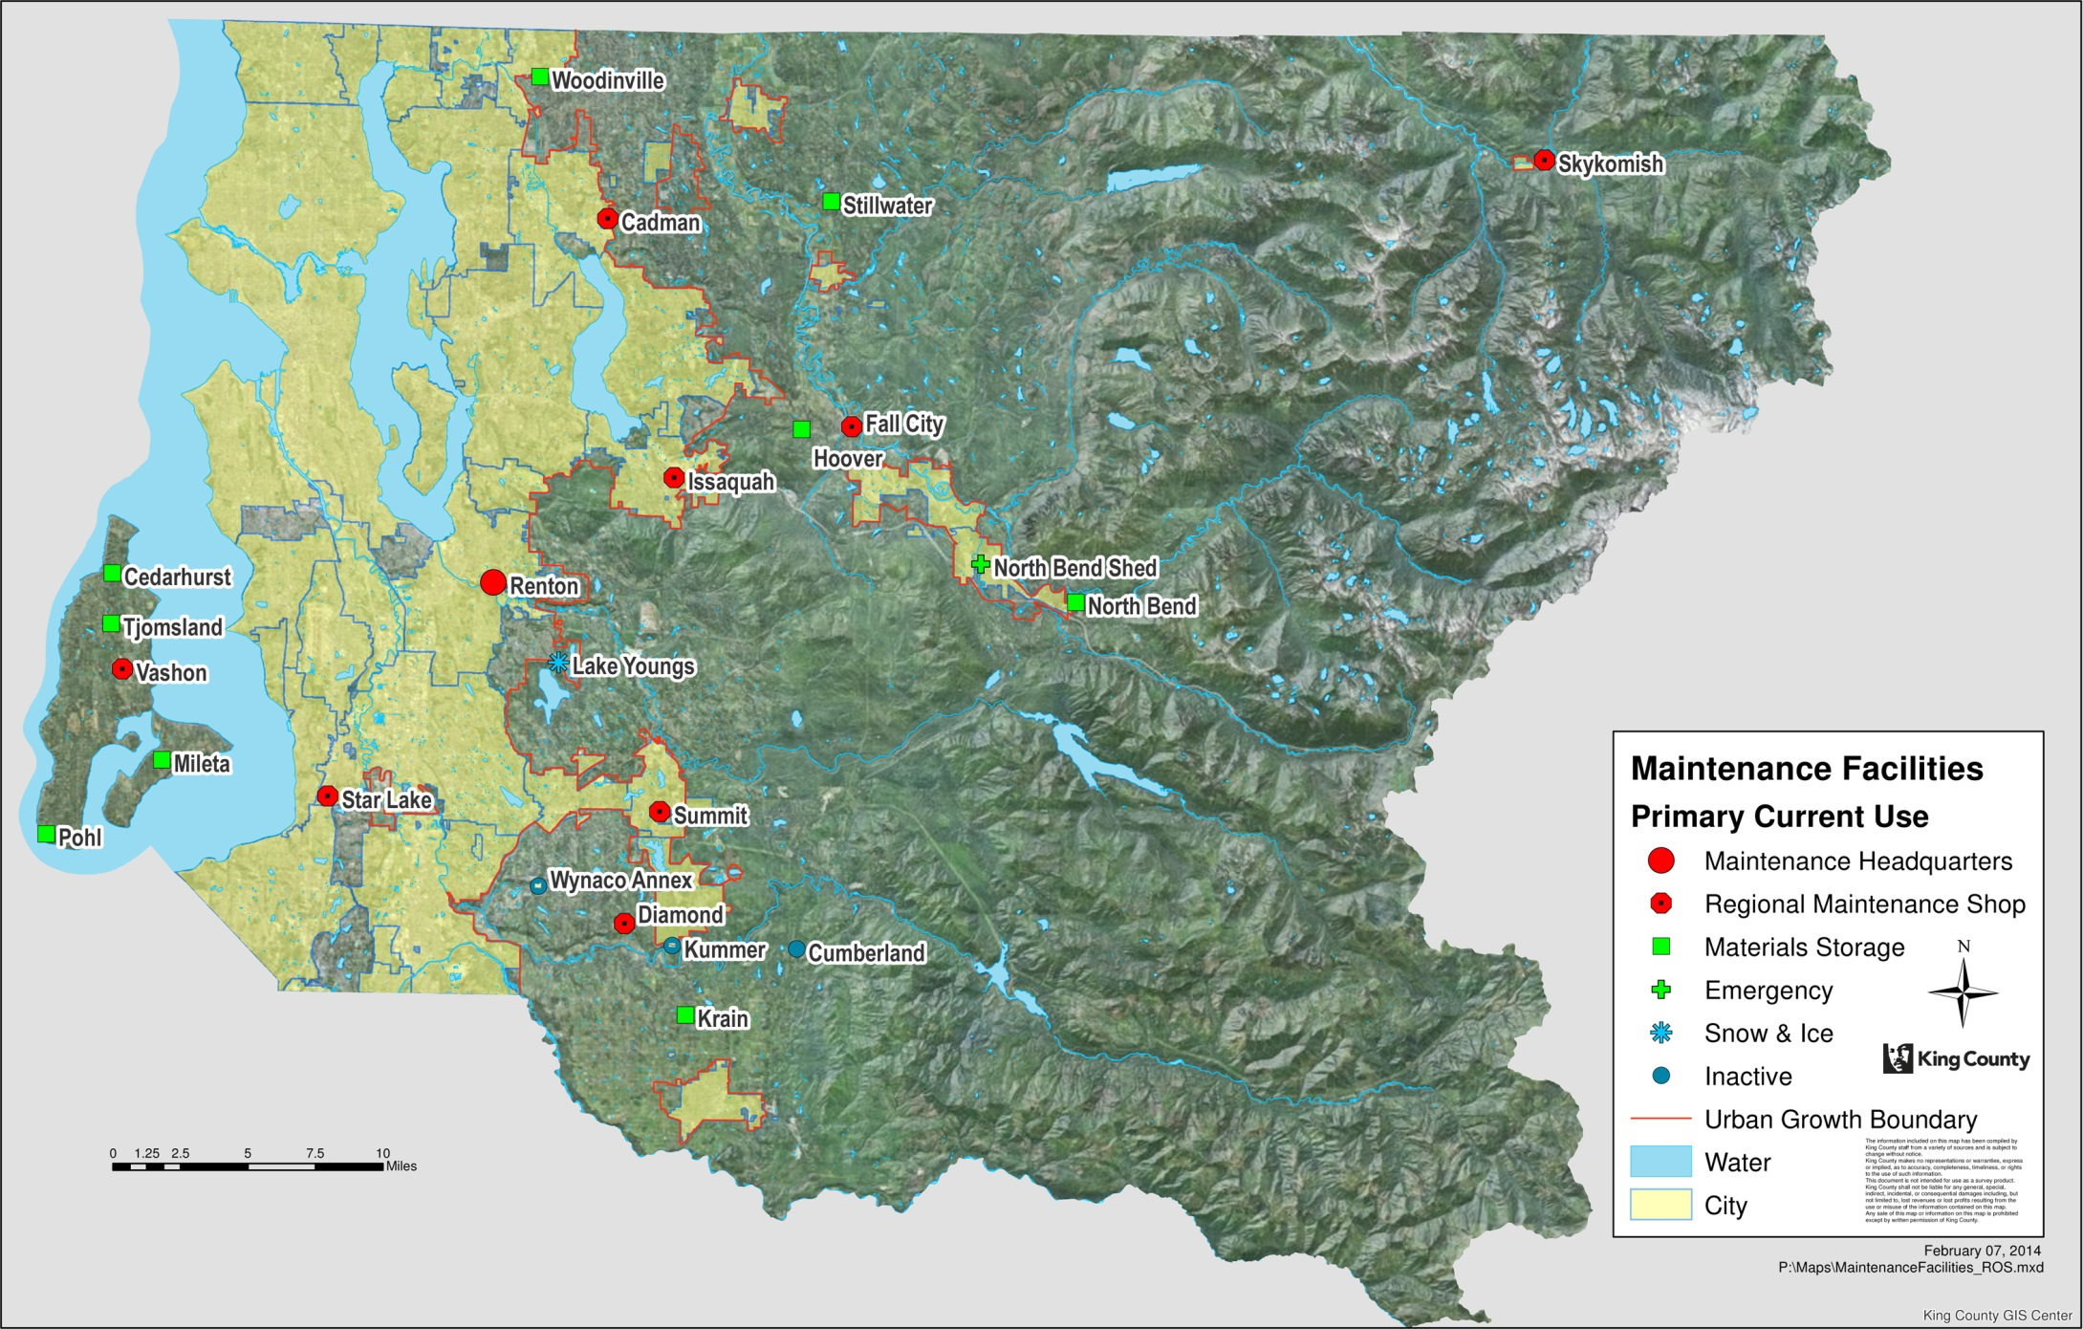
Appendix G-2: Condition Assessment Summary
High Priority Maintenance Repairs
 | Project Categories | Description | Construction Cost Estimate | With 40% Soft Cost (design/eng.)
Building Conditions,  Health & Safety | Roofs | Roof repair work have been identified at North Bend, Renton, Skykomish, Summit, Vashon, and Cadman | $1 million | $1.4 million
Building Conditions,  Health & Safety | HVAC Systems | HVAC systems replacement or repairs have been identified at several Renton facilities | $680,000 | $952,000
Building Conditions,  Health & Safety | Septic System | Septic systems replacement and repair work have been identified at Renton and Summit. | $130,000 | $182,000
Building Conditions,  Health & Safety | Others: walls, lighting, plumbing, painting, floors, ceiling, and large specialized equipment | One or a combination of these repair work have been identified at several of the facilities. | $1.4 million | $1,960,000
Structure & Grounds | Asphalt | Paving work has been identified at Star Lake, Diamond, Fall City, Issaquah, Renton Headquarters, Summit and Vashon. | $75,000 | $105,000
Security | Doors and windows | All existing regional maintenance shops require doors and windows repair and replacement work. | $120,000 | $168,000
Security | Fencing | Fencing replacement and repair have been identified at Renton and Fall City | $50,000 | $70,000
Grand Total |  |  | $3,455,000 | $4,837,000

Summary of high priority maintenance repairs derived from DLR Group King County MDS KC Roads FAME Study, November 20, 2013 – Deferred Maintenance Report, also known as the Immediate Needs Report. The Immediate Needs Report provides detailed information regarding immediate replacement or capital maintenance repairs that are immediately evident during the assessment. Examples of these immediate replacement or repairs include non-functional roof drainage system; rusted corrugated walls; rusted shower room metal walls; HVAC system; and leaky roofs. The Immediate Needs Report is available for review.
Assessed sites: Cadman, Diamond, Fall City, Issaquah, North Bend Pit, North Bend Shed, Renton Headquarters, Skykomish, Star Lake, Summit and Vashon
30-Year Estimated End of Useful Life Costs Summary
Predictive Maintenance Needs | Grand Totals  (Incl. hard costs and soft costs (40%) and COLA (6%))
Near Term Predictive Maintenance Needs (2015-2018) - a two year look-ahead of systems that are at or near the end of their expected useful life and should be considered for replacement to prevent any associated damage or higher replacement costs if they are deferred further or are run to failure. | $11,284,553
Long Term Predictive Maintenance Needs (2019-2024) – projects the replacement costs of the systems that are aging and are likely to need replacement between years four and ten. | $44,182,922
2025-2044 Maintenance Needs | $191,572,018
TOTALS | $247,039,493

The End of Useful Life (EUL) Report, also called the 30-Year Report, lists observable systems and their repair/replacement costs broken down over a thirty-year period. EUL is a combination of an expected ‘standard life’ and an engineering formula. This allows for a reasonable measuring beyond the original expected ‘standard life’ for systems that are in better shape.
The EUL Report is available for review.

Assessed sites: Cadman, Diamond, Fall City, Issaquah, North Bend, North Bend Shed, Renton Headquarters, Skykomish, Star Lake, Summit and Vashon

Appendix G-3: Functional Criteria
- Administrative and crew facilities  - Administrative offices and meeting rooms  - Crew room, restrooms, showers/locker room, and drying/mud room  - Kitchen facilities  - Vehicle service and storage  - Covered/uncovered and heated/non-heated storage per vehicle type requirements  - Vehicle wash  - Materials storage & handling  - Covered/uncovered raw materials storage per material type requirements (gravel, rock, soil, pipe, etc.)  - Covered erosion and sediment control material storage space  - Traffic materials/sign/paint storage  - Supply storage  - Small equipment/tools storage building | - Hazardous waste handling/ storage building  - Snow/ice operations area  - Covered sand & bulk salt storage  - Liquid anti-ice storage tank  - Coordinated reduction of waste materials area  - Fill materials area  - Emergency power system  - Access to fuel  - System-wide needs  - Truck Scales  - SWAP (Street Waste Alternative Program) materials area  - Vactor/decant facility

Criteria | Why this is critical/important?
CROW pad | CROW (Consolidated Reduction of Waste) is the Road Services Division’s (RSD) program for recycling and reusing of waste materials generated from road maintenance activities. Maintenance wastes temporarily stored on the CROW pad include: clean soil, asphalt, concrete, brush, chips, stumps, litter (e.g., couches, appliances, tires, electronics, paper, waste oil, drug lab wastes, construction debris, and other illegally dumped waste materials), scrap metal, and soil mixed with vegetation. The CROW pad serves an important function as it allows the maintenance staff to consolidate these materials into whole loads reducing the number of trips to vendors or fill sites where they can be recycled or properly disposed. Having these CROW facilities located close to where maintenance work is performed reduces the travel time from the project site to the dump site, allowing staff to maximize productivity and accomplishment levels. The CROW pad itself includes facilities to control runoff and run on of storm water to minimize the potential of surface and ground water contamination.
Vehicle covered and heated storage as required by the vehicles assigned to the site | RSD uses many different types of heavy equipment and vehicles to perform its road maintenance activities. Providing heated storage for this equipment keeps equipment that uses water (such as street sweepers, vacuum flush trucks and compactors) from freezing, eliminating the chance of ruptured water lines and the need for expensive repairs and subsequent downtime. Storage under cover and out of the weather also increases the useful life of the equipment which reduces the hourly cost of operation, and keeps the equipment available for all types of emergencies. In addition, a locked garage for trucks holding small tools overnight could result in efficiency and have a significant impact on annual work accomplishment. If the vehicle is stored outside, these tools must be loaded and unloaded daily which results in lost efficiency of up to 30 minutes a day.
Hazardous waste storage building | A properly designed hazardous waste storage building is required to protect the environment and staff from unanticipated releases of hazardous materials. Some of the wastes generated by maintenance activities require special handling following their use as defined by state law. In addition the County finds illegally dumped waste in the roadway that must be stored and handled as required by this law. The building needs to be designed so that barrels can be added and removed easily and must also include secondary containment in case of spills or leaks.
Uncovered raw material storage, pipe, gravel, rock, frames and grates, etc. | To effectively operate during non-business hours, each Regional Maintenance Shop must maintain stockpiles of the materials it needs to respond to all types of road and weather emergencies. In addition, maintaining stockpiles of materials increases efficiency by allowing crews to transport a first load of raw materials to a job site at the time of dispatch. This eliminates the possibility that the crew would be left waiting at the job site for materials before work can begin because a truck had to go to a vendor to pick up materials first.
Vehicle wash | A vehicle and equipment wash is necessary to keep equipment clean for transport; to prevent contamination of materials by unwanted debris; and to prevent debris falling off of equipment during transport or operation that can cause a traffic accident. Other advantages of regular vehicle washes include extending the useful life of equipment and identifying problems quickly as observed by mechanics.
Vactor/Decant | Vacuum flush truck decant facilities are required by state law and County code for handling water and solids resulting from the cleaning of storm drainage systems. This liquid is considered an industrial waste and can contain oil and other contaminants which cannot be discharged to ground or to a surface water system. RSD developed these decant facilities following the first NPDES (National Pollutant Discharge Elimination System) permit to provide appropriate and legal locations for the County’s use to reduce the potential of environmental damage resulting from inappropriate disposal of the waste. Private vendors also use these decant stations that are open to the public which are ones where sanitary sewer connections are authorized. Where decant stations are located with no sanitary sewer connections such as at certain regional maintenance shops, the liquid is stored temporarily and hauled back to a public decant station using a large tanker truck. Having a facility to temporarily store the liquid improves efficiency by allowing the equipment to return to the work area quickly increasing accomplishment while utilizing less costly equipment to transport the liquid to a final disposal site. A vacuum flush truck can only carry about 1,000 gallons of water while a tanker truck can carry six times that amount. With only a few decant stations connected to sewer, this can save several hours of travel time per day.
Supply storage | This is storage for commonly used and replaced small tools, protective equipment, and materials. It is efficient and cost effective to keep these materials on hand. Commonly stored materials include shovels, rakes, gloves, rain gear, hammers, nails, ice scrapers, and other fasteners.
Traffic material storage | This is storage for commonly used traffic materials such as paint, glass spheres for reflectivity, buttons, concrete curbing, and sign installation materials. During the peak re-striping season, significant cost savings and efficiencies can be realized by storing paint and glass spheres at outlying regional maintenance shops to allow the striper truck to refill without having to return to the Renton Headquarters. During peak season the striper truck needs to refill 2-3 times per day and having these satellite storage sites can reduce travel costs by 2-3 hours per day per striper truck. For proper storage, paint must be covered and in a facility with secondary containment and glass beads must be kept in a dry space and be protected from the weather.
Truck scales | For all filling activities, RSD is required to keep track of where the fill material came from and how much material was filled annually to show compliance with required permits. Truck scales provide a simple way to get this information into a tracking system. Truck scale is also used when the County is performing work for a contract city or another County agency. The scale provides a way to directly input the amount of material and associated disposal charges into a bill for the service. State law requires an accurate way of billing for this activity and ensuring RSD recovers its costs. It is desirable to have scales at all fill sites and storage sites to ensure the material disposal information are tracked accurately.
Covered sand storage | Covered sand storage is needed because sand left out in the elements holds moisture which then freezes during cold weather with portions of it unusable when it is needed the most. Efficiency is also lost as crews try to remove the frozen sand from the pile before loading the sanders. Other problems occur when wet sand is loaded into a sander and it freezes resulting in a plugged sander that crews must break up by hand and remove. Additionally not having frozen sand can reduce liability for damage to private vehicles due to clods of sand being discharged from the sander on the snow plow during sanding operations.
Liquid anti-ice storage tank | This is typically a 6,000-10,000 gallon plastic tank containing a brine solution used for preventing the formation of ice on the roadway. Having the anti-ice solution readily available allows immediate access when needed so that it can be applied prior to freezing temperature conditions. Timely application of the anti-ice solution prevents the formation of ice and improves snow removal during plowing by creating a thin layer of water between the snow and the pavement. Once snow has been removed, the roadways dry up quickly reducing the need to return and plow them again. The tank requires a secondary liner to catch any spills during transfer to the application truck or to the tank from the delivery truck. A small gasoline powered pump is used to transfer the material. During the summer months this material is used for dust control on gravel roads and at fill sites.
Small tools storage building | Small tools are kept at all regional maintenance shops for use in accomplishing routine maintenance activities. Tools kept onsite include hand compacters, pumps, chainsaws, weed whackers, shovels, rakes, digging bars, machetes, and other items. As this type of equipment is attractive for thieves, it must be kept in secure rooms to ensure it is available when needed.
Sign storage | All road maintenance work requires some form of notification to the traveling public when crews are performing road maintenance activities in the public road way. The most common method is to post warning signs indicating construction work ahead. Other signs required include road closure signs with barricades and “water over the road” signs that are used extensively during major storm events. Signs are required to have certain reflectivity and be in a good state of repair so they are readable and recognizable to the public. Keeping the signs out of the weather prior to use helps ensure that they maintain their reflectivity and are in usable conditions. A covered storage area is necessary to achieve longevity of the signs and ensure adequate numbers are readily available when needed. Adequate storage at locations where crews are dispatched is critical to operation efficiency.
Capacity to permanently place up to 4,000,000 cubic yards of clean fill material | Road maintenance operations generate a significant amount of clean soil that must be disposed of outside of the road right of way. RSD has been tracking the amount of soil since 1990 at an average rate of 100,000 to 160,000 cubic yards per year. The 2013 cost of disposal at County-owned and permitted fill sites is $7.10 per cubic yard and the cost for disposal at a vendor averages around $20.00 per cubic yard. Vendors are often used when the haul distance to a County-owned facility is substantially longer than to the vendor and the time savings offsets the disposal cost difference. Fill sites are most efficient when distributed across the maintenance service areas, but cost of maintaining them in accordance with permit requirements goes up with more sites so reaching the least cost option often results in one primary fill site with several stockpile sites. The cost of fill disposal including haul to the primary fill site from a stockpile site for the County averages $17.60 per cubic yard.
Covered erosion and sediment control material storage space | The County uses many different types of erosion and sediment control materials for its routine road maintenance activities. Much of this material is designed to biodegrade with time when exposed to sunlight and weather. These materials are routinely purchased in bulk rolls or quantities to reduce the per-unit cost. In order to preserve their useful life, these materials must be stored out of the sun and the weather.
Emergency power system | Road maintenance operations facilities must be able to function during adverse weather events and natural disasters. To be fully operational and to be able to function at an optimal level during these adverse times, an emergency power system is necessary at all regional maintenance shops and when available at snow and ice sites.
Fuel Station | Having easy access to fuel station is more cost effective, efficient, and reduces travel time. If a fuel station is on site, vehicles can fuel up and crews can quickly load tools and equipment for the day’s tasks without losing time from having to travel to a fuel station outside the site. This time savings apply at the end of the day as well; if staff has to get fuel on the way in from the field they will have to leave early to get done on time.  During a power outage or other emergency event when fuel is limited, County vehicles may have to wait in long lines and compete for fuel needs with the public. Private fuel stations that are open may run out of fuel quickly which would be disastrous during response and recovery operations. This is when roads are being repaired in order to get transportation operations back to normal following an event. Since regional maintenance shops have emergency power, a fuel station on site will more likely remain operable during an event. Other agencies such as police and fire often use existing fueling stations at regional maintenance shops during these events, as wait times are significantly less when they are not competing with the public for fuel.
Office Requirements: Crew room, men and women restrooms, locker room, drying/mud room, office space for supervisor and crew chiefs, kitchen facilities, KC I-Net (Institutional Network) access, sewer service if available, fire protection, computer terminals for crews. | Regional maintenance shops require office and crew space for staff. Safety meetings and other routine training are also held at these locations. Road maintenance work is often done in all weather conditions, good or poor. Locker rooms for crews are necessary so that the crews have a place to change in and out of their work clothes; dry their wet clothes and boots; and shower if needed. Private office space is necessary for disciplinary discussions, personnel investigations, and daily work planning. I-Net service will provide a high-speed communication network for transmission of voice and data that will be vital in sending citizen action requests to the maintenance staff for resolution and allow interactive updates to work orders and the GIS tracking systems associated with the asset management system. Computer docking stations are needed for crew chiefs and supervisors and desktop computers for the crew to use for e-mail, time input, and other needs. Since a regional maintenance shop is considered a commercial facility, the building code will require fire protection. If sewer service is available, efficiency can be improved for the industrial operations that occur at a regional maintenance shop like equipment washing and vactor/decant stations by eliminating the need to store this industrial waste water for treatment on site or for hauling to a sanitary sewer discharge site. Industrial waste water cannot be discharged to an onsite septic system without costly pre-treatment.

Appendix G-4: Location Criteria
- Area  - Size  - Transportation  - Adjacent to arterial  - Drive time  - Meets goal of 45 minutes drive time  - Floodplain  - <=10% of lot area  - Drainage basin clearing restrictions  - Topography  - Relatively flat (up to 15% maximum grade)  - Utilities  - BPA easement location and <= 10% of lot area  - Sensitive areas  - Wetland <=10% of lot area or  - Stream buffers <=10% of lot area | - Aquifer recharge area and type  - Distance from major intersections  - Location within public water district boundaries  - Location within public sewer district boundaries  - Location of larger utility distribution lines on site  - Existing easements on properties  - Land-use stability includes considerations for the following:  1) Known community opposition;  2) Permitting challenges;  3) Land use issues;  4) Nearby neighbor concerns; and  5) Whether the site is inside city limits and thus subject to regulation by another jurisdiction

Criteria | Why this is critical/important?
Acreage (minimum regional maintenance shop site size of 35 acres and 10 acres for materials storage, snow & ice, and emergency sites) | Acreage requirements are needed to meet zoning code requirements for buffers to minimize impacts on adjacent land uses. In addition, some facilities need space to permanently place clean soils removed from roadway areas during routine maintenance operations. For regional maintenance shop sites, it is desirable to have a main fill area at the site since all the equipment is stored here and maintenance of a fill site can be efficiently performed at the end or start of a work day without need to transport equipment back and forth to the fill area. Fill requirements vary but can reach as high as 40,000 cubic yards per year in a major storm year (8,000 truck trips). For a 40 year design life, this would result in 1,600,000 cubic yards. This requires 40 acres filled to a depth of 25 feet. Actual space needed for this activity is based on contours and site characteristics such as sensitive areas, adjacent land uses, and view impacts. In addition to the fill space, areas must also be provided for access roads, buildings, stockpiles, and storm water facilities. Since materials storage sites could meet part of this fill capacity function, regional maintenance shop can be sited on a property with a minimum size of 35 acres (although 160 acres reduces neighborhood impacts and provides better buffers).
Transportation: adjacent to arterial | Zoning code requirement due to truck traffic and impacts to residential areas during emergency operations.
Drainage basin clearing restriction | Zoning code requirement- currently, clearing restrictions are set for the Bear Creek and Issaquah Creek basins.
Drive Time: 90% w/in 20 min = 3; 90% w/in 30 min =1; 90% w/in 40 = -1; and 90% w/in 45 min = -3 | Drive time goal attempts to address efficiencies related to travel time spent to and from the work site. It is desirable to have the lowest travel time by locating the regional maintenance shop at the centroid of the road maintenance service area. The further the regional maintenance shop is from the centroid of the service area, efficiencies associated with travel time are reduced. A travel time of 45 minutes one-way or 1.5 hours round trip represents approximately 19% of the workday associated to travel and not actual work.  Similar criteria are used for analyzing the efficiency impact of travel to disposal sites and material storage sites as crews are often waiting for trucks to dump their load and return to the job site before they can go back to work. Since there may be about 10-20 trips per day from these sites, any reduction in travel time increases efficiency and ultimately cost savings.
Topography: Relatively flat (up to 15% maximum grade) | Flat topography provides the most space for facilities while a slight grade can reduce space needed for filling activities. Flat topography also reduces facility construction cost by reducing site grading.
Utilities: BPA easement location and <= 10% of lot area | Easements for utility lines can severely limit activities allowed on a property. Additionally, some utility lines like large gas transmission mains can be very devastating if they fail. Only overhead power lines (not buildings) can be built within the easement.
Sensitive Areas: Wetland <=10% of Lot Area or Stream Buffers <=10% of Lot Area | Sensitive areas limit site use resulting in costly mitigation or requirement for larger lot size to accomplish facility construction. Often, additional best management practices are required to minimize impacts during the life of the facility.
Aquifer Recharge Area and Type | Aquifer recharge areas can cause difficulties as they are relatively new addition to the Critical Areas Ordinance and impacts to road maintenance operations are not yet fully understood. These areas typically infiltrate runoff very quickly resulting in poor treatment of storm water that may have come in contact with pollutants typically found at road maintenance facilities such as salt, petroleum products, solid waste, and waste materials to be recycled.
Distance from Major Intersections | Locating facilities near major intersections is important because it makes moving around the service area quicker and easier. If a facility is close to a major intersection, travel time to work areas improve. Additionally it provides detour route options if a roadway is blocked by an accident, construction work or closed by some other type of emergency.
Location within Public Water District Boundaries | This may impact facility location either positively or negatively. A positive impact would be that public water is available to support the many functions that utilize water in their operations and costly private onsite water systems are not required. A negative impact is when water service is not currently available and water mains must be extended to reach the site. This can be very costly.
Location within Public Sewer District Boundaries | This may have a positive as well as a negative impact on facility location. A positive impact is having the ability to locate a vactor/decant station on site, which would reduce long-term maintenance costs, by not having to haul vactor liquids to a sanitary sewer system connected to a treatment plant. Vactor liquid is considered an industrial waste and is not allowed to be discharged into an onsite sewer treatment system. A negative impact is the potential high cost to connect to a sewer system.
Location of Larger Utility Distribution Lines on site: Olympic Pipeline, Northwest Pipeline, Seattle Water Line, and NW Pipeline | Easements for utility lines can severely limit activities allowed on a property. Additionally, some utility lines like large gas transmission mains can be very devastating if they fail. Only overhead power lines (not buildings) can be built within the easement.
Existing Easements on properties | Existing easements such as utility easements can severely limit activities allowed on a property. See BPA easement above.
Land-use stability includes considerations for the following: 1) known community oppositions; 2) permitting challenges; 3) land use issues; 4) nearby neighbor issues; 5) whether site is inside city limits | The operation of roads maintenance facilities located in a city or residential area involves complying with regulations of another jurisdiction, and managing issues and concerns raised by neighbors. County properties do not produce tax revenue for cities and they are typically located on larger properties to minimize impacts to surrounding land use. These areas may be perceived as unused or not fully used, which could result in the fostering of development interest in an alternative use of the property. Neighbors may express concern about noise and truck traffic, which can be at odd hours and especially concentrated during emergencies. If it is not located within the unincorporated area, the County is not the regulating authority that determines how a property can be developed, and costs for permitting, mitigation, and compliance may be higher and less predictable.

Appendix G-5: Location and Functional Needs Evaluation Summary of Existing Facilities
-

 | Facilities | Location Evaluation Summary | Functional Needs Evaluation Summary
1. | Cadman | - Cadman meets all of the critical location criteria for regional maintenance shop, materials storage, snow and ice, and emergency sites.  - Although smaller than the 35+ acreage requirement for regional maintenance shop, Cadman’s current function as regional maintenance shop grandfathers it for any buffer and permitting requirements (i.e., legal nonconforming status).  - Cadman does not meet the drive time criteria because of its location at the edge of its service area. Although 90% of its service area roads are within a 45-minute drive time, most of these roads are at the longer end of the drive time; a low score requires at least 90% of the drive time to be within 40 minutes. As population and traffic volumes are expected to increase in this area, drive time to Cadman’s service area is expected to worsen. Long drive times waste time, are inefficient, add significant cost and reduce productivity.  - Cadman does not meet the aquifer recharge area criteria; however this does not preclude it from being able to provide the functions of regional maintenance shop, but may raise permitting issues when expansion of certain functions is planned.  - Under land use stability criteria, Cadman scores low due to consistent expression of development interest concerning the property:  1) One such interest is access to Union Hill Rd, as truck traffic are not allowed to use the Brick Road, potentially fostering interest in opening 192nd Street NE; and  2) The city of Redmond (city) has expressed interest in locating a regional storm water facility at Cadman, and recently completed Critical Aquifer protection codes that will require improvements to the existing drainage system on site and a covered building over the CROW pad at the site.  The development issues described above may or may not have short-term impacts, but certainly may impact the continued long-term use of the site as a regional maintenance shop.  In addition, Cadman is subject to city regulations and permitting requirements since it is located in the city. One such regulation will require RSD to make drainage improvements at Cadman when enforced by the city. | - Cadman has part of the following functions, but does not meet current needs or regulatory requirements; or functions could be established with relative ease: CROW pad, covered/heated vehicle storage, vehicle wash, vactor/decant, covered sand storage, covered bulk salt storage, liquid anti-ice storage tank, fill capacity (permitted and has capacity, but not at the desired level of four million cubic yards), covered ESC (erosion and sediment control) material storage space, office requirements, and SWAP (although permitting will be difficult due to recent Aquifer Recharge Protection codes enacted by the city).  - Cadman does not have the following function presently, but could be provided at the site with relative difficulty: traffic material storage.  - All other functions are adequately met.  - Fueling station to serve Cadman is missing. Fueling does not need to be provided on site, but a station is needed that is relatively near, open 24 hours a day/7 days a week, and that primarily serves public agencies.
2. | Diamond | - Diamond meets all of the critical location criteria for regional maintenance shop, materials storage, snow and ice, and emergency sites.  - Diamond does not meet the following criteria:  - Aquifer recharge area; however this does not preclude it from being able to provide the functions of regional maintenance shop , but may raise permitting issues when expansion of certain functions is planned; and  - Location within public sewer criteria; the impact of not having sewer available is the difficulty or inability to provide some of the necessary functions that require access to sewer such as decant.  - Under land-use stability criteria, Diamond scores medium due to potential environmental related issues that may come up, if the site is further developed. | - Diamond has part of the following functions, but does not meet current needs or regulatory requirements; or functions could be established with relative ease: CROW pad, covered/heated vehicle storage, vehicle wash, covered sand storage, covered bulk salt storage, liquid anti-ice storage tank, covered ESC material storage space, and office requirements.  - Diamond does not have the following functions presently, but could be provided at the site with relative difficulty: vactor/decant, traffic material storage, truck scales, sign storage, and fill capacity.  - All other functions are adequately met.
3. | Fall City | - Fall City does not meet all of the critical location criteria for regional maintenance shop, materials storage, snow and ice, and emergency sites. | - Not evaluated for function since Fall City does not meet any of the location criteria for all facility types.
4. | Issaquah | - Issaquah does not meet all of the critical location criteria for regional maintenance shop, materials storage, snow and ice, and emergency sites. | - Not evaluated for function since Issaquah does not meet any of the location criteria for all facility types.
5. | Renton Headquarters | - Renton Headquarters meets all of the critical location criteria for regional maintenance shop, materials storage, snow and ice, and emergency sites.  - Does not meet the aquifer recharge area criteria; however, this does not does not preclude it from being able to provide the functions of regional maintenance shop, but may raise permitting issues when expansion of certain functions is planned .  - Scores medium in distance from major intersections.  - Scores medium in land use stability because of its location within the city limits of Renton. | - Renton Headquarters has part of the following functions, but does not meet current needs or regulatory requirements; or functions could be established with relative ease: covered/heated vehicle storage, covered sand storage, liquid anti-ice storage tank, emergency power system and SWAP.  - Renton Headquarters does not have the following function presently, but could be provided at the site with relative difficulty: fill capacity.  - All other functions are adequately met.
6. | Skykomish | - Skykomish meets all of the critical location criteria for regional maintenance shop, materials storage, snow and ice, and emergency sites.  - Although smaller than the 35+ acreage requirement for regional maintenance shop, Skykomish’s current function as regional maintenance shop grandfathers it for any buffer and permitting requirements.  - Scores low in the aquifer recharge area criteria, but this does not preclude it from being able to provide the functions of regional maintenance shop.  - Does not meet the criteria of being in a sewer district. | - Skykomish has part of the following functions, but does not meet current needs or regulatory requirements; or functions could be established with relative ease: covered/heated vehicle storage, uncovered raw material storage, vehicle wash, covered sand storage, and liquid anti-ice storage tank.  - Skykomish does not have the following functions presently, but could be provided at the site with relative difficulty: CROW pad, vactor/decant, and traffic material storage.  - Skykomish is inadequate to meet the needs of the following functions: truck scales, fill capacity, and SWAP.  - All other functions are adequately met.
7. | Star Lake | - Star Lake does not meet all of the critical location criteria for regional maintenance shop: it did not meet the drive time criteria.  - Star Lake does meet the critical location criteria for materials storage, snow and ice, and emergency sites.  - Star Lake scores medium in land use stability because of its location within a city. | - Star Lake has part of the following functions, but does not meet current needs or regulatory requirements; or functions could be established with relative ease: covered sand storage and covered bulk salt storage.  - Star Lake is inadequate to meet the needs of the following functions: fill capacity and SWAP.  - All other functions for materials storage, snow and ice and emergency sites are adequately met.
8. | Summit | - Summit meets all of the critical location criteria for regional maintenance shop, materials storage, snow and ice, and emergency sites.  - Summit does not meet the land use stability criteria due to significant development pressure that exists on the property:  - The property has been annexed to the city of Maple Valley subjecting it to city zoning and development plan;  - A portion of the property has already been purchased with plans to develop it for a new high school.  These will impact long-term use of the site as a maintenance facility. | - Summit has part of the following functions, but does not meet current needs or regulatory requirements; or functions could be established with relative ease: covered/heated vehicle storage, vehicle wash, vactor/decant, covered sand storage, covered bulk salt storage, liquid anti-ice storage tank, and office requirements.  - Summit does not have the following functions presently, but could be provided at the site with relative difficulty: traffic material storage.  - All other functions are adequately met, including SWAP and fill capacity.
9. | Vashon | - Vashon meets all of the critical location criteria for regional maintenance shop, materials storage, snow and ice, and emergency sites.  - Although smaller than the 35+ acreage requirement for regional maintenance shop, Vashon’s current function as regional maintenance shop grandfathers it for any buffer and permitting requirements.  - Vashon scores low in the aquifer recharge area criteria and medium in the land use stability criteria. | - Vashon has part of the following functions, but does not meet current needs or regulatory requirements; or functions could be established with relative ease: covered/heated vehicle storage, uncovered raw material storage, vehicle wash, covered sand storage, covered bulk salt storage, liquid anti-ice storage tank, and office requirements.  - Vashon does not have the following functions presently, but could be but could be provided at the site with relative difficulty: CROW pad, vactor/decant, and traffic materials storage.  - Vashon is inadequate to meet the needs of the following functions: truck scales, fill capacity, and SWAP.  - All other functions are adequately met.
10. | Cedarhurst | - Cedarhurst does not meet all of the critical location criteria for regional maintenance shop, materials storage, snow and ice, and emergency sites primarily because of size and drive time. | - Not evaluated for function since Ceharhurst does not meet all of the critical location criteria for all facility types.
11. | Hoover | - Hoover meets all of the critical location criteria for regional maintenance shop, materials storage, snow and ice, and emergency sites.  - Hoover does not meet the following criteria:  - Aquifer recharge area; however this does not preclude it from being able to provide the functions of regional maintenance shop, but may raise permitting issues when expansion of certain functions is planned; and  - Location within a public sewer district; the impact of not having sewer available is the difficulty or inability to provide some of the necessary functions that require access to sewer such as decant.  - Hoover scores low for land use stability which may impact future development plans, if any. | - Hoover has part of the following functions, but does not meet current needs or regulatory requirements; or functions could be established with relative ease: CROW pad and fill capacity.  - Hoover does not have the following functions presently, but could be provided with relative difficulty: covered/heated vehicle storage, hazardous waste storage building, vehicle wash, vactor/decant, supply storage, traffic material storage, truck scales, covered sand storage, liquid anti-ice storage tanks, small storage building, sign storage, covered ESC material storage space, emergency power system, and office requirements.  - Hoover is inadequate to meet the needs of the following functions: SWAP.  - All other functions are adequately met.
12. | Krain | - Krain meets all of the critical location criteria for regional maintenance shop, materials storage, snow and ice, and emergency sites.  - Krain scores medium in the drive time, sensitive area, and distance from major intersections criteria.  - Krain scores low in the following criteria:  - Aquifer recharge area; however this does not preclude it from being able to provide the functions of regional maintenance shop, but may raise permitting issues when expansion of certain functions is planned; and  - Land-use stability  - Krain does not meet the location within public sewer district criteria; the impact of not having sewer available is the difficulty or inability to provide some of the necessary functions that require access to sewer such as decant. | - Krain has part of the following functions, but does not meet current needs or regulatory requirements; or functions could be established with relative ease: CROW pad, covered sand storage, and fill capacity.  - Krain does not have the following functions presently, but could be provided with relative difficulty: covered/heated vehicle storage, hazardous waste storage building, vehicle wash, vactor/decant, supply storage, traffic material storage, truck scales, liquid anti-ice storage tanks, small storage building, sign storage, covered ESC material storage space, emergency power system, and office requirements.  - All other functions are adequately met.
13. | Lake Youngs | - Lake Youngs meets all of the critical location criteria for snow and ice and emergency site, but does not meet all of the critical location criteria for regional maintenance shop and materials storage sites because of property size and buffer requirements.  - Lake Youngs scores medium in land use stability because it is located within the urban growth boundary and will eventually get annexed to a city. | - Lake Youngs has part of the following functions, but does not meet current needs or regulatory requirements; or functions could be established with relative ease: CROW pad, covered bulk storage, covered sand storage, small office space for 2-5 staff.  - All other functions for snow and ice and emergency sites are adequately met.
14. | Mileta | - Mileta meets all of the critical location criteria for regional maintenance shop, materials storage, snow and ice, and emergency sites.  - Mileta scores low in the following criteria:  - Aquifer recharge area; however this does not preclude it from being able to provide the functions of regional maintenance shop, but may raise permitting issues when expansion of certain functions is planned; and  - Location within a public sewer district; the impact of not having sewer available is the difficulty or inability to provide some of the necessary functions that require access to sewer such as decant. | - Mileta has part of the following functions, but does not meet current needs or regulatory requirements; or functions could be established with relative ease: covered sand storage, covered bulk salt storage, small office space for 2-5 staff, and fill capacity.  - Mileta does not have the following functions presently, but could be provided with relative difficulty: covered/heated vehicle storage, hazardous waste storage building, vehicle wash, vactor/decant, supply storage, traffic material storage, truck scales, liquid anti-ice storage tanks, small storage building, sign storage, covered ESC material storage space, emergency power system, and office requirements.  - All other functions are adequately met.
15. | North Bend | - North Bend meets all of the critical location criteria for materials storage, snow and ice, and emergency sites; it does not meet all of the critical location criteria for regional maintenance shop primarily because of property size and drive time. | - North Bend has part of the following functions, but does not meet current needs or regulatory requirements; or functions could be established with relative ease: covered sand storage, covered bulk salt storage, fill capacity, and small office space for 2-5 staff.  - All other functions for materials storage, snow and ice, and emergency site are adequately met.
16. | North Bend Shed | - North Bend Shed does not meet all of the critical location criteria for regional maintenance shop, materials storage, snow and ice, and emergency sites primarily because of size and drive time. | - Not evaluated for function since North Bend Shed does not meet any of the location criteria for all facility types.
17. | Pohl | - Pohl meets all of the critical location criteria for materials storage, snow and ice, and emergency sites, but does not meet all of the regional maintenance shop critical location criteria primarily because of size and not adjacent to an arterial.  - Pohl scores medium in land-use stability criteria. | - Pohl has part of the following functions, but does not meet current needs or regulatory requirements; or functions could be established with relative ease: covered bulk salt storage, covered sand storage, and fill capacity.  - Pohl does not have the following function presently, but could be provided with relative difficulty: small office space for 2-5 staff.  - All other functions for materials storage, snow and ice and emergency sites are adequately met.
18. | Stillwater | - Stillwater meets all of the critical location criteria for materials storage, snow and ice, and emergency sites, but does not meet all of the regional maintenance shop critical location criteria primarily because of size and drive time.  - In addition to meeting the general criteria for location for emergency site, Stillwater is located east of the Snoqualmie River where a facility that can serve as an emergency facility is absent. | - Stillwater has part of the following functions, but does not meet current needs or regulatory requirements; or functions could be established with relative ease: covered bulk salt storage, covered sand storage, and small office for 2-5 staff.  - Stillwater does not have the following function presently, but could be provided with relative difficulty: fill capacity.  - All other functions for materials storage, snow and ice and emergency sites are adequately met.
19. | Tjomsland | - Tjomsland meets all of the critical location criteria for materials storage, snow and ice, and emergency sites, but does not meet all of the regional maintenance shop critical location criteria primarily because of property size and not adjacent to an arterial.  - Tjomsland scores medium in land-use stability criteria. | - Tjomsland has part of the following functions, but does not meet current needs or regulatory requirements; or functions could be established with relative ease: covered bulk salt storage, covered sand storage, fill capacity, and small office space for 2-5 staff.  - All other functions for materials storage, snow and ice and emergency sites are adequately met.
20. | Woodinville | - Woodinville meets all of the critical location criteria for materials storage, snow and ice, and emergency sites, but does not meet all of the regional maintenance shop critical location criteria primarily because of property size and drive time. | - Woodinville has part of the following functions, but does not meet current needs or regulatory requirements; or functions could be established with relative ease: covered bulk salt storage, covered sand storage, and small office for 2-5 staff.  - Woodinville does not have the following function presently, but could be provided with relative difficulty: fill capacity.  - All other functions for materials storage, snow and ice and emergency sites are adequately met.

Appendix G-6: Regional Maintenance Shops Key Issues and Deficiencies
 | Regional Maintenance Shops | Location/Site | Functions
1. | Cadman | - Cadman does not meet the drive time criteria because of its location at the western edge of the service area. As population and traffic volumes are anticipated to increase in the area, drive time will worsen.  - Due to its location within the City of Redmond, Cadman may be the focus of increasing development interest from the city and neighboring property owners over time.  - Cadman is also subject to city regulations and permitting requirements. One such regulation will require RSD to make drainage improvements at Cadman when enforced by the city in April 2014. | - To maximize service delivery efficiencies, meet current environmental regulations, and provide safe and healthy work environment, various functions need to be improved and/or added.  - The following regional maintenance shop functions are present, but improvements are needed to fully meet the functional needs: CROW pad; covered/heated vehicle storage; vehicle wash; decant; fill capacity; covered sand and ESC material storage; liquid anti-ice storage tank; and office requirements.  - Fueling station to serve Cadman is missing. Fueling does not need to be provided on site, but a station is needed that is relatively near, open 24 hours a day/7 days a week, and that primarily serves public agencies.  - Cadman is permitted for and has fill capacity, but not at the desired level of 4 million cubic yards.  - Although Cadman currently has some office functions, improvements will be needed to bring it up to necessary regional maintenance shop office space requirements.  - Cadman does not have SWAP, but there is sufficient space to build it there if so desired. Permitting will be difficult due to the recent Aquifer Recharge Protection codes enacted by the City.
2. | Diamond | - Diamond rated high comparatively in location/site evaluation for regional maintenance shop, but environmental related issues may limit further development of the site to fully meet the necessary functions of a regional maintenance shop. | - Major upgrades and repair work will be required to meet current needs, including office requirements.  - Several functions are currently not being met by Diamond that is relatively high in importance to maintenance operation, such as decant, truck scales, and fill capacity. If these can’t be developed at Diamond, they need to be provided at other sites to meet the system-wide needs.
3. | Fall City | - Fall City is too small at only 2.5 acres and located in the floodplain to serve as regional maintenance shop. | - The existing facilities are inadequate and old; all needed functions of a regional maintenance shop cannot be adequately placed in the limited space at Fall City.
4. | Issaquah | - Issaquah’s location in the city does not meet the drive time needs of the service area; it would also be subject to city zoning and development interest that could impact its long-term use as a maintenance facility. | - The existing facilities are inadequate and old; more specifically, the crew facility is in need of major repair work in order to provide a safe and healthy work environment.
5. | Renton Headquarters | - Renton Headquarters meets all the critical location/site criteria for regional maintenance shop to serve the current and core unincorporated service areas.  - Renton Headquarters did not score the maximum score for land use stability because of its location within the city limits of Renton; may not have the same long-term concern as Cadman due to surrounding properties with similar use that include the city of Renton’s own public works facility. | - The main function not met by Renton Headquarters is fill capacity, a function that will need to be met at another site.  - Functions that are inadequate, but could easily be met with relative ease include: covered/heated vehicle storage, covered sand storage, liquid anti-ice tank, and emergency power system.  - Upgrades to aging systems and facilities will be needed, as well as immediate maintenance repair work estimated to cost $2.5 million (includes $500,000 for Parks-leased facilities).
6. | Skykomish | - Skykomish is located appropriately and appropriately sized to serve its service area. | - Existing facilities are in good condition with minor immediate maintenance repair work needed.
7. | Star Lake | - Did not meet the critical criteria of drive time.  - Located in the western part of the city of Kent, making its location too far west from the core unincorporated service areas. | - Because it did not meet one of the critical criteria for location, the drive time criteria, Star Lake was not evaluated for functions.  - Star Lake does have a decant facility that its use should be retained to serve the remaining urban unincorporated area and the agriculture district.
8. | Summit | - Now that Summit has been incorporated into the city of Maple Valley, city zoning, urban development interest, and a proposed high school on a portion of the property impacts long-term use of the site as a regional maintenance shop.  - Closure of Summit as a maintenance facility is inevitable. However, the challenge is not knowing how long it can continue to be in operation. | - Summit scored the second highest weighted score in function for regional maintenance shop (Renton Headquarters scored the highest).  - Summit is the only site that is presently able to provide the major function of fill capacity, which will have to be met system wide once Summit is vacated.
9. | Vashon | - Vashon is located appropriately to serve its service area, but the property is too small to fully meet the necessary functions of regional maintenance shop that needs to be developed. | - Existing facilities are old and some will need to be upgraded, repaired, and/or rebuilt.

Appendix H: Glossary of Terms

Annexation: Adding more land into a city’s jurisdiction.
Arterial: Categories of roads that fall between highways and local roads in functional classification systems. Arterials typically have higher speed limits and more stringent traffic control measures at intersections (e.g., traffic signals or stop signs) than local roads, but lower speeds than highways.
Best management practices (BMP): Schedules of activities, prohibitions of practices, maintenance procedures, and other management practices to prevent or reduce pollution. BMPs may also include treatment requirements, operating procedures, and practices to control site runoff. BMPs have been developed for many types of activities, including project construction and maintenance, stormwater management, agriculture, industrial procedures, and soil management.
Capacity: A measure of the supply side of a transportation facility. It reflects the ability of the transportation facility to accommodate a moving stream of people or vehicles.
Capital Improvement Program (CIP): A six-year program of road and bridge improvement projects intended to provide safe, efficient, and environmentally sound transportation facilities for the traveling public.
Comprehensive plan: A generalized, coordinated land use policy statement of the governing body of a county or city pursuant to the Growth Management Act. Each comprehensive plan includes a plan, scheme, or design for land use, housing, capital facilities, utilities, rural areas, and transportation.
Countywide Planning Policies (CPP): Policies required by growth management legislation that provide a framework for consistency among comprehensive plans in King County.
Federal Highway Administration (FHWA): An agency that provides direction and oversight of federally funded roadway projects, including state and local projects that receive federal funding.
Geographic information system (GIS): Computerized information system that combines spatial mapping and database management to provide a wide range of mapped information and analysis opportunities.
Growth Management Act (GMA): In 1990, the Washington State Legislature passed the State Growth Management Act (ESHB 2929). The Act calls for urban counties and cities in the state to develop comprehensive plans to guide growth management decisions for at least the next decade. Amendments to the Act in 1991 require that counties, working with the cities within their boundaries, develop countywide planning policies to provide a common vision of the future to serve as the framework for all comprehensive plans throughout the county.
HAL/HARS: A list of high-accident locations (HALs) and high-accident road segments (HARS) in unincorporated King County, maintained by the Road Services Division as part of its ongoing safety management program. HALs are located at arterial intersections, and HARS consist of arterial roadway segments.
Incorporated areas: Areas within a city or a city’s jurisdiction. King County contains 39 incorporated cities.
Intelligent transportation system (ITS): The application of advanced technologies to improve the efficiency and safety of transportation systems.
Lifecycle management: A “whole life” process for managing assets. Effective lifecycle management involves making the right investment at the right time to ensure that the asset delivers the requisite level of service over its full expected life, at the minimum cost.
Lifecycle cost: A calculation of the cost of a system over its entire lifecycle.
Lifeline route: Routes which must be kept open for emergency response personnel.
Maintenance: Activities that ensure that the right-of-way and each type of roadway, roadway structure, and facility remains, as nearly as practical, in its original, as-constructed condition or subsequently improved condition.
Mitigation (environmental): Projects or activities intended to correct or compensate for anticipated adverse effects to the environment caused by a capital project or maintenance activity. Mitigation is often required as a condition of project regulatory permitting.
Mitigation payment system: A system that establishes a requirement that new growth and development pay a proportionate share of the cost of supporting needed transportation improvements. The proportionate share is related to the cost of transportation facility improvements needed by the new development.
Multimodal: Having more than one transportation mode such as auto, bus, rail, bicycle, etc.
Non-motorized: Describes modes of transport that do not require powered vehicles, including walking, bicycle, and equestrian modes.
Operating program: The part of the division’s budget that is not related to capital expenditures. Its activities include administration, maintenance, and traffic operations.
Pavement condition score (PCS): Numerical standards for rating the condition of pavement. King County follows standard pavement engineering methodology to determine scores based on visual inspection of the road surface. A PCS of 100 indicates a pavement surface with no visible distress.
Pavement condition score: Numerical standards for rating the condition of pavement.
Potential annexation area (PAA): An area in unincorporated King County that is adjacent to a city and is expected to be annexed by the city, and to which that city will be expected to provide services and utilities, within the next two decades.
Preservation: Specialized maintenance activities that serve to extend the originally estimated life of a roadway, roadway structure, or facility.
Right-of-way: Land, property, or property interest (e.g., an easement), usually in a strip, acquired for or devoted to transportation purposes.
Road: A facility that provides public or private access, including the driving surface and all other improvements (such as sidewalks, paths, landscaping, drainage pipes, etc.) inside the right-of-way. NOTE: “Road”, “Street”, and “Roadway” will be considered interchangeable terms for the purpose of this plan.
Rural areas: Unincorporated areas outside the designated Urban Growth Area in which little residential or job growth in planned.
Rural cities: Incorporated areas in the rural parts of King County. There are six: Carnation, Duvall, Enumclaw, North Bend, Skykomish, and Snoqualmie.
Traffic signal interconnection: The adjustment of the amount of traffic signal green time for each street and coordination of operation between each traffic signal to maximize traffic flow and minimize delay. Adjustments are based on real-time changes in demand.
Transportation concurrency: Requires that transportation facilities must be available to carry the traffic of a proposed development. A certificate of transportation concurrency is issued when a proposed development meets the County’s adopted level of service standards.
Transportation Needs Report (TNR): The King County long-range transportation capital needs list and the transportation capital facilities element of the King County Comprehensive Plan.
Travel demand forecasting model: Computer model used to predict the impacts of various development patterns, policies, and programs on future traffic volumes in King County.
Unincorporated area: An area not within any city and under the jurisdiction of King County.
Unincorporated Area Councils (UACs): Councils representing the residents, business owners, and property owners in each of six unincorporated areas in their dealings with the government of King County and other entities with respect to issues affecting them and their property. The six UACs are: Four Creeks, Greater Maple Valley, North Highline, Upper Bear Creek, Vashon-Maury Island, and West Hill.
Urban growth area (UGA): The area designated by a county pursuant to the State of Washington Growth Management Act to accommodate 20-year growth projections. These areas are supported by urban services and facilities.
WSDOT: Washington State Department of Transportation.

2012 inventory data
Population estimates in this section are from the King County Office of Performance, Strategy and Budget.
Rural areas and two large urban planned developments that will not be annexed.
Source: 2008 King County Annual Growth Report
Proviso P1 to Section 65 of the 2013 King County Budget Ordinance 17476
Office of Economic and Financial Analysis, August 2013 King County Economic and Revenue Forecast
Percentage of 2009 asset inventory
The Pavement Condition Score (PCS) is a standard government pavement condition measure. Scores correspond to the following categories: 50-100 good to excellent; 30-49 fair; 0-29 poor.
A work order is the mechanism used by the Road Services to assign, track, and record work performed. It typically provides a description of the work and associated tasks (e.g., assets installed, maintained, repaired or replaced), location, projected and actual start and finish dates, and information about equipment, labor and materials.
The Roads Operational Master Plan Phase I was a product of the first phase of the planning effort that lead to the development of the 2010 Strategic Plan for Road Services.
Puget Sound Regional Council: “Puget Sound Trends: Vehicle Miles Traveled” August 2007

