STAFF REPORT

Agenda Item: | 7 | Name: | Mary Bourguignon
Proposed No.: | 2024-0226 | Date: | September 11, 2024

SUBJECT

Proposed Ordinance 2024-0226 would authorize the condemnation of a 114 square foot permanent property acquisition for a station for the RapidRide I Line and a 1,397 square foot temporary construction easement that would expire on December 31, 2026.

SUMMARY

Metro currently operates seven RapidRide lines (A-F, H) and is working to develop five more lines (G, I, J, K, R) for planned openings between 2024 and 2031. The RapidRide I Line, which is planned to open in 2026, will be a 17-mile north-south bus rapid transit line with 82 stations connecting the cities of Renton, Kent, and Auburn, largely along the path of Route 160 (see Attachments 8 and 9 for maps and station locations).

In 2020, following a community engagement and design process, the Council approved a Locally Preferred Alternative for the I Line that established the route’s alignment (pathway) and station locations. Construction for the I Line is planned to begin in 2025, with service anticipated to begin in Fall 2026.

The I Line has a total project budget of $174 million, with $79.7 million in federal Small Starts grant funds, $46.6 million from other state and federal grants, and $47.8 million in local funding. The Small Starts grant funding comes with requirements, including that Metro adhere to the alignment and station locations identified in the adopted Locally Preferred Alternative and that each station location provide a covered shelter.

To construct the west side station of the station pair identified in the Locally Preferred Alternative at 108th Avenue SE and SE 186th Street in Renton, Metro seeks to acquire 114 square feet, as well as 1,397 square feet as a temporary construction easement. Metro has been unable to secure these property rights and is seeking condemnation.

Amendment 1 would make a technical correction to replace the word “citizens” with “residents.” Following committee action, public notice and notice to the affected property owners would be provided as required by RCW 8.25.290.

BACKGROUND

RapidRide Implementation. RapidRide is the name of Metro’s bus rapid transit service. RapidRide lines offer high frequency operation; faster, more reliable trip times using exclusive lanes and/or transit signal priority at intersections; improved shelter waiting areas, with off-board payment and real-time information at major stops; all-door boarding; and red/gold branded buses and facilities.

Metro currently operates seven RapidRide lines (A-F, H), with the G Line planned to start service in September 2024. Metro’s long-range plan, Metro Connects, which was first adopted in 2017, proposed an expansion of the RapidRide network. Work has concluded or is underway on four of these next-generation lines (G-J). The Council has adopted an alignment for each of these lines, with the H Line opened in March 2023 and the G, I, and J lines planned to open between 2024 and 2027. Metro has begun planning for two additional lines (K, R). Tables 1 and 2 summarize the status of the existing and planned RapidRide lines.

Table 1. Existing Rapid Ride Lines
Line | Pathway | Alignment Ordinance | Service Ordinance | Start Date
A | Federal Way to Tukwila | 16725 | 16844 | Oct 2010
B | Bellevue to Redmond | 16725 | 17100 | Oct 2011
C | Westwood Village to South Lake Union | 16725 | 17320 | Sept 2012
D | Crown Hill to Downtown Seattle | 16725 | 17320 | Sept 2012
E | Aurora Village to Downtown Seattle | 17391 | 17584 | Feb 2014
F | Burien to Renton | 17391 | 17584 | June 2014
H | Burien to Downtown Seattle | 18894 | 19422 | Mar 2023

Table 2. Planned Rapid Ride Lines
Line | Pathway | Alignment Ordinance | Service Ordinance | Planned  Start Date
G | Madison Valley to Downtown Seattle | 19012 | 19750 | Sept 2024
I | Renton to Auburn | 19098 | -- | 2026
J | Downtown Seattle to U District | 19312 | -- | 2027
K | Kirkland to Bellevue | -- | -- | 2030
R | Rainier Beach to Downtown Seattle | -- | -- | 2031

RapidRide I Line. In May 2019, Metro began community engagement to develop draft concepts for a new RapidRide line between Renton, Kent, and Auburn (the I Line), and started the process to apply for Federal Transit Administration (FTA) Small Starts Capital Investment Grant funding for capital investments along the line.

In December 2019, following community input on station locations, transit access, and service changes, Metro recommended a Locally Preferred Alternative that included a proposal for the I Line’s alignment (pathway), station locations, and service levels.

As proposed by the Locally Preferred Alternative, the I Line would travel 17 miles between the Renton Transit Center and Auburn Station, via Kent Station, with 82 station locations. It would replace service on Route 160.  The proposed I Line alignment would connect the new I Line to the Rapid Ride F Line, I-405 bus rapid transit, and Sounder commuter rail. As proposed, service on the I Line would be offered every 10 minutes during peak weekday hours, every 15 minutes mid-day, 15 to 30 minutes at night, and every 15 minutes on weekends.  In April 2020, the Council approved the Locally Approved Alternative for the I Line. | 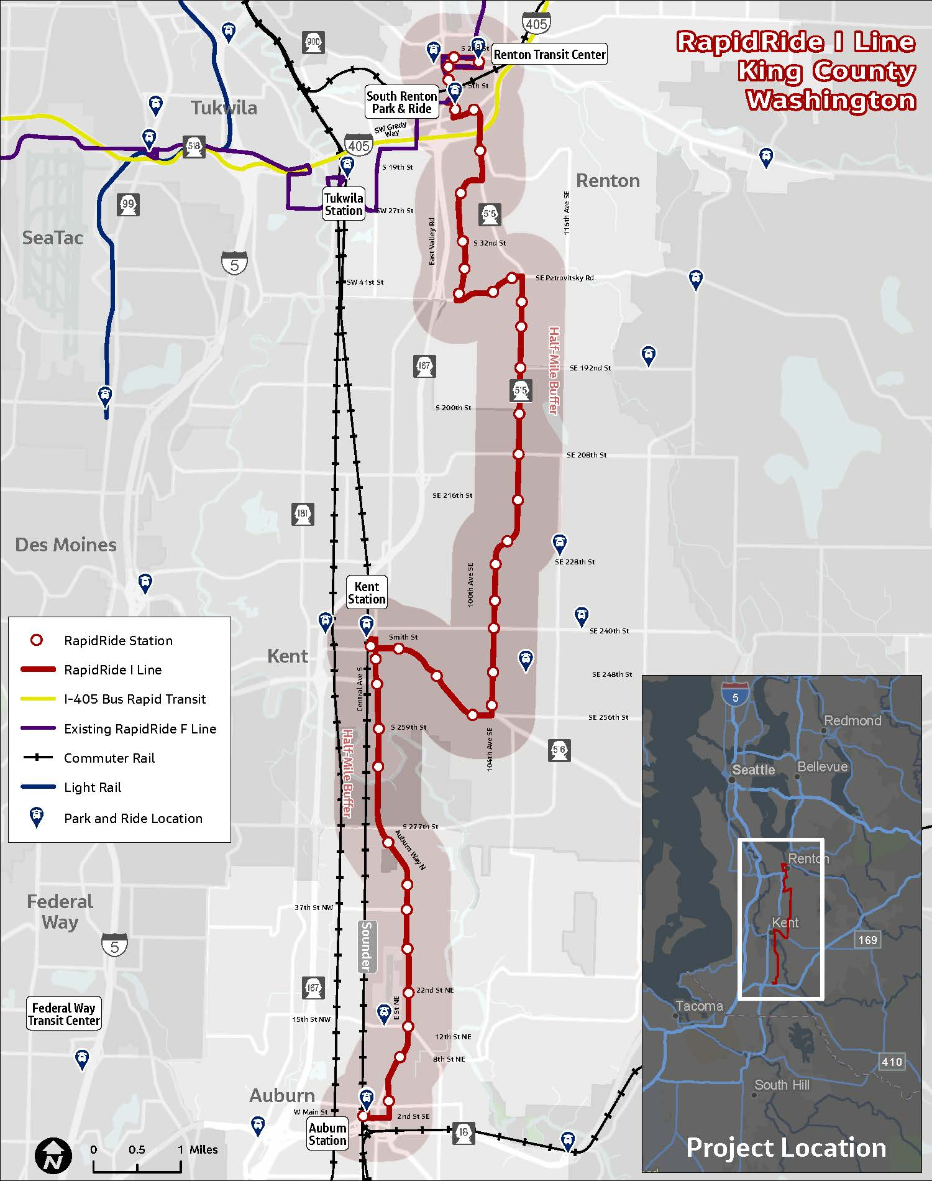

The ordinance establishing the Locally Approved Alternative also authorized Metro to enter a commitment of minimum service levels on the I Line for up to five years, which is a condition of federal funding. (See Attachments 8 and 9 for the approved alignment and station locations.)

Work on the I Line was prioritized during the pandemic even as other future RapidRide lines were cut or delayed, because Metro had already applied for federal grant funding for the I Line, the I Line would operate in an area with high equity scores, and the I Line would improve service on a corridor served by a lower-frequency bus route (Route 160).

In November 2020, as part of the 2021-2022 biennial budget, the Council appropriated $106.9 million for capital improvements for the I Line, with an additional $31.7 million appropriated in November 2022 as part of the 2023-2024 biennial budget, and an additional $24.2 million in July 2024 in the 2023-2024 third omnibus, for a total project budget of $174 million (including pre-2021 appropriations).

This funding is being used to plan, design, and implement infrastructure improvements for the I Line, including passenger facilities; roadway, signal, and intelligent transportation system (ITS) improvements to increase transit speed and reliability; access to transit projects to help passengers get to the RapidRide station locations; and communication and technology efforts to support the service. The funding includes the associated costs for public outreach and marketing but does not include fleet vehicles.

In June 2021, Metro completed the environmental review process, receiving a Documented Categorical Exclusion from the FTA. By the end of 2021, Metro had reached the 60% design level for the project.

In May 2022, the Puget Sound Regional Council’s General Assembly adopted the 2022-2050 Regional Transportation Plan, which included the I Line as part of the region’s fiscally constrained Regional Capacity Project List.

Also in spring 2022, the Federal Transit Administration (FTA) recommended federal funding for I Line development through a Small Starts Capital Investment Grant. In total, the I Line has received $79.7 million in federal Small Starts grant funding, as well as $46.6 million from other state and federal grants.

Prior to service beginning on the I Line in 2026, a service change ordinance would be transmitted to the Council to allocate the transit service hours to provide service on the new RapidRide line.

As noted above, as part of the Locally Preferred Alternative, King County has committed to minimum service levels on the I Line for up to five years, which is a condition of federal funding.

ANALYSIS

The adopted Locally Preferred Alternative for the RapidRide I Line identified a list of 41 “station pair” locations. Each of these 41 locations is identified by cross street, with a station to be placed on each side of the street at that location for a total of 82 stations. (See Attachment 9 to this staff report for the adopted station locations.)

For the identified station location at 108th Avenue SE and SE 186th Street in Renton, Metro has identified the need to acquire 114 square feet outright, as well as 1,397 square feet for a temporary construction easement at a property on the west side of 108th Avenue SE, to allow for the construction of a RapidRide station at that location.

The property currently has a bus stop located where the RapidRide station is proposed. The additional 114 square feet proposed to be acquired would permit the construction of a covered bus shelter (as noted above, one of the conditions of the federal Small Starts grant funding is that each of the RapidRide I Line stops must include a covered bus shelter), as well as lighting, benches, a trash can, and an electronic real-time arrival sign.

The property in question is 10,018 square feet, zoned residential, and being used for a duplex. (Attachment 8 to this staff report shows a map of the adopted alignment and station locations from the Locally Preferred Alternative, the station location that would be affected by Proposed Ordinance 2024-0226, and the specific acquisition and construction easement that is proposed for the subject property.) The proposed acquisition would not make any changes to the residential structure currently on the property and would not make any permanent changes to access to the property.

The Executive states that this station is part of the station pair that was identified as part of the Locally Preferred Alternative and that the specific parcel for which the acquisition and construction easement are proposed was identified so that the stations on both sides of the street for this station pair will be located near a new mid-block pedestrian crossing for passengers. The Executive notes that the crossing location has been approved by the Washington State Department of Transportation and City of Renton. The Executive also notes that constructing a smaller passenger facility at the subject parcel would not change the amount of property that must be acquired.

The transmitted legislative packet includes, for informational purposes, a fiscal note (included as Attachment 4 to this staff report), a property summary (Attachment 5 to this staff report), and an Attachment A to the property summary, which includes a letter from Metro to the owners of the subject property (Attachment 6 to this staff report; note that this Attachment A is named “Property Summary 2” in the Council’s legislative records). The transmitted property summary also references an Attachment B, which includes additional exhibits and graphic renderings. This Attachment B was inadvertently omitted from the transmittal packet; it is included in this staff report as Attachment 7.

The Executive reports that there has been an impasse in negotiations with the property owners and that condemnation authority is sought to be able to meet the construction schedule for the I Line. The Executive states that condemnation would be used only as a last resort to maintain the project schedule and goals.

Following committee action, public notice and notice to the affected property owners would be provided as required by RCW 8.25.290. To accommodate this notice period, if the committee takes action on September 11, 2024, a public hearing and possible action at full Council would not occur until October 1, 2024.

AMENDMENT

Amendment 1 would make a technical correction to replace the word “citizens” with the word “residents” to conform the language used in the ordinance to the 2020 Charter amendment.

INVITED

- Mark Ellerbrook, Director, Capital Division, Metro
- Janine Robinson, Transit Capital Project Manager, Capital Division, Metro

ATTACHMENTS

- Proposed Ordinance 2024-0226
- Amendment 1
- Transmittal Letter
- Fiscal Note
- Property Summary 1 (from Executive’s transmittal)
- Property Summary Attachment A
(aka “Property Summary 2” from Executive’s transmittal)
- Property Summary Attachment B
- I Line maps
- I Line station locations list (from Ordinance 19098)

Ordinance 19098
Ordinance 18449, since updated through Ordinance 19367. Additional study in Motion 14956.
The G, H, J, and R lines are being developed in collaboration with Seattle.
RapidRide I Line Project Profile (link)
Route 160 was a new route that was implemented during the September 2020 service change as part of the Renton Kent Auburn Area Mobility Project (Ordinance 19097). Route 160 replaced Route 169 and the Auburn Station-Kent Station portion of Route 180.
Ordinance 19098
Due to pandemic-era budget and operational issues, the J Line’s alignment was truncated and the City of Seattle agreed to take primary responsibility for the local share of capital costs; planning work for the K and R Lines was paused in 2020, though restarted in 2021; and a potential future L Line was eliminated.
Equity scores are calculated for each bus route and station area based on the makeup of priority populations (race, income, disability, foreign-born, limited English speaking) in the area. These scores are defined in the King County Metro Service Guidelines (Ordinance 19367, Attachment B).
Ordinances 18835 and 19210, Fund 3641, Project 1134237
Ordinance 19546, Fund 2641, Project 1134237 (this amount came from federal and state funding)
Ordinance 19791
As part of the Small Starts grant aware, the FTA has required Metro to construct a bus shelter at every station/stop, regardless of average boardings and alightings.
Metro has indicated that the I Line will use hybrid coaches from the existing RapidRide fleet. These coaches will be made available after Metro introduces new RapidRide fleet on the F Line.
Puget Sound Regional Council, 2022-2050 Regional Transportation Plan (link)
Federal Transit Administration, Annual Report on Funding Recommendations, Fiscal Year 2023, Capital Investment Grants Program and Expedited Project Delivery Pilot Program (link)
In addition to the federal Small Starts grant, other grants for the I Line include: $2,956,249 federal Surface Transportation Block Grant; $6 million federal Congestion Mitigation Air Quality Grant; $10,287,062 FTA Section 5307 Equity Formula Funding (through PSRC); $19,371,059 State Regional Mobility Grant (of which $8M is Kent pass-through and $10M is Renton pass-through); and $8,000,000 State Move Ahead Washington Grant.
Ordinance 19098
Ordinance 19098, Attachment B

