STAFF REPORT

Agenda Item: | 8 | Name: | Andy Micklow
Proposed No.: | 2025-0084 | Date: | March 18, 2025

SUBJECT

An ordinance relating to the Lower Duwamish Waterway cleanup and authorizing the King County executive to sign and fulfill the obligations in the consent decree and the associated multi-party settlements to govern the cleanup of sediment contamination at the Lower Duwamish Waterway Superfund Site.

SUMMARY

Proposed Ordinance 2025-0084 would authorize the King County Executive to enter into a consent decree with the United States Environmental Protection Agency (EPA) and the Washington State Department of Ecology (Ecology) to govern cleanup of the Lower Duwamish Waterway Superfund Site. The proposed ordinance would also authorize the Executive to enter into related multi-party settlements that secure funding for cleanup costs across responsible parties.

The Lower Duwamish Waterway Superfund Site (Site) is a five-mile stretch of the Duwamish River contaminated by over 100 years of heavy industrial and commercial use. The Site extends from the southern tip of Harbor Island in Seattle and terminates in Tukwila.

Construction for the first cleanup phase began in November 2024 under a unilateral "bridge" order issued by EPA to the City of Seattle, King County, and The Boeing Company. The EPA's bridge order allowed cleanup to begin pending completion of the consent decree and multi-party settlements.

The Consent Decree sets the timetables and scope of work for cleanup, requires long-term monitoring and controls following cleanup, and settles party liability subject to certain reservations and reopeners in exchange for the performance and/or funding of cleanup. Once executed by all parties, the consent decree would be lodged in federal court and made subject to public comment prior to being made effective. The consent decree would supersede EPA's bridge order to govern cleanup.

BACKGROUND

The Lower Duwamish Waterway Superfund Site is a five-mile stretch of the Duwamish River contaminated by a century of heavy industrial and commercial use. The Lower Duwamish Waterway (LDW) refers to the last five miles of the Duwamish River, a section that was transformed into an engineered waterway for industrial use. The Site extends from the southern tip of Harbor Island in Seattle, five miles south to Tukwila. The Site is flanked by industrial corridors, as well as the South Park and Georgetown neighborhoods. The Site is shown in Figure 1 (detailed maps included in Appendix C to Attachment A to Proposed Ordinance 2025-0084).

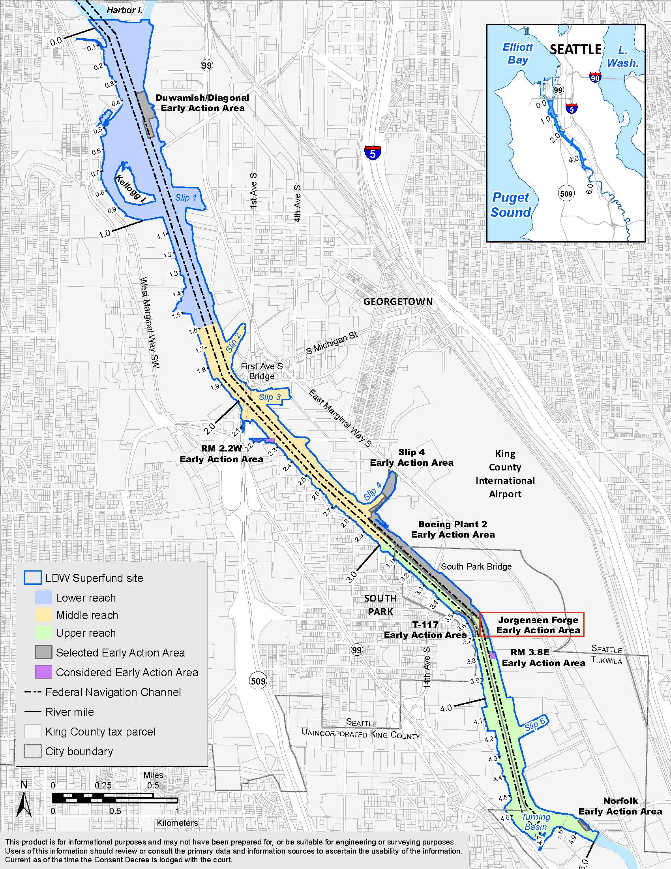
Figure 1. Lower Duwamish Waterway Superfund Site
The Lower Duwamish Waterway and adjacent upland areas have served as Seattle's major industrial corridor since the early twentieth century when part of the Duwamish River was straightened through dredging and filling. Pollution in the Duwamish River was generated by businesses, including The Boeing Company (Boeing) and other manufacturers, Port of Seattle (Port) properties, and public drainage and sewer systems. The County's potential responsibility stems from discharges from the regional sewer system (combined sewer overflows), the King County International Airport, Harbor Bond properties, and stormwater drainage from County roads and bridges.

Hazardous substances generated by industrial and urban activities entered the waterway environment through direct discharges, spills, leaks, dumping, and other inappropriate management practices. The primary contaminants driving most of the need for cleanup in the waterway are polychlorinated biphenyls (PCBs).

The largest health risk to users of the Site is from the consumption of contaminated local seafood. The Human Health Risk Assessment (HHRA) conducted by the Lower Duwamish Waterway Group (LDWG) in 2007 and 2009 identified four Contaminants of Concern (COCs) for human health: PCBs, arsenic, cPAHs, and dioxins/furans (polychlorinated dibenzo-p-dioxins and furans). Human health risks associated with seafood consumption are due to PCBs and arsenic in resident fish, crabs, and clams. Lower risks were associated with activities that involve direct contact with sediment, such as clamming, beach play, and net-fishing.

The Site also poses a risk to organisms that live in the sediment and the wildlife that use the site. The baseline Ecological Risk Assessment (ERA) completed by LDWG in 2010 estimated risks for four types of ecological receptors of concern exposed to the contaminants in the LDW, either directly or via ingestion of prey: benthic invertebrates and crabs, fish, birds, and certain wildlife species (river otter, harbor seal). Forty-one contaminants (including PCBs and arsenic) identified based on the ERA were selected as COCs for benthic protection.

The communities along the LDW face economic and health challenges. LDW is also the location of the Muckleshoot and Suquamish Tribal Usual and Accustomed Fishing Areas.

Superfund. The EPA declared the Lower Duwamish Waterway a Superfund site in 2001, meaning it is eligible for a special federal cleanup program due to the severity of its contamination. The EPA is responsible for administering the cleanup of sediments in the Waterway, and Ecology is responsible for controlling sources of pollution to the Waterway. The Site was also designated a state hazardous site in 2002.

Lower Duwamish Waterway Group. In 2000, the County joined the Port of Seattle, the City of Seattle, and The Boeing Company to form the Lower Duwamish Waterway Group prior to the Superfund listing in 2001. LDWG members work under a voluntary Administrative Order on Consent signed in 2000 with the EPA and Ecology to study the Site and to identify feasible options for the eventual cleanup of contaminated sediments.

LDWG members agreed to cover the costs under the 2000 Order at 25% each, subject to future reallocation. In 2014, LDWG members launched a confidential Allocation process, known as the Lower Duwamish Waterway Allocation, to secure funds from other parties and to reallocate costs between members. LDWG members also entered into multiple successive amendments of the 2000 Order to advance site work toward cleanup while the Allocation concluded.

As part of Allocation, a neutral Allocator weighed evidence to assign percent cost shares (adding to 100%) to all participants and one non-participant, the United States. Participants could accept or reject their shares for the purpose of settlement. The largest cost share was assigned to Boeing at 30.1%. The County was allocated an 8.4% share of costs. As part of the Allocation, the County's share was defined by ownership, enabling appropriate agencies to be assigned shares. The Wastewater Treatment Division (WTD) was allocated 65.4% of the County's share, the King County International Airport (KCIA) 20.7%, the Facilities Management Division (FMD) 13.6% for the Harbor Bond properties, and Roads 0.3% for stormwater drainage from County roads and bridges.

Only one participant, the Port, rejected its allocated cost share. The Port withdrew from the Allocation and LDWG in 2022 and sued Boeing, arguing Boeing should pay more for cleanup, but later withdrew its suit. The Port remains subject to the 2000 Order and continues to contribute its 25% share to pre-cleanup costs. The Port is not paying for the cleanup work being conducted under the 2024 Cleanup Order, including the construction in upper reach that commenced in November 2024.

Overall Cleanup Strategy and Timeline. The overall strategy for addressing contamination and the associated risks in the Site includes:
- early identification and cleanup of Early Action Areas (EAAs) to address the most contaminated areas in the waterway;
- controlling sources of contamination to the waterway; and
- cleanup of the remaining contamination in the waterway, including long-term monitoring to assess the success of the remedy in achieving cleanup goals.

The remedial investigation completed by LDWG in 2010 identified some of the most contaminated areas where early cleanups could be started. Several EAAs were selected for action by the EPA and Ecology. By the end of 2015, these early action cleanups removed 50% of PCB contamination in the river bottom.

In December 2014, the EPA released a final cleanup plan, also known as a Record of Decision (ROD), prescribing a "remedy" or cleanup plan for the remaining sediment cleanup. Cleanup will involve dredging, capping, and natural sedimentation. In 2014, the cleanup was estimated to cost $342 million. The Selected Remedy in the ROD addresses the third element of the overall cleanup strategy.

The ROD anticipated the following active remediation:
- Dredging or partially dredging and capping approximately 105 acres of highly contaminated sediments (approximately 960,000 cubic yards).
- Placing engineered sediment caps on approximately 24 acres of highly contaminated sediments where there is sufficient water depth for a cap.
- Placing a thin layer of clean material (referred to as Enhanced Natural Recovery [ENR]) on approximately 48 acres of sediments in areas that meet the criteria for ENR.
- Applying location-specific cleanup technologies to areas with structural or access restrictions, such as under-pier areas and near dolphins/pilings, bulkheads, and riprapped or engineered shorelines.

In addition, the ROD estimated 235 acres for Monitored Natural Recovery (MNR). MNR relies on natural processes to reduce ecological and human health risks to acceptable levels while monitoring sediments over time to determine remedy success. Within the LDW, the natural burial of contaminants through sedimentation from upstream is the primary natural recovery mechanism.

In 2015, the Council adopted Motion 14368 related to the Lower Duwamish Waterway cleanup and the health of communities adjacent to the Lower Duwamish Waterway. The motion acknowledged the degradation of the sediment quality of the Lower Duwamish Waterway due to historical industrial uses in the area. Motion 14368 also encouraged the analysis of equity and social justice impacts and the development of a remedial design that best protects the health of its diverse communities of residents.

In 2016, LDWG conducted the Lower Duwamish Waterway Fishers Study Data Report to gather information from people who either harvested or consumed resident seafood.
In 2017 and 2018, two years of "baseline" sampling of sediment, water, and seafood were completed. Sampling results showed improvements in the average levels in sediment of the four main contaminants for human health identified in the Human Health Risk Assessment conducted by LDWG in 2007 and 2009.

In 2021, the EPA published an Explanation of Significant Differences (ESD), which documents changes to the ROD issued in 2014 for the Lower Duwamish Waterway Superfund Site. The changes included remedial action levels, cleanup levels, and target tissue levels for cPAHs.

In January 2023, the EPA issued Special Notice Letters to Boeing, the City, the County, the Port, and certain United States agencies, including the Department of Defense, inviting formal Consent Decree negotiations to conduct or finance the cleanup of the LDW. Boeing, the City, and the County responded with a good faith offer to perform cleanup, subject to acceptable terms being reached in settlement with the United States and other parties.

Consent Decree negotiations extended past EPA's expected start date for cleanup due to the need to negotiate separately to secure contribution from the United States. In 2024, the EPA issued a Unilateral Administrative Order in July 2024 to the City, County, and Boeing as a bridge to allow cleanup construction to begin on EPA's expected timeline, pending completion of the Consent Decree. Cleanup construction began at the Site in November 2024.

ANALYSIS

Proposed Ordinance 2025-0084 would authorize the King County Executive to sign and fulfill the county's obligations in the Consent Decree and Settlements.

Consent Decree. The Lower Duwamish Waterway Superfund Site Consent Decree (Attachment A to Proposed Ordinance 2025-0084) would set the timetables and scope of work for implementing LDW cleanup, require 30 to 50 years of long-term monitoring and controls following cleanup, and settle party liability subject to certain reservations and reopeners in exchange for the performance and/or funding of cleanup.

As the Performing Parties, the City, County, and Boeing would continue to implement the cleanup with EPA and Ecology oversight while other parties, including federal and state agencies with responsibility, would pay their agreed-to shares of costs. One party would pay an ongoing share of costs as a Funding Party. The Consent Decree also contains all terms in settlement of the United States' government liability, including payment of a share of past costs, a share of future estimated costs, plus a premium to cash out. Key sections of the Consent Decree (Attachment A) are noted below.

Performance of the Work. Under paragraph 7, the County, City, and Boeing (i.e. Settling Work Defendants) would be required to "finance, develop, implement, operate, maintain, and monitor the effectiveness of the Remedial Action all in accordance with the SOW." The SOW (Statement of Work) is Appendix B to the Consent Decree.

Reservations and Reopeners. Paragraphs 11 and 71 through 74 are the reservations and reopeners. Paragraph 78 settles the County's liability subject to certain reservations and reopeners in exchange for the performance and/or funding of cleanup. Reopeners could be triggered by the discovery of unknown conditions and a determination by the EPA that the remedy at the Site is not protective of human health or the environment.

The Consent Decree also incorporates the following appendices:
- Appendix A - 2014 Record of Decision (pages 141 through 384 of Attachment A)
- Appendix B - Statement of Work (SOW) (pages 582 through 717 of Attachment A)
- Appendix C - map of the Site (pages 385 through 392 of Attachment A)
- Appendix D - complete list of Settling Defendants and Owner Settling Parties (pages 393 through 397 of Attachment A)
- Appendix E - 2000 Administrative Order on Consent for Remedial Investigation/ Feasibility Study and SOW, as amended (pages 398 through 571 of Attachment A)
- Appendix F - list of All Parties Considered by the LDW Allocator (pages 572 through 581 of Attachment A)

Once executed by all parties, the Consent Decree would be lodged in federal court and made subject to public comment prior to being made effective. The Consent Decree would supersede EPA's 2024 bridge order to govern cleanup.

Settlement Agreements. According to Executive staff, most settling Allocation parties have agreed to pay a share of past costs, their allocated shares of future estimated costs, and cover future liability by paying a premium to cash out. The Port is not part of the settlement agreements. The associated proposed multi-party settlements are included as Attachments B, C, D, and E to Proposed Ordinance 2025-0084.

Attachment B - Performing Parties. Performing Parties means the parties responsible for performing the work required by the Consent Decree, which are Boeing, the City, and the County. Under this agreement, the Performing Parties would perform the cleanup and cover gaps in funding at the shares discussed in the Project Costs section.

Attachment C - Cash-Out Parties. Under this settlement agreement, Allocation parties would pay upfront at a premium ​to cash out on all future liability. Settling Cash-Out Parties and Settlement Payment are listed in Appendix B to the agreement. Most Cash-Out Settlement Payments consist of a past cost payment and a future cost payment.

Attachment D - Funding Party. Under this settlement agreement, one Allocation party would pay an ongoing share of costs (1.7%), subject to cost overruns and reopeners. The Funding Party would also be able to seek a cash-out settlement with the Settling LDWG Parties (Boeing, the City, and the County) in the future.

Attachment E - Allocation Costs. This settlement agreement reallocates Allocation fees among remaining Allocation participants. In other words, between Non-LDWG Parties and LDWG Parties (Boeing, the City, and the County).

Project Costs. Cleanup costs were estimated to be $668 million in 2022. The $668 cost estimate is based on EPA's feasibility-level assessment from 2014 of the cleanup cost, updated for inflation to 2022.

As noted in the Background section, the County's allocated share is 8.4% of cleanup costs. The County is currently paying a performance share of the ongoing cleanup cost at 14.9%. The performance share is the share of cleanup costs, in relation to their Allocation shares, that the County pays along with the City and Boeing when needed to cover 100% of costs.

Table 1.
Shares of Cleanup Costs

Party | Allocated Share | Performance Share
The Boeing Company | 30.1% | 53.6%
City of Seattle | 17.7% | 31.5%
King County | 8.4% | 14.9%

Absent the settlements described in the previous section, the Performing Parties would continue to pay performance shares for the full cost of cleanup. With settlements, other parties would pay the Performing Parties $282 million upfront towards cleanup and one party would pay upfront costs plus an ongoing 1.7% share of costs as shown in Table 2.

Table 2.
Proposed Settlements

Party | Proposed Settlement
United States | $140 million upfront with premium
Cash-Out Parties | $141 million upfront with premium
Funding Party | $1.3 million upfront plus ongoing 1.7% share

For King County, other parties would pay the County $52 million upfront, with $13 million toward $24 million in past costs and $39 million toward future cleanup costs. Past costs are not included in the $668 million cleanup cost estimate. Past costs include costs for conducting the remedial investigation (nature and extent of contamination), feasibility study (alternative analysis to inform EPA's Record of Decision), baseline sampling to compare post-cleanup results to determine progress towards cleanup goals, and early actions that have already reduced PCB sediment concentrations by half. Settlements will reimburse the County for part of its past costs. The Wastewater Treatment Division has paid past costs to date.

The County has recovered insurance funds that will help pay the County's share of the cost of site cleanup as well as other site cleanup/liabilities. The County also received a settlement award from the Monsanto PCB class action settlement process for the Site and multiple other site cleanups/liabilities. The County-recovered insurance settlements for claims in the Lower Duwamish and Elliott Bay will cover all KCIA's, FMD's, and Roads' costs and a portion of WTD's.

According to Executive staff, "the County's share of cleanup would be approximately $59 million, and collateral funds could cover much of that total. Decisions are still to be made on how collateral funds are allocated to County agencies based on various responsibilities for which they were recovered." Executive staff also note that the County has received and will continue to apply for State-issued grant funding to cover cleanup costs.

Impact on WTD Sewer Rate. According to Executive staff, the actual effect on the rate is to be determined, but since much of the cleanup costs will come from collateral funds, the costs are not considered a significant driver for the 2026 rate proposal.

INVITED

- Kamuron Gurol, King County Wastewater Treatment Division Director
- Kristie Elliott, King County Senior Deputy Prosecuting Attorney
- Sharman Herrin, Government Relations, Wastewater Treatment Division

ATTACHMENTS

- Proposed Ordinance 2025-0084 (and its attachments)
- Transmittal Letter
- Fiscal Note
- Lower Duwamish Waterway Superfund Site Cleanup Consent Decree and Settlements PowerPoint, presented to the Regional Water Quality Committee by King County Executive Staff on March 5, 2025

Harbor Bond properties referes to properties purchased with the proceeds of the Harbor Bonds passed by King County voters in 1910 to support the purchase of waterfront properties to be held in trust for “improvement and enlargement of county harbors.”
The Comprehensive Environmental Response, Compensation, and Liability Act (CERCLA) is commonly known as Superfund.
EPA identification number for the Site is WA00002329803.
The Port of Seattle was a member of LDWG from 2000 to 2022.
https://ldwg.org/about-ldwg/
https://semspub.epa.gov/work/10/100353876.pdf
https://cumulis.epa.gov/supercpad/SiteProfiles/index.cfm?fuseaction=second.cleanup&id=1002020
https://cumulis.epa.gov/supercpad/SiteProfiles/index.cfm?fuseaction=second.cleanup&id=1002020
https://semspub.epa.gov/work/10/100353876.pdf
https://semspub.epa.gov/work/10/100036528.pdf
https://ldwg.org/wp-content/uploads/2020/06/LDW-Data-Evaluation-Report_toEPA_06-26-20.pdf
Actual costs may be higher.

