STAFF REPORT

Agenda Item: | 5 | Name: | Terra Rose
Proposed No.: | 2023-B0092  2023-B0107 | Date: | September 13, 2023  October 11, 2023

SUBJECT

A briefing about long-term disposal in King County's regional solid waste system and background on waste-to-energy facilities.

SUMMARY

King County's Solid Waste Division (SWD) operates a regional solid waste system for the unincorporated areas and 37 partner cities. This system includes one remaining local landfill, the Cedar Hills Regional Landfill, a 920-acre site located in unincorporated Maple Valley owned and operated by the County. In 2019, the Council approved the 2019 Comprehensive Solid Waste Management Plan, which directed further development of the Cedar Hills landfill to maximize disposal capacity instead of the other considered options. SWD has begun work on the series of capital projects for landfill expansion that are anticipated to add approximately ten years to the landfill's capacity with an estimated closure in 2038.

The interlocal agreements with the partner cities obligate the County to dispose of waste through 2040 and therefore, a new disposal method will be needed following the closure of Cedar Hills. The 2019 Comprehensive Solid Waste Plan did not select this next disposal option to allow for consideration of emerging technologies. Executive staff anticipate that the next disposal method will be determined in partnership with the two solid waste advisory committees and included in a future Comprehensive Solid Waste Management Plan.

Historically, the County has contemplated two options for long-term disposal - export by rail to a landfill outside of King County and a waste-to-energy (WTE) facility built in the county. In the 2019-2020 biennial budget, the Council directed the Executive to hire a consultant to further study the feasibility of each option. The resulting report, the King County Waste-to-Energy and Waste Export by Rail Feasibility Study, concluded based on the consultant's financial modeling that the total costs offset by revenues for both options are similar in the ten-year time horizon, but that a WTE facility could cost less in the fifty-year timeframe. Additionally, the consultant estimated that a WTE facility would have comparatively less greenhouse gas emissions than waste export by rail given the opportunity for emissions offsets through recycling the resulting ash byproduct and recovered metals.

In 2023, the Executive released the Re+ Strategic Plan, which describes the County's approach to meeting its goal for zero waste of resources by 2030. "Zero waste" is a planning principle designed to eliminate the disposal of materials with economic value. SWD is anticipating that diverting useful materials in the waste stream away from the landfill to better uses, such as composting food or reducing consumption, will impact which next disposal method that is chosen. This appears to be based on the premise that successful diversion from landfilling could lower overall tonnage, as well as change the types of waste, that needs processing, which could allow for other methods of final disposal to be considered beyond waste export and waste-to-energy.

BACKGROUND

King County Solid Waste System Overview. The King County Solid Waste Division (SWD) is responsible with providing solid waste planning, management, transfer, and disposal services through 2040 for 37 partner cities that have signed interlocal agreements and the unincorporated areas, a combined service area that encompasses approximately 1.9 million people.

In the regional system, garbage generated in the County's service area is transported to the Cedar Hills Regional Landfill for disposal, while recyclables, organics, and most construction and demolition materials are taken directly to private processing or compost facilities.

Cedar Hills Regional Landfill. The Cedar Hills Regional Landfill is a 920-acre site owned and operated by King County and is the single operational landfill in the county. Located in unincorporated Maple Valley, the Cedar Hills landfill has served as the final disposal location for the County's municipal solid waste since opening in 1965. Approximately 865,000 tons of garbage were disposed at the landfill in 2022, representing a one percent decrease compared to the previous year. Figure 1 shows the annual tons disposed at Cedar Hills since 2015.

Figure 1.
Tons Disposed at Cedar Hills Regional Landfill (2015-2022)

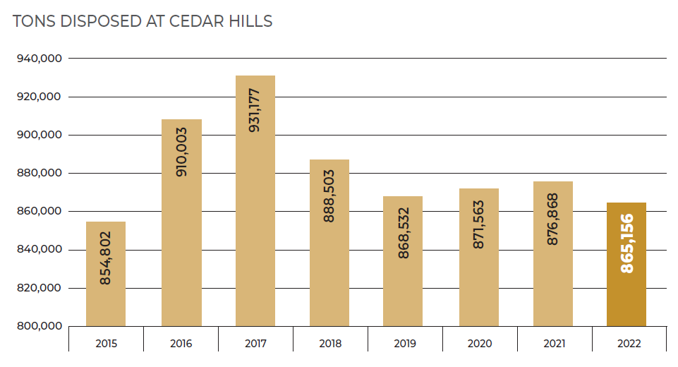
Source: King County Solid Waste Division 2022 Annual Report

Capacity of the landfill is based on acreage within the permitted boundaries of the site, as well as associated air space. Closure projections depend, in part, on tonnage received, waste settling, and other factors. Estimates from the late 1990s predicted the Cedar Hills landfill would reach capacity and close in 2012. However, according to the 2019 Comprehensive Solid Waste Management Plan (2019 Solid Waste Comp Plan; 2019 Plan), since that time, new practices and policies have made better use of landfill space, new capacity has been built, and the tons going to the landfill have been reduced, all of which have extended the lifespan beyond previous predictions.

In 2018, Executive staff projected that with no action the capacity of Cedar Hills was to be exhausted in 2028. The 2019 Solid Waste Comp Plan recommended further development of the landfill to maximize disposal capacity as the preferred option over the other considered options of a waste-to-energy facility and waste export by rail to an out-of-county landfill.

Following Council adoption of the 2019 Plan and associated appropriation requests, SWD began the planning, environmental, and engineering work on the series of landfill capital projects related to expansion. A Final Environmental Impact Statement (EIS) for landfill development was issued in March 2022 that presented a no action alternative, as well as three landfill development scenarios that would be expected to extend the capacity between nine and eighteen years for a potential closure range of 2037 to 2046. Following the Final EIS in late 2022, Executive staff selected Action Alternative 2 as the preferred alternative. Based on the tonnage predictions used at the time, the Final EIS indicates this option would add approximately 13 million cubic yards and 10 years to the landfill capacity, projecting closure in 2038.

Executive staff provided planning level estimates in mid-2022 for the total cost of completion of the landfill expansion capital projects, which are summarized in the figure below. However, Executive staff anticipate that actual costs will be higher than those provided and that more accurate estimates will be available at 30 percent design.

Figure 2.
Planning Level Cost Estimates for Landfill Expansion Projects

Project | Planning Level Estimated Cost at Completion
Facility Relocation | $94.6 million
Area 9 Development | $119.2 million
Area 5 | $34.5 million
Area 6 | $34.5 million
Total Estimated Cost at Completion of Combined Projects  (Planning Level, Pre-30% Design) | $282.8 million

Next Disposal Method. According to the 2019 Solid Waste Comp Plan, even with further development, the Cedar Hills landfill capacity will be exhausted at some point in the future and a new disposal option will be needed. However, to allow consideration of emerging technologies, the 2019 Plan did not specify the next disposal option for after Cedar Hills closes. In late 2021, as required by the 2019 Plan, Executive staff with input from the solid waste advisory committees prepared the Solid Waste Long-Term Disposal Method Report (Long-Term Disposal Report), which details the actions thought to be needed to make the decision on the next disposal method.

Executive staff anticipate that this decision will be made in partnership with the two solid waste advisory committees and included in the next Comprehensive Solid Waste Management Plan, as provided under state law and the interlocal agreements with the partner cities. The Long-Term Disposal Report recommends that an updated Comprehensive Solid Waste Management Plan be adopted with approximately ten years of lead time prior to the projected Cedar Hills closure to allow for the siting and construction of any new long-term disposal methods. At the time of the Report, closure was assumed to be in 2037 and therefore, adoption of the next Comprehensive Solid Waste Management Plan would need to occur in 2026. According to the Report, each advisory committee expressed concern that may be too early to decide on the next long-term disposal method because impacts from recycling and prevention efforts under the Re+ program may not yet be known. The Report indicates that the advisory committees recommended that the region should press forward with long-term disposal action based on the projected impacts of Re+ actions that are endorsed by the cities.

The Long-Term Disposal Report identifies a series of steps to determine the next disposal method, some of which have already been completed, and that include:

- Complete the EIS process for Cedar Hills capacity expansion;
- Finalize the Re+ Plan;
- Hire a consultant to analyze long-term disposal options based on the Re+ Plan projected impacts to waste tonnage and characterization;
- Draft the Comprehensive Solid Waste Management Plan update that includes the next disposal method;
- Conduct the comment period and EIS process for Comprehensive Solid Waste Management Plan; and
- Cities and the King County Council adopt the Comprehensive Solid Waste Management Plan update.

In 2023, the Executive released the Re+ Strategic Plan, which describes the County's approach to meeting its goal of zero waste of resources by 2030 and creating a more circular economy. While the most recent available county recycling rate of 56 percent (2016) was substantially higher than the national average of 32.1 percent (2018), the county's recycling rates in the past several years have remained relatively flat. Further, the Re+ Strategic Plan indicates that approximately 70 percent of the materials disposed of at Cedar Hills every year are recyclable and that preventing 75 percent of that material from entering the waste stream could divert 450,000 tons from the landfill.

Historically, the County has contemplated two options for when Cedar Hills reaches capacity – waste export by rail to a landfill outside of King County and a waste-to-energy facility built in the county. However, Executive staff are anticipating that diverting useful materials in the waste stream to better uses, as outlined in the Re+ Strategic Plan, will impact which long-term disposal method is chosen. According to the Long-Term Disposal Report, this is based on the premise that successful diversion is expected to lower the tonnage and change the types of waste to process, which could allow for more methods for disposal to consider beyond waste export and waste-to-energy.

Waste-to-Energy Background. The U.S. Environmental Protection Agency (EPA) defines "waste-to-energy" as the process of energy recovery from waste through the conversion of waste materials into usable heat, electricity, or fuel through a variety of processes, including combustion, gasification, pyrolization, anaerobic digestion, and landfill gas recovery. This staff report will focus on waste-to-energy using municipal solid waste as its feedstock or the inputs to the process, as opposed to, for example, anaerobic digestion, which uses organic materials as feedstock.

According to the EPA, the first incinerator in the United States was built in 1885 in New York and by the mid-20th Century, hundreds of incinerators were in operation. The EPA indicates that little was known about the environmental impacts of the water discharges and air emissions until the 1960s. When the Clean Air Act went into effect in 1970, existing facilities had to install technology needed to meet the regulations or close. In the 1990s, the EPA enacted the Maximum Achievable Control Technology regulations in recognition of the newly recognized threats posed by mercury and dioxin emissions. Again, existing facilities were required to be retrofitted with air pollution control systems or shut down.

WTE Facilities in the U.S. At the beginning of 2022, 60 WTE facilities using municipal solid waste as feedstock were operating in the United States, according to the U.S. Energy Information Administration (EIA). These facilities, depicted on the map in Figure 3, are located throughout the country with the majority in urban areas along the East Coast. (Note that this count and the associated map does not include anaerobic digestion, which uses organic materials as opposed to municipal solid waste as its feedstock).

Figure 3.
Operating WTE Facilities Using Municipal Solid Waste as Feedstock (as of 2022)

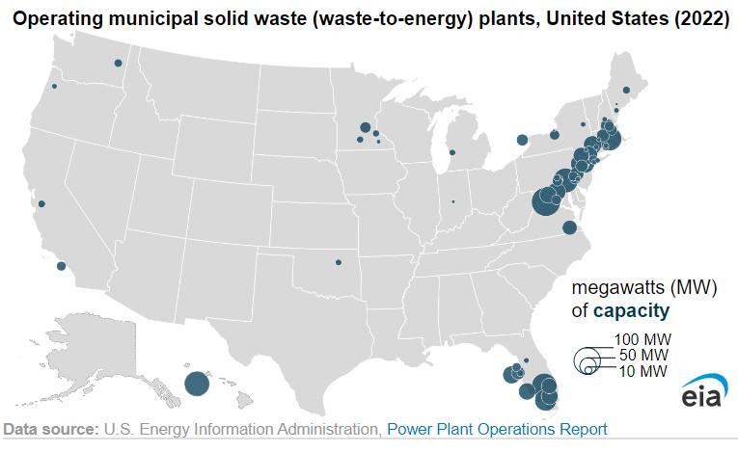
Figure Source: U.S. Energy Information Administration website

In Washington state there is only one WTE facility that uses municipal solid waste as feedstock. This facility is located in Spokane and has been the main solid waste disposal option for Spokane County since 1991. The facility's website indicates it can handle up to 800 tons of municipal solid waste a day and can generate 22 megawatts of electricity, enough to power 13,000 homes.

To Council staff's knowledge, the most recent WTE facility to come online in the United States is in West Palm Beach, Florida, which began operation in 2015. According to the facility's website, it is capable of processing 3,000 tons of waste per day and generates 100 megawatts of electricity, which is enough to provide power to an estimated 45,000 homes and businesses. The Solid Waste Authority of Palm Beach County indicates that its integrated solid waste management system is designed to minimize the reliance on landfilling in an environmentally responsible and cost effective manner, and that the facility is estimated to reduce the amount of waste going to the SWA's landfill by up to 90 percent, ensuring the landfill lasts until approximately 2053.

The EPA's website on waste-to-energy states that municipal solid waste combustion accounts for a relatively small portion of American waste management and cites multiple potential reasons:

Generally speaking, regions of the world where populations are dense and land is limited (e.g. many European countries, Japan), have greater adoption of combustion with energy recovery due to space constraints. As the United States encompasses a large amount of land, space limitations have not been as important a factor in the adoption of combustion with energy recovery. Landfilling in the United States is often considered a more viable option, especially in the short term, due to the low economic cost of building an MSW landfill verses an MSW combustion facility.
Another factor in the slow growth rate of MSW combustion in the United States is public opposition to the facilities. These facilities have not always had air emission control equipment, thus gaining a reputation as high polluting. In addition, many communities do not want the increased traffic from trucks or to be adjacent to any facility handling municipal waste.
Additionally, the upfront money needed to build an MSW combustion facility can be significant and economic benefits may take several years to be fully realized. A new plant typically requires at least 100 million dollars to finance the construction; larger plants may require double to triple that amount.
EPA Waste Management Hierarchy. In recognition that no single waste management approach is suitable for managing all materials and waste streams in all circumstances, the EPA developed the waste management hierarchy, shown in Figure 4, and which ranks various management strategies from most to least environmentally preferred. On the current hierarchy, energy recovery ranks below source reduction and recycling/reuse, but above treatment and disposal.

Figure 4.
U.S. Environmental Protection Agency Waste Management Hierarchy
(ranked from most to least environmentally preferred)

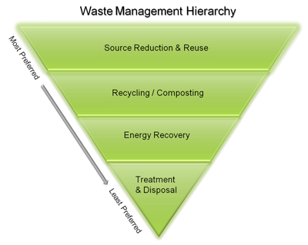
Source: U.S. EPA Sustainable Materials Management Website

King County Waste-to-Energy and Waste Export by Rail Feasibility Study. In the 2019-2020 biennial budget, the Council directed the Executive to hire a consultant for a study that evaluates the feasibility of a waste-to-energy facility and waste export by rail as the County's next disposal method. Motion 15548 acknowledged receipt of the King County Waste-to-Energy and Waste Export by Rail Feasibility Study developed by the consultant Arcadis.

The consultant concluded based on its financial modeling that the total costs (offset by revenues) for both long-term disposal options are similar in the ten-year near-term at over one billion dollars, but that a WTE facility could cost less in the fifty-year long-term ($6.96 to $8.90 billion for WTE and $11.25 to $16.14 billion for waste export). Additionally, the consultant estimated that a WTE facility would have comparatively less greenhouse gas emissions than waste export by rail given the opportunity for emissions offsets through recycling the resulting ash byproduct and recovered metals. The study notes, however, that the estimates are dependent on the different variables and assumptions made in the financial and greenhouse gas models. Further detail concerning how these figures were derived and the consultant's assumptions, as well as other considerations, can be found in the staff report for Motion 15548 (Attachment 1), as well as in the study and associated appendices.

INVITED

- Pat McLaughlin, Director, Solid Waste Division

ATTACHMENTS:

- Staff Report for Motion 15548 (Acknowledging receipt of the King County Waste-to-Energy and Waste Export by Rail Feasibility Study)

Ordinance 18893
Cedar Hills Regional Landfill Development Project Website [Link]
King County Waste-to-Energy and Waste Export by Rail Feasibility Study [Link]
Re+ Strategic Plan [Link]
K.C.C. 10.04.010
Solid Waste Long-Term Disposal Method Report (2022-RPT0012)
All cities in King County except Seattle and Milton have executed ILAs with the County.
Population figure source: Re+ Strategic Plan.
King County Solid Waste Division 2022 Annual Report (2023-RPT0030)
2001 Comprehensive Solid Waste Management Plan
Cedar Hills Regional Landfill Development Project Website [Link]. Action Alternative 2 would develop approximately 34 acres for construction of a new refuse area in the southeast portion of the landfill (proposed Area 9), with landfilling in Areas 8 and 9 to no more than 830 feet above mean sea level. Landfilling would also occur in existing Areas 5 and 6, to no more than 788 feet, and in the southern portion of Areas 2/3, 4, and Central Pit, also to 788 feet.
Cedar Hills Regional Landfill 2020 Site Development Plan and Facility Relocation Final Environmental Impact Statement [Link]
(1) Metropolitan Solid Waste Management Advisory Committee; (2) Solid Waste Advisory Committee. Section 5.1 of the interlocal agreements require the County to engage with the two solid waste advisory committees at least seven years before the date that the County projects that the landfill will close, or prior to the end of the interlocal agreement, whichever is sooner, to seek their advice and input on the disposal method to be used after the closure of Cedar Hills.
2022-RPT0012
King County Code defines "zero waste of resources" as a planning principle and framework designed to eliminate the disposal of materials with economic value through reuse, recycling, or both (K.C.C. 10.04.020). Zero waste of resources is a . In this context, "zero waste" does not mean that no waste will be disposed, but instead proposes that maximum feasible and cost-effective efforts be made to prevent, reuse, and reduce waste.
Re+ Strategic Plan [Link]
2020 Strategic Climate Action Plan [Link]
EPA National Overview: Facts and Figures on Materials, Wastes and Recycling Website [Link]
Figure 4-2, 2019 Comprehensive Solid Waste Management Plan
EPA Energy Recovery from the Combustion of Municipal Solid Waste Website [Link]
EPA Energy Recovery from the Combustion of Municipal Solid Waste Website [Link]
EIA Waste-to-Energy Plant Information 2023 Website [Link]
City of Spokane Solid Waste Services Waste to Energy Facility Website [Link]
Solid Waste Authority of Palm Beach County Renewable Energy Facility 2 Website [Link]
EPA Energy Recovery from the Combustion of Municipal Solid Waste Website [Link]
U.S. EPA Sustainable Materials Management: Non-Hazardous Materials and Waste Management Hierarchy Website [Link]
Ordinance 18835, Sec. 19 (Proviso P4; Expenditure Restriction ER2); Sec. 102 (Proviso P3; Expenditure Restriction ER3)
King County Waste-to-Energy and Waste Export by Rail Feasibility Study [Link]
Total costs include capital and operating costs offset by revenues. The consultant indicates that some departmental costs are not included in the cited figures as they are expected to be the same under both options.

