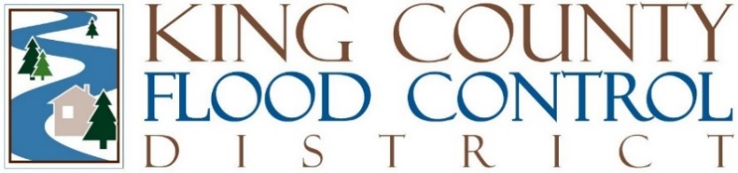

BRIEFING STAFF REPORT

Agenda Item: | 9 | Name: | Michelle Clark
Briefing No: | FCD2025-B04 | Date: | May 13, 2025

BRIEFING NO: FCD2025-B04: Update on Integrated Floodplain Management & Capital Project Prioritization.

During the 2025 budget process, the King County Flood Control District (“District”) Board of Supervisors addressed the issue of the District’s projected expenditures outpacing revenues in three ways: (1) adjusting 2025 revenues, (2) directing staff to prepare a proposed bonding policy by April 17, 2025, and (3) directing staff to work with the District Advisory Committee (“Advisory Committee”) to propose a capital project prioritization paradigm focused on risk, severity, and consequence. This briefing is an update on capital project prioritization.

Integrated Floodplain Management & Capital Project Prioritization

Because of this policy direction in the adopted 2025 budget, the Advisory Committee has monthly meetings scheduled through August and has met twice. The first meeting was a high-level discussion of the 2025 budget and a preview of the District’s 2025 work plan as presented to the Executive Committee in February. The second meeting was a discussion of the draft Integrated Floodplain Management & Capital Project Prioritization White Paper (“White Paper”) attached to this briefing.

The White Paper combines the District adopted policy that prioritizes actions to mitigate flood and channel migration risks based on the consequences of inaction, urgency (or risk), legal responsibility and authority, and funding and partnership opportunities. This hierarchy combined with the District’s Integrated Floodplain Management or so-called Multi-Benefit Motion (FCD2020-07) and Capital Project Delivery Motion (FCD21-16) provide a robust framework for accomplishing the District’s mission of implementing flood risk reduction policies and projects to protect life and property while advancing various multiple benefits including equity and social justice, habitat protection, and resilient communities. The White Paper also acknowledges the District’s commitment to working in collaboration with Tribes, federal, state, and local governments, environmental and community organizations, interested parties, and the public reflecting our shared values and priorities.

The three key components of the District’s effort to prioritize and fund flood risk reduction policies and projects are: (1) Flood Risk Reduction; (2) Advancing Multi-Benefits, and (3) Other considerations including adhering to all applicable laws including Tribal Treaty Rights and permitting requirements. The White Paper also includes a glossary of terms.

Next Steps

May 13th | Present White Paper to Board of Supervisors
June 10th | Board of Supervisors Adopt Capital Project Prioritization Policy
June -August | Application of Capital Project Prioritization Policy
August | Advisory Committee recommends 2026 Budget and 6-year CIP
September – November | Board develops 2026 Budget
January 2026 | Implement New Capital Project Prioritization Policy

Attachments:
DRAFT Integrated Floodplain Management & Capital Project Prioritization White Paper
Capital Project Prioritization Timeline

