Sale Property Summary
Photo of Property
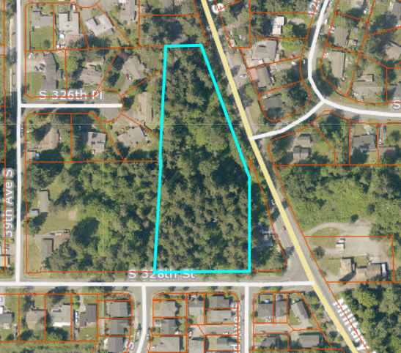

Address 32XXX Military Rd S, Federal Way
Sale Price $675,000
Sale Area 149,410 Square Feet
Assessor's Parcel 152104-9016
Zoning RS 9.6, one dwelling unit per 9,600 square feet
Council District Seven
Funding Source Road Services Division (RSD)
Declared Surplus October 24, 2025
Template Status: County template with changes to remove due diligence contingency
Offer Expiration: Proposed Ordinance to be in effect by June 17, 2026, per the terms of the Purchase and Sale Agreement.

Property Information
The proposed Ordinance provides for the sale of a 149,410 square foot vacant, unused residential lot, parcel number 152104-9016, located near South 328th Street and Military Road South, in the City of Federal Way. There is no formal physical address due to this property being categorized as a vacant, undeveloped parcel. Upon completion of this sale, should the new owner choose to develop this property, the new owner would apply for permitting to develop the property and an address would be assigned at that time by the City of Federal Way. The buyer, Tajinder Bal, also owns an adjoining property. The sale of this property will alleviate liability and maintenance costs to the County.

Context
Rationale for transaction: The property is surplus to the current and future needs of the RSD and the County. The property, commonly referred to as the Hatfield Pit, was purchased by the RSD in 1919 as a borrow pit for gravel and has not been used in many years. The sale will provide one-time revenues to the Roads Fund.

Policy considerations : Given current and future anticipated RSD operations, this property is no longer needed to support the RSD, or other King County operations. Retaining the property results in additional liability.

Political considerations: The property is located in the City of Federal Way. The Facilities Management Division’s Real Estate Services Section contacted the City of Federal Way on September 30, 2025, to see if they had interest in purchasing the property. On October 29, 2025, the City declined to purchase the property.

Community considerations
or partnerships: N/A

Fiscal considerations: Sale of this property will relieve the County of assessments totaling $9.99/year.

Other considerations: N/A

CIP/operational impacts: N/A

Change in property use: The property is vacant land and has never had public use. The buyer may develop the property but must comply with City of Federal Way zoning code restrictions.​

SEPA Review Required yes/no: No

King County Strategic Plan impact: N/A

Equity and Social Justice impact: In accordance with Real Property Asset Management Plan (RAMP) policy, the Facilities Management Division reviewed this legislation for Equity and Social Justice (ESJ) impacts. This location is in the City of Federal Way. This property is being sold, and King County no longer needs this property. This sale is not expected to negatively impact low-income communities, communities or color or limited English proficient communities.

Surplus Process
Interest from other county agencies? No
Property suitable for affordable housing? No, the Department of Community and Human Services determined the property was not suitable for affordable housing on October 1, 2025.
Property determined to be surplus? Yes, October 24, 2025

Marketing and Sale
Indicate whether the property was marketed or not, and if so, how it was marketed:
MLS
Commercial Broker
County Website
Social Media
Onsite Signage
Not Marketed (briefly explain)

Appraisal Process
Summary
Date of valuation: April 12, 2025
Appraised by: Integra Realty Resources
Appraisal factors: The Sales Comparison Approach was used, which is typical for residential vacant lots.
Comps analysis: Seven land sales were utilized.
Estimated FMV: $600,000
Appraisal Summary Chart
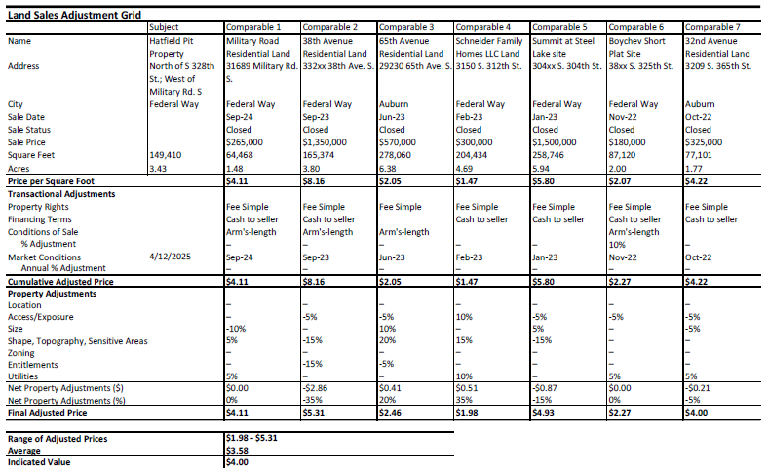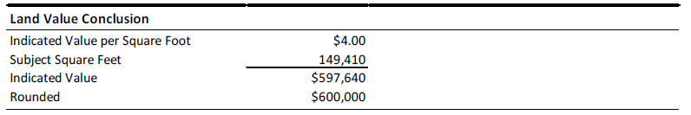

Vicinity View Map

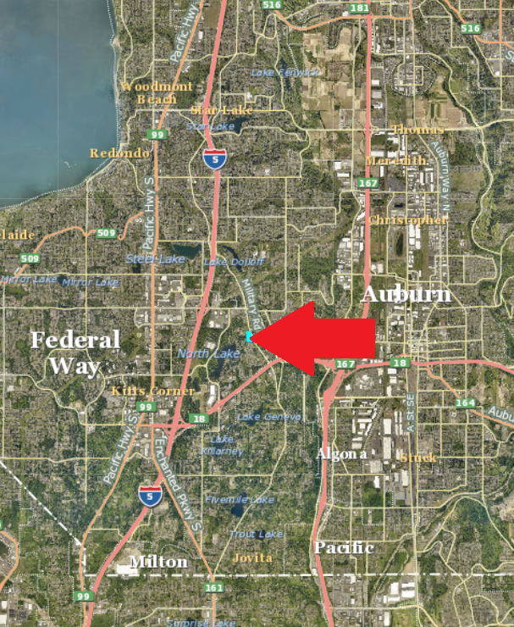

Parcel Map



