Lease Property Summary
Photo of Property
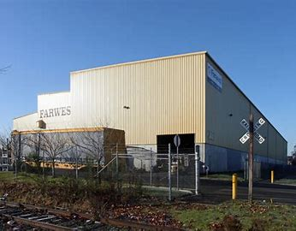

Property Owner: 201 SW 34th Street LLC
Address: 201 SW 34th Street, Renton, WA
Cost Per Sq. Ft.: $9.71
Operational Costs: $3.72
Term: Eight years
Square Footage: 98,306 SF/5.6 acres
Template: King
Council District: Five
Funding Source: King County Solid Waste CIP Fund, 3901 Fund
Previous Location: Temporary location for the truck maintenance facility during construction at the Cedar Hills Landfill.
Offer Expiration: Property owner has requested execution of agreement in early 2025, current lease agreement ends in March 2026.

Lease Synopsis:
The Truck Maintenance Facility (TMF) was originally located onsite at the Cedar Hills Regional Landfill (CHRLF). In April 2021, an initial five-year lease was executed for the Farwest Steel Building to temporarily relocate the TMF from its location at CHRLF to allow TMF operations to continue while construction of a new facility at CHRLF (in support of the 2019 Comprehensive Solid Waste Management Plan.) is underway.
Due to rising construction costs, the construction project was temporarily put on hold to allow for an alternative site analysis. The proposed extended lease term will allow TMF operations to continue while construction is underway at the CHRLF.
Context

Rationale for transaction: The additional lease term is needed to ensure the operational support provided by the TMF continues uninterrupted while the alternative site analysis is being conducted. The TMF needs to remain at the Farwest Steel Building until a permanent solution is identified.

Policy considerations: This transaction supports continued landfill operations while alternative analysis for the permanent facility is being completed.

Political considerations: N/A

Community considerations
or partnerships: N/A

Fiscal considerations: The rent for the initial lease is $75,000 per month triple net lease, or NNN, which means that the tenant is responsible for expenses such as taxes, insurance, and utilities. The lease includes three percent annual increases. The additional term after initial five years continues with three percent annual increases.

Other considerations: N/A

CIP/operational impacts: This agreement includes a $45,000 tenant improvement allowance, and current tenant improvement costs total $74,728 to paint the administration area and restrooms. The Solid Waste Fund will cover the remaining $29,728 to complete the tenant improvement project.

King County Strategic Plan impact: N/A

Equity and Social Justice impact: In accordance with King County’s Real Property Asset Management Plan (RAMP) policy, the Facilities Management Division and Solid Waste Division reviewed this legislation for potential equity and social justice (ESJ) impacts. This lease is located in the Cedar Hills neighborhood of Renton. The proposed continued use is consistent with existing services in the area. The SWD Truck Maintenance Facility program supports solid waste services in all areas of King County.

Energy Efficiency impact: N/A

Lease Alternatives Analysis
Summary: Because this is an extension of an existing lease, alternatives were not considered.
Vicinity View Map

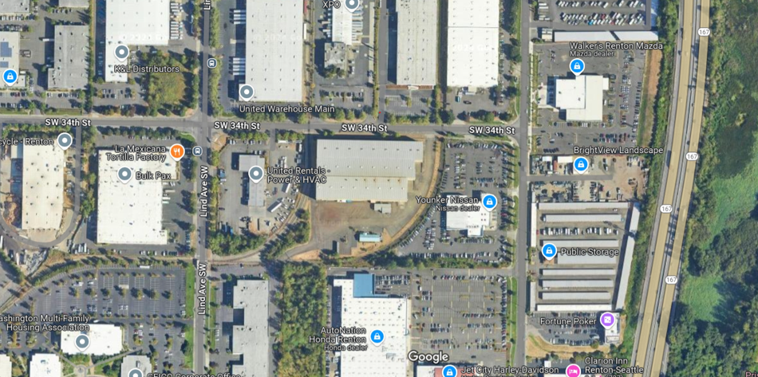

Parcel Map
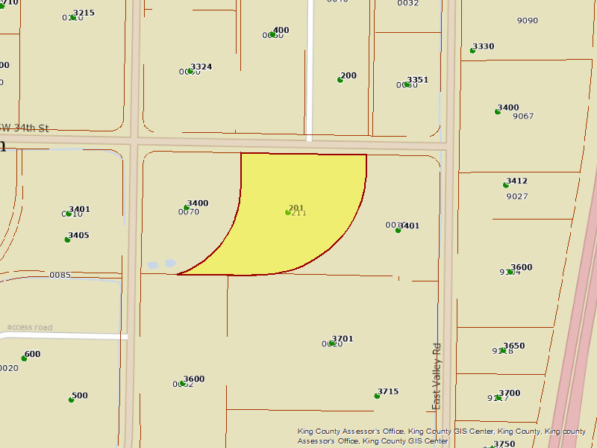

https://kingcounty.gov/en/dept/dnrp/waste-services/garbage-recycling-compost/solid-waste-planning-monitoring/comprehensive-solid-waste-management-plan

