Proposed 2027 Sewer Rate and Capacity Charge
and 2027-2046 Financial Forecast

April 23, 2026

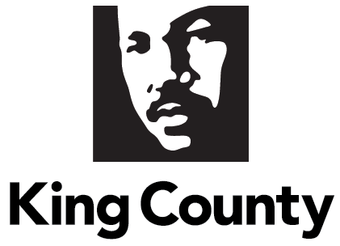

Table of Contents
Table of Figures…………………….……………………….………….……………….……………………….………………………….….………………….….…………….…….3
Executive Summary 5
Introduction…… 7
Operating Expenditures 10
Operating Forecast 10
WTD Operating Expenditures Forecast 11
Capital Improvement Program 11
Portfolio Management 11
2025 Performance and Accomplishment Rate 11
Estimated CIP Spending for 2027-2046 Financial Forecast 12
Capital Expenditure Delivery Capacity Analysis 14
Capital Improvement Program Funding 16
Cash Funding 16
Debt Financing 16
Reserves Management 22
WTD Operating Fund 4611 22
WTD Construction Fund 3611 23
Debt Reserve Funds 8921 and 8922 24
Revenue…………. 24
Revenue Requirement 25
Sewer Rate 27
Legal Disclaimer 30
Alternative Scenarios 31
Council Request Scenario 31
Theoretical Regulatory Deadline Extension Scenario 32
Capacity Charge 33
Other Revenues 36
Reference and Additional Information 37
Supplemental WTD Debt Information 37
Types of WTD Financing 37
Forecast Assumptions 38
2025 Wastewater Treatment Division Financial Performance 39
Contaminants of Emerging Concern (e.g., PFAS) – Cost Tracking 41
Appendix. Attachment A 43
Endnotes………… 44

Table of Figures
Figure 1 Proposed 2027 Sewer Rate and 2027-2046 Forecast 6
Figure 2 Adopted 2026 Sewer Rate and 2026-2045 Forecast 6
Figure 3 Proposed 2027 Capacity Charge and 2028-2031 Forecast 6
Figure 4 System Map 8
Figure 5 2025 Average Reported Residential Capacity Equivalents by Local Sewer Agency 9
Figure 6 2025-2026 WTD Operating Expenses ($ ‘000s) 10
Figure 7 Historical Annual Increase in WTD Operating Expenditures 10
Figure 8 Capital Portfolio Category Descriptions 11
Figure 9 Historic Accomplishment Rate 12
Figure 10 Historical Accomplishment Rates for the Capital Program ($ in millions) 13
Figure 11 WTD CIP Investment Strategy 14
Figure 12 Proposed Capital Investments by Portfolio Category for 20-Year Forecast 17
Figure 13 Capital Funding Sources 18
Figure 14 Existing and New Debt Balances 19
Figure 15 Debt to Asset Balance 19
Figure 16 Sample Defeasance 22
Figure 17 Summary of WTD Reserves 23
Figure 18 Surety Bond Summary 25
Figure 19 Operating Revenue Components Sorted by Size 26
Figure 20 2026 - 2046 Sewer Rate Forecast Revenue Requirement 27
Figure 21 Proposed 2026 Sewer Rate and 2027-2045 Forecast [also available on page 6] 27
Figure 22 History of WTD DSC and Ratings 28
Figure 23 RCE Reporting to Sewer Rate Billing Lag 28
Figure 24 Reported SFRs and Flow-Based RCEs by Quarter (2011-2025) 29
Figure 25 Historical Sewer Rate Increases (1990-2026) 30
Figure 26 Adopted 2026 Sewer Rate and 2026-2045 Forecast 31
Figure 27 Proposed 2027 Sewer Rate and 2027-2046 Forecast [also available on page 6] 31
Figure 28 Capital Forecast—Council Requested Rate 32
Figure 29 2027 Council Requested Rate and 2027-46 Rate Forecast 33
Figure 30 Capital Forecast—Theoretical Regulatory Deadline Extension 33
Figure 31 2027 Theoretical Regulatory Deadline Extension Rate and 2027-46 Rate Forecast 34
Figure 32 Historical Capacity Charge Increases (2003-2026) 35
Figure 33 Proposed 2027 Capacity Charge and 2028-2031 Forecast [also available on page 6] 36
Figure 34 Historical Capacity Charge Ongoing Payments and Prepayments (2012-2025) 37
Figure 35 2025 Year-End Outstanding Debt Balances 38
Figure 36 Forecast Assumptions Used in Financial Forecast 39
Figure 37 Wastewater Treatment 2025 Forecast vs. Preliminary 2025 Actuals 41

Executive Summary

Key Assumptions for the Proposed 2026 Sewer Rate and 2027-2045 Financial Forecast
The 2027 sewer rate process builds on the substantive changes incorporated into the 2026 rate process, including an extension of the forecast period to 20 years (Council Motion 16449), an updated Combined Sewer Overflow (CSO) consent decree schedule reflecting 2037 completion (see Capital Improvement Program section for greater detail), and updated cost estimates for large CSO projects including the Mouth of the Duwamish Wet Weather Facilities.,,
The 2027 sewer rate process sought to incorporate additional project cost updates while also:
- moderating near-term rate increases;
- responding to 2026/27 budget proviso Section 115 P4 and Sewer Rate and Capital Work Plan requirements of Capital Improvement Program (CIP) scenarios with clear policy choices and tradeoffs;
- balancing to a status quo operating expenditure forecast; and
- maintaining King County Wastewater Treatment Division’s (WTD) strong financial policies to minimize debt burden and risk.
A continued challenge for the County’s WTD CIP includes the “stacking” problem of multiple concurrent and large capital needs. The three main drivers continue to be high-risk priority asset replacement and renewal investments, meeting contract obligations to serve new growth capacity, and substantial regulatory requirements. These regulatory requirements have fixed and concurrent deadlines for large CSO projects, making up the largest driver of near-term rate increases.
There are also continued significant regulatory “known unknowns,” including how nutrient regulations will affect CIP needs, especially since the Puget Sound General Nutrient Permit was recently invalidated by the state Pollution Control Hearings Board (PCHB No. 21-085). Given the uncertainty, WTD continues to include comparably modest costs for initial optimization-level nutrient reduction in its CIP. WTD and legal counsel will continue to monitor the status of nutrient litigation and regulation and endeavor to anticipate and respond to regulatory requirements and options.
This 2027 sewer rate proposal and forecast prioritize regulatory compliance and positions WTD to proactively replace some of the most critical assets prior to failure and avoid building moratoria driven by insufficient capacity. The proposed scenario limits the rate increase forecast through 2034 as the County continues to better define the affordability challenges in the region, make concerted efforts to contain internal cost growth, and support local and national efforts to address affordability.

Committee Engagement
Throughout 2025, WTD engaged the Metropolitan Water Pollution Abatement Advisory Committee (MWPAAC) on the sewer rate and related topics, including rate-setting methodology, cost estimation methodology, and capital program needs and forecasting. Beginning in January 2026, WTD engaged with MWPAAC and its Rates and Finance Subcommittee to share the preliminary sewer rate forecast for 2027-2046, including multiple potential capital scenarios designed to reduce rate impacts. Details, rationale, and methodology were shared by WTD staff in these forums, including costs and timing of capital investments.
The process to develop the proposed 2027 sewer rate also included providing briefings to the Regional Water Quality Committee (RWQC) beyond the level of engagement provided to RWQC in past years. These included briefings on the preliminary sewer rate forecast in February 2026 and on WTD’s proposed sewer rate in March.
In recent years, comments from MPWAAC and RWQC include desire for more predictability in the rate forecast and concern for the higher rate increases after 2026. WTD shares their interest in predictability and their concern for customer affordability. WTD recently shared options for better predictability at MWPAAC and, as part of the Regional Wastewater Services Plan (RWSP) update, WTD is working to better characterize local affordability, develop metrics to measure it, and focus on actionable solutions.
Proposed Sewer Rate and Capacity Charge
The proposed 2027 sewer rate is $70.65, or a 12.75 percent increase over the 2026 rate of $62.66. The 2027-2046 sewer rate forecast shown in Figure 1 includes smoothed annual increases of 12.75 percent through 2030, followed by increases of 11.25 percent in 2031 and 2032, followed by lower rate increases in 2033 and beyond. A smoothed sewer rate forecast allows for the collection of revenues that exceed expenditures in a given year and are less than expenditures in subsequent years to fully fund the utility over the forecast period with less volatility. These proposed rate increases enable WTD to fund the projected CIP and sufficiently perform operations and maintenance.
Figure 1 Proposed 2027 Sewer Rate and 2027-2046 Forecast
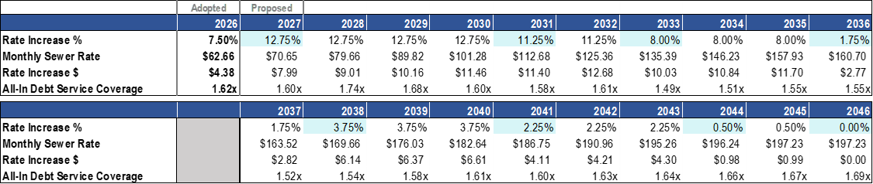
For reference, the 2026 sewer rate forecast is shown in Figure 2.
Figure 2 Adopted 2026 Sewer Rate and 2026-2045 Forecast
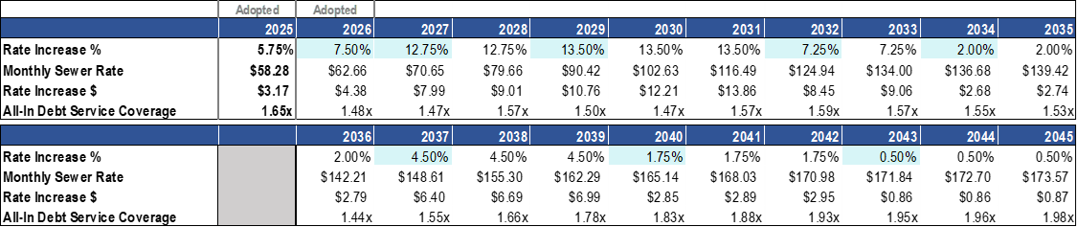
The proposed capacity charge is $83.10, or a 6.6 percent increase over the 2025 rate of $77.99. The financial forecast incorporates capacity charge revenue increases as shown in Figure 3.

Figure 3 Proposed 2027 Capacity Charge and 2028-2031 Forecast
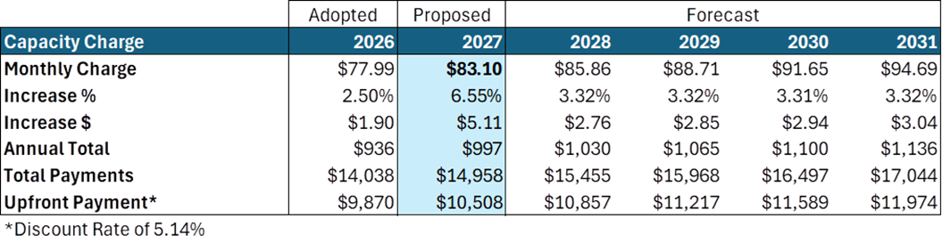

Introduction

King County Wastewater Treatment Division
The Wastewater Treatment Division (WTD) of the Department of Natural Resources and Parks (DNRP) is a utility providing wholesale wastewater treatment and major conveyance for 34 local sewer agencies (18 cities, 15 sewer districts, and the Muckleshoot Indian Tribe) in the Puget Sound region. Distributed over a 424-square-mile service area, the King County (County) sewer system collects and treats an average of 182 million gallons of sewage a day from approximately 2 million residents. WTD’s service area map can be found in Figure 4.
WTD is responsible for the construction, operation, and maintenance of the County’s regional wastewater conveyance and treatment system. The system includes three regional secondary treatment plants (West Point in Seattle, South Plant in Renton, and Brightwater in southern Snohomish County); 400 miles of conveyance lines; 48 pump stations; and 26 regulator stations. Other WTD facilities include five combined sewer overflow (CSO) treatment plants, four CSO storage facilities, 39 CSO outfall locations, two secondary community-scale treatment plants (Vashon Island and Carnation), and one community septic system on Vashon Island.

Local Sewer Agencies
WTD’s service area is comprised of Local Sewer Agencies (LSAs), which include 18 cities and 15 sewer districts in King County, southern Snohomish County, northern Pierce County, and the Muckleshoot Indian Tribe.
LSAs contract directly with WTD for wholesale wastewater treatment services. WTD does not have a direct relationship with individual sewer ratepayers, except for Capacity Charge, High-Strength Surcharge, and Industrial Waste customers., Engagement with the LSAs is accomplished through the MWPAAC and the Regional Water Quality Committee (RWQC). The sewage disposal contracts with the LSAs specify that the following year’s sewer rate must be determined before July 1 of the current year. This provides time for the LSAs to include the WTD rate in preparing budgets and proposing local sewer collection rates for the following year.
The LSA contracts define two customer classes for billing the sewer rate: single-family residential (SFR) and flow-based residential customer equivalents (RCEs). Flow-based RCEs include all other customer classes (commercial, multifamily, and industrial), and one flow-based RCE is equivalent to one SFR. The service contracts specify that each flow-based RCE equals 750 cubic feet per month of water usage. In addition to sewer fees, LSAs are invoiced for their customers’ high-strength surcharge and industrial waste compliance and monitoring fees. To compensate for seasonal variation in water use, the service contracts provide for a quarterly rolling average to convert reported water use to billed RCEs. A list of the LSAs and their average 2025 reported RCEs is provided in Figure 5.

Financial Forecast
Utilities such as WTD are self-supporting enterprise funds and, therefore, must set fees to recover the cost of providing services. Utility costs include operations, maintenance, debt service, and building new capital infrastructure. Utilities must also account for cash requirements from financial policies, such as funding reserves and how capital projects are funded. The total revenue that must be generated by a utility, in any given year, to cover costs and meet financial policies is referred to as a utility’s revenue requirement.
WTD’s sewer rate and capacity charge are adopted annually and include development of a longer-term financial forecast. Initiated in response to Council Motion 16449, the rate forecast now extends to 20 years, instead of the previous 10. The proposed 2027 sewer rate and capacity charge are prepared in the context of the utility’s revenue requirements over the 20-year financial forecast. This document will cover each element of the financial forecast (Operating Expenditures, Capital Expenditures, Reserves Management, and Revenue).
Figure 4 System Map
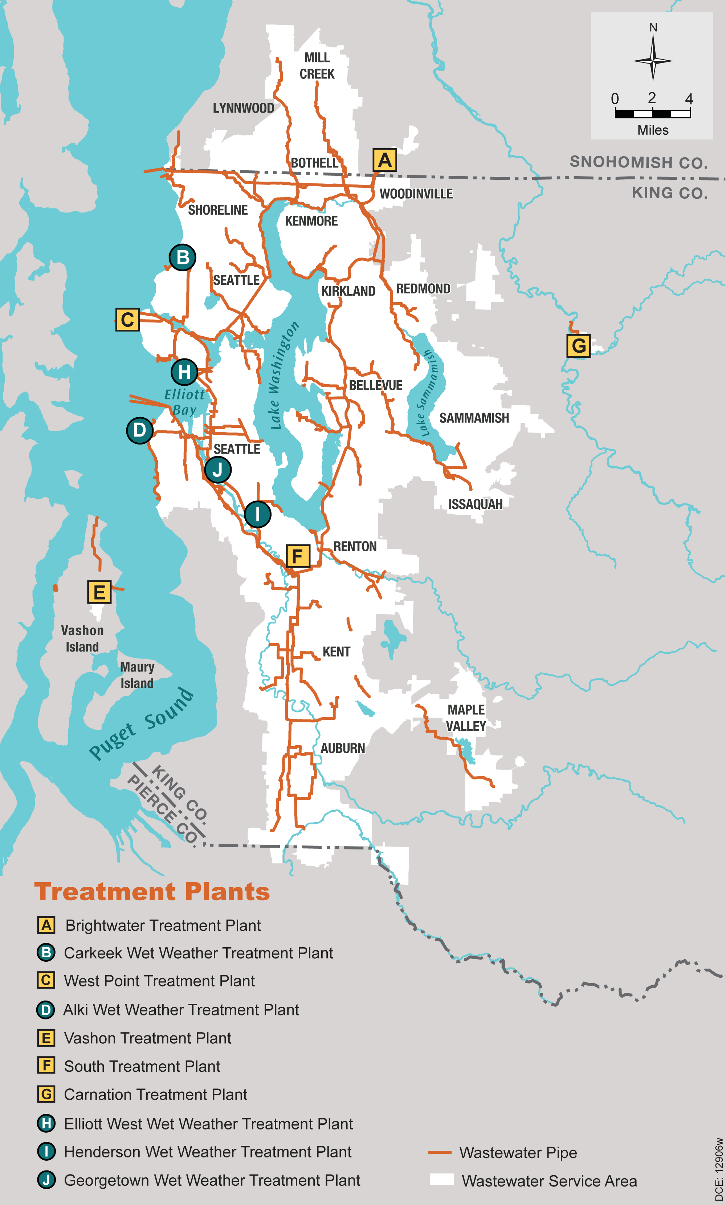
Figure 5 2025 Average Reported Residential Capacity Equivalents by Local Sewer Agency
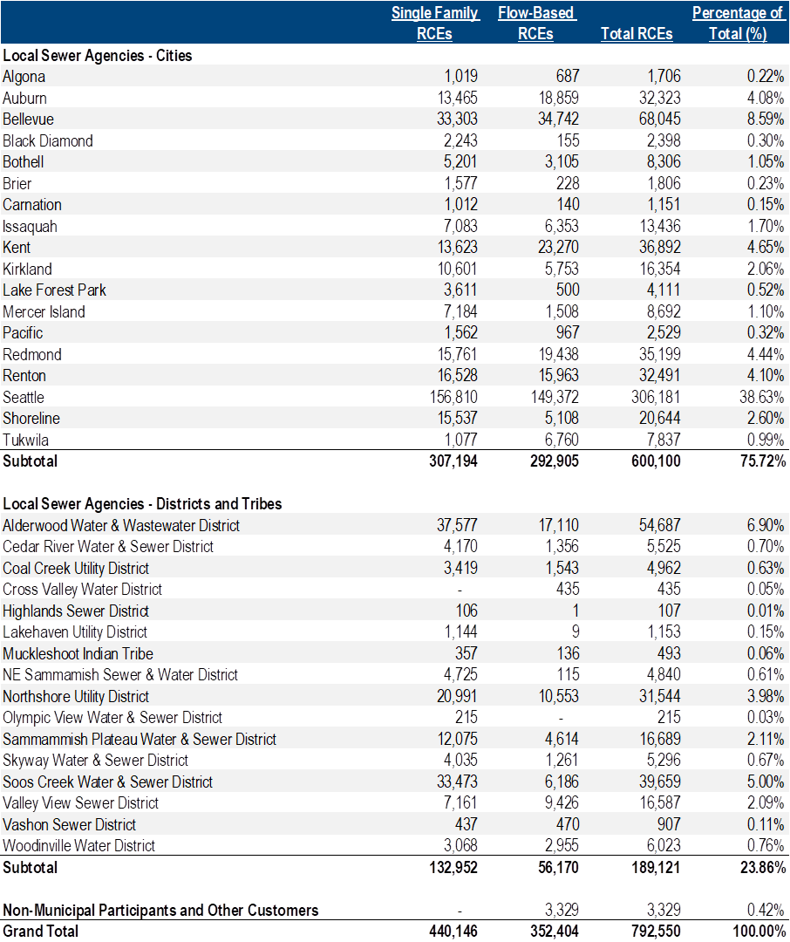

Operating Expenditures
WTD’s 2026 operating budget is the basis for forecasting operating costs for future years. The 2026 sewer rate and financial forecast included budgeted operating expenditures at $249 million.
Figure 6 shows the 2025 preliminary actuals compared to the adopted budget, along with the 2025 budget with percentage change, year over year. Of note, the County typically budgets on a biennial schedule, while the sewer rate is based on annual requirements. An annualized version of the biennial appropriation is used in rate-setting.
The 2025 operating expenses shown in Figure 6 reflect the existing operating budget as adopted, including the mid-year supplemental budget capturing unspent contractual commitments carried forward from 2024 as well as unplanned major repairs to the West Point access road.
Figure 6 2025-2026 WTD Operating Expenses ($ ‘000s)

Operating Forecast
Before the inflation surge that began in 2022, annual growth in WTD operating expenditures averaged nearly four percent per year. Including the recent high inflation years results in an annual average of 5.3 percent between 2014 and 2025. This growth represents a composite of inflation, supporting new facilities that come online, and maintaining an aging and growing system. Figure 7 shows the annual growth in operating expenditures going back to 2014.
Figure 7 Historical Annual Increase in WTD Operating Expenditures

WTD Operating Expenditures Forecast
WTD is maintaining the same bottom-line operating expenses for 2027 as was forecast during the 2026 rate process. This assumes all the budget adds from 2026 are maintained, plus large nondiscretionary adds related to utilities (primarily electricity), chemicals, biosolids hauling, and multiple labor agreement updates, totaling approximately $13 million in unbudgeted labor costs for the 2026/27 biennium based on current estimates. Given the size of the labor agreement costs and WTD’s commitment to focus on the highest efficient use of existing resources, additional staff are not proposed at this time. This will be revisited for the 2028 rate process and 2028-29 proposed budget.
Beyond 2027, incremental operating costs are forecast based on general cost and labor cost inflation at four percent. Growth in operating costs is forecast as shown in Figure 35.
WTD is preparing the specific decision packages for submittal in the 2026-2027 supplemental budget process.

Capital Improvement Program

Portfolio Management
Beginning in 2017, WTD focused on developing a more comprehensive and structured approach to managing its capital program. This work included the goal of aligning the mix of projects in WTD’s Capital Improvement Plan (CIP) with its strategic initiatives and overall mission. A pilot of this prioritization approach informed the 2019 sewer rate development and, since then, has been used to inform rate and budget-setting processes.
Projects are organized and prioritized within the following categories:
Figure 8 Capital Portfolio Category Descriptions
Category | Description
Asset Management Plants and Conveyance | Maintain level of service through the rehabilitation or replacement of critical assets.
Capacity Improvement | Increase capacity in WTD facilities to accommodate future growth.
Operational Enhancements | Reduce/improve operating costs at treatment plants through the delivery of projects that create efficiencies.
Regulatory | Deliver projects and programs that respond to permit, regulation, and/or consent decree legal deadlines.
Resiliency | Improve the survivability and operability of core assets against natural disasters through the delivery of projects that address known deficiencies.
Resource Recovery | Support the King County Strategic Climate Action Plan (SCAP) initiative through the delivery of projects that reduce energy use or recover valuable resources from wastewater.
Planning and Administration | Incorporate programs and projects that facilitate execution of the overall capital portfolio through a series of planning- and administration-related efforts.

2025 Performance and Accomplishment Rate
The capital accomplishment rate is the amount of actual or forecasted capital spending that occurs in the year compared with the amount of capital spending planned. WTD’s capital program accomplishment rate internal performance target of 85 percent for annual expenditures is evaluated against the actual spending in recent years to ensure that it remains a valid performance indicator.
The 2025 aggregated projects forecast was $534 million. Actual spending totaled $429 million or 80 percent of the forecast.
Drivers for the 80 percent accomplishment rate against WTD’s internal performance target include two large projects with significant underspend in 2025:
- The West Point Primary Effluent and Return Activated Sludge Pipe Restoration/Replacement project is currently under construction and involves multiple work packages that are dependent on dry season work. Because of this seasonal dependency to accommodate operation of the plant, scope needed to be re-phased and an additional work window in 2028 was added to the schedule. The project finished 2025 spending at $18 million, or 68 percent of the $26 million forecast.
- The North Mercer Island and Enatai Interceptors project also is currently under construction; however, the project is experiencing a delay in meeting contractual milestones. The external construction contractors are currently repairing defective work on a portion of the newly installed conveyance line, which has delayed progress on the pump station as well as the remaining work under the conveyance contract. King County is monitoring these contractors on daily activities to get the project back on schedule. The project finished 2025 spending at $18 million, or 75 percent of the $24 million forecast.
Figure 9 Previous Accomplishment Rate Measurement
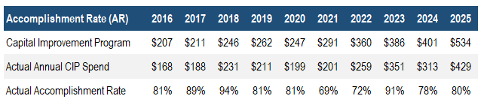

Risk-Adjusted Accomplishment Rates
Since 2022, as part of developing the proposed 2023 sewer rate, WTD has incorporated an assessment of expected staffing resources and schedule risks into its capital spending assumptions. This approach ensures that WTD does not secure funding for work it does not reasonably expect to deliver. By integrating this risk‑based analysis, WTD produced portfolio‑level capital forecasts that were lower than the sum of project‑by‑project estimates traditionally used in the sewer rate model. Since adopting this practice, the difference between actual capital spending and the assumptions used in the sewer rate model has narrowed, indicating improved alignment between planned and achievable capital delivery, as shown in Figure 10.
In developing the 2026 sewer rate proposal, the capital program forecast was reviewed to account for schedule risk and the likelihood that some project expenditures may shift into later years. This review resulted in a risk-adjusted forecast of $462 million. Compared to this adjusted target, 2025 actual spending of $429 million represents a 93 percent accomplishment rate.

Figure 10 Historical Accomplishment Rates for the Capital Program ($ in millions)

Estimated CIP Spending for 2027-2046 Financial Forecast
To develop the 20-year financial forecast, WTD estimates spending for active projects and develops conceptual forecasts for future projects and programs. Updates to project and program spending estimates consider changes in scope, risk, and schedule. The capital component of the forecast’s second decade also incorporates long-term forecast methodology developed by a consultant, Raftelis, to support WTD in response to Council Motion 16449 as interim financial estimates until the Regional Wastewater Services Plan Update provides the long-term capital project plan.
While WTD has prepared a 20-year capital forecast for sewer rate planning, the County budgets capital projects on a six-year CIP schedule. The following five projects are the largest individual components of WTD’s six-year CIP.

Mouth of Duwamish Combined Sewer Overflow
The Mouth of Duwamish Combined Sewer Overflow Program (MDCSO) will control five CSO outfalls in the area of the mouth of the Duwamish River. The outfalls (called Chelan, Hanford #2, Lander, Kingdome, and King Street) are located in the east and west waterways of the Duwamish River on both sides of Harbor Island and along the Seattle shoreline of Elliott Bay in the neighborhoods of SODO and West Seattle. This work fulfills consent decree requirements with the Washington State Environmental Protection Agency (EPA) and Department of Ecology (Ecology). The program team shared the proposed solution to control the five MDCSO outfalls in May 2025 and is currently doing on-the-ground surveys in the area around the planned facilities.

West Point Electrical Improvements
This program will replace approximately 300 electrical assets, relocate an additional nine electrical assets, and coordinate these efforts with other electrical and asset replacement projects at West Point Treatment Plant (WPTP) in Seattle. WPTP was constructed in the early 1960s and underwent a major expansion during the 1991 Secondary Treatment Facilities project. WPTP electrical assets from the Secondary Treatment Facilities project are now more than 25 years old and reaching the end of their life cycle. Additionally, assets installed during earlier WPTP construction are beyond the end of their life cycle and need replacement as soon as possible. Failure to replace these critical assets may result in diminished reliability, interrupted facility operations, and potential National Pollutant Discharge Elimination System (NPDES) permit violations. The program team forecasts that the improvements will be completed by 2033.

Elliot West Wet Weather Treatment Station
The Elliott West Wet Weather Treatment Station (EWWTS) project consists of new and upgraded treatment facilities to treat CSOs prior to discharge through the existing outfall in Elliott Bay. The project will make improvements that will result in full NPDES permit compliance at the EWWTS. Construction is anticipated to begin in 2027 and extend through 2033.

East Ship Canal Wet Weather Facilities
The conceptual project scope anticipates construction of a large storage facility around the University of Washington and Montlake areas to control and bring into compliance the University and Montlake Regulator Stations, the Belvoir Pump Station, and upgrade the Densmore Pump Station. This project is required by the modified 2013 federal consent decree with the U.S. Department of Justice, the EPA, and Ecology. The project recently secured budget appropriation in the 2026-2027 biennial budget to begin planning and preliminary design activities.

West Point Treatment Plant Critical Gate Refurbishment
The project will restore full functionality to critical treatment plant wastewater flow control gates and their support systems at the WPTP in Seattle. Support systems include operators, hydraulics, and controls. Gates and support systems will be renewed or replaced in kind. The first two major projects identified under this program address the WPTP primary effluent gate and the chlorine mix structure gate. These projects are currently forecasted to be completed by 2029 and 2030, respectively.

Other Capital Projects
New projects, along with updated spending forecasts and schedules for the existing capital program, form the basis for developing the CIP for the financial forecast. The updated forecast includes continued deferral of pipeline capacity projects that have neither a population growth driver nor overflows within the last five years, so that capital delivery capacity can be dedicated to higher-priority system investments.
Figure 11 summarizes the capital investment strategy used to develop the proposed sewer rate forecast.
Figure 11 WTD CIP Investment Strategy
CIP Policy Topic | Basis for Investment Strategy
CSO Consent Decree Cost & Schedule | Maintains project cashflows related to the CSO consent decree to meet 2037 end date. Includes recent cost updates to the Mouth of the Duwamish CSO control program.
Nutrient Removal - Ecology Permit | Includes Nitrogen Reduction Planning, Nutrient Reduction Evaluation Study, and Near-Term Optimization Capital Investments. Includes proactive/multibenefit investment to optimize nitrogen removal at South Plant as comparably modest investments while nutrient regulations are uncertain.
Asset Management (Plants & Conveyance) | Continues sequencing of projects remaining in the current high-risk inventory, then transitions to replacing assets at end of useful life; cost projected to year of replacement
Building for Capacity | Includes conceptual forecasts for projects identified by the Treatment Planning Program and Conveyance System Improvements Program to address plant and conveyance system capacity limitations. Deprioritizes conveyance system projects resulting from inflow and infiltration in the first decade.
Capital Program Staffing | Assumes that a ramp-up of capital delivery continues as WTD continues to hire, onboard, and train additional staff added in previous budget cycles. No additional staffing assumed for 2027.

Capital Expenditure Delivery Capacity Analysis
WTD is preparing for a significant increase in the volume of capital projects it will need to deliver to meet regulatory requirements, address aging infrastructure, and meet the needs of a growing regional population. As the capital program expands, the division is intentionally aligning commitments and funding requests with realistic delivery capacity so that WTD does not secure funding for work that it does not anticipate having resources to deliver.
Expansion of Full Time Equivalent (FTE) Positions
Between 2021 and 2025, WTD steadily increased the number for FTEs dedicated to capital delivery. This investment has expanded the division’s ability to plan, design, and construct projects. During the same period, annual capital expenditures have increased from approximately $200 million in 2021 to $429 million in 2025.
Many of the recently added staff are currently assigned to projects in early design phases. As these projects advance to construction, WTD expects a corresponding increase in project throughput and capital spending.
Additional Strategies to Increase Throughput
WTD has implemented several additional strategies to increase delivery capacity. These include:
- Aligned project delivery staff with operational facilities, which reduces onboarding time and improves coordination.
- Expanded consultant support in engineering and program management to support internal staff.
- Bundled discrete scopes of work into larger contract packages to reduce the number of procurements and accelerate delivery.
- Increased use of alternative delivery when appropriate to improve schedule and cost certainty.
- Enhanced contractor outreach to strengthen WTD’s position as an owner of choice and encourage competitive bidding.
Mega Project Delivery Considerations
A significant portion of forecasted spending through 2036 is being driven by mega projects with costs exceeding $1 billion. These projects benefit from economies of scale in staffing, as they typically rely on a relatively small team of internal staff, supported by large consultant teams. Construction costs also represent a larger share of total overall costs when compared to typical projects.
For example, to deliver the Brightwater Treatment Plant, which cost $900 million, about three percent of the total cost was WTD staff labor and about 13 percent was consultant labor. The remaining costs were land purchases, permitting, and construction.
Pre-Budget Capacity Analysis
The 2026-2027 Biennial budget and six-year CIP form the basis of the WTD capital forecast. To assess delivery capacity, WTD performed two complementary analyses during budget request development.
Model 1: Qualitative Assessment by Project Delivery Managers
WTD delivers projects using a matrixed staffing model. Project teams are composed of cross-functional staff from managerial units organized by functional discipline, such as engineering or construction management. Each discipline is managed by a functional unit manager responsible for assigning staff to cross-functional project teams.
These functional unit managers conducted a qualitative review of staffing based on professional judgement and knowledge of anticipated workloads. Because capital projects vary widely in scope and complexity, this approach focused on understanding the nature of upcoming work and the cross-functional labor required.
Each unit evaluated its current workload and identified available capacity to initiate new projects in 2026. This established a baseline for near-term delivery capacity. Managers then projected staffing needs for 2027 and identified the additional positions needed to deliver the planned work. This resulting staffing gap informed the 2026 FTE request. Division leadership refined this request prior to budget submittal.
Model 2: Quantitative Forecasting Using Project Level Labor Data
WTD also piloted a quantitative resource forecasting model that estimates staffing needs based on the project-level labor forecast included in the 2026–2027 capital budget requests. The model incorporates historical project labor expenditure data, forecasted labor needs for ongoing projects, and standard labor-hour assumptions to convert hours into FTEs.
The model’s results closely aligned with the staffing needs identified through qualitative assessment, validating its results. WTD will continue to refine the model by comparing forecasted labor demand with actual labor data. Over time, WTD anticipates using this tool to help model staff labor demand and capacity.

Figure 12 shows the annual capital investments included in the proposed sewer rate and financial forecast in their respective portfolio categories.
Figure 12 Proposed Capital Investments by Portfolio Category for 20-Year Forecast
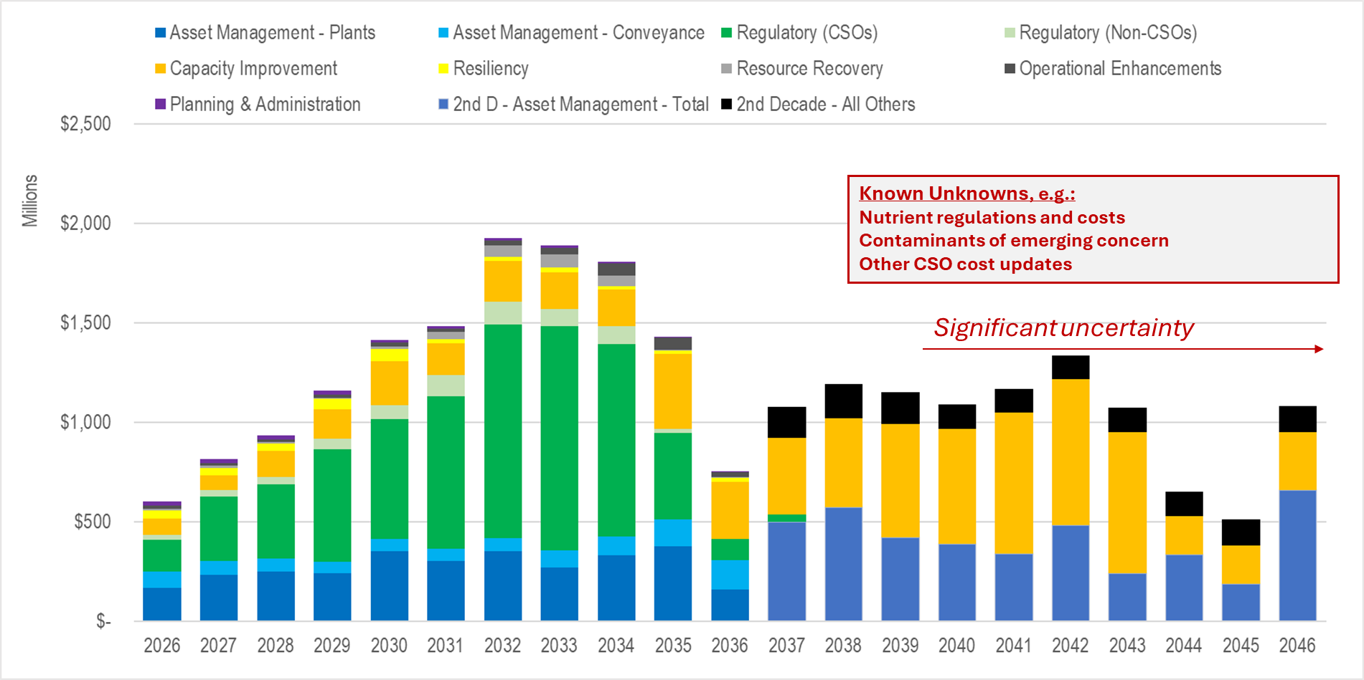

Capital Improvement Program Funding
The capital improvement program is funded by two primary sources: 1) cash generated from the sewer rate and capacity charge revenues; and 2) debt financing from revenue bonds or low-interest state and federal loan programs.

Cash Funding
Since 2023, WTD has used an original cost depreciation method for setting cash funding targets for its capital program. This method consists of targeting annual cash funding generated from sewer rate revenue, equivalent to WTD’s annual depreciation (including estimated new depreciation resulting from completion of projects in the CIP that become depreciating assets). The total forecasted depreciation over the next 10 years translates into approximately 27 percent of the total CIP. Cash-funding requirements are averaged over the next 10 years of the forecast period, allowing WTD to smooth rate increases and produce a more stable rate path.
Since the target cash funding is accumulated over the course of the year, a single year-end transfer to the construction fund from the operating fund makes the cash available for funding capital projects in the following year.

Debt Financing
Debt financing is used to provide the remaining funds needed after the use of cash. Debt financing represents 73 percent of total project funding over the next 10 years. The main sources of debt available to WTD include state loans, federal Water Infrastructure Finance and Innovation Act (WIFIA) loans, and revenue bonds.
As interest rates began rising in 2022, WTD successfully reduced its reliance on issuing new high-interest revenue bonds in 2022 and 2023. This was possible due to a large bond issuance in 2020 at record-low interest rates, low-cost commercial paper for interim financing, and the availability of state and federal loans at below-market interest rates. With reduction in interest rates beginning in the second half of 2024, WTD raised funds again from the bond markets. In 2025, WTD raised $565.0 million from new bond issuances, including $400.0 million new money for capital funding and balance $165.0 million for refunding. WTD also signed Tranche 3 under the WIFIA Master Agreement for $65.0 million for its Black Diamond Trunk Capacity upgrade project in January 2026.
Figure 13 shows the capital funding forecast and the use of various debt instruments secured to fund the capital program. The higher cash funding shown in 2026 is the result of WTD’s debt issuance in November 2025 to fund capital programs in 2026.
Since state and federal loans work on a reimbursement basis, WTD needs to issue interim debt prior to being reimbursed for the project costs. Once reimbursed, WTD can retire the interim debt, which is then available for future projects that require interim financing. By 2032, WTD plans to draw on its $255.4 million WIFIA loan to reimburse interim debt. This strategy is beneficial as WTD can use low-interest interim debt during the construction period while remaining eligible for an interest rate reduction, provided the loan remains undrawn, capital expenditure does not exceed 51 percent of total costs, and the State and Local Government Services (SLGS) rate is lower than when the loan agreement was first signed.
Figure 13 Capital Funding Sources
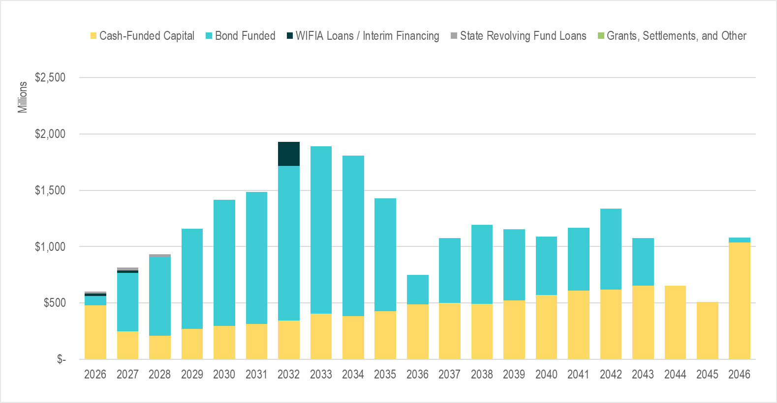
Figure 14 illustrates how, as existing debt is retired, repayment capacity is replaced by new debt issued to fund the capital program. Figure 14 shows how WTD’s debt-to-asset ratio declines over time, demonstrating the higher cash funding percentage over time and an increase in the total asset base as capital expenditure ramps up.
Figure 14 Existing and New Debt Balances
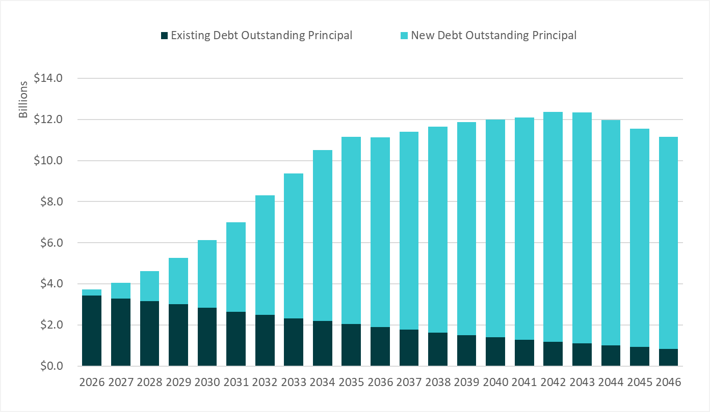

Figure 15 Debt to Asset Balance
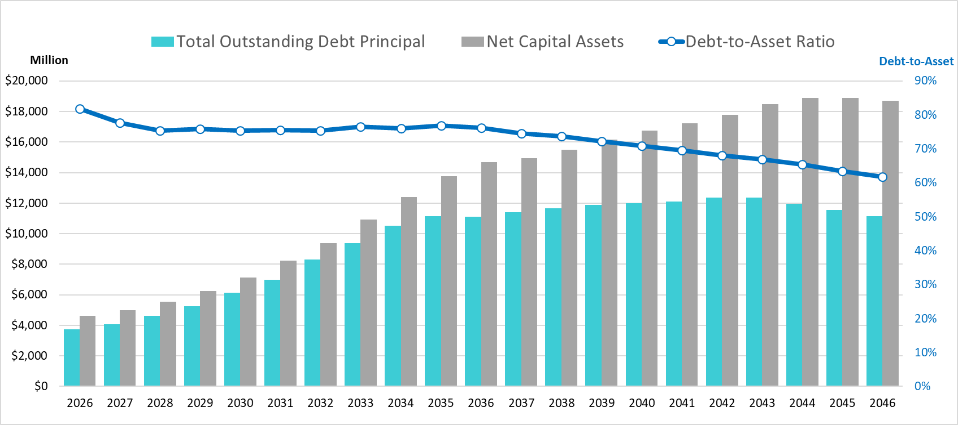

State Revolving Fund Loans
Joint Ship Canal Water Quality Project. In 2022, the Joint Ship Canal project was awarded $3 million in addition to $23 million awarded in 2021, for a total of $26 million at a 1.4 percent interest rate. The $26 million state revolving fund (SRF) loan amendment was approved by Ordinance 19575 in February 2023. It will provide $12.6 million in total savings over a 30-year period due to a low interest rate. WTD drew $11.4 million from this loan and expects to fund the balance costs via the WIFIA loan as construction progresses over the course of 2026 and 2027.
Multiple SRF Loan Agreements. In 2024, Council approved multiple SRF loan agreements with Ecology to support key wastewater projects. On February 27, 2024, Council approved a $9.4 million SRF loan at 1.4 percent interest over 30 years for the West Point Passive Weir Emergency Bypass project. On September 24, 2024, Council approved two 20-year SRF loan agreements to fund $10.2 million for the West Duwamish CSO Control project’s design and $14.9 million for the West Point Treatment Plant Raw Sewage Pump Replacement project at 1.2 percent interest. On December 10, 2024, Council approved two additional 20-year SRF loans at 1.2 percent interest, including $1.1 million for the West Point Treatment Plant Grit Classifier Replacement project and $8.1 million for the Sammamish Plateau Diversion project. The $43.7 million in SRF funding will provide an estimated $22.6 million in total savings over the life of the loans.
In 2025, Council approved additional $43.9 million loan at 1.6 percent for West Duwamish CSO Control project’s construction.

Water Infrastructure Finance and Innovation Act Loans
Joint Ship Canal Water Quality Project. In January 2021, WTD was awarded a $96.8 million WIFIA loan at 1.69 percent interest, which will provide an estimated $32.5 million in total savings over a 35-year period due to a low interest rate. In April 2024, WTD made its first $9.6 million draw and in December 2025, WTD made an additional $33.3 million draw, with the final draw to occur by March 2028. WTD plans on drawing from this loan as construction progresses over the course of 2026 and 2027.
WIFIA Master Agreement. In January 2024, the County was awarded its first WIFIA Master Agreement for the King County Wastewater 2024 Improvement Projects in the amount of $498.3 million. The Master Agreement will finance 11 water quality projects across four separate loan tranches over the eight years of construction. The first loan tranche was signed in conjunction with the Master Agreement in the amount of $194.1 million at 4.4 percent interest for the group of West Point Treatment Plant projects. In December 2024, WTD signed its second loan tranche in the amount of $89.9 million at 4.44 percent interest for two projects at South Plant. In January 2026, WTD signed its third tranche in the amount of $65.0 million at 4.79 percent interest for the Black Diamond Trunk Capacity upgrade project. WTD plans to initially fund these projects with low-cost interim commercial paper and draw from the loans later. Although the interest rate is higher than prior WIFIA loan agreements, WTD can apply for an interest rate reduction over the next several years, which would reduce WTD’s expected debt service. The subsequent loan tranche (totaling $149.3 million) is slated to be signed in 2026.

Proposed Legislation to Restore Tax-Exempt Advanced Refunding
Tax-exempt bonds are issued by state and local governments for public infrastructure projects. WTD uses tax-exempt bond financing as its primary source of long-term financing for the capital program. Investors who purchase these bonds are exempt from paying federal income tax on interest earnings, so they are willing to buy the bonds at a lower interest rate than those of conventional bonds, which translates as lower-cost debt to the borrower. Prior to the 2017 federal Tax Cuts and Jobs Act (TCJA), tax-exempt advance refunding bonds could be issued to refund outstanding tax-exempt debt with higher-than-current-market interest rates. The TCJA eliminated tax-exempt advance refunding bonds.
In April 2025, proposed federal legislation, S.1481–LOCAL Infrastructure ACT, the Lifting Our Communities through Advance Liquidity for Infrastructure Act, was introduced in the U.S. House of Representatives. This is the most recent piece of legislation that would restore the tax-exempt status of advance refunding bonds. WTD is closely monitoring the viability of this effort as it moves through the legislative process and has prepared a list of potential refunding opportunities should the legislation be enacted.
The current restriction resulting from the TCJA on issuing tax-exempt advance refunding bonds does not limit the use of cash for advance refunding. In comparison with issuing tax-exempt advance refunding bonds, the ability to take high-interest-rate debt off the books through defeasance is limited by the utility’s ability to generate cash from ongoing revenue sources.

The Financial Data Transparency Act of 2022
Former President Biden signed the Financial Data Transparency Act of 2022 (FDTA) into law in December 2022. The FDTA sets forth a sequence of regulatory steps to implement structured data requirements for the securities markets, including the municipal bond market, with the goal of providing machine-readable, searchable, comparable (e.g., standardized), structured financial data to investors and others. Along with other federal financial regulatory agencies, the federal Securities and Exchange Commission (SEC) is required to adopt data standards, including municipal market data standards for information submitted to the Municipal Securities Rulemaking Board (MSRB).
The sequence of regulatory steps is expected to take place during 2026, with municipal market data standards adopted by December 2026. Compliance is expected to begin in 2027. WTD is following this development closely with bond counsel and the County’s financial advisor.

Defeasance
Defeasance is the process of setting aside funds or assets to repay a debt or obligation, thereby releasing the debtor from further liability. Cash generated from WTD’s funding policy (see cash funding section above) can be used to directly fund capital spending or to pay down higher-interest outstanding debt. This accomplishes the same debt-balance outcome as directly cash-funding the CIP, while replacing high-interest-rate debt with lower-interest-rate new debt in the current market. A defeasance transaction usually occurs when interest rates are favorable enough to achieve maximum savings and meet the County’s minimum savings threshold of five percent of the par amount of the refunded bond. In February 2025, WTD defeased $92.3 million of bonds and generated $8.6 million in total savings and $7.2 million in present-value savings through this mechanism.
Figure 16 demonstrates how the use of the cash collected from sewer rate revenue for CIP funding can be used for defeasance and accomplish the same debt-balance management goal.
In the no-defeasance scenario, new bonds are issued and added to the debt balance at 60 percent of the annual CIP, while the remaining 40 percent is cash-funded. The sample ending debt balance in this scenario is $800.
In the defeasance scenario, additional debt is issued to cover the full CIP (rather than 60 percent), which frees the cash from rates to pay down outstanding higher-interest-rate debt. There is an effective exchange of higher-interest-rate debt on the books for lower-interest-rate debt available at current market conditions. The sample ending debt balance in this scenario is also $800.
Figure 16 Sample Defeasance

Reserves Management
WTD maintains financial reserves that address minimums required by debt covenants (contracts), working capital targets, management of loan proceeds, and other capital resources, rate increase smoothing, and mitigation of revenue risk. This section describes those reserves and the reserve levels targeted in the financial forecast.
Figure 17 Summary of WTD Reserves
*Ecology eliminated this provision for loans awarded after 2018

WTD Operating Fund 4611

Unrestricted Operating Balances
The Operating Fund is where WTD’s daily expenses, such as most personnel costs, supplies, and other costs associated with operating and maintaining the utility, are funded. Funds exceeding minimum reserve levels in the Operating Fund at year-end are unrestricted and evaluated for optimal use. Some uses for unrestricted funds include potential transfer to the Construction Fund or contribution to defeasance transactions.

Liquidity Reserve
The Liquidity Reserve is targeted to provide sufficient cash balances for variance of revenue and expenditure cycles throughout the year. The working capital target is established as 10 percent of operating expenditures in any given year. As a result, a reserve increase must be funded each year as operating expenditures increase. The proposed 2027-2046 financial forecast includes $26.8 million in Operating Liquidity Reserve, $5 million in the Capital Liquidity Reserve, and $35 million in the Capital Liquidity Threshold for 2027.

Voluntary Operating Reserve
The Washington State Auditor’s Office publishes financial ratios for government agencies in its Financial Intelligence Tool (FIT). In mid-2024, the State Auditor began publishing ratios for King County’s major enterprise funds for the first time and WTD showed a “concerning” indicator.
One of those indicators is the current ratio (current assets divided by current liabilities), which should be at least 1.0. For 2023, WTD’s ratio was 1.05, only slightly above the minimum target. Given the current ratio concerns and the importance ratings agencies place on unrestricted liquidity, WTD is establishing a “voluntary reserve” in Fund 4611. These funds are not legally restricted by bond covenants but using those funds would likely result in negative consequences from bondholders and ratings agencies, including potentially higher future borrowing costs. The voluntary reserve currently consists of $103 million in the operating fund.

Rate Stabilization Reserve
A Rate Stabilization Reserve (RSR) is unique in that bond covenants are written to allow that, in any given year, use of this reserve can be recognized as revenue eligible for inclusion in the bond coverage calculation. In years that WTD contributes to this reserve from WTD Fund revenues, that portion of revenue is deducted from the revenue basis for calculating bond coverage. This allows WTD to use reserves to manage rate levels without compromising the ability to meet annual bond coverage targets. Funds in the RSR also enhance the liquidity metrics used by the rating agencies when they evaluate WTD’s credit quality.
WTD considers the use of reserve balances in the context of Ordinance 19782, which states that the RSR is for the purpose of smoothing rates between years. Use of reserves represents a one-time resource, and excess reserves should be applied to one-time expenditures. There is no planned use of the RSR ($46.25 million) in the proposed 2027-2036 sewer rate forecast. There has been interest from stakeholders in WTD transitioning to a multiyear rate proposal beginning in 2028. If implemented, the RSR could be used in the event of a revenue shortfall in later years of the rate cycle.

WTD Construction Fund 3611

Unrestricted Construction Fund Balances
WTD’s Construction Fund is where capital project costs are charged, loan proceeds are reserved and spent, transfers are received for cash-funded capital from the Operating Fund, and capital reserves, such as the Asset Management Reserve, are maintained. Accumulated reserves above the policy minimum are used to fund projects.

Capital Liquidity Reserve and Threshold
In 2024, WTD established a minimum $35 million ending balance in the capital fund (Capital Liquidity Threshold) to complement its $5 million Capital Liquidity Reserve. This change reflects the increase in monthly capital spending since the inception of the policy. The Construction Fund balance is projected to end at the $40 million liquidity reserve ($5 million reserve + $35 million threshold) target in each year of the financial forecast.

Asset Management Reserve
The Asset Management Reserve is maintained as an emergency reserve and, as such, is not forecast to deviate from the $15 million balance. This reserve could be an important resource if an asset failure should occur during a period of significant revenue constraint.

Debt Reserve Funds 8921 and 8922
WTD’s debt reserve minimums were originally established as a requirement in bond covenants or by the loan-granting agency. However, with 51 percent of bondholders consenting to the “Springing Amendment” through their purchase of parity bonds, WTD is no longer required to maintain an amount equal to the maximum annual debt service on outstanding parity bonds in the Debt Service Reserve Fund (DSRF)., , In June 2024, Council approved Ordinance 19785, which not only authorized the issuance of $1.2 billion in senior lien debt through December 2026, but it also provided the framework for the King County Finance Director to change the definition of reserve requirement. This means the County can create different reserve requirements for different sets of parity bonds, including the bonds themselves. The County could also lower any reserve requirement, even down to zero, in any calendar year, as long as it is less than the maximum annual parity debt service. In 2025, WTD sprung the entire cash portion of the DSRF into a Redemption Account ($37.0 million) to fund future bond payments, a Voluntary Reserve ($83.2 million) to act as cash on hand to manage short-term liquidity, and into longer dated investments managed by the County ($10.6 million). A Debt Redemption Account is a restricted account used to accumulate funds designated for the repayment, redemption, or defeasance of outstanding debt obligations. Amounts held in the account may be used to pay scheduled principal and interest or to retire debt prior to maturity in accordance with bond covenants or applicable financial policies. Currently, there are no funds in the DSRF. WTD has still maintained its investments of $29.6 million in surety bonds.
Ecology had a reserve requirement but eliminated this provision for loans awarded after 2018. Reserves for pre-2018 Ecology loans decreased from $13.5 million to just $219,400 after the refunding of a group of loans in 2021 and the repayment of the Denny Way Elliott West Pipeline SRF loan. The current balance is also $219,400 as of December 31, 2025.

Figure 18 Surety Bond Summary

Revenue
Once WTD’s operating and capital obligations have been forecast, the revenue requirement can be calculated. The sewer rate and capacity charge, together, made up 92 percent of total operating revenues for 2025. Figure 19 shows WTD’s 2025 revenue and projected 2026 and 2027 revenue by source.
Figure 19 Operating Revenue Components Sorted by Size
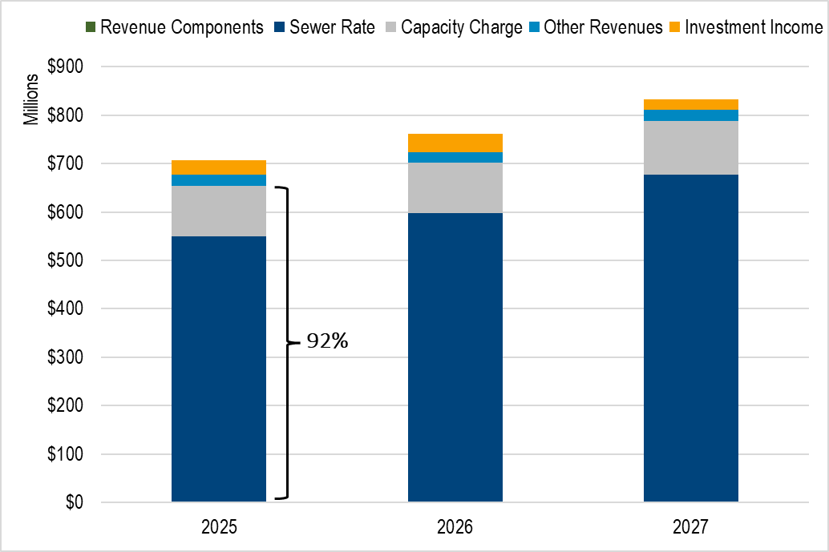

Revenue Requirement
Two tests guide rate setting and determine a utility’s annual revenue requirement: the cash test and the debt service coverage test.

Cash Test
The utility must first ensure that it can support its cash obligations, including operating expenditures, debt service repayment, and any financial policy targets, such as cash to fund the capital program.
King County Code 28.86.160 Financial Policies state:
King County shall charge its customers sewer rates and capacity charges sufficient to cover the costs of constructing and operating its wastewater system. Revenues shall be sufficient to maintain capital assets in sound working condition, providing for maintenance and rehabilitation of facilities so that total system costs are minimized while continuing to provide reliable, high-quality service and maintaining high water quality standards.
Figure 20 shows the components that make up the total annual revenue requirement, compared with revenue under the existing sewer rate.
Figure 20 2026 - 2046 Sewer Rate Forecast Revenue Requirement
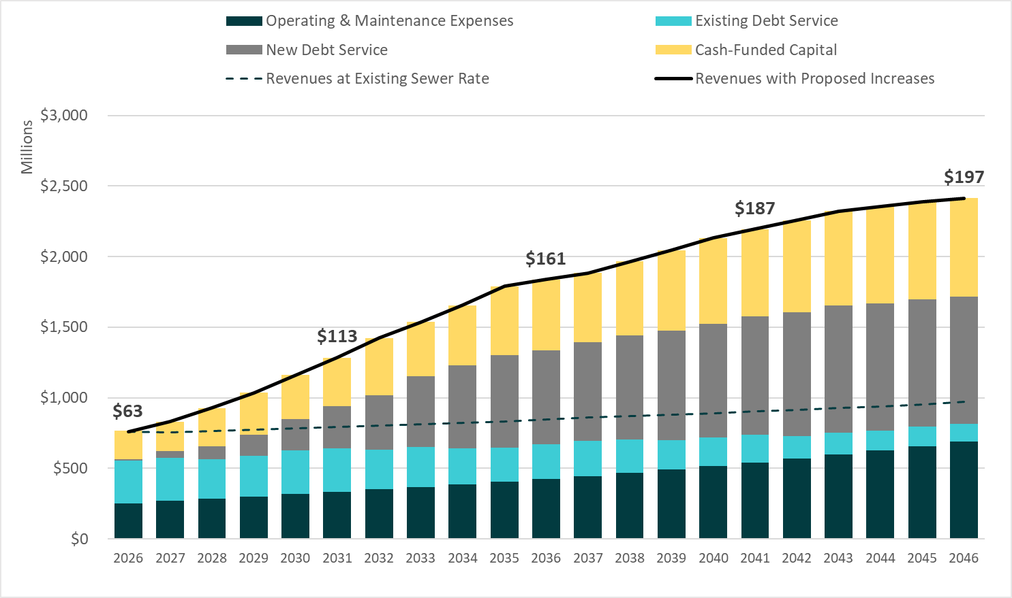
Beginning from the bottom of Figure 20, the first stack (dark blue) in the bar represents the annual operating and maintenance (O&M) expenses with projected inflation and growth. The second stack (teal) shows the debt service obligations for existing outstanding WTD debt. The third stack (gray) represents new debt service repayments generated by funding the capital program in this forecast. The top stack (yellow) represents the policy to cash-fund the capital program from revenue, at an amount based on annual depreciation.
The dashed line shows the forecasted level of revenue generated if the sewer rate were to remain at the current 2026 rate of $62.66 for all years of the forecast, to demonstrate the utility’s funding gap at the current rate. The solid line at the top of the bars shows the revenue meeting the annual requirement in each year based on the proposed rate forecast.
Figure 21 Proposed 2026 Sewer Rate and 2027-2045 Forecast [also available on page 6]

Debt Service Coverage Ratio Test
The second revenue requirement test is the debt service coverage ratio (DSC) test. DSC is a financial metric used to assess an entity's ability to generate enough cash to cover its debt service obligations. DSC is calculated by taking free cash flow, cash available after paying for operation and maintenance, and dividing it by current debt obligations. DSC is broadly used in the industry and is of particular interest to rating agencies. MWPAAC recommended WTD maintain a DSC ratio above 1.40 in 2017 and WTD must maintain a DSC above 1.15 per bond Ordinance. The sewer rate proposal and financial forecast produce a DSC ratio of free cash flow to current debt obligations ranging from 1.49 to 1.74. As shown in Figure 22, WTD’s historical coverage performance has increased steadily since 2016 and achieved a record-high DSC in 2024. WTD’s bond ratings did not change in 2025, although the DSC decreased slightly to 1.86.
Figure 22 History of WTD DSC and Ratings
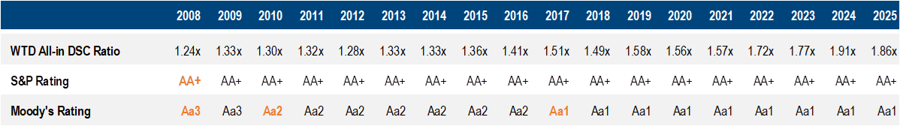

Sewer Rate
Sewer rate revenue is the largest component of WTD operating revenues at 78 percent. Single-Family Residential (SFR) customers make up 56 percent of the sewer rate customer base and are billed at one unit per household, regardless of water use. The remaining 44 percent of residential customer equivalents (RCEs) are comprised of commercial and multifamily customers in a combined rate class. An RCE is a unit used for billing purposes that converts reported water use (as a proxy for sewage flows) to the approximate equivalent of one SFR. As defined in the LSA contracts and King County Code 28.86.160, Financial Policy 15, one RCE is equal to 750 cubic feet of water usage per month.

Billing Structure
In contrast to the retail agencies that read meters and bill customers, either monthly or bimonthly, RCE reporting and billing are performed on a quarterly cycle. As shown in Figure 23, billings for the SFR class in a given quarter are based on RCEs reported in the quarter before the previous one (e.g., Q2 billing is based on Q4 reported).
The commercial and multifamily billing structure includes additional delays because these billings are based on a quarterly rolling average of RCEs, with the intent of minimizing variability of billings to the agencies. Figure 24 shows there is significant seasonal variability to flow, which the quarterly rolling average smooths. There was a significant drop in flow-based RCEs in 2020 as a result of the COVID-19 pandemic, but they have now recovered to pre-pandemic levels.
Figure 23 RCE Reporting to Sewer Rate Billing Lag
Figure 24 shows the historical trend in total customers billed since 2011.

Figure 24 Reported SFRs and Flow-Based RCEs by Quarter (2011-2025)
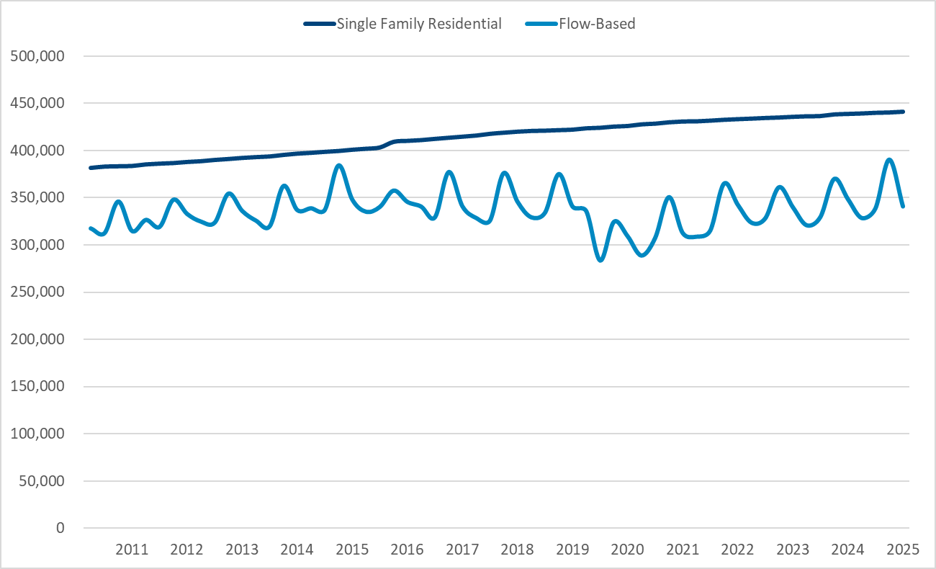

Historical Sewer Rate Increases
To provide context for the historical rate of growth to the revenue needs of the utility, rate increases since 1990 are provided in Figure 25. Since 1990, the average annual rate increase is 4.7 percent.
Figure 25 Historical Sewer Rate Increases (1990-2026)

2027 Sewer Rate Proposal and 2027-2046 Forecast
After determining revenue requirements and revenue generated from other sources, the sewer rate proposal is developed to meet both the cash test and the DSC test. A monthly sewer rate of $70.65 in 2027, which is a 12.75 percent increase, is proposed in the Ordinance.
While an increase in the rate forecast is proposed, the 2027 proposed rate is the same as the 12.75 percent increase forecasted in the 2026 rate forecast. The 2027 updated rate forecast beyond the 2027 proposed rate includes higher rate increases as shown in Figure 26 and Figure 27 below. Highlighted changes between rate forecasts include:
- Multiple Scenarios—Per Council Budget Ordinance 20023, Proviso Section 115 P4, WTD is required to provide two alternative scenarios in addition to the Executive’s proposed rate, including at least one that is two percentage points lower than the Executive's proposed rate. These two scenarios are presented in detail later in this memorandum. Although both achieve some short-term rate relief within the next few years, neither result in a sustained lower rate path compared to the proposed rate.
- Updated capital cost estimates and schedule—WTD received updated cost and schedule estimates for multiple projects (such as the Mouth of the Duwamish CSO control project) mandated by the federal CSO consent decree. These revised estimates resulted in higher capital costs, but also a slightly deferred schedule, resulting in a slight decrease in projected rate increases in the next five years compared to the 2026 forecast.
- Schedule Risk Adjustment—This is the second year of WTD’s new capital forecasting approach. Previously, WTD applied an 85 percent accomplishment rate, where rates were set to fund 85 percent of the projected capital project expenditures in a given year based on WTD’s experience with how much capital spending could reasonably be accomplished. This had the effect of applying a “haircut” to the forecast, rather than showing the additional 15 percent in future forecast years. WTD now implements a “schedule risk adjustment,” where deferred costs (20 percent of early years) are now shown in future years of the forecast.
Figure 26 Adopted 2026 Sewer Rate and 2026-2045 Forecast

Figure 27 Proposed 2027 Sewer Rate and 2027-2046 Forecast [also available on page 6]

Legal Disclaimer
The rate forecast above projects approximately $14 billion over the next decade to meet state and federal regulations, serve the needs of new population growth, and maintain and modernize King County’s aging infrastructure. Investments in this system are essential to protect water quality and public health for decades to come.
The rate forecast proposes significantly higher rates beginning in 2027, and extending for several years. This increase is driven by multiple factors, the largest of which are capital projects required under federal and state clean water regulations.
WTD regcognizes that higher sewer rates add to the already high cost of living in the Puget Sound region and have the greatest impact on lower-income households. As stewards of public dollars, WTD is committed to a rate-setting process that is transparent, fact-informed, and thorough, and exploring cost-effective ways to keep rates as affordable as possible for all King County families.
As part of this work, the King County Council requested that WTD develop several rate scenarios outlining the benefits, risks, and other impacts associated with each approach.
While these scenarios show that deferring some current and planned capital projects may provide short-term rate relief, delaying capital investments can also introduce significant long-term risks that ultimately increase costs and operational challenges exponentially.
The theoretical regulatory deadline extension scenario is dependent on federal and state regulators agreeing to further modify the CSO consent decree, which was recently modified and finalized in 2025 after a six-year negotiation process. Others may illustrate circumstances under which projects with specific federal or state requirements and/or funding agreements would be deferred. The scenarios are purely intended to outline potential impacts over time. They do not represent, imply, or establish any plan, commitment, or intent by WTD or the Department of Natural Resources and Parks.

Alternative Scenarios
As part of the 2026-27 budget process, Council developed a proviso requiring the Executive to transmit a proposed sewer rate, plus two additional scenarios, one of which must be two percent lower than the Executive Proposed Rate. WTD has developed the following rate scenarios in addition to the proposed rate:
- The “Council Request Scenario” was required to be at least two percent less than the Executive’s proposed rate.
- The “Theoretical Regulatory Deadline Extension Scenario” represents a hypothetical scenario where WTD has renegotiated its consent decree requirements related to CSOs to allow for a longer implementation period. Successful negotiations with state and federal regulators would be needed to implement a similar scenario.

Council Request Scenario
The Council Request Scenario accepts higher additional risk of asset failure and some financial risk compared to the proposed rate by deferring $1.4 billion of asset reliability and system capacity projects out of the first decade of the forecast to slightly mitigate rate increases in the near term. Deferrals in this scenario would impact asset replacement and capacity projects, resulting in increased likelihood of detrimental impacts such as overflows, sinkholes, equipment damage, permit violations, and life-safety risks, as well as introducing additional risk of bond rating downgrades and higher costs of borrowing. This scenario does not achieve long-term rate relief, and the 20-year forecast rate is slightly higher than the proposed rate forecast. Figure 28 shows the 10-year capital forecast for this scenario, with the deferrals shown in gray.
Figure 28 Capital Forecast—Council Requested Rate
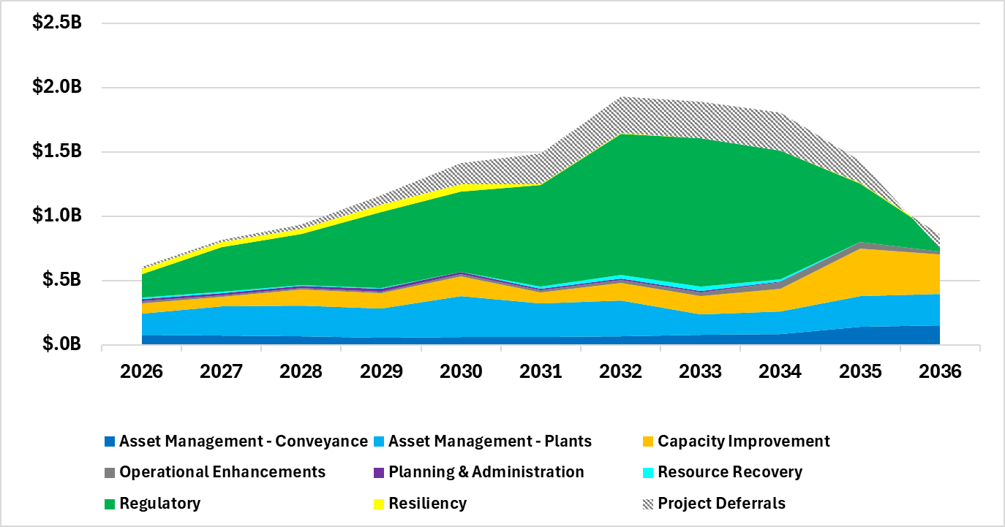

Figure 29 shows the Council Requested Rate and associated rate forecast.
Figure 29 2027 Council Requested Rate and 2027-46 Rate Forecast

Theoretical Regulatory Deadline Extension Scenario
The Theoretical Regulatory Deadline Extension Scenario assumes successful renegotiation of the federal and state regulatory consent decree, adds compliance and financial risk, and defers $1.8 billion of planned projects out of the first decade of the forecast. Although this scenario offers some near-term rate relief by deferring project costs, it results in a higher 20-year forecast rate than the proposed rate forecast. Asset reliability and safety risk, as well as system capacity risk remain the same as the proposed scenario, but regulatory compliance projects are no longer assumed to meet established deadlines, with additional potential risks including future borrowing costs, civil contempt sanctions, injunctive relief, and criminal contempt proceedings. Figure 30 shows the 10-year capital forecast for this scenario.

Figure 30 Capital Forecast—Theoretical Regulatory Deadline Extension
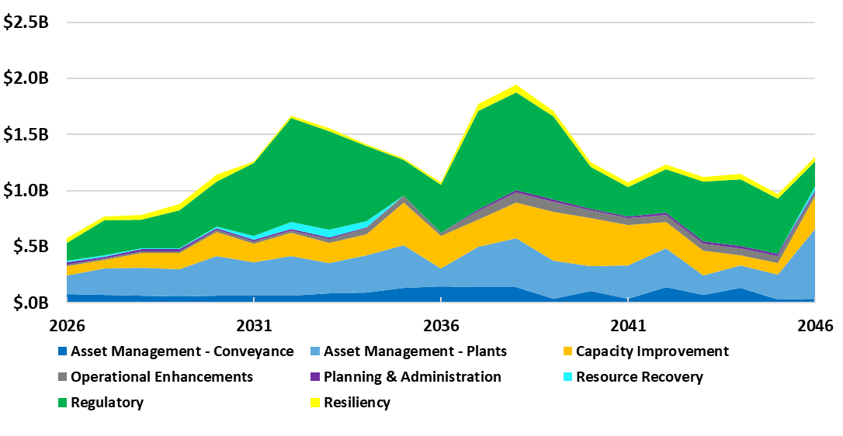
Figure 31 shows the Theoretical Regulatory Deadline Extension Rate and associated rate forecast.
Figure 31 2027 Theoretical Regulatory Deadline Extension Rate and 2027-46 Rate Forecast

Capacity Charge
Since 1990, King County has levied a capacity charge on structures with new connections to the sanitary sewer system., , This charge is paid over 15 years and is in addition to the monthly sewer bill assessed by the LSA. Newly connecting customers are directly billed by King County for the capacity charge. The capacity charge rate is set annually by the County Council and is $77.99 per month over the 15-year payment period for properties connecting in 2026.
The Revised Code of Washington (RCW) 35.58.570 authorizing the capacity charge states:
(1) A metropolitan municipal corporation that is engaged in the transmission, treatment, and disposal of sewage may impose a capacity charge on users of the metropolitan municipal corporation's sewage facilities when the user connects, reconnects, or establishes a new service to sewer facilities of a city, county, or special district that discharges into the metropolitan facilities. The capacity charge shall be based upon the cost of the sewage facilities' excess capacity that is necessary to provide sewerage treatment for new users to the system.
(2) The capacity charge is a monthly charge reviewed and approved annually by the metropolitan council.
Currently, state statute does not allow the County to require up-front payment of the capacity charge, which is the most common industry approach to new development charges, such as impact fees and utility connection charges. The monthly charge reference is unique to the authorizing language for metropolitan municipal corporations and is not included in RCW authority for city and special-purpose district connection charges that share much of the same language.
King County Code 28.86.160 Financial Policies state: “The capacity charge may be paid by new customers in a single payment or as a monthly charge at the rate established by the council…”
Customers may elect to pay the capacity charge in one lump sum or be billed quarterly based on the monthly rate for 15 years. The charge is linked to the property, meaning that the charge transfers between owners of the property until the capacity charge is paid off.

Capacity Charge Rate Structure
In 2020, the County approved updates to the rate structure of the capacity charge. As of January 1, 2021, the County began using small, medium, and large classes for newly connecting single-family residential properties. The classification differential is based on data that links the home size to average persons per household, and average persons per household to capacity demands from the connecting property.
The RCEs assigned to single-family homes is based on size: small (<1,500 sq. ft. = 0.81 RCE), medium (1,500–2,999 sq. ft. = 1 RCE), and large (>3,000 sq. ft. = 1.16 RCE).
Using persons-per-household data also resulted in an update to RCEs assigned to multifamily units. King County Code provides a permanent classification for accessory dwelling units, such as backyard cottages and basement apartments, set at 0.59 RCE per unit.
Multifamily structures are billed by unit at 0.81 RCEs for two to four units and 0.64 RCEs for five or more units.
Commercial structures are billed based on fixture counts and/or flows.
A list of historical capacity charge rates from 2003 is provided in Figure 32 below.
Figure 32 Historical Capacity Charge Increases (2003-2026)

Capacity Charge Updates
WTD’s regular updates to the underlying assumptions are guided by the King County Code 28.86.160, Financial Policy 15, which states: “Customer growth and projected costs, including inflation, shall be updated every three years beginning in 2003. The county should periodically review the capacity charge to ensure that the actual costs of system expansion to serve new customers are reflected in the charge.”
The 2023 capacity charge update was planned to be a transition from the County’s Regional Wastewater Service Plan (RWSP) to an updated comprehensive plan for the WTD system. The comprehensive plan for the utility serves as the basis for projecting the number of customers, capital projects needed for capacity, and financial assumptions. The timing of this transition depended on progress of the regional plan update. The plan update was paused in 2021 to consider feedback and because of regulatory uncertainty for the Nutrients and Combined Sewer Overflow consent decree; the update resumed in 2024, concluded in 2025, allowing WTD to propose a new methodology that would take effect in 2027, based on an industry-standard “average cost” approach. The methodology was updated to comply with the 2016 KC Auditor’s report recommending a more transparent model, and aims to:
- Align with Revised Code of Washington (RCW) Requirements, including RCW 35.58.570’s “equitable share” requirement
- Account for current system investments and capacity, and future expanded capacity investments
- Apply a cost-based approach based on the value of system assets (existing and future)
- Determine cost per Residential Customer Equivalent (RCE) based on existing and future capacity
- Achieve a more transparent and predictable calculation
The updated methodology resulted in a 6.6 percent proposed increase in 2027 and will be indexed to the Construction Cost Index over time. The capacity charge will be re-evaluated as part of the RWSP planning process.
Figure 33 shows the 2027 proposed capacity charge of $83.10 and projects the charge and related lump-sum elective payment option for the forecast period.
Figure 33 Proposed 2027 Capacity Charge and 2028-2031 Forecast [also available on page 6]

Capacity Charge Revenue Forecast
The majority of capacity charge revenue comes from regular capacity charge customer billings, with the rest coming from elective pre-payments. Ongoing payments are stable, while pre-payments vary significantly from year to year and are difficult to forecast.
Figure 34 shows the historical split between ongoing payments and elective pre-payments for the last 13 years (2012-2025). Until 2019, ongoing capacity charge pre-payment revenues grew at an average annual rate of more than nine percent, driven by a regional construction boom that added large numbers of new connections every year. The growth rate slowed significantly during 2020-23, before increasing again in 2024 and 2025. Capacity charge pre-payments have ranged between 14 to 31 percent of total capacity charge revenues, without a clear, discernible pattern from one year to the next. Pre-payments in the global COVID-19 pandemic-impacted years of 2020 and 2021 decreased to levels close to the averages seen before the record-high years of 2017, 2018, and 2019. The full capacity charge revenue forecast can be found in the Appendix.
Figure 34 Historical Capacity Charge Ongoing Payments and Prepayments (2012-2025)
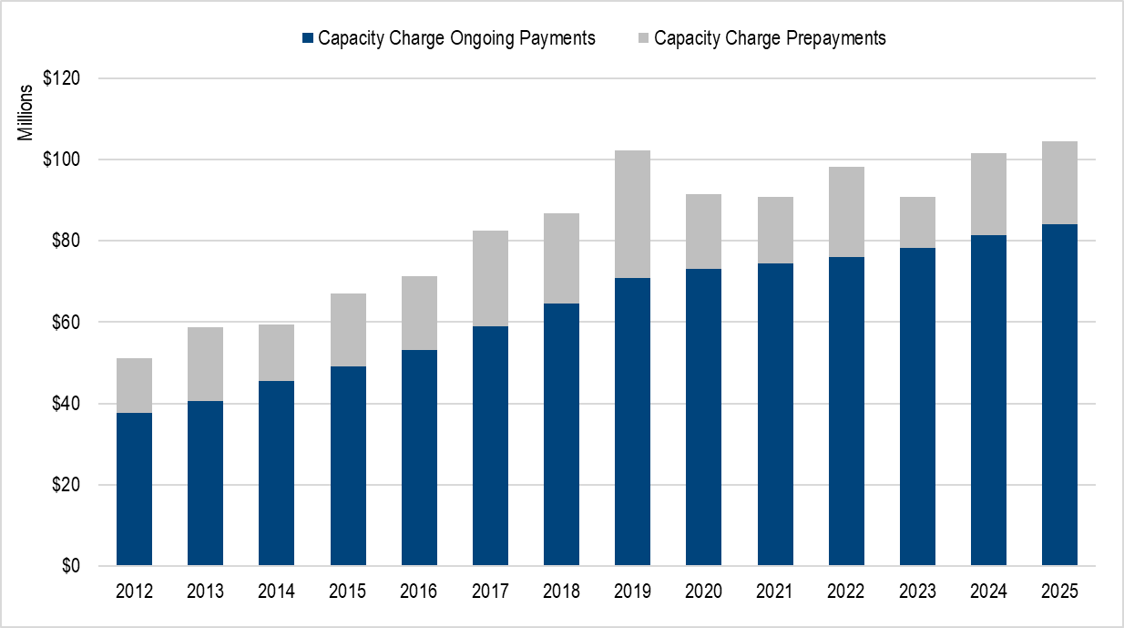
Capacity charge revenues are forecasted based on an analysis of connection growth and the percentage of pre-payments in any given year. This results in an overall capacity charge revenue increase of three to seven percent per year throughout the forecast period, as shown in Figure 36.

Other Revenues

Interest earnings
Interest earnings, also known as investment income, is revenue obtained by the County’s Water Quality Fund through investments of its cash balances in the King County Investment Pool (Pool). The Pool pursues a low-risk investment strategy that prioritizes the availability of funds for its participating agencies to meet daily cash-flow requirements. In 2025, WTD cash balances averaged approximately $793 million throughout the year, which included cash balances for all WTD reserve accounts.
Interest-rate forecasts for the Pool come from King County’s Office of Economic and Financial Analysis. The 2026 interest rate is estimated to be four percent. Changes to interest rates have a limited impact on WTD revenues, representing less than one percent of total revenue. Any reduction of interest earnings is significantly offset by savings from a lower cost of debt.

High-Strength Surcharge, Septage, Resource Recovery
Other WTD income is generated from more than 25 separate revenue sources. The largest of these sources come from the high-strength surcharge, resource recovery activities (methane sales with renewable identification numbers, or RINs), and septic hauler fees. The high-strength surcharge recovers the additional operating costs imposed by treating high-strength wastewater and is defined by King County Code. In 2026, the rate is $0.4890 per pound of biological oxygen demand, and $0.5675 per pound of total suspended solids. WTD conservatively assumes that RINs revenue will decrease from over $7 million in the last few years to $4 million in 2026, due to the risk of changes to existing regulatory framework under a new federal administration. Septic hauler fees had declined by about 25 percent since 2022, from $4 million to $3 million, but increased to $3.6 million in 2025. Per conversations with septic haulers, this is related to the opening of a private facility in Sumner that opened at that time and diverted some of the septage typically treated at WTD facilities. Due to this uncertainty, septage revenues are not forecast to increase. Most of the other revenue components are forecast at three percent annual growth.

Reference and Additional Information
This section contains additional reference information about WTD’s funding strategies, forecast assumptions, historical financial performance, and costs of contaminants of emerging concern.

Supplemental WTD Debt Information
Figure 35 2025 Year-End Outstanding Debt Balances

Types of WTD Financing

Bonds
Sewer revenue bonds are secured by a pledge of revenue of the sewer system, subject to payment of all operating and maintenance expenses of the sewer system. When revenue bonds are additionally backed by a pledge of the full faith and credit of the issuer (meaning the County’s General Fund revenue and taxing power), the bonds are referred to as limited tax general obligation (LTGO) bonds. Sewer revenue bonds can also be issued at the junior lien, which is subordinate to both senior lien sewer revenue bonds and LTGO bonds.

State Loans
WTD receives loans from Ecology under the SRF Loan Program and from the Washington State Department of Commerce’s Public Works Board. The loans require either semi-annual or annual payments of principal and interest from 2025 through 2056, and bear interest at stated rates from 0.5 percent to 2.7 percent. As of December 31, 2025, the balance due on all state loans is $339.9 million. State loans are secured by a subordinate lien on the net revenues of the system.

WIFIA Loans
WIFIA is an established federal loan program administered by the EPA for eligible water and wastewater infrastructure projects. The WIFIA program accelerates investment in the nation's water infrastructure by providing long-term, low-cost supplemental loans for regionally and nationally significant projects at a maturity similar to the U.S. Treasury rates. The WIFIA loans, after draws are made, are secured by a pledge of revenue from the sewer system, subject to payment of all operating and maintenance expenses of the sewer system. As of December 31, 2025, WTD has successfully secured and received five federal WIFIA loan agreements, totaling $463.5 million. These loans bear interest rates ranging from 1.69 percent to 4.79 percent. The most recent WIFIA loan, signed in January 2026, carries an interest rate of 4.79 percent signed, compared to WTD’s most recent bond interest rate of 4.14 percent issued in November 2025. WIFIA allows an interest rate reset prior to spending 50 percent of the project cost, and WTD is hoping to utilize this on the Tranche 3 loan and lower the interest rate in the future before drawing on the loan.

Commercial Paper
The Commercial Paper (CP) program provides low-cost, flexible, interim financing for WTD capital projects. Its main purpose is to provide interim financing to pay for WTD’s capital projects pending permanent financing from state and federal loans. CP has also been utilized to refund high-interest outstanding debt and serve as a permanent element of WTD’s variable-rate debt portfolio. As of December 31, 2025, WTD has $183.9 million in outstanding commercial paper debt.

Variable-Rate Debt
King County Code 28.86.160, Financial Policy 14, limits the utility’s variable-rate debt exposure to a maximum amount equal to 20 percent of all outstanding debt and, currently, WTD uses a target of 15 percent in the financial forecast. This limits WTD’s interest rate risk on its outstanding debt, i.e., increased borrowing cost in case of increase in interest rates. Also, typically an investor can sell variable-rate bonds back with just a week’s notice. Variable-rate debt allows WTD to achieve a borrowing cost that historically has been much lower than traditional fixed-rate debt. This type of investment warrants the lowest borrowing cost in any given interest rate environment. Variable-rate debt is issued on the junior lien level, which is subordinate to parity bonds (senior lien sewer revenue bonds) and parity bond lien obligations (LTGO). WTD’s initial variable-rate issuance was its $100.0 million CP program in 1996. As of December 31, 2025, WTD has expanded its variable-rate portfolio to $556.6 million.

Forecast Assumptions
Figure 36 summarizes the assumptions used to forecast revenues and expenditures in the 20-year financial forecast (2027-2046).
Figure 36 Forecast Assumptions Used in Financial Forecast

2025 Wastewater Treatment Division Financial Performance

Revenue
Figure 37 shows that total RCEs were 0.2 percent higher than projected and related sewer rate revenues were 0.1 percent higher in 2025.
Capacity charge revenues were $6.2 million higher than previously forecast, due to higher-than-expected elective early payoff activity.
Other operating revenues presented better-than-forecast results, mostly due to increased septage revenues, although high-strength surcharge revenue decreased.
Investment income exceeded the forecast, with interest rates from the King County Investment Pool averaging 4.15 percent in 2025.
Overall, revenues exceeded the 2025 forecast by 1.8 percent, 88 percent of which was driven by investment returns and early payoffs of the capacity charge.
Figure 37 Wastewater Treatment 2025 Forecast vs. Preliminary 2025 Actuals

Expenditures
In 2025, WTD realized operating expenditure savings of $18 million below the revised budget, and $8.9 million below the 2026 sewer rate forecast. The largest contributors to underspend were staffing vacancies and delays in the WaterWorks Grant Program, the latter of which was due to a change in the King County budget schedule. The remainder is made up of lower-than-expected purchases of supplies and services. Vacancy savings are those related to supplies and services that are not expected to continue as WTD has aggressively filled vacancies throughout 2025 and into early 2026, and prices of the affected supplies and services are projected to increase. WaterWorks savings are designated by ordinance to their specific use and may not be repurposed. This underspend will either be utilized by the grantees over their contract period or could be rolled into future granting cycles.

Debt
On February 26, 2025, WTD issued $64.0 million in commercial paper and on July 2, 2025, WTD issued $62.0 million in commercial paper to provide interim funding for its WIFIA and Joint Ship Canal projects. This financing will be redeemed when WTD gets reimbursements from the respective SRF/WIFIA projects, financing for which has already been signed through respective loan agreements.
On July 31, 2025, WTD issued $200.0 million of Junior Lien Variable Rate Sewer Revenue Bonds, for which liquidity support will be provided by a Standby Purchase Agreement. The proceeds will provide financing for various capital projects.
On October 23, 2025, WTD issued $101.0 million of Junior Lien Variable Rate Sewer Revenue Bonds, for which liquidity support will be provided by a Standby Purchase Agreement. The issuance refunded RV2020B Variable Rate Sewer Bonds, which were due January 1, 2026.
On November 25, 2025, WTD issued $264.0 million of Sewer Revenue Bonds at par amount of $264.0 million, plus a premium of $24.1 million. The proceeds were used for refunding $9.5 million of RF2015B, refunding $78.1 million of RF2016A, and $200.0 million of new money for financing various capital projects through H1 2026. Refunding RF2015B and RF2016A produced $4.8 million in total savings and $4.6 million in present value savings.
Due to the higher net revenue, WTD projects that, despite slightly higher debt, it will comfortably exceed each of its key coverage targets in 2025, namely 1.25 times senior lien debt service and 1.15 times total debt service.

Cash Funding and Defeasance
A new money par issuance of $85.9 million of senior lien 2024A Sewer Revenue Bonds was sold in August 2024. The net proceeds, in the amount of $98.1 million, were deposited into the construction fund, freeing up the same amount of operating cash that was subsequently used in February 2025 to defease outstanding high-coupon bonds. This transaction produced $8.6 million in total savings and $7.2 million in present value savings.

Net Cash Flow
WTD transferred $170 million of operating revenue to the capital fund at year-end, in addition to a $20.5 million transfer to the new Voluntary Operating Reserve from the DSRF. This left an ending fund balance of about $11 million in unrestricted cash in the operating fund.

Contaminants of Emerging Concern (e.g., PFAS) – Cost Tracking
Per Council Motion 16434: “Beginning with the 2025 sewer rate forecast, the wastewater treatment division shall include in its technical memorandum submitted with the annual sewer rate Ordinance a section identifying the cost of activities it has undertaken and plans to undertake to address contaminants of emerging concern, including PFAS.”

PFAS Costs to Date
Between 2019 and 2021, King County evaluated the use of recycled water from the Brightwater Treatment Plant and its effects on soil, groundwater, and plant tissue. Samples were analyzed for PFAS and other chemicals of emerging concern. PFAS compounds were detected in river water, recycled (reuse) water, soils, and in plants that were grown in this soil and irrigated with either river water or reuse water. These actions total an estimated $93,750 in costs, to date, for the PFAS-portion of this work.
Between 2021-2022, King County conducted an investigation and published a report on Toxics in King County Wastewater Effluent, Evaluating the Presence of Toxic Elements in the Effluent of Treatment Plants. This investigation included the sampling of wastewater effluent for PFAS compounds at three County wastewater treatment plants. Estimated out-of-pocket costs connected to this project totaled $24,990, related specifically to PFAS.
In 2023, King County allocated approximately $421,000 for a further investigation of PFAS in King County wastewater facilities and landfill leachate, anticipated to be completed by mid-2025. In mid-2024, King County began tracking staff hours associated with PFAS on a regular basis; 2024 data estimates that 300 hours and $27,300 in costs were spent. About $30,000 was spent on PFAS testing in 2025.
Costs associated with the Nutrient Reduction Evaluation (total estimate of approximately $8 million) include hiring an external consultant to conduct analyses of nitrogen removal but also with potential compounds of emerging concern and toxics removal, including PFAS chemicals. To date, an estimated $63,500 has been spent on work attributable to PFAS chemicals.
Between 2023 and 2025, King County spent approximately $717,000 to sample monthly for PFAS in influent, effluent, and biosolids from WTD’s three major treatment plants, as well as Cedar Hills Landfill leachate.

Future Costs
WTD incurred costs to comply with Ecology’s draft NPDES permit for the West Point Treatment Plant, which required the County to update its industrial user survey by April 30, 2025, and begin to include requirements for industries to complete PFAS pollution prevention and source reduction evaluations starting in July 2025. The draft permit also requires the County to include best management practices and pollution prevention strategies in its permits to industries beginning in July 2025. The cost estimate for this work is $1 million over five years.
Other future unknown costs include monitoring for PFAS in stormwater, wastewater treatment plant influent and effluent, biosolids, and industrial waste.

Appendix. Attachment A

Endnotes

Motion 16449 can be found here.
The modified consent decree schedule can be found here.
More information on WTD’s CSO program can be found here.
WTD’s 2026-27 budget book can be found here.
More information on the case is available here.
In this context “smoothed annual increases” refers to avoidance of year-to-year volatility in the sewer rate.
Secondary treatment includes aeration, settling, disinfection, and discharge through an outfall. Secondary treatment in conjunction with primary treatment removes about 85 to 90 percent of suspended solids in wastewater.
Combined sewer overflows (CSOs) are relief points in sewer systems that carry sewage and stormwater in the same pipe. When heavy rains fill the pipes, CSOs release sewage and stormwater into rivers, lakes, or Puget Sound. They prevent sewage backups into homes and businesses but can harm people and animals living in the water because they carry chemicals and germs.
“High strength” refers to more concentrated waste. The surcharge covers the additional operating cost of treating this waste at the treatment plant.
The capacity charge is billed to new connections to the system. The charge is assessed monthly for a term of 15 years from the date the new service is established and is based on the cost of system capacity necessary to serve a new connection.
More information on compliance and monitoring fees can be found here.
More information on enterprise funds can be found in the WA State Administrative and Accounting Manual.
A combined sewer system collects rainwater runoff and domestic wastewater into a single pipe and conveys it to a wastewater treatment plant. During heavy rain events, the amount of runoff can exceed the capacity of the system, resulting in a combined sewer overflow (CSO), where untreated wastewater and stormwater flows into nearby receiving waters. More information on WTD’s CSO control program can be found here.
More information on CSO regulations and requirements can be found here.
Depreciation is an accounting concept that divides an asset’s cost by its estimated useful life, representing how much that asset is expected to wear out or lose value every year. Original cost refers to the actual cost of an asset, rather than the cost adjusted for inflation.
Debt financing occurs when WTD borrows from investors in the municipal bond capital markets, or financial institutions directly, or avails financing from state and federal agencies.
The State and Local Government Series securities program was established in 1972 to restricted state and local governments from earning arbitrage profits by investing bond proceeds in higher yielding investments. More information is available here.
Ordinance 19575 can be found here.
Ordinance 19739 can be found here.
Ordinance 19821 can be found here and Ordinance 19822 here.
Ordinance 19876 can be found here and Ordinance 19874 here.
Commercial paper is a commonly used type of unsecured, short-term debt typically used for interim financing purposes with maturities ranging between one and 270 days. WTD can issue up to $250 million in commercial paper in aggregate for both new money interim financing and refunding purposes per Ordinance 19955.
The Tax Cuts and Jobs Act can be found here.
The LOCAL Infrastructure Act - Lifting Our Communities through Advance Liquidity for Infrastructure Act - can be found here.
The Financial Data Transparency Act can be found here.
Par value is the amount that the issuer agrees to pay the bondholder upon maturity of the bond. It is also used to calculate the interest payments on the bond.
“Present-value savings” assists in analyzing the current worth of future savings by taking the time value of money and interest rates into account. This can change based on interest rates and the year savings are realized.
The following legislation is available on the King County Council website: Motion 13798, Ordinance 13680, and Ordinance 19785
Liquidity metrics refer to quantitative measures that evaluate an agency’s ability to meet its financial obligations by assessing the availability of liquid assets (cash).
Ordinance 19782 is available on the King County website.
Ordinance 19785 is available on the King County website.
Parity Bonds are secured by a lien on sewer revenue and hold a priority in payment second only to operating and maintenance expenses.
“Springing” refers to a provision within an Ordinance that activates certain conditions or changes to the current terms or requirements.
The remainder of the Voluntary Operating Reserve was funded from the Operating Fund
The King County Code Title 28 can be found here.
More information on the King County Capacity Charge can be found here.
In 1992, voters approved an amendment to the County's charter that authorized the merger of King County with the Municipality of Metropolitan Seattle (Metro), with the phased merger effective in 1994. More information on the merger is available here. As successor to Metro, the County assumed Metro’s rights and obligations, including authority to impose the capacity charge.
Revised Code of Washington 35.58.350
Revised Code of Washington 35.58.570
A 2015 internal WTD survey of utility connection charges for 18 comparable agencies nationwide included data on when the charge is assessed to new connections for 13 of the 18 agencies. Of the 13, 100 percent required payment at the time of permitting or service application. Only WTD did not require payment as a condition of development through the permitting/service application process.
RCW 35.92.025 for Cities and Towns, and RCW 57.08.005 for Districts.
More information on the capacity charge review study can be found here.
King County Code 28.84.050 O.3.
The King County Code Title 28 can be found here.
Information on the RWSP is available here.
Ongoing payments include penalty fees that have ranged between $400,000 and $1.3 million a year.
The August 2025 forecast is available here.
A RIN is a is a serial number assigned to a batch of biofuel for the purpose of tracking its production, use, and trading.
The relevant section of the King County Code (KCC 28.84.060 (M) (3)) can be found here.
Excludes principal payments from January 1, 2026, that had already been transferred to the debt service fund in December 2025.
More information on the Public Works Board can be found here.
"Subordinate" liens are those that can only be paid after more senior liens are released.
Includes the following loan agreements: $17.7 million for Georgetown Wet Weather Treatment Station, $96.8 million for Joint Ship Canal, $194.1 million for Tranche 1 Projects, $89.9 million for Tranche 2 Projects, and $65.0 million for Tranche 3 Project.
Excludes commercial paper used for interim financing and the refunding of the 2013B Sewer Revenue Bonds.
Audited 2025 financial information will be available in May 2026. Preliminary (unaudited) year-end financial data is presented for comparison to the 2025 forecast from the 2026-2045 Financial Forecast.
Per- and Polyfluoroalkyl Substances. PFAS are a group of chemicals used to make fluoropolymer coatings and products that are widely used in consumer products. PFAS are a concern because they do not break down in the environment, are able to move through soils and water sources, and build up in fish and wildlife. More information about PFAS can be found here.
Report submitted as part of Motion 16384 can be found here.

