STAFF REPORT

Agenda Item: | 6 | Name: | Jenny Giambattista and Andy Micklow
Proposed No.: | 2026-0103 | Date: | June 10, 2026

SUBJECT

Executive’s proposed 2027 sewer rate and capacity charge (Proposed Ordinance 2026-0103).

SUMMARY

The sewer rate is the primary funding source of the Wastewater Treatment Division (WTD). Proposed Ordinance 2026-0103 would increase the monthly sewer rate effective in 2027 by 12.75% from $62.66 to $70.65. This increase is the same as projected in the forecast for the 2026 rate. The 2027 proposed sewer rate is projected to generate $675.2 million in revenue in 2027.

WTD has extended the sewer rate forecast to 20 years through 2046, and this extended forecast shows the 12.75% annual increase continuing until 2030, followed by increases of 11.25% in 2031 and 2032, followed by lower increases in 2033 and beyond until eventually reaching 0.0% annual increase at the end of the forecast in 2046.

WTD reports that the largest drivers of near-term rate increases are the $6.2 billion of capital projects with fixed and concurrent deadlines required by the Combined Sewer Overflow modified consent decree.

As required by a proviso in the 2026-2027 adopted Biennial Budget, the Executive has included two additional rate options for Council consideration which could reduce the annual rate increase by 2% to 3% over the next 3 years when compared to the Executive’s proposal. Both options assume capital projects would be deferred. The Executive did not support these options because of concerns The Executive did not support these alternative options because of concerns that project deferral could result in operational and legal risk.
The proposed ordinance would also set the capacity charge for new connections to the regional system occurring in 2027 at $83.10 per Residential Customer Equivalent (RCE) per month, a 6.55% increase over the 2026 monthly charge of $77.99. The capacity charge is expected to generate approximately $111.3 million in revenue for 2027.

After the transmittal of this ordinance, WTD identified an error in the assumption in the proposed methodology used to calculate the capacity charge. The Executive is requesting an amendment to Proposed Ordinance 2026-0103 to correct the 2027 proposed capacity charge and reduce it from $83.10 to $78.94.

The schedule for Council consideration is listed below:
- Transmittal of Sewer Rate— April 23
- Budget and Fiscal Management Committee—Discussion only May 27 and Discussion/Possible Action —June 10
  - Striker Direction —June 3
  - Striker Distribution—June 5
  - Line Amendment Direction—June 8
- Briefing only at Regional Water Quality Committee (RWQC)—May 5 and June 3
- Council consideration/action—16, if needed June 23 as emergency, assuming action by BFM on June 10
- Approval date requirement for sewer rate—June 30 (Prior to July 1)

Links are provided below to the topics discussed in this staff report.
- Background
    - Sewer rate
    - Capacity charge
    - Combined Sewer Overflows (CSOs)
    - Required transmittal information
    - Recent Rate Related Legislation and 2026-2027 Budget Requirement
- Analysis of the proposed sewer rate and 10-year forecast
  - Comparing 2026 and 2027 10-year forecasts
  - Second decade forecast
  - Capital expenditure forecast
    - Updated approach to developing a capital forecast
    - Capital expenditures by category
    - Regulatory projects
        - CSO costs
        - Nutrient reduction projects
    - Other large CIPs
    - Forecasted capital expenditures versus actual expenditures
    - Comparison of 2027 10-year capital forecast to prior capital forecast
    - Capital Improvement Program funding
  - Operating expenditures
  - Rate smoothing
  - Alternative rate scenarios
- Capacity Charge
- Rate Letters

BACKGROUND

The regional wastewater system is almost entirely funded by the monthly sewer rate and the capacity charge.

Monthly Sewer Rate Charged to Local Sewer Agencies. The sewer rate is WTD's primary funding source. The monthly sewer rate collected by the County supports all Wastewater Treatment Division (WTD) expenses, including operating costs, debt service, and capital expenses. The County charges a sewer rate to utilities that deliver wastewater to the County for treatment and discharge. The monthly sewer rate charged by WTD is a wholesale rate and is billed to local sewer agencies, not ratepayers. The local utility providers, as direct service providers, set their own rates to recoup the payments required by the County plus their own "local" cost of service. The local agency sends the sewer customers the sewer utility bill.

Single-Family versus Volume-Based (Commercial, Multifamily, Industrial). Since the formation of Metro, and as directed in King County Code and all 34 local sewer contracts, King County has had a sewer rate structure based on two classes of customers: single-family and volume-based. The fee structure, as specified in the code and contract, relies on a billing unit referred to as "Residential Customer Equivalent (RCE)" to charge the two customer classes and to determine how costs are shared between the classes. One RCE unit is 750 cubic feet of wastewater and represents the assumed wastewater generated by a single-family home in a month, based on flow data from 1989. Single-family homes are charged one RCE. Volume-based customers are converted to an RCE unit by dividing the customer's monthly volume of water use by 750 cubic feet (cf) of wastewater (the "conversion factor"). This results in a usage amount for volume-based customers reported in RCEs.

Using the Number of RCEs to Calculate the Monthly Rate. WTD estimates the total number of RCEs for a given year and then divides the total projected revenue required (from sewer rates) by the number of RCEs to obtain the cost per RCE. King County then charges local sewer agencies the monthly sewer rate for each RCE in their utility.

Customer Affordability to be Considered During RWSP Update. As discussed later in this staff report, WTD is updating the long-term Regional Wastewater Services Plan. The update to the RWSP will address issues related to rate structure, customer affordability, and rate equity.

Historical Sewer Rate. Table 1 depicts the anticipated sewer rates through 2030. Prior to 2021, rates were structured effectively as biennial rates, with rate adjustments in alternating years. In 2021, after engagement with cities and sewer districts through the Metropolitan Pollution Abatement Advisory Committee (MWPAAC), the Executive recommended annual rather than biennial adjustments to sewer rates.

Table 1.
Sewer Rate (2017-2026 Actual; 2027 Proposed; 2028-2030 Projected)

Year(s) | Rate  ($/RCE/ Month) | % Increase
2017 | $44.22 | 5.20%
2018 | $44.22 | 0.00%
2019 | $45.33 | 2.50%
2020 | $45.33 | 0.00%
2021 | $47.37 | 4.50%
2022 | $49.27 | 4.00%
2023 | $52.11 | 5.75%
2024 | $55.11 | 5.75%
2025 | $58.28 | 5.75%
2026 | $62.66 | 7.50%
2027 | $70.65 | 12.75%
2028 | $79.66 | 12.75%
2029 | $89.82 | 12.75%
2030 | $101.28 | 12.75%

Capacity Charge Billed to New Customers by King County. Since 1990, a capacity charge has been levied on new connections to the sewer system. The purpose of the capacity charge is to ensure that new customers pay the "growth" costs of expanding the wastewater system.

The capacity charge is a one-time development charge, much like a new development fee or impact fee. State statute does not allow the County to require up-front payment of the capacity charge by the developer. Unless a developer voluntarily pays the capacity charge, it becomes an additional cost that buyers will encounter when purchasing properties with new sewer connections. It can be paid as a total payment up-front with a discount or as a monthly charge amortized over 15 years. If a buyer purchases property with an outstanding capacity charge, the new buyer becomes responsible for the capacity charge payments. Unlike the wholesale sewer rate, the capacity charge is billed directly to customers by King County.

PO 2026-0066 Would Update the Methodology for Determining the Capacity Charge. In previous years, the capacity charged was determined, as defined in code, by:
- Calculating what new growth will cost by subtracting rate revenue from existing customers from the total system costs,
- Subtracting what new customers will already pay in monthly rates, and then
- Dividing the remaining growth cost evenly across all new sewer connections.

The proposed approach would calculate the capacity charge using the average cost approach to system development costs, where eligible system facility costs are divided by the applicable system capacity to derive a residential cost per unit (RCE). According to WTD, industry practice defines eligible system facility costs as the existing system cost plus future system costs. Applicable system capacity means the total system capacity of the existing and future system, in RCEs.

By dividing the eligible system facility costs by the total system capacity, the cost per unit is calculated. The monthly capacity charge is calculated by dividing the cost per unit over 15 years. In calculating the monthly charge, WTD reports that it applies a "discount" rate of 5.14% to the cost per unit to ensure that customers paying over time are not effectively being charged less than customers who pay in a lump sum.

Combined Sewer Overflows. WTD has been implementing King County's Combined Sewer Overflow (CSO) program for over three decades to control the County's CSO outfalls to the Washington State standard of no more than one untreated CSO discharge per year on a 20-year average. WTD reports it has spent over $1.1 billion on CSO control since the early 1990s.

In 2013, King County entered into a federal consent decree to complete its CSO control projects in compliance with the federal Clean Water Act by December 31, 2030. In mid-2024, King County, Ecology, and the EPA reached an agreement in principle on the First Material Modification to the 2013 Consent Decree on Combined Sewer Overflow (CSO), which extends the compliance milestones for the remaining CSO control projects and extends the overall compliance schedule from 2030 to 2037. All CSO costs associated with the modified consent decree are now included in the 10-year forecast.

Past CSO Expenditures. Since the 2013 consent decree, the following completed CSO projects have cost an estimated $538M:
- Ballard Siphon
- North Beach Wet Weather Storage
- Murray Pump Station Upgrade
- Barton Pump Station Upgrade and Green Stormwater Infrastructure
- South Magnolia
- Rainier Valley Storage
- Georgetown Wet Weather Storage

The following additional projects are underway with an estimated $258M spent to date:
- Ship Canal Water Quality Project
- West Duwamish Wet Weather Storage
- Elliot West Wet Weather Treatment Station Upgrade
- Mouth of Duwamish CSO Control Program

Regional Wastewater Services Plan. The Regional Wastewater Services Plan (RWSP) was adopted by Ordinance 13680 in November 1999 to ensure the continuation of high-quality wastewater treatment services through 2030. The RWSP is codified in K.C.C. 28.86.010 and 28.86.040 through 28.86.150. The RWSP outlines programs and projects through 2030 to increase wastewater system capacity and function; gives guidance on recovering and recycling beneficial resources from the wastewater treatment process; and provides direction on protecting and monitoring water quality and meeting permit conditions.

Many of the major projects outlined in the RWSP have been completed as the plan reaches the end of its intended planning period of 2030. WTD has re-launched a planning effort to update the Regional Wastewater Services Plan. This planning effort has the potential to impact future capital and operating expenses.

Required Rate Transmittal Information. The financial policies listed below specify the contextual information that is to accompany the rate transmittal. WTD has prepared a technical memo (Attachment 4) with the required information on revenues, expenditures, debt service, operations, and capital programs that inform the rate. Additionally, as required by Motion 16434, beginning with the 2025 sewer rate forecast, the technical memorandum submitted with the annual sewer rate identifies the cost of activities WTD has undertaken and plans to undertake to address contaminants.

Financial Policy-16: The executive shall prepare and submit to the council a report in support of the proposed monthly sewer rates for the next year, including the following information:

Key assumptions: key financial assumptions such as inflation, bond interest rates, investment income, size and timing of bond issues, and the considerations underlying the projection of future growth in residential customer equivalents.

Significant financial projections: all key projections, including the annual projection of operating and capital costs, debt service coverage, cash balances, revenue requirements, revenue projections and a discussion of significant factors that impact the degree of uncertainty associated with the projections.

Historical data: a discussion of the accuracy of the projections of costs and revenues from previous recent budgets, and

Policy options: calculations or analyses, or both, of the effect of certain policy options on the overall revenue requirement. These options should include alternative capital program accomplishment rates and the rate shall be selected that most accurately matches historical performance in accomplishing the capital program and that shall not negatively impair the bond rating.

Recent Rate Related Legislation and 2026-2027 Budget Requirement. The following section summarizes the recent legislation and 2026-2027 budget language related to the sewer rate.
Capital Forecasting Motion 16410. Motion 16410 (September 2023) was initiated by the Regional Water Quality and adopted by the County Council in 2023. It requests WTD research and identify methodologies for forecasting the long-term costs of its capital improvement needs. This was completed.
Long-term Rate Forecasting Motion 16449. Motion 16449 (October 2023) was initiated by the Regional Water Quality Committee and requests WTD develop a long-term financial and sewer rate forecast. A final report was presented to RWQC in September 2025.
Motion 16900 WTD Sewer Rate and Capital Work Plan to Improve Engagement, Transparency, and Accountability. Motion 16900 (November 2025) requests that WTD implement a work plan to continue to improve engagement, transparency, and accountability in the sewer rate-setting process. The work plan is Attachment A to Motion 16900. WTD provides a monthly status report to RWQC on each task and the latest status report is Attachment 5.
Key Topics in the Work Program Include:
- Develop and implement a process for MWPAAC and RWQC (as requested) to review a limited number of large capital projects selected by MWPAAC that substantively affect the rate.
- Develop public engagement strategy for rate payers in coordination with local contract agencies to explain why wholesale WTD rates are increasing and provide opportunities for public engagement.
- Independent consultant to review WTD’s capital program.
- Evaluate regulatory requirements.
- Significant changes in capital project costs.
- Options for multi-year rate predictability.

2026-2027 Adopted Budget Proviso Requesting Rate Options for 2027 Sewer Rate. This proviso encumbers $1 million until the executive includes an analysis of a range of policy choices resulting in at least two rate options for 2027 in addition to the executive's recommended rate for 2027. The transmitted options are discussed later in the staff report.
Timing of Rate Adoption. By contract with partner cities and sewer districts, the County is to complete its consideration of the sewer rate for the following year by July 1 of each year.

ANALYSIS

Proposed Ordinance 2026-0103 would adopt the 2027 sewer rate and capacity charge. It would increase the monthly sewer rate, effective in 2027, by 12.75%, from $62.66 to $70.65. The proposed ordinance would also set the capacity charge for new connections to the regional system occurring in 2027 at $83.10 per Residential Customer Equivalent (RCE) per month, a 6.6% increase over the 2026 monthly charge of $77.99

The first part of this analysis section discusses the Sewer Rate and the key assumptions and changes influencing the proposed rate and the forecast. The Capacity Charge is discussed later in the staff report.

Sewer Rate. This section of the staff report will compare the 2026 and 2027 sewer rate forecasts, capital cost drivers, financing, operating expenses, and alternative rate scenarios.

Comparing 2026 and 2027 10-Year Sewer Rate Forecasts. As shown in Tables 2 and 3, the proposed 2027 rate increase of 12.75% is the same as the prior forecast, even though, as discussed later in the staff report, capital expenditures are increasing relative to the prior forecast. This consistency in the 2027 rate increase with the prior year reflects the Executive's policy decision to maintain the predictability of the prior year's forecast. This is possible because WTD sets its cash revenue (rate) requirements based on a 10-year average over the forecast period, allowing it to adjust the annual rates.

Table 2.
Proposed 2027 Sewer Rate and Forecast

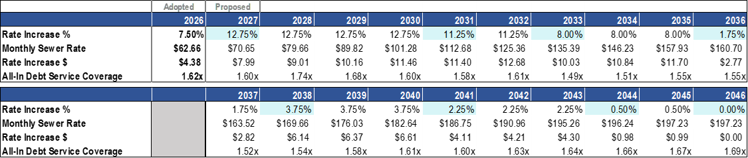

Table 3.
Adopted 2026 Sewer Rate and Forecast

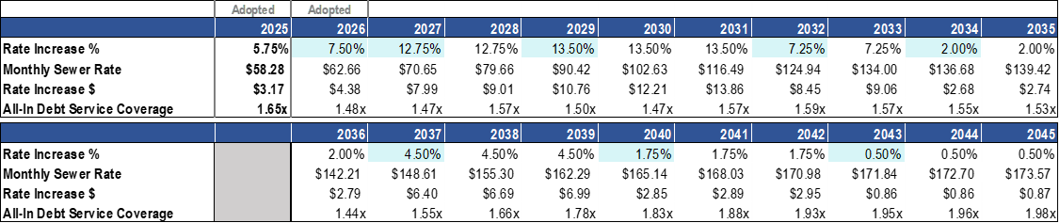

As shown in Figure 1, the 2027 monthly rate forecast begins to increase when compared to the prior 10-year forecast in 2034.

Figure 1.
Comparing 2026 and 2027 Sewer Rate Path

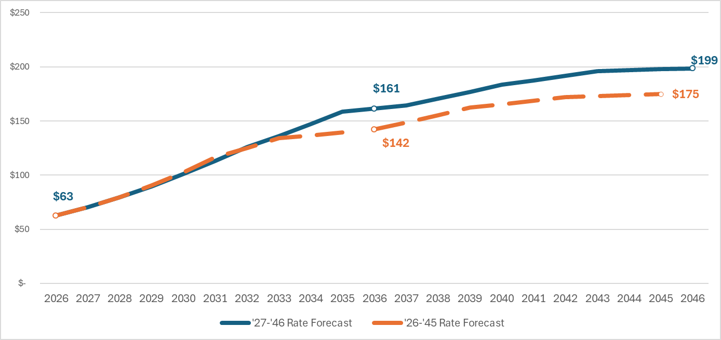

Second Decade Forecast. As shown in Table 2, the 2027 sewer rate forecast extends the forecast period by an additional 10 years. The declining annual rate increases in the second decade of the 2027 forecast reflect a reduction in capital expenditures expected in the second decade compared to the first ten years, including no regulatory expenditures projected beyond 2038, no costs related to contaminants of emerging concern, and no nutrient removal costs beyond the first permit. WTD reports that the forecast for this second decade has significant uncertainty.

Capital Forecast Continues to Project Significant Growth. The projected sewer rate increases over the forecast period are primarily driven by the increasing capital portfolio of projects and the need for cash to fund capital projects and pay new and existing debt services. The 2027-2036 10-year capital forecast is $14.2 billion and reflects the steep increase in capital expenditures over the forecast period. WTD's capital expenditures are forecast to climb to a peak of $1.9 billion in 2032. As WTD reports, the CIP projection continues to reflect the challenge of a "stacking" problem of multiple, large projects needing to happen at the same time. This staff report will compare the 2026 and 2027 10-year forecasts, the major CIP projects in the 10-year forecast, forecast uncertainty, and the proposed approach to financing the capital forecast.

Figure 2.
Proposed 2027 Capital Forecast vs. Adopted 2026 Plan

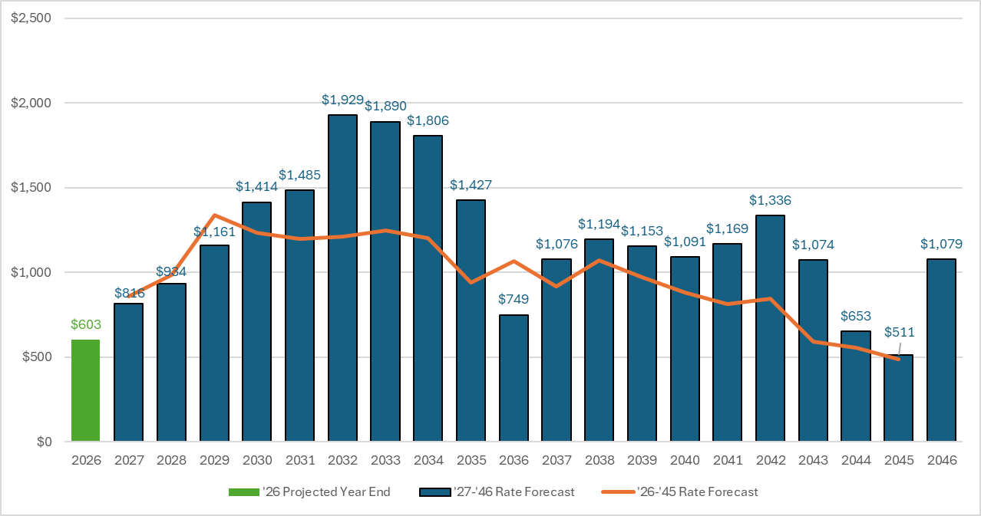

Comparing 2026 and 2027 10-year capital forecasts. The 2027-2036 total capital forecast is $14.2 billion, $2.8 billion higher than the previous 10-year forecast. Revised estimates resulted in higher capital costs, but also a slightly deferred schedule, resulting in a slight decrease in projected expenditures over the next several years and a slight reduction in projected rate increases in the next five years.
WTD provided the following information to explain the $2.8 billion increase in the forecast:
- Increase of $290 million reflects the effect of 2025 leaving the forecast window and 2036 entering the forecast window.
- Notable regulatory cost increases include:
  - $320 million increase to the Elliott West Wet Weather Treatment Station
  - $270 million increase to the East Ship Canal CSO Program
  - Addition of South Magnolia Supplemental Compliance project for an overall increase of $235 million.
- Other notable project increases include:
  - $490 million increase to minor asset management programs to address critical small asset replacements that reduce risk, based on past cost data for small asset replacements.
  - $460 million increase to the Sammamish Plateau Diversion,
  - $170 million increase to South Plant Electrical Improvements
  - $110 million increase to the Lake Hills Trunk and NW Lake Sammamish Interceptor Upgrade
  - $85 million increase to the Brightwater Aeration Basin No. 4 project, based on an updated Class 10 or Unclassified cost estimate.
- Additional increases in the 10-year forecast reflect cumulative smaller adjustments across individual projects and escalation that occurs when projects are deferred into the second half of the decade to help reduce impacts on near-term rates.
Figure 3 shows that regulatory compliance and asset management projects are the largest categories of projects in the first 10 years of this forecast. The second 10 years of the forecast contain significant uncertainty, largely due to unknown future regulatory requirements.

Figure 3.
CIP Components for 2027-2046 Financial Forecast

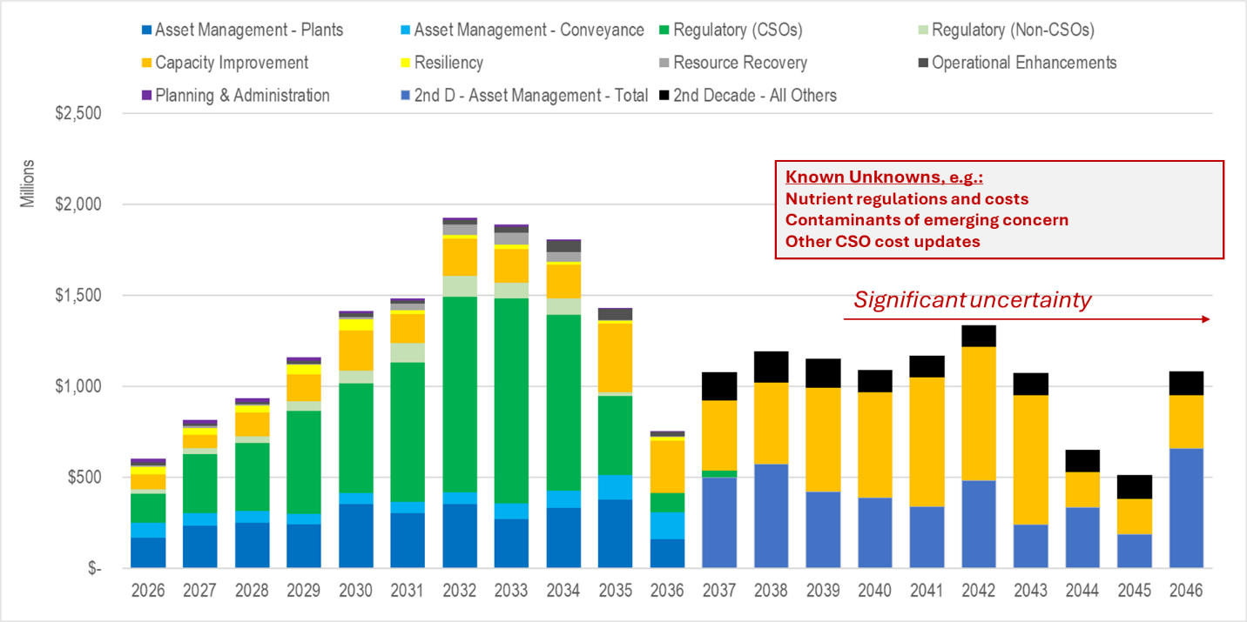

Regulatory Projects

Modified Combined Sewer Overflow (CSO) Consent Decree Costs. When the Council adopted the Modified Consent Decree in July 2024 (Ordinance 19801), the estimated total cost to complete the remaining projects was $3.3 billion. The cost to complete the CSO projects assumed for the 10-year 2027 forecast is now $6.2 billion. Figure 4 shows the increasing CSO costs in the 10-year rate forecasts over the last six rate forecasts. CSO costs have increased in each forecast for several reasons: new cost estimates for the Mouth of Duwamish CSO, the completion date for other CSOs moved from 2040 to 2037, and a new year (2036) replacing a lower-cost year. The 2027 10-year forecast shows CSO costs are now $900 million higher than in the previous 10-year forecast. WTD received updated cost and schedule estimates for multiple projects (such as the Mouth of the Duwamish CSO control project). These revised estimates resulted in higher capital costs and a slightly deferred schedule.

Figure 4.
Evolving CSO Costs in Rate Forecasts

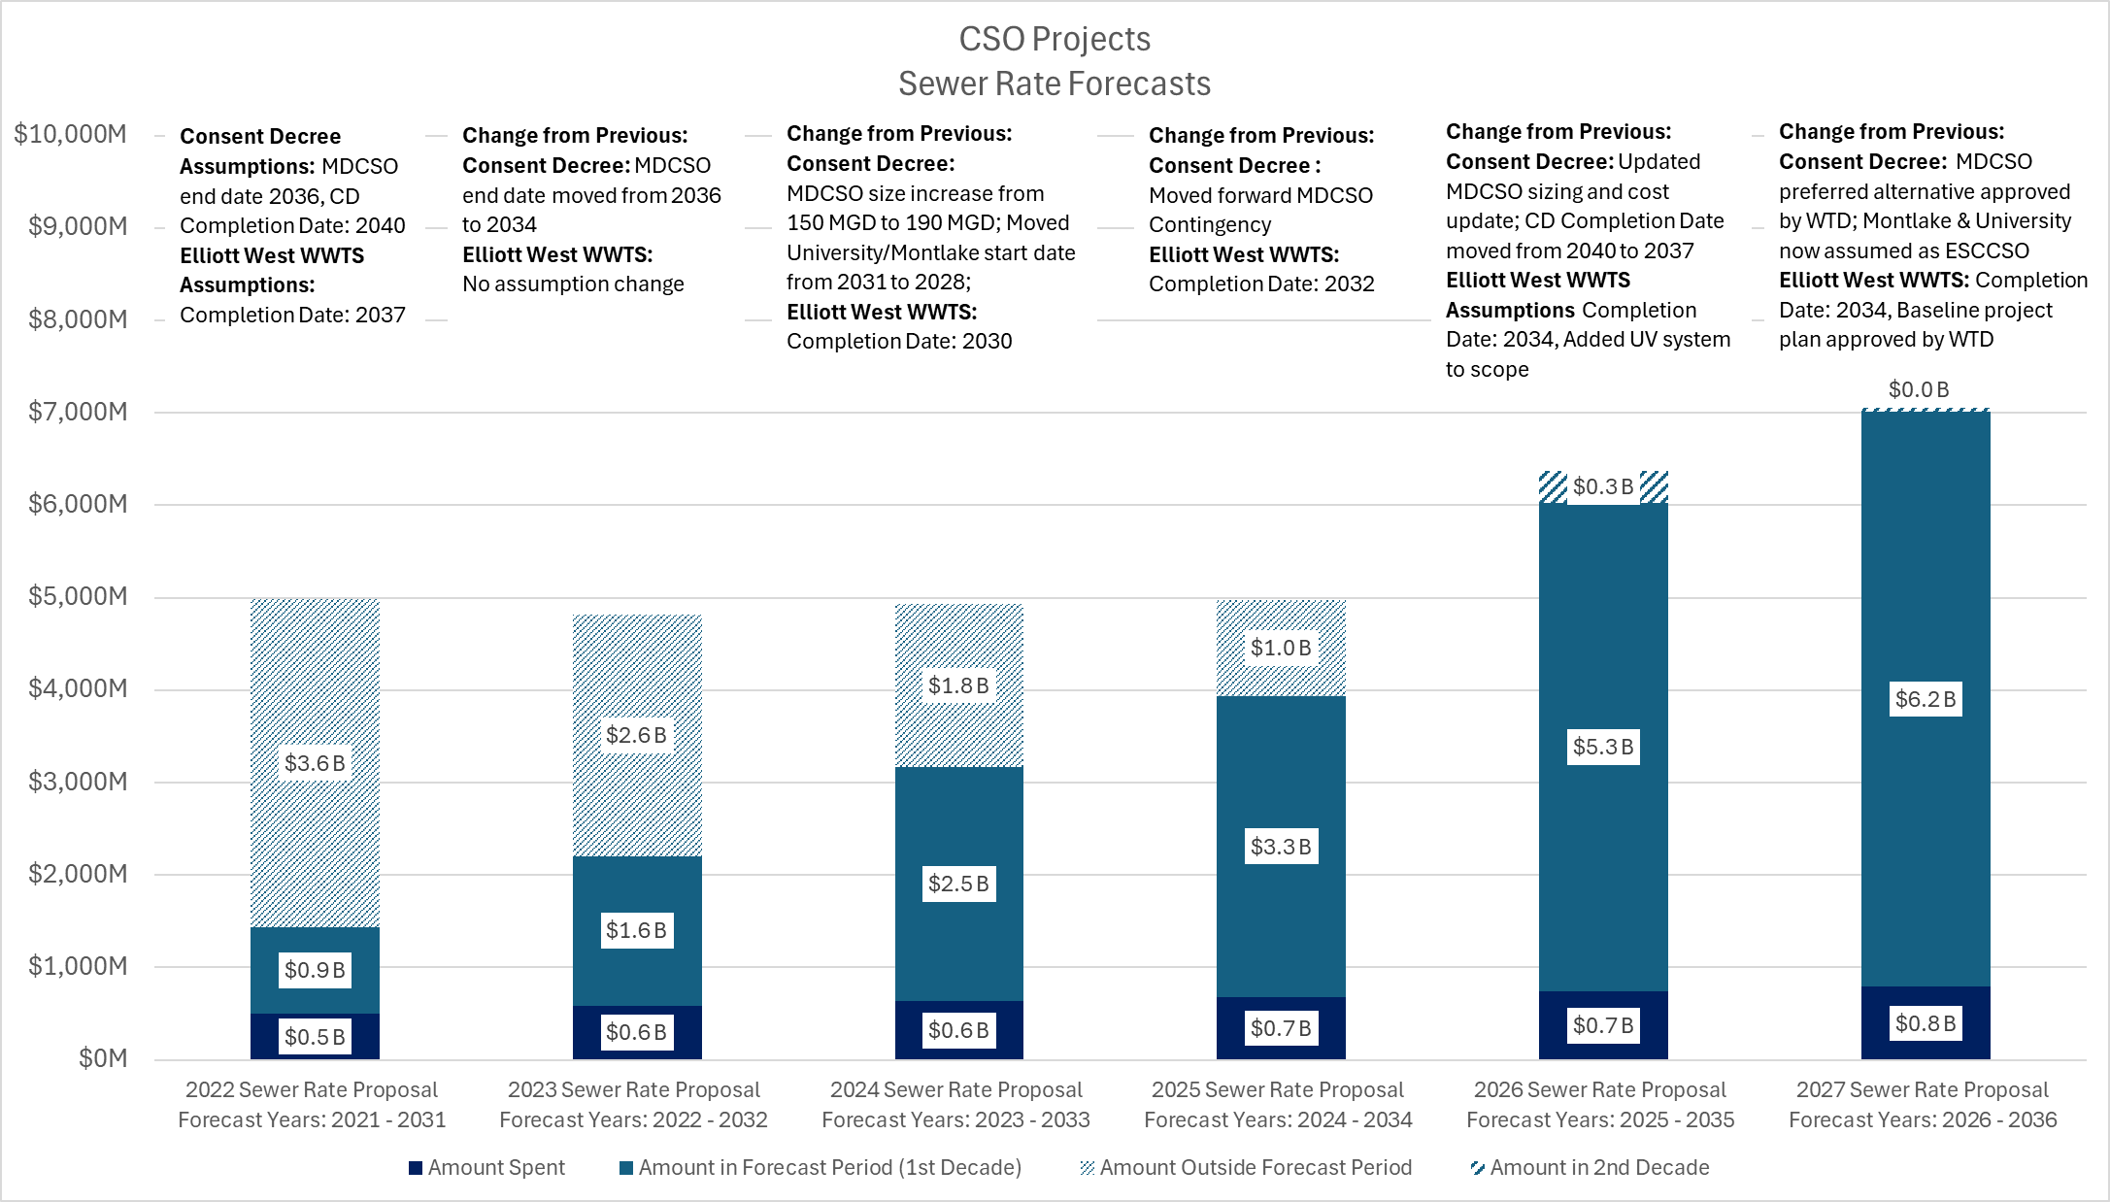

In addition to the project costs listed above, the modified Consent Decree requires supplemental compliance activities for projects that were completed but have not brought an outfall into control. WTD currently has supplemental compliance plans for four uncontrolled outfalls. An estimated $127.1 million (escalated) is forecast in the 2027 Sewer Rate Forecast CIP to bring these outfalls into control by 2037 based on early planning-level estimates.

Expenditure Schedule for CSO. As discussed later in the staff report, the capital expenditure forecast for CSO projects reflects the policy decision to assume that 100% of the costs for regulatory projects will be expended as required by regulation. As such, the project schedule is based on legal obligations to meet the modified consent decree deadlines and avoid penalties. Council staff asked how realistic the spending plan is for the CSO projects. WTD reports that the spending projections are considered realistic based on the current phase of the Program and WTD Capital Project delivery practices at the time the forecast was developed. WTD reports it has resourced the program with internal staff and consultants to meet the schedule.

  - Nutrient Reduction Projects. According to the Department of Ecology, discharges of excess nutrients, particularly nitrogen, from wastewater treatment facilities are contributing to the existing low oxygen levels in Puget Sound. Since the regulatory framework for nutrients has not been finalized, there is uncertainty about the nutrient investments required in the forecast. The 2027-2036 forecast includes about $410 million related to nutrient reduction. Depending upon the final regulatory requirements issued by the Department of Ecology, compliance costs may be much greater.

Asset Management Expenditures. The forecast for asset management categories for 2027-2036 is $3.9 billion. (This includes some of the projects listed above.) As the system continues to age, the scope and cost of Tier 1 projects, the highest priority project, have continued to increase. In the 2027 10-year forecast, WTD intends to address 76% ($3.8 billion) of Tier 1 asset management projects and 24% ($1.2 billion) of Tier 1 projects in the second decade.
  - Other Large CIP Projects. In addition to the regulatory projects described earlier in the staff report, there are over 200 other capital projects in the forecast, including the following five projects over $200 million:

- Sammamish Plateau Diversion ($571.3 million)
- Offsite Level Controls and Communication Upgrade. ($500.1 million)
- West Point (WP) Electrical Improvements ($397.5 million)
- West Point Digestion Capacity Expansion ($279.7 million)
- South Plant Electrical Improvements ($242.4)
- WPTP Critical Gate Refurbishment ($206.3)
A complete list of all projects in the 10-year forecast is included in Attachment 6. This project list represents a placeholder list of projects until the final list of projects to be funded is selected each year as part of the budget process and the development of the six-year CIP.

Forecast Methodology. With every rate proposal, WTD updates its 10-year forecast of capital expenditures to determine the amount of funding (cash and debt) needed to pay for the CIP and to directly impact the forecast. With the 2027 10-year rate forecast, WTD is continuing the approach it used for the 2026 capital forecast, in which, for purposes of determining revenue requirements for non-regulatory projects, WTD assumes that only 80% of the expenditures will be spent in the projected year. The remaining 20% is carried over into a future year.

Uncertainty in Capital Expenditure Forecasts. The 10-year capital forecast associated with WTD's proposed 2027 sewer rate includes projects and programs at different stages of scope development and with varying degrees of cost uncertainty. WTD uses the industry standard AACEi classification system to identify the status of a project throughouts its lifecycle. The class level ranges can range from planning-level conceptual AACEi Class 10 cost estimates with an anticipated range of -100% to +300% to construction-phase detailed AACEi Class 1 cost estimates with an anticipated range of -10% to +15%. Projects early in the planning process have more uncertainty due to many factors, including staffing capacity to deliver projects, contractor availability, project delays, scoping changes, cost increases, and regulatory decisions. The narrowing of the anticipated cost estimate range over a project's lifecycle is meant to account for the decreasing level of uncertainty as impacts such as inflation, project delays, scope refinements, and macroeconomic effects are realized as projects achieve greater definition through design.

Many of the largest projects in the forecast are at Class 4 or 5, which is still early in the project life cycle. This can contribute a high level of uncertainty to the capital portfolio and may represent a potential for increased costs in the forecast. While individual projects are classified using AACEi, at this time WTD does not have a broader assessment of the level of uncertainty for the overall forecast based on the class status of individual projects in the portfolio. For future forecasts, the Council may wish to request that WTD assess the level of uncertainty in the 10-year forecast based on the class status of the projects in the forecast.

Forecasted Capital Expenditures Versus Actual Expenditures. The capital accomplishment rate is the amount of actual capital spending that occurs in the year compared with the amount of capital spending planned after the expenditure plan is adjusted for schedule risk. The accomplishment rate is an important metric because it shows how accurately WTD predicts capital expenditures and the necessary revenue requirements in a given forecast. As shown in Table 4, WTD has achieved high accomplishment rates in recent years while rapidly increasing its capital program.

Table 4.
Historical Accomplishment Rates for the Capital Program ($ in millions)

Capital Improvement Program Funding. Two primary sources fund the capital improvement program: 1) cash generated from the sewer rate and capacity charge revenues, and 2) debt financing from revenue bonds or low-interest state and federal loan programs. Figure 5 shows the amount of forecasted cash and debt funding.

Figure 5.
Capital Funding Sources
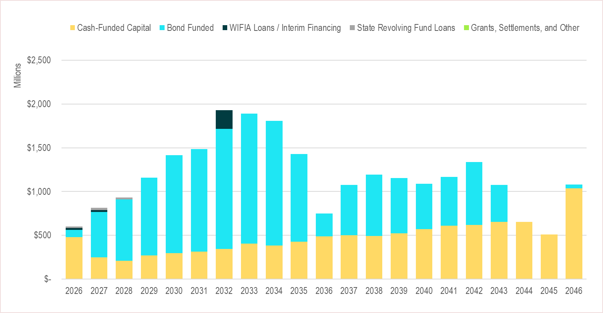

Cash Funding. Since 2023, WTD has used an original cost depreciation method to set cash funding targets for its CIP. With this method, the average annual cash contribution is equivalent to the average annual depreciation over the forecast period. This means that WTD uses the total expected depreciation over the forecast period to determine the total cash contributions required in the next 10 years. Cash-funding requirements are averaged over the next 10 years of the forecast period, allowing WTD to smooth rate increases and produce a more stable rate path. According to WTD, this original depreciation approach reduces near-term rate spikes caused by large CIP investments in a given year because the fiscal impact of the CIP investment is spread over the asset's useful life. A 2022 WTD presentation notes, "this methodology is widely accepted in the industry, reduces the volatility in rate forecasting, and achieves lower rate increases given projected CIP forecasts."

According to the technical memo, the total forecasted depreciation over the next 10 years translates into approximately 27% of the total CIP. WTD reports that the cash funding approach is set for review and reconsideration on a five-year cadence. WTD reports that the next substantive review will occur again in 2027 for 2028 implementation of any potential updates. Additionally, Council staff note that analysis of financial policies for capital financing and debt management, and financial planning and revenue sufficiency, is also set to occur as part of the RWSP Update in 2026, according to the RWSP Charter.

Debt Financing. WTD uses debt financing to provide the remaining funds needed after the use of cash. Debt financing represents 73% of total project funding over the next 10 years. The main sources of debt available to WTD include state loans, federal Water Infrastructure Finance and Innovation Act (WIFIA) loans, and revenue bonds. Figure 5 above shows the capital funding forecast and capital funding sources.

Operating Expenditures. Operating expenditures are forecast to account for 32% of the revenue requirements for the sewer rate in 2027. During the 2026 rate process, WTD forecasted 2027 operating expenditures of $267.7 million. The proposed 2027 rate forecast maintains this projection. Beyond 2027, incremental operating costs are forecast to increase by 4% per year for general and labor costs.

This $267.7 million in operating expenditures for 2027 reflects all annualized budget adds from the 2026-2027 adopted budget, including inflationary operational costs, additional funding for major maintenance repairs, and additional staffing for operations, capital, and administrative support.

The $267.7 million in operating expenditure also assumes other expenses for 2027 identified after the budget adoption, such as large nondiscretionary adds related to utilities (primarily electricity), chemicals, biosolids hauling, and multiple labor agreement updates (totaling approximately $9 million in labor costs). Because these expenses were not included in the 2026-2027 budget, WTD will be requesting additional appropriation authority in a supplemental budget for some or all of these costs while seeking to maintain expenditures below the operating forecast of $267.7 million.

Rate Smoothing. Over the forecast period, WTD aims to develop a "smooth" sewer rate forecast that provides for fewer steep spikes. According to the technical memo, a smoothed sewer rate forecast allows for the collection of revenues that exceed expenditures in a given year and are less than expenditures in subsequent years to fully fund the utility over the forecast period with less volatility.

Smoothing rates means moving from considering only revenue needs in a particular year to considering them over a longer period to smooth year-to-year increases. The first step in rate smoothing is to set the cash target for each year of the forecast to match the estimated annual depreciation. As shown in Table 5, using only the original cost depreciation method would still result in spikes in the sewer rate during the forecast period. To smooth those spikes, WTD reviews the entire forecast period and, when necessary, creates a gradual trajectory of rate increases by anticipating transferring more cash to the capital fund than the cash-funding target for that year. The same amount is reduced from the transfer in a later year of the forecast. At the end of the 10-year forecast, total cumulative revenues and expenditures are balanced.

Table 5.
2027 Forecast Before and After Rate Smoothing

Table 5 shows the impact of rate smoothing on the sewer rate. The second row of the table shows that even with the original cost depreciation method, the proposed rates would still exhibit steep ups and downs. The smoothed rate is shown in the fourth row. WTD notes that rate smoothing is part science and part art. Part of this is balancing customer impact (avoiding "rate shock") with financial risk. The financial risk comes from collecting revenues below cash-funding target in the first years, expecting to make up for it in the following years. Any stair-stepping more gradual than the current proposal would either incur higher financial risk in the short term or require a higher rate increase peak in the middle of the forecast.

With each new forecast, more information becomes available about the timing of future expenditures. WTD reports that the projected rate path may need to be re-smoothed by making adjustments from the prior forecast.

Alternative Rate Scenarios. The 2026-2027 adopted Biennial Budget includes a proviso requiring WTD to provide two alternative scenarios in addition to the Executive's proposed sewer rate, including at least one rate that is 2% lower than the Executive's proposed rate. Each of the proposed scenarios is briefly discussed below.

Scenario 1: Two Percent Below Executive's Proposal. As shown in Figure 6, the Executive achieved the 2% reduction by deferring capital expenditures, with deferrals shown in gray. WTD reports that deferrals in this scenario would impact asset replacement and capacity projects, resulting in increased likelihood of detrimental impacts such as overflows, sinkholes, equipment damage, permit violations, and life-safety risks, as well as introducing additional risk of bond rating downgrades and higher costs of borrowing. This scenario does not achieve long-term rate relief, and the 20-year forecast rate is slightly higher than the proposed rate forecast.

Figure 6.
Scenario 1: Two Percent Below Executive's Rate Proposal
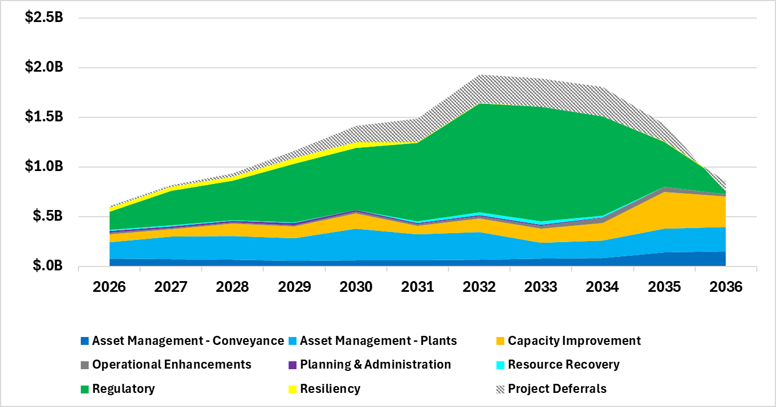

Table 6.
Scenario 1: Two Percent Below Executive's Rate Proposal and 2027-46 Rate Forecast

Council staff asked WTD to consider whether the 2% rate reduction could be achieved by applying an 80% approach to regulatory project forecasting, lowering the debt service coverage (DSC) ratio to 1.45, and removing $100 million of CIP spending from the forecast period. WTD reports this would result in a 1.5% reduction in rates from 2027-2030, and higher increases in the early 2030s. WTD noted that the risks of such a scenario could include the potential or perceived risk of not completing the CSO projects on time, and could worsen the credit position with rating agencies, and deferring any capital projects increases costs because project costs increase with delays.

Scenario 2: Theoretical Regulatory Deadline Extension. The Theoretical Regulatory Deadline Extension Scenario assumes successful renegotiation of the federal and state regulatory consent decree and, as shown in Figure 7, defers $1.8 billion in planned projects from the first decade of the forecast. This scenario offers near-term rate relief by deferring project costs and results in a higher 20-year forecast rate than the proposed rate forecast. Asset reliability and safety risk, as well as system capacity risk, remain the same as in the proposed scenario, but regulatory compliance projects are no longer assumed to meet established deadlines, with additional potential risks including future borrowing costs and legal risks.

Figure 7.
Scenario 2: Capital Forecast—Theoretical Regulatory Deadline Extension

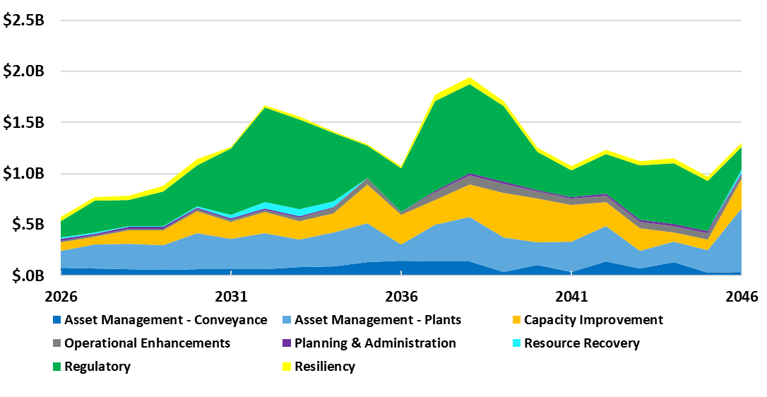
Table 7 shows the Theoretical Regulatory Deadline Extension Rate and associated rate forecast.
Table 7.
Scenario 2: Theoretical Regulatory Deadline Extension Rate and 2027-46 Rate Forecast

WTD notes that the theoretical regulatory deadline extension scenario depends on federal and state regulators agreeing to modify further the CSO consent decree, which was recently modified and finalized in 2025 after a six-year negotiation process. Other scenarios may illustrate circumstances under which projects with specific federal or state requirements and/or funding agreements would be deferred. The scenarios are purely intended to outline potential impacts over time. They do not represent, imply, or establish any plan, commitment, or intent by WTD or the Department of Natural Resources and Parks.
WTD Sewer Rates versus Regional Agencies. WTD prepared Attachment 7 comparing WTD sewer rates to peer agencies across the region.
Capacity Charge. The amount of the capacity charge is set each year by the Council. See the Background Section of this staff report for more information on the capacity charge.

Proposed Ordinance 2026-0103 would set the 2027 capacity charge at $83.10 each month, assuming payment over 15 years. This would reflect a 6.55% increase from $77.99 in 2026. According to the transmittal, in 2027, the capacity charge is expected to generate $111.2 million and account for about 13.4% of WTD's revenues.

Table 8.
Proposed 2027 Capacity Charge and 2028-2031 Forecast

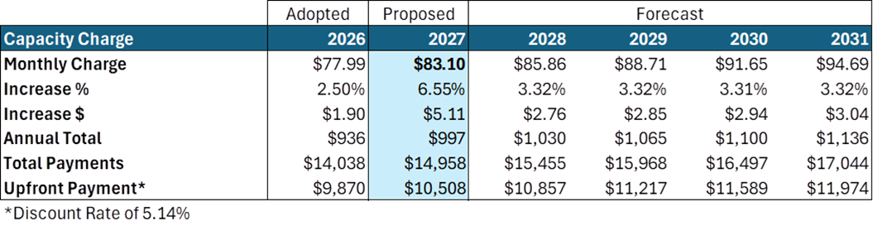

After the transmittal of this ordinance and the capacity charge methodology update (Proposed Ordinance 2026-0066), WTD identified an error in an assumption in the proposed methodology used to calculate the capacity charge. WTD reports that, under the current approach, as permitted by code, it allocated only 95% of growth costs to new customers to avoid overcharging new connections. As explained by WTD, because the proposed methodology is now more precise, WTD calculated the 2027 capacity charge using 100% of growth costs. WTD has since recognized that five of thirty-four sewer contracts contain a provision setting the amount at 95%, and charging more than 95% of growth costs could conflict with those contract provisions.

Since this proposed ordinance assumed revenue from a capacity charge with 100% recovery, WTD is now requesting an amendment to decrease the capacity charge amount from $83.10 to $78.94 for 2027. This would reduce the projected capacity charge revenues in 2027 by $563,645. WTD reports this change will not impact the near-term sewer rate.

Letters from RWQC, MWPAAC, SCA, and contract cities. The following letters from RWQC, MWPAAC, and contract cities regarding the proposed sewer rate and capacity charge have been received.

- Regional Water Quality Committee letter to King County Executive dated April 9, 2026 2027 Sewer Rate and Capacity Charge (Attachment 9)
- Metropolitan Water Pollution Abatement Advisory Committee April 29, 2026 WTD 2027 Rate Recommendation (Attachment 10)
- Sound Cities Association May 22, 2026 (Attachment 11)
- City of Seattle May 5, 2026 Proposed 2027 Sewer Rate and Future Projections (Attachment 12)
- King County Executive May 18, 2026 (Attachment 13)
- City of Bothell May 12, 2026 King County King County 2027 Wastewater Treatment Rates (Attachment 14)
- Regional Water Quality Committee letter to King County Executive dated June 4, 2026 2027 Sewer Rate and Capacity Charge (Attachment 15)

AMENDMENTS

Amendment 1 (Attachment 2)
As discussed above, the Executive is requesting an amendment to PO 2026-0103 to decrease the capacity charge amount from $83.10 to $78.94 for 2027 to address an error in the calculation of the capacity charge. This would reduce the projected capacity charge revenues in 2027 by $563,645. WTD reports this change will not impact the near-term sewer rate.

INVITED

- Kamuron Gurol, Director, Wastewater Treatment Division
- Caitlyn Hall, Financial Services Manager, Wastewater Treatment Division
- Crystal Fleet, Capital Portfolio Planning and Analysis Unit Manager, Wastewater Treatment Division

ATTACHMENTS

- Proposed Ordinance 2026-0103 (and its attachments)
- Amendment 1
- Transmittal Letter
- Fiscal Note
- Technical Memo Proposed 2027 Sewer Rate and Capacity Charge
- Monthly Status Update on WTD’s Rate Work Plan to Improve Engagement, Transparency, and Accountability
- List of capital projects in 10-year capital spending forecast
- WTD Sewer Rates versus National Peer Agencies
- RWQC Rate Letter to King County Executive April 9, 2026 2027 Sewer Rate and Capacity Charge
- MWPAAC Letter April 29, 2026 WTD 2027 Rate Recommendation
- Sound Cities Association Letter
- City of Seattle Letter May 5, 2026 Proposed 2027 Sewer Rate and Future Projections
- King County Executive Letter May 18, 2026
- City of Bothell Letter May 12, 2026 King County King County 2027 Wastewater Treatment Rates
- RWQC Rate Letter to King County Council, June 4, 2026

Ordinance 19801
Ordinance 20023, Section 115, Proviso P4
K.C.C. 28.86.160.C Financial Policy 15
Industrial users pay an additional fee beyond the monthly sewer rate. These fees help the King County Industrial Waste Program recover the costs associated with monitoring and administering the pretreatment program.
2027 Sewer Rate Technical Memo, page 30
RCW 35.58.570
K.C.C. 28.86.160.C FP-15
The proposed changes to the capacity change methodology are being considered under Proposed Ordinance 2026-0066.
The process to update the RWSP started in 2019 as the Clean Water Plan, which WTD paused at the end of 2021 to consider feedback it had received. The planning process restarted in 2024.
2027 Sewer Rate Technical Memo, page 6
2027 Sewer Rate Technical Memo, page 6
Provided by WTD
These changes reflect project cost estimates assumed at the time of the 2027 sewer rate proposal development. WTD notes that any additional changes to cost estimates will be reflected in the separate proviso response letter. Those changes have not yet gone through a full governance board review process, and may ultimately not be approved and adopted, therefore the estimates included in the sewer rate process are still the most certain.
2027 Sewer Rate Technical Memo, page 17
Prepared by Wastewater Treatment Division
Association for the Advancement of Cost Engineering
2027 Sewer Rate Technical Memo, page 13
2027 Sewer Rate Technical Memo, page 18
Depreciation is an accounting concept calculated by dividing an asset’s cost by its estimated useful life, representing how much that asset is expected to wear out or lose value every year. Original cost refers to the actual cost of an asset, rather than the cost adjusted for inflation.
Expenditures include depreciation-based cash transfers to capital
Provided by Wastewater Treatment Division
Ordinance 20023, Proviso Section 115 P4
2027 Sewer Rate Technical Memo, page 32
2027 Sewer Rate Technical Memo, page 33
2027 Sewer Rate Technical Memo, page 33
2027 Sewer Rate Technical Memo, page 34
2027 Sewer Rate Technical Memo, page 36
As transmitted.

