Youth Sports Facilities Grant Program

Motion 13763 Report

September 15, 2014

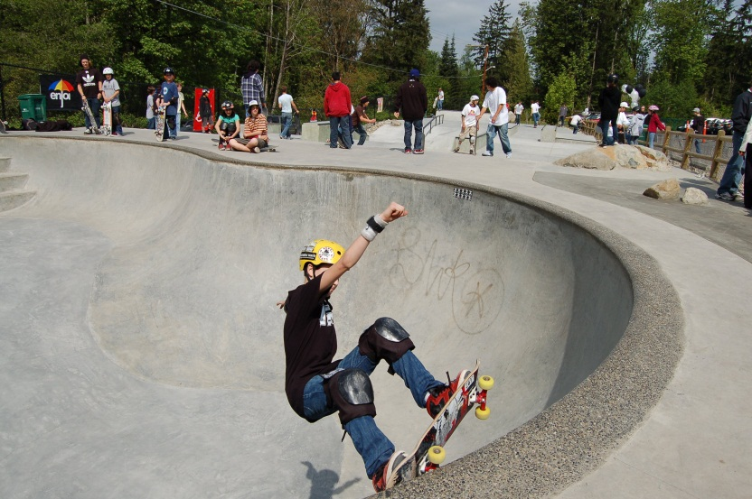

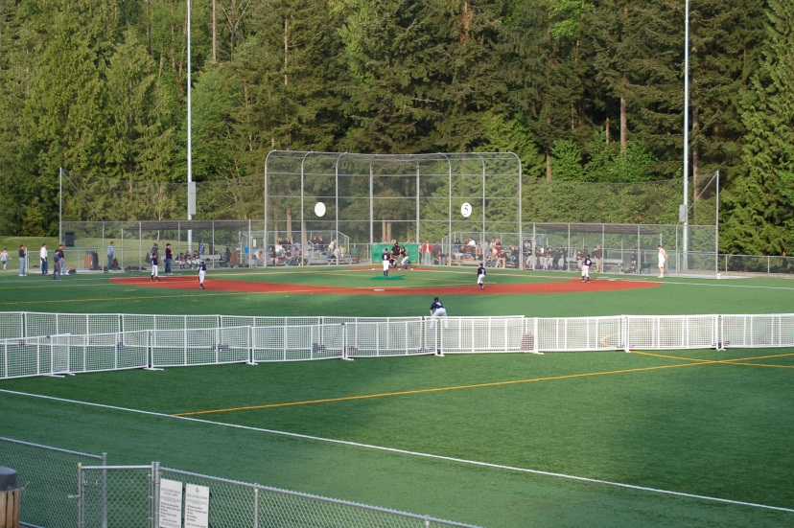

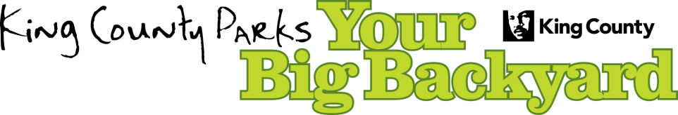

King County Parks and Recreation Division

Department of Natural Resources and Parks

Introduction
This report responds to the following requirement stated in Motion 13763 on the Youth Sports Facilities Grant program.

“The executive shall transmit a motion and report to the council regarding the status of applications to this program by September 15, 2014. The report shall include the following information: a. The number of project applications during 2013 and 2014; b. Project funding amounts requested vs. amounts funded; c. Projects funded in low- and moderate-income communities; and d. Effects on applications attributable to lowered match requirement. The report shall also recommend whether the lowered match requirement should remain in force or be changed for future years.”

History of the Youth Sports Facilities Grant Program (YSFG)
For the past two decades, the YSFG program has worked with community partners to renovate or build more than three hundred youth sports amenities in communities across the County at minimal taxpayer expense. The YSFG program provides matching grant funds ranging from $5,000 to $75,000 to support youth recreation, creating more livable and healthy communities.

Past grants have been awarded for a variety of facilities, including athletic fields, skate parks, playgrounds, sport courts, and rowing facilities. Applications from qualified groups are reviewed annually and scored based on criteria designed to select the most viable projects that will best meet the needs of the community. Additional criteria include project management, sustainable design, matching funds, and sound budgets. Prior to 2013, applicants were required to provide a 50 percent match. In 2013, the match requirement changed to 25 percent per council Motion 13763. Prior to the change, a policy was in place to allow low- and moderate-income applicants the ability to request a reduced or waived community match.

Since its inception in 1993, the YSFG program has awarded $12.5 million in grant funds benefiting youth athletics in King County. In 2013, the program funded 11 projects with approximately $555,000 in grant awards.

Youth Sports Facilities Grant Program Application Status
This attached table summarizes the status of the applications and funding, including:

a. The number of project applications during 2013 and 2014;
b. Project funding amounts requested vs. amounts funded; and
c. Projects funded in low- and moderate-income communities.

Note that the final determination of 2014 funding is pending council adoption of the 2015 budget; as a result, some of the information provided in the table will not be finalized until the budget is adopted.

Effects on Applications Attributable to Lower Match Requirement
In 2011 and 2012, the two years prior to the match requirement change, 21 percent of the applicants contributed a minimum match requirement of exactly 50 percent match and 79 percent contributed more than 50 percent match. In the two years following the policy change (2013 and 2014), 69 percent of applicants met or exceeded the 50 percent match. This change means proportionally less is contributed by the applicant and more by YSFG grant funds. As a result, one fewer project will be funded with more grant dollars generally allocated to each project. Thirty three applications were received in 2013-2014 compared to 30 received in 2011-2012. This suggests that the lower match requirement may not be significantly increasing the number of applications.

Youth Sports Facilities Grant Program Data

 | 2014 |  | 2013 |  | 2012 |  | 2011
 | Requested | Funded | Requested | Funded | Requested | Funded | Requested | Funded
Number of project applications | 15 | TBD | 18 | 11 | 11 | 11 | 19 | 13
Project funding amounts | $1,051,129 | $775,000* | $1,189,444 | $555,000 | $658,404 | $530,075 | $1,143,697 | $685,165
Projects funded in low to moderate-income communities | 4 | TBD | 4 | 2 | 7 | 7 | 4 | 4
Low- and moderate-income applications / Total applications | 4/15  (27%) |  | 4/18  (22%) |  | 7/11  (64%) |  | 4/19  (21%)

*(Estimated final upon Council adoption of 2015 budget)

Recommendation for Match Requirements
Given the effect on the program as noted above, and that a policy is in place to allow low- and moderate-income applicants the ability to request a reduced or waived community match, the Council may wish to consider reinstating the 50 percent match requirement. In discussions with some previous community partners who did not apply for grants this year, an overall lack of additional capital funds available to bring a project forward played a significant role in the decision not to apply for grant funds rather than simply an inability to meet matching requirements. At the same time, some partners may have taken advantage of the reduced match requirement despite being in a position to contribute more, and simply requested more grant funds to offset project costs. Finally, it should also be noted that a 50 percent match requirement is typical for grant programs including Washington State’s Recreation and Conservation Office grant programs, so potential partners are accustomed to this requirement.

