Amendments to King County Countywide Planning Policies, as adopted by Ordinance 19660


December 2024

In the Vision and Framework chapter, beginning on page 9, amend as follows:

FW-1 Maintain the currency of the Countywide Planning Policies through periodic review and amendment. Initiate and review all amendments at the Growth Management Planning Council through the process described below:
a) Only the Growth Management Planning Council may propose amendments to the Countywide Planning Policies except for amendments to the Urban Growth Area that may also be proposed by King County in accordance with policies DP-16 through DP-18B;
b) Growth Management Planning Council recommends amendments to the King County Council for consideration, possible revision, and approval; proposed revisions by the King County Council that are of a substantive nature may be sent to the Growth Management Planning Council for their consideration and revised recommendation based on the proposed revision;
c) A majority vote of the King County Council both constitutes approval of the amendments and ratification on behalf of the residents of Unincorporated King County;
d) After approval and ratification by the King County Council, amendments are forwarded to each city and town for ratification. Amendments cannot be modified during the city ratification process; and
e) Amendments must be ratified within 90 days of King County approval and require affirmation by the county and cities and towns representing at least 70 percent of the county population and 30 percent of those jurisdictions. Ratification is either by an affirmative vote of the city’s or town’s council or by no action being taken within the ratification period.

In the Development Patterns chapter, beginning on page 25, amend as follows:
DP-17 Allow expansion of the Urban Growth Area ((only if at least one of the following criteria is met)) as follows:
a) A countywide analysis determines that the current Urban Growth Area is insufficient in size and additional land is needed to accommodate the housing and employment growth targets, including institutional and other non-residential uses, and there are no other reasonable measures, such as increasing density or rezoning existing urban land, that would avoid the need to expand the Urban Growth Area. Expansions under this subsection shall also be consistent with the criteria in DP-18A; ((or))
b) ((A)) Through the Four-to-One Program, where a proposed expansion of the Urban Growth Area is accompanied by dedication of permanent ((open space)) natural area that is at least four times the size of the proposed expansion to the King County Open Space System.((, where the acreage of the proposed open space:
1) Is at least four times the acreage of the land added to the Urban Growth Area;
2) Is contiguous with the Urban Growth Area
with at least a portion of the dedicated open space surrounding the proposed Urban Growth Area expansion; and
3) Preserves high quality habitat, critical areas, or unique features that contribute to the band of permanent open space along the edge of the Urban Growth Area)) Expansions under the Four-to-One Program shall also be consistent with the criteria in DP-18B; or
c) The area is currently a King County park being transferred to a city to be maintained as a park in perpetuity(( or is park land that has been owned by a city since 1994 and is less than thirty acres in size)).

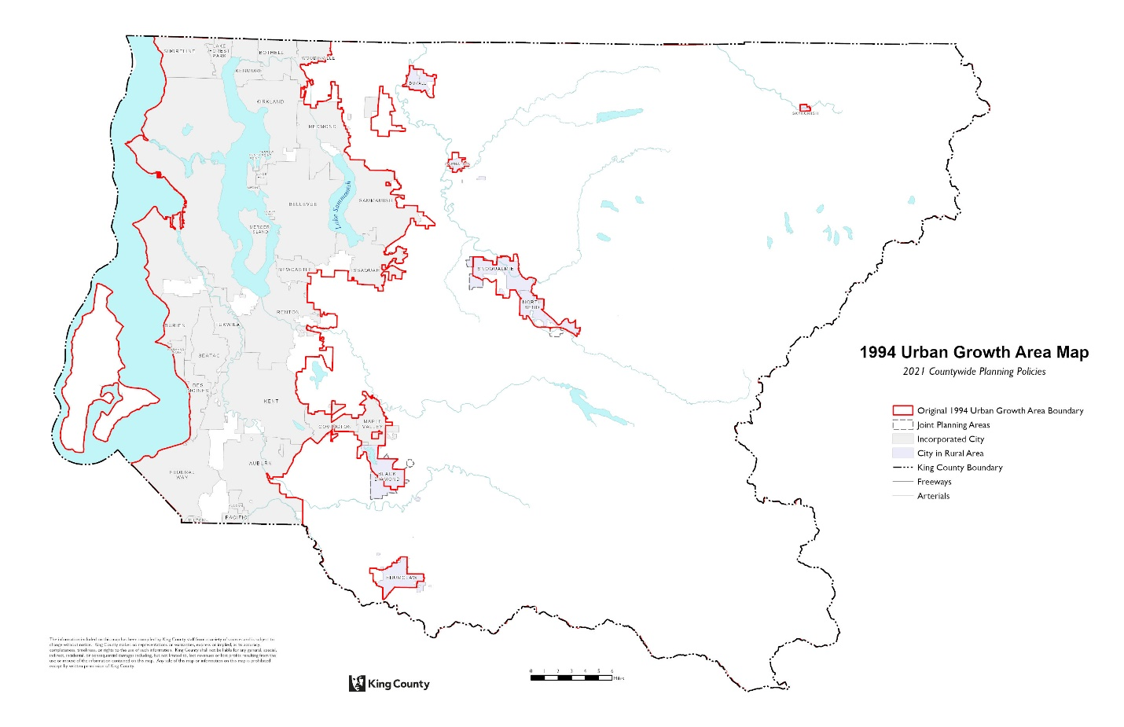
Notes: This map is for reference only. The information on this map has been compiled by King County staff from a variety of sources and is subject to change without notice. A detailed map of the 1994 Urban Growth Area boundary can be found at http://gismaps.kingcounty.gov/iMap. The Joint Planning Areas (JPA) represents information from the following ordinances: 10450, 11446, 11575, 11593, 12065, 12081, 12302, 12421, 12533, 12534, 12535, 13690, 14115, 14117, 14391, 14448, 14775, 16919, and 16949. King County makes no representation or warranties, express or implied, as to the accuracy, completeness, timelines, or rights to the use of such information. This document is not intended for use as a survey product. King County shall not be liable for any general, special, indirect, incidental, or consequential damages including, but not limited to, loss revenues or lost profits resulting from the use or misuse of the information contained on this map.

DP-18A ((Add land to the Urban Growth Area only if expansion of the Urban Growth Area is warranted based on the criteria in DP-17(a) or DP-17(b), and it)) An expansion of the Urban Growth Area under Policy DP-17(a) shall meet((s all of)) the following criteria:
a) ((Is)) Be adjacent to the existing Urban Growth Area;
b) (( For expansions based on DP-17(a) only, is)) Be no larger than necessary to promote compact development that accommodates anticipated growth needs;
c) Can be efficiently provided with urban services and does not require supportive facilities or services to cross or be located in the Rural Area or Natural Resource Lands;
d) Follows topographical features that form natural boundaries, such as rivers and ridge lines and does not extend beyond natural boundaries, such as watersheds, that impede the provision of urban services;
e) Is not currently designated as Natural Resource Land;
f) Is sufficiently free of environmental constraints to be able to support urban development without significant adverse environmental impacts, unless the area is designated as an Urban Separator by interlocal agreement between King County and the annexing city; and
g) Is subject to an agreement between King County and the city or town adjacent to the area that the area will be added to the city’s Potential Annexation Area. Upon ratification of the amendment, the Countywide Planning Policies will reflect both the Urban Growth Area change and Potential Annexation Area change.

DP-18B Expansions of the Urban Growth Area under the Four-to-One Program in Policy DP-17(b) shall meet the following criteria:
a) The proposed expansion of the Urban Growth Area:
1. Shall only allow for residential development;
2. Can be efficiently provided with urban services and does not require supportive facilities or services to cross or be located in the Rural Area or Natural Resource Lands;
3. Follows topographical features that form natural boundaries, such as rivers and ridge lines and does not extend beyond natural boundaries, such as watersheds, that impede the provision of urban services;
4. Is not currently be designated as Natural Resource Land;
5. Is sufficiently free of environmental constraints to be able to support urban development without significant adverse environmental impacts, unless the area is designated as an Urban Separator by interlocal agreement between King County and the annexing city;
6. Is adjacent to the original Urban Growth Area boundary which was adopted in the 1994 King County Comprehensive Plan, unless there are limitations due to the presence of critical areas, and does not expand the Urban Growth Area from a location that was previously expanded through the Four-to-One program;
7. Is subject to an agreement between King County and the city or town adjacent to the area that the area will be added to the city’s Potential Annexation Area. Upon ratification of the amendment, the Countywide Planning Policies will reflect both the Urban Growth Area change and Potential Annexation Area change; and
8. Where the area is adjacent to an incorporated area, no development proposal or activity shall be allowed until the land added to the Urban Growth Area is annexed into a city or town; and
b) The proposed natural area shall:
1. Be at least four times the acreage of the land added to the Urban Growth Area;
2. Provide at least three-quarters of the area required to be dedicated natural area is on-site,
3. Fully surround the portion of the proposed Urban Growth Area expansion that is adjacent Rural Area and Natural Resource Lands; and
4. Preserves high quality habitat, critical areas, or unique features that contribute to the band of permanent natural area along the edge of the Urban Growth Area.
DP-19 Allow redesignation of Urban land currently within the Urban Growth Area to Rural land outside of the Urban Growth Area if the land is not needed to accommodate projected urban growth, is not served by public sewers, is ((contiguous with)) adjacent to the Rural Area, and:
a) Is not characterized by urban development;
b) Is currently developed with a low-density lot pattern that cannot be realistically redeveloped at an urban density; or
c) Is characterized by ((environmentally sensitive)) critical areas making it inappropriate for higher density development.

