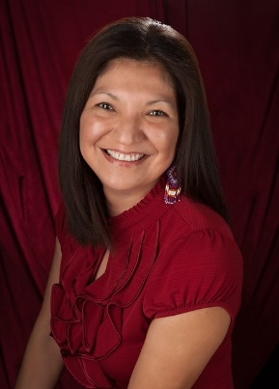
Hi I am, Jolene Williams, a member of the Snoqualmie Tribe and a Tribal Council member. I am the daughter of Caroline M. Enick Glendale of Snoqualmie and Eugene R Jack of Yakama Nation, granddaughter of James Enick of Sauk Suiattle Tribe and Evelyn M. Keenum Enick of Snoqualmie Tribe also my paternal grandparents Ella Olney and Raymond Jack both from Yakama Nation and Great Granddaughter of Chief Jerry Keenum of Snoqualmie Tribe. Who resides in Tolt known as Carnation to some. My practice and teachings have always been to introduce oneself and your family ties so those who are listening can understand the connections to why you are present.
I am a current Snoqualmie Tribal Council member for 8 years now and entering a 3rd-4-year term as of May 2024. I also sat on Snoqualmie Tribal council as an alternate council member in 2010 to 2012. I currently have master’s degree in Managerial Communications, Bachelors in Business completed through an online program from Bellevue University of Nebraska. I have been in the gaming industry (aka Casino) for 20 years.
I am a wife to a wonderful man named Steve L Williams, Sr going on 25 years come February.
I am a proud parent of 5 beautiful children 3 boys and 2 girls and a grandparent to 7 great beings who steal my heart every moment I see them. I currently reside in Marysville WA. Yes I commute everyday to work for my people in the Snoqualmie Valley area. My grandparents did the same commute when I was growing up. I have many memories at the Tolt Mac Donald Park. My family still picnics there annually to keep our ancestors’ stories and practices alive.
I am in hopes to add my knowledge, experience and my tribe’s attributions to conversations had on King County Behavioral Health Committee.
We have to share who we are after we know who we are! Respect the grounds we walk because our ancestors laid the foundation of our existence to be who we have become now!
Jolene R Williams, MMC
Snoqualmie Tribal Councilwoman

