STAFF REPORT

Agenda Items: | 7, 8 and 9 | Name: | Mary Bourguignon  Leah Krekel-Zoppi
Proposed No.: | 2017-0246  2017-0504  2018-0273 | Date: | September 19, 2018

SUBJECT

Proposed Motions 2017-0246, 2017-0504, and 2018-0273 would acknowledge receipt of three progress reports on the East Lake Sammamish Trail that were required by the 2017-2018 biennial budget (Ordinance 18409, Section 132, Proviso P1).

SUMMARY

The East Lake Sammamish Trail (ELST) follows a former Burlington Northern Santa Fe (BNSF) rail corridor for 11 miles between Redmond, Sammamish, and Issaquah on the east side of Lake Sammamish. King County purchased the corridor from BNSF in 1998, opened an interim gravel trail in 2006, and opened completed, paved segments of the trail in 2011, 2013 and 2015.

As part of the 2017-2018 biennial budget, the Executive requested $9.97 million for the final two segments of the ELST: to complete construction of the 1.2-mile South Sammamish A segment (which opened to the public in 2017); and to complete preliminary and final design of the 3.6-mile South Sammamish B segment.

In response to this funding request, the Council included a proviso in the biennial budget ordinance requiring three progress reports (in June 2017, December 2017, and June 2018) on the status of work completed, funds expended, and coordination with the City of Sammamish on these two remaining segments of the trail.

Proposed Motions 2017-0246, 2017-0504, and 2018-0273 contain the required progress reports. The reports summarize a total of $8.2 million expended on these two trail segments between the first quarter of 2017 and the first quarter of 2018, summarize the work completed on each segment, and summarize the coordination underway with the City of Sammamish. As transmitted, the three motions satisfy the terms of the proviso requirement.

BACKGROUND

Project History. The East Lake Sammamish Trail (ELST) project includes the design and construction of a paved and soft surface multi-use recreational trail along 11 miles between Redmond, Sammamish and Issaquah on the east side of Lake Sammamish. When completed, it will connect with the Burke Gilman Trail, Marymoor Connector Trail, Sammamish River Trail, and Issaquah Preston Trail. Figure 1 shows a map of the ELST within the context of the regional trails system.

Figure 1. East Lake Sammamish Trail and Regional Trails System

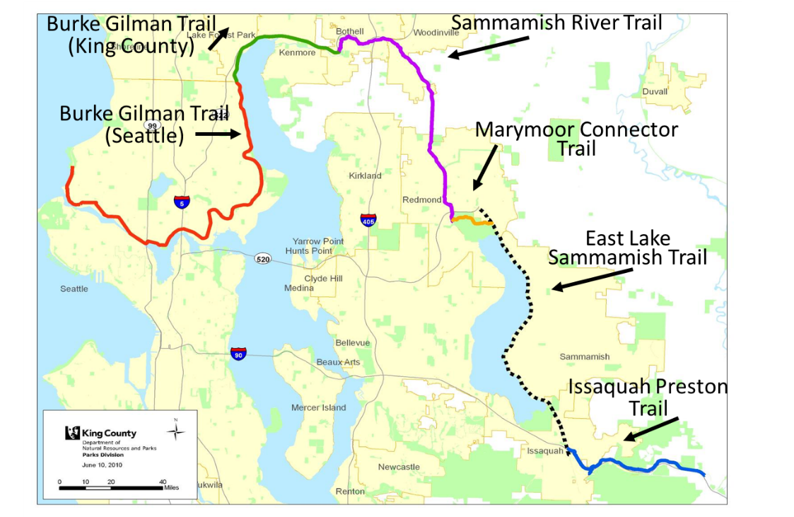
Source: King County Department of Natural Resources and Parks

King County purchased the corridor from BNSF in 1998, opened an interim gravel trail in 2006, and completed preliminary design for the entire corridor in 2009. Since then, the County’s Parks and Recreation Division has been developing the trail in segments based on funding availability.

- A 1.2-mile Redmond segment at the northern end of the corridor was opened in 2011;
- A 2.2-mile Issaquah segment at the southern end of the corridor was opened in 2013; and
- A 2.6-mile North Sammamish segment just south of the Redmond segment was opened in 2015.

In fall 2016, as part of the proposed 2017-2018 biennial budget, the Executive requested $9.97 million for the final two segments of the ELST:

- To complete construction of the 1.2-mile South Sammamish A segment (from SE 43rd Way to SE 33rd Street, just north of the Issaquah segment); and
- To complete preliminary and final design of the 3.6-mile South Sammamish B segment (from SE 33rd Street to Inglewood Hill Road, just south of the North Sammamish segment).

Proviso Requirement. In response to this funding request, the Council included a proviso in the biennial budget ordinance requiring three progress reports (in June 2017, December 2017, and June 2018) on the status of work completed, funds expended, and coordination with the City of Sammamish on these two remaining segments of the ELST. The proviso states:

Ordinance 18409, Section 132, P1 PROVIDED THAT:

Of this appropriation, $300,000 shall be expended or encumbered only in three increments of $100,000 and only after the executive transmits each of three reports on East Lake Sammamish Trail progress and an accompanying motion that should acknowledge receipt of each East Lake Sammamish Trail progress report and reference the subject matter, the proviso's ordinance, ordinance section and proviso number in both the title and body of each motion and a motion acknowledging receipt of each East Lake Sammamish Trail progress report is passed by the council. Upon passage of each motion, $100,000 is released for encumbrance or expenditure.

Each East Lake Sammamish Trail progress report shall include, but not be limited to:

A. The progress on budgeted work on South Sammamish segments A and B;

B. The status of coordination with the city of Sammamish; and

C. The status of money spent, quarterly and cumulatively during the biennium, on work completed on South Sammamish segments A and B as compared with this ordinance.

The executive should file the three progress reports and the motions required by this proviso by June 1, 2017, December 1, 2017, and June 1, 2018, in the form of a paper original and an electronic copy with the clerk of the council, who shall retain the original and provide an electronic copy to all councilmembers, the council chief of staff and the lead staff for the transportation, economy and environment committee, or its successor.

Proposed Motions 2017-0246, 2017-0504, and 2018-0273 include the three progress reports required by the proviso. Each report provides an update on the three elements required by the proviso:

- Progress on budgeted work on South Sammamish segments A and B. The progress reports outline the work tasks completed during each time period. As Table 1 shows, for the South Sammamish A segment, work was completed and the trail segment was opened to the public in December 2017; for the South Sammamish B segment, permitting is currently underway.

Table 1. Work Tasks Completed on Proviso Trail Segments

Report | ELST South Sammamish  A Segment | ELST South Sammamish  B Segment
Report #1 (2017-0246) | - Installation of construction and erosion control fencing  - Clearing and grubbing  - Construction of concrete channel | - 60 percent design plans  - Submission of the Shoreline Substantial Development Permit (SSDP) application and 30-day comment period  - Submission of the Grading Permit application
Report #2 (2017-0504) | - Installation of underground utilities  - Construction of retaining walls  - Construction of trail intersections  - Installation of chain link fencing  - Construction of rest stops  - Trail paving  - Placing topsoil and mulch in landscape, mitigation areas | - Review and preparation of responses to city and public comments on SSDP  - Continuation of trail design and drainage analysis
Report #3 (2018-0273) | - Paving of driveway approaches  - Installation of trail signage, bollards, guardrail, split rail fence,  - Planting at landscape and mitigation areas  - Striping at intersections  - Construction of 33rd Street plaza  - Trail opened December 2017 | - Reviewed, prepared, and posted responses to city and public comments on SSDP  - Identified encroachments  - Completed City of Sammamish SSDP hearing (and preparing for Washington State Shorelines Hearing Board SSDP hearing)  - Prepared for summer 2018 project with City of Sammamish to construct Zaccuse Creek fish culverts

- The status of coordination with the city of Sammamish. The progress reports outline the coordination activities completed during each time period. Table 2 summarizes these activities.

Table 2. Coordination with Sammamish on Proviso Trail Segments

Report | ELST South Sammamish  A Segment | ELST South Sammamish  B Segment
Report #1 (2017-0246) | - City Inspector attends weekly construction meeting and visits project daily  - City receives weekly project updates and newsletters, an updated 3-week construction schedule each week, a monthly communications log, notice of homeowner issues, and notice of any shutdowns | - City receives a monthly communications log, notice of homeowner issues, and project newsletters  - Parks and City hold a weekly conference call to discuss Zaccuse Creek  - Parks and City hold frequent discussions regarding permitting and design issues
Report #2 (2017-0504) | - City Inspector attends weekly construction meeting and visits project daily  - City receives weekly project updates and newsletters, an updated 3-week construction schedule each week, a monthly communications log, notice of homeowner issues, and notice of any shutdowns | - City receives a monthly communications log, notice of homeowner issues, and project newsletters  - Parks and City hold a weekly conference call to discuss Zaccuse Creek  - Parks and City hold frequent discussions regarding permitting and design issues
Report #3 (2018-0273) | - City receives project updates and newsletters, a monthly communications log, and notice of homeowner issues | - City receives a monthly communications log, notice of homeowner issues, and project newsletters  - Parks and City hold a weekly conference call to discuss Zaccuse Creek  - Parks and City hold frequent discussions regarding permitting and design issues

- The status of money spent, quarterly and cumulatively during the biennium, on work completed on South Sammamish segments A and B as compared with this ordinance. The progress reports summarize a total of $8.2 million expended through the first quarter of 2018, out of the total of $9.9 million appropriated for the entire biennium. Table 3 shows the funds expended for each trail segment by report and quarter.

Table 3. Status of Money Spent on Proviso Trail Segments

Report / Time Period | ELST South Sammamish  A Segment | ELST South Sammamish  B Segment
Report #1 / Q1 2017 | $1,591,243 | $242,925
Report #2 / Q2 2017 | $1,283,830 | $432,717
Report #3 / Q 3-4 2017 | $3,495,002 | $973,630
Report #3 / Q1 2018 | $177,529 | $48,977
TOTAL through Q1 2018 | $6,547,604 | $1,698,249

ANALYSIS

The three progress reports transmitted with Proposed Motions 2017-0246, 2017-0504, and 2018-0273 meet the terms of the proviso requirement. Each progress report was transmitted by the required deadline; and each provided an update on the required information on work progress, coordination with the City of Sammamish, and money spent on the two segments of the trail.

ATTACHMENTS

- Proposed Motion 2017-0246 and Attachment A
- Proposed Motion 2017-0504 and Attachment A
- Proposed Motion 2018-0273 and Attachment A

INVITED

- Katy Terry, Interim Director, Parks and Recreation Division, Department of Natural Resources and Parks

Ordinance 18409, Fund 3581, Project 1044600
Ordinance 18409, Section 132, Proviso P1
Ordinance 18409, Fund 3581, Project 1044600

