WASTEWATER TREATMENT OPERATING
Analyst: Jenny Giambattista

 |  | Expenditures |  | Revenues |  | FTEs |  | TLTs
2025 Revised Budget Biennialized |  | $473,394,808 |  | $1,387,308,490 |  | 946.0 |  | 8.0
2026-2027 Base Budget Adjust. |  | ($6,815,327) |  | ($2,000,000) |  | 0.0 |  | 0.0
2026-2027 Decision Packages |  | $36,093,460 |  | $173,606,051 |  | 69.0 |  | 8.0
2026-2027 Proposed Budget |  | $502,673,000 |  | $1,558,915,000 |  | 1015.0 |  | 16.0
% Change from prior biennium, annualized |  | 6.2%
Dec. Pkg. as % of prior biennium, annualized |  | 7.6%
Major Revenue Sources: Sewer rate and capacity charge revenue, etc.

Description

The Wastewater Treatment Division (WTD) is responsible for collecting and treating wastewater from its designated service area, and for reclaiming wastewater, recycling solids, and generating energy. WTD expenditures are organized in three budgets, including the Wastewater Operating, Water Quality Construction, and Wastewater Debt Service budgets. The operating budget includes both expenditures to operate the five wastewater treatment plants and 390 miles of conveyance pipeline, and rate revenues to support operating, capital, and debt service needs. As such, revenues associated with the operating budget significantly exceed operating costs; the bulk of revenues have historically been transferred to the capital fund, debt service fund, and used for debt defeasance.

Operating programs are focused on the conveyance, treatment, and recycling of wastewater and its treatment residuals. Wastewater is received from cities and sewer districts, who deliver it to County interceptor pipelines; generators include both households and business/industry. The West Point, South, and Brightwater treatment plants are considered regional treatment plants and receive and process the bulk of the region’s wastewater; the Carnation and Vashon plants address more limited and localized wastewater processing needs. Agency services also support resource recovery efforts, including biosolids recycling, reclaimed water utilization and distribution, and natural gas/biomethane processing and reuse. The agency’s Industrial Waste program issues permits, and conditions discharge of industrial waste into the sewer system, requiring pretreatment of discharges to minimize impacts on treatment facilities.

Primary revenue sources include the sewer rate, paid by all dischargers, and the capacity charge, assessed for new connections to the wastewater system. In June 2025, the Council approved a sewer rate increase of 7.5% for 2026 and at that time WTD projected an increase of 12.75% for 2027. Increases in operating expenditures can have a larger impact on the rate than an equivalent increase in capital costs because operating expenditures must be funded by cash (rate revenue).

Summary of Proposed Budget and Changes

The 2026-2027 proposed operating budget is 6.2% higher than the 2025 annual biennialized budget. The increase reflects inflationary operational costs, additional funding for major maintenance repairs, and additional staffing for operations, capital, and administrative support. For the FTE requests related to capital, only the share of the FTE costs related to operations is requested in this operating budget. The remaining costs are charged to capital projects.

How the Annual Sewer Rate Adoption Process Works with WTD’s Biennial Budget. As WTD is largely funded by the sewer rate and capacity charge, its projected operating expenditures and FTEs are based on the annual rate adoption, which by contract with local sewer agencies, must occur prior to June 30 each year. WTD budgets only based on adopted rates, not projected rates. Therefore, the proposed 2026-2027 budget only assumes the expenditure level and FTEs for the biennium that are supported at the 2026 adopted sewer rate level. After the 2027 rate is adopted by June 30, 2026, for the 2027 fiscal year, the Executive will have an opportunity to transmit a supplemental budget ordinance to reflect any changes in expenditures for 2027 based on revenues from the new 2027 adopted rate. Additional staffing and operational needs beyond those supported by the 2026 rate will be considered based on the 2027 adopted rate. During the 2026 rate adoption, WTD forecasted the rate in 2027 would increase 12.75%. If this rate increase is proposed by the Executive and adopted by the Council, there would likely be a corresponding supplemental budget request in 2027.

WTD provided the figure below to illustrate the major categories of new operational investments requested in the 2026-2027 proposed budget.

Figure 1
2026-2027 Proposed WTD Operating Adds
Definitions: PPD=Project and Planning; DO=Director’s Office; F&A=Finance and Administration; ECS=Environmental and Community Services; O&M = Operations & Maintenance

Key decision packages are listed below.

Major maintenance repairs - $6.7 million. This decision package includes funding to address aging assets, failing assets, and unforeseen repairs of assets. WTD reports its current repair budget of $3 million is insufficient and it can no longer absorb additional costs to complete this work.

West Point Treatment Plant - $5.2 million and 13 FTEs. Five decision packages including requests for five mechanics, three instrument technicians, three maintenance electricians, one industrial maintenance specialist, and one process engineer.

Transfer to Water and Land Resources Division (WLRD) - $4.6 million. This decision package would increase the transfer to WLRD to reflect inflationary cost increases to the approximately $42 million of biennial operating transfer to WLRD for environmental lab services and other science services. This is in addition to the $1.5 million increase to WLRD in the 2025 budget.

Project Planning and Delivery - $2.2 million and 27 FTEs. This decision package would add an additional 27 FTEs to support the expanding capital portfolio of programs and projects. Additionally, the 2026-2027 proposed budget includes two Water Quality Planner/Project Manager positions at $74,201, related to the expanding capital program. An additional $14.7 million is included in the appropriation for the capital projects to support the capital portion of the FTEs requested in the operating budget.

Increasing Electricity Costs - $2.9 million. This includes $2.1 million for South Plant electricity costs and $799,152 for projected increasing costs at West Point Treatment. The increase at South Plant is due to both increased consumption and Puget Sound Energy rate increases. This is in addition to the $1.3 million added in 2025 and represents an approximate 18% increase from South Plant’s current budget for electricity. The increase at West Point is largely due to expected Seattle City Light rate increases.

South Plant Staffing - $2.5 million and 7 FTEs. The decisions packages would add 5 FTEs for South Plant mechanics with corresponding tools and vehicles, one South Plant industrial procurement specialist and one additional South Plant Treatment Engineer. These 7 FTEs will be added to the existing 130 staff for South Plant.

Administrative, Business and Finance staff - $1.5 million and 8 FTEs. The 2026-2027 proposed budget includes five decision packages adding a total of eight positions related to administrative, business, and finance support.

Biosolids - $1.9 million. This includes $1.4 million for increased costs for biosolids hauling and application and $500,000 (one-time) for the operational costs of the biosolids compost pilot located at South Treatment Plant. The pilot which began producing a compost in late November of 2024 has provided proof of concept in WTD’s ability to produce a high-quality biosolids-derived compost that meets Class A requirements. The pilot is performing as expected and is anticipated to run for a five-year period to allow for testing and evaluation of the product.
Brightwater Treatment Plant Staffing - $980,693. This decision package includes one gardener and two supervisor FTEs at Brightwater Treatment Plant.

Expand Director’s Office - $905,829 and 3 FTEs. This decision package would add one Chief of Staff, one Special Projects Manager, and one Construction Safety Specialist to the Director’s Office. The Special Projects Manager will manage politically sensitive, inter-governmental, strategic, regulatory, and confidential projects/programs for the WTD’s Director’s Office. These staffing adds would bring the total FTEs in the Director’s Office to 41 FTE.

WaterWorks Grant Program - $797,450. This decision package would add an inflationary increase to the WaterWorks Grant Program based on 1.5% of WTD operating budget.

The budget also includes a large revenue adjustment of $173.6 million to revise budgeted revenues to match the current forecast projected to increase, largely due to increasing rate revenues. In addition, there are technical budget expenditure reductions totaling $14.1 million.

Key Issues

Issue 1 – Continued Increase In staffing

The proposed budget would add 69.0 FTEs to the existing 946 FTEs, for an increase of 7.2% in the size of the employee pool. The specific positions are identified in the summary above and requested positions address both operating and capital needs.

As shown in Table 1, this increase reflects the continued growth in WTD staffing beginning in 2023 and is expected to continue as the capital program continues to grow. In addition to the 2026-2027 proposed positions, WTD anticipates seeking a supplemental appropriation to address staffing needs based on the 2027 sewer rate. Council staff have requested additional information on potential anticipated adjustments to the 2026-2027 budget.

The 2025 budget authorized an additional 78 FTEs of which 48 are reported vacant as of September 10, 2025. Overall, WTD has 131 vacancies, which is about 14% of WTD’s total FTEs and represents a higher vacancy rate than September 20024.

Table 1
WTD FTE Growth 2013-2025

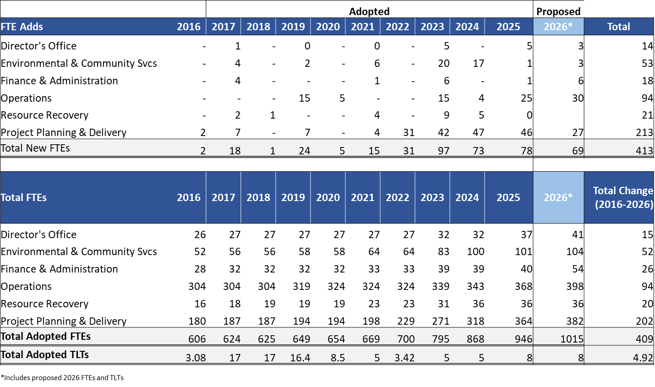

WTD reports additional operating staff are needed because:
- WTD facilities are aging, requiring attention to address hundreds of minor repairs and adjustments.
- With an increasingly large capital portfolio, operations staff are needed to participate in systems planning, construction, start-up, and commissioning process.
- Permit conditions are more complex, requiring more monitoring and adjustment to meet water and air quality requirements.
- Contracts and policy goals require more investments in biosolids, biogas, recycled water, and sewer heat.

For the capital staffing FTE requests, at the request of Council staff, WTD provided a detailed discussion of the division’s approach to forecasting additional FTEs to support the expanded capital appropriation request. The discussion describes an informed-decision making process that primarily relies on a qualitative review that is based on the extensive experience WTD has with capital staffing. As part of this approach, WTD assesses the specific staffing needed for each WTD section to staff the projected projects. WTD confirmed the existing approach using a pilot forecasting model that estimates FTE needs for both current projects and new projects in the 2026-2027 capital budget proposal by using historical project labor expenditure data and current and planned capital project labor expenditure forecasts. Both approaches confirmed the request for an additional 27 FTEs for the capital program. As the growth in the capital program and the corresponding hiring rate is unprecedented for WTD, the division will continue to evaluate staffing needs and the capacity to hire and onboard staff.

See the discussion above explaining the 2027 portion of WTD’s 2026-2027 proposed budget.
The Total FTE figures are inclusive of new FTE add as well as internal transfers.

