18317

Protocol Committee

Report to the

King County Council

May 5, 2016

Table of Contents

- Historical Background and Detailed Methodology Utilized to Tab 1
Determine Judicial Need

- Application of Methodology to Current Data Tab 2

- Executed Protocol Committee Agreement: April 2016 Tab 3

Tab 1

Measuring the Need for Judicial Positions in King County Superior Court
- An update of the 2007 Protocol Indicators

December 2015

Background

In 1989, the three branches of King County government entered into a protocol agreement concerning the criteria for adding judges in King County Superior Court. In that agreement, the King County Council authorized the addition of 4 judges for King County Superior Court. It also mandated “the development of long-term methodology for determining future judicial staffing needs …”

Between 1989 and 1998, the court used the 1989 protocol to determine the judicial needs for King County Superior Court. In 1998, a working group consisting of staff of the three branches of County government was formed to evaluate the 1989 protocol. After an extensive discussion, the working group felt that the parameters specified in the 1989 protocol had significant deficiencies and that the protocol parameters needed to be revised.

In 1998, the working group developed and proposed a new set of indicators to measure the need for judicial positions in King County Superior Court. The new protocol parameters were more appropriate for measuring judicial need based on several factors. As a result, the three branches of King County government approved the proposed changes and entered into a new protocol agreement which governed the addition of judges in King County Superior Court. In the 1998 protocol, three specific indicators and associated criteria were specified. When the criteria for one of the three indicators are met, it prompts a discussion and full analysis on whether the court is in need of additional judges. Specifically, the three indicators measure the trends in: 1) pending caseload; 2) age of pending cases; and 3) the utilization of pro tem judicial resources.

In 2005, a more rigorous review and analysis of the three existing indicators was carried out regarding the reliability of the methodology and the relevance of the indicators. As a result of that effort in 2005, modifications were suggested to change the way the three indicators were calculated and to improve the effectiveness of these three indicators. This review and analysis led to the adoption of a new protocol agreement between the court, the Executive, and the County Council in 2007.

Since 2007, the court has been applying the 2007 protocol agreement to measure the judicial needs of the court. The court added its last judge position in 2008 in response to the striking increase in filings between 2005 and 2007. While the methodology in the 2007 protocol indicators remain valid, we need to note that the 2007 protocol agreement was based on caseload and judicial resource data from prior to 2005. Since the adoption of the protocol agreement in 2007, there have been significant changes in many areas. The notable changes are: 1) filing patterns in criminal, Involuntary Treatment Act (ITA), and juvenile offender cases; 2) the expansion of specialized treatment courts; and 3) the court’s resource allocation as a response to the ever-changing environment in both the budget arena and court operations. These changes have made the indicators, particularly the Weighted Caseload Index indicator, in the 2007 protocol agreement outdated, since they were based on data from prior to 2005. It is necessary to revisit and update the protocol indicators using more current data on both case volume and judicial resource allocation while upholding the underlying methodology and rationale.

2007 Protocol Indicators

In this section, we briefly review the three protocol indicators as specified in the 2007 inter-government agreement. These three indicators are:

- The caseload indicator (weighted caseload index, or WCI):

The computed WCI has shown to be equal or greater than 102 in four consecutive quarters.
$$\text{WCI}=\sum{(\text{weight* current pending caseload})=}0\text{.}\text{111}P_{1}+0\text{.}\text{039}P_{2}+0\text{.}\text{062}P_{3}+0\text{.}\text{087}P_{4}$$
where$P_{i}$ (i = 1, 2, 3, 4) is the current pending caseload for criminal, civil and domestic cases without children, domestic with children and paternity cases, and juvenile offender and dependency cases, respectively. $W_{i}$ (i=1, 2, 3, 4) is the computed weights for the four case categories.

This WCI indicator is the primary and most important indicator among the three protocol parameters. This indicator examines the quarterly caseloads in four major case types: criminal, civil, domestic, and juvenile offender and dependency. The weights used in the 2007 indicator were based on caseload data and judicial resource data from prior to 2005.

- The age indicator (AI)

The median age of pending cases shows an increase of 10% or more for four consecutive quarters compared to the same quarter of the previous year.

This age indicator measures the time since filing for the pending cases. It examines whether a delay in the adjudication process exists for prolonged periods. If a significant increase is observed in the age indicator over consecutive periods, it may point to the fact that delays are occurring. This would initiate an analysis to ascertain whether the court has adequate judicial resources for properly adjudicating cases without further delay.

- The pro tem indicator (PTI)

A consistent use of more pro tems than are required to backfill for judicial vacancies or long term unplanned absences (i.e. exceeding two weeks) over a period of four quarters.

The third protocol indicator relates to the external judicial resources the court utilizes in its operation. Concern may be warranted if large number of pro tems are used over a long time period. If the court is using an extremely large number of pro tems consistently, it may indicate a lack of regular judicial resources. Furthermore, utilization of significant amount of pro tems and pending caseload is expected to be inversely correlated. Increase in pro tem judicial capacity will likely lead to decrease in pending caseload.

When discussing judicial needs, all three indicators should be considered concurrently. Because of the complexity of the adjudication process and court operations, it is quite possible that the indicators may not uniformly point in the same direction, to either the over-capacity or under-capacity of judicial resources. Whenever one of the indicators varies from the specified criteria, a full analysis is needed to ascertain the real situation.

Updating the 2007 Indicators

The 2007 protocol indicators were based on the underlying data from prior to 2005. Many changes in both filing patterns and court operations have occurred since that time. It is necessary to revisit the indicators and make necessary changes.

In the process of updating the 2007 protocol indicators, it is important to consider the following factors:

(1) Court Leadership Time. The efficient management of the court requires utilization of judicial resources for leadership responsibilities. The opening of the Maleng Regional Justice Center (MRJC) and the establishment of specialized courts (for example, the Unified Family Court) required judicial resources dedicated to court leadership responsibilities. As in the 2007 protocol agreement, we still take into account the judicial resource needs for these management-related leadership duties. Estimating court leadership time is a challenging task since there is often no clear division between case-related and court leadership duties for chief judges. A feasible approach is to rely upon the experience of chief judges. After an in-depth discussion with chief judges in 2007, we concluded that a reasonable estimate of the time allocated for leadership responsibilities was 25% for all five chief judges - chief MRJC judge, Seattle chief criminal judge, chief civil judge, chief UFC judge, and chief juvenile judge, for a total of 1.25 FTEs. In addition, the presiding judge devotes his/her entire time to court management. Therefore, a total of 2.25 FTEs is needed for court leadership responsibilities. It should be noted that this 2.25 FTEs does not capture any time by other judges for their leadership duties or tasks. In the current undertaking, we propose keeping the same amount of leadership time (2.25 FTEs) as in the 2007 agreement.

(2) Modifications. One of the 1998 protocol indicators is based on the pending caseload. However, as examined in the 2007 analysis, there are a significant number of modification matters that are not part of the pending cases because these modifications are embedded in the existing or already-adjudicated cases, particularly, in the domestic and paternity case types. These modifications are not counted in new filings or pending cases, and therefore not captured in regular court statistics even though they require significant judicial intervention and resources. It is difficult, perhaps even impossible, to know precisely what proportion of the workload of Superior Court originates from these modifications. In the 2007 protocol agreement, the judicial resource needed for these modifications was estimated as one judge position. Since then, the number of modifications has remained stable, staying just under 2000 modifications annually. Therefore, we will continue to use one judge position for the modifications as in the 2007 protocol agreement.

(3) Focus on cases assigned to judges only. Because the protocol agreement only addresses judge positions, we will solely consider cases that are either assigned to judges (civil and domestic cases) or primarily presided over by judges (for example criminal and juvenile offender cases).

There have been changes in how the court assigns judges to special case types. For example, the 2007 protocol agreement grouped the juvenile dependency and juvenile offender cases together. Unlike 2007, the court now assigns a dedicated judge to dependency and termination matters, so it is appropriate to exclude the dependency judge and dependency caseload in our new calculation.

For the development of new weights, we will focus on the following 4 groups of cases: 1) criminal cases; 2) civil cases and domestic cases without children; 3) family law cases (domestic cases with children and paternity), and 4) juvenile offender cases.

We propose an update of the WCI indicator using more recent data in both case volume and judicial resources. We will recalculate the weights for different case groups. By introducing weights, we acknowledge differences in the demand for judicial involvement among different case types. It is important to note that the weights do not further distinguish potential difference in charges or actions within each category.

Before we start, we need to acknowledge that the determination of weights is still a difficult but critical task. For the purpose of determining weights for different case types, first we need to determine the judicial allocations to different departments. Second, we need to identify the case types managed by the judges in different departments. Again, since we are evaluating judge needs, we will only focus on the caseload with judge assignments. After we identify the judicial resource allocation and the caseload assigned to the judges in different departments, we are able to compute the weights for different case types.

In summary, we will develop the weights for different case groups by: 1) focusing on the caseload for cases either assigned to or primarily adjudicated by judges; 2) basing on underlying caseload and judicial resource allocations in 2011-2014 as baseline data; and 3) addressing the workload related to modification matters not captured in regular caseload statistics. As a result, we propose a single WCI measure for each quarter. Since the weighted caseload index is expected to vary from quarter to quarter, we further recommend a smoothing method to capture the trend in the weighted caseload index.

Determining Judicial Sources Allocated to Different Cases

Currently, King County Superior Court has 53 judges. Based on our earlier discussion, 2.25 judges are allocated for court leadership. Excluding the 2.25 FTEs, the judicial resources available for managing cases are 50.75 judges. In addition, there is one dedicated judge for ITA and another dedicated judge for juvenile dependency/and termination matters. Therefore, a total of 48.75 judges are available for all other case types, except ITA and dependency and termination matters. Currently, criminal judges also receive assignment for civil and domestic without children cases. Criminal judges manage their assigned civil and domestic cases until trial. It is estimated that criminal judges spend approximately 25% of their time on these assigned civil and domestic matters. As a result of the current judge and caseload assignment, the number of judges allocated to different case groups is estimated as: criminal (17.75), civil and domestic without children (20.5), Unified Family Court – domestic cases with children and paternity cases (7.75), and juvenile offender cases (2.75).

Judicial resources for criminal cases. The majority of the workload for judges in the criminal department is related to criminal matters. In addition, criminal judges also manage a portion of the caseload in civil and domestic cases without children. While the precise allocation of time that criminal judges spend on criminal and civil/domestic cases without children is difficult to determine, a reasonable assumption by judges is that criminal judges use 75% of their time for criminal cases, and the remaining 25% for civil/domestic cases without children. As a result, a total of 17.75 judges are assigned to criminal cases. The proportion of judicial resources devoted to criminal cases can be calculated as:

$$R_{1}=\frac{\text{17}\text{.}\text{75}}{\text{48}\text{.}\text{75}}=0\text{.}\text{364}$$

Judicial resources for civil and domestic without children cases. Judges in both criminal and civil departments manage civil cases as well as domestic cases without children. Based on the number of judges in the two departments, a total of 20.5 judges are assigned to civil and domestic cases without children cases. The portion of judicial resource allocated to civil and domestic cases without children is:

$$R_{2}=\frac{\text{20}\text{.}5}{\text{48}\text{.}\text{75}}=0\text{.}\text{421}$$

Judicial resources for domestic with children and paternity cases. Judges in the Unified Family Court (UFC) preside over all domestic cases with children and paternity cases. Currently, 7.75 judges are assigned to UFC. As described earlier, there are about 2000 modifications that are not counted in the caseload since the modifications are embedded in already-adjudicated cases. To address and offset this unmeasured work for modifications, as in the 2007 protocol agreement, we calculate the weight for domestic cases with children and paternity cases by increasing one judge. In this approach, the judicial resource assigned to UFC matters is now 8.75 judges. The portion of judicial resource for UFC (domestic with children and paternity cases) can therefore be calculated as:

$$R_{3}=\frac{8\text{.}\text{75}}{\text{48}\text{.}\text{75}}=0\text{.}\text{179}$$

Judicial resources for juvenile offender cases. Judges in the juvenile department manage juvenile offender cases. A total of 2.75 judges are assigned to juvenile offender cases. The portion of judicial resource for juvenile offender cases is determined as:

$$R_{4}=\frac{2\text{.}\text{75}}{\text{48}\text{.}\text{75}}=0\text{.}\text{056}$$

Determining Weights

In the section above, we have determined the judicial resource allocation to the following case groups: 1) criminal; 2) civil and domestic without children; 3) domestic with children and paternity; and 4) juvenile offender. The next step is to calculate the weights for each case group using the proportions of judicial resource allocation and the caseload. Dividing the judicial resource percentage by the caseload gives us a weight for a given case category.

Generically, the weight for each case group can be computed as the ratio of judicial resource over the baseline caseload, namely

$$W_{i}=\frac{R_{i}}{P_{i}}=\frac{\text{judicial resource}}{\text{baseline caseload}}$$

where $R_{i}$(i=1,2,3,4) is the judicial resource allocated to each case group as discussed in the previous section, $P_{i}$ (i=1,2,3,4) is the baseline caseload, and $W_{i}$ (i=1,2,3,4) is the computed weight.

After significant changes in criminal and offender filings in 2009 and civil filings in 2010, the filings of most categories have been stable. The judge positions also remain at 53 since 2009. We use the average of quarterly caseloads between 2011 and 2014 as the baseline data. The rationale in using the 2011-2014 data reflects the relative stability in both caseloads and judicial resources.

Based on these assumptions, the weights for different case groups can be calculated as follows (expressed by a multiplication of 1000 as the weight per 1000 cases):

Criminal cases:

$$W_{1}=\frac{0\text{.}\text{364}}{\text{2783}}x\text{1000}=0\text{.}\text{131}$$

Civil and domestic without children cases:

$$W_{2}=\frac{0\text{.}\text{421}}{\text{10018}}x\text{1000}=0\text{.}\text{042}$$

Domestic with children and paternity cases:

$$W_{3}=\frac{0\text{.}\text{179}}{\text{2250}}x\text{1000}=0\text{.}\text{080}$$
Juvenile offender cases:

$$W_{4}=\frac{0\text{.}\text{056}}{\text{656}}x\text{1000}=0\text{.}\text{086}$$

A larger weight reflects the fact that a case in the corresponding group requires more judicial resource. Based on the caseloads for the 4 years (2011-2014), the resulting weights for different case groups is ranked as:

Criminal (0.131) > Juvenile Offender (0.086) > UFC (0.080) > Civil and Domestic without children (0.042).

Weighted Caseload Index (WCI)

After establishing the weights for different case types, we can compute the weighted caseload index (WCI) using these weights and the current caseloads in evaluating the judicial resource need. This WCI is a summation of the product between the weights and current caseloads at the reporting time (for example at each quarter end). This can be written mathematically as

$$\begin{aligned}\text{WCI}=\sum{W_{i}}P_{i}=\sum{(\text{weight* current pending caseload})=}W_{1}P_{1}+W_{2}P_{2}+W_{3}P_{3}+W_{4}P_{4} \\ 0\text{.}\text{131}P_{1}+0\text{.}\text{042}P_{2}+0\text{.}\text{080}P_{3}+0\text{.}\text{086}P_{4}\end{aligned}$$

where$P_{i}$ (i = 1, 2, 3, 4) are the current caseload for criminal, civil and domestic without children, domestic with children and paternity, and juvenile offender cases, respectively; $W_{i}$ (i=1,2,3,4) are the computed weights.

A deviation from a WCI value of 100 indicates the relationship between current judicial resources and the underlying data from 2011-2014. In other words, a WCI of greater than 100 means under-capacity of judicial resources and a WCI value of less than 100 points in the other direction.

Smoothing WCI

It is anticipated that the WCI will show fluctuations from quarter to quarter even using the weighted approach. As mentioned before, the intention of the protocol agreement is to detect the trend across time. Therefore, we need to smooth out the potential short term ups and downs in the WCI. One approach is to take the running average of the WCIs of previous reporting periods immediately before the current period. In this revision, we still recommend the average of a total 4 quarters (current quarter plus three previous quarters) be utilized to minimize the influence of the fluctuations in the WCI.

The court currently has approximately 49 judges for criminal, civil, domestic, paternity and juvenile offender cases, so each judge has roughly 2% of the caseload. One may assume that every 2 points in the smoothed WCI approximately reflects one judge position.

Summary

Since the implementation of the 2007 protocol agreement, we have applied the three protocol indicators to monitor the need for judicial positions in King County Superior Court. A revision is necessary to weight different case types using more relevant data from 2011 through 2014. While keep the age indicator (AI) and pro tem indicator (PTI) unchanged, we recommend and propose a change in the computation of the Weighted Caseload Index (WCI). Therefore, the new protocol indicators are:

If condition for one or more of the following three protocol indicators is met, the court should conduct a full analysis to investigate the adequacy of judge positions in King County Superior Court.

WCI Indicator

"A 2-point deviation from a scale of 100 in WCI represents approximately 1 judge position:

$$\text{WCI}=\sum{(\text{weight* current pending caseload})=}0\text{.}\text{131}P_{1}+0\text{.}\text{042}P_{2}+0\text{.}\text{080}P_{3}+0\text{.}\text{086}P_{4}$$
where$P_{i}$ (i = 1, 2, 3, 4) are the current caseload for criminal, civil and domestic cases without children, domestic with children and paternity cases, and juvenile offender cases, respectively.

Age Indicator (AI)

The median age of pending cases shows an increase of 10% or more for four consecutive quarters compared to the same quarter of the previous year.

Pro tem Indicator (PTI)

A consistent use of more pro tems than are required to backfill for judicial vacancies or long term unplanned absences (i.e. exceeding two weeks) over a period of four quarters.

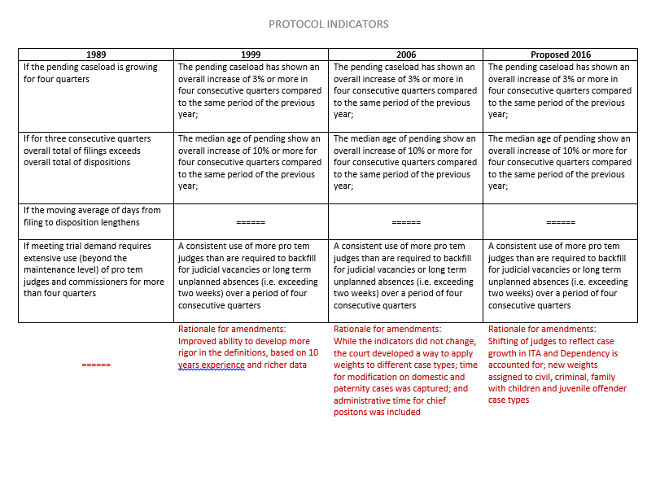

Tab 2

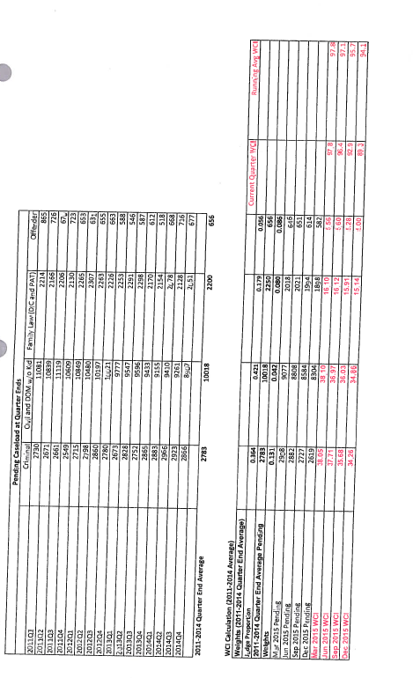

Tab 3






















