STAFF REPORT

Agenda Item: | 16 | Name: | Terra Rose
Proposed No.: | 2022-0224 | Date: | June 21, 2022

SUBJECT

Proposed Ordinance 2022-0224 would authorize the Executive to sign a use agreement with the City of Kirkland that would allow Kirkland to design, construct, operate, and maintain a new crossing on a County-owned portion of the Eastrail Corridor at 134th Court NE, Kirkland.

SUMMARY

Eastrail (formerly called the "Eastside Rail Corridor" or "ERC") is a 42-mile former rail line running from the City of Renton to the City of Snohomish and extending through the cities of Snohomish, Woodinville, Kirkland, Bellevue, Renton, and Redmond, and parts of unincorporated Snohomish and King Counties. Proposed Ordinance 2022-0224 would authorize the County to enter into a thirty-year agreement with the City of Kirkland (City) for the City to design, construct, operate, and maintain a crossing extending 134th Court NE across a portion of the Eastrail owned by King County. According to the proposed agreement, the anticipated crossing would accommodate the potential relocation of Lee Johnson Chevrolet who is in negotiations with Google, Inc. to sell its existing property near the proposed Sound Transit I-405 and NE 85th Street Bus Rapid Transit station and purchase two parcels adjacent to the County-owned portion of the Eastrail in Kirkland.

The Executive is proposing to enter into this agreement under the authority provided in K.C.C. 4.56.150.E (paragraph c), which allows the County to enter into agreements for the use of County property with another governmental agency if the property is to be used by the government agency "to make improvements to the county property." Executive staff note that the crossing constitutes an improvement that increases safety for trail users by replacing an uncontrolled crossing with a signaled crossing. Under the proposed agreement, the City would be obligated to design, construct, operate, and maintain the future crossing at 134th Court NE at the City's sole cost and expense (as provided in the proposed agreement and as described later in this staff report), as well as enter into a binding agreement with the Developer with a series of requirements, some of which involve attempts to limit traffic on the crossing. The County, under the proposed agreement, would be responsible for closing the existing crossing on the King County-owned portion of the Eastrail at 135th Avenue, as well as removing the existing rail and constructing an interim, gravel trail in the area.

Council staff have identified some grammatical errors in the proposed agreement, as well as some ambiguous language where the expectations in certain circumstances were not as clear as they could be. For instance, it is unclear what would occur if Lee Johnson Chevrolet is not able to purchase the second parcel they are interested in for their relocation or don't relocate at all.

On May 17, 2022, the Kirkland City Council approved Resolution R-5538, which authorized the Kirkland City Manager to sign a use agreement "substantially similar" to the use agreement attached to the resolution that would allow for the construction of a crossing at 134th Court NE.

BACKGROUND

Eastrail History. Eastrail (formerly called the "Eastside Rail Corridor" or "ERC") is a 42-mile former rail line running from the City of Renton to the City of Snohomish and extending through the cities of Snohomish, Woodinville, Kirkland, Bellevue, Renton, and Redmond, and parts of unincorporated Snohomish and King Counties. In 2003, the BNSF Railway Company (BNSF) announced its intention to divest itself of this rail corridor. In response, a group of regional partners, including King County and the Port of Seattle, signed a Memorandum of Understanding that envisioned a regional effort to preserve the corridor for multiple uses. To begin that regional effort, the Port of Seattle acquired BNSF's interests in the corridor between Renton and Snohomish. The southern portions of the corridor (between Woodinville and Renton, and from Woodinville to Redmond) were railbanked. King County became the Interim Trail Sponsor of the 21-mile railbanked portion and purchased a multi-purpose easement from the Port in the railbanked area. King County's wastewater treatment system includes facilities that run within and cross the Eastrail.

On February 8, 2013, King County and the Port executed a purchase and sale agreement for King County to acquire the Port's interest in the remaining 15.6 miles of the railbanked area, as well as a 3.6-mile trail easement north of the railbanked area, between Woodinville and the Brightwater Treatment Plant. In addition, the County continues to own its multipurpose easement in the areas of Eastrail acquired by Kirkland and Sound Transit, comprising approximately 6.6 miles. In total, King County owns property interests in approximately 25.8 miles of Eastrail.

In 2015, the City of Woodinville purchased ownership of 2.6 miles of corridor within the active freight area between the northern terminus of King County's ownership and the city limits. In 2016, Snohomish County purchased the remaining portion of active rail corridor between the Snohomish County line and the City of Snohomish.

The five entities that acquired the Port's interest in the railbanked portion of the Eastrail – King County, Sound Transit, the City of Redmond, the City of Kirkland, and Puget Sound Energy) began planning collaboratively around a shared, multi-use vision for the corridor through a Regional Advisory Council (RAC). In 2013, the RAC produced "Creating Connections," a report containing the RAC recommendations on the Eastrail. In 2017, the RAC was expanded to include Snohomish County, the City of Bellevue, the City of Renton, the City of Woodinville, and the Eastside Greenway Alliance, under a new memorandum of understanding (MOU), which also expanded the RAC's scope of work to align with the 2013 Creating Connections report and the 2016 work plan adopted by the RAC. This MOU also established the purpose, membership, leadership, and staffing for the RAC.

After a public outreach process, the RAC in 2019 adopted "Eastrail" as the new name for the Eastside Rail Corridor, as well as a corresponding logo to use for signage to unify and promote the corridor. The King County Council adopted the name change later that year.

Circumstances Surrounding Proposed Use Agreement. The proposed agreement indicates that Lee Johnson Chevrolet, a multi-decade business in the city of Kirkland "whose different lines of auto sales provide substantial sales tax to the City and the County," is in negotiations with Google, Inc. to sell its current auto dealership property near the proposed Sound Transit I-405 and NE 85th Street Bus Rapid Transit station for redevelopment as Class A technology office space. The proposed agreement also notes that the redevelopment is "a more appropriate land use and will provide thousands of jobs for the region located close to high-capacity transit service."

Lee Johnson Chevrolet, referred to in the proposed agreement as "the Developer," seeks to purchase two parcels in the Totem Lake area (referred to in the proposed agreement collectively as the "Site") "to retain the auto dealership business in the City and the County."

On July 20, 2021, the Department of Natural Resources and Parks entered into a Memorandum of Understanding with the City that identified a need for the proposed use agreement.

ANALYSIS

Proposed Ordinance 2022-0224 would authorize the County to enter into a thirty-year agreement with the City of Kirkland (City) for the City to design, construct, operate, and maintain the Crossing at a new northerly extension of 134th Court NE, which would cross Eastrail property owned by King County (referred to as the "Crossing" and depicted in yellow in Figure 1). Note that "Site" does not refer to the location of the Crossing but parcels adjacent to the portion of the Eastrail owned by King County. The County-owned portion of the Eastrail that would be subject to the Crossing is identified in the proposed agreement as the "Property". The Property is subject to easements by Puget Sound Energy, Sound Transit, and the King County Wastewater Treatment Division (referred to in the agreement as the "Easement Holders").

The map in Figure 1 highlights the location of 134th Court NE in yellow and the Site, which is the two parcels Lee Johnson Chevrolet is interested in purchasing to relocate, is outlined in black. The Eastrail is shaded green.

Figure 1.
Location of 134th Court NE and Potential Relocation Site of Lee Johnson Chevrolet in Kirkland

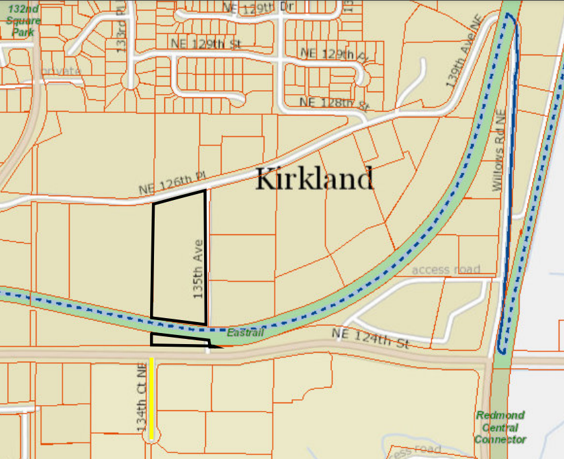
NOTE: Map was staff-generated in King County's iMap application and parcel outline is for reference location purposes only and not for legal use.

The proposed agreement would be effective when signed by each party following affirmative action by both the King County Council and the Kirkland City Council. On May 17, 2022, the Kirkland City Council approved Resolution R-5538, which authorized the Kirkland City Manager to sign a use agreement "substantially similar" to the use agreement attached to the resolution that would allow for the construction of a crossing at 134th Court NE.

The proposed agreement would allow for subsequent five-year terms by amendment.

Executive Rationale and Authority. King County Code 4.56.150.E allows the county to enter into agreements for the use of County property with another governmental agency if it is to be used in one of four ways described in Code. Executive staff specifically indicate that the Executive is proposing to enter this agreement under the authority in paragraph c, which is "to make improvements to the county property," and further note that the Crossing constitutes an improvement that increases safety for trail users by replacing an uncontrolled crossing with a signaled crossing, and also supports corridor-adjacent economic development.

The Statement of Facts in the proposed ordinance states that "The new dealership location requires access across the county owned portion of the corridor at 134th Court NE for business to be conducted." Additionally, the proposed agreement states that the Crossing would provide access to the Site "such that the Site can be accessed in a manner that meets the requirements to protect the public health, safety, and welfare, including facilitating police and fire emergency response."

Council staff requested additional information about why this access to the Site was necessary when there is already access from NE 126th Place. Executive staff indicated that additional access is necessary because the auto dealership requires street frontage and customer access from a high-volume roadway. Executive staff further note that, in the longer-term, the future land use and transportation network will be higher density mixed-use, and this access is supportive of that future vision.

County and City Obligations. Under the proposed use agreement, the primary obligations of the City are to:

- Design, construct, operate, and maintain the future crossing at 134th Court NE at the City's sole cost and expense (except as provided in the proposed agreement and as described later in this staff report) to applicable law and the specifications in the agreement;
- Enter into a binding agreement with the Developer and ensure compliance of said agreement where the Developer shall (1) agree that deliveries and staff shall not access the Site from the Crossing absent an emergency and will instead enter from NE 126th Place; (2) adhere to railbanking standards; (3) agree to enable access connecting the Crossing to the building occupying an adjacent parcel to the Site and to build a paved connection that allows vehicular access between the public roadway to said parcel; (4) work with the City to design a public road connection from the Site to NE 126th Place in order to maintain lower traffic volumes at the Crossing while allowing police and fire vehicle access for emergency response; and
- Coordinate with County as required by the proposed agreement.
The County, under the proposed agreement, would:

- Agree that redevelopment of the existing Lee Johnson Chevrolet location to Class A technology office space "is a more appropriate land use";
- Agree that the Site requires access across the Eastrail at the proposed crossing in order for business to be conducted on the Site;
- Close the existing crossing across the King County-owned portion of the Eastrail at 135th Avenue;
- Remove the existing rail and construct an interim, gravel trail between 132nd Place NE and 139th avenue NE/Willows Road where the Eastrail Corridor connects with the City's Willows Road Connector project;
- Operate interim trail crossings of the Eastrail Corridor at 132nd Place NE and Willows Road;
- Review and approve all plans and specifications, and submit the City's plans to Puget Sound Energy, Sound Transit, and the King County Wastewater Treatment Division for review and approval; and
- Act as the intermediary between Easement Holders and Kirkland as necessary under the easement agreements.

Potential Trail User Impacts. The proposed agreement states that the Crossing will be designed and constructed to prioritize Eastrail non-motorized use when possible. According to Executive staff, construction is anticipated to be phased to allow continuous trail use during the construction period with minimal impact to trail users. Further, the proposed agreement states that the County "desires to promote the safety and high-quality experience of trail users and therefore intends to not increase the current number of trail crossings in the King County Corridor." As described previously, the proposed agreement requires the County to use its discretionary legal authority to close the existing crossing located at 135th Avenue that provides access to a parcel adjacent to the Site.

Executive staff indicate that following construction, trail users will have priority over vehicular traffic at the intersection, and while users need to be aware of traffic and use appropriate caution, they will not be delayed.

The proposed agreement also includes efforts to attempt to limit traffic on the proposed Crossing through requiring the City to enter into the binding agreement with the Developer that requires the Developer to agree that deliveries and staff will not access the Site from the Crossing, which is intended to be primarily for customer traffic. The binding agreement also requires the Developer to work with the City to design a public road connection from the Site to NE 126th Place in order to maintain lower traffic volumes at the Crossing while allowing police and fire vehicles access for emergency response.

With these efforts, however, there is a limited enforcement role for the County. Executive staff indicate that while they would notify the City if the Developer was out of compliance, the City would ultimately be responsible for monitoring and enforcement. Additionally, the proposed agreement requires the Developer to work with the City to design a public road connection from the Site to NE 126th, but does not guarantee that it is constructed, or if it is, that it functions to lower traffic volumes.

Council staff inquired about available and projected traffic data and Executive staff indicate that a traffic study will be completed as part of the permitting process. Ultimately, Executive staff characterize this project as a low quality/low volume crossing at 135th Avenue being replaced with a higher quality/higher volume crossing at 134th Court NE, and note that the crossing controls will be consistent with the anticipated volumes similar to many other crossing locations both on the Eastrail and the larger regional trails system.

Potential Fiscal Impacts. The proposed agreement includes language in four areas where the County could potentially incur costs, however, Executive staff anticipate any costs to be minimal. The four areas are described below:

- Design changes during construction and/or after completion: Under Section 2.4 of the proposed agreement, the County would be responsible with approving in writing all plans and specifications at 30, 60, 90, and 100 percent design, as well as design changes during construction, with 30 days to review. However, if the County proposes changes to the project design during construction, the proposed agreement states they shall be borne by the proposing party. Additionally, once the Crossing is completed, if future modifications intended to protect public health and safety due to changing conditions or standards, design features and cost allocation of these future improvements would be negotiated by the parties.

- Extinguishing the nearby crossing at 135th Avenue: Under Section 2.5, the County would agree to close the existing crossing at 135th Avenue no later than the opening of the crossing at 134th Court NE proposed by this agreement. Executive staff indicate that this process involves a conditional use permit. According to Executive staff, coordination with any existing permit holders may be required, but that costs are expected to be minimal.

- Removal of rail on King County portion of Eastrail and construction of an interim trail: Section 3 of the proposed agreement would require the City to reimburse the County up to $600,000 for costs associated with rail removal and construction and operation of an interim, gravel trail between 132nd Place NE and 139th Avenue NE/Willows Road where the Eastrail connects with the City's Willows Road Connector project. While under the language the County would be responsible with any costs exceeding $600,000, Executive staff indicate they are in the process of closing out the rail removal and interim trail construction project and the cost is under $600,000.

- Construction delay resulting from County action or inaction: Section 5.8 of the proposed agreement states that "if the County's actions or inactions cause significant construction delays, then the County shall be responsible for any costs related to such construction delays." The proposed agreement does not describe what constitutes a "significant construction delay" nor how the costs related to such a construction delay would be determined. It is expected that any potential disagreements related to this provision would use the process outlined in Section 9 for Default.

Issues with Transmitted Agreement and Proposed Ordinance. Council staff identified some grammatical errors, as well as some ambiguous language in the proposed agreement and proposed ordinance. These and other issues are listed below:

- In the transmitted use agreement, there is no diagram or other legal description of the Property and it would be clearer to have a depiction of the area and Crossing. There is a diagram in an exhibit to Exhibit E of the use agreement, which is the MOU between the County and City from 2021, but Executive staff indicate the MOU is nonbinding. Executive staff indicate that attaching the full MOU to the proposed agreement was inadvertent and they had intended only to include the MOU diagram.
- There is some ambiguity about what the County's obligations are in the event the transaction for the remaining unpurchased parcel of the Site does not go through and/or the Developer does not relocate. Under the proposed agreement, the City has a right to terminate the agreement with six months written notice. However, the County does not have a reciprocal right outside of the Default provisions (Sec. 9).
- In the proposed ordinance, the third fact in the Statement of Facts states that Lee Johnson Chevrolet dealership has purchased the two parcels comprising the Site. However, according to Executive staff, one parcel has been purchased as of Fall 2021, but the second parcel of the Site is in the acquisition process and the closing date is not known.

Timing. The Kirkland City Council staff memo from the May 17, 2022 meeting for the resolution authorizing the Kirkland City Manager to sign the proposed agreement indicated that they expect action by the King County Council by the end of June. However, Executive staff indicated that any time constraints are coming from the City and the rationale for the desired action by the end of June is unclear.

INVITED

- Warren Jimenez, Director, Parks Division
- Jason Rich, Parks Capital Improvement Program Managing Supervisor – Regional Trails, Parks

ATTACHMENTS

- Proposed Ordinance 2022-0224 (and its attachments)
- Transmittal Letter
- Fiscal Note

Ordinance 16738
Under the Federal National Trails Act, also known as the Rails to Trails Act, 16 U.S.C. §1247(d).
As the Interim Trail User, the County is subject to legal obligations imposed by Section 8(d) of the Rails-to-Trails Act, 16 U.S.C. § 1247(d) and 49 C.F.R § 1152.29, as implemented through the Notices of Interim Trail Use (NITUs) for the various parts of the Corridor issued by the Surface Transportation Board (STB), and also the Trail Use Agreement entered into between BNSF and the County, and the STB-required Statement of Willingness to Accept Financial Responsibility (SWAFR). Pursuant to the Rails to Trails Act, all interim uses of railbanked corridors are subject to reactivation of potential interstate freight rail service.
Ordinance 16084
Ordinance 17503
Motion 13801
Motion 14922
Motions 15530 and 15531
King County Parcel Numbers 2726059043 and 2726059101
King County Parcel No. 2726059092
King County Parcel No. 2726059092

