Budget Provisos – Ordinance 15652
Section 58 – Roads
Section 120 – Roads Capital Improvement Program

Revised Work Plan - Dockton Road Preservation - north half (CIP 300111) and Dockton Road Preservation - south half (CIP 300208)

Introduction
Dockton Road SW is a collector arterial located on the east shore of Vashon Island and is supported by a 4000-foot long seawall. This seawall has been identified in the county’s Vulnerable Road Segments report (April 2006) as a top candidate in need of improvements. The timber seawall is nearly 100-years old, varies in height from 3 to 11 feet, and is in poor condition. Much of the seawall has failed and has been buttressed over the years with loosely placed riprap and concrete debris. Portions of the wall have been failing on a yearly basis during winter storms, leading to costly emergency repairs and road closures. Detailed engineering studies have not yet been completed and development of this project is at the planning level.

The Dockton North and Dockton South Preservation projects are along the same contiguous stretch of roadway and are separated only by a 220-foot long portion of the seawall that was replaced in 2003. The overall Dockton Road SW project was broken into two projects for budget phasing purposes. Because the work plan and the alternatives analysis are identical for both projects, they have been combined.

This revised work plan is in response King County Council’s request to ensure that the alternatives analysis requested by the two provisos of Ordinance 15652, Section 58 - Roads and Section 120 – Roads Capital Improvement Program are incorporated as part of the environmental review for these two projects. The revised work plan outlines how this will be accomplished and provides information on the environmental review process itself.

Scope of Work
Under this revised work plan, the appropriate environmental process will be selected; various alternatives will be analyzed based on evaluative criteria as required by these provisos and the selected environmental review process. Using these evaluative criteria in a comparative process the preferred alternative that best meets the needs of the Dockton Road North and South Preservation projects will be chosen.

Selecting the Environmental Review Process
Three environmental processes are possible in determining the preferred alternative. State Environmental Policy Act (SEPA) and National Environmental Policy Act (NEPA) processes would be included in each of the following environmental review options:

1) SEPA Environmental Checklist / NEPA Documented Categorical Exemption (CE)
At a minimum, a SEPA Environmental Checklist with a Determination of Non-significance (DNS) would be required and this avenue would be pursued if it were assumed that there probably are no significant adverse impacts. This SEPA process requires only limited public involvement with a 14-day comment period and at least one public meeting, although King County would likely increase public outreach, including the formulation of a Citizen Advisory Group (CAG) to assist in gathering public input. Including the comment period, the checklist process would be complete in roughly six months; however, the Alternatives Analysis would need to be largely completed before work on the checklist could begin, lengthening the schedule. After consultation with Army Corps of Engineers staff, the NEPA Documented CE would simply be a letter from King County to the Corps confirming the exemption from further NEPA process.

2) SEPA Environmental Checklist / NEPA Environmental Assessment (EA)
A SEPA checklist would be completed as mentioned in process 1) above. If there were uncertainty as to whether there were significant adverse impacts, a NEPA EA would be prepared with the Corps assuming NEPA lead agency responsibility for completing that process. Although King County would supply all of the pertinent information, this decision is entirely in the hands of the Corps acting as the NEPA Lead Agency. A formal public process including a CAG would be included in this NEPA process. The timeframe needed to complete this process could be in the 1-2 year range.

3) SEPA / NEPA Environmental Impact Statement (EIS)
If the potential impacts of the project are expected to be significant, a Determination of Significance (DS) under SEPA would be issued by King County, and an EIS would be required under both SEPA and NEPA. King County would then act on its own behalf as the SEPA Lead Agency, with the Corps assuming lead agency responsibility under NEPA. This process would include a CAG and extensive public involvement. The EIS could take two or more years to complete but would be preceded with an additional 7-month consultant selection process.

The appropriate environmental process will be chosen by King County in conjunction with the appropriate federal lead agency. In general, the simpler projects can be implemented with only a SEPA Checklist whereas the more complex projects must undergo a SEPA / NEPA Environmental Impact Statement (EIS). An Environmental Assessment (EA) does not review the alternatives as rigorously as an EIS and falls between the checklist and EIS review boundaries.

Factors scrutinized in selecting the appropriate environmental process include:
- Agency and public controversy - ranging from low (checklist) to high (EIS)
- Significance of impacts - ranging from insignificant (checklist) to very significant (EIS)
- Extent of mitigation - ranging from limited (checklist) to extensive (EIS)
- Range of alternatives - ranging from one (checklist) to many (EIS)

There are no clearly defined impact thresholds that mandate which environmental review process must be used for a given project. The principal consideration is whether or not the project is likely to result in significant adverse impacts that warrant a more
in-depth analysis of impacts, other alternatives, and potential mitigation measures. Another key factor is the level of controversy that may occur from either agency or public stakeholders. In order to establish which SEPA and NEPA processes are required for this project, additional information will need to be gathered, particularly input from relevant regulatory agencies as well as public stakeholder groups and individuals (particularly those affected directly by prospective alternatives).

Alternatives Development
The alternatives to be examined include reconstructing the seawall and road generally in their current alignment, examination of potential alternative routes, partial or full closure of the road, and a “no build” alternative that perpetuates the past practice of repairing damage as it occurs. In addition, other possible alternatives will be developed and examined as part of this process. These other, yet to be determined, alternatives may arise from new information or from input from the community and stakeholders involved with the project. From this development process those alternatives that are deemed to be reasonable and feasible will move forward into the environmental review process for further review and analysis.

Alternative Analysis
The alternatives analysis will occur within the environmental review process that has been determined to be appropriate for these projects. In depth studies will be done on each of the alternatives and then compared and evaluated. The following evaluative criteria requested in the provisos will be included at a minimum along with other criteria that may be required by the environmental review process in order to compare and evaluate the alternatives:

- Traffic Operations (Operating Efficiencies)
- Environmental Impacts
- Community/Social Elements
- Traffic Impacts, including Non-motorized Elements
- Historic/Cultural Resource Elements
- Hazardous Material Impacts
- Construction Duration and Impacts
- Project Costs (Cost Efficiencies)
- Life Cycle Costs

Through this comparative process the alternatives will be evaluated and a preferred alternative selected.

Public Outreach
The Road Services Division is keenly aware of the interest by the Vashon Community in these projects. It is the Road Services Division’s goal that the community is fully informed about the projects, has access to inform and provide input to the project team, and is kept up to date with the status and decisions made at each step of this process. The Roads Services Division will seek their input through the establishment of a Citizen Advisory Group, public meetings, project newsletters and a project website.

Schedule
Three possible schedules could result from these three environmental review scenarios. It is important to note that all three schedules are very preliminary and all assume there is no appeal of the documents.

Dockton North and Dockton South Preservation schedules

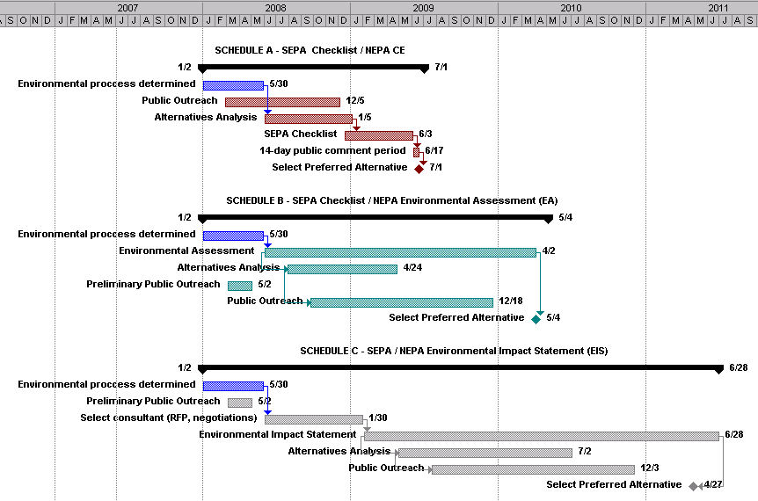

Budget Estimate to Arrive at Preferred Alternative
The following table shows the potential range of costs of arriving at a preferred alternative through each of the three possible environmental review processes.

Schedule A – SEPA Checklist | $350K | 18-month effort
Schedule B – NEPA Environmental Assessment (EA) | $1.0M | 28-month effort
Schedule C – SEPA / NEPA Environmental Impact Statement (EIS) | $2.5M | 42-month effort includes consultant selection process
Tasks
The following tasks requested in the above provisos will be implemented to perform the scope of work:

- Project Management - Coordinate and manage all aspects of work, attend meetings, resolve issues, confirm accuracy and overall quality of the work and deliverables, and complete work on time and within budget.
- Alternatives Analysis - Analyze three or more alternatives including a “no-build” option and alternative roadway alignments. Perform conceptual engineering design to further develop and evaluate alternatives for the purpose of refining structure design, identifying alternate routes and improvements needed, developing cost estimates, aiding public involvement processes and decision making.
- Public Outreach - Inform the public of the alternatives and solicit their input through public meetings. Organize a Citizen Advisory Group and meet regularly with them to solicit their input and keep them informed. Issue project newsletters and maintain a project website.
- Life Cycle Cost / Benefit Analysis - Prepare a life cycle cost analysis for each alternative by developing a detailed estimate of design, construction, right of way, maintenance, and any other tangible costs over the projected life of the alternatives.
- Comparison Matrix - Develop an alternatives comparison matrix, relating each alternative to applicable technical discipline, in order to aid in the comparison of potential impacts across alternatives and the selection of a preferred alternative.

East end of Vashon Highway Preservation project
Looking east at numerous scour areas along seawall. Arrows indicates rock wall failures.
West end of Vashon Highway Preservation project

