Puget Sound
Passenger Ferry Coalition
March 18, 2005
Volume 1, Issue 1
Important Meeting Reminder!
PSPF Coalition Olympia Meeting
Click on link above for details
Tuesday, March 29, 2005
12:00PM-1:00PM
Capitol Room in the Legislative Building
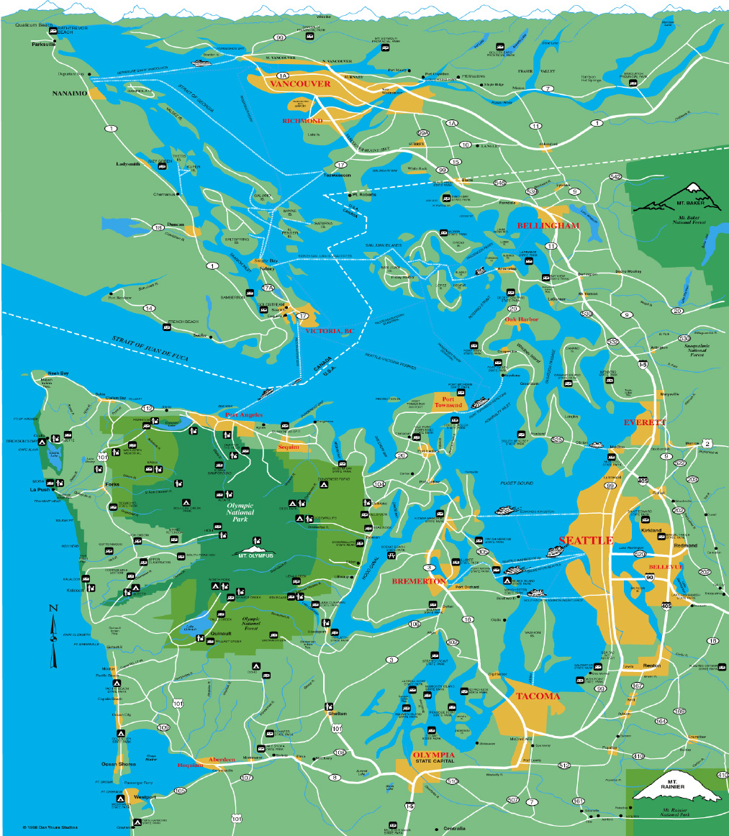  Coalition Mission:  Communication with other ferry systems to support federal initiatives to enhance the role of ferries as an intergral part of our nation's transportation system.  Coordination of local intiatives for appropriate public private partnerships and joint development agreements in ferry and water taxi service around Puget Sound and adjacent waterways.  Connectivity at ports with multi-modal transportation systems and community development initiatives.  Expansion of jobs in the maritime trades industry leading to a positive economic impact.  Coalition Facilitator  Bruce Agnew  Cascadia Center  Executive  Committee  Mark Asmundson,  Mayor of Bellingham  Cary Bozeman  Mayor of Bremerton  Dow Constantine  Councilmember, King County  Bruce King  Garvey Schubert Barer  Darrell Bryan  Clipper Navigations, Inc.  Chris Endresen  Commissioner, Kitsap County  Peter Philips  Pacific Maritime Magazine  Gretchen Wilbert  Mayor, Gig Harbor  David Frieboth  IBU/ILWU  Cascadia Center  206-292-0401 |  | UPDATE  When the Cascadia Center launched the Puget Sound Passenger Ferry Coalition aboard the Royal Argosy in July of 2003 little did we know how fast the development of new passenger ferry routes would progress. From Bellingham to Gig Harbor, communities are rallying around new or proposed routes.  That is not to say that the development of new passenger ferry service is free of controversy. Washington State Ferries (WSF), acting on the findings of its consultant, Berk & Associates, has requested funding from the Legislature for a new “triangle route” between Southworth, Vashon and Seattle that would supplement the existing Vashon-Seattle route. Meanwhile, two private sector operators --Aqua Express and Mosquito Fleet--have filed petitions to the Washington Transportation and Utilities Commission to begin service between Southworth and Seattle.  The request for new state funding for the triangle route sparked a standoff between the respective chairs of the House Transportation Committee, Rep. Ed Murray (who supports it) and Senate Transportation Committee, Senator Mary Margaret Haugen (who opposes it).  The issues are laid out in the following news articles:  King County Metro eyes passenger ferry service  The Seattle Times  Government Overboard  Puget Sound Business Journal editorial  Tradeoff could trigger higher fares  Kitsap Sun  Transit has plans for Southworth  Kitsap Sun  Our Coalition has members on both sides of the issue and has requested, in a letter to the chairs of the committees, for a clarification of state policy towards passenger ferry service.  Please plan on attending our legislative luncheon in Olympia at the Columbia Room in the Capitol Building on March 29. Legislative, community, private sector and labor representatives will review the current situation for the triangle route as well as other passenger ferry initiatives around the Sound.
Federal Funding For Ferries Doubles In House
Mark-Up of TEA-21
One of the primary missions of the Coalition is to work with WSF, other states, maritime labor and the private sector Passenger Vessel Association to increase federal funding for the nation’s ferry system.
Those efforts received a big boost in the markup of the House version of TEA-21(the six year federal transportation program). Federal funding for ferries was doubled to $443 million over the period of the bill with WSF still receiving a set aside allotment. Congressman Rick Larsen, a member of the House Transportation and Infrastructure Committee, deserves special credit for the provision. Please contact Senator Patty Murray and Senator Maria Cantwell to encourage their continued support in the comparable Senate version of TEA-21 reauthorization which is now underway.
North Puget Sound
Through the North Sound Connecting Communities project and with funding from the Federal Transit Administration, a new draft study has just been completed by Wilbur Smith Associates, which reviews possible routes and funding in North Puget Sound. Copies of the report presented at the March 17th meeting in Anacortes, will be available soon at www.cascadiaproject.org, under passenger ferries.
In essence, the report recommends new passenger ferry routes linking Bellingham to Friday Harbor and Bellingham to Seattle with connections to Island, Skagit, and Snohomish counties. Regional governance and funding ideas, including a possible transit benefit district in the San Juan Islands, are under review and community forums are scheduled. Tribal governments have also expressed interest in the North Sound routes. We have been coordinating with the Makah tribe, which is conducting a feasibility study for service across the Strait of Juan de Fuca to British Columbia.
Central Sound/
Lake Washington/
Lake Union
Our passenger ferry coalition has been watching the evolution of new passenger ferry service and transit connections between Kitsap Transit, Pacific Navigation (Bremerton - Seattle) and Aqua Express (Kingston - Seattle). At our recent session in Bremerton, hosted by Mayor Cary Bozeman and Kitsap Transit, we learned how local communities are embracing the new private service for commuting as well as recreational, cultural and medical needs.
On Friday, March 18th the Marine Transportation Association of Kitsap and the Seattle Bremerton Passenger-Only Fast-Ferry Project Team invited those interested in the South Kitsap and North Kitsap areas to take a community ferry cruise aboard the new-generation foot ferry currently conducting wake tests along Rich Passage. The "Spirit," a Teknicraft fast passenger ferry built by All-American Marine in Bellingham, started conducting wake tests last month with support from the Federal Transit Administration Research program. Pacific International Engineering is the lead entity conducting the tests.
Challenges remain on the Bremerton-Seattle route where Washington State Ferries and the private operator directly compete. On the Kingston-Seattle route, the private operator does not compete and, after the first few weeks of service, reports higher than expected ridership.
King County Metro is embarked on a major study of passenger ferry service routes across Puget Sound and throughout Lake Washington and Lake Union.
King County Metro eyes passenger ferry service
The Seattle Times
The Cascadia Center serves on an advisory committee for the study and participated in two major work sessions in Seattle. Results of the study will be released in June. For an update check their website at transit.metrokc.gov.
Last year, Metro was a major sponsor of a “Return of the Mosquito Fleet” (Lake Wa/Lake Union) of 160 people at Adobe in Fremont last September. There was strong interest for both a triangle route linking U.W., Fremont and South Lake Union as well as cross-Lake Washington service to Kirkland and Renton. Some concerns were raised by the rowing community with regard to safety and operation of boats in early morning hours. At the forum, we learned that there are over 7,000 rowers in the greater Seattle area!
Meanwhile, King County Councilmember Dow Constantine reported strong continued growth in ridership for the West Seattle water taxi operated by Argosy Cruises.
See cascadiaproject.org for copies of forum presentations.
South Sound
South Sound: The Coalition is sponsoring informal discussions and community surveys between leaders and potential operators in Gig Harbor, Des Moines, and Tacoma to gauge the interest for a potential triangle route that could connect to Sea-Tac Airport through a shuttle service from Des Moines Marina. Des Moines Mayor Dan Sheckler, city councilmember Susan White and Gig Harbor Mayor Gretchen Wilbert are playing active roles in this initiative.
Water Taxi floats Mayor’s Boat
Tacoma News Tribune
Direct service between these communities could also help alleviate congestion during the Tacoma Narrows Bridge and I-5 improvement projects and provide direct alternative access to the rapidly growing Tacoma waterfront. Initial community surveys were conducted recently by the Port of Tacoma indicating substantial local interests in the concept of passenger ferry service in South Sound. A more comprehensive analysis of potential routes, ridership, financing and other issues is necessary.
Upcoming...
The upcoming Summer Nights series, which has been moved from Elliott Bay to South Lake Union for the summer, offers an ideal opportunity to test a water taxi pilot project similar to successful operations in the inner harbors of Vancouver and Victoria, B.C. Cascadia has sponsored a group, “Connecting Lake Union” that is working to establish links between potential water taxi service, Metro bus service, and the proposed Westlake-South Lake Union streetcar and the Seattle Monorail’s Green Line.

