Sale Property Summary
Photo of Property
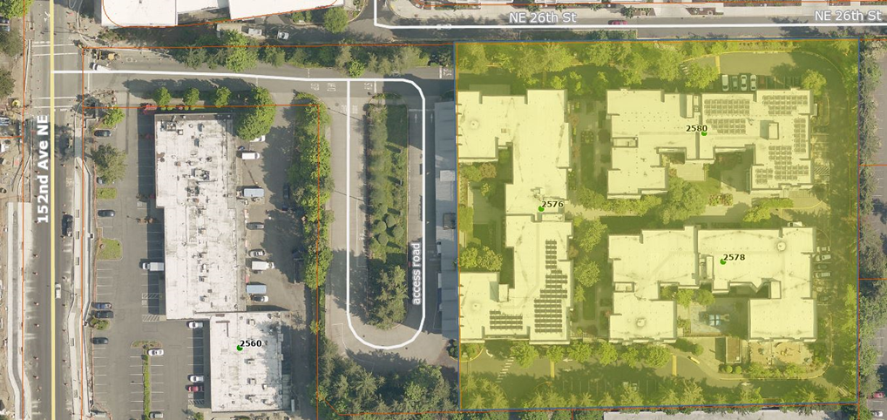

Address 2578 152nd Ave. NE, Redmond, WA 98052
Sale Price $1,250,000
Sale Area 3.42 acres of affordable housing development and parking garage, King County will retain an easement for commuter parking use of the garage
Assessor's Parcel 8944420020
Zoning Overlake Mixed Use
Council District Six
Funding Source Federal Transportation Administration (FTA) in 1978
Declared Surplus July 28, 2024
Template Status: County template with negotiated changes
Offer Expiration: Per the terms of the Purchase and Sale Agreement, the proposed Ordinance must be effective by July 16, 2025; King County has an optional 60-day extension, which would extend the deadline to September 15, 2025

Property Information
The property, the Village at Overlake Station, is located adjacent to the Overlake Park & Ride bus loop parcel in the City of Bellevue. The Village at Overlake Station was developed by King County Metro Transit (Metro) and the King County Housing Authority (KCHA) in 2000 as a Transit Oriented Development (TOD). It was designed to provide additional mixed income housing in the county while serving as a park and ride facility and regional transit center. The housing development is on land owned by King County and is the subject of a 75-year ground lease with KCHA. The TOD property includes a parking garage with 203 covered parking spaces. The parking garage and spaces are maintained and provided by KCHA for the use of transit customers during the peak ridership time of 5:00AM to 1:00PM, Monday through Friday. KCHA is required to provide 150 stalls for exclusive use for commuters during the peak ridership time Monday through Friday, with the exception of holidays. The rest of the parking is shared use on a first come first serve basis. Parking spaces can be used by residents of Overlake Village in the evenings and on weekends. A transit operator comfort stations is provided for the use of King County bus operators at zero cost to the County.

Context

Rationale for transaction: In 2000, King County entered into a ground lease with KCHA for the surface parking lot at Overlake Transit Center (referred to as Overlake Park & Ride) for 75 years. The ground lease provided a transit-oriented development known as the Village at Overlake Station, replacing the existing surface parking lot with affordable housing and shared parking. KCHA holds the 75-year ground lease and manages the housing development on the property.

In 2024, KCHA approached Metro to discuss opportunities to lower KCHA’s costs associated with the property, specifically interest rates. KCHA developed and constructed the Village at Overlake Station between 2000 – 2002 at a cost of more than $44 million dollars. The cost of construction included KCHA’s construction of the parking garage and fixtures such as lighting, signage, handrails, that are used for the commuter parking.

KCHA’s primary financing for the construction work associated with the TOD is a variable rate loan, where the interest rate can fluctuate high or low at any time. As an example, a spike in interest rates of two percent could result in a potential increase in interest of $30,000. The balance of this loan is approximately $18 million dollars and according to KCHA, this loan has no upper limit of how much an interest rate can increase. Due to the rising interest rates during early 2022 through the middle of 2023, the variable rate loan increased from around $20,000 per month to over $70,000 per month. While interest rates have come down slightly, due to continued uncertainties of the financial markets KCHA would like to refinance the loan from a variable interest rate to a fixed interest rate to avoid the fluctuations of interest costs.

KCHA and Metro fundamentally agreed to sell the ownership of the land the housing development sits on to KCHA for fair market value, in place of the ground lease. As part of the agreement, KCHA will continue to provide the maintenance of the facility, commuter parking and comfort stations for transit operators at no cost to the County. Concurrently with closing, KCHA and Metro will execute and record as appropriate the following agreements, memorializing the parking and maintenance arrangements:

- Easement For Public Commuter Parking.

- The Easement for Public Commuter Parking grants the County the right to use the parking garage for commuter transit parking in perpetuity. This document will be recorded with the King County Recorder’s Office at closing.

- Memorandum of Operations and Maintenance Agreement for Commuter Facilities at the Village at Overlake Station.

- The Memorandum of Operations and Maintenance Agreement will be recorded with the King County Recorder’s Office at closing in place of the whole agreement. This practice is used when the full document contains sensitive information and/or does not meet the standards for recording.

- Operations And Maintenance Agreement for Commuter Facilities at The Village at Overlake Station

- The Operations and Maintenance Agreement outlines maintenance and operation responsibilities/obligations of Metro and KCHA. This document will not be recorded, as the Memorandum of Operation and Maintenance Agreement, in item #2, will provide the function of recording.

- Easement Agreement for Access and Utilities.

- The Easement of Agreement of Access and Utilities document identifies access and utility easement across the north 60 feet of the County parcel providing the only source of ingress/egress to the residents of the Overlake Village. This document will be recorded at closing substantially in the form of Exhibit H of the Purchase and Sale Agreement.

Due to the FTA funding source, Metro sought concurrence from the FTA for the intended transaction and received a concurrence letter dated February 11, 2025.

Policy considerations : This transaction will further County policies of supporting TOD and regional partnerships by assisting KCHA in reducing debt service costs.

Political considerations: N/A

Community considerations
or partnerships: There are no changes planned to the existing built environment. This action changes ownership of the ground beneath the existing housing and parking structure.
Fiscal considerations: The fair market value appraised price of the property, which is also the negotiated sale price, is $1,250,000.

Other considerations: The County will retain an easement for the continued use of the parking in the parking garage for Metro customers.

CIP/operational impacts: There are no known CIP/operational impacts.

Change in property use: The Property’s use will not change as a result of the transaction.

SEPA Review Required yes/no: Yes. Determination of Non-Significance was issued on August 8, 2024.

Equity and Social Justice impact: In accordance with Real Property Asset Management Plan (RAMP) policy, the Facilities Management Division and King County Metro Transit reviewed this legislation for Equity and Social Justice (ESJ) impacts. This property action helps a vital provider to reduce its costs, thereby supporting the organization to better meet its goals of proving quality, affordable rental housing and assistance to people living in King County.

Surplus Process
Interest from other county agencies? No
Property suitable for affordable housing? Yes, it is the current use of the property
Property determined to be surplus? Yes, declared Surplus on July 24, 2024

Marketing and Sale
Indicate whether the property was marketed or not, and if so, how it was marketed:
MLS
Commercial Broker
County Website (number of website views:_______________)
Social Media
Onsite Signage
Not Marketed
The transaction was directly negotiated with KCHA as authorized by KCC 4.56.100.A.1.

Appraisal Process
Summary
Date of valuation: July 7, 2024
Appraised by: Andrew Sorba
Appraisal factors: Lengthy existing ground lease encumbering the property.
Comps analysis: Appropriate and timely comparable properties were utilized.
Estimated FMV: $1,250,000.
Appraisal Summary Chart
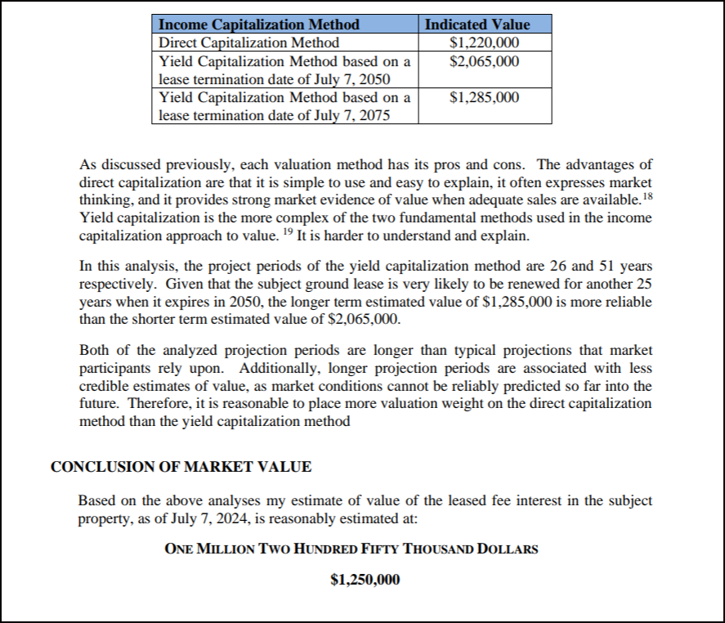

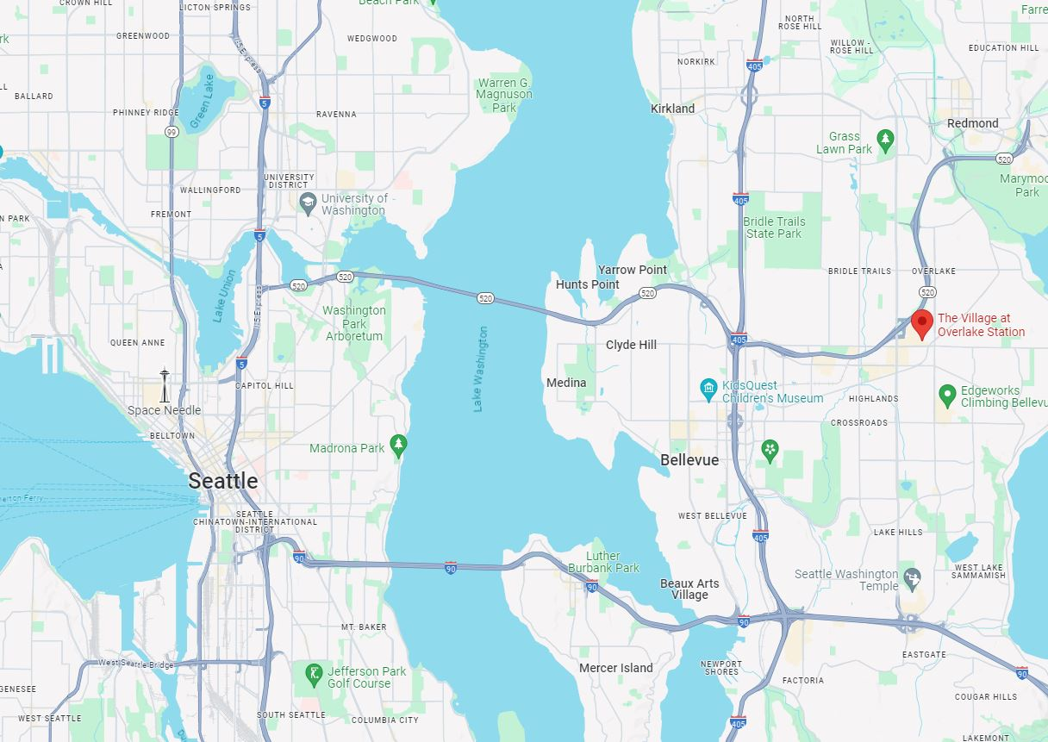
Vicinity View Map
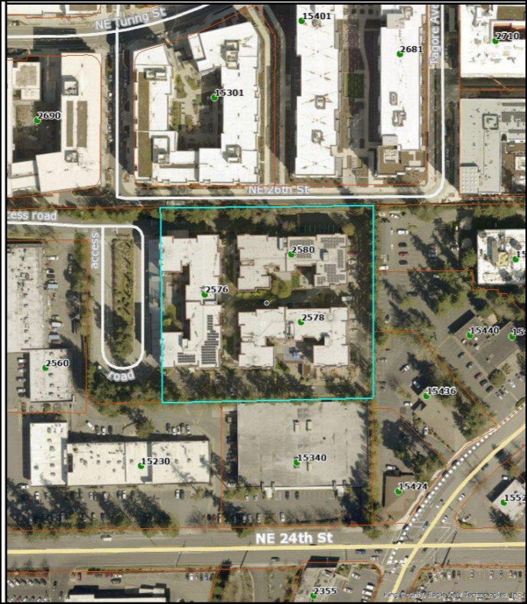
Parcel Map

