License Property Summary
Photo of Property
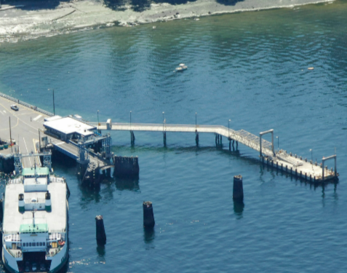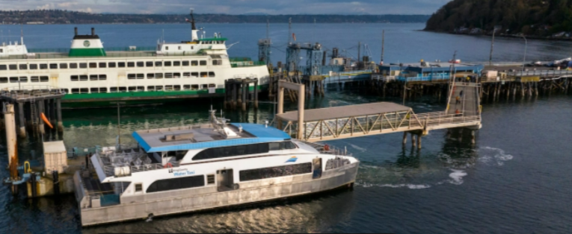

Property Owner: Washington State Department of Transportation (WSDOT) Ferries Division
Address: 10800 N Vashon Highway, Vashon, WA 98070
Rent: $12,050 first year rent payment then adjusted annually based on CPI.
Operational Costs: None
Term: 10 years with two extension options of five years each
Council District: Eight
Funding Source: King County Metro Transit Department (Metro)
Previous Location: Same location
Offer Timeline: WSDOT approval requested by/around 1st Quarter of 2026 and County Council approval requested by/around 2nd Quarter of 2026

License Synopsis:
Washington State Department of Transportation (WSDOT) owns the Vashon Island Ferry Terminal (Vashon Island Terminal) at 10800 North Vashon Highway, Vashon, WA 98070. Metro’s Marine Division (Marine Division) uses the Vashon Island Terminal passenger-only ferry landing (POF landing) for its passenger-only ferry (“POF”) service, commonly referred to as the King County Water Taxi. The proposed license agreement guarantees the Marine Division the exclusive right to enter onto and use the west side of the POF landing at the Vashon Island Terminal, and grants the Marine Division a non-exclusive right to enter onto and use the east side of the POF landing.

Context
Rationale for transaction: The Marine Division had a previous license agreement to use the POF landing from August 2011 until June 30, 2019, when it expired. Although the parties did not execute a written agreement extending the term, the Marine Division continued to use the POF landing at the Vashon Island Terminal. This new license agreement will allow the County to continue using the POF landing for water taxi service.

Policy considerations: This license agreement allows the county to continue providing critical water taxi service to and from Vashon Island and is part of the Metro Connects network.

Political considerations: None

Community considerations or partnerships: The King County Water Taxi provides significant public benefit by connecting Vashon Island and downtown Seattle. This long-term license agreement provides a measure of certainty regarding the Marine Division’s use of the Vashon Island Terminal for the County’s existing and continued water taxi service. Providing passenger-only service at the Vashon Island Terminal helps mitigate vehicle traffic congestion on County roadways and serves as a key transportation alternative to the frequently strained Washington State ferry system.

Fiscal considerations: The base rent is $12,050 with an annual adjustment tied to the U.S. Consumer Price Index, and includes the option to recalculate the base rent every five years based on local moorage rates and vessel length. Continuing to use the existing POF landing and passenger staging area at the Vashon Island Terminal saves the County the cost and risk associated with securing and developing its own POF landing and facility.

Other Considerations: Another consideration for remaining at the current location is the lack of a comparable alternative. The other state terminal is at the opposite end of the island, requiring additional travel time, fuel, operational adjustments, and service impacts. The other state terminal does not offer the same nearby parking and bus connections. Other private marinas are smaller, inlet restricted, and less suitable, making the existing location the most practical and efficient option.

CIP/operational impacts: None

King County Strategic Plan impact: NA

Equity and Social Justice Impact: This location serves the Seattle and Vashon Island area of King County, providing residents living in unincorporated area of King County access to county and city services located in downtown Seattle.

Energy Efficiency impact: Not Applicable

License Alternatives Analysis
Summary: N/A – not relevant for this particular transaction.

Vicinity View Map
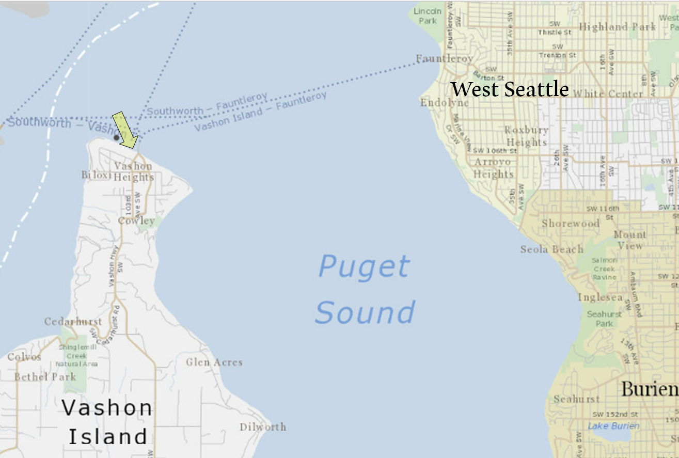

Site Map

POF landing outlined in red.


