Sale Property Summary
Photo of Property

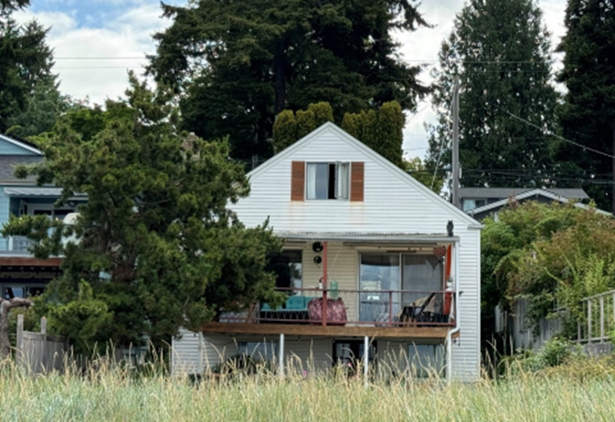

Address 8923 Fauntleroy Way SW, Seattle WA 98106
Sale Price $1,825,000.00
Sale Area 2,480 Square Foot (SQFT) residential home on a 13,984 SQFT lot
Assessor's Parcel 352403-9112
Zoning Neighborhood Residential
Council District Eight
Funding Source Wastewater Capital Improvement Fund 03611
Declared Surplus August 20, 2015
Template Status: County template
Offer Expiration: Proposed Ordinance to be in effect by June 2, 2026, per the terms of the Purchase and Sale Agreement, with an optional 60-day extension to August 3, 2026.

Property Information
8923 Fauntleroy is two-bedroom one bath residence located adjacent to the Fauntleroy Ferry Terminal. The property was originally purchased in 2008 for $950,000 by the Department of Natural Resources, Wastewater Treatment Division (WTD) for the Barton Pump Station Upgrade Project to serve as a field office and construction materials laydown area.

Context
Following completion of the Barton Pump Station upgrade in July 2015, WTD determined that the property was surplus to its needs. Because the Barton Pump Station is located within a City right-of-way, the County and the City of Seattle explored a potential property trade. The proposed trade would have allowed the County to acquire the property underlying the pump station improvements, while enabling the City to expand its existing park and public access to the beach. Ultimately, the trade was not pursued because the City determined there was insufficient support for expanding the park and waterfront access. In response to clear and consistent neighborhood feedback, the County leased the property to a residential tenant in 2016.

In 2024, the Washington State Department of Transportation’s (WSDOT) Washington State Ferries Division engaged FMD about a direct sale of the property for WSDOT’s upcoming SR 160 - Fauntleroy Terminal - Trestle & Transfer Span Replacement project for use as a construction management office. Pursuant to King County Code (KCC) 4.56.140 and KCC 4.56.100.A.1, FMD and WSDOT directly negotiated the sale of the property at appraised market value and under WSDOT’s potential imminent threat of its right of eminent domain to obtain the property. As a condition of sale WSDOT required the property to be vacant. The existing tenant was relocated by WSDOT, and the property has been vacant since September 2025.

Rationale for transaction: The property is surplus to King County’s current and future needs and will eliminate operating costs, liability, and assessments of $997.68 per year.

Policy considerations : The property was originally acquired by WTD for use as a construction office and WSDOT’s Washington State Ferries Division also intends to use the property as a construction office.

Political considerations: N/A

Community considerations
or partnerships: The community is active regarding this area. WSDOT convened advisory groups within the community starting in summer 2021 to educate and inform the community about the updates to the terminal and to seek input and feedback.

Fiscal considerations: The transaction will provide one time revenue of $1,825,000 to WTD and will eliminate operating costs, liability, and assessments of $997.68 per year.

Other considerations: N/A

CIP/operational impacts: The sale will not impact the operations of WTD.

Change in property use: WSDOT’s Washington State Ferries Division does not intend to pursue a change of use on the property.

SEPA Review Required yes/no: No

King County Strategic Plan impact: N/A

Equity and Social Justice impact: In accordance with Real Property Asset Management Plan (RAMP) policy, the Facilities Management Division and Wastewater Treatment Division reviewed this legislation for equity and social justice (ESJ) impacts. The property will support WSDOT’s Washington State Ferries Division’s replacement of the Fauntleroy Ferry Terminal which will serve the greater public in better connecting our region with effective transportation opportunities.

Surplus Process
Interest from other county agencies? No
Property suitable for affordable housing? No
Property determined to be surplus? Yes, declared surplus August 20, 2015

Marketing and Sale
Indicate whether the property was marketed or not, and if so, how it was marketed:
MLS
Commercial Broker
County Website (number of website views:_______________)
Social Media
Onsite Signage
Not Marketed – Pursuant to KCC 4.56.140, the County may dispose of county real property to another governmental agency by negotiation, upon such terms as may be agreed upon and for such consideration as may be deemed by the County to be adequate.

Appraisal Process
Summary
Date of valuation: October 22, 2024
Appraised by: Matthew Sloan, SOVA Consulting
Appraisal factors: A state-operated ferry terminal is located directly adjacent to the property.
Comps analysis: Appropriate and timely comparable properties were utilized
Estimated FMV: $1,825,000.00
Appraisal al Summary Chart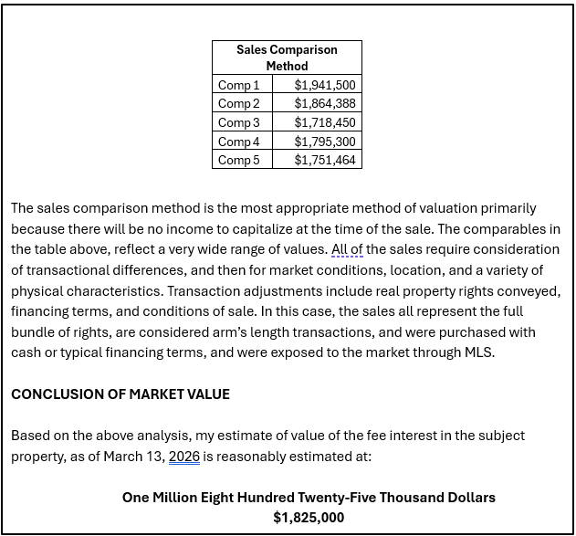

Vicinity View Map

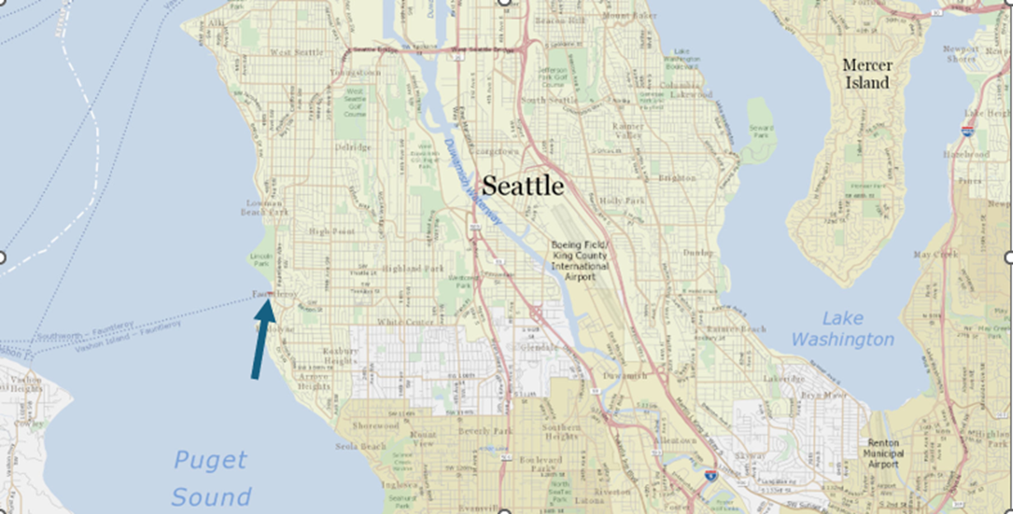

Parcel Map

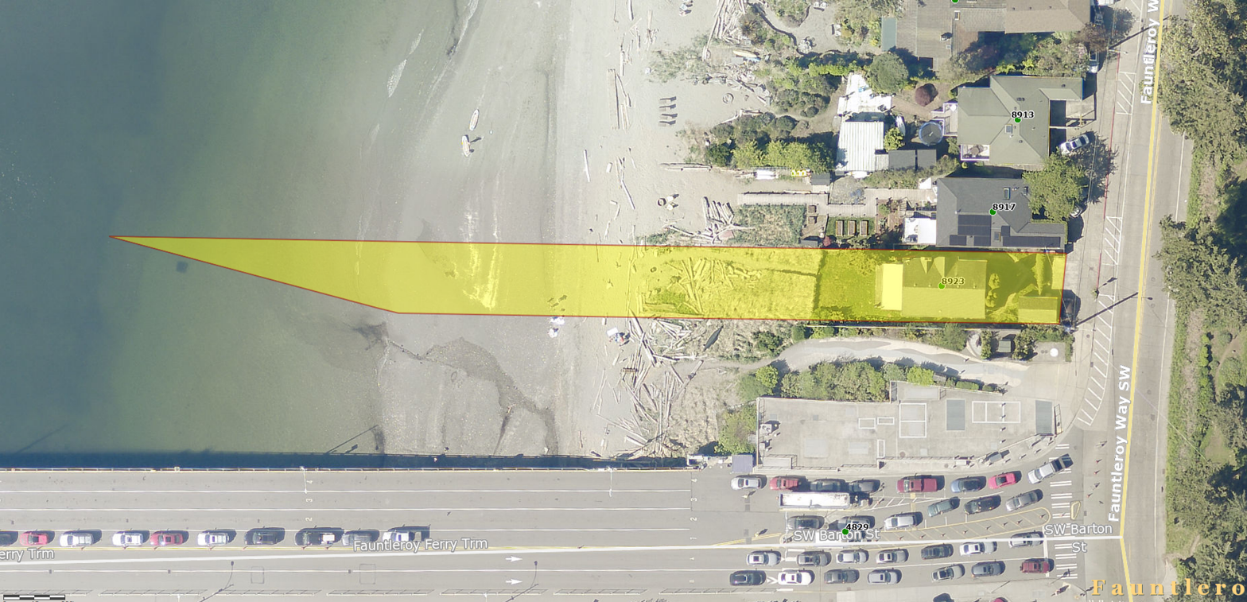

Ordinance 16764, DNRP/WTD-Barton Pump Station [Link]
WSDOT Fauntleroy Terminal – Trestle & Transfer Span Replacement Project [Link]
King County Code – 4.56 [Link]
A situation where a government entity or authorized agency notifies a property owner that their land is required for a public project, and if the owner does not agree to a voluntary sale, the agency will use legal authority to acquire the property through condemnation.

