United States of America

R-1 |  | $100,000,000

THE TRANSFERABILITY OF THIS BOND IS
RESTRICTED AS DESCRIBED IN THE BOND ORDINANCE

STATE OF WASHINGTON
KING COUNTY
JUNIOR LIEN VARIABLE RATE DEMAND
SEWER REVENUE BOND, SERIES 2012

MATURITY DATE: January 1, 2043
ISSUE DATE: ____________________
REGISTERED OWNER: WELLS FARGO MUNICIPAL CAPITAL STRATEGIES, LLC
375 Park Avenue
New York, NY 10152
TAX IDENTIFICATION NUMBER: 45-2541449
PRINCIPAL AMOUNT: ONE HUNDRED MILLION AND NO/100 DOLLARS
INTEREST RATE: VARIABLE, AS DESCRIBED HEREIN
King County, Washington (the “County”), hereby acknowledges itself to owe and for value received promises to pay to the Registered Owner identified above, or registered assigns, on the Maturity Date specified above, the Principal Amount specified above and to pay interest thereon from the date hereof, or the most recent date to which interest has been paid or duly provided for, until payment of this Bond at the variable interest rate determined as provided in the Bond Ordinance (hereinafter identified), payable on each Interest Payment Date.
Both principal of and interest on this Bond are payable in lawful money of the United States of America. Principal of this Bond is payable to the Registered Owner upon presentation and surrender of this Bond at the office of the fiscal agency of the State of Washington in New York, New York (the “Registrar”), and interest shall be paid by check or draft of the Registrar mailed by first-class mail to the Registered Owner at the address as it appears on the registration books maintained by the Registrar. Notwithstanding the foregoing, so long as this Bond is held by Wells Fargo Municipal Capital Strategies, LLC (“Wells Fargo”), or its successor or permitted assigns under the Continuing Covenant Agreement dated as of December 1, 2012, between the County and Wells Fargo (the “Agreement”), payments of principal of and interest on this Bond will be made in accordance with the Bond Ordinance and the Agreement.
This Bond is the duly authorized “King County, Washington, Junior Lien Variable Rate Demand Sewer Revenue Bond, Series 2012” (the “Bond”). The Bond is issued in the principal amount of $100,000,000 under the authority of and in full compliance with the Constitution and statutes of the State of Washington, and pursuant to Ordinance _______ passed by the King County Council on _______________, 2012 (the “Bond Ordinance”). Capitalized terms used herein and not otherwise defined have the meanings given them in the Bond Ordinance, unless the context otherwise requires.
The Bond is issued by the County to finance a portion of the cost of capital improvements to the County’s sewer system (the “System”).
The Bond is subject to optional and mandatory tender for purchase and redemption prior to maturity as provided in the Bond Ordinance and the Agreement. This Bond may be transferred and exchanged as provided in the Bond Ordinance and the Agreement.
The Bond is a special limited obligation of the County and is not an obligation of the State of Washington or any political subdivision thereof other than the County, and neither the full faith and credit nor the taxing power of the County or the State of Washington or any political subdivision thereof is pledged to the payment of the Bond.
The County hereby covenants and agrees with the owner of this Bond that it will keep and perform all the covenants of this Bond and of the Bond Ordinance to be by it kept and performed. The County pledges and binds itself to set aside out of Revenue of the System and to pay into the Junior Lien Bond Fund the various amounts required by the Bond Ordinance to be paid into said fund, all within the times provided by the Bond Ordinance.
The amounts covenanted to be paid out of the Revenue of the System and deposited into the Junior Lien Bond Fund shall constitute a lien and charge on such revenue junior, subordinate and inferior to Operating and Maintenance Expenses; junior, subordinate and inferior to the lien and charge on such revenue for the payments required to be made into the Parity Bond Fund and the accounts therein; junior, subordinate and inferior to the lien and charge on such revenue of the payments required to be made into the Parity Lien Obligation Bond Fund and the accounts therein; equal to the lien and charge on such revenue to pay and secure the payment of the outstanding Junior Lien Obligations and any Additional Junior Lien Obligations; and superior to all other liens and charges of any kind or nature, including, inter alia, the lien and charge on such revenue to pay and secure the payment of the Subordinate Lien Obligations, and the SRF Loans and Public Works Trust Fund Loans.
The pledge of revenues and other obligations of the County under the Bond Ordinance may be discharged prior to maturity of the Bond by making provisions for the payment thereof on the terms and conditions set forth in the Bond Ordinance.
This Bond shall not be valid or become obligatory for any purpose or be entitled to any security or benefit under the Bond Ordinance until the Certificate of Authentication hereon shall have been manually signed by the Registrar.
It is hereby certified that all acts, conditions and things required by the Constitution and statutes of the State of Washington and the Charter and ordinances of the County to exist, to have happened, been done and performed precedent to and in the issuance of this Bond have happened, been done and performed and that the issuance of this Bond does not violate any constitutional, statutory or other limitation upon the amount of bonded indebtedness that the County may incur.
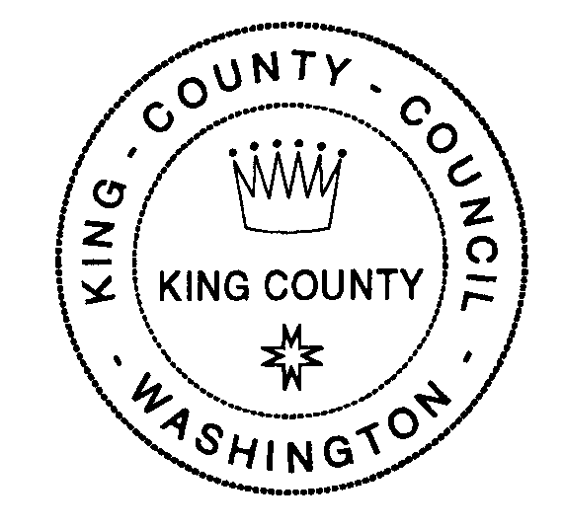
IN WITNESS WHEREOF, King County, Washington, has caused this Bond to be executed with the manual or facsimile signatures of the County Executive and Clerk of the County Council and caused a facsimile of the official seal of the County to be reproduced hereon.
KING COUNTY, WASHINGTON
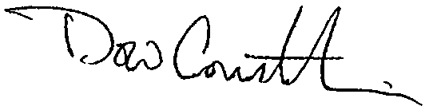

By
County Executive
ATTEST:


By
Clerk of the County Council

AUTHENTICATION CERTIFICATE
This is the King County, Washington, Junior Lien Variable Rate Demand Sewer Revenue Bond, Series 2012, described in the within-mentioned Bond Ordinance.
WASHINGTON STATE FISCAL AGENCY,
as Registrar

By
Authorized Signatory
Date of Authentication:
ASSIGNMENT
The following abbreviations, when used in the inscription on the face of the within-mentioned bond and in the assignment below, shall be construed as though they were written out in full according to applicable laws or regulations.
TEN COM: as tenants in common
TEN ENT: as tenants by the entireties
JT TEN: as joint tenants with right
of survivorship and not as
tenants in common

UNIF GIFT MIN ACT Custodian
(Cust) (Minor)
Additional abbreviations may also be used though not in the above list.
FOR VALUE RECEIVED, the undersigned do(es) hereby sell, assign and transfer unto ___________________________________________________________________ the within-mentioned registered bond and hereby irrevocably constitute(s) and appoint(s) ________________________________________________, attorney, to transfer the same on the books of the Registrar with full power of substitution in the premises.
Dated: ________________________

Note: The signature(s) to this Assignment must correspond with the name(s) as written on the face of the within bond in every particular, without alteration or enlargement or any change whatsoever.
SIGNATURE GUARANTEED:

NOTICE: Signature(s) must be
guaranteed by an eligible
guarantor institution.

