Modular Housing: A Bridge Out of Homelessness?

Prepared for the King County Council Health, Housing and Human Services Committee

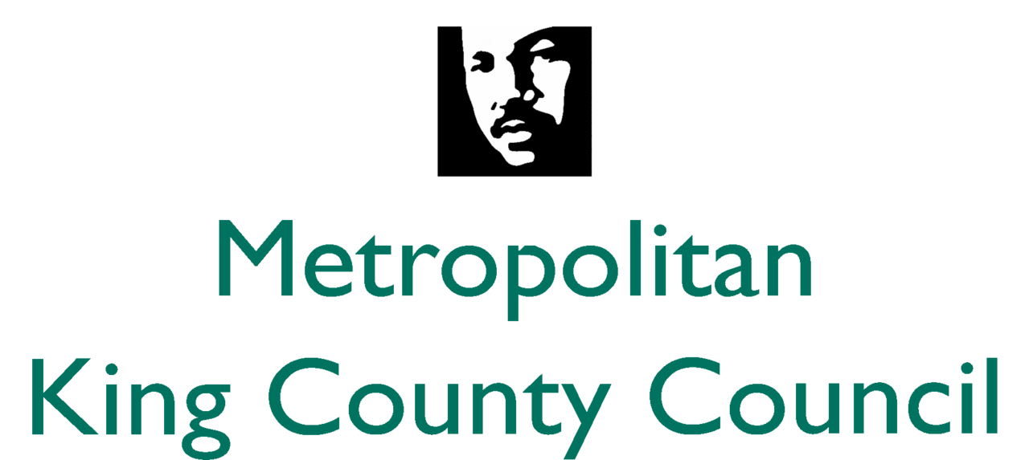

Prepared by Molly Bauer, Austin Goble, Isaac Horwith, Emma Kirby, and Max Nelson in partial fulfillment of Master of Public Administration, Evans School of Public Policy & Governance

DRAFT - NOT FOR PUBLICATION

Contact: isaachorwith@gmail.com - 206-250-6550

Thanks to:
Mary Bourguignon, Principal Legislative Analyst for King County Council
Mark Ellerbrook, Regional Housing and Community Development Manager
Ardel Jalal, SDCI Engineering & Technical Codes Manager
‎ Seattle City Councilmember Rob Johnson
Alison Mendiola, Housing Coordinator for King County Council
Bill Mills, SDCI Land Use Planner Supervisor
Director Alfie Ramos, WA State Department of Veterans Affairs
All Home King County
Housing Development Consortium

Introduction
This report examines the potential for modular housing as a policy tool to address homelessness in King County. We used our research findings and analysis of the current housing policy landscape to produce guidelines and policy options for modular housing projects covering a broad range of possible scenarios.

Modular Housing
The term “modular housing” refers to a construction model where units of housing are manufactured in a facility and then transported for installation at a given location. Modular housing presents a potential solution to the high cost and long development cycles that normally characterize public housing in a tight urban market.
Several municipalities around the United States and the world are already using modular housing to address their homelessness and affordability problems. King County Council Member Jeanne Kohl Welles asked us to evaluate the potential use of modular housing to address homelessness in Seattle.

Our research answers two primary questions:
- Why should King County use modular housing compared to other “bridge”, or short to medium-term, methods of alleviating homelessness?
- How should modular housing be implemented in King County?

The Problem: Causes and Context of Homelessness
Unemployment, substance abuse, a large increase in rent, a divorce or separation, and mental health issues were the most common self-identified causes in the City of Seattle’s 2016 homeless needs assessment.
While there are many root causes to homelessness at the individual level, a lack of affordable housing is a growing problem closely correlated to our current homelessness crisis. A study conducted by Zillow found that a 5% increase in rent in Seattle would lead to an additional 238 people living unsheltered. The scale of this problem is also difficult to grasp: the Regional Affordable Housing Task Force identified a need of 240,000 newly affordable units in King County by 2040. With such dramatic increases in the cost of housing regionally, this is likely one of the primary contributing factors to our current increases in homelessness.

Current spending on housing and homeless programs in King County
According to research by the Seattle Times, the total funds spent on homeless programs in King County in 2017 was $195,588,532.
- Federal Funding:
  - King County Housing Authority $38,000,000
  - Seattle Housing Authority $35,000,000
- Seattle Budget:
  - Federal $20,329,997
  - City $40,002,742
- King County Budget:
  - Federal $20,094,140
  - State $24,136,637
  - County $10,636,840
- Private Funding $7,387,770

About $98,894,351 (50.6%) goes to permanent housing, $31,258,837 (16%) goes to emergency shelters, and $65,435,343 (33.4%) goes to other housing and preventative services. Important to note is that the majority of funds in King County come from federal and state sources, which come with stipulations that limit the County’s ability to redirect funds and will have implications in our analysis.

Existing/Committed Funds for Modular Housing
There are more than ten million dollars committed specifically to modular housing by City, County and State actors.
Government | Funding Source | Dollar Amount
City of Seattle | Funds from sale of South Lake Union property, committed to modular housing | $5.5 Million
King County | Money originally allocated for renovation of a King County building into a homeless shelter, now allocated for modular housing | $3 Million
State | Money allocated in capital budget | $3 Million

Examples of Modular Housing Communities
Tiny or modular bridge housing can occur in many forms such as tiny homes or villages, backyard dwelling units, permanent housing, or temporary housing. Below are several national examples in Washington, Oregon, and California, as well as a few international examples in Ireland and Canada.

Examples of Modular Housing
Housing Type | Location | Characteristics | Cost
Seattle Tiny House Villages | Seattle, WA | • Overseen by the Low Income Housing Institute (LIHI)  • Operated by SHARE and Nickelsville  • City only sanctioned these villages and did not provide any funds for construction or operation  • Mayor has made a campaign promise to construct 1,000 additional tiny or modular homes for the homeless in her first term | • $2,500 per house
Potter's Lane Permanent Cargo Housing Complex | Orange County, CA | • First multi-unit permanent housing complex fashioned from cargo containers in the nation  • Three containers are insulated together to provide 16 units of micro housing specifically for veterans  • Other amenities include a common room, central patio with a barbecue, and a garden  • Rents are subsidized with wraparound services offered through the Veterans Affairs and Orange County’s Illumination Foundation | • Initially estimated at $1.9 million
Dignity Village Tiny House Community | Portland, OR | • Developed in 2001 in northeast Portland  • Consists of 43 one- and two-person rectangular structures, which accommodate about 60 homeless individuals per night.  • Community features offer a central gathering and meeting space with electricity, heat from a woodstove, office and computer room, temporary showers and portable toilets, and an outside garden containers  • Also include portable toilets, garbage, internet, phone, office supplies, insurance, and water and sewer | • Annual operating costs: $29,088  • Annual costs: $44,078 (which includes internal operating costs and costs to the City)  • Estimated average cost per person per night at $4.82
Co-Modular Housing | Portland, OR | • Meyer Memorial Trust awarded Transition Projects a $500,000 capital grant to build a 72-unit affordable housing development in north Portland  • Since the nonprofit will purchase land from the city, the project can operate for decades without ongoing land service leasing fees, which many other existing villages must pay  • Units will also offer residents plumbing, heating, and other basic amenities | • Anticipated construction cost per unit to be about $155,000
Backyard Tiny Home | Portland, OR | • Pilot program addressing homelessness, “A Place for You”, creates an opportunity for homeowners to develop tiny homes in their backyards  • Will give participating homeowners a tax abatement in exchange for providing a tiny house for five years  • The tiny home designs will be about 200 square feet and connected to city sewer, water, and electrical systems | • $350,000 pilot project
Transitional Micro-Housing Community | Eugene, OR | • Developed by SquareOne Villages in the summer of 2013  • 30 micro-homes range from 60-80 square feet and are supported by common cooking, gathering, restroom, and laundry facilities  • The City of Eugene interpreted the tiny homes to be “sleeping units”, rather than “dwelling units”, so the homes could meet code requirements for structural strength, fire safety, and ventilation  • The startup costs for the project were funded through $98,000 in private cash donations and small grants, plus an estimated in $114,000 of in-kind materials and labor | • Annual operating budget:$30,000 (expenses for utilities, maintenance, bus passes for all residents, and insurance)  • Residents pay $30 per month in utility fees
Prefabricated Modular Housing Rapid Build | Dublin, Ireland | • Dublin reported 581 families housed in commercial hotels and detailed a housing intervention of 500 new prefabricated homes  • The first twenty two houses have a sixty-year lifespan and had a projected construction timeframe of 16 weeks, as compared to 18-36 months for traditional houses  • The city plans to construct 500 more in 2018 and has five sites identified that can accommodate another 150 houses | • The average cost per house was €180,000 (214.000 USD)
Temporary Modular Housing | Vancouver, BC | • 600 modular houses are designed be three stories, contain 50 studios, easy to relocate, and built according to code  • Plans indicate a six-month build time, and include using underused or vacant lots to temporarily site the homes  • Standard units are 250 sq. ft, include a bathroom and kitchen, share common areas for dining, laundry and recreation; twenty-four hour support services are also available | • C$66 million (C$110,000 per house) (85,275 USD)

Possible Benefits of Modular Housing
Based on interviews with multiple policy experts, the proposed advantages of modular housing are privacy, speed, cost, and mobility.

Speed and Cost: Faster and cheaper than brick and mortar
There are currently many efforts to construct traditional permanent low-income housing in King County. However, it can take two to three years at least for a nonprofit housing developer to secure funding and construct a low-income housing project. Current DCHS estimates from modular housing manufacturers are between six to twelve months from order to open. Although there are questions about how modular units retain their value long-term, its cheap upfront costs make it an appealing option.

Privacy: The power of a key
An individual modular unit with a lock and key provides much greater privacy and stability than living on the street or in a tent, vehicle, or emergency overnight shelter. A secure space in which they can store their belongings gives people a chance to attend appointments, job interviews, or whatever else they need to accomplish during the day. Without having to carry everything they own with them or worry about their belongings being stolen.

Mobility
One of the most challenging aspects of providing low-income housing is finding a suitable location. Land in King County is expensive, especially in areas where social services are easily accessible and homeless people are currently located. There is also often resistance from the nearby community when siting permanent low-income housing. Modular housing has the political advantage of being able to be sited in a neighborhood on a more temporary basis. Mobility also opens up more potential locations that may only be available for a certain period of time.

Modular Housing Models
We can broadly divide housing projects into three categories, based on their zoning and legal characteristics.
- Permanent Housing: Plumbing in each individual unit, permanently sited, extended stays expected for residents (6 month to 1-year leases)
- Shelter: Communal units with separate communal plumbing and dining facilities, day-to-day stays expected for residents
- Transitional Encampment: Typically individual units with separate communal plumbing and dining facilities, temporarily permitted at a given site for one year with an option for a one year extension, medium-term stays expected for residents

Guidelines for Modular Housing Developments
We developed a series of guidelines based on our research and analysis to inform our recommendations. These guidelines double as a toolkit for evaluating future modular construction proposals.

Population Served
The needs of the population served in a given development also determines the level of services required to provide basic needs and ensure client safety. If a housing development is intended to serve the homeless population broadly, the most important factor is volume--building a large number of units cheaply to take advantage of the cost savings inherent to modular construction.
Meanwhile, chronically homeless people often struggle with mental, behavioral, or substance abuse require greater attention from operational staff to monitor and enforce rules of conduct. If the housing development is intended to serve the chronically homeless, the physical units must be coupled with extensive case management. This means serving a smaller number of people with a greater level of social services.

Zoning
In Seattle, the Land Use Code (SMC 23) is used to regulate land use and development in the city. Per various zoning guidelines, a modular housing project can fall into three legal categories: encampments, shelter, or housing. The category is essentially determined by the number of units and overall design of the structure, the terms of residency, and which housing amenities are provided and in what form.

Design
The architectural design of each unit affects the form and function in serving residents. Communal units, or shared bedrooms, are unpopular with clients because they do not foster the same sense of security, privacy, or ownership that individual units do. This could be mitigated if the operator were successful in fostering an atmosphere of community and psychological stability, but this may be easier said than done. Individual units foster a sense of individual ownership and psychological safety, sometimes referred to as “the power of a key”.
If the target population is chronically homeless people, individual units present their own challenges. Chronically homeless people require extensive monitoring by caseworkers for reasons of basic safety. Giving each client their own module with a lock on the door could dramatically multiply the amount of time and effort spent on this basic task. The housing policy experts we interviewed reported individual units would increase maintenance costs of the facilities. Based on the recommendations of social service providers regarding the optimal size of a development, whatever model is chosen, the development should not house more than 100 people.

Cost
Each project will inevitably be governed by its own cost rules, but we can establish some generalities.
- Housing people individually costs more than housing them in communal units, both in the construction of the units and in the operation and maintenance of the development.
- Providing housing for chronically homeless people costs more than housing the broader homeless population, as they require a greater degree of social service provision and case management.
The main cost advantages of modular housing are in the manufacturing/construction, siting and installation of the units. This means that modular housing saves money on capital costs, and not operating costs. Therefore, projects whose costs are primarily operating costs (such as those that provide extensive social services) benefit less from the use of modular construction, because operating costs are unaffected. Modular construction saves the most money in projects where capital costs are relatively high compared to operating costs.

Modular Housing Designs: Policy Options
Because modular construction is merely a method of construction, it is not necessarily suited to a particular housing model. This section delineates the key differences in the goals, relevant land use code, potential codes of conduct, and political/neighborhood processes between the three housing categories we have defined as permanent housing, shelters, and encampments. The basic features of the three categories of our analysis are as follows:
Relying primarily on government documents, code, and interviews, we performed housing model, code, manufacturer & operator, political, and site analyses. Based on this analysis, we developed a set of guidelines to generate five policy options which outline potential modular housing models or strategies:
- Modular Backyard Cottages can have a significant impact on the supply of affordable housing through a suite of policies that reduce barriers and encourage homeowners to construct them. This option could produce hundreds of units for a range of income levels at a comparatively low cost, but requires action at the City level.
- Modular Supportive Housing provides a high level of social services to a smaller group of chronically homeless individuals. Due to its high operating costs, this model would house a smaller number people than the other options, but would provide them with wraparound social services.
- Subsidized Low-Income Housing leverages the modular model to construct a large number of units for low-income individuals, regardless of their specific levels of need. This model would provide direct help to the largest number of people, but with a level of social services insufficient for high-need clients.
- Modular 24/7 Shelter with communal dormitories. This model would house fewer people than the low-income housing or backyard cottage models, but would provide them with comprehensive social services navigation and case management.
- Modular Encampment with individual sleeping units and communal plumbing and dining facilities. This model best leverages the uniquely mobile aspect of modular construction, but would require an increase to the number of sanctioned encampments in Seattle. Its units would be inferior to the supportive housing and subsidized low-income housing models, but would house more people than the former, and would provide a higher level of social services than the latter.

King County Modular Housing Policy Matrix
 |  | Housing Options |  |  | Shelter Option | Encampment Option
Goals | Criteria | Backyard cottages Incentives | Supportive Transitional Housing | Subsidized Low-Income Housing | 24/7 Shelter | Mobile Modular Housing Community
Decrease rate of homelessness | Impact | Depends on uptake. Limited interest.  Increases supply of housing overall; needs incentives to focus on homeless | Small number of units providing high level of social services and amenities | Could bring enormous volume if cost advantages of modular housing are appropriately leveraged | Ideally would house no more than 100 people per development. Impact is constrained by how many developments can be zoned. | Ideally would house no more than 100 people per development. Impact is constrained by how many developments can be zoned.
Decrease rate of homelessness | Suitability for Modular | High | Moderate, constrained by operating costs | Moderate, will likely be subject to design review | Moderate, constrained by operating costs | High
Decrease rate of homelessness | Trade offs | Increased demand on permitting and inspection process | “Transitional housing” becomes permanent | Does not serve highest need population. | Provides little stability, no sense of privacy or ownership | Highly dependent on ability to re site at regular intervals
Decrease rate of homelessness | Equity | Potentially benefits homeowners more than homeless. May not target currently homeless. | Houses a small number of highly vulnerable individuals. | Serves a large cohort of the homeless and general low-income population. Does not target most vulnerable population. | Entry criteria highly dependent on demographic served, could mean choosing between vulnerable populations | Entry criteria highly dependent on demographic served, could mean choosing between vulnerable populations
 |  | Housing Options |  |  | Shelter Option | Encampment Option
Goals | Criteria | Backyard cottages Incentives | Supportive Transitional Housing | Subsidized Low-Income Housing | 24/7 Shelter | Mobile Modular Housing Community
Implementation | Siting | Little to no work. All on property owner. | Requires owning or acquiring land. Can be located in residential or commercial zones | Requires owning/acquiring land. Can be located in residential or commercial zones | Requires owning/acquiring land  Allowed in most zones. | Has to be sited every two years
Implementation | Additional Funding Sources | Leverages Private $ | Low-income housing tax credit, multifamily tax exemption | Low-income housing tax credit, multifamily tax exemption | County $3m only for shelter | New initiative $
Implementation | Cost | Depends on uptake and level of incentives | Cost of social services likely quite high | Cheap to construct large number of units, small operating costs | Cheap to build and site, potentially expensive to operate | Cheap to build and site, potentially expensive to operate
Implementation | Legal Barriers | Changes in code required, would not require design review | Would require design review | Would require design review |  | Would require more sanctioned encampments
Implementation | Political Feasibility | Literally NIMBY,  Others may challenge equity issues | Opposition from residents who fear crime, declining property values, etc | Opposition from residents who fear crime, declining property values, etc | The most difficult thing to put in a neighborhood after safe injection sites | Temporary siting increases feasibility
Overall Effectiveness |  | Smaller investment for moderate impact | Small quantity of high quality housing with high quality services | Large quantity of moderate quality housing with no services | Moderate quantity of low quality housing with moderate services | Moderate quantity of low quality housing with moderate quality services

If built on a small scale on individual private property, housing follows the residential zoning rules. If constructed on a large scale, new modular development may require design review, which could extend the build time by six months to a year.
Based on Seattle Department of Construction and Inspection Director’s Rule 9-2016, transitional encampments may only be permitted outside of residential zones. Additionally, the number legally sanctioned in Seattle is limited to six at any given time. Encampments are also constrained by how long they can exist on a given site: they are approved for one year with an optional one-year extension.

Potential Manufacturers
The King County Council received five responses to its request for information (RFI) from modular housing manufacturers. These RFI responses include rough cost information on how much each manufacturer’s units would cost, how many people those units could potentially house, and many other details about the units. Additionally, King County Principal Legislative Analyst Mary Bourguignon presented a report to the King County Council budget and fiscal management committee regarding several possible modular projects. Below we summarize basic details about what these manufacturers offer and include a breakdown of the projected per unit cost and capacity for each manufacturer.

Modular Housing Cost Comparisons
Source | Project | Type (Self Described) | Capital Cost ($) | Operating Cost ($/Year) | People Served | Capital Cost per Person ($)
King County Council Presentation | Shelter in Modular Structure | Limited Use Emergency Shelter (Night Only) | 2,000,000 | 768,000 | 50 | 40,000
King County Council Presentation | Shelter in Modular Structure | Enhanced Shelter (24/7 w/ Social Services) | 2,750,000 | 2,000,000 | 100 | 27,500
King County Council Presentation | Bridge Housing in Modular Structure | Temporary Housing Complex | 3,500,000 | 750,000 | 35 | 100,000
RFI Responses | Catholic Housing Services | Modular Shelter Facility | 2,586,036 | 2,000,000 | 90 | 28,734
RFI Responses | Onebuild | Modular Housing Project | 8,000,000 to 10,000,000 | 2,000,000 | 150 | 53,334 to 66,667
RFI Responses | Whitley Evergreen Micro Pods | Modular Housing Project | 3,528,140 | 2,047,023 | 50 to 100 | 70,562 to 35,281
RFI Responses | Whitley Evergreen Semi Shelter | Modular Housing Project | 4,515,857 | 2,047,023 | 100 | 45,159
RFI Responses | Whitley Evergreen Encampment | Modular Housing Semi-shelter | 2,663,144 | 2,047,023 | 50 to 100 | 53,263 to 26,631

Potential Operators
Several of the RFI responses were from organizations which already provide homelessness and housing services in King County. Compass Housing Alliance, Downtown Emergency Services (DESC), and Catholic Community Services all have experience operating housing first, low barrier projects in Seattle and King County. Catholic Community Services and Compass Housing Alliance have the slight advantage of their Faith Based nonprofit status, which allows them to evade some permitting and zoning rules if new projects are pursued on their own property.
While they were not among the RFI respondents, the Low Income Housing Institute (LIHI) and their cadet organizations SHARE and WHEEL are worth noting as potential operators. They operate tiny house encampments in the City of Seattle, which are similar enough to our proposed modular encampment design that their experience would be transferable. Tiny house and encampment village operator Nickelsville may be worthy of consideration for the same reason.

Priority Sites
Each site is better suited to implement different policy options. We analyzed a list of government-owned properties provided by Speaker of the House Frank Chopp, and identified three priority sites that are well suited to a modular development:
- 4th Ave SW & 100th St SW, owned by King County Housing Authority,
- 210 Bellevue Ave East, owned by Seattle City Light, and
- 4851-4865 Martin Luther King Way S, owned by Sound Transit

Site Analysis

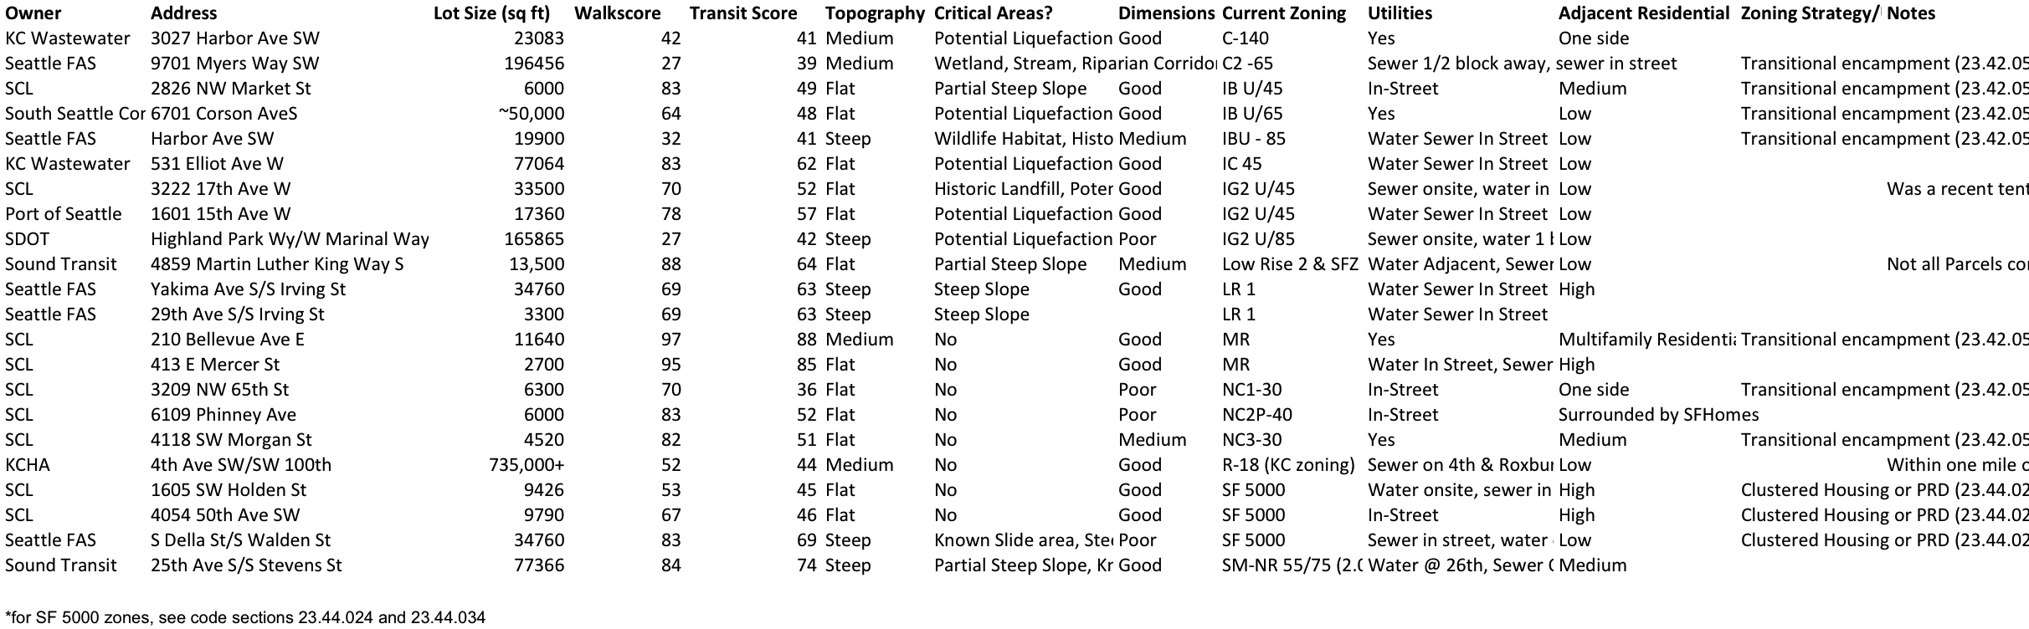

The State of Emergency
The impact of the city and county’s state of emergency declarations is primarily through informal rhetorical power, rather than explicit rules.

Emergency Order
An emergency order is essentially an executive order, and does not require a state of emergency declaration. An emergency order in the context of a modular housing community allows the Mayor or Executive to bypass the standard bidding, permitting, and community outreach processes of their government. The executive may issue an emergency order and immediately begin the process of implementation. The council may retroactively approve or reject an emergency order after the executive begins its implementation.
The largest caveat for the use of an emergency order is that by ignoring existing code, the government is vulnerable to a potential lawsuit from opposed community members or other levels of government. Overall, the use of an emergency order is a high-risk decision, and only recommended if the authorizing actor is certain that the project will receive support from the involved governments and general public. Pursuing amendments to the code is the safer option and will ultimately have more impact long-term in expediting the development of housing for the homeless.

Conclusion
Modular housing offers real advantages over conventional construction in construction cost, speed and mobility. However, it is subject to many of the same political and legal constraints as any other form of construction. The five proposed designs are each suitable for a different set of constraints, different client bases and different authorizing environments. The final recommendation therefore depends on what need King County is trying to serve, and what resources (political, financial and otherwise) are available for the project.

Thank you for reading, we welcome your questions and comments.

