

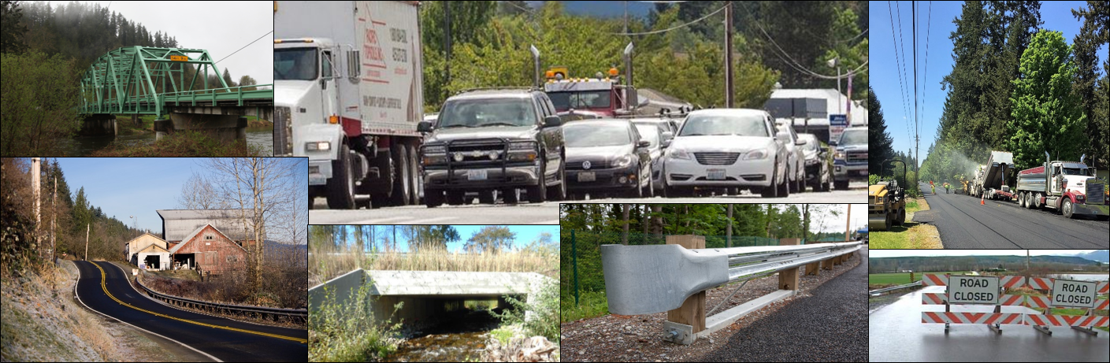

King County Department of Local Services Road Services Division
2020
Technical Appendix C1:
Transportation Needs Report
August 22, 2019

Page left blank

Table of Contents

Chapter 1. Planning Context and Introduction 4
1.1 What Is the Transportation Needs Report? 4
1.2 Relationship to the King County Comprehensive Plan 4
1.3 Strategic Context 5
1.4 King County’s Transportation Needs and Funding 6
1.5 Rural Regional Corridors 7
1.6 How is the TNR Used? 8
1.7 2020 Transportation Needs Report Changes 9
Chapter 2. Unincorporated King County Road and Bridge Assets 11
2.1 Roadway 11
2.2 Roadside 14
2.3 Traffic Control 20
2.4 Drainage Systems 26
2.5 Bridges and Structures 30
2.6 Facilities 36
Chapter 3. Transportation Modeling 40
Chapter 4. Drivers of Change Affecting Transportation in Unincorporated King County 41
4.1 Puget Sound Regional Demographic and Employment Trends 41
4.2 Puget Sound Transportation Trends 42
4.3 Transportation Trends in Unincorporated King County 43
Chapter 5. TNR Project Needs and Cost Analysis 45
Chapter 6. Financial Analysis 48
Appendix A. 2020 Transportation Needs Report Project Lists 51
Appendix B. 2020 Transportation Needs Report Maps 104

Chapter 1. Planning Context and Introduction

1.1 What Is the Transportation Needs Report?
The King County Transportation Needs Report (TNR) is a long-term, comprehensive list of improvement needs for the roads, bridges and related infrastructure located in unincorporated King County. It includes consideration of significant projects in adjacent cities, counties, and on state highways as they relate to the overall functioning of the transportation system. The transportation needs outlined in the TNR include those that are currently known as well as those that are forecast based on regionally-adopted targets for growth and development.
How does the King County Transportation Needs Report comply with the law?
- It is based on the land use element of the Comprehensive Plan.
- The list of transportation needs and recommended improvements for capacity projects was developed using travel forecasts that are based on the regionally-adopted growth targets.
- It includes a financial analysis that reflects the most recent land use changes, project amendments, costs, and financial revenue assumptions.
- It documents intergovernmental coordination, with particular attention to potential impacts on adjacent jurisdictions.
- It includes nonmotorized needs (bicycle and pedestrian).

The TNR is a functional plan of the King County Comprehensive Plan. Together with the Road Services Division (Roads) Six-Year Capital Improvement Program (CIP) and the biennial operating budget, the TNR fulfills the requirement of growth management legislation (RCW 36.70A.070) as the transportation capital facilities plan element of the King County Comprehensive Plan.

1.2 Relationship to the King County Comprehensive Plan
A primary purpose of the TNR is to fulfill specific requirements of state growth management legislation for comprehensive planning. The schedule for updating the TNR corresponds to updates of the King County Comprehensive Plan.
King County’s TNR fulfills these requirements, as outlined in state legislation (RCW 36.70A.070 (6)):
- Specific actions and requirements for bringing into compliance locally-owned transportation facilities or services that are below the comprehensive plan established level of service standards;
- Forecasts of traffic of at least ten years based on the adopted growth targets and land use plan to provide information on the location, timing, and capacity needs of future growth;
- Identification of state and local system needs to meet current and future demands;
- An analysis of funding capability to judge needs against probable funding resources;
- A multiyear financing plan based on the needs identified.
The development of the TNR is part of a comprehensive planning process guided by state growth management legislation. Figure 1 summarizes the relationships between state regulations, the King County Comprehensive Plan and the Strategic Plan for Road Services with the development of the TNR, the Roads Six-Year CIP, and the Roads biennial budget.
Figure 1. Relationship among Planning Documents
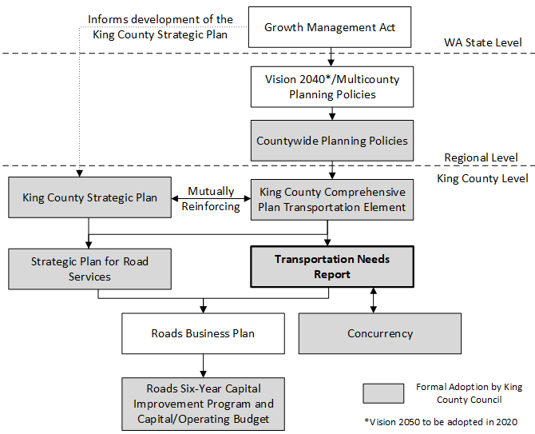

1.3 Strategic Context
The strategic context for preparation of the TNR includes insufficient funds, an aging system of roads and bridges and a backlog of maintenance and preservation needs. Roads employs a risk management approach to its roads and bridges and the Strategic Plan for Road Services (July 2014) responds to the dilemma of significantly constrained resources by setting clear priorities to guide the division’s decision-making. The strategic plan’s goals prioritize operational safety, regulatory compliance, and the maintenance and preservation of infrastructure (Figure 2):
Figure 2. Strategic Plan for Road Services strategic goals

- Prevent & respond to immediate operational life safety and property damage hazards
- Meet regulatory requirements and standards in cooperation with regulatory agencies
- Maintain and preserve the network
- Enhance mobility
- Address roadway capacity to support growth

What We Deliver

- Exercise responsible financial stewardship
- Enhance the use of risk assessment in decision making
- Provide responsive customer service and public engagement
- Support the effectiveness of our workforce in a rapidly changing environment

How We Deliver

Strategic Plan Goals

While Roads recognizes that it is not able to fully accomplish all of the concepts outlined within its strategic plan, these goals are used to guide work that meets the most critical needs within available funding and resources. This strategic context is exceptionally important as the agency grapples with near-term funding uncertainties.
Revenue projections reveal that the agency does not have the capital funds to address the majority of the project needs identified within the 2020 TNR. Roads applies its strategic plan goals and priorities to build its biennial budget and six-year capital improvement program, which results in funding safety and regulatory work first and then, due to revenue constraints, a limited amount of preservation and maintenance activities. The division lacks resources to fund roadway capacity improvements. The strategic guidance provided by the 2014 Strategic Plan for Road Services and the adopted biennium Roads Line of Business Plan, will continue to play an important role in the division’s decision-making, especially as funding for the Roads capital program decreases over time.

1.4 King County’s Transportation Needs and Funding
The TNR evaluates the difference between identified transportation needs associated with a twenty-year planning horizon and future revenues. This needs analysis augments work undertaken by Roads to assess the County’s ability to maintain the condition of its roads and bridges given declining revenues.
King County continues to experience a roads funding crisis, due to municipal annexations, the 2008 recession, declines in gas tax revenues, the effects of voter initiatives, and an aging bridge and road system. The lack of revenue is significantly impacting the County’s ability to maintain and improve roads and projections indicate that revenues will not keep pace with maintenance and preservation needs for King County’s road system. Critical safety work remains the top priority. With insufficient funds for a full preservation program or timely replacement of infrastructure, available revenues are focused on reacting to the higher risks associated with the deteriorating road system.
It has been more than a decade since a new capacity project has been funded, and preservation projects have been limited or associated with one-time funding. The six-year capital improvement program is significantly diminished from past years and is focused on addressing deterioration rather than planned preservation and maintenance. The division anticipates the need to continue to focus available resources on unplanned failures and system deterioration, recognizing that not all of these needs will be met, resulting in restricted or closed roads and bridges.
In 2015, King County convened a panel of regional leaders and community members to explore solutions for maintaining and preserving the aging bridge and road system in unincorporated King County. The Bridges and Roads Task Force reviewed the background, history, and the analysis of an independent consultant that identified a funding gap of $250 million to $400 million a year to maintain, replace, and improve county bridges and roads. In 2017 and 2018, King County collaborated with the Sound Cities Association, King County cities, the Puget Sound Regional Council, and the Washington State Department of Transportation on a Regional Transportation System Initiative to identify the critical connecting roads that comprise the regional road network and to identify unmet maintenance, operations, and capital needs. King County continues to work with local and regional partners to advance regional transportation funding solutions. See Chapter 6 of this report for additional Roads funding detail.

1.5 Rural Regional Corridors
Rural Regional Corridors are recognized in the King County Comprehensive Plan as segments of certain arterials that pass through rural lands to primarily connect urban areas. This type of roadway plays a key regional mobility role in the county’s transportation system. While additional capacity is generally prohibited by county policy on arterial roads in the rural area, a limited exception is made for Rural Regional Corridors. These corridors may receive capacity improvements if the increased capacity is designed to serve mobility and safety needs of the urban population, while discouraging inappropriate development in the surrounding Rural Area or natural resource lands.

Rural Regional Corridors must be classified as Principal Arterials and carry high traffic volumes, defined as a minimum of 15,000 average daily trips. They also have at least half of their PM peak (evening commute) trips traveling to cities or other counties. They connect one urban area to another, or to a highway of statewide significance that provides such connection, by traversing the rural area.

Based on the criteria contained within the comprehensive plan, the following King County unincorporated area roads currently quality as Rural Regional Corridors (Table 1).

Table 1. Rural Regional Corridors of Unincorporated King County
 | Woodinville Duvall Road | Novelty Hill Road | Issaquah Hobart Road | Avondale Road
Limits | Woodinville city limits to Duvall city limits | Redmond city limits to W. Snoq. Valley Road | Issaquah city limits to SR-18 | NE 116th to  Woodinville-Duvall Road
King County Arterial Classification | Principal Arterial | Principal Arterial | Principal Arterial | Principal Arterial
Average Daily Traffic | 19,000 (2016) | 23,600 (2016) | 21,400 (2017) | 25,700 (2016)

1.6 How is the TNR Used?
Roads makes use of the TNR in a variety of ways including: to support interagency coordination; to inform annexation discussions; to assess proposed development actions; to review proposed road vacations; and to inform the Roads grant program.
Interagency Coordination: The TNR leverages improved coordination between the Puget Sound Regional Council (PSRC), King County and other jurisdictions, including the Washington State Department of Transportation (WSDOT), cities and counties. The PSRC transportation model incorporates the capacity projects anticipated by local agencies. By clearly showing the scope, location and cost of unincorporated King County road system projects, the TNR provides PSRC and other jurisdictions with information that supports regional collaboration, modeling and cooperative solutions.
Annexations: As cities consider annexation of portions of unincorporated King County, the TNR provides useful summary information regarding transportation needs associated with potential annexation areas.
Development Review: The TNR is one source of information used to support the review of development proposals within unincorporated King County and nearby jurisdictions. The TNR project list is consulted to better understand how a proposed development relates to broader transportation needs of the unincorporated King County road system.
Road Vacation: Property owners can petition King County to have portions of the County’s unused road rights-of-way sold to them if the property is not needed for current or future transportation purposes. The TNR is used to identify future projects on the road system and is one tool in the road vacation process.
Grants: As grant opportunities emerge, the county’s TNR is consulted to identify transportation project needs that are consistent with the granting authority.

1.7 2020 Transportation Needs Report Changes
The 2016 adopted TNR served as a starting point for this update. The 2016 needs list was updated to reflect recently completed capital projects as well as current technical information regarding traffic safety, asset condition, regulatory requirements, community needs, and local-regional considerations. The 2020 TNR list reflects the following changes:
- 149 new needs were added to the 2020 Transportation Needs Report;
- 33 capital projects that addressed needs identified within the adopted 2016 TNR were completed by King County, these needs were removed from the 2020 Transportation Needs Report;
- 27 needs identified within the 2016 TNR were removed from the 2020 list due to updated technical information and completed studies.

Table 2 provides a summary of these changes, by TNR category. Appendix A contains a complete list of proposed transportation needs to be included within the 2020 TNR. Appendix B contains TNR maps.
Table 2. 2020 Transportation Needs Report (TNR) Summary of Changes
TNR Category | 2016 TNR |  |  |  | 2020 TNR
 | #  Projects | Completed since 2016 | Deleted for 2020 | Added for 2020 | #  Projects | Estimated cost | % of 2020 TNR costs
Capacity-Major: Capacity projects increase the size of the road to improve its ability to safely accommodate higher traffic volumes. | 19 | 0 | 2 | 0 | 17 | $368,600,000 | 21%
Bridge: Vehicular and pedestrian bridge projects include design, compliance and construction to improve safety and asset conditions of the county’s bridges. | 43 | 0 | 14 | 15 | 44 | $301,390,000 | 18%
Reconstruction: Road reconstruction projects improve safety and typically involve full removal and replacement of the surface layer, road base and related road infrastructure, such as drainage and guardrails. | 37 | 1 | 0 | 0 | 36 | $288,680,000 | 17%
Nonmotorized: Safety improvements to benefit people walking, biking, or participating in other active recreation activities. Sidewalk construction or shoulder widening/paving are common nonmotorized projects. | 58 | 3 | 0 | 18 | 73 | $269,460,000 | 16%
Intersection and Traffic Safety Operations: Projects typically incorporate one or more traffic safety measures, such as sightline improvements, traffic signals, re-channelization (“striping”) and roundabouts. | 40 | 3 | 8 | 14 | 43 | $192,260,000 | 11%
Vulnerable Road Segments: Roads frequently impacted by flooding, tides, wave action, storm surges or slides are often protected through infrastructure, such as: seawalls, armored slopes and retaining walls. | 27 | 1 | 0 | 21 | 47 | $167,430,000 | 10%
Drainage: Projects that preserve the integrity of the road and improve safety by moving water away from the road. Projects typically improve infrastructure such as culverts, ditches, catch basins and drainage systems. | 27 | 5 | 1 | 78 | 99 | $113,980,000 | 7%
Intelligent Transportation Systems: Projects that advance safety and mobility by integrating communications technologies, such as of cameras, vehicle detection, traffic signal equipment and timing upgrades into transportation infrastructure. | 20 | 2 | 2 | 0 | 16 | $9,700,000 | 1%
Guardrail: Guardrail projects to improve safety by reducing the severity of run-off-the-road collisions. | 58 | 18 | 0 | 4 | 44 | $9,510,000 | 1%
Total | 329 | 33 | 27 | 149 | 419 | $1,721,010,000 | 100%

Chapter 2. Unincorporated King County Road and Bridge Assets
King County Road Services Division (Roads) organizes its road and bridge assets into five product families: roadway, bridges/structures, drainage, traffic control/safety, and roadside. This chapter is organized by the five Roads product families. First, each product family is described and the processes used to identify and prioritize projects within each product family are summarized. Each subsection concludes with an overview of maintenance and operations programs associated with the product family.

2.1 Roadway
The roadway enables the 24/7 movement of people and goods, serving residents, commerce, emergency services, and other users. Cars, trucks, buses and bicycles all use the roadway for their travel needs. This category of assets includes the drivable surface and supporting road base (the layers of gravel, dirt, and other materials of the road that provide the structural integrity of the road). Road pavement protects against deterioration of the road base. If the road base becomes deteriorated, no amount of repaving will keep the surface smooth or provide the expected pavement lifespan.
Roadway Facts
There are nearly 1500 miles of unincorporated King County roads (more than the distance from Canada to Mexico).
About 1/3 of the road system consists of arterials.
Over 1 million trips per day occur on unincorporated King County roads.
Pavement deteriorates naturally over time. As it ages, the pavement and underlying road base become increasingly susceptible to the impacts of stormwater, weather and temperature changes, and growing traffic volumes. Roads monitors the condition of unincorporated King County roads by assessing and tracking pavement condition and other testing over time. These methods are discussed in detail below.

2.1.a Pavement Inspection and Testing
Inspection
Roads conducts regular field assessments of all roadways to visually determine the condition of the pavement using the County Road Administration Board visual data collection system (VisRate). Arterial roads are inspected every two years and local roads are inspected every three years.
The state County Road Administration Board requires the County to rate and report on pavement condition in order for the County to receive state gas tax revenues.

These assessments are based on the Pavement Condition Index rating scale, which ranges from 0 to 100, with 0 representing the worst and 100 representing the best possible condition. Roads categorizes pavement condition as Very Poor (<25), Poor (25-49), Fair (50-70), and Good to Excellent (71-100). As the ratings are based on a visual assessment of the road surface, they may not accurately indicate the condition of the underlying base and subgrade of the pavement.
Pavement Condition Index scores inform the selection of pavement preservation treatment options, including: crack sealing, overlay, and pavement rehabilitation.
Deflection Testing
Between 2003 and 2012, Roads conducted deflection testing on all of the unincorporated county arterials to evaluate the subsurface condition. The falling weight deflectometer testing used trailer mounted equipment consisting of a load package, load plate, load cell, and geophones (“deflection sensors”). The load package was made of steel plates balanced on either side of the load cell and tower assembly. This package was raised to a set height and dropped onto the load plate. The load cell recorded the amount of load applied to the plate. Testers repeated the process approximately every 200 feet, then analyzed the data using AREA and EVERCALC 5.0 programs to determine the condition of the roadway. The 2003 and 2007 deflection testing efforts collected core samples of road material, which were then analyzed for surface composition, base course thickness, composition and course condition, subgrade soil type, and subgrade strength.
The data and calculated parameters identified sections of roadway for potential reconstruction, road base or pavement rehabilitation, or overlay.

2.1.b Pavement Preservation Program
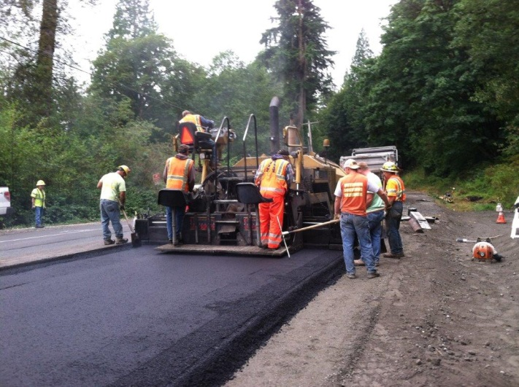
King County employs a risk management approach to its pavement preservation program as funding levels are insufficient to manage the system through a typical asset management program. The pavement preservation program has been focused only on arterial roadways with the goal of keeping these roads functioning at their current level. No major investment in preserving non-arterial roadways, other than minor maintenance activities, has been made for over 10 years.
By conducting minor rehabilitation and maintenance activities, King County’s pavement preservation program seeks to delay the decline of pavement surface conditions and extend the service life of the road system. Roads uses a variety of pavement management methods, including:
- Crack sealing, patching, minor reconstruction, seal coating, paving, and shoulder restoration.
Unincorporated King County’s arterial road system will be subject to considerable deterioration over the next ten years due to recent and projected lack of resources to invest in pavement maintenance or reconstruction. Portions of the system may be subject to speed limitations or partial closure in the future.
- Chip sealing and hot mix asphalt
- Pilot project testing of emergent pavement materials
Additionally, the County’s pavement preservation program employs the following program management strategies:
- Conducting cost-benefit analyses to guide decisions to identify appropriate use of techniques in a given location.
- Collecting life-cycle costs for each resurfacing type and updating maintenance and rehabilitation costs at the end of each construction season. Cost and performance data is compared to peer agency data.
- Preparing a yearly accomplishment report for the Governmental Accounting Standards Board (GASB) and both projection and accomplishment reports for the County Road Administration Board.
As data accumulates over time, Roads makes use of the data to establish performance measures and targets, in support of informed programmatic decision making.
Prioritization
Pavement Prioritization Process:
- Process visual condition rating data.
- Update the Pavement Management Systems as new data is received.
- Create candidate list to facilitate collaboration between maintenance and engineering staff, Capital Improvement Program planning, and potential grant funding opportunities.
- Evaluate potential preservation options based on projected funding.
- Publish final list for High Risk Roadway Candidates to be implemented by maintenance staff.
- Develop the preservation project candidate list to be implemented by a contractor in the upcoming year.

Roadway preservation prioritization follows the strategic goals in the Strategic Plan for Road Services. This approach directs funding to the highest priority locations; however, the lack of available funding leaves portions of the County roadway network inadequately preserved.
Selection
Selection of roadway preservation candidates starts with the collection and entry of pavement inspection data into the division’s Pavement Management System Database, which provides the specific roadway condition data needed to assist engineers in establishing smaller year-, tier-, or pavement condition score-specific candidate lists. Road engineers and maintenance staff jointly review these lists to coordinate pavement preservation efforts throughout the County. See inset for details.

2.1.c Roadway Reconstruction
Roadway reconstruction involves full removal and replacement of the surface layer, road base, and ancillary structures (culverts, guardrail, etc.). No reconstruction projects have been performed in the last 10 years other than a few grant funded projects.
In 2007, deflectometer testing identified 82 road segments requiring further assessment for potential reconstruction. This assessment led to preliminary scope of work and cost estimates for the reconstruction of 30 road segments, which were subsequently added to the TNR. This list has been updated to reflect additional deflectometer testing in 2012, routine pavement condition testing and other studies, completed rehabilitation projects, and completed annexations.
Roads has used pavement overlay, rehabilitation, or crack sealing and patching to temporarily preserve many of the roads identified in the 2020 TNR Reconstruction category. Depending on the original road design, these preservation measures can extend the life of the road for three to ten years, until funding is available for full reconstruction.

2.1.d Roadway Maintenance and Operations
Roads employs programs that facilitate routine inspections, maintenance, repair, and operation of the roadway. These programs fall into the following categories:
Small Surface Repairs: Pothole filling; square cut, skin surface and grinder patching; acute pavement surface repair; crack sealing and pouring; curb and gutter replacement and repair; and gravel roadway grading and patching.
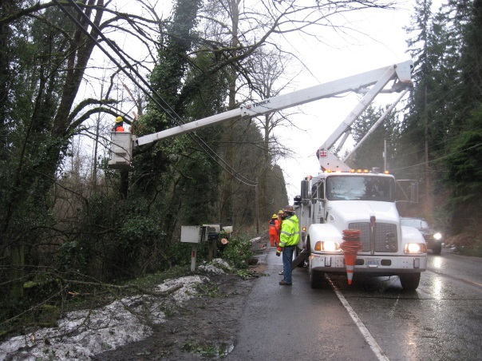
General Roadway Maintenance: Routine, but important safety and environmental compliance work, such as sweeping and dust control. This removes leaves, rocks, fallen trees and debris from the roadway for safety. Prompt cleaning also prevents sediments from polluting creeks and streams, endangering salmon and water quality.
Storm - Quick Response: Emergency or urgent maintenance and operations activities to address the effects of storms, floods, and slides, such as snow and ice control and washout repair.

2.2 Roadside
The roadside product family includes road system features and components within the road right-of-way but outside the travel lanes of the road. Drainage facilities may be located in the roadside area, but are treated as a separate category. Roadside infrastructure includes:
- Nonmotorized assets including sidewalks, pathways and curb ramps to enhance pedestrian safety and mobility
- Road shoulders to provide space for slow moving and disabled vehicles, nonmotorized travel, construction and maintenance activities and emergency and police activities
- Guardrail to prevent or mitigate the impacts of run-off-the-road collisions
- Landscaping and vegetation, such as landscaped walls, slopes and planters

2.2.a Nonmotorized Safety and Mobility
Nonmotorized transportation is an essential component of King County’s multimodal transportation system. Pedestrians, bicyclists and in some parts of the county, equestrians, are nonmotorized users of the unincorporated King County network.
In unincorporated King County, Roads maintains nonmotorized facilities such as bicycle lanes, sidewalks, and shoulders. The division provides crosswalks, signals, pavement markings, and signage to help facilitate safer nonmotorized travel. The King County Road Design and Construction Standards include accommodation for nonmotorized uses and specific criteria for marked bicycle lanes, sidewalks, or road shoulders on unincorporated roads.
Nonmotorized Evaluation
Nonmotorized transportation needs are assessed using criteria that include: connectivity to travel destinations; proximity to public transit; road traffic volumes and speeds; existing shoulder widths and roadside conditions; customer requests; proximity of a school or other community gathering place; and overall network connectivity. Roads also considers additional contextual information such as: King County arterial classification; surrounding land uses; community plan recommendations; the Puget Sound Regional Bike Network Plan; and best available traffic safety data.
A small portion of the King County regional trail network coincides with the unincorporated King County road network. In some locations, a regional trail crosses a King County road and in other locations, a short regional trail segment follows an existing unincorporated King County road. Roads collaborated with King County Parks Division to update a list of King County regional trail needs that coincide with the unincorporated King County road network (Table 3). These regional trail projects are not included within the Transportation Needs Report project lists and are included within this chapter to support future planning, collaboration and implementation by the King County Parks Division.
Table 3. King County Parks Proposed Future Projects with a Potential King County Roads Connection
Regional Trail Project | Location | Description |  | From | To | Note
Green to Cedar Rivers Trail (South Segment) | Maple Valley/Black Diamond Green River Valley at 218th Ave SE | Trail sidepath or other trail/road ROW project |  | 218th Ave SE at Green to Cedar Rivers Trail | SE Green Valley Rd | Current feasibility study uses 218th Ave SE as a possible route for the trail in south Black Diamond to SE Green Valley Rd
Green to Cedar Rivers Trail (South Segment) | Upper Green Valley at 218th Ave SE | SE Green Valley Rd crossing |  |  |  | Current feasibility study would have the trail cross SE Green Valley Rd at 218th Ave SE
Green to Cedar Rivers Trail (South Segment) | Upper Green Valley at SE Green Valley Rd | SE Green Valley Rd sidepath |  | 218th Ave SE | SE Flaming Geyser Rd | Current feasibility study envisions sidepath along SE Green Valley Rd from 218th Ave SE to SE Flaming Geyer Rd
Green River Trail, North Extension (Green to Duwamish) | Tukwila and Unincorporated King County at W. Marginal Place | W. Marginal Place sidepath or other trail/road ROW project |  | S 102nd St | S. Director St | Feasibility study envisions extending the Green River Trail along W. Marginal Place between Cecil Moses Park in Tukwila to Seattle’s South Park community
Snoqualmie Valley Trail, Snoqualmie Mill Gap | Unincorporated King County, Snoqualmie River Bridge at SE Reinig Rd | SE Reinig Rd Trail Bridge crossing |  |  |  | New trail bridge structure will be needed to cross SE Reinig Rd to facilitate trail development through the Mill Gap from the Snoqualmie River Bridge. An interim at-grade crossing may be used.
Green River Trail, Phase 2 | S. 259th St, south Kent at Green River Trail | Green River Trail, Phase 2 project at S. 259th St |  | S. 259th St | Existing Green River Trail | ROW improvements may be needed to transition trail segment to street
Green River Trail 2.2 | S. 259th St, south Kent at Green River Trail | Trail sidepath or other trail/road ROW project |  | S 259th St at Union Pacific Railway bridge | S 259th St at Green River Trail Phase 2 | Project assumes that S 259th St ROW will be used for a sidepath between the UP RR bridge and the proposed Green River Trail, Phase 2
Green River Trail, Phase 3 | Green River Rd, Unincorporated King County | Trail sidepath or other trail/road ROW project |  | Green River Rd at Green River Trail, Kent | Green River Rd at S 277th St | Alternative concept for this trail segment would likely provide a sidepath along Green River Rd where the existing Green River Trail meets the road in south Kent, and then use the Green River Rd ROW for sidepath segments to S 277th St bridge
Green River Trail, Phase 5 | Green River Valley | SE Green Valley Rd sidepath or other trail/road ROW project |  | SR-18 | SE Flaming Geyser Rd | Upper Green River Trail concept would develop a sidepath along SE Green Valley Rd and Green River
East Plateau Trail | Unincorporated King County near Klahanie; SE Duthie Hill Rd near SE Issaquah-Fall City Rd | SE Duthie Hill Rd, signalized crossing and other ROW improvements |  |  |  | Likely signalized crossing of SE Duthie Hill Rd near SE Issaquah-Fall City Rd to access Duthie Hill Park and continue trail to the northeast
East Plateau Trail | Unincorporated King County west of Trossachs Blvd SE | SE Duthie Hill Rd Trail crossing and sidepath and/or other trail/road ROW project | Duthie Hill Park west of Trossachs Blvd SE |  | Trossachs Blvd SE | Planning envisions the trail existing north entrance of Duthie Hill Park and running as a sidepath in SE Duthie Hill Rd ROW before crossing at the intersection with Trossachs Blvd SE and continuing north along Trossachs Blvd
Landsburg-Kanaskat Trail | Landsburg Rd SE at Landsburg | Landsburg Rd SE signalized crossing |  |  |  | Likely signalized crossing of Landsburg Rd SE from existing Cedar River Trail
Tolt Pipeline Trail and Bridge – Snoqualmie River | W. Snoqualmie Valley Rd NE north of NE 124th St | W. Snoqualmie Valley Rd NE signalized crossing and/or other trail/road ROW project |  |  |  | Likely crossing of W. Snoqualmie Valley Rd to continue trail to the Snoqualmie River
Redmond Ridge Trail | North side of NE Novelty Hill Rd | Trail widening |  |  |  | Links two regional trails
Soos Creek Trail Extension | Soos Creek Trail at SE 192nd St | Crossing improvement and trail extension
Preston Snoqualmie Trail | Preston Fall City Rd SE/Raging River | Trail crossing and alignment evaluation |  |  |  | Evaluate location and design alternatives at Fall City Rd SE

2.2.b Guardrail
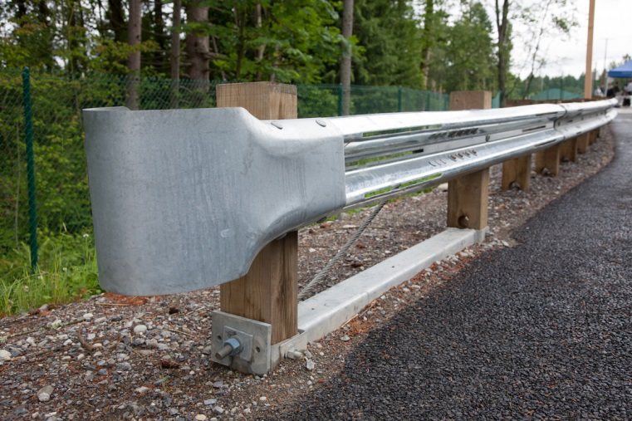
King County’s guardrail program refurbishes and upgrades existing guardrail to current standards. The program improves road safety by upgrading existing guardrail and guardrail end terminals and raising guardrail to current standard height. Federal standards for guardrail type and construction have evolved over time, and older infrastructure is replaced to comply with the latest and best practices. King County uses a quantitative methodology for identifying and ranking potential roadside safety mitigation sites into two categories: new barriers and retrofits to existing barriers.
Risk potential and severity are the primary considerations when considering guardrail prioritization. Risk is a function of the probability of vehicles running off the road. Severity is the quantitative potential for personal injury if a run-off-the-road collision were to occur. Factors included in the analysis of guardrail need and priority include collision data, average daily traffic, road functional classification, corridor geometry, bridge geometry, speed limit, embankment slope, and roadside obstacles.
New Barrier Locations
Roads develops a priority array of new guardrail locations using an algorithm to assess the factors described above. This method was fully tested following development, using statistically valid sample sizes, field review by county engineering staff, and a comparison between staff ranking and algorithm results. The testing indicated a 90% or better correlation between staff and algorithm ranking. Planned installations of new guardrail are identified in the TNR Guardrail category.
Barrier Retrofit
All sites with existing roadside barriers that are not compliant with current standards are included as candidates for retrofits. Risk exposure, degree of deficiency, and tier service level are the primary considerations in the prioritization process for barrier retrofits.

2.2.c Americans with Disabilities Act (ADA) Program
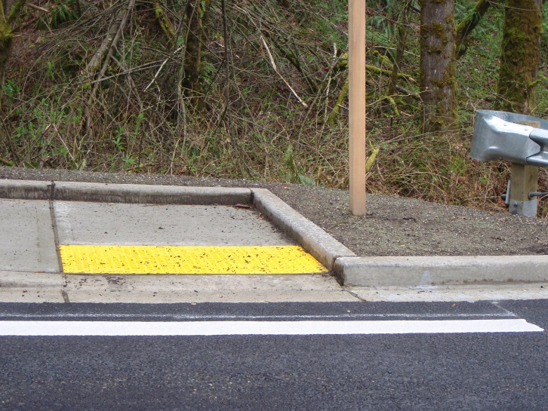
The Federal Highway Administration sets regulations to implement the federal Americans with Disabilities Act (ADA). These regulations require that pedestrian facilities such as curb ramps and signal push buttons be upgraded to be accessible to people with disabilities whenever a roadway is altered. Roadway alterations include reconstruction, rehabilitation, or simple asphalt surface overlay.
Roads is developing an ADA Transition Plan, which is to be completed by 2020. An ADA Self Evaluation was completed in 2019 which produced a geospatial inventory of sidewalks, pathways, curb ramps, crosswalks and signal push buttons associated with the unincorporated King County road network. The Roads Self Evaluation produced a valuable dataset that will inform completion of the division’s ADA Transition Plan.

2.2.d Roadside Maintenance and Operations
Maintenance and operation activities in and along roadsides are done to enhance pedestrian safety and mobility on pathways and sidewalks and to mitigate the impacts of run-off-the-road collisions. Properly maintained roadsides have good sight distance and are free of hazards, obstructions and vegetation.
Roads maintenance and operations employs a continuous cycle of inspections, maintenance, repairs, replacement, and improvements to its roadside features. These programs fall into the following categories:
- Vegetation Management includes mowing and maintaining trees, brush, and natural areas on the roadside to provide clear sightlines for drivers, improve drainage, keep signs and traffic signals from being obscured, provide pedestrians space to walk outside of the roadway, and prevent roadways from being blocked by dangerous or downed trees. Related activities include noxious weed control and shoulder/roadside spraying.
Slope and shoulder mowing serves a critical safety function by removing vegetation from lines of sight, from blocking visibility of traffic control devices, and from obstructing pedestrian walkways. Limited funding has reduced the frequency of slope and shoulder mowing activities.
- Shoulder Cleaning and Restoration includes maintenance of paved and gravel shoulders, such as gravel patching, grading and restoration, and landscape maintenance. Maintaining shoulders prevents standing water and reduces deterioration of the roadway.
- Storm Response includes bank stabilization, material removal and disposal, repairs, and other responses to storms and landslides. Roads conducts a preventive maintenance program that identifies areas with the greatest washout risk and implements measures to prevent future damage. Most critical washout repairs are made immediately, while others take more time to complete.
- Minor Maintenance of roadside features includes repair or replacement of guardrails, rock walls, gabion retaining walls, fences, sidewalks and walkways; and removal of hazardous material, debris, and litter.

2.3 Traffic Control
The traffic control product family includes traffic-related safety devices and other measures used to regulate, warn, or guide traffic. King County use and prioritization of these devices is based on King County Code Title 14 Roads and Bridges and the Manual on Uniform Traffic Control Devices (MUTCD). The MUTCD was developed by the U.S. Department of Transportation, Federal Highway Administration to set national standards for road managers when installing and maintaining traffic control devices on public streets, highways, bikeways, and private roads open to public travel. National standards set by the MUTCD apply to all traffic control devices, including:
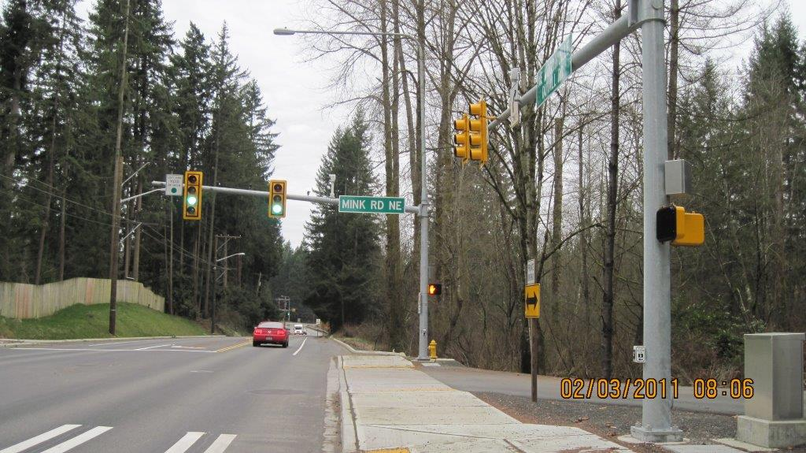
- Traffic signs to warn the public of sharp curves and intersections, provide speed limits, guide traffic, control intersections, and prohibit parking.
- Traffic signals or controls including warning flashers, exclusive and protected left turn lanes, traffic signals, signal timing, signal head and phasing revision (i.e. Flashing Yellow Arrow) and roundabouts.
- Roadway delineation or pavement markings including centerline and edge line markings, raised pavement markers, markings for crosswalks, rumble strips or post delineators.
- Street lighting
- Channelization including left and right turn lanes, acceleration or deceleration lanes, and access restrictions (i.e. curbs).
- Pavement treatments such as high friction surface treatments.
- Alignment alterations that modify the horizontal and vertical alignment, and curve geometry.
Traffic control devices optimize traffic performance, promote uniformity nationwide, and help improve safety by reducing the number and severity of traffic crashes. Additionally, by enabling the orderly movement of all road users, traffic control devices and intelligent transportation systems can promote safety, increase efficiency, and enhance transit speed and reliability. The following sections describe the processes developed for identifying projects and managing programs to address collisions, congestion, MUTCD requirements, and design constraints.

2.3.a Traffic Signals and Intersection Control
Prior to selecting signalization as a preferred intersection control solution, intersections first undergo an extensive evaluation of alternatives, as listed in the MUTCD, Section 4B.04. The list of alternative evaluations include, but is not limited to: the construction of additional lanes; revising the intersection geometrics to channelize movements and realign the intersection; installing street lighting; improving sight distance; installing roundabouts; installing measures to reduce approach speeds; changing lane use assignments; restricting movements; or adding stop controls or intersection flashers. Particular attention is given to the predominant type of collision occurring at the intersection. Intersection evaluations also include analyses of existing and future traffic patterns to determine the effectiveness of each alternative, and development of cost estimates for alternative comparisons. Safety outcomes and cost effectiveness are primary determinants for selecting intersection improvement solutions.
Traffic Signal Priority Array
King County’s process to prioritize signal needs conforms to the Strategic Plan for Road Services goals and the laws set by the federal government, adopted with amendments by state government, and presented in the Manual on Uniform Traffic Control Devices (MUTCD). Prioritization and selection of intersections for signalization starts with data collection. Roads engineers collect vehicle and pedestrian volumes, prevailing speeds, and collision history at each intersection for the most recent three-year period. Each intersection is then evaluated using MUTCD warrants based on the number of approach lanes and the collected data.
MUTCD signal warrants define the minimum conditions under which installing a traffic control signal might be justified. However, selection and use of traffic control signals are based on careful analysis of traffic operations, pedestrian and bicyclist needs and other factors, coupled with engineering judgment. Traffic signals are typically not be installed unless one or more of the nine signal warrants are met. Three of these warrants are based on traffic volumes at several periods during the day: the peak hour, the fourth highest hour, and the eighth highest hour. One warrant examines the traffic collision history, focusing on collisions correctable by signalization (left-turn and right-angle types). Two warrants examine whether pedestrian volumes warrant signalization. Two warrants examine whether signalization would improve traffic flow in a coordinated signal system or roadway network. The final warrant examines the proximity to a railway (“grade”) crossing.
Five Primary Warrants Used for Unincorporated King County
Warrant 1 – Eight-Hour Vehicular Volume
- Condition A: Minimum Vehicular Volume
- Condition B: Interruption of Continuous Traffic
Warrant 2 – Four-Hour Vehicular Volume
Warrant 4 – Pedestrian Volume
Warrant 6 – Coordinated Signal System
Warrant 7 – Crash Experience
Roads uses the five primary warrants described in the inset to evaluate signalization need and relative priority across locations. The remaining warrants are also considered in the evaluation process, but are less applicable to the suburban and rural nature of unincorporated King County.
In addition to the five warrants, King County adds a factor for proximity to a school site. This factor does not replace the pedestrian-related warrants, but addresses the potential for pedestrian activity outside of average-day activities. For locations near schools, shopping, and other pedestrian attractors, the volume of pedestrian activity is examined as well as pedestrian warrants.
For each intersection, Roads assigns values representing the degree to which each of the primary warrants is met, then sums the total for the intersection. Intersections are categorized and sorted first, by the number of collisions within the last three years that could be corrected through signalization, then by warrant rating values. The resulting list of rank-ordered intersections forms the Traffic Signal Priority Array, a list that serves as a starting point for determining locations to signalize. Table 4 summarizes intersection criteria and high, medium and low categories.

Table 4. King County Intersection Categories
Category | Intersections that meet:
High | - Warrant 1 (Eight-Hour Vehicular Volume) OR  - BOTH Warrants 2 and 7 (Four-Hour Vehicular Volume and Crash Experience)
Medium | - Warrant 2 (Four-Hour Vehicular Volume) OR  - Warrant 3 (Peak Hour) OR  - Warrant 4 (Pedestrian Volume) OR  - Warrant 5 (School Crossing)
Low | - Warrant 6 (Coordinated Signal System) OR  - Warrant 8 (Roadway Network) OR  - Warrant 9 (Intersection Near a Grade Crossing)

Traffic Signal Programmatic Needs: Phasing, Operations, and Lighting
King County regularly reviews existing traffic signal locations for left-turn signal phasing revisions and for safety and congestion concerns.
Phasing – Monitoring and evaluating the left-turn phasing at existing traffic signal locations ensures that the appropriate level of protection and capacity is provided. Engineers determine whether the left turn phase should be permissive (left-turning drivers see a solid green light or flashing yellow arrow and yield to through traffic), protected-permissive (left-turning drivers see a green arrow while through traffic is stopped, then a solid green light when they must yield), or protected-only (left-turning drivers may only turn when they see a green arrow and do not have to yield). If changes are needed, staged plans are made to implement the changes. Roads continues to monitor altered intersections for safety.
Signal Operations – Existing traffic signal operations are field-reviewed on a three-year cycle to ensure that changes in conditions such as adjacent new development, shifts in vehicle volumes, new or improved pathways or other pedestrian attractors, vegetation growth, queue lengths relative to length of existing turn pockets, vehicle delays, and other elements of the traffic signal operation are acceptable based on engineering judgment.
Street Lighting – Street lighting helps motorists and other road users safely maneuver. King County Road Design and Construction Standards require street lighting on all roadways with three or more lanes of travel and where local roads intersect arterials.

2.3.b Intelligent Transportation Systems
ITS equipment promotes safety and efficiency and can enhance transit speed and reliability by enabling the orderly movement of all road users on streets and highways. This equipment also provides real-time traffic information to King County traffic operators, the media, and the traveling public. The County’s ITS assets were primarily funded through external grant programs.
Intelligent Transportation Systems Corridor Project Prioritization Criteria
In the 2005 ITS Strategic Plan, the criteria for prioritizing projects were established based on examples from the 2004 Transportation Needs Report, other criteria specific to ITS projects, and the county’s needs. Each criterion was rated on a scale of 1 – 5 points. Priorities were established by totaling the points received by each project. A low, medium or high general priority level was then assigned by comparing scores across projects. ITS criteria included:
- Average Daily Traffic (ADT): A traffic volume scale was used to assign priority for ITS projects along roads with the highest ADT.
- Volume to Capacity Ratios: Roads whose volumes were approaching or exceeding capacity were scored higher.
- Collision Rates: Corridors with high collision rates were scored higher.
- Transit Ridership: Corridors with greater volumes of transit ridership were scored higher.
- Potential for Annexation: Corridors with little probability of annexation were scored higher.
- Availability of Communications: Corridors with access to communications infrastructure were considered scored higher.
- Links to Other Existing/Planned Projects: Corridor projects that could coordinate or build off of other county ITS corridor projects were scored higher.
- Hazard Areas: Corridors with two or more of hazard locations (ex., collision history, flooding, icing, landslides, etc.) were scored higher than those with one or fewer hazards.
Since 2005, all but two of the high priority ITS corridor projects have either been completed or annexed by other jurisdictions. The other remaining projects are low-to-medium priority. Uncompleted projects from the 2005 ITS Strategic Plan are included on the 2020 TNR project list
Programmatic Intelligent Transportation Systems (ITS) Projects
Programmatic ITS projects provide the information processing and dissemination capability to add value to the data collected by field devices. They include projects that can be implemented countywide and are not focused on one corridor. The regional ITS projects include Emergency Management, Traffic Management, Data Management, Weather and Hazard Detection, Communications, Maintenance and Construction Activity Coordination, and Traveler Information. Programmatic ITS projects were prioritized using the following criteria:
- Improvement to traffic flow
- Improvement to incident response time
- Improvement to regional information sharing for traveling public
- Improvement to the efficiency of county service delivery
- Potential for phased implementation
- Relative ease of implementation
- Eligibility to leverage non-county funding sources
- Potential to leverage existing infrastructure/projects

2.3.c High Collision Location Analysis
Critical safety work remains the top priority for Roads. King County has completed a system-wide study of collision locations every three years, and will move to a two-year cycle following completion of the on-going 2019 study. The High Collision Location analysis is consistent with the goals and criteria established by the Washington Traffic Safety Commission Target Zero program. The methodology is updated as needed to reflect current best practices.
The initial list of study locations is compiled by analyzing the spatial density of eight years of collision data to produce heat maps of intersections and road segments with a concentration of crashes. Locations with the highest concentrations receive additional study, including analyses of crash frequency and trends over time, crash rate (the number of crashes compared to the amount of traffic and/or length of road), and the crash history relative to other locations. Locations that meet thresholds from these analyses receive in-depth analysis of collision history, patterns, and trends; traffic volumes; and site conditions and roadway characteristics.
Regular maintenance of traffic control devices ensures that:
- Safety standards are met;
- Damaged signs are replaced;
- Traffic signs, stripes, and markings are replaced so that they are visible night and day;
- Intersections are operating efficiently;
- Traffic control systems are operating correctly;
- Traffic information is accurate, clear, and appropriate; and
- Traffic restrictions are clearly marked.
These location-specific studies are used to develop countermeasures (improvements intended to reduce the occurrence of collisions). There are a broad range of countermeasures, ranging from changing roadway geometrics to altering traffic signal timing. Countermeasures are selected based on predominant collision patterns, field observations, King County practices, and the experience of the review team. Countermeasures may not be developed at locations where recent improvements have been completed, where no clear collision pattern or deficiencies are noted, or where the location is no longer under King County jurisdiction.
Once countermeasures are developed, Roads prepares a benefit-cost analysis for each location. Benefit-cost analysis is frequently used to prioritize safety improvements since it can indicate if the benefits of a proposed countermeasure are greater than the costs and thus are worthy of improvement. The ratio is equal to the benefit of the expected reduction in collision costs divided by the project cost. Generally, if the ratio is equal to or exceeds one it indicates that the project is worth the investment.
To determine the benefit of the project, the expected reduction in collisions due to a given countermeasure is estimated using nationally published “reduction factors” with modifications based on King County’s past experience. The reduction factor is used in combination with typical collision costs to determine the expected societal benefit (in dollars) of completing the improvement. Benefits are then normalized by converting to a present value based on the expected service life of the improvement. Finally, the normalized benefit is divided by a planning-level cost estimate to obtain the benefit-cost ratio for the project.
The culmination of this analysis identifies a list of safety improvements, which are further prioritized according to their respective benefit-cost ratio. Although many of the proposed projects are smaller, targeted, operational improvements, the analysis informs prioritization across several TNR categories, including the Intersection and Traffic Safety Operations category.

2.3.d Traffic Control Devices: Maintenance and Operations
Common maintenance tasks to ensure the proper functioning of traffic control devices includes:
- Maintaining street lighting, signals, flashers and ITS equipment and all associated components such as controllers, lights, mast arms, timers, cameras, cabinets, and loop detectors.
- Sign maintenance including replacement and installation, fabrication, inspection, cleaning, and responding to community member concerns.
- Pavement marking maintenance including replacement of pavement markings, including paint striping, thermoplastic, and raised pavement markings (“buttons”).

2.4 Drainage Systems
Standing water can be a safety hazard to road users and accelerates the deterioration of the roadway surface and substructure. The drainage asset product family includes infrastructure that moves stormwater away from the roadway and reduces flood risk to the built environment (public and private property) by collecting and redirecting stormwater to natural bodies of water and designated collection points. Drainage infrastructure reduces water pollution by collecting stormwater and filtering out pollutants and sediment via settlement, infiltration, or other processes.
Roads is responsible for the drainage infrastructure within, alongside and under unincorporated road right-of-way, including: pipes, ditches, catch basins, manholes, retention/detention ponds, rain gardens, vaults, and bio-swales.

2.4.a Large Drainage Project Identification and Prioritization
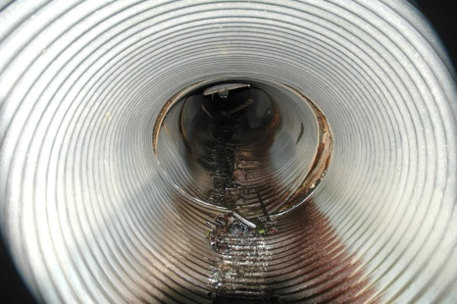
The largest and most costly component of King County’s aging system are the enclosed pipes 24 inches and greater in diameter. These pipes serve a critical role in conveying regional surface water and will have the largest consequences if they fail, because their failure poses the greatest risk to public safety, property, and aquatic resources.
In unincorporated King County, regional pipe systems represent about 2% of the drainage system in the road right-of-way. This section discusses how larger-scale drainage projects are identified and prioritized. These large projects are listed in the 2020 TNR. Smaller projects, constructed by in-house staff under the Road Services Countywide Drainage Program, are not included in the TNR project list but are prioritized in the same manner.
Field Confirmation
Drainage problems and concerns are brought to the attention of Roads in variety of ways, including community member inquiries, routine road patrol and field work, or from other agencies. Drainage concerns are then reviewed to determine the responsible asset manager. When Roads is responsible, a project is created in Roadworks, Roads’ asset management database.
Two evaluation systems are used to prioritize drainage projects: Field Priority Score and Habitat Evaluation. A third system based on water quality benefits was developed using 2014 grant funding, but is on hold pending additional funding.
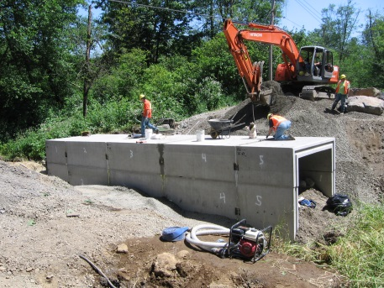
Field Priority Score: Scores for field priority reflect the problem’s threat to public safety and impact on private property. There are eight criteria used to evaluate each problem (see inset). These criteria help identify system-wide impacts of each drainage problem.
Field priority criteria are assigned point values (from 0 to 10) and weights (from 1 to 5) based on their importance to the maintenance of the county road system.
Habitat Evaluation Process: To address federal, state and local regulatory requirements (such as the Endangered Species Act, the Washington State Hydraulic Code and the King County Critical Areas Ordinance) and to improve environmental health, a staff biologist completes a field visit and habitat evaluation for projects that affect aquatic areas, fish habitats and their buffers. The project’s impacts or benefits are identified using the habitat evaluation criteria. The Habitat Evaluation also documents potential regulatory mitigation requirements.
Drainage Project Prioritization
Field Priority Criteria
- Threat to public safety
- Threat to public property
- Threat to private property
- Water quality improvement
- Maintenance problem resolved
- Road closure severity (detour length and availability, if needed
- Road classification (local access, arterial use, collector use)
- Road failure potential

Habitat Evaluation Criteria

- Fish stock status (species of concern or listed under Endangered Species Act )
- Site specific information (fish passage, water quality, wetland improvement or risk of habitat damage)
- Basin/system concerns
The Field Priority Score, Habitat Evaluation, and other available information are entered into Roadworks. Roadworks is then used to monitor the status of the projects through design, permitting, and project completion. This software can also be used to evaluate lifecycle costs once fully populated, track problems by area, and help guide coordination with other departments using its geospatial analysis and countywide drainage layer.
Life-Cycle Analysis/Condition Assessment
A large portion of King County’s unincorporated drainage system is at or nearing the end of its useful life and its current condition is largely unknown. To address this lack of knowledge, an effort was developed to identify the location, age, type, size, and condition of regional drainage facilities in unincorporated King County right-of-way. This information was necessary to identify and assess the urgency and cost of drainage facility maintenance and renewal needs. In 2015, Roads coordinated this effort with the King County Water and Land Resources Division (WLRD) for the most at risk system elements, which is estimated at 40% of the pipes that are 24” and larger, or 2% of the entire system in the roadway. This program identified 33 regional system projects deemed critical; work to address these deficient systems is currently underway.
This effort provided information for completing an inventory and condition assessment of the remaining drainage system. The assessment also informed policy discussions regarding the responsibility and funding structure for operation, maintenance, and renewal of regional drainage systems in the unincorporated areas.
Fish Passage Prioritization
In order to support the County’s Fish Passage Restoration Program, Roads has developed a Culvert Replacement and Fish Passage Program. Projects selected for this program are identified through collaboration with the King County Water and Land Resources Division (WLRD). The selection process identifies projects that are a priority for both the safety and condition of the public road system (using the field confirmation process described above), and fish passage purposes. This selection process is expected to evolve based on WLRD’s proposed habitat and condition assessment, additional feasibility analysis, preliminary design work, and consultation with tribes and Washington Department of Fish and Wildlife. These projects are included in the TNR Drainage category.
Emergency projects and project schedules
Projects are scheduled in the Countywide Drainage Preservation Program annually. Scheduling annually helps reduce frequent reallocation of resources. However, drainage problems are reported to Roads almost daily. Some of these concerns are so urgent that they must be included in the current year’s work program. Project priorities are reevaluated every time a new project is identified to ensure that effort is expended on the most urgent safety and preservation projects.

2.4.b Drainage Program Programmatic Needs
Roads prioritizes all known major and minor drainage infrastructure needs, from the replacement of small segments of pipe to large cross-culvert replacements. They can be triggered by regulatory requirements, safety, or preservation needs. Projects that impact streams undergo a significantly different planning process. These projects are required to meet state or federal design standards for fish passage or other aquatic habitat needs relating to vertical drops, water depth, water velocity, and other needs. Projects that do not impact streams typically include stormwater system retrofits and the installation or replacement of catch basins, vaults or pipes.
Drainage infrastructure is doing its job when…
- Safety and environmental standards are met.
- Water on the roadway causes minimal impact to travelers, infrastructure or private property.
- Surrounding streams, rivers and lakes enjoy good water quality.
- Ponds, ditches and enclosed drainage systems are free of litter/debris.
- Road-related ponds or ditches are mosquito free.

2.4.c Drainage Maintenance and Operations
To ensure successful drainage management, Roads employs routine inspections, regular maintenance, repair, and infrastructure replacement that falls into the following categories:
- Quick response: Work associated with unanticipated failures of the drainage system.
- Drainage system cleaning: Routine maintenance to the drainage system, including cleaning pipes and catch basins, removing sediment, and completing incidental repairs.
- Ditch maintenance: Reshaping and cleaning roadside ditches to ensure proper drainage. This work is primarily preformed through bucket ditching with a front end loader or a backhoe.
- Other repair: Using best management practices to repair or replace drainage pipes, catch basins, catch basin lids, trash racks and headers, and rip-rap; mark pipes to ensure infrastructure visibility; prevent erosion; install stream bypasses; and restore streams.
- Stormwater pond maintenance: Mowing, brush removal, and cleaning of storm water ponds.

2.5 Bridges and Structures
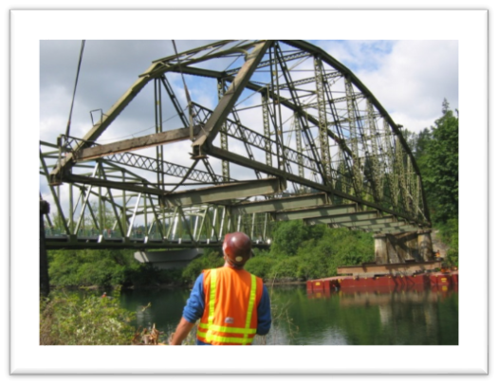
Bridges and structures are key components of the County road network, providing routes over bodies of water, roads, lowlands, railroad tracks, or other obstacles. Structures enable County roads to exist in diverse landscapes by controlling and shaping the natural environment and providing protection from environmental impacts such as flooding, tides, waves, storm surges, or landslides. Types of roadway structures include: seawalls, retaining walls, and mechanically stabilized earth walls.

2.5.a Bridge Program
King County Road Services Division owns and maintains 182 bridges in the unincorporated area of King County. Built over many generations, these bridges are made of concrete, steel, timber, or a combination of the three building materials. King County’s bridge inventory includes long span bridges (those over 20 feet in span length, which appear on the national bridge inventory), short span bridges, safety enhancement bridges that keep wildlife off roadways, and pedestrian bridges.
The Bridge Program employs an integrated and comprehensive strategy to maintain and preserve the county’s bridges and the continuity of the roadway network. Primary bridge program goals include:
- Keep bridges open and safe for public use.
- Preserve bridge infrastructure by maximizing its useful life through active maintenance, repair, load upgrades or rehabilitation.
- When possible, replace existing bridges with reliable new structures when repair, load upgrades or rehabilitation is not feasible.
Essential to meeting these goals is having a well-documented inspection program coupled with a robust bridge preservation program to maximize the useful life of the inventory. Once preservation is no longer an option, it becomes necessary to close or replace bridges. Management challenges for the County’s bridge inventory include:
- Bridges are aging beyond their useful life and exceeding their theoretical design life
- Traffic volumes are continuing to grow
- Type and size of highway trucks are changing, resulting in more concentrated loading on bridges
- Costs to replace bridges are increasing
The County’s bridges range in age from less than 10 years to over 100 years in age and many are failing. The average age of the bridge inventory is 50 years old. At the end of 2018, there were 75 bridges beyond their expected useful life. The issue is particularly pronounced with timber bridges, which make up about one-third of the inventory. Although timber bridges have a typical useful life of 50 years, the average age of the County’s inventory is 67 years old. The issue of the aging inventory is compounded by the steep revenue decline over the last six years. Figure 3 summarizes the number of King County vehicle bridges built by decade.
Figure 3. Number of King County vehicle bridges built by decade (2018 King County Annual Bridge Report)

King County Roads prepares an Annual Bridge Report to fulfill the requirements of Washington Administrative Code (WAC) 136-20-060. The annual report summarizes best available information about the county’s bridges and summary information regarding inspections, priority array for bridge replacement/rehabilitation, capital project status, and other maintenance/operations information.
The Annual Bridge Report includes an update to the County’s bridge priority ranking using criteria adopted by the King County Council in 1994 (Ordinance 11693). The bridge priority ranking is used to guide bridge replacement and rehabilitation decisions and is published annually as a supporting document to the Roads budget.

Bridge Inspections and Assessments
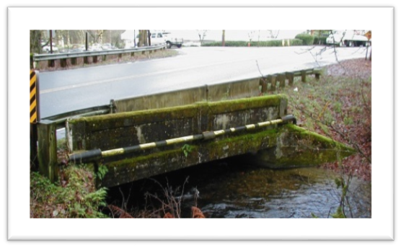
One facet of the County’s annual bridge ranking process includes bridge weight-carrying capacity information. There are 178 vehicular bridges in the County’s inventory and, as mandated, the county is evaluating each using current bridge-condition information and the new federal standards to calculate bridge weight-carrying capacity. The bridge load rating update program is underway with 71 ratings complete at year end 2018. Under the new criteria, almost 30 percent of those bridges have been posted with weight restrictions. Load rating analysis is due by the end of 2022 for another 105 bridges and the number of restricted bridges is expected to grow as more evaluations are completed.
Assessment of bridge needs begins with inspection of all County roadway bridges. Roads inspects and assesses its bridges regularly to ensure the safety of the traveling public. Inspection of all County roadway bridges occurs on a two-year cycle and aims to implement the National Bridge Inspection Standards by calculating a sufficiency rating for each bridge. The sufficiency rating is based on factors such as structural adequacy and safety, serviceability and functional obsolescence, and how essential the bridge is for public use. Sufficiency rating ranges from zero (worst) to 100 (best). The sufficiency rating score is used to establish eligibility for federal bridge replacement and rehabilitation funds. Bridges with a sufficiency rating less than 40 and classified as structurally deficient are eligible for replacement funds. Any bridge with a sufficiency rating less than 80 and classified as structurally deficient is eligible for rehabilitation funds.
Routinely inspected and maintained bridges and structures serve the public by ensuring that:
- Bridges are kept safe for public use.
- Structures are free of hazards.
- Roads remain open to travel.
- Crossing delays are minimized.
In Washington, the Washington State Department of Transportation Local Programs Division (WSDOT) allocates federal bridge funds to local agencies using a technical, competitive process. WSDOT focuses on funding local agency bridges that are classified as structurally deficient with a sufficiency rating less than 40 for replacement, and structurally deficient with a sufficiency rating of less than 80 for rehabilitation projects.
Though the sufficiency rating establishes eligibility for federal funding, it is inadequate to prioritize King County’s bridges for replacement or rehabilitation because the rating does not give enough emphasis to important criteria such as load limitations, hydraulics, geometric deficiency, and expected useful life. The King County Bridge Priority Process, updated annually and described earlier in this report section, establishes the need and priority for individual bridge replacement using a wider set of criteria approved by the King County Council (Ordinance 11693).
Minor maintenance, repair, and quick response activities are addressed by maintenance and operations. Larger projects are designated as stand-alone preservation projects or are addressed through preservation programs, including:
Bridge Preservation
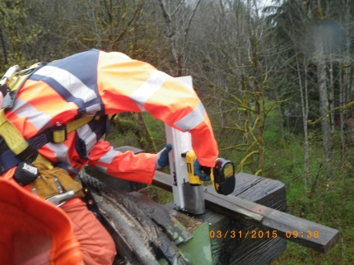
Includes bridge needs outside of routine operations. The intent of the program is to perform cost-effective projects to extend the useful life of the County’s bridges. The bridge preservation program includes the following work categories:
- Load upgrades
- Re-decks
- Painting
- Scour protection
- Seismic retrofits
- Bridge Priority Maintenance Repairs
Bridge Painting
King County has 22 bridges with painted steel components requiring future repainting, including trusses, steel girders and floor beams, plus secondary stabilizing members. Of these bridges, approximately one-third have lead paint that was applied prior to 1970. All lead paint must be properly removed prior to applying new paint, which necessitates a costly full lead containment and abatement system.
Bridge Inspection Program
All bridges are inspected at two-year intervals and the reports for bridges on the National Bridge Inventory are collected and reported to the Federal Highway Administration by the Washington State Department of Transportation. Some bridges require more frequent or special inspections when deterioration is being closely monitored. This work includes not only the labor, but also the equipment and contract services that sustain inspection activities.
Bridge Replacement
The 20-year projected need for bridge replacement includes 43 bridges selected by using three factors; the current bridge condition and projected remaining useful life based on the age of the bridge, the King County Council-approved criteria for bridge funding priority, and a review of candidate bridges by bridge technical subject matter experts and Roads management. The resultant list is the best current representation of the bridges that will be most in need of replacement over the next 20 years. The list includes both short-span and long-span bridges which includes the long-span bridges eligible for federal funding. These projects are included in the 2020 TNR Bridge Replacement Category.

2.5.b Structures Needed to Protect Vulnerable Road Segments
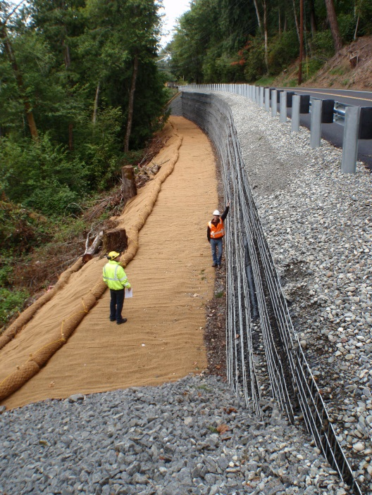
A subset of unincorporated King County roads have suffered repeated failures requiring expensive or frequent repairs following storm or prolonged rain events. In 2005 the Vulnerable Road Segments (VRS) study identified, quantified, and prioritized vulnerable road segments throughout the county and developed projects to resolve their vulnerability. The study developed a list of unstable slopes and other locations requiring frequent reactive maintenance. Sixty-three road segments were initially identified as candidates. Each of the road segments was grouped into one of six problem categories: steep slopes, landslide, seawall, river erosion, flood, and roadway settlement. These categories helped identify proposed solutions, possible environmental impacts, and cost estimates.
Each segment was then analyzed regarding:
- Traffic data
- Engineering assessment of the problem
- Estimated cost to remedy the problem
- Guardrail needs
- Roadway classification
- Detour length
General information was recorded for each road segment, including descriptions of the segment and its location. Recommendations for potential long-term fixes or continued maintenance were developed during this phase. The study prioritized projects based on:
- Maintenance Cost per Year: this is the average estimated amount of money spent each year repairing the road segment to its pre-damage condition (temporary repair). Those projects with higher annual maintenance costs were given a higher priority.
- Construction Cost per Vehicle: this factor divides the cost of the permanent construction fix by the average daily number of vehicles that travel the road. Projects with a lower cost benefitting a higher number of vehicles were given a higher priority.
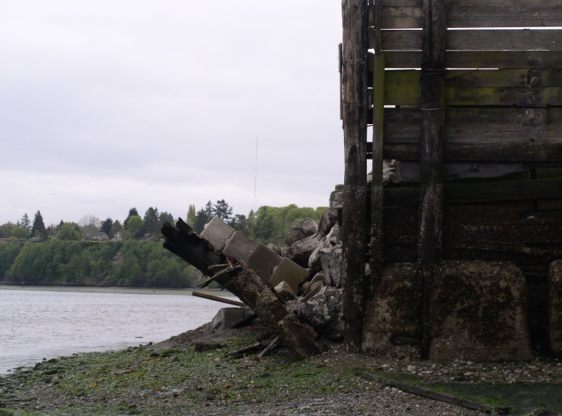
- Impact of Failure: this factor addressed the importance of correcting a vulnerable road segment. Scoring reflected the likelihood and extend of road failure and closure if the segment was left unaddressed beyond routine maintenance.
- Driver Inconvenience: this factor measured the overall level of driver inconvenience if a road segment was closed, taking in to consideration the detour length and traffic volume. Road segments involving longer detours with higher traffic volumes were given more priority.
- Inclusion in a Future Project: this factor gave priority to segments that were included in the Roads capital improvement program or Transportation Needs Report to account for the opportunity to address two needs with one project.
- Guardrail Need: this factor gave a higher priority to road segments slated for future guardrail improvements to account for the opportunity to address two needs with one project.
The team selected and refined the factors above through an iterative process, adjusting the scoring and factor weighting for reasonableness after each iteration. The final ranking process distributed the full numerical range of each factor across the segments and the factor weights resulted in a logical ranking.
Proposed permanent solutions to these vulnerabilities include:
- Constructing retaining walls to prevent slides on steep slopes above and below the roadway, stabilizing the slope and adjacent river banks
- Replacing seawalls to adequately support the road prism, protect the road from storm wave action, and eliminate routine road failures.
- Replacing undersized culverts with bridges to provide better conveyance of water, silt, and debris.
- Raising the roadway using walls or other armored structures (i.e. rip rap) to minimize flooding and erosion impacts to the roadway. Typically these projects require perforations in the armored walls to allow for the conveyance of water and the inclusion of guardrails.
- Armoring road shoulders with riprap or other hardened structures to prevent routine washouts during flood events.
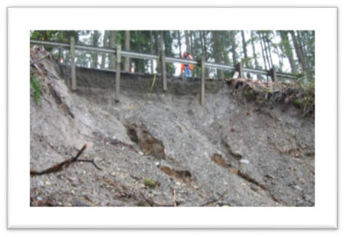
Projects were not proposed for some locations with low average daily traffic, difficulty in obtaining regulatory approvals, limited right-of-way, or sufficient minor repair or routine maintenance options. In 2011, the original study was reevaluated based on current conditions and three new road segments were added. In 2019 the vulnerable road segment list was reviewed with respect to best available information and as a result, eight additional vulnerable road segments were added to the list.
The 2020 TNR Vulnerable Road Segment category of needs includes the recommended projects from the 2005 VRS study and the 2011 and 2019 updates. This category also includes needs identified within the adopted six-year capital improvement program.

2.5.c Bridges and Structures – Maintenance and Operations
If bridges and road structures are not regularly inspected and maintained, they may become unsafe and require closures which can result in loss of access to property or longer travel times. If maintenance facilities do not supply the necessary tools to accomplish routine or emergency tasks, or are not situated in a location that provides efficient access to the surrounding road network, the public will experience inefficient and inconsistent service. To minimize these consequences and maximize the outcomes listed above, Roads employs programs that facilitate routine maintenance and repair of bridges and structures. These programs fall into the following categories:
- Minor bridge maintenance and repair: Includes work associated with the Maintenance Operations Program with routine bridge maintenance and repair such as small repairs, debris removal, surface cleaning, and graffiti removal. Routine inspections inform the need for the minor maintenance and repair of structures.
- Operations: Includes the resources needed to operate the County’s bascule (“moveable”) South Park Bridge, including funding for staff to raise the bridge for boat traffic.
- Quick response: Includes work associated with unexpected bridge and seawall failures.

2.6 Facilities
Roads has five regional maintenance facilities that provide routine maintenance and emergency services to the road system throughout the unincorporated area, including remote facilities on Vashon Island and in the Skykomish area near Stevens Pass. Roads also has a maintenance headquarters campus in Renton that provides the following: centralized maintenance and administration functions; regional maintenance facility; and specialized services like the materials lab, traffic sign and signal shops, and other specialty services and equipment used throughout the system. Another ten satellite maintenance sites are located throughout King County and are used for the stockpiling and storage of waste, supplementary equipment, snow and ice or other emergency response materials, and for project staging.
Many of the County’s existing road maintenance facilities are old and require significant capital improvements or have exceeded their useful lives and require replacement. Most are between 40 and 60 years old, with a few dating back to the early 1900s. As such, some do not meet current building standards or do not readily accommodate the needs of a modern workforce and equipment inventory. Some facilities have inadequate heat, insufficient restrooms, or failing septic systems. Some facilities have been plagued by leaking roofs, mold, or rodent infestations.
Maintenance activities keep the county’s road-related assets in working condition to maximize the public’s investment and provide for the safety of users. Some common maintenance activities include routine maintenance and repair of pavement, bridge components, ditches, culverts, shoulders, and guardrail, as well as vegetation management, debris removal, maintenance of traffic control devices and road striping. The existing conditions of Roads maintenance facilities compromise the agency’s ability to provide routine and emergency services.
The ability to respond to incidents and public emergencies 24 hours a day, seven days a week is critical to operating a road network. Emergency response capability keeps the road system safe and operational during severe weather and after earthquakes or other events. Examples of emergency response Roads activities include: responding to significant collisions that impede travel; winter storm response activities such as plowing, sanding and salting of the roads; removing downed trees and clearing other debris caused by landslides; managing flood-related or other types of emergency road closures; and completing storm-related repairs to roadways and other assets such as bridges, drainage systems, shoulders, and adjacent slopes. Adequate maintenance facilities located in the right places and kept in operational condition are necessary for the efficient provision of vital services to the traveling public. Investments in Roads maintenance facilities are necessary for continued delivery of essential safety and routine maintenance services.

2.6.a Assessment of current facilities
The Strategic Plan for Roads Services (2014 update) reflected an extensive evaluation of the division’s maintenance facilities. An outcome of this evaluation was an identified need to deliver maintenance services more efficiently, consolidate facilities, and to complete priority facility repairs. Roads maintenance facilities were evaluated according to its physical condition, location suitability, and functional/operation sufficiency.
Physical Condition. To establish a baseline and get a comprehensive understanding of the condition of its existing maintenance facilities, buildings and properties were assessed and site specific capital needs with cost estimates were generated.
Location Suitability. The location of each maintenance facility was assessed using a set of criteria that considered travel time, size, land use issues, and other contextual factors. As the unincorporated service area has changed significantly with annexations and incorporations over the past two decades, a number of facilities are no longer sited in the best locations to serve the core unincorporated service areas. In addition, facilities sites have certain size, land use, zoning, environmental and other requirements. Because Roads facilities have been sited, acquired, and developed ad hoc over a very long period of time, many current facilities have issues related to their location (e.g., the Fall City site is located in the Snoqualmie River floodplain). In order to deliver the most service possible with limited resources and to be able to respond to emergencies, crews need to be located central to their maintenance districts.
Functional/Operational Deficiencies. Each facility’s functional and operational deficiencies were assessed to evaluate: covered and heated bays for vehicle and equipment storage; covered sand and bulk salt storage for snow and ice operation; and adequate, safe administrative and crew facilities.
The facility planning and assessment effort identified the following types of facility needs:
- Exploration of facility co-location opportunities with WSDOT
- Construction, relocation, and/or expansion of permanent facilities
- Enhancement of two emergency response satellite facilities
- Major renovation of existing facilities
- High priority maintenance, repair, or installation of septic systems, fencing, doors and windows, HVAC systems, roofs, and interior improvements such as electrical and plumbing systems.
In 2017, the King County Road Services Regional Maintenance Facility Siting Assessment identified candidate site alternatives for two maintenance facilities: Vashon and Cadman. Consistent with county financial policies, Roads intends to use the proceeds of future property sales to fund facility replacement activities.
The Vashon Island facility is very old, significantly undersized, and the facilities are failing. There are a limited number of suitable land parcels on Vashon Island in terms of size, location, allowable zoning, and site conditions. Roads has prioritized advancing the acquisition of one of these sites, from the few identified as viable in the 2017 siting assessment study, before there are no options left for replacing the failing Vashon maintenance facilities.
The location of the Cadman facility, in northeast King County, does note best serve current and future operational needs. Roads has proposed to acquire land and construct a new, centrally located maintenance facility, to better serve northeastern King County, replacing the existing Cadman facility that is currently mislocated within the City of Redmond.

2.6.b Facility Maintenance and Operations
The needs associated with efficiently maintaining and operating facilities include, but are not limited to: yard maintenance, cleaning, utility service, building security, carpentry, electrical repair, painting, fence repair, machinery service, structural repairs, and plumbing.

Chapter 3. Transportation Modeling
The Transportation Needs Report (TNR) is informed by a regional travel forecasting model that is maintained by the Puget Sound Regional Council (PSRC). The PSRC model is trip-based and reflects a system of mathematical and statistical processes that estimate daily travel patterns within the Puget Sound region. This regional model uses existing traffic, population, employment, trip rates, and other data to develop a traffic demand model for a base year, then uses forecast population, employment, and other data to estimate future traffic. These forecasts are used to understand demand versus capacity (level of service), and to meet other policy, planning, and engineering needs. For additional information regarding PSRC’s regional model, please visit the PSRC website https://www.psrc.org/trip-based-travel-model-4k.
King County Roads collaborates closely with PSRC and makes use of the regional transportation model to ensure regional planning consistency with the TNR. The regional model also satisfies the following requirements of the Growth Management Act (RCW 36.70A.070(6)(a)):
- Traffic forecasts of 10 years or more: the model forecasts to 2031, 11 years from the expected adoption of the TNR in 2020.
- Land use assumptions: the model incorporates regionally-adopted household, population and employment data.
- Intergovernmental coordination: the model incorporates growth targets agreed to by a coalition of King County jurisdictions.
- Estimated traffic impacts to state-owned facilities: projected travel on state facilities was included in the sufficiency analysis.
- Consistency of plans: PSRC solicited input from member jurisdictions in the development of the travel model, including forecast land use and road improvement assumptions.

The 2020 TNR was prepared using best available information, including findings from the PSRC regional model.

Chapter 4. Drivers of Change Affecting Transportation in Unincorporated King County

4.1 Puget Sound Regional Demographic and Employment Trends
The most powerful indicators of how people travel are where they live and work. The Puget Sound region is expected to continue to grow jobs and urbanize, creating more demands on an already burdened transportation system. New forecasts from the Puget Sound Regional Council (PSRC) indicate population in the region is expected to reach about 5.8 million people by 2050, a nearly 50 percent increase from 2018. This substantial increase in population will create a need for more housing, employment and services and in turn will create significant impacts to existing roads, travel patterns and demands.

The Puget Sound region’s current transportation system reflects and is guided by land use patterns developed through decades of growth. As the region continues to grow, its demographic profile will further evolve and change over time. Future transportation system users will be older (on average), and be more ethnically and racially diverse. As jobs increasingly locate into large city centers, transit and nonmotorized modes will become increasingly important. The region is and will remain relatively affluent, with higher wages led by workers in information, technical, and management sectors, historically located in a few urban areas. Their willingness to pay for transportation choices that they value remains high, as evidenced by voter support for the 2016 Sound Transit 3 levy and the 2015 Move Seattle levy. In contrast, lower income populations will face increasing economic challenges as housing, transportation, and other living costs continue to escalate.

Increasing public preferences for living in compact, walkable neighborhoods may encourage increased density in the County’s urban core, yet high housing demand, affordability issues, and low inventory often force residents to move farther from their jobs, thereby increasing reliance on single-occupancy vehicles and road congestion. The Washington State Growth Management Act (GMA) and its implementation in King County has produced intended and unintended consequences related to transportation and road congestion. Urban centers have and will continue to experience intended densities with improved access to multi-modal transportation systems, while rural unincorporated King County areas have experienced increased road congestion due to travel to and from urban centers.

4.2 Puget Sound Transportation Trends
In 2017, most trips in the region were by car (81%). While this represents a decrease since 1999 (86%), single-occupancy vehicle travel will likely continue to be an important mode choice, particularly in the rural areas, where the lack of density and scarcity of funding makes mass transit service impractical. Average trip distance across all types of trips has remained relatively constant for all modes of travel.

As with overall travel, driving remains the primary travel mode for commuting, despite a reduction from 2010 to 2017 (85% vs. 83% of commute trips). Average commute trip length for those driving alone reached a high of 12.2 miles in 2014 before falling to 10.2 miles in 2017, while commute trip lengths for transit fell to a low of 13.6 miles in 2014 before reaching 15.2 miles in 2017. Average commute duration hovered around ½-hour for single-occupancy vehicle travel and one hour for transit between 1999 and 2017. However, the share of King County commuters with a travel time greater than one hour has increased (7% in 2010 vs. 13% in 2017), and the share of those with a travel time less than ten minutes has decreased (10% in 2010 vs. 7% in 2017). These statistics point to growing congestion and delays on the region’s transportation system.

Transit use is likely to play an increasingly large role in urban and suburban travel. Annual transit boardings increased every year between 2010 and 2017, reaching over 200 million boardings in 2017. Annual boardings are forecast to reach nearly 500 million in 2040, when 80% of the region’s population is expected to be within a ten-minute walk of transit.

Roadway tolling of state route highways may play a role in shaping regional housing and employment trends. The PSRC Regional Transportation Plan sets broad direction for a regional tolling system and other user fees to raise critical funding for transportation investments and to reduce peak-period demand on the transportation system. The Washington State Department of Transportation has already implemented tolls on SR 520, I-405, and SR 167, plans for additional tolling on I-405 and SR 99 in the future, and will likely finance major highway capacity projects at least partially through tolls. Additionally, the Washington State Transportation Commission is currently analyzing the results of a pilot program to measure and charge drivers for road use. Results of this state legislature-mandated study are due in 2020.

Future gas prices may also encourage location of housing near employment. The second highest expense for a typical U.S. household is transportation. Gasoline prices are always unpredictable and volatile, mirroring crude oil prices which are determined in the global crude oil market by the worldwide demand for and supply of crude oil. As of January 2019, Washington State’s gas price ($3.01 per gallon) and gas tax (49.4 cents per gallon state tax plus 18.4 cents per gallon federal tax) were both third highest in the nation.

4.3 Transportation Trends in Unincorporated King County
Unincorporated King County’s nearly 1,500 mile road network supports more than one million trips per day with people across the region traveling to work, school, and other destinations. Decades of annexations, limited sales tax revenues, flat/declining gas taxes, and the effects of voter initiatives have contributed to the decline of revenues needed to maintain the road system. King County Roads has an unsustainable financial model with insufficient revenue to support the preservation of unincorporated road and bridge infrastructure or address capacity and congestion.

The majority of King County’s population, development, and employment growth has been within the Urban Growth Area, not within unincorporated King County. Following adoption of King County’s first Comprehensive Plan in 1994, the percent of growth in rural areas has generally declined each year and this growth trend is expected to continue. The combined population of all small cities and towns is just 5.4% of the county total. With the majority of people and jobs located within the urban growth area, there are few employment options in the County’s rural area and many rural residents drive long distances to urban employment centers. The PSRC estimates that close to 92% of employed residents outside the contiguous urban growth boundary (those in unincorporated rural areas, freestanding cities and towns, tribal reservations, military installations, etc.) travel to jobs inside the Urban Growth Boundary, and they travel about twice as far, with an average commute of 22 miles.

Unless changes are made to the state and regional transportation funding allocation process, federal, state and local transportation investments will continue to be focused within King County’s Urban Growth Boundary, serving the densest residential and employment centers. Allocated transportation funding in support of improved local and regional transit will benefit urban portions of unincorporated King County, while more geographically dispersed populations of unincorporated rural King County will continue to receive fewer transit and multi-modal investments. King County Metro is developing innovative and cost-efficient transit service delivery options, such as reservation-based or flexible route shuttles, community vans, real-time ridesharing, and partnerships with taxi and transportation network companies in areas that don’t have the infrastructure, density, or land use to support regular, fixed-route bus service. In spite of these efforts, limited transit service within rural unincorporated King County will continue to result in many unincorporated King County residents relying on their personal vehicles for transport to work and other destinations. Additionally, demand and usage of unincorporated roads by residents of incorporated areas and other counties will likely continue to increase.

The policies set forth within Washington State’s Growth Management Act have successfully created public benefits such as protected parks, farm land and open spaces by focusing growth within designated cities and urban areas. However, this has created regional traffic demand on the unincorporated road network without commensurate funding. Funding availability for unincorporated King County roads has decreased dramatically as a direct outcome from annexations and associated reductions in property and sales tax contributions to the King County Road Fund. Yet, traffic volumes and use of the unincorporated King County road system has increased over time and portions of the network experience extreme congestion because road capacity has been exceeded. Additionally, a large number of facilities have reached the end of their useful life, requiring complete replacement or reconstruction. Insufficient funding has resulted in a backlog of road and bridge projects and portions of the system are imminently faced with closure if unmet Roads funding needs are not addressed. This issue is regional and King County Roads will continue to work with residents, cities, Washington State and other partners to achieve scaled-up, regional funding solutions.

Chapter 5. TNR Project Needs and Cost Analysis
The 2020 Transportation Needs Report represents King County’s contemporary thinking regarding transportation needs across its system of unincorporated roads and bridges. The underlying approaches taken to identify needs and evaluate road and bridge assets are summarized within Chapter 2 of this report. This chapter provides the cost analysis associated with the 419 identified transportation project needs, organized using nine TNR categories:
- Capacity-Major: Capacity projects increase the size of the road to improve its ability to safely accommodate higher traffic volumes.
- Bridge: Vehicular and pedestrian bridge projects include design, compliance and construction to improve safety and asset conditions of the county’s bridges.
- Reconstruction: Road reconstruction projects improve safety and typically involve full removal and replacement of the surface layer, road base and related road infrastructure, such as drainage and guardrails.
- Nonmotorized: Safety improvements to benefit people walking, biking, or participating in other active recreation activities. Sidewalk construction or shoulder widening/paving are common nonmotorized projects.
- Intersection and Traffic Safety Operations (INT-TSO): Projects typically incorporate one or more traffic safety measures, such as sightline improvements, traffic signals, re-channelization (“striping”) and roundabouts.
- Vulnerable Road Segments (VRS): Roads frequently impacted by flooding, tides, wave action, storm surges or slides are often protected through infrastructure, such as: seawalls, armored slopes and retaining walls.
- Drainage: Projects that preserve the integrity of the road and improve safety by moving water away from the road. Projects typically improve infrastructure such as culverts, ditches, catch basins and drainage systems.
- Intelligent Transportation Systems (ITS): Projects that advance safety and mobility by integrating communications technologies, such as of cameras, vehicle detection, traffic signal equipment and timing upgrades into transportation infrastructure.
- Guardrail: Guardrail projects to improve safety by reducing the severity of run-off-the-road collisions.
Together the total cost estimates for Capacity, Reconstruction, and Bridge projects account for over half of the total cost of the TNR Project Needs List (see Figures 4 and 5). This is due to the significantly higher cost of engineering, materials, labor, environmental permitting and right-of-way that goes into rebuilding and widening roads and replacing bridges compared to relatively smaller-scale projects associated with other TNR categories. Figure 6 summarizes the average project cost by TNR category and reveals similar cost patterns. For example, the average Capacity-Major project costs over five times the average TNR project cost.
Figure 4. 2020 TNR summary of costs, by category
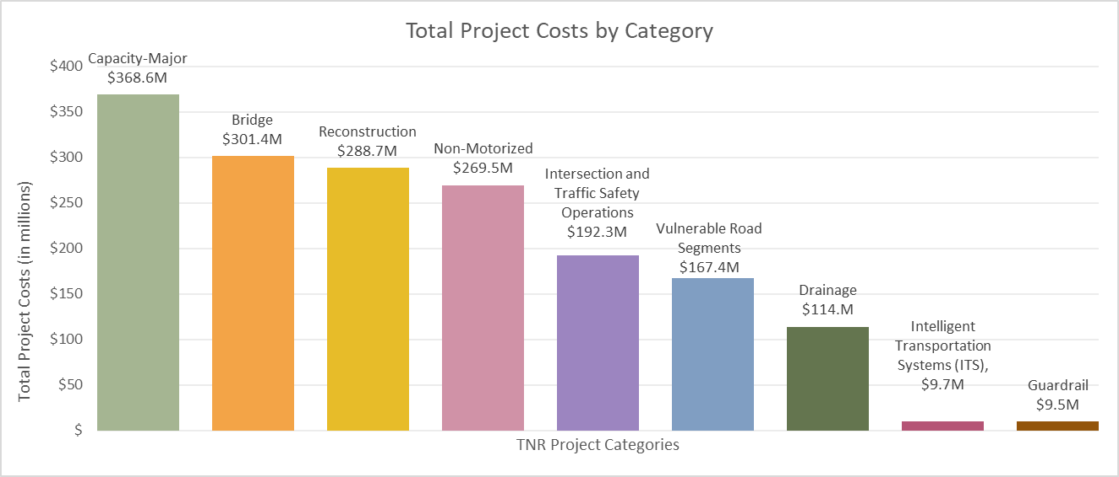
Figure 5. 2020 TNR percentage of total cost, by category
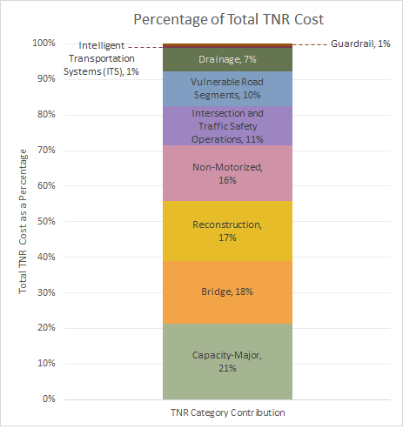
Figure 6. Average project cost, by category
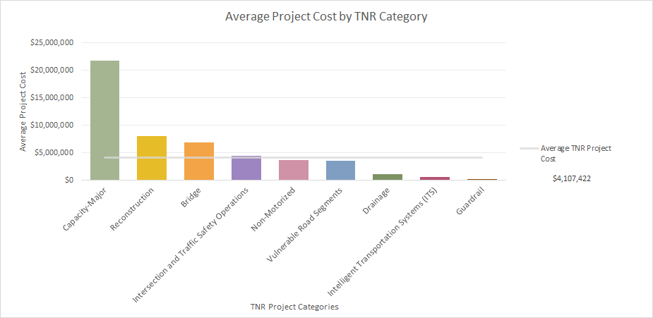

Chapter 6. Financial Analysis
A financial analysis was completed to compare the estimated costs, over twenty years, of projected transportation needs to Roads’ anticipated revenue. Planning level cost estimates were generated for each of the 419 transportation needs identified within the 2020 Transportation Needs Report (TNR). Cost estimating in support of the 2020 TNR reflects contemporary estimation methods, market rates and best available information. Table 5 summarizes these estimated costs across nine thematic TNR needs categories. The total estimated cost associated with the identified needs exceeds $1.7 billion.

Table 5. 2020 TNR Financial Summary of Estimated Cost
2020 TNR Category | # of  2020 TNR Projects | 2020 Estimated  TNR Costs
Capacity-Major | 17 | $368,600,000
Bridge | 44 | $301,390,000
Reconstruction | 36 | $288,680,000
Nonmotorized | 73 | $269,460,000
Intersection and Traffic Safety Operations (INT-TSO) | 43 | $192,260,000
Vulnerable Road Segments (VRS) | 47 | $167,430,000
Drainage | 99 | $113,980,000
intelligent Transportation Systems (ITS) | 16 | $9,700,000
Guardrail | 44 | $9,510,000
Total Estimated 2020 TNR Cost | 419 | $1,721,010,000

King County continues to experience a road funding crisis as a result of a structural gap. This is a result of a rural tax base supporting a local and a regional system, municipal annexations reducing the tax payer base, the 2008 recession, voter initiatives limiting property tax growth, and an aging bridge and road system. The lack of sufficient revenue is significantly impacting the County’s ability to maintain and improve roads. It has been more than a decade since a project adding new capacity to the system has been funded, and preservation projects have been limited to or associated with one-time funding. The approved six-year capital improvement program has significantly diminished from past years and is focused on addressing deterioration rather than planned preservation and maintenance. The 2020 TNR was prepared with this funding crisis as a backdrop.

This structural gap between revenues and expenditures has resulted in insufficient funds for a full preservation program or timely replacement of infrastructure. Available revenues are focused on reacting to the higher risks associated with the deteriorating road system. Expenditures are increasing at a greater rate than the growth of revenue. The increasing cost of current service levels without a commensurate increase in revenues directly impacts Roads capital and maintenance programs. By 2024, if no sustainable revenue source is identified, the Road Fund contributions to the Roads capital program will end. Figure 7 summarizes the effect of the loss of this revenue source from 2024 onward, which includes a dramatically reduced capital program and a reduction in operating programs.

Figure 7. Decline in Roads CIP Contribution and Future Operating Reduction

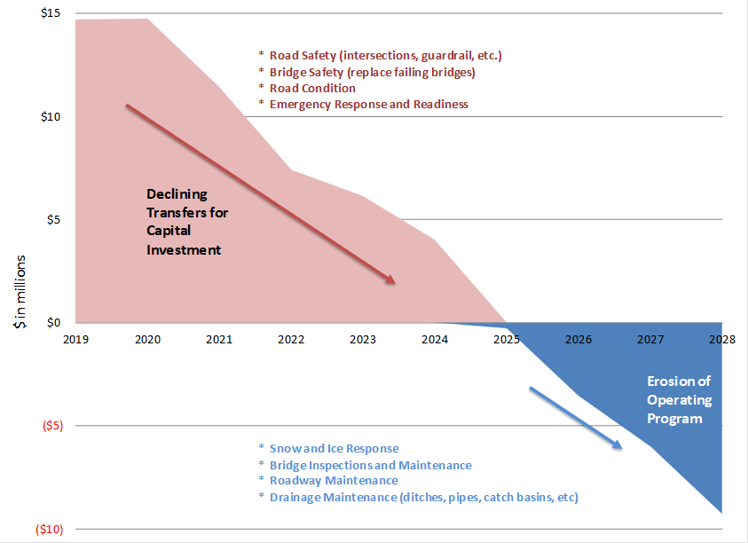

Primary revenue sources for Roads capital projects include the Road Fund contribution, as well as state and federal grants. A portion of the Roads capital program is also funded through other agencies and their revenue sources, such as the Surface Water Management Fee, which funds certain agreed upon drainage projects, and grants from the Flood Control District. Across these revenue sources, approximately $172 million is forecast to be available to fund 2020 TNR identified needs over a twenty-year period, which translates to an overall funding shortfall of approximately $1.5 billion (Table 6).

Table 6. 2020 TNR Funding Shortfall
Item | Amount
Total estimated 2020 TNR Cost | $1,721,010,000
Projected Revenue (2020-2039 forecast) that is available to fund TNR Needs | $172,705,000
Funding Shortfall Associated w/the 2020 TNR | $1,548,305,000

Of the available TNR revenues to fund needs identified within the 2020 TNR, over $77 million in needs are funded through the Roads adopted 2019-2024 six-year capital program using Road’s funding sources, including 30-year bonds backed by the Roads Fund for bridge replacement projects. In addition, it is anticipated that non-Road Fund revenue sources will fund approximately $95 million of 2020 TNR identified needs through 2039 (Table 7).

Table 7. Funded 2020 TNR Needs, 2020-2039

TNR Category | Funded 2020 TNR Needs (2020-2024) | Anticipated 2020 TNR Investments  (2025-2039) | Totals, by category
Capacity -- Major | $ 0 | $ 0 | $ 0
Bridge | $ 35,544,000 | $31,571,000 | $ 67,115,000
Reconstruction | $ 5,094,000 | $ 0 | $5,094,000
Nonmotorized | $361,000 | $ 0 | $361,000
Intersection and Traffic Safety Operations | $ 8,910,000 | $15,000,000 | $23,910,000
Vulnerable Road Segments | $ 9,710,000 | $ 0 | $ 9,710,000
Drainage | $16,571,000 | $48,644,000 | $65,215,000
Intelligent Transportation Systems | $ 0 | $ 0 | $ 0
Guardrail | $ 1,300,000 | $ 0 | $ 1,300,000
Total Funded TNR Needs (2020-2025) | $77,490,000 | $95,215,000 | $172,705,000

Appendix A. 2020 Transportation Needs Report Project Lists
The 2020 Transportation Needs Report (TNR) contains a project list that is comprised of 419 project needs. Individual project needs are organized geographically, using tables (Appendix A) and maps (Appendix B). The 2020 TNR contains 22 maps, each map is named and each map table contained within Appendix A correlates to a map included within Appendix B.
Each TNR project list table contained within Appendix A provides the following information for each identified TNR need:
- TNR Project Number. The TNR project number is a unique identifier for the 2020 TNR. TNR project numbers are contained on the related TNR map, in Appendix B, proximate to the project location.
- TNR Category. Each TNR project need is categorized using one of nine 2020 TNR categories
  - Capacity-Major
  - Bridge
  - Reconstruction
  - Nonmotorized
  - Intersection and Traffic Safety Operations (INT-TSO)
  - Vulnerable Road Segments (VRS)
  - Drainage
  - Intelligent Transportation Systems (ITS)
  - Guardrail
- Location. Each TNR project need is geo-located, using the nearest intersection or street address.
- Project Scope. A high level, preliminary scope is identified for each TNR project need. Scope information is highly conceptual.
- Estimated Cost. A planning level cost estimate is provided for each identified 2020 TNR project need. Estimates reflect best available unit costs, market rate and other contemporary approaches to generating planning level cost estimates.
- Community Service Area. Unincorporated King County is divided into seven Community Service Areas (CSA). The related CSA is identified for each 2020 TNR project need.

Map Number 1: North Vashon
TNR Project Number | TNR Category | Location | Scope | Estimated Cost | Community Service Area
DR-8 | Drainage | SW 171st St & 93rd Ave SW (Gorsuch Creek) | Replace/construct drainage infrastructure | $ 300,000 | Vashon/Maury Island
DR-20-19 | Drainage | Beall Rd SW at SW 188 St | Replace/construct drainage infrastructure | $ 2,700,000 | Vashon/Maury Island
DR-20-20 | Drainage | SW 156 St E of Vashon Hwy SW | Replace/construct drainage infrastructure | $ 1,170,000 | Vashon/Maury Island
DR-20-67 | Drainage | 11010 SW Cemetery Rd | Replace/construct drainage infrastructure | $ 1,200,000 | Vashon/Maury Island
NM-15-9 | Nonmotorized | SE Cemetery Rd/ Beall Rd SW: From 107th Ave SW to SW 184th St | Provide nonmotorized facility | $ 7,670,000 | Vashon/Maury Island
NM-0106 | Nonmotorized | SW Bank Rd: From 97 Pl SW to Beall Rd SW | Provide nonmotorized facility | $ 580,000 | Vashon/Maury Island
NM-0203 | Nonmotorized | SW 177th St/98th Pl SW: Vashon Hwy SW to SW Bank Rd, Vashon Hwy SW north of SE SW 177th St, SW Bank Road: Vashon Hwy SW to 98th Pl SW | Provide nonmotorized facility | $ 480,000 | Vashon/Maury Island
NM-5054 | Nonmotorized | SW Bank Rd: From 107th Ave SW to Vashon Hwy SW | Provide nonmotorized facility | $ 5,150,000 | Vashon/Maury Island
RC-56 | Vulnerable Road Segments | Westside Highway SW: From Crescent Dr SW to McIntyre Rd SW | Reconstruct roadway | $ 620,000 | Vashon/Maury Island
RC-58 | Vulnerable Road Segments | Crescent Dr SW: From Westside Highway SW to SW Cove Road | Reconstruct roadway | $ 780,000 | Vashon/Maury Island

Map Number 2: South Vashon
TNR Project Number | TNR Category | Location | Scope | Estimated Cost | Community Service Area
DR-15-13 | Drainage | Chautauqua Beach Rd SW & Ellisport Creek | Pipe replacement, seawall removal, contaminated solid removal | $ 2,000,000 | Vashon/Maury Island
DR-20-18 | Drainage | SW 232 St at Old Mill Rd SW | Replace/construct drainage infrastructure | $ 3,780,000 | Vashon/Maury Island
DR-20-49 | Drainage | 23737 Old Mill Rd SW | Replace/construct drainage infrastructure | $ 2,250,000 | Vashon/Maury Island
GR-15-40 | Guardrail | Dockton Rd SW: From SW Ellisport Rd to SW 222nd St | Construct guardrail along seawall | $ 760,000 | Vashon/Maury Island
GR-15-41 | Guardrail | Vashon Hwy SW Seawall: From SW 240th Pl to 115th Ave SW | Construct guardrail along seawall | $ 640,000 | Vashon/Maury Island
GR-15-42 | Guardrail | SW Quartermaster Dr: From Monument Rd SW to Dockton Rd SW | Construct guardrail along seawall | $ 370,000 | Vashon/Maury Island
NM-9975 | Nonmotorized | SW Tahlequah Rd near Tahlequah Ferry Dock | Provide nonmotorized facility | $ 130,000 | Vashon/Maury Island
RC-10 | Vulnerable Road Segments | Dockton Rd SW: From SW Ellisport Road to Portage Way SW | Replace seawall | $ 42,410,000 | Vashon/Maury Island
RC-15 | Vulnerable Road Segments | Vashon Hwy SW: From 115th Ave SW to SW 240th Pl | Replace seawall | $ 21,150,000 | Vashon/Maury Island
RC-54 | Vulnerable Road Segments | SW Governors Lane: From 99th Ave SW to 96th Ave SW | Replace seawall | $ 3,780,000 | Vashon/Maury Island
RC-59 | Vulnerable Road Segments | Kingsbury Rd SW: From SW 234th St to 80th Ave SW | Reconstruct roadway | $ 780,000 | Vashon/Maury Island
VRS-20-11 | Vulnerable Road Segments | SW Quartermaster Drive | Rebuild seawall and raise road | $ 6,000,000 | Vashon/Maury Island

Map Number 3: White Center/Skyway
TNR Project Number | TNR Category | Location | Scope | Estimated Cost |  | Community Service Area
OP-RD-12 | Capacity-Major | 8th Ave S: From Seattle city limits to Burien city limits (S 112th St) | Construct congestion relief measures | $ 11,500,000 |  | West King County Areas
OP-RD-14 | Capacity-Major | 6th Ave S: From Myers Way S to 5th Ave S | Construct congestion relief measures | $ 4,400,000 |  | West King County Areas
DR-6 | Drainage | 60th Ave S/S Langston Rd: From S 129th St to S 124th St | Replace/construct drainage infrastructure | $ 3,000,000 |  | West King County Areas
DR-15-5 | Drainage | S 96th St: From 4th Ave S to 10th Ave S | Replace/construct drainage infrastructure | $ 550,000 |  | West King County Areas
DR-15-6 | Drainage | S 96th St: From 4th Ave S to 10th Ave S | Replace/construct drainage infrastructure | $ 3,290,000 |  | West King County Areas
DR-20-21 | Drainage | SW 108 St at 10 AVE SW | Replace/construct drainage infrastructure | $ 600,000 |  | West King County Areas
DR-20-23 | Drainage | S 120 St at 75 AVE S | Replace/construct drainage infrastructure | $ 150,000 |  | West King County Areas
DR-20-29 | Drainage | S Langston Rd at 132 AVE SE | Replace/construct drainage infrastructure | $ 450,000 |  | West King County Areas
INT-TSO-20-12 | Intersection and Traffic Safety Operations | 64th Ave S & S 129th St | Intersection improvement | $ 4,800,000 |  | West King County Areas
INT-TSO-20-14 | Intersection and Traffic Safety Operations | Meyers Way S & 6th Ave S | Intersection improvement | $ 2,100,000 |  | West King County Areas
ITS-12 | Intelligent Transportation Systems (ITS) | Renton Ave S: From Seattle city limits (S 112th St) to Renton city limits (S 130th St) | Cameras, vehicle detection, sync signals, fiber | $ 250,000 |  | West King County Areas
IPA-35 | Nonmotorized | Renton Ave S: From 74th Ave S to 75th Ave S | Provide nonmotorized facility |  | $ 910,000 | West King County Areas
IPA-36 | Nonmotorized | Renton Ave S: From 76th Ave S to 78th Ave S | Provide nonmotorized facility |  | $ 300,000 | West King County Areas
IPA-37 | Nonmotorized | S 114th St: From Cornell Ave S to 80th Ave S | Provide nonmotorized facility |  | $ 1,320,000 | West King County Areas
IPA-38 | Nonmotorized | S 126th St: From 76th Ave S to 78th Ave S | Provide nonmotorized facility |  | $ 260,000 | West King County Areas
NM-0004 | Nonmotorized | 76th Ave S: S 114th St to S 116th St | Provide nonmotorized facility |  | $ 550,000 | West King County Areas
NM-15-1 | Nonmotorized | S Langston Rd: From 64th Ave S to S 132nd St | Provide nonmotorized facility |  | $ 4,050,000 | West King County Areas
NM-15-2 | Nonmotorized | S 132nd St: From S Langston Rd to S 133rd St | Provide nonmotorized facility |  | $ 1,280,000 | West King County Areas
NM-15-3 | Nonmotorized | S 120th St: From Beacon Ave S to 68th Ave S | Provide nonmotorized facility |  | $ 2,200,000 | West King County Areas
NM-15-4 | Nonmotorized | S 133rd St: From State Route 900 to S 132nd St | Provide nonmotorized facility |  | $ 9,110,000 | West King County Areas
NM-15-5 | Nonmotorized | 84th Ave S: From Rainier Ave S to S 124th St | Provide nonmotorized facility |  | $ 12,730,000 | West King County Areas
NM-15-6 | Nonmotorized | S 120th Pl: From 68th Ave S to Skyway Park | Provide nonmotorized facility |  | $ 890,000 | West King County Areas
NM-15-7 | Nonmotorized | S 123rd St: From S 125th St to S 124th St | Provide nonmotorized facility |  | $ 1,390,000 | West King County Areas
NM-15-8 | Nonmotorized | 81st Pl S/S 124th St: From SE side of middle school to 84th Ave S | Provide nonmotorized facility |  | $ 1,450,000 | West King County Areas
NM-15-10 | Nonmotorized | 14th Ave SW: SW 110th St to SW 114th St | Provide nonmotorized facility |  | $ 620,000 | West King County Areas
NM-20-6 | Nonmotorized | 8th Ave S: S 105th St to S 100th St | Provide nonmotorized facility |  | $ 1,010,000 | West King County Areas
NM-20-18 | Nonmotorized | Renton Avenue S between 68th Avenue S and Seattle City Limits (S 112th Street) | Provide nonmotorized facility |  | $ 3,740,000 | West King County Areas
NM-20-22 | Nonmotorized | S Langston Rd between S 132nd St and 76th Avenue S | Provide nonmotorized facility |  | $ 880,000 | West King County Areas
NM-20-23 | Nonmotorized | 69th Avenue S/S 125th Street between S 128th Street and 70th Avenue S | Provide nonmotorized facility |  | $ 400,000 | West King County Areas
NM-0302 | Nonmotorized | 1st Ave SW: From SW 108th St to SW 112th St | Provide nonmotorized facility |  | $ 920,000 | West King County Areas
NM-4012 | Nonmotorized | 80th Ave S: From S 114th St to S 118th St | Provide nonmotorized facility |  | $ 320,000 | West King County Areas
NM-4077 | Nonmotorized | SW 112th St: From 16th Ave SW to 10th Ave SW | Provide nonmotorized facility |  | $ 1,760,000 | West King County Areas
NM-5018 | Nonmotorized | SW 104th St: From 15th Ave SW to 17th Ave SW | Provide nonmotorized facility |  | $ 1,780,000 | West King County Areas
NM-5020 | Nonmotorized | 8th Ave SW: From SW 108th St to SW 100th St | Provide nonmotorized facility |  | $ 3,910,000 | West King County Areas
NM-5021 | Nonmotorized | 76th Ave S: From S 124th St to S 128th St | Provide nonmotorized facility |  | $ 760,000 | West King County Areas
NM-9920 | Nonmotorized | 28th Ave SW: From SW Roxbury St to SW 102nd St | Provide nonmotorized facility |  | $ 330,000 | West King County Areas
NM-9922 | Nonmotorized | SW 112th St: From 16th Ave SW to 26th Ave SW | Provide nonmotorized facility |  | $ 890,000 | West King County Areas
NM-9930 | Nonmotorized | SW 112th St: From 1st Ave S to 4th Ave SW | Provide nonmotorized facility |  | $ 1,120,000 | West King County Areas
NM-9936 | Nonmotorized | 75th Ave S / S 122nd St: From Renton Ave S to 80th Ave S | Provide nonmotorized facility |  | $ 810,000 | West King County Areas
NM-9937 | Nonmotorized | S 120th St: From 76th Ave S to 80th Ave S | Provide nonmotorized facility |  | $ 570,000 | West King County Areas
NM-9938 | Nonmotorized | 78th Ave S: From S 120th St to S 124th St | Provide nonmotorized facility |  | $ 1,430,000 | West King County Areas
NM-9939 | Nonmotorized | 76th Ave S: From S 120th St to S 124th St | Provide nonmotorized facility |  | $ 570,000 | West King County Areas
RC-41 | Vulnerable Road Segments | 68th Ave S: From State Route 900 to Renton city limits | Construct retaining wall |  | $ 2,950,000 | West King County Areas

Map Number 4: Kent/Des Moines
TNR Project Number | TNR Category | Location | Scope | Estimated Cost | Community Service Area
BR-3108 | Bridge | Soos Creek Bridge: 148th Ave SE at Soos Creek, about 0.2 mile north of SE 240th | Replace bridge | $ 2,460,000 | West King County Areas
BR-3109A | Bridge | Soos Creek Bridge: SE 216th St at Big Soos Creek, about 0.3 mile east of 132nd Ave SE | Replace bridge | $ 1,850,000 | West King County Areas, Greater Maple Valley/  Cedar River
BR-3109B | Bridge | Lake Youngs Way Bridge: SE Lake Youngs Way at Big Soos Creek. 0.3 miles northeast of SE 208th St | Replace bridge | $ 2,040,000 | West King County Areas
BR-3110 | Bridge | Soos Creek | Replace bridge | $ 2,010,000 | West King County Areas
BR-3126 | Bridge | S 277th St Bridge: Mullen Slough, west of State Route 167 | Replace bridge | $ 1,750,000 | SE King County
CP-5 | Capacity-Major | Military Rd S: From S 272nd St to S Star Lake Rd | Construct congestion relief measures | $ 7,700,000 | West King County Areas
CP-15-6 | Capacity-Major | S 277th St & 55th Ave S / S Star Lake Rd | Construct congestion relief measures | $ 4,300,000 | West King County Areas
DR-2 | Drainage | S 277th St & 55th Ave S | Replace pipe, retaining wall, and signal | $ 2,500,000 | West King County Areas
DR-15-9 | Drainage | Green River Rd S & 94th Pl S | Replace/construct drainage infrastructure | $ 1,380,000 | West King County Areas
DR-15-10 | Drainage | West Valley Hwy N, 1300 Ft S of S 277th | Replace/construct drainage infrastructure | $ 780,000 | SE King County
DR-20-48 | Drainage | 20530 140 Av SE | Replace/construct drainage infrastructure | $ 750,000 | Greater Maple Valley/  Cedar River
DR-20-57 | Drainage | 21015 148 Av SE | Replace/construct drainage infrastructure | $ 900,000 | Greater Maple Valley/  Cedar River
GR-15-29 | Guardrail | S 282nd St: From 46th Ave SE to 48th Ave SE | Construct guardrail | $ 40,000 | West King County Areas
INT-TSO-20-3 | Intersection and Traffic Safety Operations | 48th Ave S & S 288th St | Intersection improvement | $ 1,800,000 | West King County Areas
INT-TSO-20-7 | Intersection and Traffic Safety Operations | 148th Ave SE & SE 208th St | Intersection improvement | $ 300,000 | Greater Maple Valley/  Cedar River
OP-INT-120 | Intersection and Traffic Safety Operations | 40th Ave S & S 272nd St | Add turn lanes on 272nd, rebuild traffic signal | $ 4,100,000 | West King County Areas
SW-20 | Intersection and Traffic Safety Operations | 148th Ave SE & SE 224th St | Intersection improvement | $ 3,500,000 | Greater Maple Valley/  Cedar River
NM-20-8 | Nonmotorized | S 285th Pl: 46th Ave S to 48th Ave S | Provide nonmotorized facility | $ 260,000 | West King County Areas
NM-20-17 | Nonmotorized | S 304th Street between 32nd Ave S and 37th Ave S | Provide nonmotorized facility | $ 310,000 | West King County Areas
NM-20-19 | Nonmotorized | 42nd Avenue S vicinity S 278th Street | Provide nonmotorized facility | $ 150,000 | West King County Areas
NM-20-20 | Nonmotorized | S 298th Street between 36th Place S and 39th Place S | Provide nonmotorized facility | $ 280,000 | West King County Areas
NM-20-25 | Nonmotorized | Military Rd S from SR 516 to S 240th St | Provide nonmotorized facility | $ 1,560,000 | West King County Areas
NM-20-26 | Nonmotorized | Military Rd S from S 272nd St to S Star Lake Rd | Provide nonmotorized facility | $ 1,940,000 | West King County Areas
NM-5015 | Nonmotorized | Green River Rd: From Kent city limits (S 259th St) to Kent city limits (S 277th St) | Provide nonmotorized facility | $ 4,850,000 | West King County Areas
NM-5038 | Nonmotorized | SE 208th St: From 148th Ave SE to Kent city limits | Provide nonmotorized facility | $ 3,080,000 | Greater Maple Valley/  Cedar River, West King County Areas
NM-9970 | Nonmotorized | 34th Ave S: From S 288th St to S 298th St | Provide nonmotorized facility | $ 1,190,000 | West King County Areas
NM-9971 | Nonmotorized | 36th Pl S/ S 294 St/ 45 Pl S: From S 298th St to S 288th St | Provide nonmotorized facility | $ 2,070,000 | West King County Areas
RC-24 | Vulnerable Road Segments | S 304th St: From 32nd Ave S to 37th Ave S | Armor shoulders to reduce road washouts | $ 270,000 | West King County Areas
VRS-20-14 | Vulnerable Road Segments | S 272nd Way debris slump | Construct retaining wall | $ 1,000,000 | West King County Areas

Map Number 5: East Federal Way
TNR Project Number | TNR Category | Location | Scope | Estimated Cost | Community Service Area
BR-3014 | Bridge | Neely Bridge | Replace bridge | $ 15,320,000 | SE King County
BR-3015 | Bridge | Patton Bridge: SE Green Valley Rd at Green River, about 1.5 miles southeast of Highway 18 | Replace bridge | $ 24,430,000 | SE King County
DR-20-13 | Drainage | S 370 St east of Enchanted Parkway S | Replace/construct drainage infrastructure | $ 630,000 | West King County Areas
DR-20-37 | Drainage | 13405 Auburn Black Diamond Rd | Replace/construct drainage infrastructure | $ 900,000 | SE King County
INT-TSO-20-1 | Intersection and Traffic Safety Operations | 28th Ave S & S 360th St | Intersection improvement | $ 3,500,000 | West King County Areas
INT-TSO-20-2 | Intersection and Traffic Safety Operations | Military Rd S & S 342nd St | Intersection improvement | $ 2,000,000 | West King County Areas
INT-TSO-20-4 | Intersection and Traffic Safety Operations | Military Rd S & 42nd Ave S | Construct turn lanes | $ 1,900,000 | West King County Areas
INT-TSO-20-9 | Intersection and Traffic Safety Operations | SE Auburn Black Diamond Rd & Green Valley Rd | Intersection improvement | $ 1,800,000 | SE King County
IPA-25 | Intersection and Traffic Safety Operations | Military Rd S & S 360th St | Intersection improvement | $ 4,100,000 | West King County Areas
OP-INT-100 | Intersection and Traffic Safety Operations | S 321st St: From S Peasley Canyon Rd to 46th Pl S | Reconstruct 321st St approach; expand turn lanes | $ 3,800,000 | West King County Areas
OP-RD-48 | Intersection and Traffic Safety Operations | S 360th St: From State Route 161 to 28th Ave S | Construct turn lanes | $ 7,900,000 | West King County Areas
SW-21 | Intersection and Traffic Safety Operations | 51st Ave S & S 316th St | Intersection improvement | $ 3,500,000 | West King County Areas
SW-73 | Intersection and Traffic Safety Operations | 46th Pl S & S 321st St | Intersection improvement | $ 3,500,000 | West King County Areas
NM-20-9 | Nonmotorized | S 308th St: 38th Ave S to 42nd Ave S | Provide nonmotorized facility | $ 240,000 | West King County Areas
NM-20-21 | Nonmotorized | S 360th Street 32nd Avenue South to Sequoyah Middle School | Provide nonmotorized facility | $ 390,000 | West King County Areas
NM-20-27 | Nonmotorized | Military Rd S from 31st Ave S to S 320th | Provide nonmotorized facility | $ 11,400,000 | West King County Areas
NM-4066 | Nonmotorized | 28th Ave S: From S 349 St to S 360th St | Provide nonmotorized facility | $ 1,650,000 | West King County Areas
NM-5014 | Nonmotorized | Military Rd S: From Federal Way City Limits to State Route 161 | Provide nonmotorized facility | $ 38,720,000 | West King County Areas
RC-137 | Reconstruction | SE Auburn Black Diamond Rd: From Highway 18 to SE Green Valley Rd | Reconstruct roadway | $ 870,000 | SE King County
RC-138 | Reconstruction | SE Auburn Black Diamond Rd: From SE Green Valley Rd to SE Lake Holm Dr | Reconstruct roadway | $ 970,000 | SE King County
RC-139 | Reconstruction | SE Auburn Black Diamond Rd: From SE Lake Holm Rd to 148th Way SE | Reconstruct roadway | $ 10,970,000 | SE King County
RC-140 | Reconstruction | SE Lake Holm Rd: From SE Auburn Black Diamond Rd to 147th Ave SE | Reconstruct roadway | $ 8,250,000 | SE King County
RC-42 | Vulnerable Road Segments | Peasley Canyon Way S: From S Peasley Canyon Rd to Military Rd S | Construct retaining wall | $ 750,000 | West King County Areas
VRS-20-5 | Vulnerable Road Segments | SE Green Valley Road | Elevate roadway | $ 100,000 | SE King County
VRS-20-16 | Vulnerable Road Segments | S Peasley Canyon Road Shallow Debris Slide | Construct retaining wall | $ 10,000,000 | West King County Areas

Map Number 6: Woodinville
TNR Project Number | TNR Category | Location | Scope | Estimated Cost | Community Service Area
BR-240A | Bridge | Cottage Lake Creek Bridge: NE 132nd St at Cottage Lake Creek, east of Avondale Rd NE | Replace bridge | $ 2,730,000 | Bear Creek/  Sammamish
BR-333A | Bridge | Bear Creek Bridge: NE 133rd St at Bear Creek, east of Bear Creek Rd NE | Replace bridge | $ 2,590,000 | Bear Creek/  Sammamish
BR-480A | Bridge | Bear Creek Bridge: NE 116th St at Bear Creek, east of Avondale Rd NE | Replace bridge | $ 1,610,000 | West King County Areas, Bear Creek/Sammamish
BR-1136B | Bridge | Woodinville-Duvall Road Bridge Duvall Slough: NE Woodinville Duvall RD 0.3 mile west of State Route 203 | Replace bridge | $ 55,730,000 | Snoqualmie Valley NE King County
BR-1136C | Bridge | Woodinville-Duvall Road Bridge: NE Woodinville Duvall Rd 0.6 mile west of State Route 203 | Replace bridge | $ 9,850,000 | Snoqualmie Valley NE King County
BR-1136D | Bridge | Woodinville-Duvall Road Bridge: NE Woodinville Duvall Rd 0.8 mile west of State Route 203 | Replace bridge | $ 6,020,000 | Snoqualmie Valley NE King County
BR-1136E | Bridge | Woodinville-Duvall Road Bridge: NE Woodinville Duvall Rd 0.9 mile west of State Route 203 | Replace bridge | $ 4,920,000 | Snoqualmie Valley NE King County
CP-8 | Capacity-Major | Novelty Hill Rd: From 197th Pl NE to 234th Pl NE | Construct congestion relief measures | $ 44,000,000 | Bear Creek/  Sammamish
CP-12 | Capacity-Major | Woodinville-Duvall Rd: 171st Ave NE to Avondale Rd NE | Construct congestion relief measures | $ 16,500,000 | Bear Creek/  Sammamish
CP-15-3 | Capacity-Major | W Snoqualmie Valley Rd: From NE 124th St to NE Novelty Hill Rd | Construct congestion relief measures | $ 9,100,000 | Snoqualmie Valley NE King County
CP-15-5 | Capacity-Major | Avondale Rd NE: From NE 133rd St to NE Woodinville Duvall Rd | Construct congestion relief measures | $ 44,000,000 | Bear Creek/  Sammamish
CP-15-8 | Capacity-Major | NE Novelty Hill Rd: From 243rd Ave NE to W Snoqualmie Valley Rd NE | Construct congestion relief measures | $ 81,800,000 | Bear Creek/  Sammamish
CP-16 | Capacity-Major | NE Woodinville Duvall Rd: From Avondale Rd NE to 194th Ave NE | Construct congestion relief measures | $ 3,800,000 | Bear Creek/  Sammamish
OP-RD-52 | Capacity-Major | NE 128th St/Avondale Rd NE/NE 132nd St: 181st Ave NE to NE 133rd St | Construct congestion relief measures | $ 34,000,000 | Bear Creek/  Sammamish, West King County Areas
DR-15-1 | Drainage | 185th Ave NE, north of NE 179th St | Elevate roadway | $ 1,300,000 | Bear Creek/  Sammamish
DR-15-7 | Drainage | NE 124th St & 162nd Pl NE | Replace/construct drainage infrastructure | $ 560,000 | Bear Creek/  Sammamish
DR-20-3 | Drainage | 18430 NE 128 St | Replace/construct drainage infrastructure | $ 1,710,000 | Bear Creek/  Sammamish
DR-20-7 | Drainage | Avondale Rd NE at NE 144 PL | Replace/construct drainage infrastructure | $ 2,130,000 | Bear Creek/  Sammamish
DR-20-8 | Drainage | NE 165 St at 176 NE | Replace/construct drainage infrastructure | $ 1,290,000 | Bear Creek/  Sammamish
DR-20-12 | Drainage | NE Woodinville Duvall Rd at NE 172 St | Replace/construct drainage infrastructure | $ 2,230,000 | Bear Creek/  Sammamish
DR-20-31 | Drainage | 243 AVE NE at NE Novelty Hill Rd | Replace/construct drainage infrastructure | $ 150,000 | Bear Creek/  Sammamish
DR-20-33 | Drainage | NE 138 ST WEST & SR 203 | Replace/construct drainage infrastructure | $ 450,000 | Snoqualmie Valley NE King County
DR-20-41 | Drainage | 15165 148 Av NE | Replace/construct drainage infrastructure | $ 900,000 | Bear Creek/  Sammamish
DR-20-47 | Drainage | NE 133 St & 227 Ave NE | Replace/construct drainage infrastructure | $ 750,000 | Bear Creek/  Sammamish
DR-20-50 | Drainage | 17502 NE 131 St | Replace/construct drainage infrastructure | $ 600,000 | West King County Areas
DR-20-53 | Drainage | 148 Av NE & 140 Pl NE | Replace/construct drainage infrastructure | $ 900,000 | Bear Creek/  Sammamish
DR-20-54 | Drainage | 148Th Ave NE & 140Th Pl NE | Replace/construct drainage infrastructure | $ 900,000 | Bear Creek/  Sammamish
DR-20-56 | Drainage | 16116 140 Pl NE | Replace/construct drainage infrastructure | $ 1,200,000 | Bear Creek/  Sammamish
DR-20-59 | Drainage | NE Woodinville-Duvall Rd @ NE Old Woodinville-Duvall Rd | Replace/construct drainage infrastructure | $ 1,200,000 | Bear Creek/  Sammamish
DR-20-60 | Drainage | 187Th Ave NE & NE 161St Pl | Replace/construct drainage infrastructure | $ 600,000 | Bear Creek/  Sammamish
DR-20-61 | Drainage | 20229 NE 198 St | Replace/construct drainage infrastructure | $ 600,000 | Bear Creek/  Sammamish
DR-20-69 | Drainage | 19020 NE Woodinville/Duvall Rd | Replace/construct drainage infrastructure | $ 1,500,000 | Bear Creek/  Sammamish
DR-20-70 | Drainage | 12527 183 Av NE | Replace/construct drainage infrastructure | $ 300,000 | West King County Areas
GR-15-17 | Guardrail | Mink Rd NE: From Bear Creek Rd NE to NE Woodinville Duvall Rd | Construct guardrail | $ 180,000 | Bear Creek/  Sammamish
GR-15-21 | Guardrail | NE Redmond Rd: From NE Novelty Hill Rd and 204th Ave NE | Construct guardrail | $ 100,000 | Bear Creek/  Sammamish
GR-15-22 | Guardrail | 222nd Way NE: From NE Woodinville Duvall Rd and NE 194th St | Construct guardrail | $ 100,000 | Bear Creek/  Sammamish
GR-15-26 | Guardrail | 232nd Ave NE: From NE 133rd St to Old Woodinville Duvall Rd | Construct guardrail | $ 150,000 | Bear Creek/  Sammamish
INT-TSO-20-11 | Intersection and Traffic Safety Operations | Novelty Hill Rd & NE Redmond Rd | Construct roundabout | $ 2,800,000 | Bear Creek/  Sammamish
INT-TSO-20-13 | Intersection and Traffic Safety Operations | NE Woodinville-Duvall Rd & 194th Ave NE | Construct turn lanes | $ 1,700,000 | Bear Creek/  Sammamish
IPA-23 | Intersection and Traffic Safety Operations | 162nd Pl NE & NE 124th St | Intersection improvement | $ 2,700,000 | West King County Areas
IPA-40 | Intersection and Traffic Safety Operations | NE Woodinville-Duvall Rd & West Snoqualmie Valley Rd NE | Intersection and drainage improvements | $ 5,700,000 | Snoqualmie Valley NE King County, Bear Creek/  Sammamish
OP-INT-81 | Intersection and Traffic Safety Operations | 155th Ave NE & NE 146th Pl | Reconstruct intersection to improve sight distance | $ 2,200,000 | Bear Creek/  Sammamish
OP-INT-99 | Intersection and Traffic Safety Operations | Avondale Road NE & NE 165th St | Turn lanes, replace traffic signal | $ 3,700,000 | Bear Creek/  Sammamish
OP-INT-122 | Intersection and Traffic Safety Operations | NE 124th St & West Snoqualmie Valley Rd NE | Construct turn pockets and replace signal | $ 3,400,000 | Snoqualmie Valley NE King County
ITS-13 | Intelligent Transportation Systems (ITS) | NE Woodinville Duvall Rd: From 212th Ave NE to Duvall city limits | Install weather sensors, travel time equipment | $ 120,000 | Bear Creek/  Sammamish, Snoqualmie Valley NE King County
ITS-16 | Intelligent Transportation Systems (ITS) | NE 124th Way/NE 128th St: From Redmond city limits to Avondale Road NE | Cameras, vehicle and flood detection | $ 3,700,000 | West King County Areas, Bear Creek/Sammamish
ITS-18 | Intelligent Transportation Systems (ITS) | W Snoqualmie Valley Rd NE: From NE Woodinville Duvall Road to Ames Lake Carnation Rd NE | Vehicle detection, flood detection, cameras | $ 830,000 | Snoqualmie Valley NE King County
ITS-35 | Intelligent Transportation Systems (ITS) | NE Novelty Hill Rd: From 208th Ave NE to West Snoqualmie Valley Road | Weather sensors, travel time, and EB DMS | $ 200,000 | Bear Creek/  Sammamish
NM-20-7 | Nonmotorized | NE 150th St: 216th Ave NE to 221st Ave NE | Provide nonmotorized facility | $ 1,240,000 | Bear Creek/  Sammamish
NM-5001 | Nonmotorized | 204th Ave NE/NE 198th St/197th Ave: From NE Woodinville Duvall Rd to Snohomish County line | Provide nonmotorized facility | $ 9,150,000 | Bear Creek/  Sammamish
NM-5002 | Non-motorized | NE Woodinville Duvall Rd: From Avondale Rd NE to Duvall city limits | Provide nonmotorized facility | $ 24,070,000 | Bear Creek/  Sammamish, Snoqualmie Valley NE King County
NM-5026 | Nonmotorized | 172nd Ave NE: From NE 134th Pl to NE 125th St | Provide nonmotorized facility | $ 2,720,000 | West King County Areas
NM-5027 | Nonmotorized | 171st/174th Ave NE: From NE Woodinville Duvall Rd to NE 172nd Pl | Provide nonmotorized facility | $ 2,870,000 | Bear Creek/  Sammamish
OP-RD-7 | Reconstruction | NE 165th St: From 179th Pl NE to 183rd Pl NE | Reconstruct roadway | $ 2,590,000 | Bear Creek/  Sammamish
OP-RD-9 | Reconstruction | NE Old Woodinville-Duvall Rd: From NE Woodinville-Duvall Rd to NE Woodinville-Duvall Rd | Reconstruct roadway | $ 8,420,000 | Bear Creek/  Sammamish
OP-RD-18 | Reconstruction | NE 175 St/NE 172nd Pl NE: From 164th Ave NE to 174th Ave NE | Reconstruct roadway | $ 3,160,000 | Bear Creek/  Sammamish
OP-RD-45 | Reconstruction | 232nd Ave NE: From NE 142nd Pl to Old Woodinville Duvall Rd | Reconstruct roadway | $ 8,200,000 | Bear Creek/  Sammamish
RC-113 | Reconstruction | West Snoqualmie Valley Rd NE: From NE 124th St to NE Novelty Hill Rd | Reconstruct roadway | $ 1,670,000 | Snoqualmie Valley NE King County
RC-151 | Reconstruction | Avondale Rd NE: From NE 133rd St to NE Woodinville Duvall Road | Reconstruct roadway | $ 31,460,000 | Bear Creek/  Sammamish
RC-150 | Vulnerable Road Segments | West Snoqualmie Valley Rd NE: From Snohomish County line to NE Woodinville Duvall Rd | Replace seawall | $ 4,100,000 | Snoqualmie Valley NE King County
RC-39 | Vulnerable Road Segments | West Snoqualmie Valley Rd NE: From NE 124th St to Ames Lake Carnation Rd NE | Replace seawall | $ 4,390,000 | Snoqualmie Valley NE King County
RC-43 | Vulnerable Road Segments | NE Woodinville Duvall Rd: From Old Woodinville-Duvall Rd to W Snoqualmie Valley Rd NE | Construct retaining wall | $ 650,000 | Bear Creek/  Sammamish, Snoqualmie Valley NE King County
RC-48 | Vulnerable Road Segments | NE 146th Pl: From Woodinville city limits to 155th Ave NE | Construct retaining wall | $ 160,000 | Bear Creek/  Sammamish
VRS-20-20 | Vulnerable Road Segments | NE 124 St east of 162 Way NE | Reinforce slope | $ 500,000 | West King County Areas

Map Number 7: Redmond/Sammamish
TNR Project Number | TNR Category | Location | Scope | Estimated Cost | Community Service Area
BR-180A | Bridge | Evans Creek Bridge: NE 50th St, about 0.1 mile west of State Route 202 | Replace bridge | $ 1,690,000 | Bear Creek/  Sammamish
CP-15-1 | Capacity-Major | NE Union Hill Rd: From 196th Ave NE to 208th Ave NE | Construct congestion relief measures | $ 12,800,000 | Bear Creek/  Sammamish
OP-RD-5 | Capacity-Major | NE Union Hill Rd: From 208th Ave NE to 238th Ave NE | Construct congestion relief measures | $ 19,300,000 | Bear Creek/  Sammamish
DR-7 | Drainage | NE 40th St & 264th Ave NE (Dry Creek) | Replace/construct drainage infrastructure | $ 630,000 | Bear Creek/  Sammamish
DR-20-4 | Drainage | 238 AVE NE at NE 70 St | Replace/construct drainage infrastructure | $ 1,160,000 | Bear Creek/  Sammamish
DR-20-9 | Drainage | NE 80 St at 240 PL NE | Replace/construct drainage infrastructure | $ 650,000 | Bear Creek/  Sammamish
DR-20-30 | Drainage | 208 AVE NE at NE 89 St | Replace/construct drainage infrastructure | $ 600,000 | Bear Creek/  Sammamish
DR-20-40 | Drainage | NE Union Hill Rd & 247 Av Ne | Replace/construct drainage infrastructure | $ 600,000 | Bear Creek/  Sammamish
GR-15-27 | Guardrail | NE 50th St: From 196th Ave NE to Sahalee Way NE | Construct guardrail | $ 200,000 | Bear Creek/  Sammamish
OP-INT-113 | Intersection and Traffic Safety Operations | 208th Ave NE & NE Union Hill Rd | Construct turn lanes | $ 1,900,000 | Bear Creek/  Sammamish
SW-51 | Intersection and Traffic Safety Operations | 238th Ave NE & NE 63rd PL | Intersection improvement | $ 2,900,000 | Bear Creek/  Sammamish
ITS-11 | Intelligent Transportation Systems (ITS) | NE Union Hill Rd: From 238th Ave NE to NE Ames Lake Rd | Cameras, speed warning system, vehicle detection | $ 230,000 | Bear Creek/  Sammamish
ITS-20 | Intelligent Transportation Systems (ITS) | NE Union Hill Rd: From 196th Ave NE to 238rd Ave NE | Utilize fiber between 196th and 208th Ave NE, curve warning system, weather station, and travel time equipment | $ 340,000 | Bear Creek/  Sammamish
NM-20-24 | Nonmotorized | 208th Ave NE: NE Union Hill Road to 204th Pl NE | Provide nonmotorized facility | $ 4,070,000 | Bear Creek/  Sammamish
RC-116 | Reconstruction | NE Union Hill Rd: From 238th Ave NE to 258th Ave NE | Reconstruct roadway | $ 6,540,000 | Bear Creek/  Sammamish
RC-35 | Vulnerable Road Segments | NE 50th St: From 214th Ave NE to State Route 202 | Armor shoulders to reduce road washouts | $ 90,000 | Bear Creek/  Sammamish
RC-44 | Vulnerable Road Segments | NE Union Hill Rd: From 196th Ave NE to 206th Pl NE | Construct retaining wall | $ 210,000 | Bear Creek/  Sammamish
RC-51 | Vulnerable Road Segments | NE Union Hill Rd: From 229th Pl NE to 238th Ave NE | Construct retaining wall | $ 2,870,000 | Bear Creek/  Sammamish
VRS-20-10 | Vulnerable Road Segments | NE 8th St at Lake Allen Outlet | Study culvert replacement and road-raising options to reduce flooding. | $ 2,800,000 | Bear Creek/  Sammamish
VRS-20-18 | Vulnerable Road Segments | NE Ames Lake Road | Construct retaining wall and/or flatten slope | $ 500,000 | Bear Creek/  Sammamish

Map Number 8: Newcastle/Issaquah
TNR Project Number | TNR Category | Location |  |  | Scope | Estimated Cost | Community Service Area
GR-15-34 | Guardrail |  | 169th Ave SE/SE Licorice Way: From SE 112th St to end of road (173rd Ave SE) | Construct guardrail |  | $ 70,000 | Four Creeks/  Tiger Mountain
OP-RD-24 | Intersection and Traffic Safety Operations | SE May Valley Rd: From Renton city limits (148th Ave SE) to State Route 900 |  |  | Widen travel lanes | $ 14,300,000 | Four Creeks/  Tiger Mountain, West King County Areas

Map Number 9: East Renton/Lake Youngs
TNR Project Number | TNR Category | Location | Scope | Estimated Cost | Community Service Area
BR-493C | Bridge | Fifteen Mile Creek Bridge: SE May Valley Rd at Fifteenmile Creek, west of Issaquah Hobart Rd SE | Replace bridge | $ 5,320,000 | Four Creeks/  Tiger Mountain
BR-1384A | Bridge | Fifteen Mile Creek Bridge: Issaquah Hobart Rd SE at Fifteenmile Creek, south of SE May Valley Rd | Replace bridge | $ 8,290,000 | Four Creeks/  Tiger Mountain
BR-1741A | Bridge | Issaquah Creek Bridge: 252nd Ave SE at Issaquah Creek, south of Issaquah Hobart Rd SE | Replace bridge | $ 7,940,000 | Four Creeks/  Tiger Mountain
BR-3202 | Bridge | Maxwell Road Bridge: 225th Ave SE/Maxwell Rd SE cattle crossing | Replace bridge | $ 1,510,000 | Greater Maple Valley/  Cedar River
CP-15 | Capacity-Major | 140th Ave SE & SE Petrovitsky Rd | Construct congestion relief measures | $ 12,700,000 | West King County Areas
CP-15-2 | Capacity-Major | Issaquah Hobart Rd SE: From Issaquah city limits to Cedar Grove Rd SE | Construct congestion relief measures | $ 38,700,000 | Four Creeks/  Tiger Mountain
CP-15-4 | Capacity-Major | SE Petrovitsky Rd: From 151st Ave SE to SE 184th St | Construct congestion relief measures | $ 16,900,000 | West King County Areas
OP-RD-25 | Capacity-Major | 154 PL SE / SE 142 PL: From SE Jones Rd to 156th Ave SE (Renton city limits) | Construct congestion relief measures | $ 7,100,000 | West King County Areas
DR-20-1 | Drainage | 13515 208 AVE SE | Replace/construct drainage infrastructure | $ 1,280,000 | Four Creeks/  Tiger Mountain
DR-20-16 | Drainage | SE Fairwood Blvd at 151 AVE SE | Replace/construct drainage infrastructure | $ 4,320,000 | West King County Areas
DR-20-17 | Drainage | SE Petrovitsky RD at 134 AVE SE | Replace/construct drainage infrastructure | $ 4,080,000 | West King County Areas
DR-20-24 | Drainage | 134 AVE SE at SE 187 PL | Replace/construct drainage infrastructure | $ 2,700,000 | West King County Areas
DR-20-28 | Drainage | SE 143 St at 177 AVE SE | Replace/construct drainage infrastructure | $ 740,000 | West King County Areas
DR-20-68 | Drainage | 26803 SE 200 St | Replace/construct drainage infrastructure | $ 450,000 | Greater Maple Valley/  Cedar River
GR-15-19 | Guardrail | 236th Ave SE / 235th Ave SE: From SE 196th St to SE Norvydan Rd | Construct guardrail | $ 310,000 | Greater Maple Valley/  Cedar River
GR-15-35 | Guardrail | SE 156th St: From SE Cedar Grove Rd to Issaquah Hobart Rd SE | Construct guardrail | $ 40,000 | Four Creeks/  Tiger Mountain
GR-15-36 | Guardrail | SE Mirrormont Dr: From Issaquah Hobart Rd SE to Tiger Mountain Rd SE | Replace jersey barrier with guardrail | $ 80,000 | Four Creeks/  Tiger Mountain
GR-15-38 | Guardrail | 184th Ave SE / Peter Grubb Rd: From SE Lake Youngs Rd to SE 224th St | Construct guardrail | $ 30,000 | Greater Maple Valley/  Cedar River
INT-TSO-20-5 | Intersection and Traffic Safety Operations | SE Petrovitsky Rd & 162nd Pl SE | Intersection improvement | $ 2,800,000 | West King County Areas
INT-TSO-20-6 | Intersection and Traffic Safety Operations | Issaquah-Hobart Rd SE & SE Cedar Grove Rd | Intersection improvement | $ 5,900,000 | Four Creeks/  Tiger Mountain
INT-TSO-20-8 | Intersection and Traffic Safety Operations | SE Petrovitsky & 140th Ave SE | Replace and upgrade signal equipment and detection | $ 930,000 | West King County Areas
IPA-1 | Intersection and Traffic Safety Operations | SE Petrovitsky Rd: From 140th Ave SE to 143rd Ave SE | Street lighting for existing turn lanes and tapers | $ 430,000 | West King County Areas
OP-INT-124 | Intersection and Traffic Safety Operations | Issaquah-Hobart Rd SE & SE May Valley Rd | Intersection improvement | $ 5,100,000 | Four Creeks/  Tiger Mountain
OP-RD-22 | Intersection and Traffic Safety Operations | SE May Valley Rd: From SE 128th Way to Issaquah Hobart Rd SE | Widen travel lanes | $ 18,600,000 | Four Creeks/  Tiger Mountain
OP-RD-26 | Intersection and Traffic Safety Operations | SE May Valley RD: From State Route 900 to SE 128th Way | Improve sight distance | $ 11,200,000 | Four Creeks/  Tiger Mountain
SW-81 | Intersection and Traffic Safety Operations | SE 140th Ave SE & SE 200th St | Construct turn lanes | $ 1,800,000 | West King County Areas
ITS-15 | Intelligent Transportation Systems (ITS) | Issaquah City Limits to SR 18 | Cameras, message signs, weather stations, and travel time equipment | $ 960,000 | Four Creeks/  Tiger Mountain
ITS-19 | Intelligent Transportation Systems (ITS) | 154th Pl SE / SE 142nd Pl: From State Route 169 to 156th Ave SE | Cameras, pavement sensors, speed warning system | $ 270,000 | West King County Areas
ITS-24 | Intelligent Transportation Systems (ITS) | SE Petrovitsky Rd: From 151st Ave SE to Highway 18 | Cameras, vehicle detection, data collection station, weather station, DMS, Travel time (to 134th) | $ 740,000 | Greater Maple Valley/  Cedar River, West King County Areas
ITS-28 | Intelligent Transportation Systems (ITS) | SE 128th St: From 158th Ave SE to SE May Valley Road | Cameras, data collection station, weather station, curve warning system | $ 390,000 | Four Creeks/  Tiger Mountain, West King County Areas
ITS-29 | Intelligent Transportation Systems (ITS) | SE May Valley Rd: From State Route 900 to Issaquah Hobart Rd SE | Cameras, vehicle detection, road weather sensors, travel time equipment | $ 370,000 | Four Creeks/  Tiger Mountain
ITS-34 | Intelligent Transportation Systems (ITS) | 164th Ave SE: From SE 128th St to SE May Valley Rd | Cameras, data collection station, weather station | $ 110,000 | Four Creeks/  Tiger Mountain
NM-20-4 | Nonmotorized | 169th Ave SE: SE 136th St to SE 144th St | Provide nonmotorized facility | $ 4,580,000 | West King County Areas
RC-3 | Reconstruction | SE Petrovitsky Rd: From 134th Ave SE to 143rd Ave SE | Reconstruct roadway | $ 9,040,000 | West King County Areas
RC-118 | Reconstruction | Issaquah Hobart Rd SE: From S Issaquah city limits to SE May Valley Rd | Reconstruct roadway | $ 8,280,000 | Four Creeks/  Tiger Mountain
RC-119 | Reconstruction | Issaquah Hobart Rd SE: From SE May Valley Rd to Cedar Grove Rd SE | Reconstruct roadway | $ 10,870,000 | Four Creeks/  Tiger Mountain
RC-120 | Reconstruction | Issaquah Hobart Rd SE: From SE 156th St to Cedar Grove Rd SE | Reconstruct roadway | $ 9,480,000 | Four Creeks/  Tiger Mountain
RC-121 | Reconstruction | Issaquah Hobart Rd SE: From SE 156th St to Highway 18 | Reconstruct roadway | $ 14,740,000 | Four Creeks/  Tiger Mountain
RC-129 | Reconstruction | SE 216th Way: From State Route 169 to 244th Ave SE | Reconstruct roadway | $ 7,060,000 | Greater Maple Valley/  Cedar River
RC-50 | Vulnerable Road Segments | 196th Ave SE: From SE 162nd St to SE 170th St | Construct retaining wall | $ 1,260,000 | Greater Maple Valley/  Cedar River
VRS-20-4 | Vulnerable Road Segments | Cedar Grove Road | Elevate roadway | $ 100,000 | Greater Maple Valley/  Cedar River
VRS-20-9 | Vulnerable Road Segments | SE 162nd Avenue at SE 166th Court | Study culvert replacement and road-raising options to reduce flooding. | $ 2,530,000 | West King County Areas

Map Number 10: Covington/Black Diamond
TNR Project Number | TNR Category | Location | Scope | Estimated Cost | Community Service Area
BR-3085 | Bridge | Covington | Replace bridge | $ 2,950,000 | SE King County
BR-3086OX | Bridge | Berrydale OX Bridge: Kent Black Diamond Rd SE over the railroad, at SE 292nd St (Jenkins Creek) | Replace bridge | $ 9,770,000 | SE King County
BR-3087 | Bridge | Big Soos Creek | Replace bridge | $ 2,630,000 | SE King County
DR-9 | Drainage | 164th Ave SE & SE 225th St | Replace/construct drainage infrastructure | $ 1,250,000 | Greater Maple Valley/  Cedar River
DR-10 | Drainage | North Fork Rd SE & N Fork Snoqualmie River | Replace undersized culvert with a bridge structure | $ 1,940,000 | Greater Maple Valley/  Cedar River
DR-15-17 | Drainage | Kent Black Diamond Rd SE & SE 292nd St at Jenkins Creek | Replace/construct drainage infrastructure | $ 1,310,000 | SE King County
DR-20-14 | Drainage | SE 317 PL and Thomas Rd SE | Replace/construct drainage infrastructure | $ 1,050,000 | SE King County
DR-20-22 | Drainage | Landsberg RD SE at SE Summit Landsberg Rd | Replace/construct drainage infrastructure | $ 150,000 | Greater Maple Valley/  Cedar River
DR-20-43 | Drainage | 156 Av SE And SE 240 St | Replace/construct drainage infrastructure | $ 600,000 | Greater Maple Valley/  Cedar River
GR-15-25 | Guardrail | SE 224th St: From 244th Ave SE to 276th Ave SE | Construct guardrail | $ 100,000 | Greater Maple Valley/  Cedar River
GR-88 | Guardrail | 156th Ave SE: From SE 240th St to SE 251st St/Covington city limits | Construct guardrail | $ 20,000 | Greater Maple Valley/  Cedar River
IPA-22 | Intersection and Traffic Safety Operations | SE Kent-Kangley Rd & Landsburg Rd SE | Intersection improvement | $ 3,500,000 | Greater Maple Valley/  Cedar River
IPA-33 | Intersection and Traffic Safety Operations | 164th Pl SE & SE Covington-Sawyer Rd | Intersection improvement | $ 3,700,000 | SE King County
OP-INT-92 | Intersection and Traffic Safety Operations | SE Kent-Kangley Rd & Retreat Kanaskat Rd | Realign Intersection and install turn lanes | $ 1,700,000 | Greater Maple Valley/  Cedar River
OP-RD-41 | Intersection and Traffic Safety Operations | SE Covington-Sawyer Rd: From Thomas Rd to 216th Ave SE | Realign roadway | $ 18,700,000 | SE King County, West King County Areas
SW-13 | Intersection and Traffic Safety Operations | SE Petrovitsky Rd & Sweeney Rd SE | Intersection improvement | $ 3,600,000 | West King County Areas
SW-56 | Intersection and Traffic Safety Operations | 164th Ave SE & SE 240th St | Intersection improvement | $ 2,900,000 | Greater Maple Valley/  Cedar River
NM-20-5 | Nonmotorized | SE Covington Sawyer Way: 164th Pl SE to 216th Ave SE | Provide nonmotorized facility | $ 7,590,000 | SE King County, West King County Areas
NM-0202 | Nonmotorized | 195th Ave SE: From E Lake Morton Dr SE to SE 320th St | Provide nonmotorized facility | $ 250,000 | SE King County
NM-4033 | Nonmotorized | 164th Ave SE: From SE 224th St to SE 240th St | Provide nonmotorized facility | $ 2,040,000 | Greater Maple Valley/  Cedar River
NM-4041 | Nonmotorized | SE 240th St: From 156th Ave SE to 172nd Ave SE | Provide nonmotorized facility | $ 3,500,000 | Greater Maple Valley/  Cedar River
NM-5034 | Nonmotorized | 168th Ave SE: From Kent-Black Diamond Rd SE to SE Auburn Black Diamond Rd | Provide nonmotorized facility | $ 3,700,000 | SE King County
NM-5049 | Nonmotorized | SE 216th St: From 276th Ave SE to Maxwell Rd SE | Provide nonmotorized facility | $ 9,700,000 | Greater Maple Valley/  Cedar River
NM-5050 | Nonmotorized | Sweeney Rd SE/SE Petrovitsky: From 196th Ave SE to SE 232nd St | Provide nonmotorized facility | $ 7,520,000 | Greater Maple Valley/  Cedar River, West King County Areas
NM-5051 | Nonmotorized | Black Diamond-Ravensdale Rd SE: From State Route 169 to SE Kent-Kangley Rd | Provide nonmotorized facility | $ 14,480,000 | Greater Maple Valley/  Cedar River
NM-5068 | Nonmotorized | SE 240th St: From 148th Ave SE to 164th Ave SE | Provide nonmotorized facility | $ 4,510,000 | Greater Maple Valley/  Cedar River, West King County Areas
NM-5069 | Nonmotorized | SE 240th St: From 164th Ave SE to 180th Ave SE | Provide nonmotorized facility | $ 4,490,000 | Greater Maple Valley/  Cedar River
NM-9980 | Nonmotorized | 168th Way SE & Covington Creek | Construct pedestrian bridge | $ 2,110,000 | SE King County
RC-6 | Reconstruction | SE Covington-Sawyer Rd: From Covington city limits to 216th Ave SE | Road rehabilitation (pavement treatment) | $ 23,910,000 | SE King County, West King County Areas
RC-15-3 | Reconstruction | SE Summit Landsburg Rd: From Kent city limits (244th Ave SE) to Landsburg Rd SE | Reconstruct roadway | $ 10,000,000 | Greater Maple Valley/  Cedar River
RC-127 | Reconstruction | 276th Ave SE: From SE 216th St to SE Summit Landsburg Rd | Reconstruct roadway | $ 12,240,000 | Greater Maple Valley/  Cedar River
RC-128 | Reconstruction | Landsburg Rd SE: From SE Summit Landsburg Rd to SE Kent Kangley Rd | Reconstruct roadway | $ 5,840,000 | Greater Maple Valley/  Cedar River
RC-130 | Reconstruction | SE 216th St: From 244th Ave SE to 276th Ave SE | Reconstruct roadway | $ 9,520,000 | Greater Maple Valley/  Cedar River
RC-132 | Reconstruction | SE Kent-Kangley Rd: From Kent city limits to Landsburg Rd SE | Reconstruct roadway | $ 6,760,000 | Greater Maple Valley/  Cedar River
RC-133 | Reconstruction | SE Kent Kangley Rd: From Landsburg Rd SE to Retreat Kanaskat Rd | Reconstruct roadway | $ 4,870,000 | Greater Maple Valley/  Cedar River
RC-135 | Reconstruction | SE Ravensdale Way: From SE Kent-Kangley Rd to 268th Ave SE | Reconstruct roadway | $ 2,590,000 | Greater Maple Valley/  Cedar River
VRS-20-19 | Vulnerable Road Segments | SE Auburn Black Diamond | Relocate road | $ 20,000,000 | SE King County

Map Number 11: North Enumclaw
TNR Project Number | TNR Category | Location | Scope | Estimated Cost | Community Service Area
BR-3020 | Bridge | Green Valley Rd Bridge: SE Green Valley Rd, about 5.5 miles east of Highway 18 | Replace bridge | $ 1,610,000 | SE King County
BR-3030 | Bridge | SE 380th St Bridge: SE 380th St & SE 383rd Way, about 1 mile west of State Route 169 | Replace bridge | $ 2,040,000 | SE King County
DR-15-16 | Drainage | SE Auburn Black Diamond Rd at Krisp Creek | Replace/construct drainage infrastructure | $ 1,270,000 | SE King County
DR-20-2 | Drainage | 180 AVE SE at SE 408 St | Replace/construct drainage infrastructure | $ 1,050,000 | SE King County
DR-20-6 | Drainage | 36500 200 AVE SE | Replace/construct drainage infrastructure | $ 1,040,000 | SE King County
DR-20-76 | Drainage | 292 Av SE, 1070 Feet South Of SE 392 St | Replace/construct drainage infrastructure | $ 900,000 | SE King County
GR-15-28 | Guardrail | SE 384th St/ SE 383rd St/ SE 380th St: From 244th Ave SE to State Route 169 | Construct guardrail | $ 150,000 | SE King County
GR-15-32 | Guardrail | 292nd Ave SE/SE 416th St: From SE 392nd St to 284th Ave SE | Construct guardrail | $ 130,000 | SE King County
GR-15-33 | Guardrail | 278th Way SE: From SE 392nd St to SE 416th St | Construct guardrail | $ 260,000 | SE King County
INT-TSO-20-10 | Intersection and Traffic Safety Operations | Kent Black Diamond Rd & SE Auburn Black Diamond Rd | Intersection improvement | $ 12,100,000 | SE King County
IPA-12 | Intersection and Traffic Safety Operations | SE Auburn Black Diamond Rd & 190th Ave SE | Realign intersection | $ 1,300,000 | SE King County
ITS-27 | Intelligent Transportation Systems (ITS) | SE Auburn Black Diamond Rd: From Kent Black Diamond Rd SE to SE Lake Holm Rd | Vehicle detection/flasher system, slide detection | $ 200,000 | SE King County
NM-20-15 | Nonmotorized | 212th Ave SE: SE 409th St to SE 416th St | Provide nonmotorized facility | $ 760,000 | SE King County
NM-5007 | Nonmotorized | Veazie-Cumberland Rd SE: From SE 384th St to SE 416th St | Provide nonmotorized facility | $ 9,590,000 | SE King County
NM-5012 | Nonmotorized | 244th Ave SE: From Enumclaw city limits (SE 436th) to SE 400th St | Provide nonmotorized facility | $ 7,850,000 | SE King County
NM-5010 | Reconstruction | SE 400th Way: From SE 400th St to SE 392nd St | Reconstruct roadway | $ 2,900,000 | SE King County
RC-142 | Reconstruction | SE Green Valley Rd: From 243rd Ave SE to State Route 169 | Reconstruct roadway | $ 10,140,000 | SE King County
VRS-20-6 | Vulnerable Road Segments | SE 384 St @ 176 Ave SE | Study culvert replacement and road-raising options to reduce flooding. | $ 1,650,000 | SE King County
VRS-20-7 | Vulnerable Road Segments | SE 380 Pl at SR 164 | Study culvert replacement and road-raising options to reduce flooding. | $ 690,000 | SE King County

Map Number 12: South Enumclaw
TNR Project Number | TNR Category | Location | Scope | Estimated Cost | Community Service Area
BR-3049 | Bridge | 284th Ave SE Bridge | Replace bridge | $ 1,840,000 | SE King County
BR-3051 | Bridge | Boise Creek | Replace bridge | $ 1,510,000 | SE King County
BR-3055A | Bridge | Boise X Connection Bridge: SE Mud Mountain Dam Rd at Boise Creek, south east of State Route 410 | Replace bridge | $ 2,070,000 | SE King County
BR-3060 | Bridge | 208th Ave SE | Replace bridge | $ 2,040,000 | SE King County
DR-3 | Drainage | SE 440th St at the 27000 block | Replace/construct drainage infrastructure | $ 630,000 | SE King County
DR-20-32 | Drainage | 27609 SE 432 St | Replace/construct drainage infrastructure | $ 1,350,000 | SE King County
DR-20-44 | Drainage | 47322 284 Av SE | Replace/construct drainage infrastructure | $ 750,000 | SE King County
DR-20-55 | Drainage | 46913 284 Av SE | Replace/construct drainage infrastructure | $ 750,000 | SE King County
GR-15-31 | Guardrail | SE 424th St: From 196th Ave SE to State Route 169 | Construct guardrail | $ 480,000 | SE King County
GR-20-2 | Guardrail | SE 472nd St: From 288th Ave SE to 303rd Ave SE | Construct guardrail | $ 100,000 | SE King County
GR-86 | Guardrail | 284th Ave SE: From SE Mud Mountain Rd to SE 451st St | Construct guardrail | $ 70,000 | SE King County
GR-92 | Guardrail | 228th Ave SE: From SE 400th St to SE 452nd St | Construct guardrail | $ 100,000 | SE King County
GR-96 | Guardrail | SE 456th Way: From 196th Ave SE to 228th Ave SE | Construct guardrail | $ 30,000 | SE King County
GR-103 | Guardrail | SE 432nd St: From Enumclaw city limits to 284th Ave SE | Construct guardrail | $ 30,000 | SE King County
GR-104 | Guardrail | 196th Ave SE: From SE 400th St to SE 456th St | Construct guardrail | $ 100,000 | SE King County
NM-5008 | Nonmotorized | SE 432nd St: From 284th Ave SE to Enumclaw city limits | Provide nonmotorized facility | $ 2,310,000 | SE King County
VRS-20-12 | Vulnerable Road Segments | 212 AVE SE at 43200 Block | Study to reduce flooding and improve flow capacity. | $ 200,000 | SE King County

Map Number 13: Duvall
TNR Project Number | TNR Category | Location | Scope | Estimated Cost | Community Service Area
BR-267X | Bridge | Cherry Valley Trestle | Replace bridge | $ 5,240,000 | Snoqualmie Valley NE King County
DR-4 | Drainage | NE 106th St & 314th Ave NE | Replace/construct drainage infrastructure | $ 1,000,000 | Snoqualmie Valley NE King County
DR-5 | Drainage | NE 195th St & Margaret Creek. West of 327th Ave NE | Replace/construct drainage infrastructure | $ 1,000,000 | Snoqualmie Valley NE King County
DR-15-12 | Drainage | NE Lake Joy Rd & Cherry Creek. North of NE Moss Lake Rd | Replace/construct drainage infrastructure | $ 1,900,000 | Snoqualmie Valley NE King County
DR-20-11 | Drainage | NE Lake Joy Rd at NE 118 PL | Replace/construct drainage infrastructure | $ 1,730,000 | Snoqualmie Valley NE King County
DR-20-39 | Drainage | NE Stossel Crk Wy @ 4.5 Mi Mark Off Paved Rd | Replace/construct drainage infrastructure | $ 450,000 | Snoqualmie Valley NE King County
DR-20-46 | Drainage | 27033 NE Cherry Valley Rd | Replace/construct drainage infrastructure | $ 900,000 | Snoqualmie Valley NE King County
DR-20-62 | Drainage | 28810 NE Cherry Valley Rd | Replace/construct drainage infrastructure | $ 900,000 | Snoqualmie Valley NE King County
DR-20-66 | Drainage | NE 124Th St And SR 203 | Replace/construct drainage infrastructure | $ 900,000 | Snoqualmie Valley NE King County
DR-20-73 | Drainage | 29925 NE Big Rock Rd | Replace/construct drainage infrastructure | $ 750,000 | Snoqualmie Valley NE King County
GR-15-23 | Guardrail | NE Lake Joy Rd: From Kelly Rd NE to W Lake Joy Dr NE | Construct guardrail | $ 280,000 | Snoqualmie Valley NE King County
GR-15-24 | Guardrail | Mountain View Rd NE / 318th Ave NE: From NE Cherry Valley Rd to end of road | Construct guardrail | $ 270,000 | Snoqualmie Valley NE King County
GR-20-4 | Guardrail | NE Stossel Creek Way: From 348th Ave NE to 351st Ave NE | Construct guardrail | $ 40,000 | Snoqualmie Valley NE King County
GR-94 | Guardrail | NE 124th St: From State Route 203 to end of road (286th Ave NE) | Construct guardrail | $ 120,000 | Snoqualmie Valley NE King County

Map Number 14: Carnation
TNR Project Number | TNR Category | Location | Scope | Estimated Cost | Community Service Area
BR-257Z | Bridge | Horseshoe Lake Creek Bridge: 310th Ave NE at Horseshoe Lake Creek | Replace bridge | $ 2,210,000 | Snoqualmie Valley NE King County
BR-1023A | Bridge | Stossel Bridge | Replace bridge | $ 20,250,000 | Snoqualmie Valley NE King County
BR-1320A | Bridge | Ames Lake Trestle | Replace bridge | $ 7,550,000 | Snoqualmie Valley NE King County
BR-2133A | Bridge | Sikes Lake Trestle: 284th Ave NE at Sikes Lake, about 0.5 mile east of State Route 202 | Replace bridge | $ 13,950,000 | Snoqualmie Valley NE King County
DR-20-5 | Drainage | 33609 NE 24 St | Replace/construct drainage infrastructure | $ 1,050,000 | Snoqualmie Valley NE King County
DR-20-10 | Drainage | NE 80 St at West Snoqualmie Valley Rd NE | Replace/construct drainage infrastructure | $ 1,260,000 | Snoqualmie Valley NE King County
DR-20-26 | Drainage | W Snoqualmie River Rd at NE Tolt Hill Rd | Replace/construct drainage infrastructure | $ 150,000 | Snoqualmie Valley NE King County
GR-15-18 | Guardrail | SE 24th St / Lake Langlois Rd: From State Route 203 to end of road | Construct guardrail | $ 500,000 | Snoqualmie Valley NE King County
GR-15-30 | Guardrail | 310th Ave NE / NE 60th St: From NE Carnation Farm Rd to State Route 203 | Construct guardrail | $ 200,000 | Snoqualmie Valley NE King County
GR-15-37 | Guardrail | NE 100th St: From W Snoqualmie Valley Rd NE to 284th Ave NE | Construct guardrail | $ 100,000 | Snoqualmie Valley NE King County
GR-80 | Guardrail | West Snoqualmie River Rd SE: From SE 24th St to NE Tolt Hill Rd | Construct guardrail | $ 160,000 | Snoqualmie Valley NE King County
GR-115 | Guardrail | East Ames Lake Dr NE: From W Ames Lake Dr NE to W Ames Lake Dr NE | Construct guardrail | $ 150,000 | Bear Creek/  Sammamish
ITS-25 | Intelligent Transportation Systems (ITS) | W Snoqualmie River Rd SE: From SE 24th St to NE Tolt Hill Rd and State Route 203 | Cameras, vehicle detection, pavement sensors | $ 590,000 | Snoqualmie Valley NE King County
OP-RD-37 | Reconstruction | NE Tolt Hill Rd: From Tolt Hill Bridge to 500 feet west of State Route 203 | Reconstruct roadway | $ 1,890,000 | Snoqualmie Valley NE King County
RC-18 | Vulnerable Road Segments | West Snoqualmie River Rd NE: From NE Tolt Hill Rd to SE 24th St | Armor shoulders to reduce road washouts | $ 430,000 | Snoqualmie Valley NE King County
RC-32 | Vulnerable Road Segments | Tolt Hill Rd: From Tolt Hill Bridge to State Route 203 | Armor shoulders to reduce road washouts | $ 120,000 | Snoqualmie Valley NE King County
RC-34 | Vulnerable Road Segments | 284th Ave NE: From NE 100 St to NE Carnation Farm Rd | Armor shoulders to reduce road washouts | $ 240,000 | Snoqualmie Valley NE King County
RC-36 | Vulnerable Road Segments | NE 80th St: From West Snoqualmie Valley Rd NE to Ames Lake-Carnation Rd | Armor shoulders to reduce road washouts | $ 1,780,000 | Snoqualmie Valley NE King County
RC-38 | Vulnerable Road Segments | NE 100th St: From West Snoqualmie Valley Rd to 284th Ave NE | Armor shoulders to reduce road washouts | $ 790,000 | Snoqualmie Valley NE King County
VRS-20-1 | Vulnerable Road Segments | NE 124th St, NE Woodinville Duvall Rd, NE Carnation Farm Rd, Tolt Hill Rd | Study major cross-Snoqualmie Valley roadways to determine cost effectiveness of flood-improvement. | $ 500,000 | Snoqualmie Valley NE King County
VRS-20-17 | Vulnerable Road Segments | NE Tolt Hill Road Debris Slide | Construct retaining wall and/or flatten slope | $ 500,000 | Bear Creek/  Sammamish

Map Number 15: Snoqualmie
TNR Project Number | TNR Category | Location | Scope | Estimated Cost | Community Service Area
BR-249B | Bridge | C.W. Neal Road Bridge: Neal Rd SE, about 1.5 mile south of State Route 203 | Replace bridge | $ 1,510,000 | Snoqualmie Valley NE King County
BR-271B | Bridge | Upper Tokul Creek | Replace bridge | $ 4,360,000 | Snoqualmie Valley NE King County
BR-1086A | Bridge | Kimball Creek Bridge: SE 80th St at Kimball Creek, 0.4 mile west of State Route 202 | Replace bridge | $ 2,420,000 | Snoqualmie Valley NE King County
BR-1239A | Bridge | Upper Preston Bridge: Upper Preston Rd SE at Echo Lake Creek, north of SE 110th St | Replace bridge | $ 4,160,000 | Snoqualmie Valley NE King County
DR-15-14 | Drainage | Just east of Preston Fall City Rd SE on SE 47th St | Replace/construct drainage infrastructure | $ 950,000 | Snoqualmie Valley NE King County
DR-20-15 | Drainage | SE Duthie Hill Rd at 270 AVE SE | Replace/construct drainage infrastructure | $ 1,470,000 | Snoqualmie Valley NE King County
DR-20-35 | Drainage | 30829 SE 40 St | Replace/construct drainage infrastructure | $ 900,000 | Snoqualmie Valley NE King County
DR-20-38 | Drainage | About 250' East Of 41502 SE Reinig Rd | Replace/construct drainage infrastructure | $ 1,050,000 | Snoqualmie Valley NE King County
DR-20-42 | Drainage | 5935 Preston/Fall City Rd SE | Replace/construct drainage infrastructure | $ 900,000 | Snoqualmie Valley NE King County
DR-20-51 | Drainage | 35827 SE David Powell Rd | Replace/construct drainage infrastructure | $ 600,000 | Snoqualmie Valley NE King County
DR-20-52 | Drainage | 28405 SE High Point Way | Replace/construct drainage infrastructure | $ 900,000 | Snoqualmie Valley NE King County
DR-20-63 | Drainage | 8106 382 Av SE | Replace/construct drainage infrastructure | $ 450,000 | Snoqualmie Valley NE King County
DR-20-64 | Drainage | 8416 Preston/Fall City Rd SE | Replace/construct drainage infrastructure | $ 1,200,000 | Snoqualmie Valley NE King County
DR-20-71 | Drainage | SE North Bend Way & Meadowbrook Way. | Replace/construct drainage infrastructure | $ 1,350,000 | Snoqualmie Valley NE King County
DR-20-72 | Drainage | 30211 SE 40 St | Replace/construct drainage infrastructure | $ 900,000 | Snoqualmie Valley NE King County
DR-20-75 | Drainage | SE David Powell Rd & 347 Pl. S.E. | Replace/construct drainage infrastructure | $ 450,000 | Snoqualmie Valley NE King County
DR-20-77 | Drainage | 30415 SE 40 St | Replace/construct drainage infrastructure | $ 600,000 | Snoqualmie Valley NE King County
DR-20-78 | Drainage | 8528 378 Av SE | Replace/construct drainage infrastructure | $ 450,000 | Snoqualmie Valley NE King County
GR-15-20 | Guardrail | 356th Dr SE/ 364th Way SE: From State Route 203 to end of road (SE 27th St) | Construct guardrail | $ 450,000 | Snoqualmie Valley NE King County
GR-20-3 | Guardrail | Raging River Dike Rd (312th Way SE): From Upper Preston Rd SE to Under I-90 Overpass | Construct guardrail | $ 80,000 | Snoqualmie Valley NE King County
GR-28 | Guardrail | SE David Powell Rd: From Preston-Fall City Rd SE to end of route | Construct guardrail | $ 600,000 | Snoqualmie Valley NE King County
GR-98 | Guardrail | Fish Hatchery Rd/ 372nd Ave SE: From State Route 202 to State Route 202 | Construct guardrail | $ 500,000 | Snoqualmie Valley NE King County
IPA-27 | Intersection and Traffic Safety Operations | SE 82nd St/ SE High Point Way & SE 82nd St | Intersection improvement | $ 3,600,000 | Snoqualmie Valley NE King County
OP-INT-88 | Intersection and Traffic Safety Operations | Preston Fall City Rd SE & SE 43rd St | Realign intersection | $ 4,500,000 | Snoqualmie Valley NE King County
ITS-14 | Intelligent Transportation Systems (ITS) | Preston Fall City Rd SE: From I-90 to State Route 202 | Cameras, road sensors, weather station, data collection station | $ 400,000 | Snoqualmie Valley NE King County
RC-7 | Reconstruction | Neal Rd SE: From State Route 203 to State Route 203 | Reconstruct road at re-occurring sinkhole | $ 3,770,000 | Snoqualmie Valley NE King County
RC-15-4 | Reconstruction | Preston Fall City Road: From the 7600 block to 7800 block | Reconstruct roadway | $ 1,270,000 | Snoqualmie Valley NE King County
RC-15-5 | Vulnerable Road Segments | Upper Preston Rd: From SE 97th St to SE 97th St | Stabilize downhill side and improve drainage | $ 3,020,000 | Snoqualmie Valley NE King County
RC-17 | Vulnerable Road Segments | SE 24th St: From 309th Ave SE to W Snoqualmie River Rd SE | Armor shoulders to reduce road washouts | $ 430,000 | Snoqualmie Valley NE King County
RC-40 | Vulnerable Road Segments | Neal Rd SE: From State Route 203 to State Route 203 | Armor shoulders to reduce road washouts | $ 1,500,000 | Snoqualmie Valley NE King County
VRS-20-2 | Vulnerable Road Segments | SE Reining Road | Elevate roadway | $ 50,000 | Snoqualmie Valley NE King County
VRS-20-8 | Vulnerable Road Segments | SE David Powell Rd | Project will repair existing failing revetment and extend MSE wall to prevent undercutting. | $ 2,200,000 | Snoqualmie Valley NE King County
VRS-20-13 | Vulnerable Road Segments | SE David Powell Rd | Reinforce slope | $ 1,000,000 | Snoqualmie Valley NE King County
VRS-20-15 | Vulnerable Road Segments | 356th Dr SE | Construct horizontal drains and retaining wall | $ 1,000,000 | Snoqualmie Valley NE King County

Map Number 16: Tiger Mountain/Hobart
TNR Project Number | TNR Category | Location | Scope | Estimated Cost | Community Service Area
BR-909B | Bridge | Clough Creek Bridge: 415th Way SE & SE 141st St | Replace bridge | $ 1,610,000 | Snoqualmie Valley NE King County
DR-15-18 | Drainage | 276th Ave SE at Carey Creek | Replace/construct drainage infrastructure | $ 4,320,000 | Greater Maple Valley/  Cedar River
DR-20-36 | Drainage | 11429 Upper Preston Rd SE | Replace/construct drainage infrastructure | $ 600,000 | Snoqualmie Valley NE King County
DR-20-45 | Drainage | 13918 415 Way SE | Replace/construct drainage infrastructure | $ 300,000 | Snoqualmie Valley NE King County
DR-20-58 | Drainage | Kerriston Rd 4 Mi Past End Of Pvmnt - Marker 44 | Replace/construct drainage infrastructure | $ 450,000 | Greater Maple Valley/  Cedar River
GR-57 | Guardrail | SE 208th St: From 276th Ave SE to end of route | Construct guardrail | $ 200,000 | Greater Maple Valley/  Cedar River
RC-125 | Reconstruction | 276th Ave SE: From Highway 18 to SE 200th St | Reconstruct roadway | $ 5,000,000 | Greater Maple Valley/  Cedar River
RC-126 | Reconstruction | 276th Ave SE: From SE 200th St to SE 216th St | Reconstruct roadway | $ 7,810,000 | Greater Maple Valley/  Cedar River

Map Number 17: Ravensdale
TNR Project Number | TNR Category | Location | Scope | Estimated Cost | Community Service Area
DR-20-65 | Drainage | 346 Av SE And SE 268 St | Replace/construct drainage infrastructure | $ 450,000 | Greater Maple Valley/  Cedar River
GR-11 | Guardrail | SE 309th St: From Cumberland-Kanasket Rd SE to SE 310th St | Construct guardrail | $ 200,000 | Greater Maple Valley/  Cedar River
GR-95 | Guardrail | SE Courtney Rd: From Kanasket-Kangley Rd to end of route | Construct guardrail | $ 60,000 | Greater Maple Valley/  Cedar River
RC-136 | Reconstruction | Retreat Kanaskat Rd: From SE Kent Kangley Rd to Cumberland Kanasket Rd SE | Reconstruct roadway | $ 14,870,000 | Greater Maple Valley/  Cedar River

Map Number 18: Cumberland
TNR Project Number | TNR Category | Location | Scope | Estimated Cost | Community Service Area
BR-3035A | Bridge | Coal Creek Bridge: SE Lake Walker Rd at Coal Creek. 1.5 mile southeast of Veazie-Cumberland Rd SE | Replace bridge | $ 3,140,000 | SE King County
DR-20-74 | Drainage | SE Kuzak Rd And Cumberland-Kanasket Rd | Replace/construct drainage infrastructure | $ 900,000 | SE King County

Map Number 19: Mount Si
TNR Project Number | TNR Category | Location | Scope | Estimated Cost | Community Service Area
BR-364A | Bridge | Deep Creek Bridge: North Fork Rd SE, about 13.7 miles north of North Bend | Replace bridge | $ 2,990,000 | Snoqualmie Valley NE King County
DR-20-34 | Drainage | North Fork Rd SE, 5.3 Miles Past Ernies Grove Rd | Replace/construct drainage infrastructure | $ 450,000 | Snoqualmie Valley NE King County
RC-8 | Reconstruction | N Fork Rd SE: From 428th Ave SE to Lake Hancock Rd | Road reconstruction and drainage infrastructure | $ 10,920,000 | Snoqualmie Valley NE King County

Map Number 20: East North Bend
TNR Project Number | TNR Category | Location | Scope | Estimated Cost | Community Service Area
BR-122I | Bridge | North Fork | Replace bridge | $ 22,280,000 | Snoqualmie Valley NE King County
BR-122N | Bridge | Tate Creek Bridge: SE 73rd St at Tate Creek, west of 440th Ave SE | Replace bridge | $ 5,940,000 | Snoqualmie Valley NE King County
DR-20-25 | Drainage | SE Reinig Rd east of 428 AVE SE | Replace/construct drainage infrastructure | $ 2,100,000 | Snoqualmie Valley NE King County
GR-20-1 | Guardrail | 428th Ave SE: From SE 108th St to SE Reinig Rd | Construct guardrail | $ 240,000 | Snoqualmie Valley NE King County
OP-RD-54 | Reconstruction | SE Middle Fork Rd: From 496th Ave SE to 476th Ave SE | Reconstruct roadway | $ 6,760,000 | Snoqualmie Valley NE King County
VRS-20-3 | Vulnerable Road Segments | SE 92nd Street | Install box culvert to reduce flooding | $ 750,000 | Snoqualmie Valley NE King County
VRS-20-21 | Vulnerable Road Segments | SE Middle Fork Road lower couplet | Construct retaining walls, widen road, improve clear zone and sight distance. | $ 18,900,000 | Snoqualmie Valley NE King County

Map Number 21: Skykomish
TNR Project Number | TNR Category | Location | Scope | Estimated Cost | Community Service Area
BR-509A | Bridge | Baring Bridge: Index Creek Rd over the South Fork Skykomish River, west of Highway 2 | Replace bridge | $ 16,680,000 | Snoqualmie Valley NE King County
DR-20-27 | Drainage | NE 179 St at 644 AVE NE | Replace/construct drainage infrastructure | $ 450,000 | Snoqualmie Valley NE King County
GR-15-12 | Guardrail | NE Old Cascade Hwy: From State Route 2 to Skykomish city limits | Construct guardrail | $ 720,000 | Snoqualmie Valley NE King County
RC-57 | Reconstruction | NE Old Cascade Highway at Miller River | Permanent road end closure improvements | $ 5,050,000 | Snoqualmie Valley NE King County
RC-55 | Vulnerable Road Segments | NE Money Creek Rd & Money Creek | Construct retaining wall | $ 930,000 | Snoqualmie Valley NE King County

Map Number 22: Scenic
TNR Project Number | TNR Category | Location | Scope | Estimated Cost | Community Service Area
BR-999K2 | Bridge | Scenic Bridge | Replace bridge | $ 2,580,000 | Snoqualmie Valley NE King County

Appendix B. 2020 Transportation Needs Report Maps

Appendix B contains 22 maps that identify the approximate location of each 2020 TNR project need. Maps are formatted to print at 11x17. Please see Appendix A project list tables for additional information associated with each TNR project referenced on the 2020 TNR maps.

Strategic Plan for Roads Services (2014 Update) https://www.kingcounty.gov/~/media/depts/transportation/roads/taskforce/finalreport/Appendix_I_-_KC_Strategic_Plan_for_Roads_Services_July_2014.ashx?la=en
Puget Sound Regional Council, Draft 2050 Forecast of People and Jobs, March 1, 2018, https://www.psrc.org/sites/default/files/2050_macro_forecast_web.pdf (accessed July 23, 2019), p. 3.
Puget Sound Regional Council, Draft Vision 2050, July 2019, https://www.psrc.org/sites/default/files/draft-vision2050-plan.pdf (accessed July 23, 2019), p. 115.
Puget Sound Regional Council, Draft Vision 2050, p. 101.
Puget Sound Regional Council, Background for VISION 2050: Trends Shaping the Region, March 1, 2018, https://www.psrc.org/sites/default/files/v50_trends_final.pdf (accessed July 24, 2019), p. 15.
National Association of Realtors, Millennials and Silent Generation Drive Desire for Walkable Communities, Say Realtors, December 19, 2017, https://www.nar.realtor/newsroom/millennials-and-silent-generation-drive-desire-for-walkable-communities-say-realtors (accessed August 22, 2019). Puget Sound Regional Council, Vision 2050: Housing Background Paper, June 2018, https://www.psrc.org/sites/default/files/vision_2050_housing_background_paper.pdf (accessed July 24, 2019), p.28.
Puget Sound Regional Council, “2017 Public Release 2 Data Files and Codebook - updated Feb. 27, 2019,” Household Travel Survey Program, https://www.psrc.org/household-travel-survey-program (accessed July 23, 2019).
Puget Sound Regional Council, PSRC’S 2014 Regional Travel Study: Key Comparisons of 1999, 2006, and 2014 Travel Survey Findings, June 2015, https://www.psrc.org/sites/default/files/regionaltravelsurveyscomparison.pdf (accessed July 24, 2019), p.11.
Puget Sound Regional Council, Puget Sound Trends: Travel Time to Work, December 3, 2018, https://www.psrc.org/sites/default/files/trend-travel-time201812.pdf (accessed July 24, 2019).
Ibid
Puget Sound Regional Council, Background for VISION 2050: Trends Shaping the Region, p. 18.
Puget Sound Regional Council, The Regional Transportation Plan — 2018, May 2018, https://www.psrc.org/sites/default/files/rtp-may2018.pdf (accessed July 24, 2019), p. 65-66, 70-73.
American Petroleum Institute, “Gasoline, Diesel and Crude Oil Prices,” Gas Prices Explained, http://www.gaspricesexplained.com/#/?section=gasoline-diesel-and-crude-oil-prices (accessed July 24, 2019).
Samuel Stebbins, “How much gas tax adds to cost of filling up your car in every state,” Wall Street 24/7, USA Today, February 5, 2019, https://www.usatoday.com/story/money/2019/02/05/gas-tax-state-what-costs-fill-up-your-car-across-country/38908491 (accessed July 24, 2019).
King County Department of Transportation, Strategic Plan for Road Services, July 2014, https://www.kingcounty.gov/~/media/depts/transportation/roads/strategic-planning/SPRSUpdateJuly2014.ashx?la=en (accessed July 24, 2019), p. 1.
Puget Sound Regional Council, Regional Growth Strategy: Background Paper, March 2019, https://www.psrc.org/sites/default/files/rgs-background-paper.pdf (accessed July 24, 2019), p. 18
King County Office of Economic and Financial Analysis, “King County Population: 1990 to 2018”, Demographic Trends of King County, October 27, 2019, https://www.kingcounty.gov/independent/forecasting/King%20County%20Economic%20Indicators/KC%20Population.aspx (accessed July 24, 2019)
Puget Sound Regional Council, Regional Population Trends, August 2, 2018, https://www.psrc.org/sites/default/files/trend-population-201808.pdf (accessed July 24, 2019).
Puget Sound Regional Council, Transportation 2040 Update - Appendix R: Rural Transportation Study, May 29, 2014, p. 5
King County Metro, “Community Connections,” King County Metro Programs & Projects, July 15, 2019, https://kingcounty.gov/depts/transportation/metro/programs-projects/community-connections.aspx (accessed July 24, 2019). King County Metro, “Solutions Toolkit: Community Connections,” King County Metro Programs & Projects, February 7, 2019, https://kingcounty.gov/depts/transportation/metro/programs-projects/community-connections/toolkit.aspx (accessed July 24, 2019).
Puget Sound Regional Council, “Transportation 2040 Update - Appendix R: Rural Transportation Study,” p. 6.
King County Department of Transportation, Strategic Plan for Road Services, p. 12.
The Road Fund Contribution is funded primarily by a dedicated unincorporated area property tax and gas tax distribution. Property tax revenue projections are based on the most recent approved King County, Office of Economic and Financial Analysis forecast as of July 2019.
Existing TNR funding reflects years 2020-2024 of the adopted Roads 2019-2024 six-year CIP
Anticipated TNR funding (2025-2039) reflects no Road Fund contributions to the capital program and a continuation of grant funds and other non-Road fund revenue sources

