ATTACHMENT A TO TRANSMITTAL LETTER

PROPERTY SUMMARIES
A) PROPERTY SUMMARY

Address: 13326 -230th Avenue SE, Issaquah area

Sale Price: $230,000

Size: House – 1,980 sf.
Lot – 44,431 sf.

Assessor’s Parcel: 509040-0020
Zoning: RA-5
Council District: Nine (Dunn)
Funding Source: Road Fund; CIP # 1116640

Declared Surplus: February 2, 2011

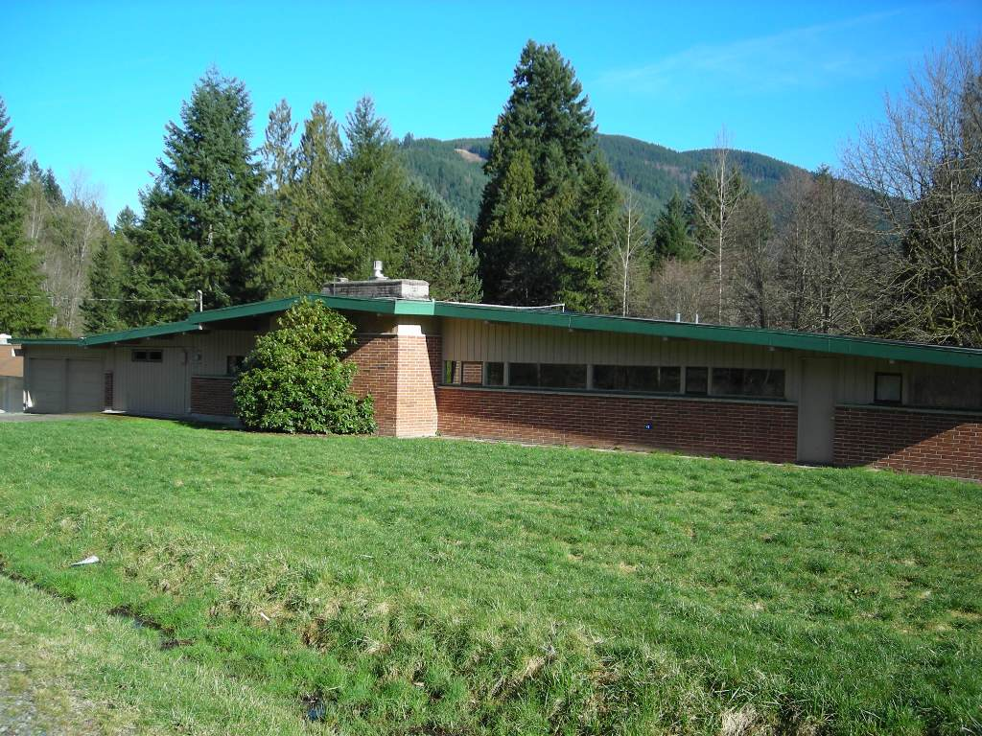

Property Synopsis: This improved residential property is located east of Issaquah-Hobart Road in the Issaquah Area. Roads purchased it in 2006 for use in the reconstruction of Bandaret Bridge which crosses Issaquah Creek on May Valley Road. The property is zoned RA-5 and contains a single-family home in fair condition. After completion of the bridge project, Roads determined that the remaining residential lot is not needed for future road purposes subject to reserving a 19,315 square foot conservation easement. This conservation easement provides environmental mitigation for the bridge project by ensuring unobstructed fish passage on Issaquah Creek and restricting access to the creek near the north side of the bridge.

Surplus Process: Pursuant to King County Code 4.56.070, FMD circulated a surplus property notice to King County agencies. None expressed interest, and the property was determined to be not suitable for affordable housing.

Marketing and Sale: Pursuant to King County Code 4.56.100, FMD listed the property for sale with the Northwest Multiple Listing Service, advertised it on the King County Real Estate Services website, and posted two for-sale signs on this corner lot. The property was marketed as a “fixer-upper” listed at the appraised value of $210,000. Three bids were received. The highest and best offer was made by Edward and Roxana Morgan for $230,000 ($20,000 over appraisal) all cash with no buyer contingencies. The Purchase and Sale Agreement requires Council approval by December 19, 2012.

Appraisal Summary: The property was originally appraised for $240,000 effective February 17, 2011. FMD re-appraised the property effective March 5, 2012 for $210,000. Compared to comparable sales, the subject was found to be toward the lower end of the market range with the most emphasis on Comparable Sales 1 and 2.

Sale Comparables: 13326 -230th Avenue SE, Issaquah area

Low Comparable Sale = $160,000 High Comparable Sale = $219,750

VICINITY VIEW

PARCEL VIEW

B) PROPERTY SUMMARY
Address: 19851 -140th Avenue SE,
Renton Area

Sale Price: $110,000
Size: House – 1,020 sf.
Lot – 12,289 sf.

Assessor’s Parcel: 815500-0040
Zoning: R-6
Council District: Nine (Dunn)
Funding Source: Roads Fund; CIP #1116637
Declared Surplus: January 11, 2010

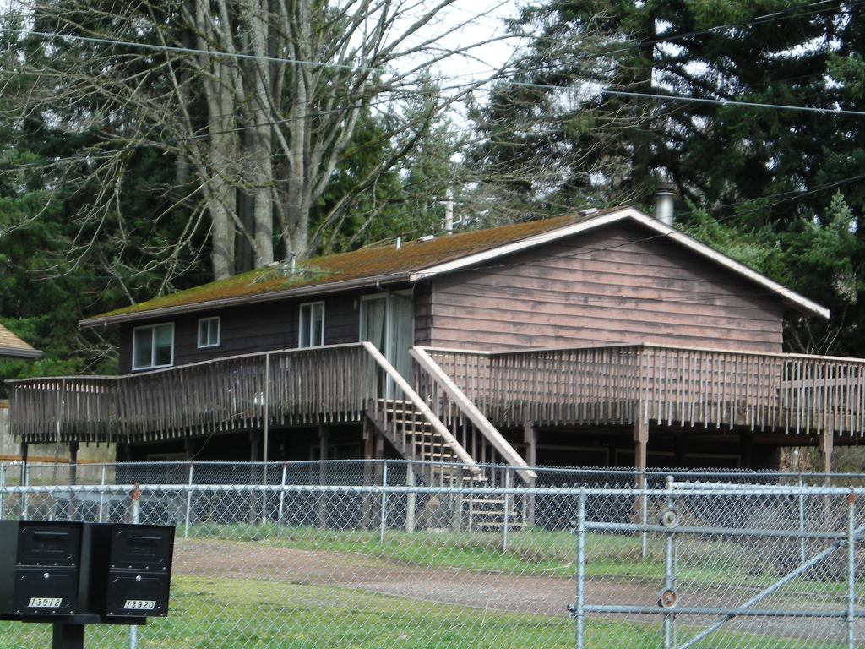

Property Synopsis: The subject parcel is located on the west side of 140th Avenue SE at the corner of SE 200th Street in the Renton area. Roads purchased the parcel in 1997 for Phase II of the 140th Avenue SE/132nd Avenue SE road improvement project. Following a subsequent redesign of that project, the property was not needed for road purposes. The existing house and built-in garage were constructed in 1967. The parcel is zoned R-6 but its small size provides limited development potential. The house retains sufficient value to justify sale as a single-family residence although the property needs many upgrades. The property provided rental income from 1998 through 2011. Roads has determined that the parcel is no longer needed for County roadway projects and is therefore surplus to its need.

Surplus Process: Pursuant to King County Code 4.56.070, FMD circulated a surplus property notice to King County agencies. None expressed interest, and the property was determined to be not suitable for affordable housing.

Marketing and Sale: Pursuant to King County Code 4.56.100, FMD listed the property for sale with the Northwest Multiple Listing Service, advertised it on the King County Real Estate Services website, and posted a for-sale sign at the site. The property was marketed as a “fixer-upper” and three offers were received. The highest and best offer was made by Michael and Anne Nguyen for $115,000 all cash. The price was subsequently adjusted to $110,000 based on several problems identified during the buyer’s due diligence inspection. The Purchase and Sale Agreement requires Council approval by December 31, 2012.

Appraisal Summary: FMD completed an appraisal dated March 2, 2011 which estimated fair market value at $135,000, based on comparable residential sales at that time.

FMD subsequently updated the appraisal effective May 4, 2012, concluding a value of $110,000 based on recent sales, with most emphasis on Comparable Sales 2, 3 and 4.

Sales Comparables: 19851 -140th Avenue SE, Renton Area

Low Comparable Sale = $103,600 High Comparable Sale = $114,440

VICINITY VIEW

PARCEL VIEW
C) PROPERTY SUMMARY

Address: NE corner of SE 179th Place and 140th Avenue SE,
Renton Area

Sale Price: $99,950
Size: Vacant Lot – 30,686 sf
.70 Acre

Assessor’s Parcel: 342305-9106
Zoning: R-6
Council District: Nine (Dunn)
Funding Source: Funding Source: Roads CIP Fund # 1116637

Declared Surplus: February 20, 2012

Property Synopsis: This vacant, level parcel is located at the northeast corner of SE 179th Place and 140th Avenue SE in the Renton area. Roads purchased the parcel and removed the existing improvements in 1996 for the 140th road-widening project south of Petrovitsky Road. The lot is zoned R-6 in a neighborhood predominated by single family dwellings. Although this lot has adequate size, shape, and topography for development of multiple units, the high cost of extending sewer service (455 feet to the south) makes single family use most likely. (Analysis below.) Water and electricity are available. Roads has determined that the parcel is no longer needed for County roadway projects and is therefore surplus to its needs.

Surplus Process: Pursuant to King County Code 4.56.070, FMD circulated a surplus property notice to King County agencies. None expressed interest, and the property was determined to be not suitable for affordable housing due to the sluggish market and the very high cost of bringing sewer to the site.

Marketing and Sale: Pursuant to King County Code 4.56.100, FMD listed the property for sale with the Northwest Multiple Listing Service, advertised it on the King County Real Estate Services website, and posted a for-sale sign at the site. Two offers were received with the highest and best offer made by Chi L. Nguyen for the list price of $99,950 all-cash with no buyer contingencies. The Purchase and Sale Agreement requires Council approval by December 31, 2012.

Appraisal Summary: FMD completed an appraisal dated December 14, 2011 which compared value as both a single-family home and for multi-family development, as summarized below. The appraiser concluded value at $95,000 based on highest and best use as a single-family lot. (Note that the sale price is $4,590 over the appraisal.)

Value as Single Family Residence ($95,000) - The appraiser’s $95,000 estimate of value was based on comparable lot sales (listed below) which sold for single-family development with septic systems.
Value as Multi-Family Subdivision ($67,000) - The existing R-6 zoning potentially allows subdivision development of up to four lots on sewer. The appraiser concluded that similar small finished home sites served by sewer would sell for approximately $75,000 based on comparable sales. Following is a summary of the appraiser’s development analysis deducting development costs, including $200 per lineal foot for sewer extension, from the potential gross value of finished lots. The resultant residual land value is $67,550.

Note that an experienced developer submitted an earlier offer for $115,000 but subsequently terminated the agreement due to potential sewer connection costs up to $200 per lineal foot (estimate from Soos Creek Water & Sewer District).

VICINITY VIEW

PARCEL VIEW

D) PROPERTY SUMMARY

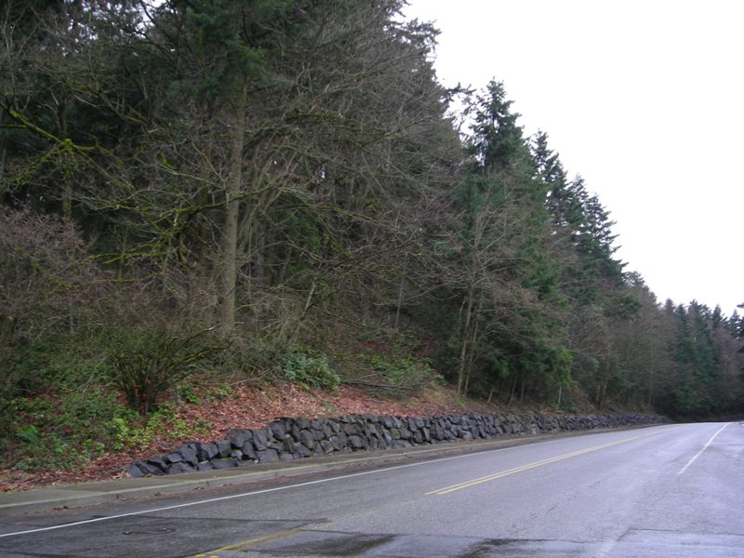
Address: Kelsey Pit Lot
21400 Blk of 37th Place South,
City of SeaTac

Sale Price: $25,000
Size: Vacant Lot – 97,138 sf.
(2.22 acres)

Assessor’s Parcel: 102204-9026

Zoning: UL-15000
Council District: Five (Patterson)
Funding Source: Funding Source: Roads Operating Fund #1114348

Declared Surplus: September 1, 2009

Property Synopsis: This hillside vacant lot is located on the west side of the 21400 block of 37th Place South in south SeaTac. Located on the sloping eastern edge of the Highline Ridge, its primary access is from Military Road on South 216th Street. Kelsey Pit was purchased for gravel mining in 1909 but was never utilized. Although the lot is zoned UL-15000 which potentially allows multiple unit development, SeaTac indicates that as a reasonable use exception to the city’s Environmentally Sensitive Areas chapter, it would only permit development of one single-family home due to the lot’s nearly total classification as a steep slope hazard area. The entire 750-foot frontage along 37th Place must be supported by a retaining wall and there is limited area to develop access. Roads has determined that the parcel is no longer needed for County roadway projects and is therefore surplus to its need.

Surplus Process: Pursuant to King County Code 4.56.070, Facilities Management Division (FMD) circulated a surplus property notice to King County agencies. None expressed interest, and the property was determined to be not suitable for affordable housing.

Marketing and Sale: Pursuant to King County Code 4.56.100, FMD listed the property for sale with the Northwest Multiple Listing Service, advertised it on the King County Real Estate Services website, and posted a for-sale sign at the site. Two bids were received and the highest and best offer was made by Maria Higuera for $25,000 ($3,000 over appraisal) all-cash with no buyer contingencies. The Purchase and Sale Agreement requires Council approval by January 31, 2013.

Appraisal Summary: FMD completed an appraisal dated February 21, 2012 which estimated fair market value at $22,000 based on highest and best use as a single-family lot.

To review the development potential for the subject property, the appraiser consulted with a senior planner at the City of SeaTac. The City reports that only one house would be permitted under the reasonable use exception to the Environmentally Sensitive Areas rules against development on steep slopes. Sewer service is available, and the city says that it may grant an administrative exception to its requirement that the line be extended along the entire 750 feet of the property’s frontage to provide service to the adjacent property at a cost of $200 per linear foot. Without such administrative exception, the financial feasibility of development of even a single family home site is limited. The appraiser concluded, however, that the highest and best use of the property would be development of a single family residence near the southeast corner of the property assuming reasonable cost to connect to the existing sewer system. The valuation placed most emphasis on Comparable Sales 1, 2 and 4.

VICINITY VIEW

PARCEL VIEW

