STAFF REPORT

Agenda Item: | 6 | Name: | Miranda Leskinen
Proposed No.: | 2024-B0094 | Date: | July 31, 2024

SUBJECT

A briefing on the 2023 Best Starts for Kids (BSK) annual report.

SUMMARY

The BSK 2023 Annual Report, the second annual report for the 2022-2027 levy period, provides information on BSK financial investments made in 2023, as well as BSK performance measures and outcomes. In 2023, the report indicates that Best Starts for Kids invested more than $129 million in the community, completed 12 competitive RFP processes, partnered with 336 community-based organizations operating 591 programs (including 187 new programs) to reach 151,919 children, young people, families, and community members across King County.

The report also links to an updated data dashboard on the Best Starts for Kids website. The dashboard provides additional measures for Best Starts for Kids programs, customizable data views, and greater geographic and financial detail.

BSK annual reports must be provided to the Council on levy implementation throughout the 2022-2027 levy period. These reports are due no later than July 15 each year from 2023 through 2028 and reflect levy implementation for the prior calendar year. A proposed motion to acknowledge receipt of the report (PM 2024-0228) will be taken up at the September meeting of the Regional Policy Committee.

Staff analysis has determined that the 2023 report meets the requirements for BSK annual reporting in Ordinance 19267.

BACKGROUND

Best Starts for Kids. Best Starts for Kids (BSK) is a levy-funded initiative in King County that is aimed at supporting the healthy development of children and youth, families, and communities across the county through strategic investments in promotion, prevention and early intervention programs and services. The inaugural six-year BSK Levy (approved by voters in November 2015) expired at the end of 2021.

2022-2027 BSK Levy. In April 2021, the King County Council approved Ordinance 19267, which placed a Best Starts for Kids (BSK) six-year renewal levy proposition on the ballot. King County voters approved the 2022-2027 BSK levy on August 3, 2021.

The 2022-2027 levy entails a first-year levy rate of $0.19 per $1,000 of assessed value in 2022 with a three percent annual limit (growth) factor. Based on the March 2024 revenue forecast, the renewal levy is expected to generate approximately $910.4 million over the six-year levy period.

Levy Investment Requirements. Ordinance 19267 directs that levy proceeds shall be used to:
- Promote improved health and well-being outcomes of children and youth, as well as the families and the communities in which they live;
- Prevent and intervene early on negative outcomes;
- Reduce inequities in outcomes for children and youth in the county; and
- Strengthen, improve, better coordinate, integrate, and encourage innovation in health and human services systems and the agencies, organizations, and groups addressing the needs of children and youth, their families, and their communities.

In the levy’s first year (2022), after accounting for attributable election costs, 22.5 percent of first-year levy proceeds are to be allocated toward the Youth and Family Homelessness Prevention Initiative (YFHPI), a new affordable child care program, a new child care workforce demonstration project, and continuing technical assistance and capacity building programs. Allocated levy proceeds may be used to plan, provide, fund, administer, measure performance, and evaluate these programs.

In the subsequent levy years (2023-2027), it is broadly directed that the amount to be distributed to these programs be allocated so that the six-year levy investment for these purposes totals at least $240 million including $1 million annually for a grant program to support capacity building and developing infrastructure in areas lacking services/services infrastructure.

Remaining levy proceeds are to be disbursed as follows to plan, provide, and administer the following:
- 50 percent for Investing Early strategies (ages 0-5)
- 37 percent for Sustain the Gain strategies (age 5 or older)
- 8 percent for Communities of Opportunity
- 5 percent for performance measurement, evaluation, and data collection; CYAB stipends; and pro-rationing mitigation (if authorized by ordinance) for applicable local metropolitan parks, fire, and public hospital districts.

The renewal levy will also invest up to $50 million (subject to levy revenue projections) to establish a new capital grants program for facility/building repairs and expansion and to support the construction of new buildings/facilities that will serve children and youth.

Implementation Plan. Ordinance 19267 required the Executive to transmit to the Council an implementation plan for the 2022-2027 BSK levy to govern the expenditure of levy proceeds. The plan, as required, details the strategies and programs to be funded and outcomes to be achieved with the use of the levy’s proceeds and includes a framework to measure the performance of levy strategies in achieving their outcomes. Council adopted the implementation plan, as amended, in November 2021.

Results-Based Accountability. As with the initial BSK levy, the renewal levy will continue to evaluate its results beginning with Results Based Accountability (RBA) and supplement RBA with additional evaluation activities. Altogether, the implementation plan indicates the evaluation framework will utilize population indicators, performance measurement and in-depth evaluation.

Levy Oversight. Levy oversight, like for the initial BSK levy, is provided by the Children and Youth Advisory Board (CYAB) and the Communities of Opportunity-Best Starts for Kids Levy Advisory Board.

Annual Reporting. Annual reports will be delivered digitally, with a notification letter transmitted to the King County Council when the report is ready for review. These reports, due no later than July 15 each year from 2023 through 2028, will cover levy expenditures, services, and outcomes for the levy for the prior calendar year and provide performance data for Investing Early, Sustain the Gain, COO, YFHPI, Child Care, Capital Grants, and Technical Assistance and Capacity Building investments. As indicated in the levy implementation plan, ZIP code-level geographic detail required by Ordinance 19267 will be phased into reports beginning with the 2022 BSK Annual Report.

Annual reporting for the levy will also describe any changes made to strategy-level investments during the reporting period, as well as indicate whether strategy-level investments are expected to change for the subsequent reporting period or remain the same.

The levy’s advisory boards, in accordance with the implementation plan, will consult on, and review the annual reports.

Additionally, the levy’s implementation plan indicates that BSK, no later than 2027, will report on the levy's performance and outcomes in conjunction with the performance and outcomes for the Mental Illness and Drug Dependency Behavioral Health Sales Tax Fund (MIDD) and the Veterans, Seniors and Human Services Levy (VSHSL), including whether the investments from these programs are achieving desired county population-level results or impacts monitored as part of the consolidated reporting dashboard for DCHS-administered human services.

ANALYSIS

The 2022-2027 BSK Implementation Plan, consistent with Ordinance 19267, outlines requirements related to the transmittal timelines, stakeholder involvement and contents of Best Starts for Kids (BSK) annual reports. The following subsections evaluate whether the 2023 BSK Annual Report is consistent with annual reporting requirements for the levy. In sum, staff analysis has determined that the 2023 report meets the requirements for BSK annual reporting.

Transmittal Timeline. BSK annual reports are due no later than July 15 each year. The Executive transmitted the 2023 BSK Annual Report on July 15, 2024, thereby meeting this requirement.

Content Requirements. BSK annual reports must describe the programs funded and outcomes for the children, youth, families, and young adults served. Specifically, annual reports are to include:

- Annual information on levy expenditures, services, and outcomes;
- Total expenditures of levy proceeds by program area by ZIP Code in King County, with partial data to be available in the report completed in 2024 and additional data available in each subsequent report;
- The number of individuals receiving levy-funded services by program area by ZIP Code of where the individuals reside at the time of service, with partial data to be available in the first annual report in 2023 and additional data available in each subsequent report; and
- Description of any changes made, and any anticipated changes, to strategy-level investments.

Description of any changes made to strategy-level investments. In 2023, Best Starts for Kids made no changes to planed strategy-level investments. The annual report notes that any underspend in a strategy or investment area’s prior annual budget that was legislatively carried forward into 2023 and future years is allocated within the same strategies and investment areas to maintain the level of commitments outlined in the levy’s implementation plan.

Review by Advisory Boards. According to the Executive, the CYAB and COO-AB members received a draft copy of the annual report in May 2024 and the final report reflects their input and feedback.

BSK 2023 Annual Report Highlights. In 2023, Best Starts for Kids invested more than $129 million in the community, completed 12 competitive RFP processes, partnered with 336 community-based organizations operating 591 programs to reach 151,919 children, young people, families, and community members across King County. Of note, the formatting for summarizing levy strategy highlights is updated for the 2023 annual report around the following five key themes that shaped BSK programming and results in 2023:
- Meeting families’ needs
- Prioritizing well-being and mental health
- Cultivating opportunities for children and young people
- Strengthening the workforce
- Building community power and capacity

Table 1 provides a summary of 2023 levy expenditures, excerpted from the annual report, organized by levy investment area. Please note that the amounts shown in the ‘2023 Budgeted’ column include approximately $16 million in 2022 commitments that were not spent in 2022 due to implementation and strategy design of new initiatives. Most of these are in the Child Care and Capital Projects investment areas, which are new for the 2022-2027 Best Starts levy.

Also of note, the annual report indicates that 2023 funds are on track to be fully committed in 2024. Capital Projects anticipates having funds allocated in contracts by the end of 2024, but some funds may need to be expended later subject to project complexity. In addition, the annual report notes that Child Care Wage Boost Pilot implementation was delayed by start-up staffing timelines and a change in community partner in Q3 of 2023, which necessitated a re-procurement. However, full implementation of the pilot is anticipated in 2024.

Table 1. BSK 2023 Expenditure by Investment Area

Investment Area | 2023 Budgeted | 2023 Expenditures
Child Care  Youth and Family Homelessness Prevention Initiative Technical Assistance and Capacity Building | $34,764,300  $4,934,290  $2,424,120 | $30,890,272  $4,774,967  $2,197,463
Subtotal (per Ord 19267 subsection 4.D) | $42,122,710 | $37,862,703
Investing Early (Prenatal to 5) | $47,552,860 | $45,855,095
Sustain the Gain (5 to 24) | $35,427,922 | $34,044,586
Communities of Opportunity | $7,737,003 | $6,736,765
Data and Evaluation | $4,931,858 | $4,446,479
Capital Projects | $9,885,000 | $204,803
Total 2023 Expenditures | $147,657,352 | $129,150,430

Figures 1 through 3 (also excerpted from the annual report) summarize geographic distributions of BSK participants (Figure 1) and levy expenditures (Figures 2 and 3) by ZIP Code. Please note that data for individual ZIP Codes are available in Appendix E to the annual report and on the BSK online dashboard.

Figure 1. Best Starts Services Participation in 2023
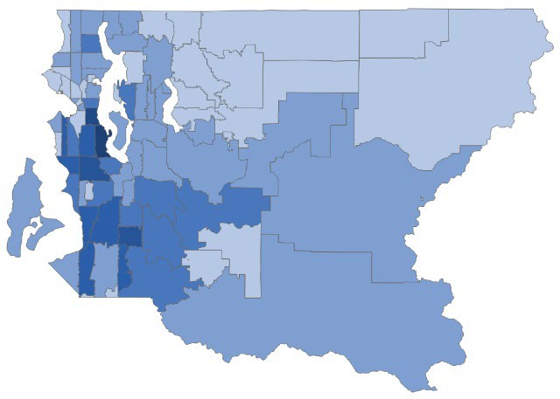
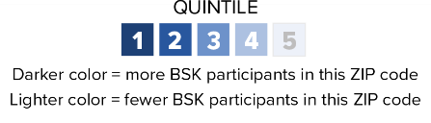
Figure 2. Best Starts Expenditures by ZIP Code in 2023 (by where participants reside)

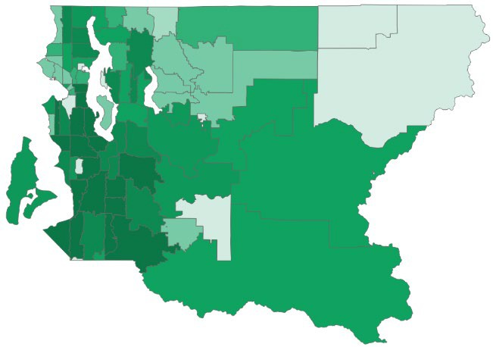

Figure 3. Best Starts Expenditures by ZIP Code in 2023 (by where office-based services are located)
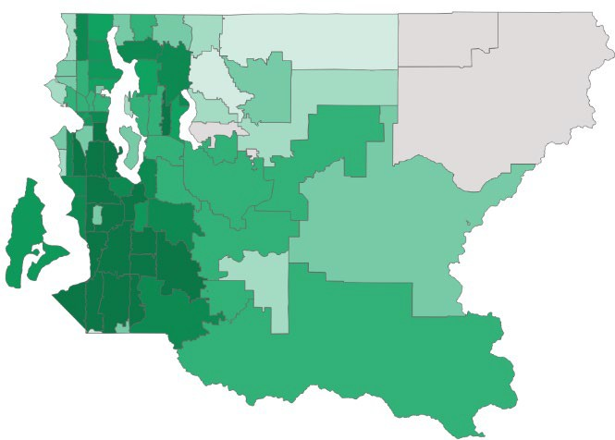
Data and Evaluation. BSK evaluators, noted in the annual report, summarized quantitative and qualitative data from performance measures and semiannual narrative reports from funded community partners to capture the levy’s work in 2023. Additionally, staff also gathered feedback throughout the year and shared themes focusing on where partners needed support and how BSK is already addressing them. The report further notes that such findings inform how BSK is working towards investing and will continue to invest in partners in 2023 and onward.

The report also links to an updated data dashboard on the Best Starts for Kids website. The dashboard provides additional measures for Best Starts for Kids programs, customizable data views, and greater geographic and financial detail. Additionally, the report includes a link to its webpage that includes the published results of more in-depth evaluations completed by third-party, independent evaluators and community partners. Additionally, key findings from evaluation reports completed in 2023 are included in the annual report itself.

ATTACHMENTS

- 2023 BSK Annual report

Best Starts for Kids dashboard - King County, Washington
The capacity building support grant program, per Ordinance 19267, must include support for development of new organizations and expansion of existing organizations.
If total projected levy proceeds exceed $822 million, the excess (up to $50 million) would fund the capital grants program. Consequently, Ordinance 19267 directs that funding for this grant program would be subject to reduction prior to other levy program funding in the event total projected levy proceeds were to fall below $822 million.
Population indicators use population-level measures to identify needs, understand baseline conditions, and track trends over time. BSK strategies intend to contribute to population-level results over the long term.
Performance measures are regular measurement of program outcomes to assess how well a levy investment or strategy is working. BSK is accountable for performance of the levy’s strategies.
Additional, in-depth evaluation activities are expected to complement performance measurement to further learning during the renewal levy in some program areas.
Including total expenditures of levy proceeds by program area by ZIP code in King County and the number of individuals receiving levy-funded services by program area by ZIP code in King County of where the individuals reside at the time of service.
BBest Starts for Kids dashboard - King County, Washington
Best Starts for Kids Reports - King County.

