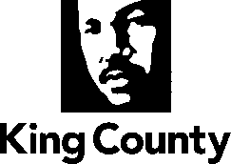 | Metropolitan King County Council  REVISED Staff Report

Committee: | Budget and Fiscal Management Committee
Agenda Item: | 7 | Analyst(s): | Nick Bowman
Proposed No.: | 2026-0069 | Meeting Date: | July 8, 2026

COMMITTEE ACTION
Proposed Substitute Ordinance 2026-0069.2 authorizing the sale of County owned property to the City of Kent passed out of committee on July 8, 2026, with a “Do Pass” recommendation. The Proposed Ordinance was amended in committee with Amendment 1 to delete the transmitted Attachment A, the Purchase and Sale Agreement, and replace it with a new Attachment A, a complete Purchase and Sale Agreement dated June 10, 2026, that includes the signed 1st amendment extending the Council contingency period to July 24, 2026 and the restrictive covenant requiring the property to be used for parks and open space.

OVERVIEW
TOPIC: An Ordinance relating to the sale of County owned property to the City of Kent.
LEGISLATION SUMMARY
Proposed Ordinance 2026-0069 would approve the sale of a 179,467 square feet of county owned property located in the City of Kent, in Council District 5, for $114,350. According to the Executive, the property was purchased by the Road Services Division in 1997 under an interlocal agreement wherein the City of Kent would reimburse the County for half of the acquisition costs and that the property would be transferred to the City for exclusive use as park and open space. However, the City of Kent did not reimburse the County, and the property was never conveyed to the City.
Sale of the property for the original 1997 property values would satisfy the obligations of the original interlocal agreement, will provide one-time revenues to the Roads Fund and relieve the County of assessments totaling $20.42 per year.

KEY ISSUES FROM THE ANALYSIS
- Sale Price Based on 1997 Property Appraisal. The City of Kent and King County have agreed to use the 1997 property values as the basis for the purchase price as intended under the original 1996 interlocal agreement and as agreed to by the Washington Interagency Committee for Outdoor Recreation (IAC).
- Incomplete Transmittal. The transmitted Purchase and Sale Agreement (PSA), which is attachment A to the proposed ordinance, did not include several key components necessary to effectuate the sale. Amendment 1 would replace the incomplete PSA with a new PSA which includes all necessary components.
AMENDMENTS
- Amendment 1 would delete the transmitted Attachment A, the Purchase and Sale Agreement, and replace it with a new Attachment A, a complete Purchase and Sale Agreement dated June 10, 2026, that includes the signed 1st amendment extending the Council contingency period to July 24, 2026, and the restrictive covenant requiring the property to be used for parks and open space.

BACKGROUND & TIMING CONSIDERATIONS BACK TO TOP
Background. In August 1990, the Washington Interagency Committee for Outdoor Recreation (IAC) awarded the County a $1 million dollar grant to purchase Clark Lake Park. As part of the grant, the IAC required that Clark Lake Park be used “forever for outdoor recreation purposes.” The City of Kent expanded its boundary to include Clark Lake Park in January 1996.
In May 1996, the King County Roads Services Division (Roads) and the City of Kent entered an interlocal agreement to widen S.E. 240th Street, a major arterial road that runs along the northern boundary line of Clark Lake Park. Under the terms of the agreement the County would acquire the property required to widen the street, and that the City of Kent would “pay the County one-half of the costs” for the property acquisition.
As part of the road widening project, the City and the County needed to convert a small section of Clark Lake Park into a storm water drainage pond. The City and the County jointly requested that the IAC approve the conversion in exchange for the City of Kent and King County acquiring parcel 212205-9183 as a replacement for the converted park land. The IAC approved the County and City of Kent’s request with the stipulation that the replacement parcel serve as “park land for public use.” The County purchased the property in May 1997 for $269,280 with the condition that it “remain in use” as a “City park and open space.”
The City of Kent did not reimburse the County for its share of the acquisition costs, and the County did not convey the parcel to the City as originally agreed to.
Maps of the proposed property are included below.
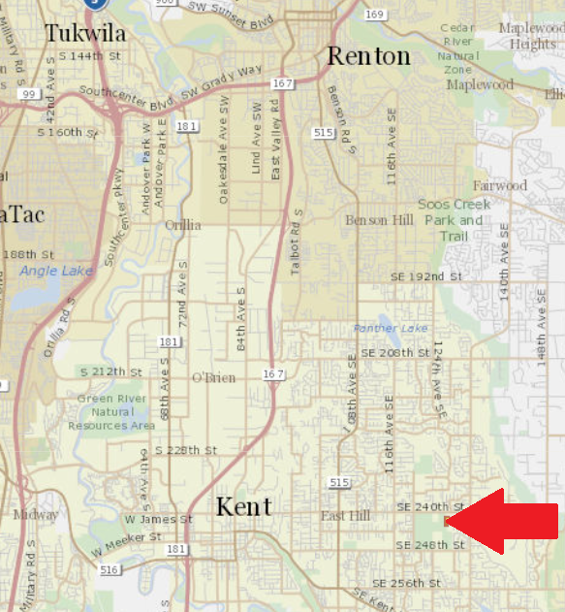

The parcel proposed for sale is highlighted in blue.
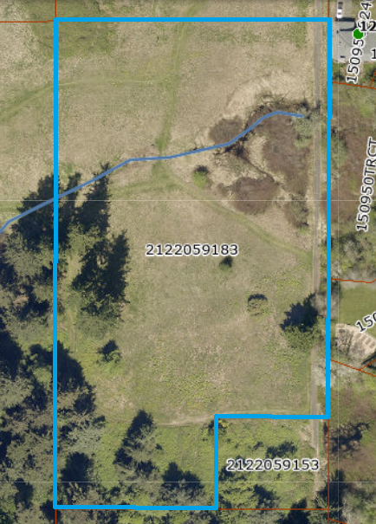
Timing Considerations. Under the Purchase and Sale Agreement, the proposed ordinance must be effective by July 24, 2026. To meet this deadline, the Budget and Fiscal Management Committee would need to approve the proposed ordinance at the July 8th committee meeting and expedite the proposed ordinance to the Full Council for approval on July 14th. The Full Council would then need to approve the ordinance on July 14th for ordinance to become effective by the July 24th deadline.

ANALYSIS BACK TO TOP
Intergovernmental Property Sale. King County Code 4.56.140 allows for the County to dispose of real property to another governmental agency by negotiation, upon such terms as may be agreed upon and for such consideration as may be deemed by the County to be adequate.
According to the Executive, the sale of the property to the City of Kent for the original 1997 property values would satisfy the obligations of the 1996 interlocal agreement, will provide one-time revenues to the Roads Fund, and relieve the County of assessments totaling $20.42 per year.

Key Issue A. Proposed Sale Price Based on 1997 Property Appraisal. According to the Executive, the County and the City of Kent have agreed to use the 1997 property values of the converted and replacement parcels to determine the purchase price because that is what was originally intended under the 1996 interlocal agreement and what the IAC approved.

The agreed upon purchase price of $114,350 was reached by deducting the appraised value of the converted parcel ($40,580) from the purchase price of the replacement parcel ($269,280) and dividing it in half.
Key Issue B. Incomplete Transmittal. The transmitted Purchase and Sales Agreement (attachment A to the proposed ordinance) did not include a signed amendment to the Purchase and Sale Agreement (PSA), the effect of which extends the Council contingency period until July 24, 2026. Without this amendment to the PSA, the Council contingency period included in the underlying PSA would have already lapsed. The amendment to the PSA also includes a restrictive covenant intended to ensure the property must always be used as a city park and open space as originally required by the IAC.

ATTACHMENTS
- Proposed Ordinance 2026-0069 (and its attachment)
- Amendment 1
- Transmittal Letter
- Fiscal Note
- 1996 King County and City of Kent Interlocal Agreement
- IAC Approval of Clark Lake Park Conversion

See Attachment 5
See Attachment 6
Under King County Charter Section 270.30, ordinances become effective 10 days after enactment.

