FINAL REPORT

OF THE

AMERICAN PUBLIC TRANSPORTATION ASSOCIATION

PEER REVIEW PANEL

FOR

King County Metro Transit

Seattle, Washington

July 2014

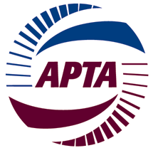

A Service of the Safety Management of the
American Public Transportation Association
FINAL REPORT

OF THE

AMERICAN PUBLIC TRANSPORTATION ASSOCIATION

PEER REVIEW PANEL

ON THE

EFFICIENCY & EFFECTIVENESS of TRANSIt Products PROVIDED BY
KING COUNTY METRO TRANSIT

Panel Members:
Carolyn Flowers
Paul Jablonski
Brian Lamb
Terry Matsumoto
Jack Requa
Mary Childress
Greg Hull

Published by the
American Public Transportation Association
1666 K Street, NW, 11th Floor
Washington, DC 20006
Michael P. Melaniphy, President
TABLE OF CONTENTS

I. INTRODUCTION ............................................................ 1

II. OBSERVATIONS & RECOMMENDATIONS ............. 3

III. CONCLUDING REMARKS............................................. 8

APPENDIX.......................................................................... 9

A – Peer Review Request
B – Peer Review Agenda
C – Document List
I. INTRODUCTION

In May 2014, Mr. Kevin Desmond, General Manager – Metro Transit Division, King County Department of Transportation (Metro) contacted the American Public Transportation Association (APTA) to request a peer review of the agency’s service delivery and financial management practices and strategies.

Through discussions between APTA and King County staff, it was determined the review would be conducted July 29 – August 1, 2014.

A panel of industry peers was assembled that provided expertise in executive leadership, financial management and service planning in the operation of a large transit agency. The peer review panel consisted of the following individuals:

Ms. Carolyn Flowers
Chief Executive Officer
Charlotte Area Transit Systems

Mr. Paul Jablonski
Chief Executive Officer
San Diego Metropolitan Transit System

Mr. Brian Lamb
General Manager
Metro Transit - Minneapolis, St. Paul

Mr. Terry Matsumoto
Chief Financial Services Officer (retired)
Los Angeles County MTA

Mr. Jack Requa
Assistant General Manager – Bus Service
Washington Metropolitan Area Transit Authority

Ms. Mary Childress
Chief Financial Officer
American Public Transportation Association

Mr. Greg Hull
Asst. VP – Public Safety, Operations, Technical Services
American Public Transportation Association

The panel convened in Seattle on July 29, 2014. Panel coordination and logistical support was provided by APTA Staff Advisor Greg Hull. Mr. Hull also coordinated panel member input in the drafting of this peer review report. Ms. Chris O’Claire provided agency liaison support on behalf of King County Metro Transit.

Methodology

The APTA Peer Review process is well established as a valuable resource to the public transport industry. Highly experienced and respected transit professionals, selected on the basis of their subject matter expertise, voluntarily provide their time and support to address the scope required. The panel conducted this peer review through documentation review and a series of briefings and interviews with staff and key stakeholders of King County Metro Transit.

Scope of Report

The scope of this review focused on evaluating the efficiency and effectiveness of Metro’s transit products with particular emphasis on whether service costs are appropriate given the characteristics of the service provided and the population served. The findings and recommendations provided through this peer review are offered as an industry resource to assist Metro in optimizing its strategies for effective service delivery and finance management.

The review will focus on the following areas:

- Appropriateness of services, programs and products
- Cost effectiveness of programs
- Policy environment impact on cost effectiveness
- Metro vis-a-vis industry practices:

- Policy Directives
- Governance Structure
- Service Quality
- Transparency & Accountability
- Performance Management
- Customer Services & Market Development
- Fare Collection
- Labor & Management Environment

- Observations and Recommendations

Opening Comments

It is clear to the panel that Metro provides a well-managed service to the citizens of King County. All Metro staff encountered were highly professional and provided the review panel with excellent data and briefings to assist in the review process.

It is evident to the panel that the costs related to providing Metro services are significantly impacted by policies and labor conditions that are beyond the control of Metro management. The panel also notes that the underlying factors that influence the cost of service delivery are not fully understood by all interested parties.

While the Metro organization is doing many things extremely well, there are opportunities for strengthening its effectiveness and efficiencies.

- Appropriateness of Service, Programs and Products

King County Metro Transit serves the entire county which covers more than 2,000 square miles and has a population of 2 million residents. Metro operates 1400 buses as well as providing Access paratransit services, a dial-a-ride (DART) service in low ridership areas, and the largest van pool program in the U.S.

The panel found that in relation to the broader transit industry, Metro offers a broad and very good range of transit services for the population it serves. The panel also found that Metro provides a very high quality of service and that the organization provides a high level of support services for its customers. High priority is placed on the safety and security for both customers and employees. The panel noted that Metro’s service planning functions are well developed and that a large amount of data is generated to ensure that the organization is in compliance with policy directives. There is an effective regional fare policy and program with the Orca system. It was also evident that Metro has developed a very strong and impressive partnership with local businesses.

The panel notes however, that the fare policy decision to decrease fares for low income persons while considering cuts to transit services, creates an inconsistent and conflicting service strategy that can actually lead to even deeper service cuts. It also appeared to the panel that the current structure for ADA fares does not create an incentive for using the more cost effective and accessible fixed transit routes.

Recommendations:

- While the panel recognizes that Metro has a strong service planning function, the organization would benefit from an external comprehensive operations analysis (COA) or comparable analysis to ensure that service levels and route configurations are optimized for their respective markets.
- The panel recognizes that Metro staff is developing recommendations for alternative services delivery especially in lower productivity areas. The panel strongly recommends that Metro staff continue to place a high priority on exploring new performance measures for alternative services.
- The panel recommends that Metro and Sound Transit continue to explore opportunities for planning and management synergies/integration between the two organizations
- Consideration should be given to a paratransit fare structure that is consistent with ADA and which would thereby encourage greater use of fixed transit route services.
- Consideration should be given to appropriately sizing or pricing services that exceed ADA requirements. The panel notes that there are now many transit agencies across the country that are currently offering free fixed route services to qualified ADA individuals and their companions.
- The panel encourages Metro to regularly review the amount and types of data it generates to ensure that the data is consistent with the changing needs and performance metrics of the organization.

- Cost Effectiveness of Programs

At first glance, and when reviewing only the Federal Transit Administration’s National Transit Data (NTD), it would appear that the cost of Metro services is higher than many other transit agencies of comparable size. The panel notes however, that Metro’s cost to deliver service is significantly impacted by higher labor rates, more restrictive work rules, and conditions that prohibit contracting opportunities. Costs for providing Metro services are also impacted by significant overhead costs and service charges that Metro pays to King County and these costs are beyond the control of Metro.

The panel recognizes Metro’s improvements and initiatives currently underway to reduce vehicle maintenance and parts inventory costs. During the panel’s cursory overview of inventory, it appeared that the dollar value of inventory per bus appeared high.

In the view of the panel, the current size of the Metro Design and Construction function may not be appropriately aligned with the current capital program activities.

Recommendations:

- The panel recommends that Metro continue its efforts to develop labor contract proposals that address current inefficient work rules and eliminate inefficient position classifications as well as to align wages with comparable national transit agencies.
- Consideration should be given to regularly explore contracting-out opportunities as a general cost-efficiency measure as well as an alternative to future service elimination.
- While the panel acknowledges Metro’s efforts to review maintenance costs, this effort could be further supported through an independent review by experienced transit maintenance professionals focusing on the overall Metro vehicle maintenance functions. Within this review of maintenance practices, also evaluate potential opportunities to contract for basic services and in support of highly technical systems.
- Continue to evaluate opportunities to revise Metro service guidelines to compare service productivity by service type as this enables a more appropriate analysis of services.
- Review staffing levels and functions of the Metro Design and Construction group for appropriate alignment to current and projected capital program requirements. Staff levels appear to be high in relation to the current level of capital projects.

- Policy Environment Impact on Cost Effectiveness

The panel recognizes the positive changes that have been made from the prior service guidelines, however, it was evident to the panel that regional tensions still exist with regards to sub-regional service levels.

Current service delivery and fare structure policies that direct the actions of Metro actually inhibit Metro’s ability to reduce costs or generate revenue. As an example, discounted fares, express fares and ADA service pricing policies are set at lower rates than is common in the transit industry. As well, policies pertaining to shelters and advertising, further restrict Metro’s opportunities for reducing costs and gaining revenue.

Metro’s environmental policies, while commendable, directly impact operating and capital costs as environmental goals do indeed necessitate additional funding to sustain. The panel also noted that retention of the historic trolley bus system would be a relatively costly service if the current federal operating and capital funds were not available to offset the service costs.

Recommendations:

- The panel recommends that Metro and King County re-visit current policies pertaining to discounted fares and fare rates, including differential rates for premium services and DART services.
- The panel recommends that Metro and King County re-visit its policies that prohibit advertising on transit shelters which thereby prohibit the contracting-out of shelters and consider the merits of introducing an “adopt a bus shelter” program. Also evaluate whether building transit shelters in-house is more cost effective than buying pre-built from a supplier.

- Metro Vis-A-Vis Transit Industry Practices

- Policy Directives

It is clearly evident to the panel that Metro has been given more policy directives than most other transit agencies in the country. In the view of the peer review panel, Metro is leading the transit industry in areas such as equity and social justice policies, environmental programs, wellness plans, and customer amenities. However, Metro is lagging with respect to policies that allow the agency to align budget and strategic initiatives that support cost effectiveness and cost controls.

The panel also considered Metro to have fewer resources available to support positive messaging and effective strategic communications. Evaluate the merits of hiring additional public relations staff to assist with strengthening external strategic communications.

Recommendations:

- There needs to be a re-evaluation and prioritization of the current myriad of mandated policy initiatives. This would enable Metro staff to have more opportunity to focus on delivering safe, reliable, effective and efficient transit services. Within this review, also consider the merit of policies that would support and provide greater flexibility for management decision-making and thereby enhance capabilities for management responsiveness and effectiveness.
- Allocate resources to enhance the effectiveness of strategic communications to reach a variety of constituency groups.

- Governance Structure

In the view of the panel, the governance and oversight structure for Metro is complex and potentially creates a confusing set of priorities.

- Transparency and Accountability

In the view of the panel, Metro takes great effort to be both transparent and accountable to all stakeholders. As indicated previously, it will be beneficial to review the effectiveness of current methodologies and mediums for strategically communicating information to interest groups.

- Performance Management

Metro appears to be consistent with effective industry practices with respect to performance management principles and metrics. Metro’s performance management practices would be further strengthened by prioritizing its performance measures and ensuring compliance throughout all divisions. The panel encourages Metro to review its current structure and strategies for staffing the operations control center functions to functionally change from a “radio control center” to a “service management center”.
With respect to fund management policies, it is evident that Metro has a formal Fund Management Policy that articulates Metro’s financial policies and which is consistent with the financial policies of peer transit agencies. The panel, however, offer several areas for further consideration by Metro;
- Transit Revenue Stabilization Reserve: There is no qualified target amount for this reserve. Typically, uses of operating reserve funds requires notification to /or approval of the governing body
- Revenue Fleet Replacement Sub-Fund Target: While the panel acknowledges it did not explore Metro’s fleet replacement in depth, the target minimum of 30% of the projected fleet replacement costs for the entire revenue vehicle fleet appears to be high. Most transit agencies unitize federal capital grants to pay for 80% or more of revenue vehicle costs. 80% grant funding implies the need for a 20% local reserve/ match. The panel encourages Metro to review its current revenue fleet replacement strategy and sub-fund target to ensure that it is appropriately aligned to Metro’s needs and effective industry practices.
- Farebox Recovery Ratio: The 25% farebox recovery ratio minimum for bus service is lower than Metro’s peers.

- Customer Services and Market Development

The Metro call center is currently receiving a very high level of requests for help on the Orca card. The panel encourages Metro to review strategies for reducing the current wait times for customers accessing the Metro call center.

With respect to market development, there may be some potential for Metro to strengthen its “brand recognition” through a variety of areas to consider including consistency of logo and color scheme, and greater presence and association with community events.

- Service Quality

In the view of the panel, Metro provides a high quality of service to its customers that is consistent with effective industry practices. The panel acknowledges that Metro has set a target for achieving a minimum metric for 80% on-time performance.

- Fare Collection

Metro is amongst industry leaders in its efforts to become a “cashless” system.

- Labor and Management Environment

The panel notes that there is a overall positive labor- management environment. However, the current labor agreement restricts Metro management from instituting further cost controls. Additionally, the panel encourages Metro to continue its efforts to work with labor to explore opportunities to further reduce and control health care costs as such costs could negatively impact the budget and service levels.

IV. Concluding Remarks

The panel sincerely appreciates the professional support, assistance, and courtesy extended throughout the peer review process by the staff and stakeholders of Metro. The panel will stand available to clarify and follow up on any aspects of this review.

APPENDIX
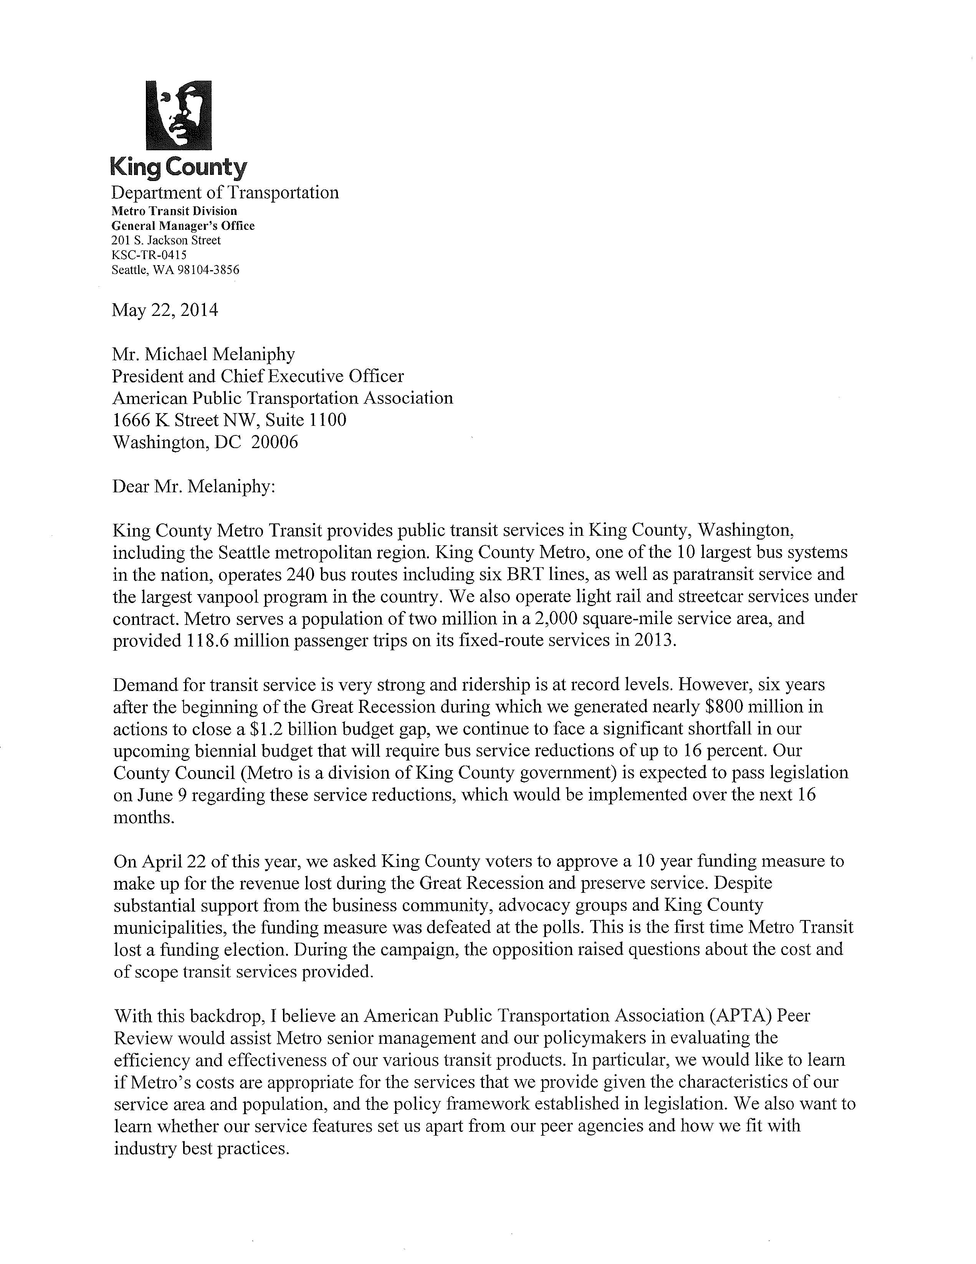
Appendix A
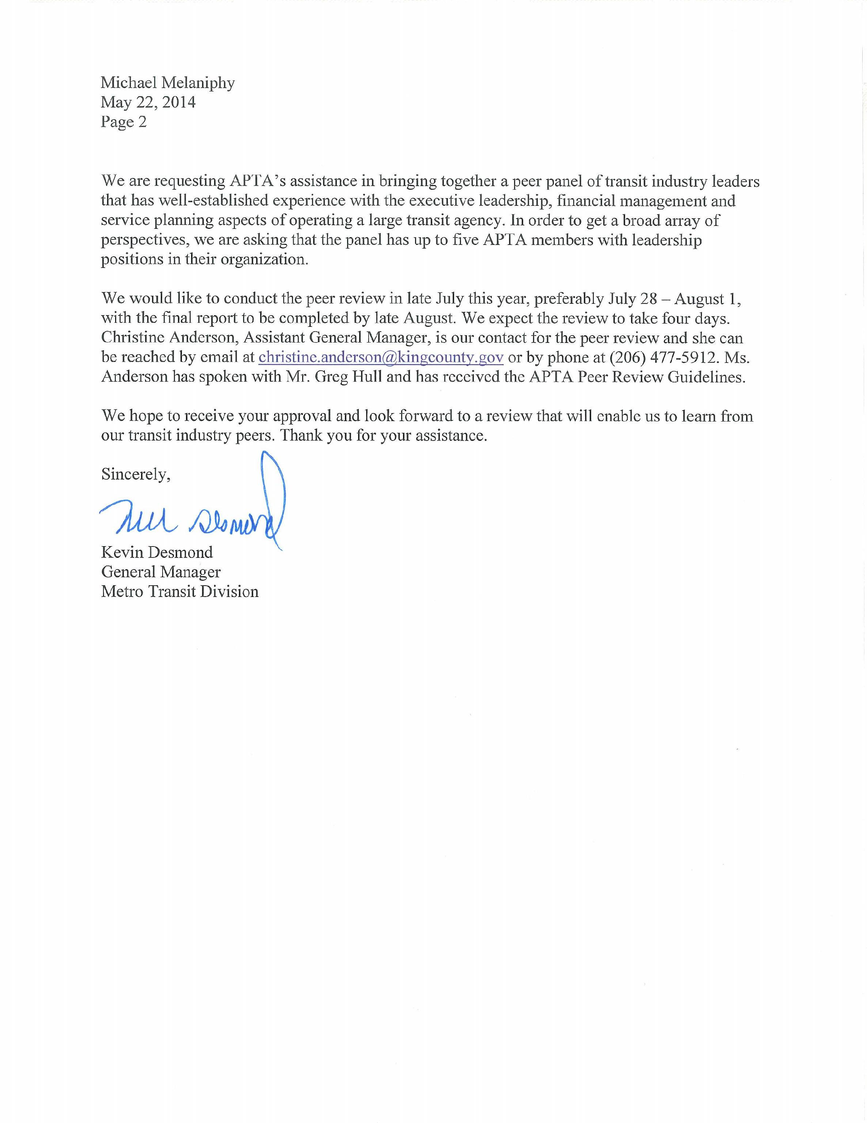
Appendix A
Agenda
Appendix B

 | 6:00 | Welcome Dinner / Metro Overview | Sazerac 1101 4th Ave

Tuesday, July 29
 | 8:00 | Arrival | King Street Center, 3A/B 201 S Jackson
- Settle In / Opening Remarks
 | 8:30 | Metro Overview | King Street Center, 3A/B
- Service Area and Customers
- Products and Services
- Service Quality
 | 9:45 | Break | King Street Center, 3A/B
 | 10:00 | Service Planning, Service Delivery, and Management | King Street Center, 3A/B
- Planning and Development of Service
- Management of Fleet and Capital Facilities to Support Service
- Delivery of Service
 | 12:00 | Working Lunch | King Street Center, 3A/B
 | 1:00 | Financial Management | King Street Center, 3A/B
- Fund Management Policies
- Fare Policies
 | 3:00 | Performance Management | King Street Center, 3A/B
- Comparison of Metro to Peers
- Metro’s Use of Comparative Tools
 | 4:00 | Policy Adherence | King Street Center, 3A/B
- Metro’s Policy Environment
Wednesday, July 30
 | 8:00 | Follow-up Q&A | Chinook 401 5th Ave
 | 9:00 | Council Discussions (45 minutes) | Chinook
 | 10:00 | SCA Meeting (45 minutes) | Chinook
 | 11:00 | Executive Office Conversation | Chinook
 | 12:00 | Working Lunch / Finance, Budget, Ad Hoc Discussion / Q&A | King Street Center, 3A/B
 | 2:00 | Panel Working Session | King Street Center, 3A/B
 | 4:30 | Metro / Panel Check-in | King Street Center, 3A/B

Thursday, July 31
 | 8:00 | Panel Report Out | King Street Center, 2A/B
 | 10:30 | Wrap-up | King Street Center, 2A/B

Appendix C

DOCUMENT LIST

- King County Strategic Plan
- King County Strategic Plan 2013 Progress Report
- King County Metro Resource Packet to Review Panel (varied background materials)
- Regional Governance Organization Charts

- King County Metro Packet of Recent Relevant Press Clippings
- King County Metro Packet of Varied White Papers and Reports
- Final Summary report of the Transit Performance Audit, 2009
- Metro Operations monthly Performance Reports (May, 2014)
- 2013 Service guidelines Report (November, 2013)
- King County Metro Trolleybus Evaluation (may, 2011)
- King County Metro Active Fleet Summary (July 29, 2014)
- Vehicle Maintenance-2014 (June 25, 2014)
- Cost per Boarding Analysis- Spring, 2013 (Draft)
- Fleet & Capital Facilities Summary Data/ Reporting Examples
- Security: Part I & II Crimes Statistics- 2nd Quarter 2014
- Design & Construction Section- Funding Uses 2012-2013
- Maintenance Employee & Position Counts (July 7, 2014)
- Operator Data- Part Time and Full Time (July 30, 2014)
- Code of Conduct- “Ride Right” Pamphlet/ “Electronic Thefts” Pamphlet
- King County Metro Transit- Contract security Organization Chart
- 2013 Fixed Route Bus (Costs Graph)
- 2013 Fixed Route Bus Costs/ Cost per Hour
- Fund Management Policies for the Public Transportation Fund (November 8, 2011)
- Regional Transit task Force Report (2010)
- Varied King County Metro Safety Data Reports (Operations & Workplace)
- 2012 National Transit Data Base (NTD) Reporting Statistics

