STAFF REPORT

Agenda Item: | 7 | Name: | Jenny Giambattista
Proposed No.: | 2024-B0084 | Date: | July 16, 2024

SUBJECT

An ordinance relating to King County's combined sewer overflow program and authorizing the King County executive to sign and fulfill the obligations in the First Material Modification to the 2013 Consent Decree with the United States Environmental Protection Agency and the Washington State Department of Ecology.

SUMMARY

In 2013, the King County Council authorized the execution of the 2013 Consent Decree with the Washington State Department of Ecology (Ecology) and the United States Environmental Protection Agency (EPA) for Combined Sewer Overflow (CSO). The 2013 Consent Decree obligates the County to complete its CSO control program through the implementation of a series of CSO control projects by December 31, 2030.

In mid-2024, King County, Ecology, and the EPA reached agreement in principle on the First Material Modification to 2013 Consent Decree on Combined Sewer Overflow (CSO). Proposed Ordinance 2024-0209 would authorize King County to enter into the First Material Modification to the 2013 Consent Decree with EPA and Ecology.

The First Material Modification extends the compliance milestones for the remaining CSO control projects and extends the overall compliance schedule from 2030 to 2037. Additionally, the First Material Modification updates design criteria for future projects, obligates the County to complete a sewer system optimization study with Seattle, updates reporting requirements, clarifies post-construction monitoring periods, and clarifies flexibility to change design specifications for future projects. Seattle has reached a similar modification of its consent decree. A completion date of 2037 is anticipated to increase the currently proposed rate forecast by approximately seven percent by the end of the forecast rate period.

BACKGROUND

Combined Sewer Overflow (CSO). Combined sewer overflows are discharges of untreated or partially treated sewage and stormwater released directly into marine waters, lakes, and rivers during heavy rainfall when the sewers have reached their capacity. Although the sewage in CSOs is greatly diluted by stormwater, both CSOs and stormwater may be harmful to public health and aquatic life because they carry chemicals and disease-causing pathogens.

From the late 1800s through the 1940s, engineers designed combined sewers (sewers that carry sewage and stormwater runoff in a single pipe) to convey sewage, horse manure, street and rooftop runoff, and garbage from city streets to the nearest receiving body of water. Combined sewers exist in many parts of older cities, including Seattle. Around the 1950s, most sewer systems were built as separated systems (sewage in one pipe; stormwater in another pipe). In the late 1950s, treating wastewater became the standard. Interceptor pipes were built to transport all wastewater (from either combined or separated systems) to treatment plants.

The vast majority of flows from the County’s combined sewer system go to West Point or one of five County wet weather stations for treatment before discharge. During heavy storms, however, untreated combined flows that exceed the capacity of sewers, storage facilities, and treatment plants discharge through CSO outfalls to Elliott Bay, Puget Sound, the Duwamish River, Lake Union, the Lake Washington Ship Canal, and Lake Washington. These CSOs serve as a safety valve in preventing sewer backups into homes and businesses.
Both King County and the City of Seattle manage CSOs within Seattle. King County's Wastewater Treatment Division manages 38 locations and Seattle Public Utilities manages 82 CSO locations. King County also has five CSO wet weather treatment plants.
Clean Water Act and CSO Control Planning and Implementation. The federal Clean Water Act was adopted in 1972. Its objective is to restore and maintain the integrity of the nation’s waters with two primary goals: eliminating discharges of pollutants into the nation’s waters and achieving/maintaining swimmable and fishable waters. The Clean Water Act requires all wastewater treatment facilities and industries that discharge effluent into surface waters to have a National Pollutant Discharge Elimination System (NPDES) permit. The Washington State Department of Ecology (Ecology) issues the permit as a vehicle for setting limits on the quality and quantity of effluent discharged from point sources such as treatment plants, CSOs, and industrial facilities.

CSO control is required by the federal Clean Water Act and Washington state law. “Control” means reducing the number of untreated overflows from each permitted CSO location to the Washington state standard of once per year based on a 20-year moving average. Any additional discharge events or discharges from unpermitted locations are unauthorized discharges in violation of Clean Water Act and NPDES permit conditions.

2013 Consent Decree. Based on a 2004 report to Congress noting the lack of progress in many communities, the EPA stepped up its efforts in nearly all major metropolitan areas that have combined sewer systems to ensure that long-term control plans were being implemented. The EPA systematically audited and then enforced compliance across the country via consent decrees which mandate CSO control actions.
In 2013, the EPA and Ecology filed a lawsuit alleging King County violated Sections 301 and 402 of the Clean Water Act and the conditions and limitations of the County’s West Point Treatment Plant National Pollutant Discharge Elimination System (NPDES) permit issued to the County by Ecology. The alleged violations related to the quality of the effluent released from CSO wet weather treatment stations that act as satellite treatment plants to the West Point Treatment Plant (West Point) and multiple unauthorized discharges from King County’s combined sewer system. In response, King County entered into a Consent Decree with EPA and Ecology. The King County Council approved Ordinance 17514, authorizing the King County Executive to execute the federal CSO Consent Decree, which took effect in July 2013.

The overall goal of the 2013 Consent Decree is to ensure that combined sewer overflows at King County’s outfalls occur on average only once per year based on a rolling 20-year average and that the effluent discharged from CSO control treatment plants meet prescribed standards. The 2013 Consent Decree obligates King County and the Department of Natural Resources and Parks (DNRP), through its Wastewater Treatment Division (WTD), to complete a series of CSO control projects by 2030. The projects listed in the 2013 Consent Decree were based on WTD’s 2012 Long-term CSO Control Plan Amendment approved by King County in September 2012 (Ordinance 17413). In addition, the 2013 Consent Decree directed the following:

- Implementation of CSO control projects already in design prior to the Consent Decree,
- Improvements in operations of existing CSO wet weather treatment stations to meet effluent standards,
- Reporting regarding progress towards the Consent Decree objectives, post-construction monitoring, etc.,
- Dispute resolution procedures, and
- Stipulated penalties for non-compliance.

The 2013 Consent Decree also directed King County to pay a $400,000 civil penalty split between EPA and Ecology. The City of Seattle (Seattle) entered into a separate Consent Decree in July 2013, to address alleged Clean Water Act violations associated with discharges from Seattle’s CSOs.

In 2016, a federal court approved a non-material modification to the 2013 Consent Decree. The non-material modification enabled the County to combine two of its projects with three Seattle projects into a single joint-project, known as the Ship Canal Water Quality Project.

Progress to date on CSO Control. Through independent and joint efforts, King County and Seattle have reduced the annual volume of untreated CSOs discharged to local waterbodies. Since the CSO control program began in the early 1980s, King County has invested more than $1 billion to reduce the average CSO discharge volume from an estimated 2.3 billion gallons to approximately one billion gallons per year. For context, Figure 2, shows the total amount of treated wastewater in 2023 versus the number of untreated gallons of flow in 2023.

Figure 1
Figure 2

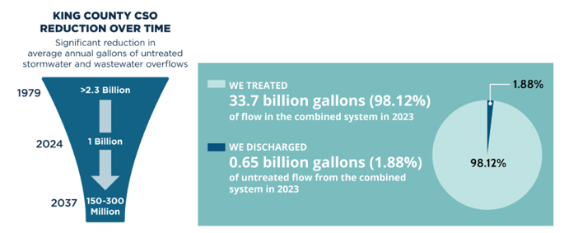
2023 WTD Treated and Untreated Flows

The locations of the completed, current, and future CSO projects are shown in Figure 3.

Figure 3
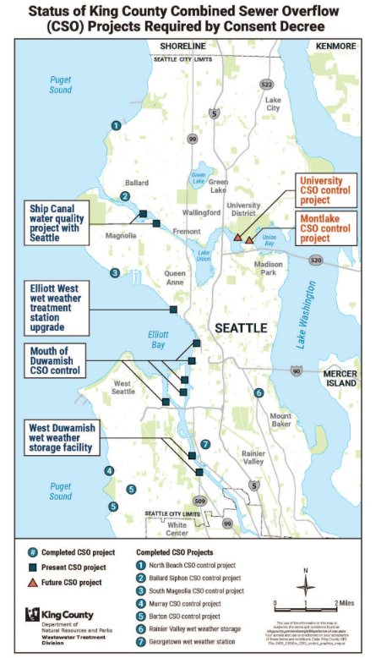

ANALYSIS

Proposed Ordinance 2024-0209 would authorize the Executive to enter into the First Material Modification to the Consent Decree to the 2013 Consent Decree with EPA and Ecology.

Proposed First Material Modification to Consent Decree. Due to changed conditions since the signing of the 2013 Consent Decree, in 2019 King County and Seattle requested to enter negotiations with EPA and Ecology to modify their respective Consent Decrees. The primary changed condition was an unexpected increase in CSO volumes for the remaining future projects, due in part, to climate change impacts on storm patterns. Increased control volumes require increased anticipated project sizes and complexities, which were projected to cause implementation costs that were significantly greater than expected in the 2013 Consent Decree. These changed conditions affect the County’s ability to complete the 2013 Consent Decree compliance program by 2030. Additional changed conditions include:

- Anticipated regulatory requirements for nutrient discharges to Puget Sound,
- Increasing need to invest in aging wastewater equipment and facilities,
- Preparation of a new long-term strategic plan for the regional wastewater system,
- Coordination with Seattle, and
- Rate affordability challenges to meet all obligations by 2030.

One example that illustrates the larger and more expensive projects is the West Duwamish project. In the 2013 Consent Decree, the West Duwamish project was described as a .32MG (million gallon) tank, which was estimated to cost $14.8 million in 2010 dollars. The proposed modification describes a 1.25MG tank, estimated to cost $100 million (in 2022 dollars). A comparison of the 2013 Consent Decree project criteria and milestones with the modified criteria and milestones can be found in Tables 2 and 3 of Attachment 4.

The negotiations between King County, EPA, and Ecology resulted in proposed modifications to address the changed conditions and other coordination, procedural, and reporting requirements that will enhance water quality improvements and ease implementation. There are twenty proposed modifications to the 2013 Consent Decree. The most significant changes as reported by WTD are bolded and explained in more detail in Attachment 4.

Proposed Modifications to the 2013 CSO Decree
- Elements of the 2013 consent decree (CD) that are not explicitly changed in this modification will still apply.
- Extends the overall compliance deadline from December 31, 2030 to December 31, 2037.
- Performance criteria are now defined in Paragraph 9 (Definitions) instead of within Appendix B.
- Streamlines the definition of “Twenty-Year Moving Average” without changing the substance and clarifies that either a Long-term Control Plan or Engineering Report may confirm the most appropriate model to use to calculate the average.
- Adds definition to clarify the meaning of “optimization” as it is used in new requirements such as the Coordinated Optimization Evaluation.
- Updates original definition by replacing “Facility Plans” with “engineering reports.” Clarifies that the monitoring window to confirm wet weather treatment station compliance begins the October following construction completion; adds Georgetown Wet Weather Treatment Station to the list of facilities; and clarifies the deadline to submit a Supplemental Compliance Plan if needed.
- Clarifies that the monitoring window to confirm wet weather treatment station compliance begins the October following construction completion; adds Georgetown Wet Weather Treatment Station to the list of facilities; and clarifies the deadline to submit a Supplemental Compliance Plan if needed.
- Extends the monitoring window for wet weather storage projects (period to demonstrate the facility meets the control standard) from “one year” to “two complete wet seasons” and clarifies the deadline to submit a Supplemental Compliance Plan if needed.
- Allows for streamlining of administrative process if reporting is required for CD supplemental Compliance and NPDES permit corrective actions, such that a single submittal can satisfy both requirements.
- Clarifies the process to revise the projects in Appendix B.
- Extends the schedule for Joint Plan updates from deadlines every 3 years to deadlines every 5 years. Adds commitment for the County’s Wastewater Treatment Division (WTD) and Seattle Public Utilities (SPU) to engage in a Coordinated Optimization Evaluation as part of the next update of the Joint Plan. This evaluation will look for ways to optimize systems and will inform the respective agencies’ CSO planning efforts.
- Confirms that the CSO Annual Report will report on the 20-year moving average for each outfall. (Note this is already done.)
- Adds Georgetown to the list of weather treatment stations. Adds additional penalties that would apply to exceedance of parameters defined in the West Point NPDES permit for each wet weather treatment station.
- Adds the Coordinated Optimization Evaluation to the description of Appendix D.
- Indicates that the outfall status listed in Appendix A was accurate as of 2012 and should be labeled as such.
- Re-sequences the remaining projects to construct Mouth of Duwamish projects before the University and Montlake projects. Replaces Appendix B with an updated table of projects and milestones.
- A,B,C acknowledge that WTD and SPU have completed the 2013 requirements to develop a Joint Plan and that the agencies continue to work together to ensure each system performs well without negatively affecting the other.
17D extends the schedule for Joint Plan updates from deadlines every 3 years to deadlines every 5 years.
17E Adds a commitment for WTD and SPU to complete a Coordinated Optimization Evaluation to conduct a joint effort to look for opportunities to strategically remove stormwater from the combined system, take advantage of system capacities in a more effective way, and/ or leverage operational strategies and technologies that improve system performance. A summary report will be due March 1, 2027 along with the existing deadline for the Joint Plan update. Note this optimization evaluation is an extension of past voluntary WTD/SPU collaborations that similarly assessed optimization opportunities.

Cost and Rate Impacts. The planning-level project cost estimate to complete the remaining CSO control projects is approximately $3.3 billion in 2022 dollars, though the total costs may range between $1.7 billion to $4.9 billion in 2022 dollars. WTD reports that the uncertainty of estimating so far ahead of project delivery necessitates a larger range estimate. Most of the estimates in the table are still early in early planning and this category of estimate can have a range of -50% to +150%. Once a project is defined and baselined, the uncertainty associated with estimating narrows dramatically. Additionally, WTD reports the estimate uses 2022 dollars to be consistent with the negotiation process the memo was developed to document. This $3.3 billion estimate is based on the following project estimates:

Table 1
Projects within the Cost Estimate

Project | Project Estimate in Millions (2022$)
Joint Ship Can Water Quality Project | $200 (King County share only)
West Duwamish (W. Michigan St./Terminal 115) | $100
Mouth of Duwamish (Chelan Ave./Hanford #2/Lander St./Kingdome/King St.) | $1,500
University | $670¹⁰
Montlake | $420¹⁰
Supplemental Compliance | $5/year¹⁰
Elliott West Wet Weather Treatment Station Upgrade | $330

Rate Impact. More than half of these cost estimates fall within the next 10 years of capital spending and are already included in the recently proposed 10-year sewer rate forecast under an assumption of a 2040 completion date. As part of the 2026 rate development process and WTD’s efforts to develop a long-term rate forecast as requested by Motion 16449, WTD will forecast how the rate impact of moving to a 2037 completion date could be spread out over the forecast period. Currently, as shown in Figure 4, the new completion date of 2037 would increase the forecasted monthly rate in 2034 by approximately seven percent. (Figure 4).

Figure 4

Sewer Rate Forecast of 2040 CSO Completion v. 2037 CSO Completion

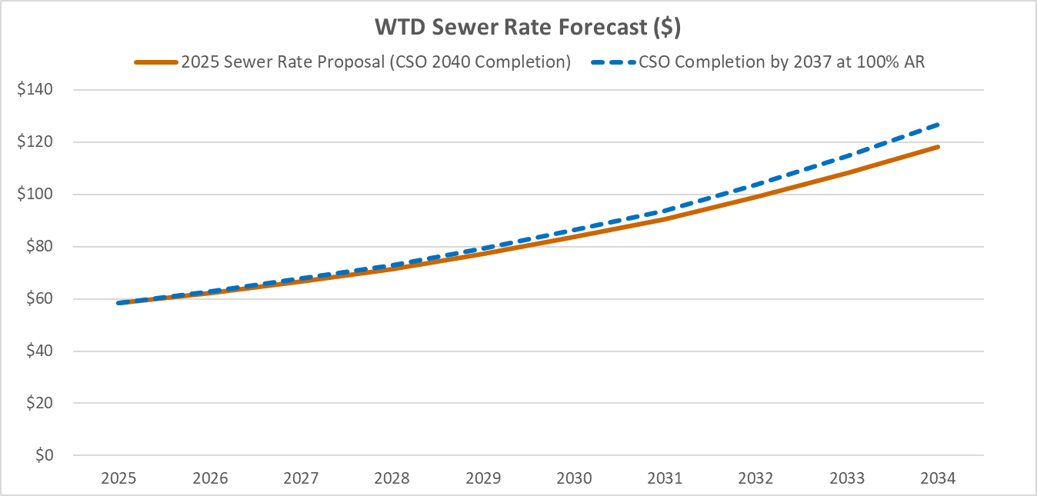

Next Steps. Once adopted by the King County Council and signed by the Executive, the First Material Modification to the 2013 Consent Decree will be lodged in federal court where a federal court judge will review the terms, allow for interested parties to comment during a comment period, and may enter the decree as final, provided all parties agree to its terms. After the First Material Modification is entered by the court, changes to the consent decree must be approved by the court.

INVITED

- Kamuron Gurol, Director, Wastewater Treatment Division, Department of Natural Resources and Parks
- Faon O’Connor, Combined Sewer Overflow Manager, Wastewater Treatment Division, Department of Natural Resources and Parks

ATTACHMENTS

- Proposed Ordinance 2024-0209 (and its attachment(s))
- Transmittal Letter
- Fiscal Note
- Overview of the Proposed Combined Sewer Overflow First Material Modification to the 2013 Consent Decree Between King County, Washington State Department of Ecology, and United States Environmental Protection Agency
- Combined Sewer Overflow Consent Decree Modification PowerPoint July 16, 2024

Ordinance 17514
Washington state law for Water Pollution Control can be found in Chapter 90.48 RCW.
The Clean Water Act establishes the basic structure for regulating discharges of pollutants into the waters of the United States and regulating quality standards for surface waters.
The EPA’s lawsuit related to violations of the Clean Water Act was part of a national enforcement strategy to compel the completion of CSO control and water quality improvements across the country.
The 2013 consent decree is filed in the United States District Court for the Western District of Washington under Case 2:13-cv-00677-JCC.
The 2016 non-material modification is filed under the same case number as the 2013 consent decree and can be found here. More information about the Ship Canal Water Quality project can be found here.
This represents investments made through September 2023.
The Puget Sound Nutrient General Permit was issued to the County on December 1, 2021. The new permit focuses on controlling discharges of excess nutrients – particularly nitrogen – to Puget Sound from domestic wastewater treatment plants. The Puget Sound Nutrient General Permit conditions apply to the County’s three regional wastewater treatment plants and the Vashon Treatment Plant.
Extends the monitoring window for wet weather storage projects (period to demonstrate the facility meets the control standard) from “one year” to “two complete wet seasons” and clarifies the deadline to submit a Supplemental Compliance Plan if needed.
Project estimates are Association for the Advancement of Cost Engineering (AACE) Class 10 cost estimates with a high degree of uncertainty. Project estimates will be refined as the projects proceed through predesign, design, and construction.
The Elliott West Wet Weather Treatment Station Upgrade is not a consent decree project but is required under the draft West Point Treatment Plant NPDES permit. It is included with the remaining consent decree projects to understand CSO related project costs on the 10-year rate forecast.
The proposed modified consent decree has some provisions for flexibility. Some of the decision-making for these changes is at the discretion of EPA and Ecology, beyond a certain threshold the court would need to approve the changes.

