Proposed 2023 Sewer Rate and Capacity Charge

and 2023-2032 Sewer Rate Plan

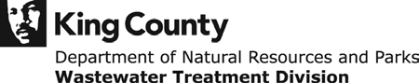

Table of Contents
King County Wastewater Treatment Division 1
Local Sewer Agencies (LSAs) 3
Sewer Rate Plan Forecast 4
Executive Summary: Proposed 2023 Sewer Rate and 2023-2032 Rate Plan 5
Background on the 2022 Sewer Rate and 2022-2031 Strategy (adopted in 2021) 5
Sewer Rate Plan Development and Stakeholder Engagement 5
Proposed 2023 Sewer Rate and 2023-2032 Rate Plan Forecast 6
Key Issues and Rate Drivers 6
Revenue Forecast 9
Capacity Charge 12
Other Revenue 17
Operating Expenditures 18
Operating Forecast 18
Incremental Forecasted Expenditures 19
Capital Improvement Plan (CIP) 19
Portfolio Management 19
2021 Performance and Accomplishment Rate 20
Proposed 2022-2032 Sewer Rate Plan CIP 21
Capital Expenditure Forecast Delivery Resource Analysis 24
Capital Program Funding Plan 27
Cash Funding 27
Debt Financing 27
2022 Planned Financing Activity and Strategies 29
Revenue Requirement 30
Cash Test 30
Debt Service Coverage Test 31
Reserves Management 32
Water Quality Operating Fund 4611 33
Water Quality Construction Fund 3611 34
Debt Reserves 8921 and 8922 34
Reference 34
Financial Policy Review 2022: 34
Supplemental WTD Debt Information 35
Forecast Assumptions 36
Asset Management Risk Profile Tier Descriptions 36
2021 Wastewater Treatment Division Financial Performance 37
Revenue 38
Expenditures 38
Debt 38
Cash Funding and Defeasance 39
Net Cash Flow 39

King County Wastewater Treatment Division
The Wastewater Treatment Division (WTD) of the Department of Natural Resources and Parks (DNRP) is the provider of wholesale wastewater treatment in the region. Distributed over a 424-square-mile service area, the King County (County) sewer system collects and treats an average of 175 million gallons of sewage a day from approximately two million residents.
DNRP is responsible for the construction, operation, and maintenance of the County’s regional wastewater conveyance and treatment system, which includes three major secondary treatment plants (West Point in Seattle, South Plant in Renton, and Brightwater in southern Snohomish County), 397 miles of conveyance lines, 48 pump stations, and 25 regulator stations. Other WTD facilities include four combined sewer overflow (CSO) treatment plants, four CSO storage facilities, 39 CSO outfall locations, and secondary treatment plants on Vashon Island and in Carnation.
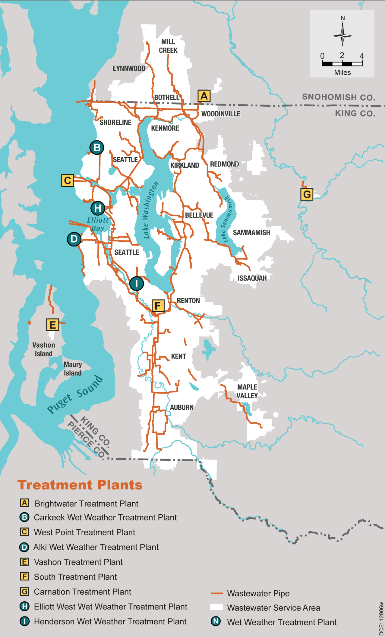

Local Sewer Agencies (LSAs)
The Local Sewer Agencies (LSAs) served by the County include 18 cities and 15 sewer districts in King County, south Snohomish County, and north Pierce County, and the Muckleshoot Tribe. The sewage disposal contracts with the LSAs specify that the following year’s sewer rate must be determined before July 1 of the current year. This provides time for the LSAs to include the WTD rate in preparing budgets and proposing local sewer collection rates for the following year.
WTD contracts directly with the LSAs; outside of the capacity charge program, WTD does not have a direct relationship with individual ratepayers. Engagement with the LSAs is accomplished through the Metropolitan Water Pollution Abatement Advisory Committee (MWPAAC) and the County Council’s Regional Water Quality Committee (RWQC).
The LSA contracts define the two customer classes for billing the agencies: single-family residential (SFR) and residential customer equivalents (RCEs). RCEs include all other customers, such as commercial, multi-family, and industrial. An RCE is determined by converting reported flows based on an equivalency that defines one RCE as 750 cubic feet per month. An industrial waste high strength surcharge is added to qualifying high strength flows.
A list of the LSAs and their year-end 2021 reported RCEs is provided in Table 1, below.
Table 1. 2021 Reported Customers by Local Sewer Agency

Sewer Rate Plan Forecast
Utility enterprise funds, such as the County’s Water Quality Operating Fund, are self-supporting and therefore must set user fees to recover costs of providing service. The total cost that must be generated by utility revenue sources in any given year is referred to as a utility’s revenue requirement. The requirement that the fund is self-supporting necessitates setting a sewer rate that results in total utility revenue sufficient to support total utility costs, including operating expenditures, debt repayment, and financial policies, such as cash funding of the capital program and debt service coverage.
WTD’s annual sewer rate-setting process includes the development of a 10-year forecast and financial plan, currently 2023-2032. The proposed 2023 sewer rate is prepared in the context of the revenue needs of the utility over the forecast period, which includes ongoing costs of operating the system and infrastructure investments to maintain system assets, meeting regulatory requirements, responding to climate change, and ensuring sufficient capacity in the regional conveyance system and treatment plants. Planning looks beyond just near-term funding needs because of the long useful life of many of the utility’s assets, which include equipment like pumps and motors, infrastructure like pipelines and tanks, buildings, vehicles and technology, and software and databases. The sewer rate is adopted annually, and the funding needs and revenues generated are viewed as part of a 10-year financial plan.

Executive Summary: Proposed 2023 Sewer Rate and 2023-2032 Rate Plan

Background on the 2022 Sewer Rate and 2022-2031 Strategy (adopted in 2021)
The 2022--2031 King County sewer rate plan (the adopted rate plan) developed in early 2021, is shown in Table 2 below. The adopted rate plan reflects:
- Annualized rate increases in response to feedback from external stakeholders to provide a smoother rate pattern and resulting customer bill impacts
- Increased capital program funding, including the power quality improvement project at West Point
- Accelerated asset management projects, including 12 new full-time equivalent employees (FTEs)
- Cash generated from sewer rate revenue that can be used to refinance debt at lower interest rates
The 2022-2031 adopted sewer rate plan included a one-year 4.0 percent rate increase in 2022.
Table 2. Adopted 2022-2031 Rate Plan

Sewer Rate Plan Development and Stakeholder Engagement
DNRP engaged the MWPAAC Rates and Finance Subcommittee throughout 2021 on topics related to the sewer rate, including financial policy and rate-setting methodology. MWPAAC requested early and transparent information on the proposed 2023 sewer rate. In response, DNRP engaged with the full MWPAAC and its Rates and Finance Subcommittee beginning in January 2022 to share findings from early policy direction that informs the preliminary sewer rate forecast. Details under consideration for the updated rate plan were shared in these forums, including elements such cost and timing of capital investments, along with a potential rate path for the 10-year financial plan. MWPAAC expressed appreciation for the responsiveness to the request for earlier and more transparent information leading up to the Executive’s proposed 2023 sewer rate and 2023-2032 rate plan.
The Regional Water Quality Committee also received an early rate briefing in March 2022, ahead of the traditional presentation at the committee’s May meeting.

Proposed 2023 Sewer Rate and 2023-2032 Rate Plan Forecast
Table 3 shows the proposed 2023 sewer rate of $52.11, which is a $2.84 or 5.75 percent increase over the 2022 rate of $49.27. The proposed 2023-2032 sewer rate plan shown in Table 3 includes smoothed annual increases rising from 5.75 percent annually through 2027 to 9.0 percent annually beginning in 2028. This increase enables WTD to meet a steep increase in the projected Capital Improvement Plan (CIP) due to the issues and rate drivers described following Table 3. A smoothed rate plan allows for the collection of revenues in excess of expenditures in a given year and less than expenditures in subsequent years to fully fund the utility over the forecast period.
For reference the table also includes for annual the debt service coverage ratio. This is an important measure considered by bond rating agencies for projected CIP expenditures in each year.
Table 3. Proposed Rate Plan
The goals for developing the proposed 2023 sewer rate are below:
- Increase reliability at West Point and offsite locations
- Comply with regulatory requirements
- Respond to growth-related demand on the sewer system
- Advance the most critical asset management projects
- Protect water quality and habitat consistent with the Clean Water/Healthy Habitat Strategic Plan
- Respond to and prepare for climate change consistent under the Strategic Climate Action Plan
- Address disparities in service delivery in alignment with the Equity and Social Justice Strategic Plan

Issues and Rate Drivers
The proposed sewer rate plan incorporates investments that make progress on each of the above goals. Rate drivers are called out based on either a significant financial impact or critical policy context.

Economic Conditions
The impacts of COVID-19 on the revenues collected by the utility are similar to the revenue forecast in the adopted sewer rate plan. The rate forecast has been calibrated to reflect actual billed RCEs coming in higher than forecast, and a one-year extension to the assumed timing of recovery to pre-pandemic 2019 billings.
Inflation rates have reached historically high levels in Q4 2021 and Q1 2022. Potential impacts to capital budgets are dependent on the rate and duration of inflation. The annual sewer rate-setting process limits risk around this unknown since it allows the County to integrate more data and updated forecasts one year from now in setting the 2024 rate.
Labor market constraints have slowed efforts to increase staffing to deliver a growing CIP. The forecasted substantial increases to the CIP relies on project delivery staff and implement delivery models. The 2022 CIP forecast is set at $283 million, after application of an 85 percent accomplishment rate. The anticipated increase from recent annual capital expenditures (about $200 million) is based on awarded construction contracts that are not limited by delivery staff constraints. Supply chain challenges and other external project delivery risks could impact the CIP forecast.

Reliability Investments
The West Point Treatment Plant Power Quality Improvement Project includes construction of an uninterruptible power supply system. This includes using large battery storage and a replacement building to house the system that will limit or eliminate overflows to Puget Sound due to power quality problems (voltage sags). Administrative Order #19477 issued by the Washington State Department of Ecology (Ecology), requires King County to address power reliability issues at West Point treatment plant. The Executive issued a Declaration of Emergency on February 25, 2021, to accelerate this work. WTD project delivery staff resources began work on this coordinated effort with Seattle City Light in 2021.
The 2022-2031 adopted sewer rate plan included completion of an inventory of critical risk asset management Tier 1 projects (e.g., repair or replacement of aging infrastructure) by the end of the plan in 2031. The 2023-2032 proposed sewer rate plan reflects an updated project schedule, including adjusting the start date for some of these projects, to 2022 because COVID-19 limited project delivery activities. The proposed 2023 rate plan includes $1.6 billion Tier 1 priority projects to be completed by 2033, including 19 updated or newly identified projects that scored as Tier 1 priority since the adopted sewer rate plan.

Responding to Regulations
The Consent Decree for Combined Sewer Overflow (CSO) projects maintains the timeline of 2040 as a completion date assumed in the 2022 adopted sewer rate plan, while moving forward some projects costs in recognition of approaching milestones. In a 2019 letter to the U.S. Environmental Protection Agency, King County requested schedule relief and opened negotiations on the CSO Consent Decree. The potentially updated timeline and project sequencing will be determined following completion of the Consent Decree negotiations. The proposed rate plan includes 40 percent of the total CSO costs ($1.68 billion), with the remaining $2.6 billion of costs assumed to be incurred in the following decade, and eventually in a future rate plan. This results in an increase of $1.2 billion, through 2032, from the $486 million currently in the adopted 2022 sewer rate plan.
Ecology issued the Puget Sound Nutrients General Permit in December 2021. The adopted 2022 sewer rate plan did not include sewer system improvements related to nutrient removal since conditions of the permit were not yet defined at the time of adoption of the 2022 sewer rate plan. In the interim, the County is negotiating a partial stay of certain permit requirements to help limit near-term costs. The proposed sewer rate plan incorporates initial investments related to permit conditions that include nitrogen reduction planning, evaluation, monitoring, and near-term optimization of plant operations, totaling $50 million.

Capacity Increasing Investments
The Flows and Loadings Study and Treatment Planning Program have identified capacity improvement needs at all three regional treatment plants. These possible future CIP projects will require adequate time for alternatives analyses, design, and construction. Some of these critical projects are past the indicated start date identified in the study and have been prioritized in the sewer rate plan CIP to ensure adequate treatment capacity and compliance with the National Pollutant Discharge Elimination System (NPDES) permits and the West Point settlement agreement.
Conveyance System Improvement (CSI) Plan The 2017 CSI Program Update identified high-priority conveyance system projects. The basis for this forecast includes the 2017 CSI Program Update, updated modeling analysis of high priority projects, and CSI Program staff input. All project locations currently identified have less than a five-year level of service; some have less than a one-year level of service. Project locations include both conveyance pipelines and pump stations. Sanitary sewer overflows have occurred at several project locations. Conveyance system improvement projects tend to have a long duration due to permitting and property issues. To address the highest capacity needs, these projects need have been prioritized in the sewer rate plan CIP.

The Clean Water Plan
The Clean Water Plan was paused in November 2021 to allow for regulatory clarity and to consider feedback received from partner agencies, stakeholder groups, and others. DNRP is thoughtfully considering adjustments to the plan and process based on this feedback. The process will resume after adjustments or enhancements to the process have been identified and discussed with stakeholders.

Climate Change
Progress on County Strategic Climate Action Plan (SCAP) goals would be made through $256 million of capital investments reflected in the proposed 2023 sewer rate plan period. Projects include the South Plant Biogas and Heat Systems Improvements Project, West Point Biogas Optimization Project, and Digester Circulation Pump Replacement Projects at the three regional treatment plants. These projects will reduce fugitive greenhouse gas emissions, increase the capture and beneficial use of biogas, and increase energy efficiency.,, Projects such as the Brightwater Reclaimed Water Storage Project and the Loop Biosolids Compost Pilot at South Plant will increase the reliability of recycled water delivery to customers in the Sammamish Valley and help build the market for compost.
Co-digestion project coordination with the Solid Waste Division began in 2022, and $10 million of initial investments are included in the proposed sewer rate plan. The process of co-digestion makes more efficient use of food waste and gas produced during the wastewater treatment process. The estimated cost to fully develop and implement co-digestion, and cost sharing across funding sources, is in development.

Additional Key Assumptions for the proposed 2023-2032 rate plan:
- The asset management Tier 1 initiative included beginning projects and ramping up CIP delivery in 2021. Due to multiple factors, but significantly related to project delivery staffing constraints, the 2021 delivery level remained at about $200 million. As a result, the accomplishment rate is at 69 percent, which is lower than the historical trend and target of 85 percent.
- In preparation for the updated forecast, staff performed a detailed project-by-project analysis to inform a realistic estimate for 2022 capital expenditures. While staff delivery capacity has not changed, the make-up of the spend forecast includes a larger portion of awarded construction contracts.
- Due to the increasing distribution of spending toward awarded construction contracts that are not constrained by project delivery staff capacity, an estimated 40 percent increase in capital expenditures over 2021 actuals is projected for 2022.
- Future CIP expenditure estimates are scaled to reflect the timing necessary to increase both the FTEs and consultant resources.

Financial Capability Assessment and Household Affordability
The EPA allows financial capability and household affordability information to be considered as part of negotiating a modification of a CSO Consent Decree. WTD engaged Raftelis Financial Consultants to perform a sewer rate affordability study and prepare the financial capability assessment to support King County’s request for a modification of its CSO consent decree. The study also produced an affordability assessment tool that will be applied to differentiate between Clean Water Plan alternatives when the plan is in process again.

Revenue Forecast
The sewer rate and capacity charge, together, make up 94 percent of total operating revenues for 2021. Table 4 shows WTD’s revenue components by size.
Table 4. Operating Revenue Components Sorted by Size
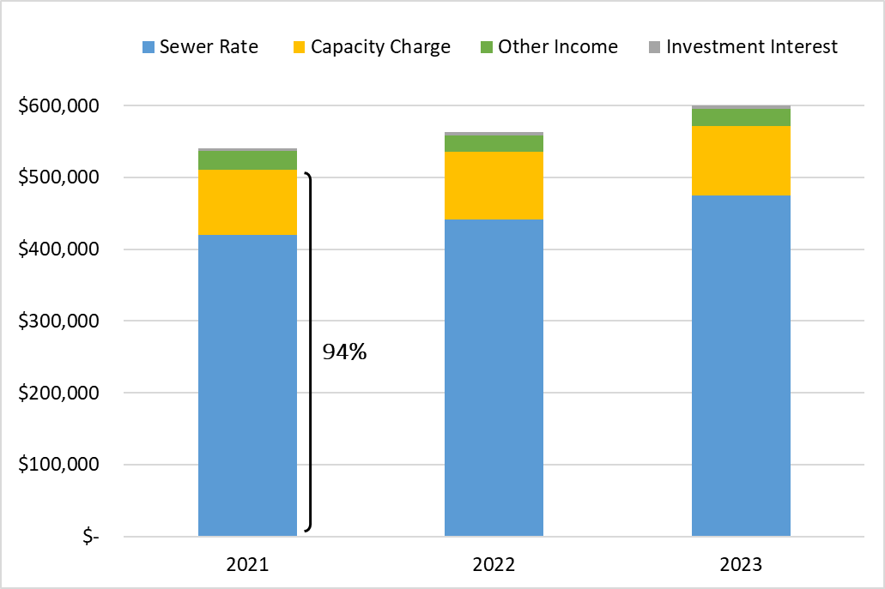

Sewer rate revenue is the largest component of WTD operating revenues at 78 percent. SFR customers make up 58 percent of the sewer rate customer base and are billed at one unit per household, regardless of water use. The remaining 42 percent of RCEs are comprised of commercial and multi-family customers in a combined rate class. An RCE is a unit used for billing purposes that converts reported water use (as a proxy for sewage flows) to the approximate equivalent of one SFR. As defined in the LSA contracts and King County Code 28.86.160, Financial Policy 15, one RCE is equal to 750 cubic feet of water usage.

Billing Structure
In contrast to the retail agencies that read meters and bill customers, either monthly or bimonthly, RCE reporting, and billing are performed on a quarterly cycle. As shown in Table 5, billings for the SFR class in a given quarter are based on RCEs reported in the quarter before the previous one (e.g., Q2 billing is based on Q4 reported).
The commercial and multi-family billing structure includes additional delay because these billings are based on a four-quarter rolling average of RCEs with the intent to minimize variability of billings to the agencies.
Table 5. RCE Reporting to Sewer Rate Billing Lag

Reported metered water use is the basis for billing the sewer rate to commercial and multi-family customers. SFR billings are fixed per unit and are not subject to changes in water demand.
Due to COVID-19, reported commercial water use dropped significantly beginning with the second quarter of 2020. Total actual revenue and billed RCEs were essentially unchanged in 2020 due to the significant billing lag timing. Billed sewer rate revenue was down 3.6 percent in 2021, as 2020 quarters came into the billing calculation. Revenue loss from both sewer rate and capacity charge revenue reductions were offset by savings resulting from very low interest rates realized in the 2020 and 2021 bond issuances (including defeasance and refundings).
COVID-19 revenue impacts are tracking closely to the forecast in the adopted sewer rate plan. The forecast is calibrated to reflect actual reported billings coming in higher than forecast, and a one-year extension to the assumed timing of recovery to pre-pandemic 2019 billings. Table 6 shows the RCE assumptions in the adopted sewer rate plan and Table 7 shows updated assumptions in the proposed sewer rate plan.
Table 6. RCE Assumptions Adopted Sewer Rate Plan
Table 7. Updated RCE Assumptions Proposed Sewer Rate Plan

In 2025, the forecast returns to the long-term growth assumption of 0.5 percent annual RCE growth for commercial and multi-family and 0.7 percent annual RCE growth for SFR. Future years are impacted by the loss of customer-base growth between 2019 and 2024, even as the rate of growth in the customer base is projected to return to pre-COVID-19 levels.

Historical Sewer Rate Increases
To provide context for the historical rate of growth to the revenue needs of the utility, rate increases going back to 1990 are provided in Table 8. The average annual rate increase is 4.7 percent going back to 1990.

Table 8. Historical Sewer Rate Increases (1990-2022)

Capacity Charge
Since 1990, King County has levied a capacity charge on structures with new connections to the sanitary sewer system. This charge is paid in addition to the monthly sewer bill assessed by the local sewer collection agency. Newly connecting customers are directly billed by King County for the capacity charge. The capacity charge rate is set annually by the County Council and is currently $70.39 per month for 2022.
In 1992, voters approved an amendment to the County's charter that authorized the merger of King County with the Municipality of Metropolitan Seattle (Metro), with the phased merger effective in 1994. As successor to Metro, the County assumed Metro’s rights and obligations, including authority to impose the capacity charge.
The Revised Code of Washington (RCW) 35.58.570 authorizing the capacity charge states:
“(1) A metropolitan municipal corporation that is engaged in the transmission, treatment, and disposal of sewage may impose a capacity charge on users of the metropolitan municipal corporation's sewage facilities when the user connects, reconnects, or establishes a new service to sewer facilities of a city, county, or special district that discharges into the metropolitan facilities. The capacity charge shall be based upon the cost of the sewage facilities' excess capacity that is necessary to provide sewerage treatment for new users to the system.
(2) The capacity charge is a monthly charge reviewed and approved annually by the metropolitan council.”
Currently, RCW does not allow the County to require upfront payment of the capacity charge, which is the most common industry approach to new development charges, such as impact fees and utility connection charges. The monthly charge reference is unique to the authorizing language for metropolitan municipal corporations and is not included in RCW authority for city and special purpose district connection charges that share much of the same language.
King County Code 28.86.160 Financial Policies state, “The capacity charge may be paid by new customers in a single payment or as a monthly charge at the rate established by the council…”
Customers may elect to pay the capacity charge in one lump sum or be billed quarterly based on the monthly rate for 15 years. The charge is linked with the property, meaning that unless a developer elects the lump-sum payment at the time of connection, it will be paid by the property owner(s) over the first 15 years that the property is connected to the system. Capacity charge payments impact households for the 15-year payment period.
While capacity charge prepayment is currently elective, King County Code 28.86.160 B F-15 3 c states that “King County shall pursue changes in state law to enable the county to require payment of the capacity charge in a single payment.”
Removing the requirement in RCW 35.58.570 that the capacity charge be a monthly charge and the provision in King County Code 28.86.160 allowing the charge to be paid over 15 years would enable the County to require payment of the capacity charge upfront in a single payment. This change to a single upfront payment would assign payment responsibility to the developer, rather than the eventual homeowner or commercial building owner. This change would be consistent with similar developer charges for infrastructure capacity, such as impact fees for transportation, school, fire, parks, and other utility connection charges.

Capacity Charge Updates
Regular updates to the underlying assumptions are guided by the King County Code 28.86.160, Financial Policy 15, which states, “Customer growth and projected costs, including inflation, shall be updated every three years beginning in 2003.
The county should periodically review the capacity charge to ensure that the actual costs of system expansion to serve new customers are reflected in the charge.”
The 2023 capacity charge update was to be a transition from the County’s Regional Wastewater Service Plan (RWSP) to an updated comprehensive plan, the Clean Water Plan. The comprehensive plan for the utility serves as the basis for projecting the number of customers, capital projects needed for capacity, and financial assumptions. The timing of this transition depended on Clean Water Plan progress.
Ordinance 19403 was passed on March 8, 2022. It provides time to incorporate both the Clean Water Plan inputs and develop the policy updates for the capacity charge methodology work that is in progress. It defers the update of customer growth and projected costs scheduled to be updated in 2021 for transmittal to the Council with the proposed 2023 sewer rate in 2022. The update is deferred until the next annual sewer and capacity charge rate proposal following council approval of the Clean Water Plan as an update to the RWSP or 2024, whichever comes first.
Until the update is completed, the proposed charge will continue to include the interim years’ annual inflation adjustment of three percent, consistent with WTD capital cost inflation forecast assumptions that will be applied. Table 9 provides the 2023 proposed capacity charge, based on the three percent adjustment to $72.50, and projects the charge and related lump-sum elective payment option for the forecast period, using the three percent interim increase.
Table 9. Capacity Charge 2023 Proposed Rate and 2023-2032 Forecast

Capacity Charge Consultant Review
In 2016, the County Council Auditor published capacity charge audit findings titled “Wastewater Capacity Charge: Unclear Whether Growth Pays for Growth.” The audit focused on whether the methodology and calculation established in 2003, and intended to be maintained and reconciled through 2030, would produce a charge that accomplishes the County’s policy that growth pays for growth through the capacity charge.
The seven recommendations outlined in the audit findings include significant and complex modeling changes and engagement with MWPAAC. Progress was made over the first three years following the audit (2017-2019), but were paused in 2020 with the onset of the COVID-19 pandemic. Recommendation 2 states that WTD “should have an independent party review the validity of the model’s methodology and calculations on a regularly scheduled basis.” WTD retained Raftelis Financial Consultants in January 2021 to respond to Recommendation 2 and provide expertise and resources to complete the remaining outstanding audit responses.
The consultant will also partner with the County in ensuring the sewer capacity needs and capital costs to provide the capacity as identified in the Clean Water Plan are incorporated into the capacity charge calculation. New customer connection charges, such as the County capacity charge, are based on the County’s comprehensive sewer planning document that forecasts future demands on the system and the cost of investments to provide any expanded capacity driven by growth or climate change. The current capacity charge approach was developed with the RWSP in the early 1990s and per King County Code 28.86.160 Financial Policies, stating, “The capacity charge shall be based upon the costs, customer growth and related financial assumptions used for the Regional Wastewater Services Plan adopted by Ordinance 13680 as such assumptions may be updated.”
Given the need for a response to the outstanding Auditor findings and recommendations, the capacity charge study is being conducted in two phases. Phase 1, as described below, has concluded with only the revised financial policy work still in progress. Phase 2 will use the cost and capacity findings in the Clean Water Plan to update the sewer capacity needs and capital costs when they are available.
Key objectives of the Phase 1 work plan include:
- Achieve transparency in both the model tool to calculate and update the charge, and in the guiding methodology.
- Evaluate an equitable and defensible growth-pays-for-growth methodology, rooted in applied concepts that can be understood by non-technical stakeholders.
- Produce revised financial policies in line with the proposed capacity charge methodology and using terminology and language that are accessible to non-technical stakeholders.
- Utilize consultant experience to produce focused and industry-supported alternatives to encourage collaborative engagement with component agencies and ultimately achieve broad consensus on selection of an alternative.
Three MWPAAC work group workshops were held between March and July 2021, with findings presented at the Rates and Finance Subcommittee and the MWPAAC general meeting in October 2021.
Phase 2 will commence when the Clean Water Plan progress is sufficient to inform calculation inputs and will include:
- Utilizing the Clean Water Plan capital cost and facility capacity forecast to draft an updated capacity charge, derived from the selected methodology alternative (based on stakeholder engagement processes) that prioritizes equity, transparency, and consistency for ongoing update.
- Utilizing the capacity charge report summarizing the data, assumptions, methodology, policies, and recommendations from Phase 1.

Capacity Charge Rate Structure
In 2020, the County approved updates to the rate structure of the capacity charge. As of January 1, 2021, the County uses average persons per household as the new basis of the capacity charge for residential structures.
The RCE assigned to single-family homes is based on size: small (<1,500 sq. ft. = 0.81 RCE), medium (1,500 – 2,999 sq. ft. = 1 RCE), and large (>3,000 sq. ft. = 1.16 RCE).
Using persons per household data also resulted in an update to RCEs assigned to multi-family units. The Council established a permanent classification for accessory dwelling units, such as backyard cottages and basement apartments, set at 0.59 RCE per unit.
A list of the historical capacity charge in each year going back to 2003 is provided in Table 10.
Table 10. Historical Capacity Charge Increases (2003-2022)

Capacity Charge Revenue Forecast
The majority of capacity charge revenue comes from customers using the 15-year payment plans, with the rest coming from elective prepayments. Ongoing payments are stable, while pre-payments vary significantly year to year and are difficult to forecast.
The level of revenue from elective prepayments of the capacity charge is difficult to predict from year to year, though these revenues are a smaller portion of the total capacity charge revenues. Table 11 shows the historical split between ongoing payments and elective pre-payments for the last 10 years. Until 2019, ongoing payments grew at an average annual rate of more than nine percent, driven by a regional construction boom that added large numbers of new connections every year. In contrast, the growth rate slowed to three and two percent for 2020 and 2021, respectively. Pre-payments have ranged between 18 to 31 percent of total capacity charge revenues, without a clear discernible pattern from one year to the next. Pre-payments in the pandemic-impacted years of 2020 and 2021 totaled amounts close to the averages seen before the record-high years of 2017, 2018, and 2019.
Table 11. Historical Capacity Charge Ongoing Payments and Prepayments (2012-2021)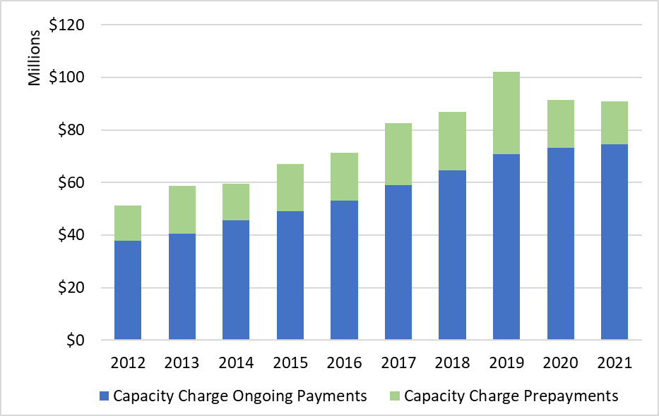
Projected revenue from 15-year payment plans has historically been escalated, based on a conservative six percent year-over-year growth. The 2022 adopted rate plan revenue forecast was reduced to three percent growth for the years 2022, 2023, and 2024 because to reflect reduced growth in capacity charge customers during COVID-19.
While the commercial real estate sector has been negatively impacted by the pandemic, residential real estate continued to benefit from increased demand for new construction. The reduced new connections forecast was based on an assumed reduction to new commercial sector connections. The 2023 sewer rate proposal maintains the lower three percent growth rate through 2024, given the flat trend observed in 2021 actuals and in line with the recovery assumptions for sewer rate revenues. Pre-payments are forecasted to grow at the same rate as ongoing payments, using the relatively low 2021 actuals as a conservative baseline. Table 27 reflects these updated assumptions, including the five percent long-term growth rate after 2024.

Other Revenue

Interest earnings
Interest earnings, also known as investment income, is revenue obtained by the County’s Water Quality Fund by investing its cash balances in the King County Investment Pool (pool). The pool pursues a low-risk investment strategy that prioritizes the availability of funds for its participating agencies to meet daily cash flow requirements. In 2021, WTD cash balances averaged approximately $630 million throughout the year, which includes cash balances for all WTD reserve accounts.
Interest-rate forecasts for the pool come from King County’s Office of Economic and Financial Analysis. The 2022 interest rate is estimated to be 0.75 percent. The economic impacts from COVID-19 resulted in a sharp decrease in interest rates and an initial commitment from the Federal Reserve (Fed) to maintain interest rates low as long as needed to sustain the economic recovery. However, elevated and persistent inflation has led the Fed to announce an acceleration to its rate-hike schedule and markets to expect considerable higher short-term rates by the end of 2022. The impact of lower interest rates on WTD’s revenues is limited since interest earnings represent less than one percent of WTD’s total revenues, and any earnings reduction is significantly offset by savings coming from a lower cost of debt.

Industrial, Septage, Resource Recovery
Other WTD income comes from 29 separate revenue sources. The largest of these sources are industrial surcharges, septic hauler fees, and sales of methane, electricity, and Renewable Identification Numbers (RINs). Most revenue components are forecasted at three percent growth beginning in 2022.

Operating Expenditures
The 2021-2022 revised operating budget for the utility is the basis for forecasting operating costs for future years. The Adopted 2022 Rate Plan included budgeted operating expenditures at $172 million in 2021 and $174 million in 2022, plus incremental costs, including staffing, to initiate the asset management Tier 1 plan and costs associated with a lease for a new building for maintenance and construction staff who are currently working at the Jameson building.
Table 12 shows the 2021 actuals compared to the adopted budget along with the2022 budget with percent change year over year.
Table 12. 2021-2022 Operating Expenses

Operating Forecast
Historically, annual growth in operating expenditures has averaged four percent as a composite of inflation and maintaining an aging and growing system. Table 13 shows the annual growth in operating expenditures going back to 2010.
Table 13. Historical Annual Increase in Operating Expenditures
(Inflation plus new and growing system costs)

Incremental Forecasted Expenditures
The County and its labor partners through the Coalition of Unions have reached a tentative agreement on a general wage increase for County employees. A 1.5 percent increase for 2021 applied retroactively, and a 3.0 percent increase for each of the subsequent three years is expected.
Central service costs are impacted by costs generated by internal service fund agencies and general fund central agencies that provide those services. It is expected that the general wage increase will impact most of these agencies. Agencies are also susceptible to industry-specific cost pressures, for example, the King County Office of Risk Management recently raised its 2022 insurance rate beyond the previously adopted level due to an unprecedented rise in claims and other costs across the country and at King County.
Last year’s proposed rate plan included an estimated annual cost for leasing a new building for maintenance and construction staff who are currently located at the Jameson building in the amount of $830,000. Based on the official lease agreement, the WTD operating fund will incur an additional $1 million over the budgeted $830,000.
New operating investments are included in the rate plan for 2023 totaling $11 million. These investments are aimed at helping WTD achieve goals and deliver on priorities, such as system reliability, regulatory compliance, managing growth-related demands, and asset management. Examples include staffing for ongoing support of new combined sewer overflow treatment and storage facilities, preparation and analysis of nutrient samples, corrective and preventative maintenance and services on HVAC and electrical systems, and conveyance inspection and flow monitoring. A total of 96 new FTEs is reflected in these cost increases.
Incremental operating costs are forecast based on general cost inflation at three percent and labor cost inflation at four percent in years beyond those covered by the tentative labor agreement through 2024, before applying forecasted growth in operating costs per Table 27.

Capital Improvement Plan (CIP)

Portfolio Management
Beginning in 2017, WTD focused on developing a more comprehensive and structured approach to managing its capital program. This work included the goal of aligning the mix of projects in WTD’s CIP with its strategic initiatives and overall mission. A pilot of this prioritization approach informed the 2019 sewer rate development and since then has been used to inform rate and budget-setting processes.
Projects are organized and prioritized within the following categories on Table 14.
Table 14. Capital Portfolio Category Descriptions

2021 Performance and Accomplishment Rate
The capital accomplishment rate is the amount of actual or forecasted capital spending that occurs in the year compared with the amount of capital spending planned. WTD’s capital program accomplishment rate target of 85 percent is evaluated against the actual spending in recent years to ensure it remains a valid assumption. Using an accomplishment rate in the financial plan allows WTD to adjust the capital program’s funding plan to more accurately reflect the impact of delays in the execution of capital projects that in turn delay spending. The 85 percent accomplishment rate is applied to the cash flow forecast for all projects, except the Georgetown Wet Weather Treatment Station and the Joint Ship Canal CSO project. Based on the progress of these two projects and the remaining costs being primarily for contracted construction, the plan assumes Georgetown will achieve the remaining $33 million planned spending and that the Joint Ship Canal will achieve its $100 million planned spending within the six-year planning period, based on a 100 percent accomplishment rate.
The resulting blended 2021 accomplishment rate was 89 percent. The 2021 actual spend of $201 million resulted in an accomplishment rate of 69 percent, a 20 percent lower accomplishment rate and cost difference of approximately $58 million less in capital spending than forecast in 2021.
Drivers for this low accomplishment rate include:
- Large Construction Projects Underspent: The Joint Ship Canal and Georgetown Wet Weather Treatment Station projects achieved 72 percent and 77 percent accomplishment rate respectively. The accomplishment rate was low for these two projects due to COVID mandates and global supply chain disruptions. The forecasts for these two projects comprised 26 percent of the total 2021 CIP forecast.
- Resources: New projects and subprojects were delayed while onboarding new staff necessary to deliver these projects. Shifting staff resources to newly prioritized projects has also resulted in delays to existing projects. This resulted in severe underspending for the projects affected.
Table 15 presents the historical accomplishment rate performance from 2016 through 2021.
Table 15. Historical Accomplishment Rates for the Capital Program ($ in millions)

Proposed 2022-2032 Sewer Rate Plan CIP
WTD reviewed project scopes, risks, cash-flow projections, and schedules of all projects in the CIP to update spending forecasts for the existing capital program. WTD developed the future capital program by developing conceptual forecasts for projects and programs that would progress the sewer rate development goals.
The following five projects are the largest individual components of WTD’s six-year CIP.

Joint Ship Canal Water Quality
The Ship Canal Water Quality Project is a joint project with the City of Seattle. The 2.7-mile tunnel project is mandated through separate consent decrees the County and City have with the EPA and Ecology. The project is expected to prevent an average of 75 million gallons of uncontrolled sewage overflows annually and currently is in construction with an anticipated completion date of 2025.

West Point Power Quality Improvements
The West Point Power Quality project includes construction of an uninterruptible power supply system using large battery storage and a replacement building to house the system that will limit or eliminate overflows to Puget Sound due to power quality problems (voltage sags). Administrative Order #19477 issued by Ecology requires King County to address power reliability issues at the West Point treatment plant. The Executive issued a Declaration of Emergency on February 25, 2021, to accelerate this work. WTD project delivery staff resources began work on this coordinated effort with Seattle City Light in 2021.

North Mercer Island/Enatai Sewer Upgrade
This project will increase the reliability and capacity of the existing North Mercer Island Interceptor and Enatai Interceptor components of the regional wastewater system to convey the 20-year peak wastewater flows projected through the year 2060. Project construction will include approximately 17,210 linear feet of new sewer pipeline and related features and will upgrade the County’s North Mercer Pump Station on Mercer Island. This project is anticipated to start construction in 2022 and extend until 2025.

Interbay Sewer and Odor Control Upgrade
The County will upgrade an aging sewer pipe in Seattle’s Interbay neighborhood. The existing pipe was built in 1967 and is nearing the end of its service life. New odor-control technology will be added to the system while the sewer pipe upgrade is underway. When complete, the sewer will provide reliable service for another 50 years or more. Construction is anticipated to be complete by 2025.

Coal Creek Sewer Upgrade
The County will upgrade a regional sewer line that serves Bellevue and Newcastle. The existing pipeline was built between 1966 and 1991. The pipeline is nearing its maximum capacity and needs to be upgraded to carry more wastewater and meet the growing needs of the community. The existing Coal Creek Trunk is approximately 2.5 miles long and primarily follows the banks of Coal Creek in the Coal Creek Natural Area between Newcastle and I-405. The new pipeline alignment will move the active pipeline away from Coal Creek, offering better protection to this sensitive environmental area. The selected pipeline alignment also aims to decrease impacts to both the Natural Area and Coal Creek Parkway SE during construction. Construction is anticipated to begin in 2023 and extend through 2027.
Updated spending forecasts for the existing program form the basis from which the CIP forecast is developed after integrating policy direction on key issues and building up the assumptions driving a ten-year capital program forecast.
Table 16 summarizes the investment strategy behind the CIP included in the proposed rate plan and is followed by a descriptive summary of rate drivers and key issues for the proposed sewer rate plan.
Table 16. WTD Proposed 2022-2032 Sewer Rate Plan CIP Investment Strategy
The proposed sewer rate plan incorporates investments that make progress on each of the sewer rate development goals. Rate drivers are called out as either significant in financial impact or critical policy context.

Economic Conditions
The impacts of COVID-19 to the revenues collected by the utility are similar to the revenue forecast in the adopted sewer rate plan. The rate forecast has been calibrated to reflect actual billed RCEs coming in higher than forecast, and a one-year extension to the assumed timing of recovery to pre-pandemic 2019 billings.
Inflation rates have reached historically high levels in Q4 2021 and Q1 2022. Potential impacts to capital budgets are dependent on the duration of currently high-cost inflation. The annual sewer rate-setting process limits risk around this unknown since it allows the County to integrate more data and updated forecasts one year from now in setting the 2024 rate.
Labor market constraints have slowed efforts to increase staffing to deliver a growing CIP. The forecasted substantial increases to the CIP relies on project delivery staff and implement delivery models. The 2022 CIP forecast is set at $283 million, after application of an 85 percent accomplishment rate. The anticipated increase from recent annual capital expenditures (about $200 million) is based on awarded construction contracts that are not limited by delivery staff constraints. Supply chain challenges and other external project delivery risks could impact the CIP forecast

Reliability Investments
The West Point Treatment Plant Power Quality Improvement Project includes construction of an uninterruptible power supply system. This includes using large battery storage and a replacement building to house the system that will limit or eliminate overflows to Puget Sound due to power quality problems (voltage sags). Administrative Order #19477 issued by the Washington State Department of Ecology (Ecology), requires King County to address power reliability issues at West Point treatment plant. The Executive issued a Declaration of Emergency on February 25, 2021, to accelerate this work. WTD project delivery staff resources began work on this coordinated effort with Seattle City Light in 2021.
The 2022-2031 adopted sewer rate plan included completion of an inventory of critical risk asset management Tier 1 projects (e.g., repair or replacement of aging infrastructure) by the end of the plan in 2031. The 2023-2032 proposed sewer rate plan reflects an updated project schedule, including adjusting the start date for some of these projects, to 2022 because COVID-19 limited project delivery activities. The proposed 2023 rate plan includes $1.6 billion Tier 1 priority projects to be completed by 2033, including 19 updated or newly identified projects that scored as Tier 1 priority since the adopted sewer rate plan.

Responding to Regulations
The Consent Decree for Combined Sewer Overflow (CSO) projects maintains the timeline of 2040 as a completion date assumed in the 2022 adopted sewer rate plan, while moving forward some projects costs in recognition of approaching milestones. In a 2019 letter to the U.S. Environmental Protection Agency, King County requested schedule relief and opened negotiations on the CSO Consent Decree. The potentially updated timeline and project sequencing will be determined following completion of the Consent Decree negotiations. The proposed rate plan includes 40 percent of the total CSO costs ($1.68 billion), with the remaining $2.6 billion of costs assumed to be incurred in the following decade, and eventually in a future rate plan. This results in an increase of $1.2 billion, through 2032, from the $486 million currently in the adopted 2022 sewer rate plan.
Ecology issued the Puget Sound Nutrients General Permit in December 2021. The adopted 2022 sewer rate plan did not include sewer system improvements related to nutrient removal since conditions of the permit were not yet defined at the time of adoption of the 2022 sewer rate plan. In the interim, the County is negotiating a partial stay of certain permit requirements to help limit near-term costs. The proposed sewer rate plan incorporates initial investments related to permit conditions that include nitrogen reduction planning, evaluation, monitoring, and near-term optimization of plant operations, totaling $50 million.

Capacity Increasing Investments
The Flows and Loadings Study and Treatment Planning Program have identified capacity improvement needs at all three regional treatment plants. These possible future CIP projects will require adequate time for alternatives analyses, design, and construction. Some of these critical projects are past the indicated start date identified in the study and have been prioritized in the sewer rate plan CIP to ensure adequate treatment capacity and compliance with the National Pollutant Discharge Elimination System (NPDES) permits and the West Point settlement agreement.
Conveyance System Improvement (CSI) Plan The 2017 CSI Program Update identified high-priority conveyance system projects. The basis for this forecast includes the 2017 CSI Program Update, updated modeling analysis of high priority projects, and CSI Program staff input. All project locations currently identified have less than a five-year level of service; some have less than a one-year level of service. Project locations include both conveyance pipelines and pump stations. Sanitary sewer overflows have occurred at several project locations. Conveyance system improvement projects tend to have a long duration due to permitting and property issues. To address the highest capacity needs, these projects need have been prioritized in the sewer rate plan CIP.

The Clean Water Plan
The Clean Water Plan was paused in November 2021 to allow for regulatory clarity and to consider feedback received from partner agencies, stakeholder groups, and others. DNRP is thoughtfully considering adjustments to the plan and process based on this feedback. The process will resume after adjustments or enhancements to the process have been identified and discussed with stakeholders.

Climate Change
Progress on County Strategic Climate Action Plan (SCAP) goals would be made through $256 million of capital investments reflected in the proposed 2023 sewer rate plan period. Projects include the South Plant Biogas and Heat Systems Improvements Project, West Point Biogas Optimization Project, and Digester Circulation Pump Replacement Projects at the three regional treatment plants. These projects will reduce fugitive greenhouse gas emissions, increase the capture and beneficial use of biogas, and increase energy efficiency. Projects such as the Brightwater Reclaimed Water Storage Project and the Loop Biosolids Compost Pilot at South Plant will increase the reliability of recycled water delivery to customers in the Sammamish Valley and help build the market for compost.
Co-digestion project coordination with the Solid Waste Division began in 2022, and $10 million of initial investments are included in the proposed sewer rate plan. The process of co-digestion makes more efficient use of food waste and gas produced during the wastewater treatment process. The estimated cost to fully develop and implement co-digestion, and cost sharing across funding sources, is in development.

Capital Expenditure Forecast Delivery Resource Analysis
Considering the sharp increase to the capital expenditure forecast in the proposed rate plan, an analysis was conducted to evaluate a potentially realistic approach to scaling up the resources necessary to deliver the priorities that drive the steep cost curve. The 2022-2032 capital forecast is based on limiting the target capital spend plan to allow timing to increase staffing and consultant resources. WTD has prepared a staffing plan that plots a timeline for the ramp up of project delivery resources.
Staff conducted an analysis of historical capital output in relation to the number of WTD FTEs dedicated to capital so that relationship could be used to estimate a capital spending target that would not unreasonably exceed staff capacity to deliver. The FTEs dedicated to capital include FTEs that are fully allocated to capital, such as those in the Project Planning and Delivery Section, and FTEs with a partial allocation to the capital program, such as Environmental and Community Services, Operations and Maintenance, and Finance and Administration.
FTE counts since 2012 were graphed against capital expenditures for the same period to generate a general relationship of number of capital FTEs to dollars delivered in a given year. The analysis relied on several assumptions including:
- New FTEs take two years to fully onboard and carry a project load equivalent to existing staff.
- Project staffing would maintain the historical in-house to consultant ratio (for every $1 spent on in-house direct labor, $1.30 is spent on consultant contracts).
- The FTE count would grow at the same rate as outsourcing to consultant community.
An approach that targets growing in-house staff at the same time as reliance on consultants seeks to:
- Meet equitable workforce development goals by deliberately recruit and hiring a diverse workforce at levels
- Build a strong bench of internal expertise that understands the wastewater system, with the ability to learn and adapt as the challenges and complexities grow reducing the learning curve and quickly responding to emergent issues.
- Increase broad understanding and experience of the wastewater system and increase staff retention by providing a variety of project assignments.
The forecast includes recognition of approaching milestones, which includes CSO costs. For this analysis, it was assumed that these expenditures would be delivered by project teams that have an FTE to consultant ratio comparable to the distribution used by WTD in delivering the Brightwater Treatment Plant and Conveyance megaproject.
Based on this approach and the assumptions described a 2022-2032 spending curve for the ten-year capital spend plan included in the proposed 2023-2032 rate plan, was developed by multiplying the historical average expenditure per FTE by the projected total productive (based on noted onboarding assumption) FTEs each year. Annual FTE additions were capped at 50 per year as the basis for a reasonably realistic recruiting and hiring assumption.
The resulting cost curve was tested to ensure the ratio of staffing to capital delivery is reflected in the total cost of capital project priorities for the period as compared to the staff delivery capacity, on a net present value basis (accounting for inflation costs in changing the timing of capital expenditures). This can theoretically be realized by shifting outward some project timing in the earlier years and increasing in the later years, while delivering the same array of CIP projects over the 10-year period.
Table 17 shows the FTE forecast assumptions and related cost curve.
Table 17. Delivery Resource Mapped Capital Expenditure Forecast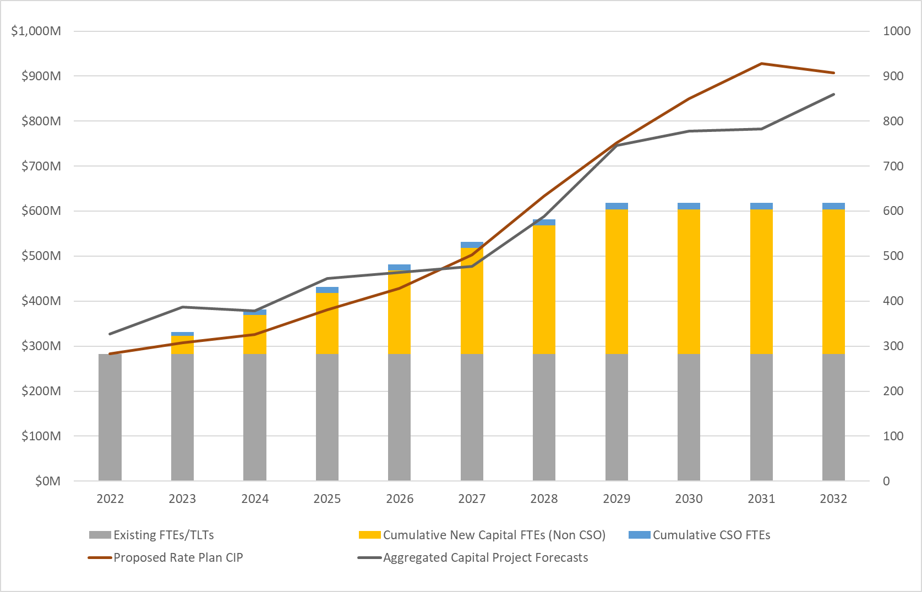

Table 18 compares the 2023 Proposed and 2022 Adopted 2022-2027 CIP spending plan.
Table 18. WTD 2023 Proposed and 2022 Adopted 2022-2027 Spending Plan
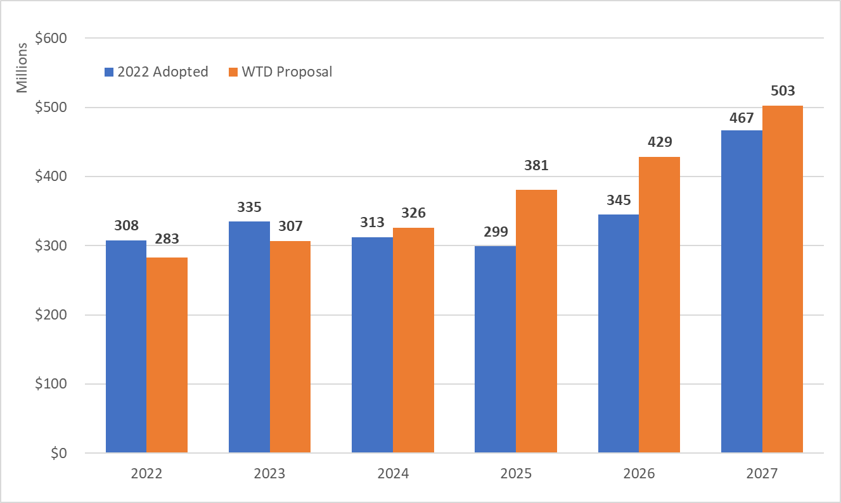

Table 19 shows the annual capital investments included in the proposed rate plan in their respective Portfolio categories.
Table 19. Proposed Capital Investments by Portfolio Category for Ten-Year Forecast
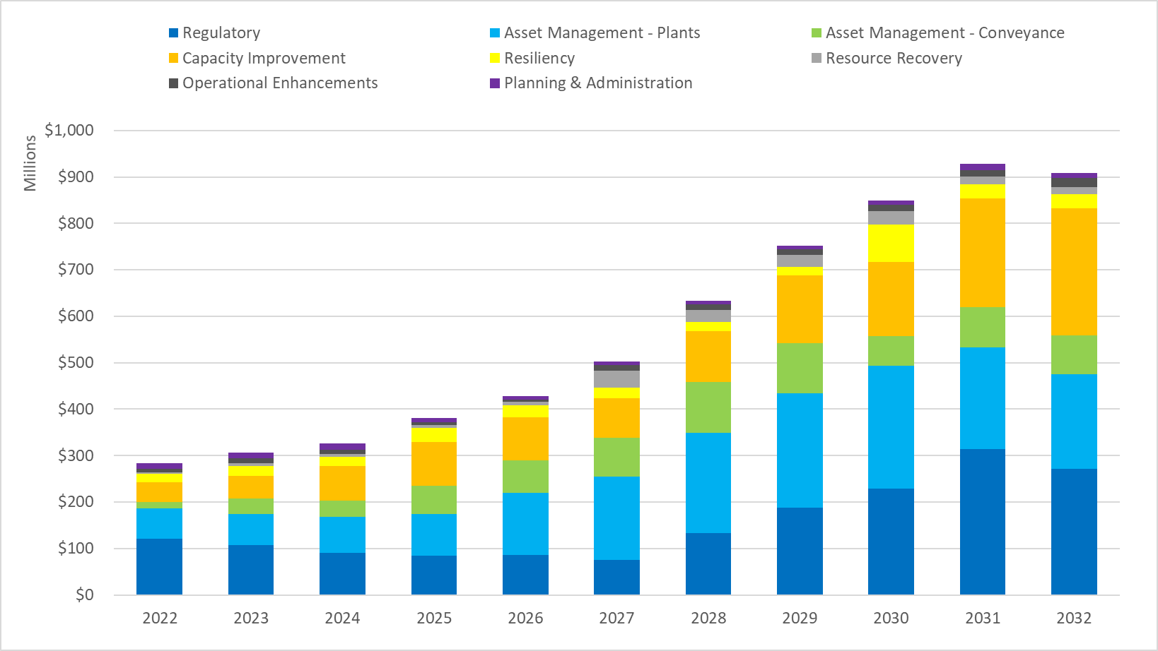

Capital Program Funding Plan
The capital program is funded by two primary sources: 1) cash generated from the sewer rate and capacity charge revenues; and 2) by debt financing from revenue bonds or low-interest state and federal loan programs.

Cash Funding
The sewer rate is set at a level to ensure that 40 percent of the capital spending plan funding is generated from revenues. Year to year fluctuations are managed to allow a smoothed rate increase plan.
Since the target cash funding is accumulated over the course of the year, a single, year-end transfer to the construction fund from the operating fund makes the cash available for funding capital projects in the following year.

Debt Financing
Debt financing is used when there is a state or federal loan secured for a project, or when revenue bonds are issued to balance the total annual funding needs after use of cash and secured loans.
While bonds have typically been issued annually. However, in order to secure record-low interest rates available in 2020, WTD issued bonds intended to balance capital funding needs through the 2021-2022 biennium, rather than annually.
Table 20 shows the capital funding plan and the use of various debt instruments secured to fund the capital program. The Bond Funded bar shows 2022 use of proceeds including some of the bond proceeds from the 2020 revenue bond issuance. WTD is planning to draw the full amount of its Georgetown federal Water Infrastructure Finance and Innovation Act (WIFIA) loan in 2023, the final year possible, and carry forward some of the cash funding from that year into 2024.
Table 20. Capital Funding Plan Funding Sources
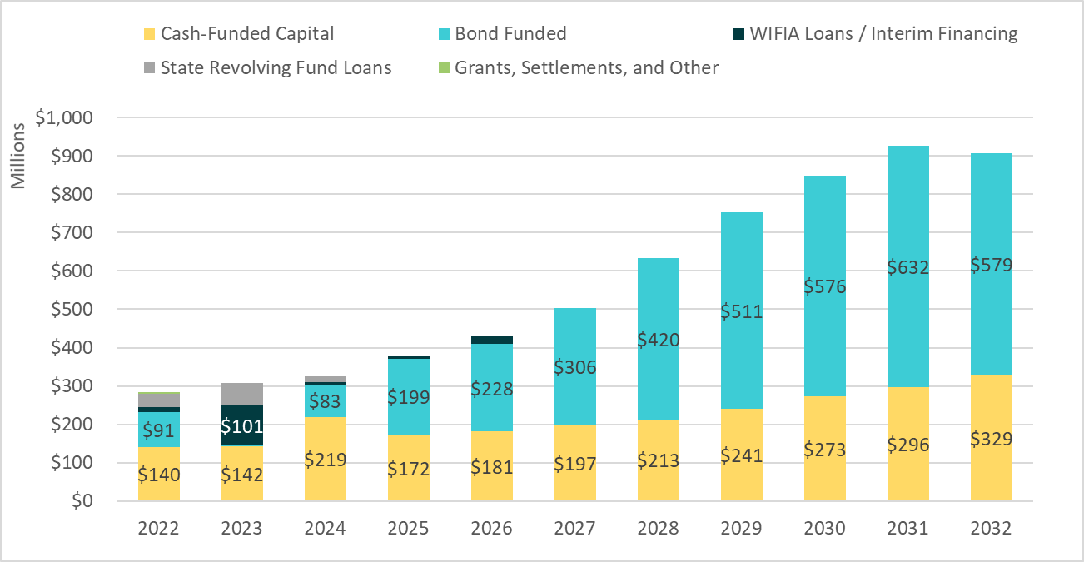

Table 21 illustrates the impact to the balance of total outstanding debt resulting from the financing activities necessary to deliver the capital program. The balances in this chart reflect the annual reduction in debt balances from debt service repayment.
Table 21. Existing and New Debt Balances
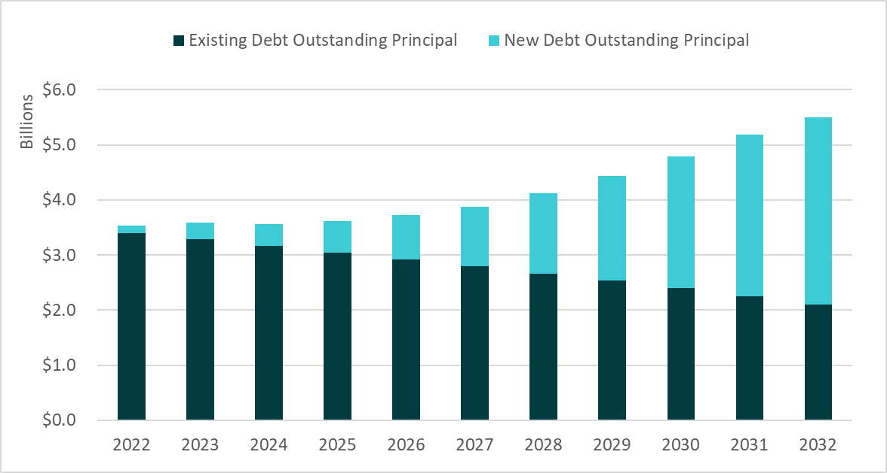

2022 Planned Financing Activity and Strategies

State Revolving Fund Loans
WTD has been awarded its third Georgetown State Revolving Fund (SRF) loan for a total of $43 million at a 1.6 percent interest rate; and has requested an additional $40 million at 1.4 percent. The additional amount requested could be revised upwards to $66 million pending updated construction costs. If approved by Ecology, this could drastically reduce the need to draw upon the full WIFIA loan of $134.5 million at an interest rate of 3.06 percent, resulting in significant cost savings. WTD expects a response from Ecology in early spring 2022.

Proposed Legislation to Restore Tax-Exempt Advanced Refunding
Tax-exempt bonds have traditionally been issued by state and local governments for public infrastructure. WTD uses tax-exempt bond financing as its primary source of long-term financing for the capital program. Investors who purchase these bonds are exempt from paying federal income tax on interest earnings, so they are willing to buy the bonds at a lower interest rate than conventional bonds, which becomes lower-cost debt to the borrower. Prior to the 2017 Tax Cuts and Jobs Act (TCJA), tax-exempt advanced refunding bonds could be issued to refund outstanding tax-exempt debt with higher than current market interest rates. The TCJA eliminated tax-exempt refunding bonds.
In February 2021, legislation was introduced in the U.S. Congress that would amend the federal tax code to restore state and local governments’ ability to use advanced refunding to manage bond debt and reduce borrowing costs for public projects. WTD is tracking the status of this proposed legislation and has prepared a list of potential projects for advanced refunding should the legislation be enacted.
The current restriction resulting from the TCJA on issuing tax-exempt refunding bonds does not limit the use of cash for advanced refunding. In comparison with issuing tax-exempt advanced refunding bonds, the ability to take high-interest-rate debt off the books through defeasance is limited by the utility’s ability to generate cash from ongoing revenue sources.

Defeasance
Cash generated from the 40 percent funding policy can be used to directly fund capital spending or to pay down higher-interest outstanding debt. This accomplishes the same debt-balance outcome as directly cash-funding the CIP, while replacing high-interest-rate debt with lower interest rate new debt in the current market.
Table 22 demonstrates how use of the cash collected from sewer rate revenue for CIP funding can be used for defeasance and accomplish the same debt balance management goal.
In the “No Defeasance” scenario, new bonds are issued and added to the debt balance at 60 percent of the annual CIP and 40 percent is cash-funded. The sample ending debt balance is $800.
In the “Defeasance” scenario, additional debt is issued to cover the full CIP (rather than 60 percent), which frees the cash from rates to pay down outstanding higher interest rate debt. There is an effective exchange of higher interest rate debt on the books for lower interest rate debt available at current market conditions. The sample ending debt balance is the same $800.
Table 22. Sample Defeasance

Revenue Requirement
Two tests guide rate setting and determine a utility’s annual revenue requirement: the cash test and the debt service coverage test.

Cash Test
The utility must ensure first that it can support its cash obligations, including operating expenditures, debt service repayment, and any financial policy targets, such as cash to fund the capital program.
King County Code 28.86.160 Financial Policies state “King County shall charge its customers sewer rates and capacity charges sufficient to cover the costs of constructing and operating its wastewater system. Revenues shall be sufficient to maintain capital assets in sound working condition, providing for maintenance and rehabilitation of facilities so that total system costs are minimized while continuing to provide reliable, high-quality service and maintaining high water quality standards.”
Table 23 shows the components that build to the total annual revenue requirement compared with revenue under the existing sewer rate.
Table 23. 2023 - 2032 Sewer Rate Plan Revenue Requirement
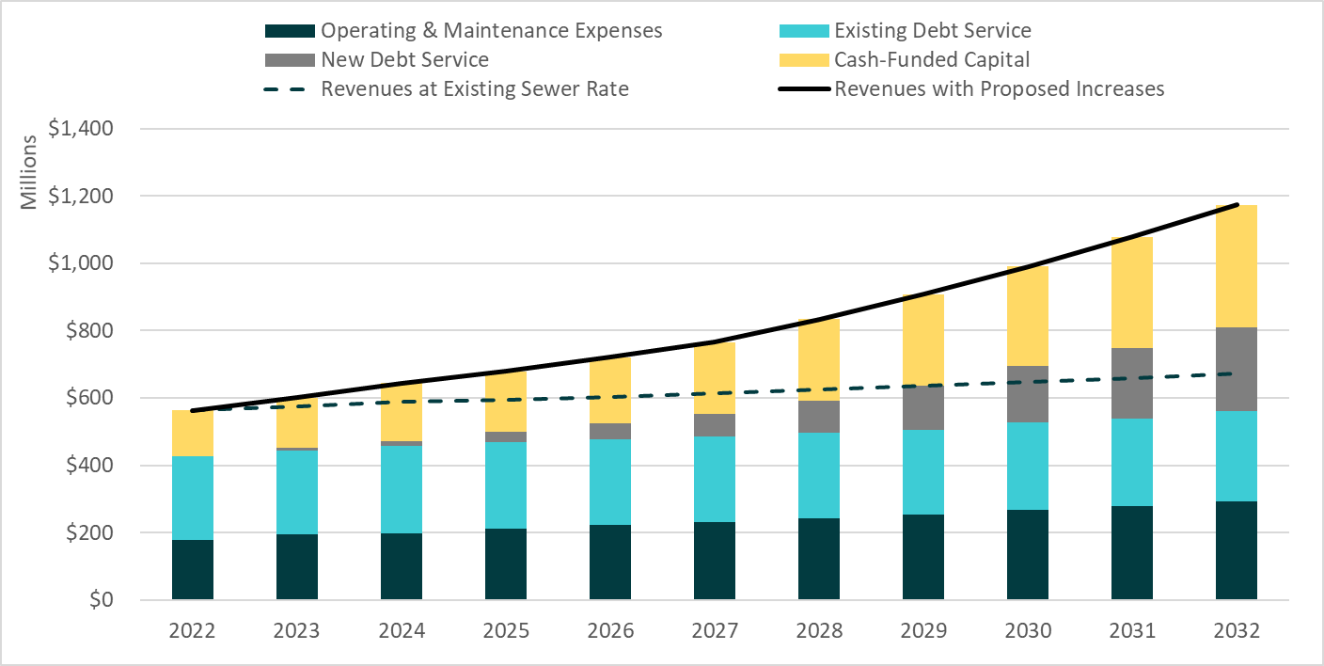
Beginning from the bottom, the first stack in the bar represents the annual Operating and Maintenance (O&M) Expenses with projected inflation and growth. The second stack shows the debt service obligation for existing outstanding WTD debt. The third stack represents new debt service repayment generated by funding the capital program in this forecast. The top stack represents the policy to cash-fund 40 percent of the capital program from revenue.
The dashed line shows the level of revenue generated if the sewer rate were to remain at the current 2022 level of $49.27 monthly for all years of the forecast, in order to demonstrate the insufficiency of the current rate level. The solid line shows the revenue meeting the annual requirement in each year based on the proposed rate plan.
[Table 3 – also available on page 5]

Debt Service Coverage Test
The secondary revenue requirement test is the debt service coverage (DSC) test. DSC is broadly used in the industry, and a specific focus from rating agencies. Generally, DSC means the available cash flow to pay current debt obligations. DSC measures the net revenue from the utility after paying operating and maintenance expenses as a factor of how many times that net revenue could cover the debt service in a single year. Since cash-funded capital policies are not part of the calculation, meeting the policy also accomplishes meeting coverage cushion. The rate proposal produces coverage ranging from 1.59x in 2023 to 1.71x in 2032.

Moody’s Investor Service’s median DSC tracking for water and sewer agencies shows about a 30 percent increase in industry median DSC between 2009 and 2019. In comparison, WTD’s DSC increased about 19 percent during the same time period. The Moody’s water and sewer sector reports have not been updated since the 2020 publication.
As shown in Table 24, WTD’s historical coverage performance has exceeded 1.40x since 2016 and trended higher (e.g., 1.64x in 2021). Median DSC for Aa (high-rated) sewer utilities in the US was 2.2x in 2018 when it was last published by Moody’s.
Table 24. History of WTD DSC and Ratings

Reserves Management
WTD maintains financial reserves that address minimums required by debt covenants (contracts), working capital targets, management of loan proceeds and other capital resources, rate increase smoothing, and mitigation of revenue risk.
While WTD historically has managed its reserves according to such functional uses, limited formal policies directing minimum or target levels and allowed use exist. The WTD Finance 2022 work plan includes research and benchmarking to develop and propose formal policies for these utility reserves that align with industry best practice and WTD financial structure. This section describes the reserves and the reserve levels targeted in rate plan development.
Table 25. Summary of WTD Reserves

Water Quality Operating Fund 4611

Liquidity Reserve
The Liquidity Reserve is targeted to provide sufficient cash balances for variance of revenue and expenditures cycles throughout the year. The working capital target is established as 10 percent of operating expenditures in any given year. As a result, a reserve increase must be funded each year as operating expenditures increase.

Rate Stabilization Reserve
A rate stabilization reserve is unique in that bond covenants (contracts) are written to allow that in any given year use of this reserve can be recognized as revenue eligible for inclusion in the bond coverage calculation. In years that WTD contributes to this reserve from Water Quality Fund revenues, that portion of revenue is deducted from the revenue basis for calculating bond coverage. This allows WTD to use reserves to manage rate levels without compromising the ability to meet annual bond coverage targets. Funds in the Rate Stabilization Reserve also enhance the liquidity metrics used by the rating agencies when they evaluate WTD’s credit quality.
WTD carefully considers use of reserve balances in context of Ordinance 12353 that states the rate stabilization reserve is the for the purpose of smoothing rates between years. Use of reserves represents a one-time resource and excess reserves should be applied to one-time expenditures. There is no planned use of the RSR in the proposed 2023-2032 rate plan. Most formal reserve policies define the period over which replenishment of the reserve to its minimum level must occur after a draw. If the County elected to draw on the RSR in the future, the County would need a plan to replenish the reserve to continue its use for long term rate management.
The current RSR balance represents approximately 11 percent of 2021 sewer rate revenue, which becomes 3.9 percent by 2032 as revenues increase and the balance does not. The 2022 reserve analysis will evaluate and recommend a formal policy on target and minimum balances and parameters for how the reserve is utilized. Typically, a rate stabilization reserve includes some cushion related to revenue risk from unexpected under-collection of revenue for reasons such as economic or weather-related changes in commercial water-consumption-based RCEs.

Unrestricted Operating Balances
Funds in excess of minimum reserves levels in the Operating Fund at year-end are unrestricted and evaluated for optimal use. Some uses for unrestricted funds include potential transfer to the Construction Fund or to contribution to defeasance transactions.

Water Quality Construction Fund 3611

Unrestricted Construction Fund Balances
WTD’s Water Quality Construction Fund is where capital project costs are charged; loan proceeds are reserved and spent; transfers are received for cash-funded capital from the Operating Fund; and capital reserves, such as the Asset Management Reserve, are maintained. Accumulated reserves above the policy-minimum are used to fund projects.
The Construction Fund balance is projected to end at the $5 million liquidity reserve target in each year of the rate plan beginning in 2024, after the balance of the WIFIA loan from the 2023 draw has been fully expended. The capital reserves will be evaluated with the 2022 reserve analysis.
Asset Management Reserve
The Asset Management Reserve is maintained as an emergency reserve and as such is not forecast to deviate from the $15 million balance. This reserve could be an important resource if an asset failure should occur during a period of significant revenue constraint.

Debt Reserves 8921 and 8922
WTD debt reserve minimums are established as a requirement in bond covenants or by the loan-granting agency. The County’s bond ordinance requires that a reserve be maintained in an amount equal to maximum annual debt service on outstanding Parity Bonds. The requirement is currently $124 million. Ecology had a similar requirement, although the agency eliminated this provision for loans awarded after 2018. Reserves for pre-2018 Ecology loans decreased from $13.5 million to just $1.4 million after the refunding of a group of loans in 2021.

Reference

Financial Policy Review 2022:
The 2017 sewer rate proposal included, for the first time, a cash-funding target equal to 40 percent of the current year CIP to reduce growth in WTD debt balance. Previous rates had been set to meet an annual 1.15x DSC minimum. The new policy was in response to recommendations from a MWPAAC Debt Review Committee that proposed WTD target 1.40x debt service coverage as a minimum for setting the sewer rate. The 1.40x coverage target is used as a secondary rate-setting threshold to the 40 percent cash target.
The August 2019 Ratings Median Data Report issued by S&P Global Ratings indicates WTD is highly leveraged in the industry:
  - King County WTD Debt-to-Capitalization Ratio 2018: 98 percent
  - Northwest Utilities: 30 percent
  - National “Very Large” Utilities: 47 percent
A key related ratio is the free cash flow to depreciation measure. This is a common investor and industry measure of the annual financial capacity to maintain utility plant facilities at current levels of service, which assumes that such assets will allow continuation of service and the ability to generate revenue without a significant rate adjustment for unfunded infrastructure needs. Projected cash funding at 40 percent (2022 projected $113 million) is less than annual depreciation ($171.8 million, 2020 audited), which suggests that WTD should maintain at a minimum the current policy target until alternatives can be evaluated with the 2022 Financial Policy Review.

Supplemental WTD Debt Information
Table 26 2021 Year-End Outstanding Debt Balances

Types of WTD Financing

Bonds - Sewer Revenue bonds are secured by a pledge of revenue of the sewer system subject to payment of all operating and maintenance expenses of the sewer system. When revenue bonds are additionally backed by a pledge of the full faith and credit of the issuer (meaning the County’s General Fund revenue and taxing power) the bonds are referred to as limited tax general obligation (LTGO) bonds.
State loans - WTD has received loans from Ecology under the Water Pollution Control SRF Loan Program and the Washington Public Works Trust Fund administered by the Washington State Department of Commerce. The loans require either semi-annual or annual payments of principal and interest from 2022 through 2053 and bear interest at stated rates from 0.0 percent to 3.1 percent. As of December 31, 2021, the balance due on all state loans is $101.2 million. State loans are secured by a subordinate lien on the net revenues of the system.
WIFIA Loans - WIFIA is an established a federal credit program administered by EPA for eligible water and wastewater infrastructure projects. The WIFIA program accelerates investment in the nation's water infrastructure by providing long-term, low-cost supplemental loans for regionally and nationally significant projects at below market rates. The WIFIA loans, after draws are made, are secured by a pledge of revenue from the sewer system subject to payment of all operating and maintenance expenses of the sewer system. WTD has successfully qualified for and received two federal WIFIA loans to date, totaling $231.3 million.

Commercial Paper
The Commercial Paper (CP) program provides low-cost, flexible, short-term financing for WTD capital projects. CP can be used to provide interim financing to pay for capital projects pending permanent financing from state and federal loans and from long-term fixed or variable-rate debt.
The initial purpose of the CP program is to pay for the Georgetown Wet Weather Treatment Station and Ship Canal Water Quality project costs prior to receiving reimbursement and permanent fixed-rate financing from the SRF and WIFIA loans secured for these projects. CP costs are expected to be lower than WIFIA and SRF loan rates. By issuing CP and delaying WIFIA and SRF draws, WTD will incur lower-interest costs over the extended construction periods for these projects. CP can also be issued to provide interim financing for the cash-funded portion of WTD’s CIP, refund high-interest debt outstanding, and serve as a permanent element of WTD’s variable rate debt portfolio.

Variable Rate Debt
WTD’s debt policy limits the utility’s variable rate debt exposure to a maximum amount equal to 20 percent of all outstanding debt; currently, a target of 15 percent is used in the forecast. WTD’s initial variable rate issuance was its $100 million commercial paper program in 1996. Over the next 25 years, WTD expanded its variable rate portfolio to a total of approximately $550 million. Variable rate debt allows WTD to achieve a borrowing cost that historically has been much lower than traditional fixed rate debt. Typically, an investor can sell variable rate bonds back with just a week’s notice and this type of investment warrants the lowest borrowing cost in any given interest rate environment.

Forecast Assumptions
Table 27 summarizes the assumptions used to forecast revenues and expenditures to future years in the proposed rate plan.
Table 27 Forecast Assumptions Used in Proposed Sewer Rate Plan

Asset Management Risk Profile Tier Descriptions
Asset management projects are ranked into Tiers 1 and 2 and prioritized based assessment of their condition within the definitions of Tiers described as follows:
Tier 1: Equipment or pipeline that is currently in poor condition, unserviceable, or for which spare parts cannot be found. Consequences of failure include sewage overflows, other operating permit violations, or operational disruptions for which there would be no easy workarounds. Because wear and tear and corrosion are progressive, every year of delay means that the risk of failure increases.
Tier 2: Equipment or pipeline that is old, showing wear, or has corrosion that indicates it will fail in the future. In the case of equipment, the equipment is currently doing its job, but due to its age will likely perform poorly or fail in the near future. Tier 2 failure has the same consequences as Tier 1 but is less likely to occur now. Tier 2 also includes equipment that may be in worse condition, but is not located in a critical process—i.e., equipment may be more likely to fail, but the consequences would not be as severe. The risk of delay is the same as Tier 1.

2021 Wastewater Treatment Division Financial Performance
Table 28. Wastewater Treatment 2021 Forecast vs. Preliminary 2021 Actuals

Revenue
Table 28 shows that total RCEs were 0.5 percent higher than projected and related sewer rate revenues were 0.6 percent higher.
Capacity charge revenues were $2 million lower than previously forecast, due to both a reduction in new connections and lower elective early payoff activity.
Other operating revenues presented better than forecast results due to increased High Strength Surcharge revenues, RINs, and COVID-19 grant reimbursements from federal and state government.
Investment income was roughly in line with the forecast and interest rates from the King County Investment Pool averaged 0.67 percent in 2021.

Expenditures
Operating expenditure savings of $17 million below budget are largely due to the reduced demand for some chemicals, lower use of central services, and lower-than-projected cost of diesel fuel and electricity. COVID-19 disruptions led to delays in completing operating projects and contracts, and their associated expenditures.

Debt
Debt service was $2.8 million higher than projected due to a $6.9 million voluntary amortization of variable rate debt, which was originally forecast at $1.9 million. Excluding this amortization, regular debt service was $2.2 million lower than the forecast, due to savings from refunding transactions and actual variable interest expense being lower than projected. Details include:
The County issued $565 million of long-term (30 year) limited tax general obligation and sewer revenue bonds. The 2021, Series A (tax-exempt) LTGO Parity Lien Obligation Bonds ($239.6 million) were issued to provide funds for the capital program, along with refunding $147.2 million in SRF loans, providing cost savings of $13.3 million, equaling a present value of 8.8 percent of the amount refunded. The true interest cost for this series with an average life of 7.4 years is 1.14 percent. The 2021, Series B (taxable) LTGO Parity Lien Obligation Bonds ($94.5 million) were issued to defease and advance refund $81.2 million of 2015 Series A LTGO Parity Lien Obligation Bonds. The true interest cost for this series with an average life of 11.1 years is 1.99 percent. The 2021, Series A (taxable) Sewer Revenue Parity Bonds ($231.2 million) were issued for the purpose of defeasing and advance refunding $198.7 million of 2015 Series A Sewer Revenue Parity Bonds. The true interest cost for this series with an average life of 16.5 years is 2.54 percent. In combination, these two series will generate present value cost savings of $55.3 million, equaling 19.8 percent of the bonds being refunded.
WTD used $143.1 million of cash to defease outstanding sewer revenue bonds, which will reduce principal and interest payments by $176.6 million through 2031.
The County started its CP program (subordinate lien debt service) in 2021 and issued $44.2 million in January, $21.5 million in June, and $13.5 million in July. This is interim debt intended to pay for projects that have already secured low-interest rate loans from the state and the federal government. Draws on these loans will then be used to repay the CP notes near project completion. This interim financing strategy is expected to reduce the County’s borrowing costs for these projects, as short-term tax-exempt rates are expected to be below the long-term rates for state and federal loans. The secondary purpose of the CP program is to provide funds to refund high interest outstanding and future junior lien sewer revenue and multi-modal LTGO bonds. Once refunded, the outstanding CP can be retired by issuing low interest variable rate debt in larger sums to maintain a variable rate debt profile of 15 percent. The County also issued $100 million of CP to refund its 2012 junior lien put bonds and $26.7 million to refund a 2012 Sewer Revenue Bond ($9.7 million) and a 2012 LTGO Bond ($16.9 million) with January 1, 2022, call dates.
Lastly, the County issued Floating Rate Notes in the par amount of $140 million. The proceeds were used for the purpose of redeeming the State Street Bank Direct Purchase ($90 million) and retiring two separate CP maturities ($25 million each) that were first issued on February 25, 2021, to refund the 2012 junior lien put bonds. This issuance will effectively avoid market uncertainty around the new LIBOR indexing methods and increase capacity to utilize CP for future interim financing or refunding purposes.

Cash Funding and Defeasance
Operating revenue dedicated to capital program funding can alternatively be used to remove outstanding high interest rate debt from the books through defeasance. Similar to refundings, defeasances are usually not incorporated in the financial plan forecasts since they are only carried out if interest rates are beneficial later in the year. In 2021 WTD ended up defeasing a total of $143.1 million, which is $54.6 million lower than the transfers to the capital fund forecast in the adopted plan. The absence of additional transfers is explained by the underspent in the capital program.

Net Cash Flow
The amount of operating revenue ultimately available for transfers to the capital fund in 2021 was $224 million (defeasance plus ending balance), which compares favorably to the $197.7 million in the forecast. This $26.3 million positive variance reflects both cost savings in 2021 and better than expected miscellanies revenues.

Secondary treatment includes aeration, settling, disinfection, and discharge through an outfall. Secondary treatment in conjunction with primary treatment removes about 85 to 90 percent of suspended solids in wastewater.
Combined sewer overflows (CSOs) are relief points in sewer systems that carry sewage and stormwater in the same pipe. When heavy rains fill the pipes, CSOs release sewage and stormwater into rivers, lakes, or Puget Sound. They prevent sewage backups into homes and businesses, but can harm people and animals living in the water because they carry chemicals and germs
The sewage treatment capacity charge is billed to customers who connected to the sanitary sewage system on or after February 1, 1990. The charge is assessed monthly for a term of 15 years from the date the new service is established and is based on the cost of system capacity necessary to serve a new connection.
More information on MWPAAC can be found on the King County website.
“High-strength” refers to more concentrated waste. The surcharge covers the additional cost of treating this waste at the treatment plant.
“RCE based Customers” include multifamily, commercial, and industrial customers and are customer units based on water consumption averaged over a four-quarter period (here Q1 through Q4 2021). Single Family Residential are reported Q4 values.
More information on enterprise funds is available here.
Information from American Water Works Association is available on its website.
WTD has historically raised rates every other year. The change to annual rate increases means increases to the sewer rate are done in smaller increments more frequently to create a smoother pattern of increases.
The West Point Treatment Plant Power Quality Improvement Project includes construction of an uninterruptible power supply system using large battery storage and a replacement building to house the system that will limit or eliminate overflows to Puget Sound due to power quality problems (voltage sags).
In this context “smoothed annual increases” refers to avoidance of year-to-year volatility in the sewer rate.
More information on Clean Water Healthy Habitat is here.
More information on the Strategic Climate Action Plan is here.
The Equity and Social Justice Strategic Plan is available here.
Information on U.S. inflation trends is available here
The capital accomplishment rate is the amount of actual or forecasted capital spending that occurs in the year compared with the amount of capital spending planned. Refer to 2021 Performance and Accomplishment Rate on page 19.
The consent decree, signed in 2013 , is a written agreement between King County, the Washington state Department of Ecology (Ecology), the U.S. Environmental Protection Agency (EPA) and the U.S. Department of Justice (DOJ) that outlines the planned actions to bring King County’s CSO program into compliance with the federal Clean Water Act (CWA)
More information on the Nutrients Permit can be found on Ecology’s website.
The Flows and Loads Study was prepared by Brown and Caldwell. More information also is available on King County’s webpage on Treatment Planning.
For more information on the West Point Settlement Agreement, see section 2.1.3, Complying with West Point Settlement Agreement, in the Regional Wastewater Services Plan: 2006 Comprehensive Review and Annual Report.
The Conveyance System Improvement (CSI) Program looks at ways to improve the wastewater conveyance system and address public health concerns, while ensuring that the system has sufficient capacity to respond to regional growth
More information on SCAP can be found on King County’s website.
The South Plant project will improve the gas scrubbing system, provide reliable heating for the South Treatment Plant’s treatment processes, and produce more renewable energy.
More information on projects underway at West Point and the digester replacements can be found here.
Fugitive gas emissions are releases of gas that are typically the result of loss of integrity that allows gas to escape. The gas can contain methane.
Loop® is King County’s biosolids product. Loop is a fertilizer alternative produced by cleaning, recycling, and transforming King County’s wastewater into biosolids.
“Co-digestion” in this context refers to a project that would use food waste at a County treatment plant to divert organic material from landfills and increase revenues from the generation of renewable gas.
Co-digestion would help King County address the “Reducing Greenhouse Gas Emissions” goal in the SCAP.
Defeasance is a provision in a contract that voids a bond or loan on a balance sheet when the borrower sets aside cash or bonds sufficient to service the debt.
More information on the merger is available here.
Revised Code of Washington 35.58.360
A 2015 internal WTD survey of utility connection charges for 18 comparable agencies nationwide included data on when the charge is assessed to new connections for 13 of the 18 agencies. Of the 13, 100 percent required payment at the time of permitting or service application. Only WTD did not require payment as a condition of development through the permitting/service application process.
https://app.leg.wa.gov/RCW/default.aspx?cite=35.92.025 Cities and Towns https://app.leg.wa.gov/RCW/default.aspx?cite=57.08.005 Districts
Impact fees are one-time charges assessed by a local government against a new development project to help pay for new or expanded public facilities that will directly address the increased demand for services created by that development.
Information on the RWSP is available here.
The auditor’s report is available here.
King County Code 28.84.050 O.3.
Ongoing payments include penalty fees that have ranged between $0.4 million and $1.3 million a year
The March 2022 forecast is available here.
Information on interest rates is available here.
A RIN is a is a serial number assigned to a batch of biofuel for the purpose of tracking its production, use, and trading.
Staff for the West Section Offsite Facilities and the North Satellite Construction Management will relocate from Jameson and ArcWeld buildings to new facilities, as those buildings have reached the end of their useful life.
The Coalition of Unions refers to unions representing King County employees that have signed the Master Labor Agreement.
Central services are services received from other County agencies that are considered “central” agencies, such as King County Information Technology, Facilities Management, and County Human Resources
A majority of WTD’s FTEs have an operating and capital personnel cost allocation. For example, an FTE could be allocated 90 percent to capital and 10 percent to operating.
A “peak” flow is a sudden and/or sustained increase in the flow.
The history of the construction of the Brightwater Treatment Plant and Conveyance Megaproject is here.
Debt financing occurs when money is raised by selling debt.
Moody’s Investor Services, Sector Profile, Water and Sewer Utilities - US – Medians, Solid Finance Performance, Ability to Increase Rates Underpin Stability, 19 May 2020
Information available by subscription only at Moody’s.
The following legislation is available on the King County Council website: Motion 13798, Ordinance 13680, and Ordinance 19112.
Liquidity Metrics measure the agency’s ability to meeting financial obligations.
Ordinance 12353 is available on the King County website.
Parity Bonds are based on sewer revenue.
Information available via subscription access on S&P Global.
Excludes principal payments from January 1, 2022, that had already been transferred to the debt service fund in December 2021
This website provides more information on bonds.
"Subordinate" liens are those that can only be paid after more senior liens are released.
Commercial Paper is a commonly used type of unsecured, short-term debt typically used for short-term liabilities. Maturities on commercial paper typically last several days, and rarely range longer than 270 days. It is usually issued at a discount from face value and reflects prevailing market interest rates.
Audited 2021 financial information will be available in May of 2022. Preliminary (unaudited) year-end financial data is presented for comparison to the 2021 forecast from the adopted (2022-2031) rate plan.
Bonds par amounts (the principal to be repaid) are lower than actual bonds proceeds because tax-exempt municipal bonds are usually sold at a premium, meaning that coupon rates offered to investors (interest payments) are higher than the prevailing market rate, but proceeds are higher than principal owed.
Defeasance is an alternative way to achieve tax-exempt bond savings: Operating cash is used to “prepay” high interest debt while new bonds are issued at lower cost to finance the capital program.
The LIBOR, or London Inter-Bank Offered Rate, is a short-term interest rate benchmark commonly used in variable rate loan contracts, such as the State Street Bank Direct Purchase Agreement. The LIBOR is being phased out and starting in 2022; it is no longer used to price new loans.

