Harborview Bond Program Monthly Status Report

November 2023

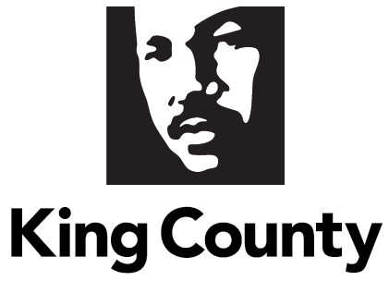

Contents
Contents 2
Executive Summary 3
Background 5
Department Overview 5
Historical Context 5
Current Context 8
Report Methodology 9
IV. Report Requirements 9
1. Description of the Current Program Scope 9
2. Updates on the Project Schedule Including Status of and Planned Dates for Major Milestones 13
3. Status and Progress for Each Component Capital Improvement Projects 14
4. Budgetary Update 15
5. Update on Tasks Completed on Major Milestones Since the Preceding Report and a Three-Month Projected Outlook on Upcoming Tasks to Accomplish Milestones 17
6. A Description of Stakeholder Engagement and Public Communications Over the Preceding Month Including Appearances on Agendas at Regional Meetings and Mailings 19
7. A Description of Risks Including Newly Identified Risks and Realized Risks 19
V. Conclusion 22
VI. Appendices 23

Executive Summary

On November 3, 2020, more than 70 percent of King County voters approved Proposition 1, authorizing the County to sell $1.74 billion in bonds to fund facility and infrastructure improvements at Harborview Medical Center. Since its passage, the staff team has worked diligently to establish the necessary organization and management structures needed to implement this complex capital program; one of the largest in King County’s history.

Harborview Medical Center (HMC) is a 540-licensed-bed hospital owned by King County and operated by UW Medicine through a Hospital Services Agreement between King County and the University of Washington (UW). The hospital is overseen by a 13-member Board of Trustees appointed by King County. Harborview Medical Center’s unique mission statement identifies and prioritizes services to the most vulnerable residents of King County. Harborview is the only adult and pediatric Level 1 Trauma Center serving a five-state region (Alaska, Idaho, Montana, Wyoming, and Washington). It provides centers of emphasis and specialized comprehensive emergency services to a broad range of patients and throughout the region. The medical center is also the disaster preparedness and disaster control location for the City of Seattle and King County.

For nearly 100 years, Harborview provided medical services from its location atop Seattle’s First Hill. It is distinctive in its consistent provision of care to King County residents regardless of their race, religion, ethnic origins, or ability to pay. As stewards of the campus facilities, King County regularly provides facility improvements and expansions through voter-approved financing, generally occurring every 15-20 years. The original center tower was constructed with bonds in 1930 and through the ensuing years, the voters continued to entrust King County with funding approvals on behalf of Harborview.

King County Council Motion 15183 called for the establishment of a planning group to identify hospital and community needs and make recommendations regarding a capital program. The resulting Harborview Leadership Group (HLG) was comprised of representatives from Harborview administration, the Board of Trustees, UW Medicine, labor partners, the First Hill Improvement Association, the mission population, the King County Council, and the King County Executive Office. The HLG provided a report making recommendations for health and safety improvements at Harborview Medical Center. The recommendations included building a new in-patient tower to increase critical care capacity and meet modern infection control standards as well as making seismic improvements to older structures on the campus to increase surge capacity, expand flexibility for hospital operations, and save lives in the event of a major earthquake.

Since the approval of the $1.74 million bond funding, the Facilities Management Division (FMD) has focused on establishing the structures and processes required to effectively implement the historic, multi-year Harborview Bond Program. Other Bond Program start-up activities included:
- Hiring key County staff;
- Selecting project management firms;
- Developing financial accounting reporting protocols;
- Expanding partnerships and collaborations with Harborview staff; and
- Establishing monthly meetings with King County Auditor’s Office staff.
As part of the Bond planning, and Coronavirus Disease 2019 (COVID-19) pandemic, and associated impacts on supply chains and workforce, King County requested that the Bond Program’s project management consulting firm, Vanir, review and update the 2019 cost assumptions used to establish the Bond. Presentation of the initial findings led King County Council to pass Ordinance 19583 (Appendix A) which called for the creation of a workgroup to identify a Program Plan within the escalated pricing for health and safety improvements at Harborview Medical Center.

The updated Program Plan approved by the King County Council on October 3, 2023, has three key components: 1) construction of a new multi-story medical tower; 2) renovation of essential services currently located in older hospital spaces; and 3) expansion of County spaces located in older hospital facilities. The updated Program Plan was determined after considering the operational needs of Harborview and the shared priorities of King County, the Board of Trustees, and UW Medicine.

The Bond Program continues with key elements of a program scope that aligns with the Bond Program’s mission. Tasks associated include:
- Progressing toward the submission of a City of Seattle Major Institution Master Plan (MIMP) major amendment;
- Developing a campuswide utility and infrastructure plan;
- Collaborating with King County and UW Medicine departments to understand new and modified spaces needed;
- Establishing the request for proposal (RFP)/Procurement processes and bid work activities needed to accomplish the Bond Program goals;
- Managing the capital improvement project budget and expenditures;
- Coordinating and conducting stakeholder engagement, meetings, and mailings;
- Identifying key milestones, risks, and realized risks for the Program Plan.

Updates since last report. This November report provides data for September 2023. Four substantive changes are reflected in this document since the October report with August data. The changes include:
- Action on Program Plan - since transmitting the first monthly report at the end of September, the King County Council unanimously approved the Program Plan on October 3, 2023. Though this report covers data and activities from the month of September, prior to the Council’s action in October, this document thus references the Program Plan as such and not the “recommended Program Plan.”
- Updated budget actual expenditures for the month of September - identifying variances from projected expenditures included in the September report.
- For milestone 1, the task list has been updated to reflect completed September tasks, including two additional tasks not previously reported, as well as the addition of one new October task and the projected December tasks.
- Updated the status and progress for components in the Capital Improvement Projects section with additional details and progress for actions introduced in the previous report.
In addition, this report includes task updates on the September activities of the Bond Program, including:
- Received the endorsed letter (Appendix F) for a major amendment to the major institution master plan (MIMP) by the Implementation Advisory Committee members (IAC), a City of Seattle MIMP Standing Advisory Committee;
- Convening by HMC of first meeting with selected campus master plan consultant NBBJ to discuss work plans and initiated engagement with work completed in space programming;
- Reviewed contractor OAC’s existing conditions report draft about Harborview’s internal and external infrastructure systems (e.g., energy, water);
- Established a ratings and risk register for infrastructure systems;
- Reviewed mechanical and equipment systems listing of Harborview’s infrastructure systems as part of the work of the County’s work with OAC, Inc.;
- Updated the projected community meetings and events calendar; and
- Provided monthly project updates to Harborview’s Capital Projects Oversight Committee and Board of Trustees, and the King County Auditor’s Office.

Background

Department Overview
The Department of Executive Services (DES) provides internal services to King County agencies and departments, and public-facing services directly to King County residents. The divisions and offices that make up DES include the Business Resource Center, Finance and Business Operations Division, Office of Emergency Management, Facilities Management Division, Fleet Services Division, Inquest Program, King County International Airport-Boeing Field, Office of Risk Management Services, and Records and Licensing Services Division. The Facilities Management Division (FMD) oversees and maintains King County's real estate assets and provides safe and secure environments for County service delivery.

Historical Context
Harborview Medical Center (HMC) is a 540-licensed-bed hospital owned by King County and operated by UW Medicine through a Hospital Services Agreement between King County and the University of Washington (UW). The hospital is overseen by a 13-member Board of Trustees appointed by King County.

HMC is a comprehensive regional health care facility dedicated to providing specialized care for a broad spectrum of patients, the control of illness, and the promotion and restoration of health. Harborview is one of the nation’s leading academic medical centers and is the only adult and pediatric Level 1 Trauma Center serving a five-state region (Alaska, Idaho, Montana, Wyoming, and Washington).

The medical center is home to a wide range of critical medical and behavioral health services, including state-of-the-art emergency medical services, general medicine and specialty clinics and centers of excellence in burn, neurosciences, ophthalmology, infectious disease, and rehabilitation therapy. Harborview’s mission ensures that the following patients and programs are given priority care:

- Persons who are non-English speaking poor
- Persons who are uninsured or underinsured
- Persons who experience domestic violence
- Persons who experience sexual assault
- Persons incarcerated in King County’s jails
- Persons with mental illness, particularly those treated involuntarily
- Persons with substance abuse
- Persons with sexually transmitted diseases
- Persons who require specialized emergency care
- Persons who require trauma care
- Persons who require burn care

Services Offered at HMC - The Harborview campus facilities house a variety of services provided by UW Medicine and King County as highlighted below:

- Behavioral Health: A variety of in and out-patient behavioral health services, including psychiatric emergency services, outpatient clinics, and medication-assisted treatment are provided at the HMC campus. In addition, King County’s Superior Court operates the Involuntary Treatment Act (ITA) Court at Harborview.

- Trauma Response: As the only Level I Adult and Pediatric Trauma Center in Washington, HMC provides specialized comprehensive emergency services to patients throughout the region and serves as the disaster preparedness and disaster control hospital for the City of Seattle and King County. It is also the only Level 1 Trauma Center serving a five-state region (Alaska, Idaho, Montana, Wyoming, and Washington).

- International Medicine: HMC is unique in its offering of an International Medicine Clinic, providing primary care and mental health care services to adult refugees and immigrants. Staff speak several languages in addition to English, including Spanish, Amharic, Cantonese, Chao Jo, Mandarin, Hmong, Khmer, Laotian, Mien, Oromo, Somali, Tigrinya, and Vietnamese; interpreter services are also available.

- Emergency Management / Disaster Relief: The medical center is the regional emergency management command center during a natural disaster or major crisis event. The hospital is required to have flexible inpatient beds, operating capacity, and rapid response systems as needed for crisis response.

- Infection and Infectious Disease Control: HMC is at the forefront of containing and combating infectious diseases. Harborview is required to have clinical facilities and isolation room capacity to respond to emergency infectious disease outbreaks.

- King County Clinics and Services: A number of King County’s core public health services are located at Harborview, including the Tuberculosis (TB) Clinic, Sexual Health Clinic, the County’s Public Health Lab, and the King County Medical Examiner’s Office (MEO). The King County Regional Homeless Authority operates a 24/7 homeless shelter at Harborview Hall in partnership with the Salvation Army.

Harborview Facility Improvements - Over time, Harborview’s medical facilities have evolved to meet the demands of a growing and diverse population, as well as advancements in the fields of patient care, research, medicine, and technology. King County has provided for such facility improvements and expansions through voter-approved financing, generally occurring every 15-20 years. Prior to the 2020 election, the last bond measure approved by voters was in 1999.

King County Council Motion 15183 called for the establishment of a planning group to identify hospital and community needs and make recommendations regarding the capital program to the Harborview Board of Trustees, the King County Executive, and the King County Council. The resulting Harborview Leadership Group (HLG), comprised of representatives from HMC management, the Board of Trustees, the University of Washington, labor partners, the First Hill Improvement Association, the mission population served by HMC, the King County Council, and the King County Executive Office, conducted a 13-month assessment between December 2018 and January 2020 of Harborview’s facility needs.

Supported by staff from HMC, UW Medicine, the King County Council, and the King County Executive Office, the HLG reviewed data and information provided by industry experts. The group hosted numerous community forums to gather public input. After conducting the assessment process, the HLG determined:
  - A majority of the medical center’s facilities are aging and out of date in terms of modern medical best practice standards for infection control and privacy.
- Due to facility configuration, Harborview Medical Center often operates at more than 100 percent capacity, and critical surge capacity and emergency department capacity are limited.
- The majority of the medical center’s patient beds are located in double patient rooms or multi-patient wards. On average, 50 patient beds per day cannot be used due to modern infection control requirements for shared rooms.
- A new inpatient facility would increase single-bed capacity and enable HMC to meet modern infection control and privacy standards. It would provide surge capacity for the hospital to effectively respond to a disaster or mass casualty event.

Table 1 summarizes the key elements of the HLG recommendations for capital improvements at Harborview to address the medical center’s facility needs.

Table 1 – Harborview Facility Improvement Recommendations
Harborview Facility Improvement Recommendations: Harborview Leadership Group 2020
Component Name | Component Description
New Tower | Increase bed capacity; expand/modify ED; meet privacy and infection control standards; disaster preparedness; plant infrastructure
New Behavioral Health Building | Existing behavioral health services/programs and Behavioral Health Institute services/programs
Existing Hospital Space Renovations | Expand ITA court; move/expand gamma knife; lab; Public Health TB, sexually transmitted disease (STD), MEO; nutrition, etc.
Harborview Hall | Seismic upgrades; improve and modify space; create space for up to 150 respite beds; (maintain enhanced homeless shelter in most appropriate location)
Center Tower | Seismic upgrades; improve and modify space for offices
Pioneer Square Clinic | Seismic and code improvements; improve and modify space for medical clinic/office space
East Clinic | Demolish East Clinic building

Ultimately the HLG provided recommendations to the Harborview Board of Trustees, King County Executive, and King County Council on the size and scope of a potential bond measure.

The King County Council, via Ordinance 19117, voted to place Proposition 1 on the November 2020 General Election ballot for consideration by King County voters. The measure sought voter approval of $1.74 billion in general obligation bond funding over 20 years for health and safety improvements at Harborview Medical Center, including: increasing critical health care capacity; updating and expanding infection control capability; and expanding capacity for behavioral health services. On November 3, 2020, over 76 percent of King County residents once again confirmed their commitment to public health and Harborview Medical Center through the approval of Proposition 1.

County Bond Program Launch - The first two years of the Bond Program work (2021-2022) saw FMD establishing the structures and processes necessary to effectively implement the historic, multi-year Harborview Bond Program. Bond Program start-up activities included:
- Hiring key County staff;
- Selecting project management firms;
- Developing financial accounting reporting protocols;
- Expanding partnerships and collaborations with Harborview staff; and
- Establishing monthly meetings with the King County Auditor’s Office staff.

For additional information, please see the biannual Harborview Bond Program reports transmitted to the King County Council for June 2021, December 2021, June 2022, and December 2022. Please note that these reports are replaced by this monthly report.

Current Context
Cost Escalation - In late 2022, King County requested that its HMC Bond Program project management consulting firm, Vanir, review and update the 2019 cost assumptions used to establish the HMC Bond Program. King County requested this review both as part of its planning for the next phases of the Bond work but also due to the global COVID-19 pandemic and associated impacts to the supply chain and workforce.

Reflective of rising costs across the country post-pandemic, the Vanir team’s review and resulting Cost Study report confirmed that the HMC Bond Program faces financial pressures from the impacts of inflation, labor, and supply chain challenges. The initial Vanir team Cost Study, dated January 24, 2023, identified an estimated $900 million gap between anticipated revenues and updated cost of the Harborview Bond Program.

In February 2023, each King County Councilmember, along with leadership from UW Medicine and the HMC Board of Trustees, received individual briefings on the expanded costs. Digital copies of the Cost Study were also provided. On March 6, 2023, the King County Council’s Committee of the Whole received an initial briefing from King County FMD staff and the Vanir team (Bond Program consultants). On March 7, 2023, as a result of analysis from the Auditor’s Office, the consultants updated the Cost Study. The funding gap was updated from $900 million to $888 million (Appendix C).

On March 29, 2023, the King County Council passed Ordinance 19583 (Appendix A) calling for a workgroup to develop and submit to the King County Council, a Program Plan recommending health and safety improvements at the Harborview Medical Center that can be built within the amount of the bond revenues estimated to be available. An Ordinance Workgroup (OWG) was established shortly after passage of the Ordinance, comprised of leaders from UW Medicine, Harborview’s Board of Trustees, the King County Council, Facilities Management Division, and King County Executive’s Office.

The OWG’s recommended Program Plan was submitted to the Council on August 1, 2023, with three key components: 1) construction of a new 10-story tower (base tower) with seven finished and three shelled floors; 2) construction of essential services currently located in older hospital spaces requiring renovation; and 3) expansion of County spaces located in older hospital facilities. Data provided by the Vanir team estimates that the components can be built within the $1.7 billion bond revenue amount. The OWG’s recommended Program Plan was determined by the OWG after considering the operational needs of Harborview and the shared priorities of King County, the Board of Trustees, and UW Medicine.

The King County Council approved the proposed Program Plan with no changes on October 3, 2023.

Report Methodology
This report was drafted by FMD staff. Data in the report is for September 2023.

IV. Report Requirements

This section is organized to align with the requirements of Ordinance 19583 (Appendix A).

Description of the Current Program Scope

This report defines the program scope proposed in the Program Plan that was approved by the King County Council on October 3, 2023. The Program Plan, approved by Motion 16435 (Appendix E), includes the health and safety improvements at the Harborview Medical Center built within the amount of the bond revenues ($1.74 billion) estimated to be available and as authorized by Ordinance 19117.

Program Plan Description - As outlined above, the Program Plan has three components: 1) construction of a new 10-story tower (base tower) with seven finished and three shelled floors; 2) construction of essential services currently located in older hospital spaces requiring renovation; and 3) expansion of County spaces located in older hospital facilities. Integrated within these components are necessary supporting infrastructure such as a new roadway and energy infrastructure. The scope of the Program Plan components are detailed below in Tables 2 and 3.

Table 2 - Program Plan Component 1: New In-Patient Tower
New Tower Component | Description of Planned Component | Estimated Square Footage of Completed  Component
Seven finished inpatient bed floors | - Estimated minimum 224 beds  - 32 beds per floor x 7 floors = 224 new beds  - Usable upon completion | 34,000 sq ft / floor
Three shelled inpatient bed floors | - Completed but unfinished floors  - Floors, windows, walls, some infrastructure (e.g., plumbing and heating, ventilation, air conditioning [HVAC])  - Will be completed as additional funds become available | 34,000 sq ft /floor
12 operating rooms (ORs) | - Additional ORs  - Including perioperative support (e.g., post anesthesia care unit, prep/holding and OR support spaces) | 65,000 sq ft
Expanded single floor emergency department (ED) | - Expanded ED with additional single patient treatment rooms and allowing for modern models of emergency care | 87,000 sq ft (includes PES & CSU)
Expanded Behavioral Health Services | - Psychiatric Emergency Services (PES): renovated & expanded by up to six new single patient rooms | 87,000 sq ft (includes PES & CSU)
Expanded Behavioral Health Services | - New Crisis Stabilization Unit (CSU): 23-hour observation unit with approximately 18 recliner chairs and single patient quiet rooms | 87,000 sq ft (includes PES & CSU)
Observation Unit | - For patients requiring less than a 24 hour stay for medical care | 20,000 sq ft
Right-sized essential services | - Pharmacy, lab, clinical engineering, environmental services, kitchen | 150,000 sq ft
Parking | - Minimum 350 replacement parking spots for View Park Garage spots that will be lost to make room for new tower | 160,000 sq ft
Helicopter pads | - Minimum two pads; potentially a third if feasible | 35,000 sq ft

Table 3 - Program Plan Component 2: County Space Expansion
County Space Expansion Component | Description of Planned Component | Estimated Square Footage of Completed  Component*
Involuntary Treatment Act (ITA) Court | - Additional space for courtrooms, admin, attorney workspace, client areas, and public entry | 20,000 sq ft
Medical Examiner’s  Office (MEO) | - Additional cooler space, offices, and education rooms | 36,300 sq ft
Tuberculosis (TB) Clinic | - Additional space for outreach, staff offices, and a conference room/break room | 11,000 sq ft
Sexual Health Clinic | - Additional clinic and office space | 22,000 sq ft
Public Health Lab | - TBD | TBD

At the time of the writing of this report, analysis of the Public Health Lab space needs is underway. Subsequent reports will update this item as information is available.

This report identifies no changes to the number, size, or components of the Program Plan.

Key Elements of the Program Scope: This subsection describes key elements associated with the scope of the Program Plan. Tasks associated with these items are discussed in subsequent subsections.

City of Seattle Major Institution Master Plan (MIMP)
- The City’s MIMP establishes the zoning rules and requirements for major institutions, such as universities, colleges, and hospitals. Changes to HMC’s adopted MIMP will be made through a prescribed, multi-step process involving the City Department of Neighborhoods (DON), Department of Construction and Inspections (SDCI), the City Hearing Examiner, and the City Council in a process that could take up to two years and potentially longer.

- The County will seek approval from the City of Seattle for a major amendment to Harborview’s MIMP. The Seattle City Council has authority to revise Hearing Examiner decisions and/or attach conditions to HMC’s MIMP amendment, either of which could potentially involve open space, parking, transportation management, building height or other items, which in turn could result in increased costs and impacts to timeline.

- Since February 2023, Seattle’s DON has led meetings with a standing Implementation Advisory Committee (IAC) to discuss HMC’s facility and campus plans as part of the MIMP amendment process. Once the IAC provides its feedback to DON, the County will initiate the MIMP amendment application process.

Infrastructure Master Plan
- FMD is developing a campuswide utility and infrastructure master plan for Harborview’s campus. The infrastructure master plan will identify the condition and capacities of the existing campus utility infrastructure to develop strategies to meet the growth in demand anticipated from the bond program components. It will also include identifying engineering solutions to enable future growth, including re-routing utilities and systems; providing energy usage improvements; and developing redundancy for mission-critical systems.

- The final infrastructure master plan document will be the strategic guide to infrastructure redevelopment for the campus. It will reflect the goals of HMC and the County, including resiliency; economic, environmental, and social sustainability; reducing reliance on fossil fuels; and evaluate options for meeting sustainability goals and potentially certification under third party programs, for the new inpatient tower and renovation projects. Notably, identified alternatives and upgrades that fall outside of the scope of the proposed Bond projects may be designed and developed in future phases.

- The Infrastructure Master Plan contract was awarded to OAC Consulting and, as of August 2023, the team had begun evaluating and rating of existing buildings and systems. The team projects completion by 1Q 2024.

Space Programming
- The space assessment informs the needs of key programs across Harborview campuses through 2040, including King County departments located in the hospital. Space programming includes planning for new or modified spaces for Harborview-located programs, developing and maintaining space planning guidelines, assessing available space to address changing needs, finding solutions for immediate and long-term space issues, and managing space requests and reallocations for County-owned and leased properties.

The process includes learning about department needs, and using tools to provide space, equipment, and furniture needed for the department to function efficiently. Departments consider items such as service-level projections, industry standards, operating needs, storage, adjacencies, and other spacing needs in their projected outlook.

- King County, HMC, Harborview-located departments, and various consultants are involved in space programming. This work will influence concurrent projects such as the Infrastructure Master Plan and information will be used to inform the procurement documents, such as the new tower request for proposal (RFP).

- King County and Harborview continue to lead blocking and stacking workshops to gather additional space programming information about department needs, identify location requirements, and outline general floor layouts across the Harborview campus. Consultant NBBJ was onboarded by Harborview in September to further advance the space planning work.

Updates on the Project Schedule Including Status of and Planned Dates for Major Milestones

The schedule of major milestones included below as Table 4 was included in the August 1, 2023, Harborview Program Plan Report transmitted to the Council. The timeline and milestones shown below in Table 4 were updated in the October monthly report, transmitted to Council on October 30, 2023. The October updates to Table 4 below included updating milestone 1 description; revising the estimated completion timeframe of milestone 1 from 3Q to 4Q; and adding a new milestone 2 to track submission of the MIMP major amendment application. There are no updates to the table for the November report.

To expedite program development, several key tasks are occurring concurrently and driving towards procurement for design and construction of the new tower. It should be noted however, that some milestones are dependent on the sequential completion of key tasks. Meeting these major milestones includes managing several tasks and sub-tasks. The subsections below outline the work being conducted by FMD around major schedule milestones and provide a three-month progress outlook. This schedule below is predicated on working with the City of Seattle to expedite its MIMP and permitting processes, particularly items denoted with * in Table 4, below.

Table 4 - OWG Program Plan Milestones
Milestone | Estimated Completion Timeframe
- MIMP Major Amendment: file notice of Intent (NOI) to apply for Major Amendment to the City of Seattle | 4Q 2023*
- Submit MIMP major amendment application to the City of Seattle. | 1Q 2024
- City of Seattle MIMP Process: (DON, SDCI, Hearing Examiner, and City Council) | 2Q 2024*
- Issue new tower request for proposals (RFP) | 3Q 2024*
- Notice to proceed | 1Q 2025*
- Design and City permitting | 2Q 2025-4Q 2025*
- Begin construction | 1Q 2026*
- Occupy new tower | 4Q 2028*

Status and Progress for Each Component Capital Improvement Projects

Component 1 – New Tower
The following narrative summarizes key elements underway for the new tower (Table 5).

Table 5 - Project Component Activities
Item | Activities Update | Objective
MIMP Amendment | The County received the IAC’s final recommendation letter supporting the major amendment to the HMC MIMP on September 21, 2023. The letter will be submitted to SDCI in October 2023. Key aspects of the major amendment addressed in the letter are:  - FAR (floor area ratio) upgrades  - Open space plans  - Height, bulk, and scale of the new tower  - New roadway access and improved emergency vehicle access  - Transportation plans and ongoing IAC reviews  - Potential up zoning of the new tower height  The County intends to submit of notice of intent to apply for the major amendment to Harborview’s MIMP to SDCI in 4Q 2023. Major amendment application to follow in 1Q 2024. | Achieve City of Seattle approval of a major amendment to the MIMP.  The MIMP will outline a number of actions, some of which have environmental impacts. The Environmental Impact Statement (EIS) will show the impacts of those actions and the alternatives considered by King County in the development of the MIMP major amendment application.
Infrastructure Master Plan | Infrastructure contractor OAC started the Harborview campuswide infrastructure analysis and engineering review of existing systems. Since OAC’s onboarding, OAC has worked with King County and HMC to review mechanical and equipment lists and established a ratings and risk register for the Infrastructure Master Plan. The infrastructure risk register, like the Bond Program’s overall risk register, will be used to determine budget and schedule contingencies, communicate with stakeholders, and inform decision-making. | A campuswide analysis of internal and external systems (e.g., electricity, gas, and steam), informing energy options to meet the hospital’s growing needs
Space Programming | HMC awarded Harborview campus master plan contract to consultant NBBJ. HMC held an onboarding meeting with NBBJ and discussed work plans aligned with the Program Plan.  King County, in partnership with HMC, is developing a program and design review process for the RFP that aligns with the HMC campus master plan work.  HMC held a blocking and stacking workshop and process overview for King County agencies on the Harborview campus. Participants included the Medical Examiner’s Office, Involuntary Treatment Act Court, Sexual Health Clinic, King County Lab, and Tuberculosis Clinic in August 2023.  A follow-up workshop was held in September with another scheduled for October. | Assess programmatic space needs, including projected future needs to inform costs, schedule, and design criteria required for the procurement process.
Procurement Process and development of the Request for Proposals (RFP) for the new tower | FMD staff continue to work with HMC and consultants, to identify project criteria and other requirements, initiating project delivery method selection, and procurement requirements for issuing the new tower RFP.  FMD released a survey in September 2023 to solicit feedback from the design and construction community prior to confirming delivery and packaging methods for the new tower RFP for release in 3Q 2024. The results will help FMD, HMC, and contractors shape the new tower RFP with community feedback.  FMD continues the coordination of property acquisition tasks and lead the development of sustainability objectives that will inform prospective bidders.  This work also includes HMC scheduling a meeting with parking vendor T2 for parking data analysis following receipt of a quote. | The objective of the new tower RFP process is to seek the prime construction contractor and subconsultants to support or manage individual projects and subprojects of the Bond Program.

Budgetary Update

Ordinance 19583 calls for “updates on the budget including expenditures to date and remaining budget for each component capital improvement project, budget and expenditures.” Table 6 below provides the required information along with projections for upcoming months.

As acknowledged in the initial monthly report (September 2023), due to the timing of the availability of the County’s final monthly financial data and the timeline for the completion of this report for transmittal to the Council, financial data in this report is for two months prior. To provide more relevant financial information to the Council, this report also includes projected expenditure data for the upcoming two months, and variance information between projected and actual months. This report provides September actuals, variance to September projected in the October report, and projected budgets for October and September.

The 2020 voter-approved bonds are expected to provide $1.74 billion in revenue. As shown in Table 6, $67M of expenditure authority has been granted to date. September expenditures total $11.7 million. Less than 0.7% percent of total revenues have been expended through September 2023.

Key Updates for November Report - The October 2023 report projected $1,477,378 expenditures for the September reporting period. The actual expenditures in September are $551,904. The variance in projected to actual expenditures is due to project management and McKinstry consulting invoices, originally projected to arrive in September, posting in earlier months.

Table 6 - September 2023 Expenditures and Projected Financial Data for Harborview Medical Center Capital Bond Program 2020 Prop 1 (Fund 3750)

Fund 3750 Harborview Medical Center Capital Program 2020
September 2023 Data
Harborview Project Plan Component | Adopted 2023-2024 Budget Total | September 2023 Actual Expenditures | September 2023 Projected | September 2023 Variance | October 2023 Projected | November 2023 Projected
New Tower | 21,569,984 | 261,559 | 524,661 | (263,102) | 366,631 | 342,021
Existing Space Renovations | 35,169,985 | 290,345 | 952,717 | (662,371) | 446,817 | 483,232
Other Costs | 10,600,000 | 0 | 0 | 0 | 0 | 0
 | 67,339,969 | 551,904 | 1,477,378 | (925,437) | 813,448 | 825,253
Total Bond Authority |  | 1,740,000,000
Remaining Bond Authority |  | 1,672,660,031

Notably, as the project moves closer to bidding of the design request for proposal in 2024, the financial reporting will transition to a more detailed budget.

In addition to this financial reporting, a joint County/HMC group meets monthly to monitor bond program financial activity. Members of this group include:
- UW Medicine Chief Finance Director;
- UW Medicine Controller;
- King County Business and Finance Officer;
- King County Harborview Bond Program Administrator;
- King County Executive Budget Analyst; and
- UW Medicine Accountants.
Finally, a data dashboard is provided to the Auditor’s office and the Capital Projects Oversight Committee (CPOC) each month which includes financial data.

Update on Tasks Completed on Major Milestones Since the Preceding Report and a Three-Month Projected Outlook on Upcoming Tasks to Accomplish Milestones

Key Updates for November Report – The task list below has been updated to reflect completed September tasks, including two additional tasks not previously identified, as well as the addition of one new October task and the projected December tasks. Language for milestones 2 and 3 clarified to reflect State Environmental Policy Act (SEPA) process. New or updated tasks are shown in italics.

Milestone 1: MIMP Major Amendment: Application Notice to the City of Seattle
Tasks completed through September include:
- Received initial draft of annotated MIMP and EIS amendments, with King County-led agency review of the amendments to identify improvements and ensure regulatory guideline alignment;
- Held a risk register workshop to develop and refine the risk register draft;
- Created MIMP major amendment schedule;
- Consultant NBBJ was onboarded by Harborview in September to further advance the space planning work;
- Received a final IAC recommendation letter to the City of Seattle which included requests that may impact the MIMP process; and
- Incorporated major amendment components into MIMP amendment document.

Projected October Tasks
- Meetings with SDCI to review schedule and prepare NOI for a major amendment to the MIMP;
- Follow-up review of a draft of MIMP and EIS major amendment by FMD;
- Review target dates for submittal of draft amendments to MIMP and EIS and identify impact on the approved Program timeline; and
- Preparation for 2023 Unlimited Tax General Obligation (UTGO) bond sale with the Office of Performance, Strategy and Budget.

Projected November Tasks
- Coordinating with Harborview’s campus master plan.

Projected December Tasks
- Complete draft of infrastructure master plan alternatives analysis;
- File NOI to apply for the major amendment to the MIMP with SDCI;
- Initiate delivery method selection process for RFP; and
- Prepare for the State’s Capital Projects Advisory Review Board (CPARB) approval process in 2024.
Milestone 2: Submit MIMP major amendment application
Following the completion of Milestone 1, the Bond Program’s projected tasks include:
- King County will work with Prosecuting Attorney’s Office and Bond consultants to amend the HMC MIMP document to reflect the new hospital conditions; and
- King County, as lead agency, will initiate the SEPA process in preparation for a significance determination of the MIMP major amendment application.
- King County will prepare for formal application of the MIMP major amendment request to the City of Seattle.
Milestone 3: City of Seattle MIMP process (DON, SDCI, Hearing Examiner, City Council)
Following the completion of Milestone 1, the Bond Program’s projected tasks include:
- King County, as lead agency, will provide a review of the Environment Impact Statement (EIS) conditions as part of the MIMP process; and
- Following NOI and completion of King County lead agency SEPA review, formally submit to SDCI major amendments to MIMP.
Milestone 4: Issue new tower request for proposals (RFPs)
Following the completion of Milestone 3, the Bond Program’s projected tasks include:
- Verifying program information from HMC to ensure the Program Plan continues to meet the growing needs of the King County and UW Medicine spaces;
- Utilizing the program to define the scope the full scope of bond program improvements;
- Establishing project delivery method and delineating that approach in the procurement documents for the new tower RFP;
- Promoting the upcoming new tower RFP through digital and in-person outreach;
- Establishing project criteria for new tower; and
- Acquiring approval of alternative project delivery method from in the State’s Capital Projects Advisory Review Board (CPARB).
Milestone 5 - Notice to proceed
- Milestone 5 is dependent on the completion of Milestones 1 to 4 and feedback from the MIMP process.
Milestone 6 - Design and City permitting
- Milestone 6 is dependent on the completion of previous milestones and feedback from the MIMP process.
Milestone 7 - Begin construction
- Milestone 7 is dependent on the completion of previous milestones
Milestone 8 - Occupy new tower
- Milestone 8 is dependent on the completion of previous milestones

A Description of Stakeholder Engagement and Public Communications Over the Preceding Month Including Appearances on Agendas at Regional Meetings and Mailings

FMD conducts outreach and engagement around the Bond Program. For the month of September no events were attended pending Program Plan approval.

Table 7 – Bond Program Outreach and Engagement
September 2023 | Event Description | Event Purpose
Stakeholder Engagement | Event attendance postponed, pending Program Plan approval | N/A

Bond outreach and engagement team members also attend small events and community health fairs across Puget Sound to increase community awareness. Updated the community meetings and events calendar for the remainder of 2023 and projected for 2024.

A Description of Risks Including Newly Identified Risks and Realized Risks

Ordinance 19583 requires this report to include the “description of risks including newly identified risks and realized risks since the preceding monthly report, with a focus on risks that may have significant impacts on the program plan scope, schedule, or budget.” Table 8 below provides the required data.

Program and project risk refers to events or conditions that, if realized, would have a negative or positive effect. Individual risks may be known (e.g., aging infrastructure) or unknown (e.g., new regulatory requirements). Some very rare risks are considered “unknown unknowns” (e.g., a global pandemic). Realized risk can have significant impacts on program, on capital project scope, schedule, budget, and quality, and can affect whether the project can meet its original objectives. By identifying and monitoring project and program risks, effective responses and mitigation can be planned and implemented with minimum impact on the project or program.

Risk management is primarily the responsibility of the program or project manager (PM) working with the project/program team, subject matter experts, and select stakeholders. A typical process is:
- Identify risks (if ‘x’ happens, then ‘y’ is a likely consequence);
- Assess risk probability and impact on scope, schedule budget, and/or quality; and
- Develop a mitigation plan for each risk.
This information is used to determine budget and schedule contingencies, communicate with sponsors and stakeholders, and inform decision-making. A common tool used to monitor risk is a risk register, which lists each risk, the associated probability and impact, risk ownership, and mitigation plan. Risks may be active, closed, or realized (i.e., point at which the risk will be managed as an issue). Risk registers are typically developed by the project team and should be updated at regular intervals or as new risks emerge or are realized. A narrative of the risk register will be included in future reports.

FMD began developing the risk register in August by identifying project risks, shown below in Table 8, and is held a risk register workshop in September to validate identified risks. Subsequent reports will include any updates to the risk register detailing risk categories, measurements, and mitigation planning. This will also identify high-risk items that may have significant impacts on the scope, schedule, and budget.

Table 8 below remains unchanged from previous reports; the September risk workshop with HMC staff validated the risks and risk descriptions identified by the HBPO.
Table 8 – Risk Identification

V. Conclusion

Since the approval of the $1.74 million bond funding, FMD has focused on establishing the structures and processes required to effectively implement the Bond Program. Foundational to that work has been identifying essential milestones for each phase of the project, informed by feedback from the program work group and key partners.

This report identifies tasks accomplished to advance the Bond Program work and details on FMD’s progress towards achieving the Bond Program goals. In addition to this report, FMD provides monthly project updates to Harborview’s CPOC and Board of Trustees and King County Auditor’s Office.

Subsequent reports will update the information in this document.

VI. Appendices
Appendix A – Ordinance 19583

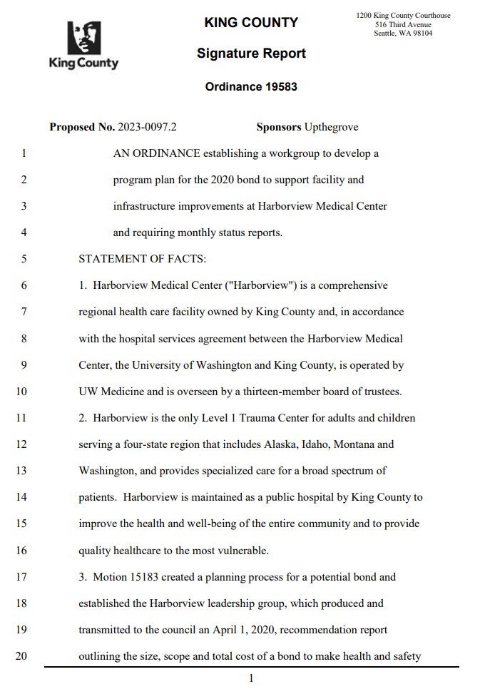
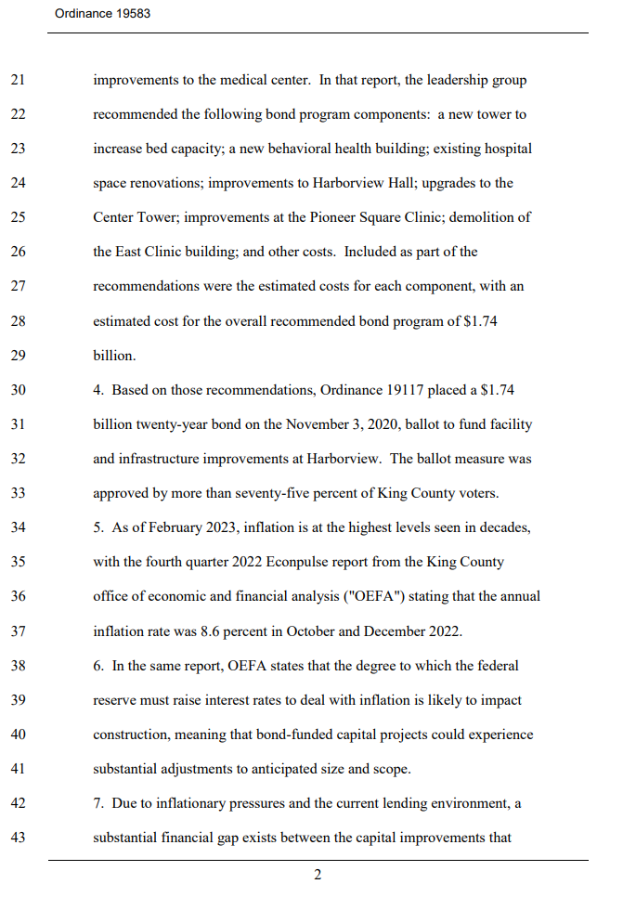
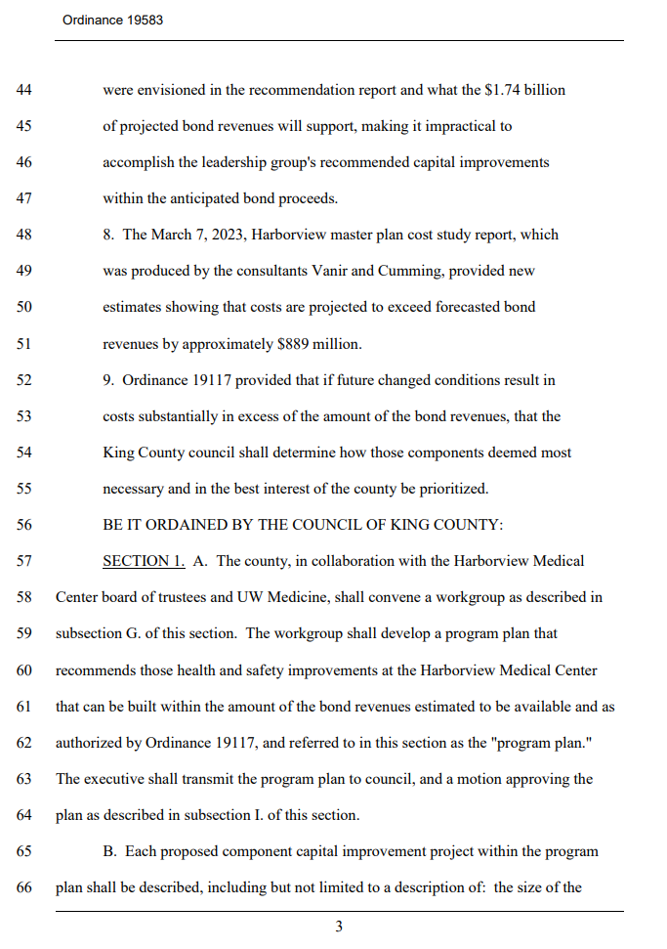
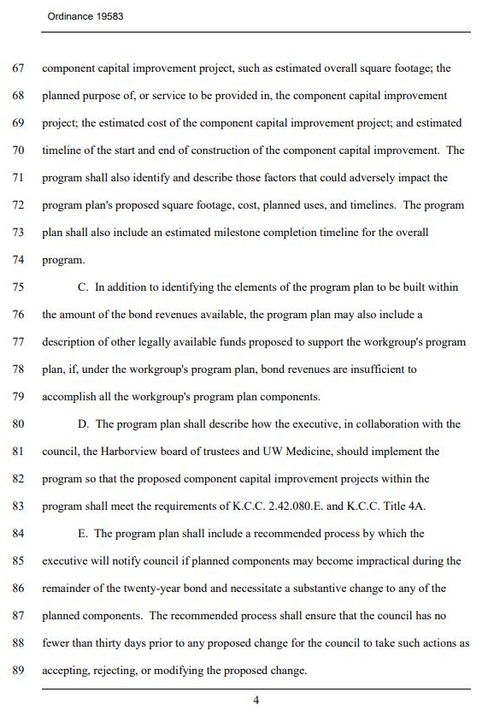
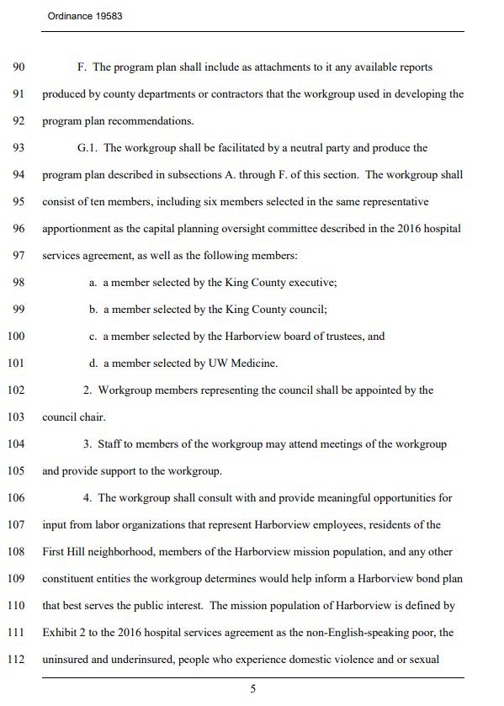
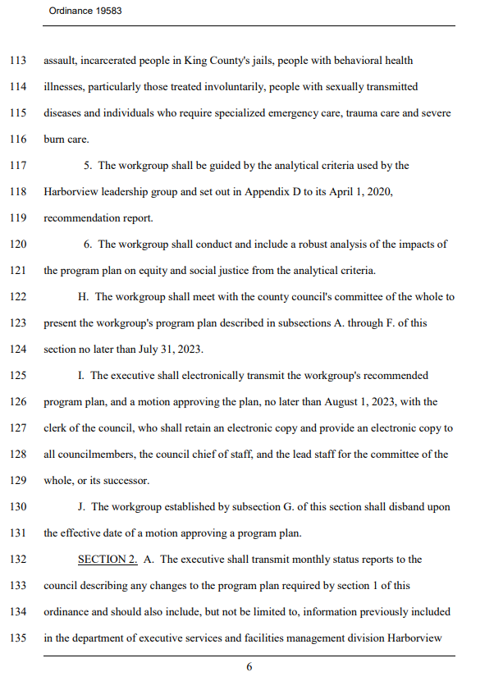
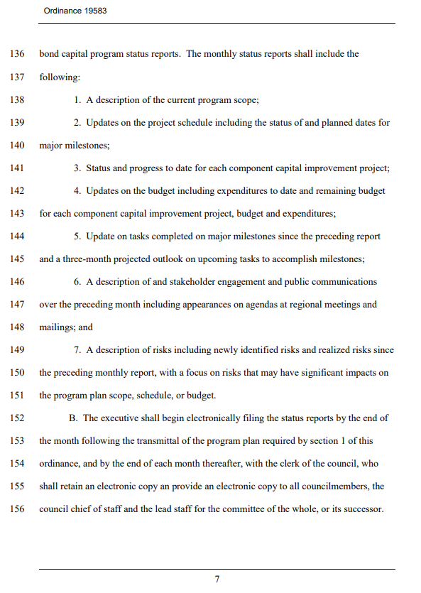
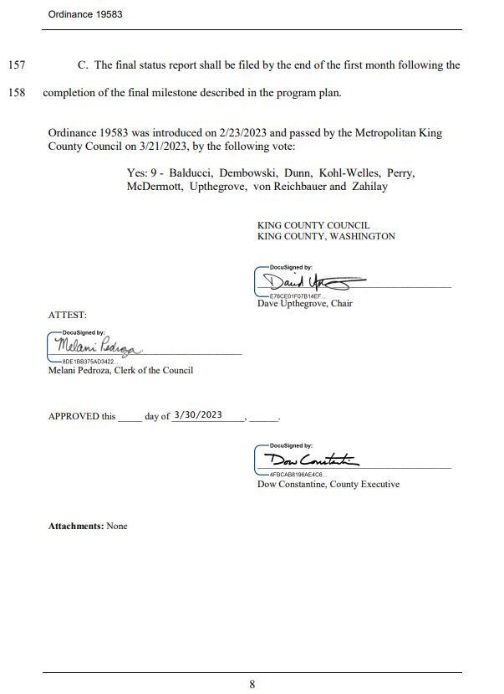
Appendix B – Harborview Mission Statement
Harborview Medical Center Mission Statement
Harborview Medical Center is a comprehensive healthcare facility dedicated to the control of illness and the promotion and restoration of health. Its primary mission is to provide healthcare for the most vulnerable residents of King County; to provide and teach exemplary patient care; to provide care for a broad spectrum of patients from throughout the region; and to develop and maintain leading-edge centers of emphasis. As the only Level I Adult and Pediatric Trauma Center in Washington, Harborview Medical Center provides specialized, comprehensive emergency services to patients throughout the region and serves as the disaster preparedness and disaster control hospital for Seattle and King County.

The following groups of patients and programs will be given priority for care:
- Persons who are non-English speaking poor
- Persons who are uninsured or underinsured
- Persons who experience domestic violence
- Persons who experience sexual assault
- Persons incarcerated in King County's Jails
- Persons with mental illness, particularly those treated involuntarily
- Persons with substance abuse
- Persons with sexually transmitted diseases
- Persons who require specialized emergency care
- Persons who require trauma care
- Persons who require burn care

Harborview's patient care mission is accomplished by assuming and maintaining a strong leadership position in the Pacific Northwest and the local community. This leadership role is nurtured through the delivery of health services of the highest quality to all patients and through effective use of its resources as determined by the Harborview Board of Trustees.

Harborview, in cooperation with UW Medicine, plans and coordinates with Public Health Seattle and King County, other County agencies, community providers, and area hospitals, to provide programs and services.

Harborview fulfills its educational mission through commitment to the support of undergraduate, graduate, post-graduate, and continuing education programs of the health professions of the University of Washington and other educational institutions, as well as programs relating to patient education.

Harborview recognizes that the delivery of the highest quality of healthcare is enhanced by a strong commitment to teaching, community service and research.

Appendix C – Vanir Cost Study Report Updated Bond Project Cost Modeling

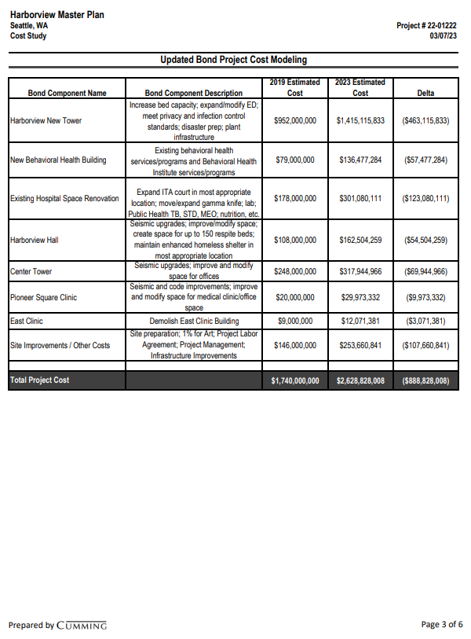

Appendix D – Phases of Construction

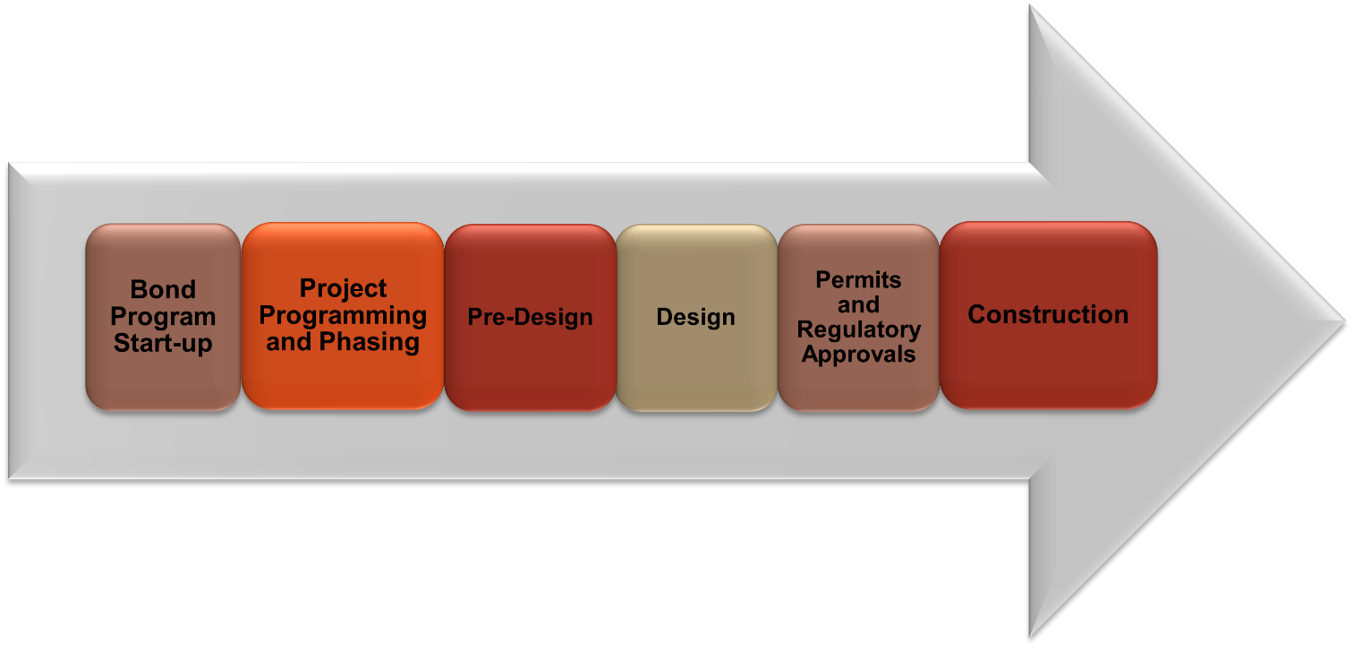

Appendix E – Motion 16435
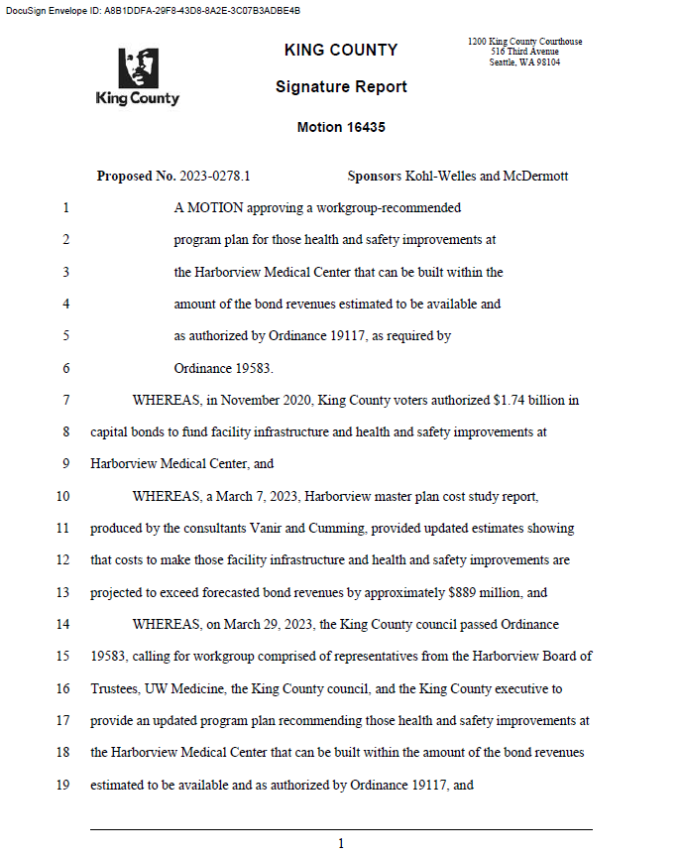

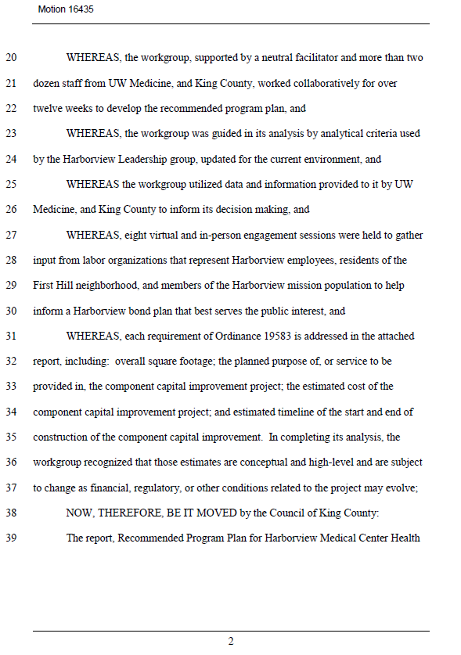

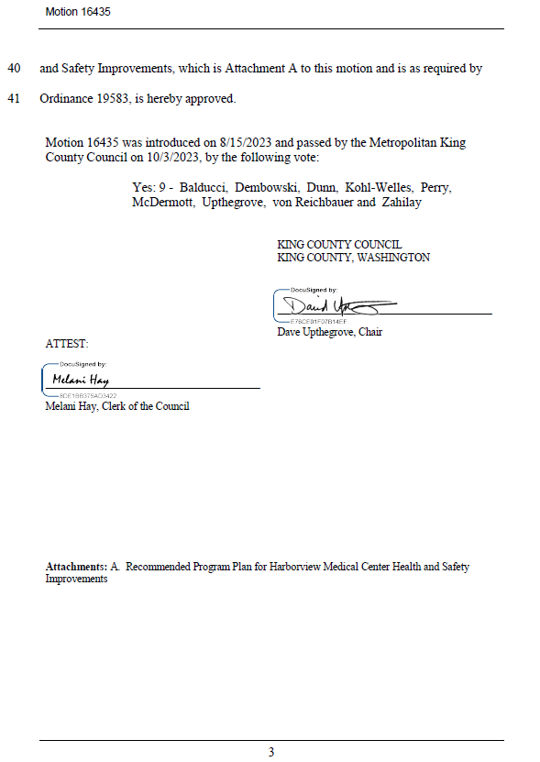

Appendix F – Implementation Advisory Committee’s final endorsed recommendation letter

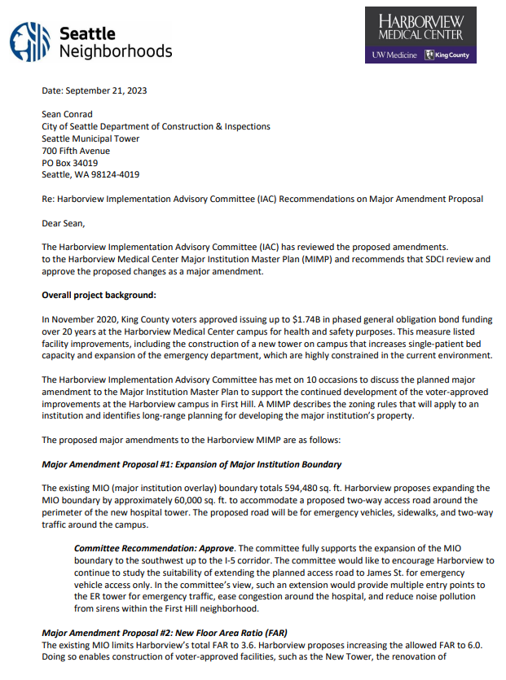

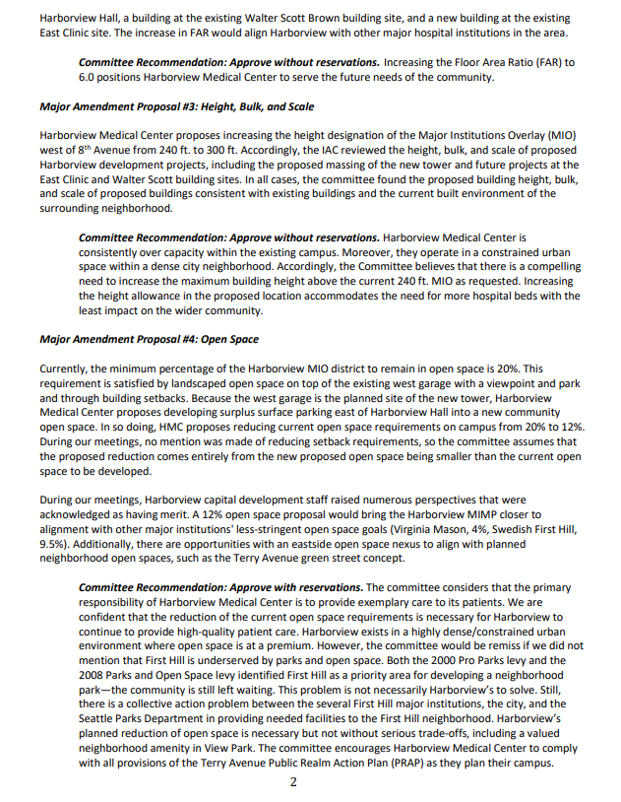

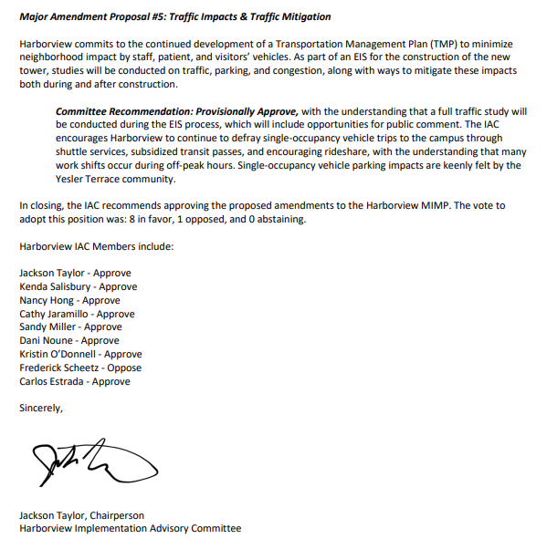

Attachment B – Harborview Medical Center Mission Statement
This report does not use the term “recommended” to describe the Program Plan, as the Council approved the Workgroup’s recommended Program Plan via Motion 16435.
Harborview’s licensed number will increase to 540 when the Maleng Single Patient Bed Project is completed. The project will deliver up to 40 new single patient rooms by converting two floors in the Maleng Building into inpatient units. Bond funds are not used for the Maleng Project.
The County-approved mission statement is incorporated into the Hospital Services Agreement via Ordinance 18232.
The Involuntary Treatment Act (ITA) Court at Harborview Medical Center handles petitions for court-ordered mental health treatment which is not part of a criminal case.
Shelled Floor: An unfinished/non-occupiable floor with basic flooring, windows, and walls. It may also have some basic HVAC, plumbing, and electrical.
Outside of describing the recommendation and approval process for the OWG recommendations, this report does not use the term “recommended” to describe the Program Plan, as the Council approved the Workgroup’s recommended Program Plan via Motion 16435.
Infrastructure analysis started in August and update scheduled for 2024.
These estimates are based on the data currently available. More detailed space needs calculations and analysis will be developed as part of the Bond program phasing and sequencing, and these numbers may change. Changes will be communicated in this report along with other established meetings and formats, such as the Capital Projects Oversight Committee (CPOC).
This work is in progress, with the City DON Implementation Advisory Committee meeting since February 2023. Staff work has been ongoing.
As noted in the report transmitted to the Council on August 1, 2023, this schedule is predicated on working with the City of Seattle to expedite its MIMP and permitting processes, particularly items denoted with * in Table 4.
NOI follows the IAC recommendations submitted in September (3Q) resulting in 4Q NOI submittal to the City of Seattle
See Appendix F
Appendix A - Ordinance 19583 lines 142-143
Budget Adopted Ordinance: - Ordinance No. 19293=$22,539,969_6/17/2021 - Ordinance No. 19546=$44,800,000_11/29/2022
September 2023 Projected Variance: New Tower – Payroll period salaries posted on September 2023 is from 8/19/23-9/15/23 and variance should post to the next period; and Existing Space Renovations – reimbursed KCMEO McKinstry invoice payment posted on August 2023 instead of September 2023.
Note that this report was completed in October, therefore tasks for October are noted as “projected”. The December report will include October tasks completed with projected November tasks.
The Capital Projects Advisory Review Board (CPARB) process is mandated by RCW 39.10 to review alternative public works contracting procedures.
Appendix D - Phases of Construction diagram

