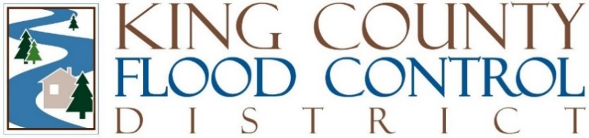

STAFF REPORT

Agenda Item: | 8 | Name: | Steven Schauer
Proposed Legislation: | FCD2024-14 | Date: | November 12, 2024

Proposed Resolution FCD2024-14: A RESOLUTION of the Board of Supervisors of the King County Flood Control Zone District, repealing and replacing Resolution FCD2024-07, approving templates for grant agreements related to the administration of the King County Flood Control Zone District’s grant programs.

The King County Flood Control District (District), as a component of its budget, funds both the Cooperative Watershed Restoration and Protection Grant Program and the Flood Reduction Grant Fund. King County Department of Natural Resources and Parks administers these grant programs, pursuant to the Interlocal Agreement between the District and King County. To ensure uniformity in the administration of the District’s grant programs, the Board of Supervisors (Board) adopted Resolution FCD2023-05, approving template grant contracts for the District's grant programs.

Following adoption of Resolution FCD2023-05, a local jurisdiction requested a change to the templates, which was authorized by the Board through the adoption of Resolution FCD2024-07. Since the adoption of Resolution FCD2024-07, a tribal government also requested a change to the template agreement. Staff met and developed an agreement to allow additional flexibility for King County to change the template for tribal governments, subject to review and approval by the King County Prosecuting Attorney and the District’s legal counsel.

This staff negotiated agreement and accompanying proposed Resolution has been reviewed and approved by the District’s legal counsel. By this Resolution, the Board would approve the agreement negotiated by staff providing flexibility to change the template for tribal governments, which would repeal and replace Resolution FCD2024-07.

