STAFF REPORT

Agenda Item: | 9 | Name: | Miranda Leskinen
Proposed No.: | 2019-0294 | Date: | August 20, 2019

SUBJECT

A Motion acknowledging receipt of the Public Health regional health plan pilot phase one plan

SUMMARY

Proposed Motion 2019-0294 would acknowledge receipt of the Phase One portion of a plan relating to a regional health plan pilot program, in compliance with a 2019-2020 biennial budget proviso (Ordinance 18835, Section 95, Proviso P3). The transmitted report generally meets the plan Phase One requirements in the budget proviso.

The transmitted report (Attachment A) includes, as required: the most recent available demographic data on the population of uninsured persons in King County; legal and regulatory considerations of establishing a regional health plan pilot program to provide health care to low-income county residents lacking health care access through existing public programs; pilot program options, potential eligibility requirements, and financial analysis; and a recommendation as to whether to proceed with Phase Two of the plan.

As described in the transmitted report, which builds on a 2018 Northwest Health Law Advocates (NoHLA) report on county-based coverage for adult immigrants, analysis looked at the feasibility (subject to available funding) of expanding access to health care coverage and services for uninsured county residents, focusing on those who, due to their immigration status, are not eligible for coverage through existing public programs. The transmitted report includes analysis of five potential options with annual cost estimates ranging from $2 million to $181 million (depending on program services scope and income eligibility criteria).

The recommendation of the transmitted report is to not proceed with Phase Two of the plan, as described in the proviso, and instead pursue action steps that focus on laying the groundwork for a longer-term statewide solution while also providing modest near-term support to improve health care access for the focus population, including:
- Identifying health care access for low-income uninsured non-citizen adults as a priority on the 2020 county legislative agenda;
- Studying the feasibility of re-opening the Washington State Health Insurance Pool (WSHIP);
- Engaging the county’s Immigrant and Refugee Commission; and
- Enhancing outreach to connect the focus population to services for which they are currently eligible.

If Council passes the proposed motion acknowledging receipt of the Phase One portion of the plan, then the Executive would be required to proceed to develop Phase Two of the plan, due to Council by December 31, 2019, which would include a pilot program implementation roadmap and an evaluation plan. Under this scenario, release to Public Health of the entire amount ($500,000) restricted by the proviso would be predicated on Council passage of a motion acknowledging receipt of the Phase Two portion of the plan. If Council were to pursue this option, the report indicates that additional time beyond the December 31st due date would be needed to complete this work, including stakeholder and community engagement, extensive legal and actuarial analysis, and development of the implementation and evaluation plans required by the proviso. According to Executive staff, if Council pursues this option, a feasible due date for transmitting the Phase Two report would be December 31, 2020; the estimated cost to prepare the report would be $500,000.

If Council does not pass the proposed motion and instead passes a motion determining that the Executive need not perform Phase Two of the plan, then the budget proviso would be satisfied and the entire $500,000 in funds restricted by the proviso would be released to Public Health. Council could alternatively allow the proposed motion to lapse and amend the budget proviso (Ordinance 18835, Section 95, P3) in order to release to Public Health the $500,000 in funds restricted by the proviso.

BACKGROUND

Health Care Access for Uninsured Persons in King County. In King County, uninsured residents can access primary care services and pharmaceuticals at 43 clinic sites run by eight Federally Qualified Health Center (FQHC) agencies in King County, the majority of which are owned and operated by non-profit, community-based providers. The clinics receive an enhanced reimbursement rate for publicly insured patients to help offset the costs of care they are required to deliver to patients regardless of their insurance status. In 2017, the FQHCs saw over 42,000 uninsured patients (less than one-third of the estimated uninsured adult population). Uninsured residents may be referred from the FQHCs and other primary care providers to specialists offering pro-bono services through Project Access Northwest, a non-profit formed in 2006 that matches volunteer specialty care providers and hospital partners with pre-screened patients in need of care. Project Access Northwest served approximately 5,000 people in 2017, approximately 2,400 of whom were uninsured.

Dental care, similar to primary care, is accessible through safety net providers; six of the eight FQHC agencies offer dental services at 30 clinics in King County. Low-cost and no-cost dental services may also be available through churches, non-profits and training sites, and through individual arrangements with dental offices. Over 114,000 patients received dental treatment in 2017, over 19,000 of whom were uninsured.

Behavioral health services are available through private non-profit providers under contract with the King County Behavioral Health Administrative Service Organization. Approximately 40 contract agencies served over 55,000 patients in 2016, over 8,000 of whom were uninsured.

Health care services for persons experiencing homelessness may be accessed through the Health Care for the Homeless Network, which provides federally-funded health care services for this population in King County through Public Health clinics, mobile medical program, Harborview Medical Center, FQHCs and other providers. The network served over 20,000 people in 2017, nearly 1,500 of whom were uninsured.

Additionally, a free annual four-day clinic (hosted by the Seattle Center) provides county residents with medical and dental care on a temporary basis every year, regardless of insurance or immigration status. The 2018 clinic served 3,661 patients, almost half of whom were uninsured.

While children from low-income families in King County generally have access to health care coverage through Washington Apple Health regardless of immigration status, adults do not. A chart summarizing health care coverage program eligibility criteria is provided below in Figure 1. This chart is also available in multiple languages on the Washington Health Benefit Exchange website.

Figure 1. Washington Health Benefit Exchange Eligibility by Immigration Status
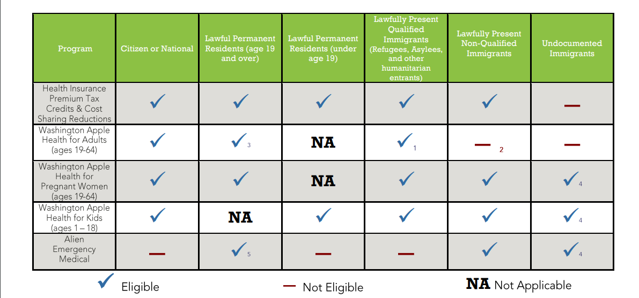

Uninsured adult non-citizens may access primary care at community health centers with cost sharing, Apple Health for Pregnant Women, Family Planning Only (for up to 12 months after pregnancy), Alien Emergency Medical Program, and hospital charity care. In sum, Washington State provides some funding for health programs that cover low-income undocumented immigrants for some health benefits, including coverage for children, pregnant women, hospital emergency care and limited cancer treatment and dialysis.

Additionally, Public Health – Seattle & King County conducts prevention efforts, testing and provides treatment for communicable diseases including HIV, tuberculosis and STDs for county residents regardless of immigration or insurance status.

It is important to note that it is the policy of King County that the county will not deny access to public health services based on immigration status.

Board of Health Resolution 18-01 In January 2018, the King County Board of Health passed Resolution 18-01 in support of expanding coverage and lowering barriers for low-income residents, regardless of immigration status, who are unable to afford private insurance and unable to access Medicaid. The following month, the Board received a briefing from the Northwest Health Law Advocates (NoHLA) on a (then) forthcoming report on efforts by county governments in California and other states to address the challenge of improving access to health care for adults who remain uninsured due to immigration status.

NoHLA Report Released in April 2018, NoHLA’s report titled “County-Based Health Coverage for Adult Immigrants: A Proposal for Counties in Washington State” examined health care coverage accessibility for uninsured adults who, due to their immigration status, are not eligible for coverage through existing public insurance programs including Medicaid, Medicare or Qualified Health Plans purchased on the Health Exchange. The NoHLA report profiled six county-based health programs and offered a number of recommendations for King and Yakima Counties to address health care coverage gaps for this population of county residents. A summary of the six county-based programs highlighted in the NoHLA report is provided in Table 1.

Table 1. County-Based Health Coverage Programs Highlighted in NoHLA Report
Program Name | Estimated Enrollees | Benefits | Coverage | Annual Budget
Healthy San Francisco (CA) | 14,200 | Comprehensive, within a defined network of public and non-profit providers and facilities | Adult residents (18+) up to 500% FPL (combined family income), uninsured for at least 90 days and ineligible for public insurance programs | $74 million
My Health LA (CA) | 142,112 | Primary care, specialty, limited hospital within a defined network of county-operated facilities and 213 non-profit clinics | Adult residents (19+) no more than 138% FPL (combined family income) and ineligible for public insurance programs | $65 million
Contra Costa Cares (CA) | Capped at 4,100 | Primary Care within a defined network of 7 sites | Adult residents (19+) no more than 138% FPL (combined family income) and ineligible for public insurance programs | $1.5 million
Montgomery Cares (MD) | 25,530 | Primary care, behavioral health, limited specialty and dental | Adult residents (18+) no more than 250% FPL (combined family income) and ineligible for public insurance programs | $12 million
Nevada Medical Discount Program (NV) | 12,000 | Comprehensive coverage through a network of participating providers paid discounted rates directly by enrollees | Residents up to 250% FPL and un/underinsured | $5 million (from fees)
Action Health NYC (NY) – 1-year pilot program | 1,300 | Comprehensive within a defined network of publicly owned facilities and non-profit clinics | Adult residents (19+) no more than 200% FPL (combined family income) and ineligible for public insurance programs | $6 million (includes evaluation funding)

As illustrated in Table 1, some local jurisdictions in other states have established county-based programs to increase access to health care coverage for uninsured residents, and a number of state and local jurisdictions have funded safety net health care providers through what the transmitted report describes as ‘coverage and access’ programs – meaning services are funded through a network of publicly-owned and non-profit providers. Many of the provider primary care clinics and public hospitals in most of the program examples are operated by the respective county.

It is important to note that while NoHLA recommended that counties should explore all potential sources to develop a plan for financing a county-based program for uninsured adult residents ineligible for existing public insurance programs, specific recommendations on financing beyond a general description of county general fund, public health and private sector sources were considered beyond the scope of the report and were not included in the report. The NoHLA report cited a preliminary 2020 cost estimate of $53 million, increasing to $68 million by 2025 to reflect estimated enrollment growth (10% projected growth – increasing from approximately 35,400 to 39,000) and medical cost inflation, for a county-based program in King County offering services similar to those available through Medicaid (based on a patient-centered medical home program model available to residents up to 400% FPL, and using a capitated payment model with no premiums or out-of-pocket costs for those below 138% FPL). As indicated by executive staff, the NoHLA cost estimate is for benefits comparable to the ‘partial benefit wrap around’ option in the transmitted proviso report which estimates annual costs at $25 million to $61 million per year (also see Table 2). As further indicated, this benefit package and NoHLA’s recommendation assume that current services for uninsured undocumented adults, such as pregnancy coverage and hospital charity care, will continue.

2019-2020 Budget proviso. As part of its deliberations on the 2019-2020 biennial budget ordinance (Ordinance 18835), the Council included a proviso on the Public Health budget (Section 95, Proviso P3) requiring the Executive to transmit a plan, developed in two phases, for a regional health plan pilot program for low-income county residents lacking access to health care through existing public programs. The proviso states:
“Of this appropriation, $500,000 shall not be expended or encumbered until: (1) the executive transmits a plan, produced in two phases, to implement a regional health plan pilot program that would provide health care to low-income county residents who are not eligible to access health care through public programs such as Medicaid, Medicare and subsidized health insurance under the Affordable Care Act; (2) the executive transmits motions for both phases of the plan and that should acknowledge receipt of the respective phases of the plan and reference the subject matter, the proviso's ordinance, ordinance section and proviso number in both the title and body of the motion; and (3) except as otherwise provided herein, a motion acknowledging receipt of each phase of the plan is passed by the council.
The plan shall be developed in two phases.
A. Phase One shall include:
1. Complete demographic analysis of the 2019, or the latest year of which data are available, uninsured population, disaggregated based on age, gender, race and ethnicity, household poverty status and city of residence;
2. Assessment of the legal and regulatory considerations of establishing a pilot program;
3. Options for a "buy in" or similar program to provide health coverage for low-income county residents;
4. Potential eligibility requirements for the pilot program;
5. Financial analysis and funding options that should evaluate both existing and new revenue sources; and
6. Recommendation on whether to proceed with Phase Two and what resources would be required for that work.
Phase One shall be developed in collaboration with HealthierHere, Northwest Health Law Advocates who authored the April 2018 report entitled "County-Based Health Coverage for Adult Immigrants: A Proposal for Counties in Washington State," and other organizations that are involved with county healthcare issues.
The executive should file the Phase One plan and a motion required by this proviso by June 30, 2019, in the form of a paper original and an electronic copy with the clerk of the council, who shall retain the original and provide an electronic copy to all councilmembers, the council chief of staff and the lead staff for the health, housing and human services committee, or its successor.
B. Following the filing of the Phase One portion of the plan by the executive, if, instead of passing a motion acknowledging receipt of the Phase One portion of the plan, the council passes a motion determining that the executive need not perform Phase Two of the plan, then this proviso shall have been satisfied and the $500,000 shall be unencumbered. Otherwise, following the passage of a motion acknowledging receipt of the Phase One portion of the plan, then the executive shall proceed to develop Phase Two of the plan, which shall include, but not be limited to, the following:
1. Coordination with all Federally Qualified Health Centers in the county and other health care providers that offer healthcare services to the underinsured;
2. An evaluation plan that should include, but not be limited to, an assessment of usage of a pilot program, a measurement of health outcomes of those benefitting from a pilot program, a cost-benefit analysis comparing the overall cost of a pilot program and savings to the overall healthcare system as a result of a pilot program, an estimate of the annual cost of operating a full-scale regional health plan for the county and the annual savings to the overall health care system as a result of a county regional health plan; and
3. A roadmap, which should include a timeline for implementing a pilot program, a timeline for evaluating a pilot program and a timeline of when a full-scale implementation may be implemented, should a pilot program confirm the feasibility of a regional health plan for the county.
Unless the council passes a motion determining that the executive need not perform Phase Two of the plan, the executive should file the Phase Two plan and a motion required by this proviso by December 31, 2019, in the form of a paper original and an electronic copy with the clerk of the council, who shall retain the original and provide an electronic copy to all councilmembers, the council chief of staff and the lead staff for the health, housing and human services committee, or its successor.”

ANALYSIS

The transmitted report (Attachment A to Proposed Motion 2019-0294) includes, as required:
- The most recent available demographic data on the population of uninsured persons in King County;
- Legal and regulatory considerations of establishing a regional health plan pilot program to provide health care to low-income county residents lacking health care access through existing public programs;
- Pilot program options, potential eligibility requirements, and financial analysis; and
- Recommendation as to whether to proceed with Phase Two of the plan.

As described in the transmitted report, which builds on the 2018 NoHLA report, analysis looked at the feasibility (subject to available funding) of expanding access to health care coverage and services for uninsured county residents, focusing on adults who, due to their immigration status, are not eligible for coverage through existing public programs. The report includes financial analysis of five potential options with estimated annual costs ranging from $2 million to $181 million (depending on program services scope and income eligibility criteria).

Public Health staff, per the proviso, collaborated with NoHLA and HealthierHere in the preparation of the transmitted report. Additionally, Public Health staff performed a topical literature review and conducted informal interviews with safety net providers, payers, other counties, immigrant rights organizations, relevant county staff, state agencies and legal counsel. Public Health indicated that, because it did not have funding, it did not conduct as part of its research formal community engagement or an in-depth analysis to understand how the focus population currently accesses care.

King County Uninsured Population – Demographic Overview. Washington’s Apple Health for Kids program makes health care coverage available to children in families with income up to 312 percent of the federal poverty line (FPL), regardless of immigration status. In 2017, approximately two percent of children in King County were estimated to lack health care coverage.

The percentage of adults in King County who are uninsured has been reduced by half since enactment of the Affordable Care Act (ACA). An estimated 147,000 adults in King County remain uninsured as of 2017. Of this number, an estimated 52,000 adults are immigrants who do not have U.S. citizenship, with south King County experiencing the highest percentages of uninsured adults. According to the transmitted report, an unknown percentage of this number are undocumented persons (not currently eligible for public health coverage programs like Medicaid, Medicare or Qualified Health Plans purchased on the Health Exchange). A demographic summary of uninsured resident non-citizen adults in King County is provided in Figure 2.

Figure 2. Uninsured Resident Non-Citizen Adults in King County (2013-2017 Average)
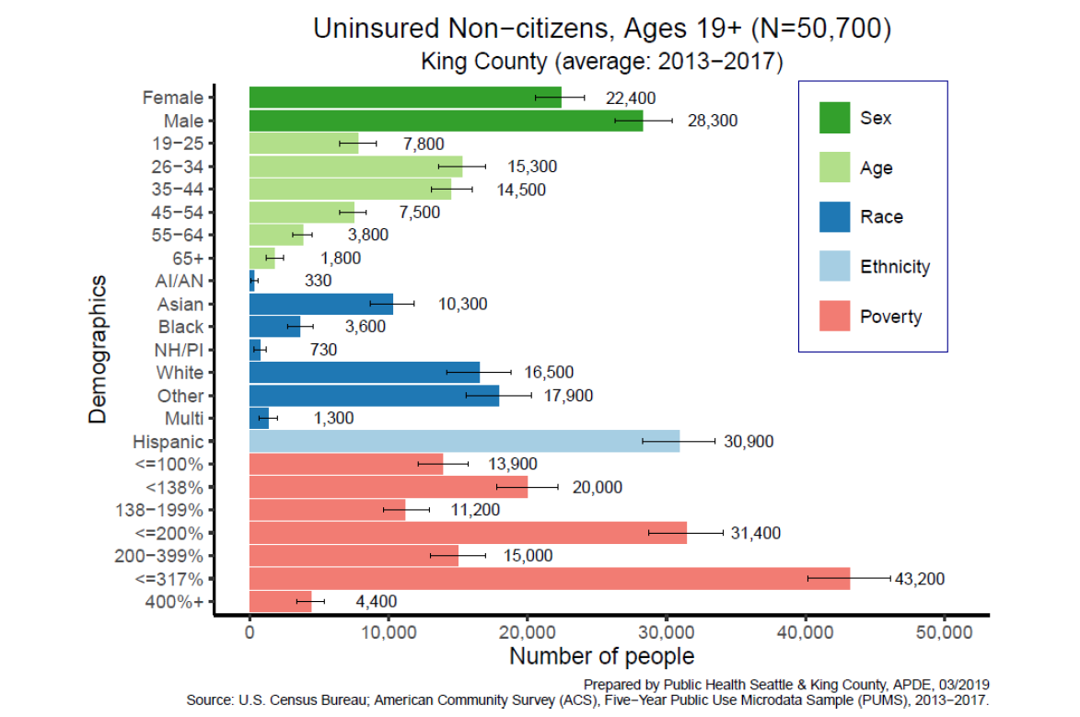

County-Based Health Coverage Pilot Program - Potential Buy-in and Coverage Options, Eligibility Criteria and Funding Considerations. According to the transmitted report, it is not currently feasible (absent changes to federal and state law) to buy-in to any existing public or county-administered health insurance programs (e.g. county employee health plan), which makes purchasing individual policy coverage outside of the Health Benefit Exchange the only feasible option for a comprehensive insurance buy-in option. As described in the transmitted report, this could entail creation of a state-only funded program that does not mix federal and state dollars (like Apple Health for Kids or the former state Basic Health Plan). Alternatively, the report also notes that purchase by the county of individual insurance policies through the commercial insurance market outside of the federally subsidized state Health Benefit Exchange may be another potential option (subject to further legal and feasibility analysis). Subject to a change in state law, re-opening of the state’s Health Insurance Pool (WSHIP) full-scope insurance program to new enrollees is listed as another potential option, although the report notes that further study is needed, including financial feasibility analysis to determine if insurance premiums for the insurance pool would be prohibitively expensive.

Five potential options for expanding coverage to low-income adult uninsured non-citizen residents are provided in the transmitted report. The options vary in scope of benefits, ranging from full scope benefits to partial or limited benefits coverage. The preliminary cost estimate for each option includes 13 percent for administration, which factors in routine administration costs, outreach, enhanced language access and care coordination. Cost estimates are based on an estimated enrollment rate of 48 percent of eligible participants. Additionally, the report assumes that many currently available services and coverage would continue (e.g. hospital charity care for persons earning less than 200% FPL). A high-level summary of the options discussed in the report is provided in Table 2.

Table 2. Policy Options and Estimated Annual Costs for King County
Option |  | Estimated Coverage | Benefits | Estimated Annual Cost
Offered via Insurance Product | Comprehensive Insurance | Up to 138% FPL = 10,000 | Comprehensive insurance coverage comparable to Medicaid or a Qualified Health Plan that covers a full range of essential benefits, offered by a private health plan | Up to 138% FPL = $65 M
Offered via Insurance Product | Comprehensive Insurance | Up to 317% FPL = 22,260 |  | Up to 317% FPL = $181 M
Not Offered via Insurance Product; Funded through Provider Contracts to expand access | Partial Benefit Wrap Around | Up to 138% FPL = 10,000  Up to 317% FPL = 22,260 | Access to a range of benefits less than full range of essential benefits (concept would be to combine with existing coverage to create full scope comparable coverage). | Up to 138% FPL = $25 M
 |  |  |  | Up to 317% FPL = $61M
 | Specialty Care | Up to 138% FPL = 10,000  Up to 317% FPL = 22,260 | All non-primary care events delivered in an office setting | Up to 138% FPL = $7 M
 |  |  |  | Up to 317% FPL = $16 M
Not Offered via Insurance Product; Funded through Provider Contracts &/or PHC services expansion | Primary Care | Up to 138% FPL = 10,000  Up to 317% FPL = 22,260 | General practice, family practice and internal medicine primary care and behavioral health delivered in an office setting | Up to 138% FPL = $3.5 M
 |  |  |  | Up to 317% FPL = $7 M
 | Dental Care | Up to 138% FPL = 10,000  Up to 317% FPL = 22,260 | Dental visits | Up to 138% FPL = $2 M
 |  |  |  | Up to 317% FPL = $4 M

Funding Considerations. In terms of existing county resources, the General Fund is the county’s most flexible county revenue stream supporting Public Health; however, state law restrictions on property tax revenue growth and sales tax revenue allocation (which together equate to more than three-fourths of the General Fund) have contributed to a structural financial gap whereby revenue growth is not keeping pace with the increasing cost of providing services (reflecting rate of inflation and population growth). In other words, as highlighted in the transmitted report, no major new investment could be funded with the current level of General Fund support for Public Health without shifting funds away from existing programs, and Public Health does not have existing resources or flexibility to dedicate federal, state and private grant funding toward setting up a pilot health coverage expansion program.

Relatedly, stemming from state and local laws, fee and levy revenues collected by the county are not flexible, meaning those revenues can only be used for specific purposes and cannot be diverted to other purposes. Moreover, implementation plans approved by Council direct the allocation of proceeds from existing human services levies (e.g. VSHSL). According to the report, use of such an existing levy lid lift would either risk reducing expenditures already committed to various community organizations or use reserves, potentially contradicting county fund reserve management policies.

Aside from existing county resources, the report identifies a levy proposal for voter approval, meaning a levy lid lift to exceed the 1 percent growth limit for property tax revenues, as a possible funding option. Other possible funding sources identified in the report include contributions from the private sector and partnerships with other entities and institutions. However, the report notes that this type of funding frequently only supports the program pilot period, leaving the local government to provide ongoing program support.

Report Recommendation on Next Steps. The recommendation of the transmitted report is to not proceed with Phase Two of the plan, as described in the proviso, and instead pursue action steps that focus on laying the groundwork for a longer-term statewide solution while also while also providing modest near-term support to improve health care access for the focus population, including:
- Identifying health care access for low-income uninsured non-citizen adults as a priority on the 2020 county legislative agenda;
- Studying the feasibility of re-opening the Washington State Health Insurance Pool (WSHIP);
- Engaging the county’s Immigrant and Refugee Commission; and
- Enhancing outreach to connect the focus population to services for which they are currently eligible.

On June 28, 2019, an Executive press release was issued announcing implementation of near-term action items (Report recommendations 2, 3 and 4) to improve access to high-quality affordable health care for all county residents. As indicated in the press release, King County will fund a study exploring the feasibility of reopening the Washington State Health Insurance Pool, as well as enhance access and outreach programs in Public Health to better assist immigrant communities with currently available health services. As confirmed by Executive staff, funding to implement these action items, including $100,000 to fund the WSHIP study and $200,000 to cover a 1.0 FTE navigator position to assist with access and outreach programs enhancement in Public Health, are currently under consideration for proposal in an upcoming supplemental omnibus appropriations request.

Additionally, the press release announced that the Executive is also engaging with the King County Immigrant and Refugee Commission, which was formed last year to integrate, strengthen and value immigrant and refugee communities and uphold the county’s commitment as a welcoming community. According to Executive staff, Public Health staff have met several times with Commission members and staff who have particular interest in health issues and received feedback during the meetings that the new Commission is interested in playing a liaison role with the groups of immigrants they represent. As further indicated, Public Health plans to make a presentation about options for expanding coverage to the Commission this fall. Additionally, the Commission has assigned this issue to a subcommittee and will engage their members and the community on the issue to the best of their ability within current resources.

If Council passes this proposed motion acknowledging receipt of the Phase One portion of the plan, then the Executive would be required to proceed to develop Phase Two of the plan, due to Council by December 31, 2019, which would include a pilot program implementation roadmap and an evaluation plan. Under this scenario, release to Public Health of the entire amount ($500,000) in funds restricted by the proviso would be predicated on Council passage of a motion acknowledging receipt of the Phase Two portion of the plan. If Council were to pursue this option, the report indicates that additional time beyond the December 31st due date would be needed to complete this work, including stakeholder and community engagement, extensive legal and actuarial analysis, and development of the implementation and evaluation plans required by the proviso. According to Executive staff, if Council pursues this option, a feasible due date for transmitting the Phase Two report would be December 31, 2020; the estimated cost to prepare the report would be $500,000.

It is important to reiterate that the Phase One report makes clear that program implementation would be subject to program funding.

If Council does not pass the proposed motion and instead passes a motion determining that the Executive need not perform Phase Two of the plan, then the budget proviso would be satisfied and the entire $500,000 in funds restricted by the proviso would be released to Public Health. Council could alternatively allow the proposed motion to lapse and amend the budget proviso (Ordinance 18835, Section 95, P3) in order to release to Public Health the $500,000 in funds restricted by the proviso.

INVITED

- Ingrid Ulrey, Policy Director, Health Policy & Planning, Public Health – Seattle & King County

ATTACHMENTS

- Proposed Motion 2019-0294
- Regional Health Plan Pilot Phase One Report
- Transmittal Letter
- PowerPoint presentation, dated August 20, 2019.

County-Based Health Coverage for Adult Immigrants: A Proposal for Counties in Washington State, April 2018. Northwest Health Law Advocates (NoHLA). An electronic copy of the report is available online at https://nohla.org/index.php/county-based-h-c-adult-immigrants/.
This information is also included in Appendix F to the transmitted report.
Seattle/King County Clinic, 2018 Final Report, https://seattlecenter.org//nas/content/live/scfweb2016/nas/content/live/scfweb2016/media/2018-SKC-Clinic-Final-Report_COMPLETE.pdf.
Apple Health encompasses various programs for very specific populations, with some programs funded in part by the Federal Government (Apple Health for Adults) and some programs funded only by the state (state-funded Apple Health for Kids). Adult lawful permanent residents (LPR) who entered the U.S. after 8/22/96 generally must be in LPR status for five years before they become eligible for Apple Health Adult coverage (except for Apple Health for Pregnant Women or the Alien Emergency Medical Program).
Ordinance 16692, Section 2.C.
The Action Health NYC pilot program was not extended beyond the pilot period, which ended at the end of June 2017. In early 2019, a new program called NYC Care was announced to launch in the Bronx borough of the city in August 2019. The program provides eligible, uninsured NYC residents with access to primary and preventive care services and other health services at public hospital facilities. The program is projected for implementation across the city’s five boroughs by the end of 2020. (City of New York, Office of the Mayor, “De Blasio Administration Launches NYC Care in the Bronx, Key Component of Mayor’s Guaranteed Health Care Commitment”, August 1 2019: https://www1.nyc.gov/office-of-the-mayor/news/376-19/de-blasio-administration-launches-nyc-care-the-bronx-key-component-mayor-s-guaranteed-health).
According to the transmitted report, funding allocated by the City of Seattle to NoHLA was used to support their participation and to engage the HealthTrends consulting firm to conduct the cost estimates of alternative coverage options included in the report. HealthTrends conducted an age, gender, demographic, employment status and income-weighted analysis to derive cost estimates and benchmarked these with other sources of health care cost information. Public Health’s Assessment, Policy Development and Evaluation Unit provided the population estimates used in the cost analysis.
Washington State Health Care Authority, Health Care for Children: https://www.hca.wa.gov/health-care-services-supports/program-administration/health-care-children. Of note, Children who would have been eligible for Apple Health for Kids (Medicaid) except for not meeting the immigration status requirements receive coverage under state-funded Apple Health for Kids.
PHSKC, Community Health Indicators, 2008-2017, accessed 8/12/19.
Patient Protection and Affordable Care Act of 2010, Public Law 111-148. Of note, major provisions of the ACA took effect in 2014.
The report estimates the number of uninsured non-citizen adults in King County between 50,700 and 52,000 depending on which data source is used. The 52,000 figure is the best estimate of the total number and the 50,700 figure is used when the group is divided into smaller demographic categories.
Additional demographic details are included in Appendices C and D to the transmitted report. Appendix D provides a demographic overview of uninsured resident non-citizens in King County (by cities with populations over 20,000). As indicated in Appendix D, cities with the highest uninsured rates were largely located in south King County.
The former Washington Basic Health Plan (ended after 2013) offered state-subsidized health coverage to low-income residents regardless of immigration status, with sliding scale premiums and a basic set of benefits. When the program ended, many former program enrollees received coverage through Medicaid expansion under the ACA; however, undocumented program enrollees lost health coverage due to Medicaid eligibility requirements relating to immigration status.
The Washington State Health Insurance Pool provides health benefits to residents denied coverage or unable to obtain comprehensive coverage. There are two WSHIP programs (WSHIP Medicare and Non-Medicare programs). Eligibility for WSHIP’s non-Medicare plans changed in 2014 to limit enrollment to individuals enrolled in WSHIP before 2014 or who reside in a county where individual plans are not offered. The WSHIP 2018 Annual Report indicates that WSHIP’s non-Medicare plans remained closed to new enrollment in 2018 since individual health plans were offered in all counties; 321 enrollees remained in these plans at the end of 2018, of whom 222 are persons with HIV/AIDS who are sponsored by the Washington State Department of Health Early Intervention Program.
These two income thresholds were used in the report’s financial analyses in order to align with state programs.
“Essential health benefits”, according to the report, includes doctor visits and hospital stays, trips to the emergency room, care before and after a baby is born, mental health and substance use disorder treatment services, prescription drugs, services and devices to help recover after injury or to help with a disability or chronic condition, lab tests, preventive services (including counseling, screening and vaccinations), management of chronic disease and pediatric care.
As indicated in the report, this option would require additional legal review to ensure compliance with state Office of Insurance Commissioner laws.
As indicated in the report, many implementation issues would have to be resolved in later work should this option be chosen, including how to protect protected health information in accordance with HIPAA.
As noted in the report, the primary care and dental care options would be more straightforward than the others to implement since Public Health already has contracts with FQHCs and could increase current per visit rates to enhance access for adults at these providers.
Prior to elimination of the state motor vehicle excise tax (MVET), Public Health received stable funding from the state. As indicated in the transmitted report, the state and City of Seattle continue to provide some funding, but the level of funding has not kept pace with cost growth (reflecting rate of inflation and population growth). Of note, some additional state funding has been provided in recent years for the provision of foundational public health services, but there remains a structural gap (revenues compared to services expenditures).
King County, Office of the Executive. Press release, “King County: Next Steps in the fight for universal coverage”, June 28, 2019: https://kingcounty.gov/elected/executive/constantine/news/release/2019/June/28-regional-health.aspx

