Consolidated Plan 2020-2024
Public Engagement Technical Report

As a part of the Consolidated Plan development, the Housing, Homelessness and Community Development Division (HHCDD) of the King County Department of Community and Human Services (DCHS) solicited input on community needs, priorities and draft strategies. Public input was encouraged throughout all phases of the Consolidated Plan, including through specific stakeholder outreach activities.

Public outreach and engagement activities were designed to reduce barriers to participation to ensure public input was broad and representative of program beneficiaries. Particular effort sought to engage stakeholders and community groups underrepresented in the past.

As part of the update process, HHCDD engaged with partner organizations, local jurisdictions and members of the public to gather input on housing and community development priorities in King County and how best to align funding with those priorities. This document describes how HHCDD worked with the community throughout the update process and outlines a strategy for continued engagement over the duration of the plan itself.

Community Participation Process
The community outreach and participation process provided multiple types of opportunities and methods to hear from the public on priorities and gather public comment on the draft Consolidated Plan. The Consolidated Plan public comment period was open from June 14 through July 26, 2019. During that time, the public could access the draft of the Consolidated Plan on the HHCDD website, at the main HHCDD office and at public meetings. Staff accepted public comments in person, by phone or via email.
The HHCDD collected feedback on Consolidated Plan strategies to ensure the Plan reflects resident needs and concerns, mitigates downstream risks, and avoids unintended consequences from the proposed actions. Community groups and the public had the opportunity to share and discuss their priorities with County staff. Lastly, HHCDD sought specific information on the following issues: changing demographics; housing needs for people with disabilities, large families, families transitioning out of homelessness, and older adults; and potential links between affordable housing, transportation, environmental health, access to opportunity and other determinants of equity. Through this outreach, HHCDD sought not only to inform the public about the Consolidated Plan, but also to demonstrate that affordable housing is a countywide need and asset.

Guidance for Public Engagement
- Recruitment
Federal | County
The Consolidated Plan must provide for and encourage participation from:  - predominantly low- and moderate-income neighborhoods, as defined by the jurisdiction  - areas where CDBG funds are proposed to be used  - all residents, including people of color and non-English speaking persons and vulnerable populations  - local and regional institutions  - Continuum of Care and other organizations (including businesses, developers, nonprofit organizations, philanthropic organizations, and community-based and faith-based organizations)  - residents of public and assisted housing developments along with other low-income residents of targeted revitalization areas in which the developments are located. | - Connect through Community Service Areas for unincorporated areas (Unincorporated Area Community News)  - Identify the appropriate partners or contacts to initiate and support engagement  - Take steps to include impacted communities that have not historically been included  - Ensure the venue is conveniently located and has access to public parking and transportation
- Content
Federal | County
Citizens, public agencies, and other interested parties should be informed of:  - the amount of assistance the jurisdiction expects to receive (including grant funds and program income)  - range of activities that may be undertaken, including the estimated amount that will benefit persons of low- and moderate-income  - plans to minimize displacement of persons and assist any persons displaced, specifying the types and levels of assistance the jurisdiction will make available (or require others to make available) to persons displaced, even if the jurisdiction expects no displacement to occur  - a general summary of the Consolidated Plan, including:  - Priority non-housing community development needs  - Housing and community development needs  - Development of proposed activities  - Review of program performance  - The citizen participation plan must state when and how the jurisdiction will make this information available.  - A summary of comments or views, and a summary of any comments or views not accepted and the reasons therefor, shall be attached to the final consolidated plan. | - Have a plan to address language and literacy needs, including translations, interpretations, reading levels (see Plain Language Style Guide, and KC Executive Order on written language translation, Guidelines on Accessible printed materials)  - Plan to inform community members of decision, progress or benchmarks following the meeting
- Method
Federal | County
HUD guidance states that the jurisdiction should “explore alternative public involvement techniques and quantitative ways to measure efforts that encourage citizen participation in a shared vision for change in communities and neighborhoods, and the review of program performance; e.g., use of focus groups and the Internet.” | - Consider alternative and non-traditional approaches, including social media  - Consider barriers and risks associated with your methods for specific populations  - Gather adequate background information on the community prior to the meeting

Alignment with Ongoing Work
The HHCDD staff coordinated with local jurisdictions and partners to ensure that the Consolidated Plan also aligned with other planning efforts. The following goals and area planning efforts were considered and consulted while writing the Consolidated Plan:
- Achieve compliance with Federal code.
- Achieve County-level public engagement standards for equitable and just resident participation from all parts of the County.
- Align with HHCDD work:
  - Equity and Social Justice “Determinants of Equity”
  - Homelessness governance work
  - Affordable Housing Committee
  - Comprehensive Plan Update/Analysis of Impediments for Fair Housing Choice
  - Subarea Planning for Unincorporated Areas
  - Communities of Opportunity
  - Opportunity Zones

Engagement Strategies
HHCDD strived to work closely with underrepresented members of the community, and provided multiple ways for the public to provide public comment or feedback in our process. Staff partnered with local jurisdiction leads to help reach more communities and to plan public meetings that might be more broadly attended. Information on the Consolidated Plan update, the notice of the public meetings and the survey were widely distributed through targeted outreach with local partners across multiple jurisdictions. The meeting notices and the survey tool were available in English, Somali, Spanish and Vietnamese from June 25, 2019-July 26, 2019. The comment period was extended to July 26, 2019 to provide a full 30 days for review.

Stakeholders
Members of these organizations received targeted outreach in the form of public meeting notices and an invitation to participate in stakeholders interviews. The partners were asked to help distribute the material to other interested parties.
Housing Providers/Policy Advocates
- Housing Development Consortium
- Housing Justice Project
- King County Housing Authority
- Puget Sound Sage
- Renton Housing Authority
- Tenant’s Union (WA State and City of Kent)
- WA Multifamily Housing Association
- WA Realtors

Nonprofit/Community Based Organizations
- African Community Housing and Development
- Alliance of People with disAbilities
- Asian Pacific Islander Americans for Civic Engagement (APACE)
- Asian Counseling and Referral Services
- Centro De La Raza
- Refugee Women’s Alliance (ReWA)
- Somali Community: Living Well Kent
- Washington State Coalition Against Domestic Violence (WSCADV)
- White Center CDA

Regional Partners
- Columbia Legal Services
- Futurewise
- Puget Sound Sage
- Skyway Solutions
- University of Washington: Evans School of Public Policy & Governance

Community Meetings Open to the General Public

Public Drop-In Forums
Three public open houses (one in each sub-region of the county) gave residents an opportunity to provide feedback on Consolidated Plan proposals and share their concerns and perspectives with King County staff. The community forums were held in mixed–income and low-income locations around King County that were walkable, were accessible by public transit, and had free parking. The venues included locations frequented by community members of all economic backgrounds, often in areas with subsidized and affordable housing options. All were publicly accessible, without architectural barriers that would preclude the attendance of people with disabilities.

King County staff talked with attendees about their priorities for fair housing, affordable housing, homeless housing and services and community development. Meetings took place on Saturday late mornings, at busy public venues to ensure the opportunity to talk to many members of the public.
These meetings were held at the following times:
- South – Tukwila, 6/29, Tukwila Library, 10:30 a.m.-12:30 p.m.
- East – Bellevue, 6/15, Crossroads Mall, 11:00 a.m.-1:00 p.m.
- North – Shoreline, 6/22, Shoreline Library, 10:30 a.m.-12:30 p.m.

Additional Meetings
King County co-hosted two community meetings jointly with the Cities of Auburn and Federal Way. An additional stakeholder meeting provided an opportunity to discuss and get feedback during work hours. Staff from the Downtown Emergency Services Center, Housing Development Consortium, and Congregations for the Homeless attended this meeting. King County staff also briefed the City of Renton Human Services Commission on this process, key findings and recommendations.

Print Media
The Seattle Times printed the public notice regarding the public meetings at the beginning of the Consolidated Plan public comment period. The following notice ran in both print and online in their Public Notices Section from 6/1/2019 thru 6/7/2019:

Notice regarding availability of the proposed King County Consolidated Housing and Community Development Plan: 2020-2024 Update
King County is seeking public comment on the Consolidated Housing & Community Development Plan & Analysis of Impediments to Fair Housing Choice
The King County Consortium
King County receives approximately $9 million in Community Planning Development (CPD) federal funds from U.S. Department of Housing and Urban Development (HUD) annually. The CPD three grants are Community Development Block Grant, HOME Investment Partnerships Program and Emergency Solutions Grants. These federal funds are received on behalf of King County and 38 cities and towns in King County outside of the City of Seattle that make up the Consortia. Funds may be used for a wide range of activities principally for low- and moderate-income persons, in accordance with the goals and objectives established in the Consolidated Housing and Community Development Plan (Consolidated Plan).
The Consolidated Plan addresses priority needs such as housing, homelessness, community development and fair housing.
The King County Consortia will be hosting three community forums on Saturdays in June to speak with residents about their priorities, gather input and take public comment on the draft plan. Representatives will be onsite for conversations during the stated times, there is no formal program planned. Everyone is welcome to come join us at the following community forums.
- Bellevue Crossroads Mall (Mini City Hall), June 15, 2019 at 11:00 a.m. to 1:00 p.m. 15600 NE 8th St., Bellevue
- Shoreline Library, June 22, 2019 at 10:30 a.m. to 12:30 p.m.
345 NE 175th St., Shoreline
- Tukwila Library, June 29, 2019 at 10:30 a.m. to 12:30 p.m.
14380 Tukwila International Blvd, Tukwila
Public Review and Comment
The proposed updated Consolidated Plan will be available for public comment for 30 days beginning on June 14, 2019. Comments must be received by 4:30 p.m. on July 15, 2019. Housing, Homelessness, and Community Development Division (HHCDD) office at 206-263-9105. The Consolidated Plan will also be available for review at the HHCDD office, located in the Chinook Building, 401 Fifth Avenue, Suite 510, Seattle. The office is open from Monday through Friday from 8:00 a.m. to 5:00 p.m.
Comments on the proposed Consolidated Plan may be submitted in writing via email to alice.morganwatson@kingcounty.gov, via phone 206-263-0794 or by mail to Dept. of Community and Human Services, HHCDD, Attention: Alice Morgan-Watson, 401 Fifth Avenue, Suite 510, Seattle, no later than 4:30 p.m. on July 15, 2019.
AVAILABLE IN ALTERNATE FORMATS UPON REQUEST
CONTACT the HCD OFFICE AT 206-263-9105; TTY: 711 (Relay Service)

Processing Feedback

Community Meeting Feedback

HHCDD staff used questions for community members as consider was an effective way to interface with the public and solicit specific feedback on a person’s experience and priorities for their community.

The following pages provide a summary of that feedback.
Citizen Participation Outreach

Mode of Outreach | Target of Outreach |  | Summary of  response/attendance | Summary of  comments received | Summary of comments not accepted and reasons
Public Meeting | Affordable Housing experts, stake-holders |  | The Regional Affordable Housing Task Force Kick-Off meeting on July 14, 2017 at the Renton Community Center included a data presentation on housing affordability and small and large group discussions. Approximately 70 individuals attended | See meeting summary  https://www.kingcounty.gov/initiatives/affordablehousing/meetings.aspx | None.
Public Meeting | Communi-ties of Color  Broad Community |  | The January 30, 2018 Regional Affordable Housing Task Force met at the New Holly Community Center (in New Holly neighborhood operated by the Seattle Housing Authority) for open public testimony on the public’s experiences of and perspective on housing affordability. 50 members of the public provided testimony. | See meeting summary  https://www.kingcounty.gov/initiatives/affordablehousing/meetings.aspx | None.
Public Meeting | People w/ lived experience of homeless-ness  Elected Leaders  Business Community  Service Providers  Broad Community |  | The January 22, 2018 One Table Kick-off meeting brought elected officials and service providers to discuss the root causes of homelessness and to develop a community approach to homelessness and affordability. | See meeting summary  https://www.kingcounty.gov/depts/community-human-services/housing/services/homeless-housing/one-table.aspx | None
 | People with lived experience of homeless-ness  Elected Leaders  Business Community  Service Providers  Broad Community |  | The April 4, 2018 One Table meeting brought elected officials and service providers to discuss the root causes of homelessness | See meeting summary  https://www.kingcounty.gov/depts/community-human-services/housing/services/homeless-housing/one-table.aspx | None
 | People with lived experience of homeless-ness  Elected Leaders  Business Community  Service Providers  Broad Community |  | The August 3, 2018 One Table meeting gathered elected officials, service providers to discuss the root causes of homelessness. | See meeting summary  https://www.kingcounty.gov/depts/community-human-services/housing/services/homeless-housing/one-table.aspx | None
Public Meeting | Broad Community |  | The April 19, 2018 Regional Affordable Housing Task Force Meeting at Kenmore City Hall featured small group discussions around a specific issue of affordable housing, with small groups reporting out to the whole. Approximately 50 people participated. | See meeting summary  https://www.kingcounty.gov/initiatives/affordablehousing/meetings.aspx | None
Public Meeting | Broad Community |  | On Sept.5, 2018 at Shoreline Community College, the Regional Affordable Housing Task Force presented a draft Action Plan and facilitated discussion on prioritizing goals. | See meeting summary  https://www.kingcounty.gov/initiatives/affordablehousing/meetings.aspx | None
Public Meeting | Broad Community |  | On Sept.8, 2018 at South Bellevue Community Center, the Regional Affordable Housing Task Force presented a draft Action Plan and facilitated discussion on prioritizing goals. | See meeting summary  https://www.kingcounty.gov/initiatives/affordablehousing/meetings.aspx | None
Public Meeting | Broad Community |  | On September 11, 2018 at the Auburn Community Center, the Regional Affordable Housing Task Force presented a draft Action Plan and facilitated discussion on prioritizing goals. | See meeting summary  https://www.kingcounty.gov/initiatives/affordablehousing/meetings.aspx | None
Online Comment Tool | Broad Community |  | The Regional Affordable Housing Task Force website hosted a public comment tool that allowed residents to share what neighborhood they live in (optionally), their experiences, and any other perspectives or solutions to address housing affordability. | See public comments here  https://www.kingcounty.gov/initiatives/affordablehousing.aspx | None
Public Meeting |  | Community Meeting (Auburn) | On April 1, 2019 King County staff participated in a community meeting organized by City of Auburn to gather input for their CDBG program and the county-wide housing needs and fair housing needs. | People expressed a desire to see more affordable housing, fewer barriers to obtaining housing including tenant screening, selective micro-targeting through social media, discrimination against domestic violence survivors, and rental application fees. Single-family zoning was mentioned as exclusionary and limiting to the housing supply. Other supply constraining factors included permitting processes and regulations. | None
Public Meeting |  | Broad Community (Bellevue) | On June 15, 2019, King County staff organized a community drop-in opportunity in Bellevue at Crossroads Mall for community members to discuss countywide housing needs and fair housing needs, as well as provide public comment on the Consolidated Plan and Analysis for Impediments. | Members of the public expressed a need for more affordable housing options for renters and homebuyers. They shared concerns that there is community becoming unaffordable. Shared concerns that employees need to travel further from work to find housing. Lack of affordable housing is impacting efforts to help people out of homelessness, so people are on waitlists longer. Community needs: workforce housing, ADUs, subsidies that provide both housing and cost of living assistance. | None
Public Meeting |  | Broad Community (Shoreline/Lake Forest Park) | On June 22, 2019 King County staff organized a community drop-in opportunity at the Shoreline Library for community members to discuss county-wide housing needs and fair housing needs, as well as provide public comment on the Consolidated Plan and Analysis for Impediments. | Residents shared the fear immigrant communities feel about public meetings, and a need for more outreach to immigrant communities, and expressed concerns about availability of housing and impact of tech companies expanding campuses. Community needs more rental assistance to keep housing, low income apartment stock, resources on what to do when you are experiencing discrimination and better responsiveness to reported discrimination. | None
Public Meeting |  | Broad Community (Tukwila) | On June 29, 2019 King County staff organized a community drop-in opportunity at the Tukwila Library for community members to discuss county-wide housing needs and fair housing needs, as well as provide public comment on the Consolidated Plan and Analysis for Impediments. | Residents shared their concerns regarding impact and misuse of evictions and concerns about the growing number of homeless women and homeless veterans. Additionally, they discussed how affordability is impacting ability to stay in their preferred neighborhoods. Community needs more help with planning around credit scores, education, financial planning, and new, accessible homes at affordable prices. | None
Stakeholder Meeting |  | Partners/  Stakehold-ers | On July 9, 2019 King County staff organized a community drop-in opportunity for partners and stakeholders to discuss county-wide housing needs and fair housing needs, as well as provide public comment on the Consolidated Plan and Analysis for Impediments. | Partners are concerned about inadequate resources for behavioral health needs, aging in place and access to adult care homes, and unhealthy housing. Partners shared that the county needs more long-term medical care, education for landlords, long-term subsidized housing, private landlord/rental repair, and fair housing testing and enforcement. | None
Public Meeting |  | JRC Committee  Members of the public | On July 12, 2019 King County staff organized a special meeting of the Joint Recommendations Committee (JRC) to review and approve the Consolidated Plan and Analysis of Impediments to Fair Housing | Members of the public shared concern for the displacement of immigrants/refugees from their neighborhoods of choice, and how that type of displacement has a ripple effect for both the person forced to move and the community left behind. | None.
Stakeholder Interview |  | Alliance of People with disAbilities | Interviewed leadership at Alliance of People with disAbilities | -Fair housing barriers: people who are impacted need extra support; housing access is unaffordable and inaccessible  -Accessible units rented on first serve basis, not held for tenants with accessibility needs; increases the wait for units  --People with disabilities are missing/ not reflected by current reports on homelessness, even though they represent a growing part of the homeless population  -Distinction between ADA accessible and accessible for specific individual; work is needed on educating housing providers on tenants’ rights to have a unit modified to be accessible for them  -Need more accessible units and subsidized housing, with range of options to customize for tenants with disabilities  -Need one-stop housing database with all currently available housing and info on housing programs  -Need voice at the table  -Need more funding for accessibility work, specifically advocating for tenants with disabilities and educating housing providers  -Need more housing to be designed and built in a more broadly accessible | None.
Stakeholder Interview |  | King County Housing Authority | Interviewed leadership and staff at KCHA | -Fair housing barriers: market availability and geographic choice  -Low-income people are being priced out; qualifying for these benefits gets you on the list but not immediate access to benefits; not enough resources to help everyone in need  -KCHA working with Seattle on Creating Moves to Opportunity Pilot to improve outcomes of children by evaluation strategies that support Housing Choice Vouchers in moving to higher opportunity neighborhoods  -KCHA increasing landlord engagement work; build and maintain relationships with local landlords to educate them about HCVs  -Challenging for housing authorities to work with undocumented family members; need to disclose all members of household living in residence  -Increase in intakes of tenants coming directly out of homelessness (40-50%); demand for Section 8 vouchers is also increasing  -Growing urgency and need for housing resources overall  -Need more multifamily housing, affordable home ownership and concessionary sales prices | None.
Stakeholder Interview |  | WA State Coalition Against Domestic Violence (WSCADV) | Interviewed staff member at WSCADV | -Fair housing barriers: Survivors of DV cannot be denied housing on the basis of DV history, but it does happen in practice (both by landlords and housing authorities)  -Lack of understanding on how to work with survivors of DV  -Need: improved education for housing providers on how to work with survivors and what a tenant’s rights are for survivors accessing safe housing or vacating housing to be safe (i.e. changing locks, breaking a lease without repercussions, requesting new housing location)  -Need: navigation for survivors help to get safe and stable housing; eviction reform and tenant screening; process of housing applications and timelines can often be the barrier | None.
Stakeholder Interview |  | Puget Sound Sage | Interviewed staff at Puget Sound Sage | -Fair housing barriers include rising house costs, restricted land use (single family housing), and rising evictions, which increases cost of housing and displacement.  -Equitable Development Initiative a good example of funding to support community initiated projects in high-risk displacement neighborhoods; community engaged in solutions  -Need more affordable housing, use more affirmative marketing and preferential strategies | None.
Stakeholder Interview |  | Asian Counseling and Referral Services (ACRS) | Interviewed staff at ACRS | -Fair housing barriers: distrust in institutions, availability of interpreters and availability of materials and forms printed in multiples languages for clients to access  -ACRS: assists clients finding housing and navigating services, but can take more time and resources due to language barriers; often end up filling out forms with clients. These barriers cause delays, as clients cannot access the information themselves, and ACRS has limited resources to meet the need.  -CEA is working well, providing multiple resources in community to determine needs. Housing First model has had a positive impact as well.  -Need: more translated materials and more interpreters available at housing provider offices to assist with housing process, forms etc. | None.
Stakeholder Interview |  | Columbia Legal Services (CLS) | Interviewed staff at CLS | -Fair housing barriers: racism/unacknowledged racism, affordability (credit score as “neutral” barrier to housing, enforcement model falls on victim to report discrimination, type of housing stock and lack of units  -Columbia Legal Services: work with clients with criminal records on access to housing (leaving jail, homelessness, accessibility of shelters, reasonable accommodation, and undocumented residents).  -Need: education on many forms of housing discrimination that exist (ex. SSN is not needed on all the forms it is requested but can have a barrier impact); increasing access for tenants with disabilities (accommodation vs. modification). | None.
Stakeholder Interview |  | University of Washington, Evans School of Public Policy and Governance | Interviewed professor at Evans School | -Fair housing barriers: discrimination without enforcement, use of other issues as proxy issues, Ban the Box had unintended consequences  -Need for more education around what fair housing is, and enforcement for parties who are violating it | None.

Key Themes Highlighted from Public Stakeholders:
- Fair Housing enforcement needs more work; relies on the injured party to report the discrimination (racism, classism, ableism, etc.).
- Inherent barriers exist to accessing housing for certain protected classes (i.e. disability, national origin etc.).
  - Need for more translated materials (forms, websites) and available interpreters to help immigrants/refugees access information and apply for housing
  - Need to prioritize more accessible units for people with disabilities
- The impacts of displacement are being felt across the county, and are primarily impacting communities of color:
  - Immigrant/refugee displacement isolates displaced members from their chosen communities and impacts the community left behind;
  - Available housing is pricing out low-income individuals;
  - Evictions are disproportionately impacting women of color;
  - Cost of housing restricts geographical choice, forces residents to relocate;
  - Number of people experiencing homelessness continues to increase;
- Immigrant and refugee communities are feeling fear of government/public entities/organizations.
- Credit scores and social security numbers are being used as neutral tools to discriminate against potential tenants.
Recommended Actions Identified by Public Stakeholders:
- Need more accessible, affordable rental housing and larger capacity units across King County
- Need more affordable home ownership across King County
- Need to further educate landlords/property managers/housing providers on working with tenants with disabilities, with domestic violence survivors, and with tenants with criminal records
- Need a centralized housing database that provides a reference list of available housing programs, resources and available units

Survey Feedback
The County posted a survey on the DCHS website (www.kingcounty.gov/hcdreports) at the start of the public comment period. It was available for members of the public to take in English, Somali, Spanish or Vietnamese through the extended comment period ending on July 26, 2019. By the end of the comment period, 46 participants submitted responses and comments through the survey.
The survey asked each participant 21 questions. The first eight questions addressed demographic information and any protected class status their household might represent. The remaining 13 questions focused on a participant’s specific experience with housing in King County.
The following questions provided further insight into survey respondents answers:
  - Question 2: Please select the race/ethnicity with which you identify. This chart shows we had mostly respondents who identify as White/Caucasian, followed by Black/African American respondents.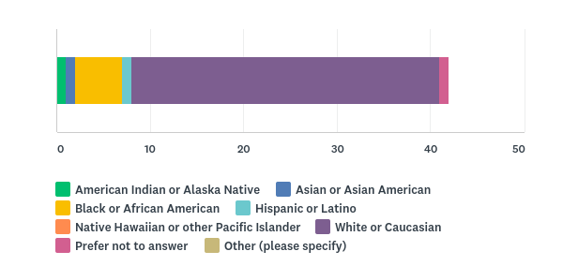

  - Question 3: Age Range. This graph depicts that a majority of the respondents were in the 25-34 range, followed by the 35-44 range.
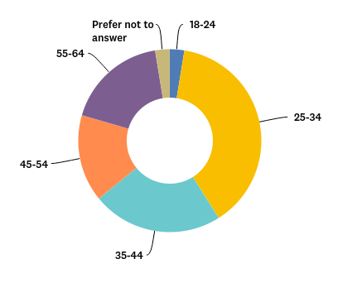

  - Question 5: Do you identify as a member of the Lesbian, Gay, Bisexual, Transgender, and Queer (LGBTQ+) community? Of the respondents who answered this question, 40% identified as a member of the LGBTQ+ community, and 6 respondents chose to skip the question.
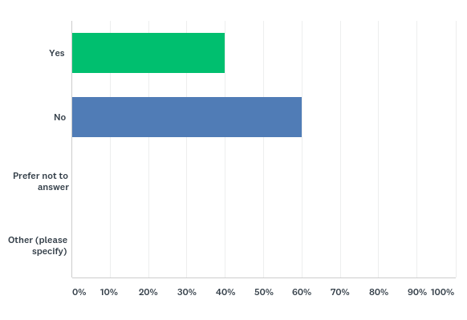
  - Question 12: When was the last time you moved? This graph reveals that 61.3% of survey respondents fall in the recently moved categories (1-2 years (12%) and 6-12 months (18%)).
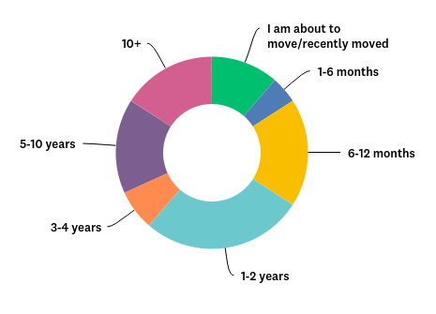
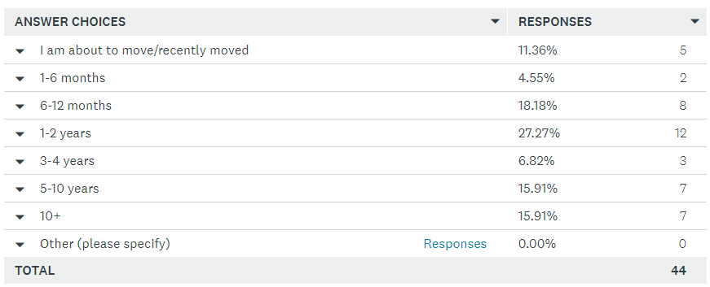
Additional comments for this question included many respondents sharing that they are getting priced out of housing due to rising rents or general affordability of rent; struggling to find roommates or a good housing fit; being forced to stay in less than ideal situations in order to be housed; moving due to an eviction, mutual lease termination or rent increases; and/or moving to lower monthly housing payments. It was notable that the reasons provided for the moves were mostly negative.
  - Question 15: Have you had trouble securing housing? If so, why? The bar graph below reflects how high cost of housing continues to play a role in a tenant’s search for a new residence. The responses reflect that, for 71% of respondents, high cost of housing continues to play a role as a tenant searches for a new residence, with 50% responding that trouble paying first/last month’s rent with a security deposit presents an additional barrier.
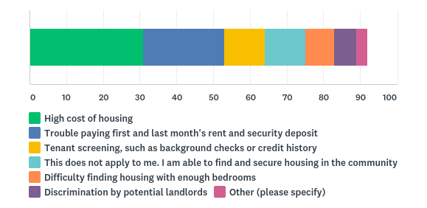
  - Question 17: If you are renting, are you paying more than 30% of your income? Of the 45 respondents that answered this question, 60% (26 people) answered yes. This reduces a tenant’s ability to respond to emergency situations with unexpected costs or further rent increases.

  - Question 20: What are the characteristics of a neighborhood you prefer to live in? These comments reflected the need for investments in community spaces and neighborhood amenities, including child friendly, safe/walkable surroundings; good schools; and a mix of types of housing close to transit and small businesses, as well as the importance of a diverse (racial, ethnic, generational, socioeconomic, LGBTQIA) representation of neighbors, low crime, and ample opportunities to engage with one’s community.

  - Question 21: What kind of features does your community need to thrive? Responses highlighted usable parks/playgrounds, safe pedestrian walkways and community center/gathering space upgrades as the top features.
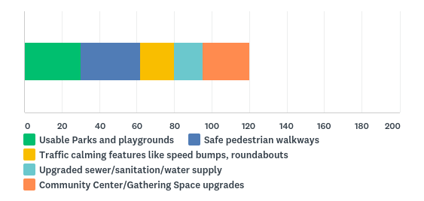
Survey Themes
- Rental Market:
  - Lack of affordable housing for low-income/fixed-income individuals
  - Instability of constantly moving due to:
    - Annual rent increases that make an area unaffordable
    - Buildings being renovated and displacing residents
  - Living with multiple roommates in crowded conditions to afford the area
  - Community members settling for sub-quality rental housing in order to manage affordability
  - Moving out of homelessness into a rental unit
- Housing ownership market is too expensive and unattainable:
  - Older housing options are the only options in lower price ranges
  - Newer housing is larger and starts in the $800K range
  - Prices prevent younger families from moving in and the elderly from staying in their homes, and pressures the new graduates to return to live at home
  - Newer housing being built does not incorporate concern for aesthetic or functional neighborhoods or communities; quantity over quality is being valued
  - Frustrated by a lack of market options/configurations; need more multi-family properties
- Need more education about how to report housing discrimination, and what tenant rights are when facing fair housing discrimination
- Need more low-barrier, affordable housing options
- Need to protect mobile home parks from development, enabling low-income residents to remain (see the work that Kenmore is doing)
Survey Questions
The following page provides the complete survey.

- What is your zip code?
- Please select the race/ethnicity terms with which you identify (check all that apply).
  - American Indian or Alaska Native
  - Asian or Asian American
  - Black or African American
  - Hispanic or Latino
  - Native Hawaiian or other Pacific Islander
  - White or Caucasian
  - Prefer not to answer

- Please select your age range.
  - Under 18
  - 18-24
  - 25-34
  - 35-44
  - 45-54
  - 55-64
  - 65+
  - Prefer not to answer

- Which gender best describes you?
  - Female
  - Male
  - Transgender
  - Prefer not to answer
  - Other (Please specify)

- Do you identify as a member of the Lesbian, Gay, Bisexual, Transgender, Queer (LGBTQ) community?
  - Yes
  - No
  - Prefer not to answer
  - Other (Please specify)

- What is the primary language you speak at home?
- Do you or anyone in your household have a disability?
  - Yes
  - No
  - Other (please specify)

- How many children live in your home?
  - 0
  - 1-2
  - 3-4
  - 5 or more

- What do you like and dislike about the available housing to rent or buy in your community?

- Are you able to live in the community of your choice?
  - Yes
  - No
  - If not, why not?

- When was the last time you moved?
  - I am about to move/recently moved
  - 1-6 months
  - 6-12 months
  - 1-2 years
  - 3-4 years
  - 5-10 years
  - 10+
  - Other (please specify)

- Tell us about your most recent or upcoming move. Why did you move? Do you think you will have to move again in the future? If so, why?

- Have you before or are you currently experiencing housing insecurity?
- Have you had trouble securing housing? If so, why? (Check all that apply)
  - High cost of housing
  - Tenant screening, such as background checks, credit history
  - Difficulty finding housing with enough bedrooms
  - Trouble paying first and last month’s rent and security deposit
  - Discrimination by potential landlords
  - This does not apply to me. I am able to find and secure housing in the community of my choice.
- If you were to experience discrimination, would you know where to get help?

- If you are renting, are you paying more than 30% of your income in rent?
  - Yes
  - No
  - I do not rent housing in Washington State.
- If you are renting, does homeownership feel attainable?
  - Yes
  - No
  - I do not rent housing in Washington State.
  - Additional Comments below:

- If you are a homeowner, do you anticipate, or currently have, one or more repairs to your home that you cannot afford to make to keep it in safe and livable conditions (for example: a roof repair)?
  - I am not a homeowner in Washington State.
  - Yes
  - No
- What are the characteristics of a neighborhood you prefer to live in?
- What kind of features does your community need to thrive?
  - Usable parks and playgrounds
  - Safe walkways
  - Traffic calming features
  - Upgraded sewer/sanitation/water supply
  - Community Center/Gathering Space upgrades
  - Other (please specify)

Title 24 CFR Part 91, Subpart B guides the Citizen Participation Plan piece of the Consolidated Plan
The County is currently developing a countywide public engagement strategy as part of the Strategic Plan update. In the meantime, guidance comes from the King County Equity & Social Justice Community Engagement Guide and the Unincorporated Areas Public Engagement Framework.

