STAFF REPORT

Agenda Item: | 9 | Name: | Nick Bowman
Proposed No.: | 2024-0277 | Date: | September 11, 2024

SUBJECT

Proposed Ordinance 2024-0277 relates to the concept of Complete Streets, which promotes roadways that are safe and convenient for all users, including pedestrians, bicyclists, transit riders, and motor vehicle drivers of all ages and abilities.

SUMMARY

The proposed ordinance would endorse the Complete Streets concept for road design and construction and require the implementation of Complete Streets on newly constructed or reconstructed roads, except under certain conditions as determined by the county road engineer.

BACKGROUND

Recent Increase in Traffic Related Injuries and Fatalities. Traffic fatalities and serious injuries have been increasing at significant rates in recent years across Washington State and in King County. According to the Harborview Injury Prevention and Research Center at the University of Washington, there were 810 traffic deaths in Washington State in 2023, a 10% increase since 2022, and the largest number of traffic deaths in the state since 1990. In King County, the Washington State Traffic Safety Commission reports that there were 167 traffic deaths involving motor vehicles in 2023; a 9% increase since 2022 and twice the number of fatalities recorded in 2014.

What are Complete Streets? Complete Streets are an approach to planning, designing, building, operating, and maintaining roadways that enables safe access for all people who need to use them, including pedestrians, bicyclists, motorists and transit riders of all ages and abilities. A single roadway may not always be able to accommodate all transportation modes, however. The differences in rural and urban settings, environmental, natural, and various other right-of-way constraints can limit what transportation facilities are feasible or even desirable. In practice then, the Complete Streets approach focuses broadly on building Complete Networks to provide multimodal connectivity. Complete Networks may use parallel routes to facilitate access that variously prioritizes different modes throughout an area while ensuring the safety of all roadway users.

Figure 1 below illustrates the Complete Streets approach to roadway design.

Figure 1
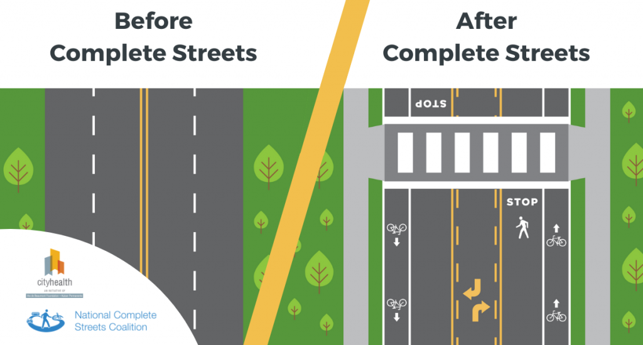

Enacted Complete Street Policies. Since the National Complete Streets Coalition began collecting data in the year 2000, over 1,500 jurisdictions across the United States have adopted Complete Streets policies. This includes the majority of state governments, 95 counties, and over 1,300 cities and towns.

Washington State adopted the Complete Streets Act in 2011 to encourage local governments to adopt their own Complete Streets ordinances, require the Washington State Department of Transportation (WSDOT) to consult with local jurisdictions and consider the needs of all users by applying context-sensitive solutions when constructing, reconstructing, or making major improvements to streets that are part of the state highway system, and establish the Complete Streets Grant Program. To be eligible for the state’s grant program, local jurisdictions must adopt a jurisdiction-wide Complete Streets ordinance that plans for the needs of all users and is consistent with sound engineering principles.

In 2022, as part of the Move Ahead Washington transportation package, the State further required WSDOT projects starting design on or after July 1, 2022, that are $500,000 or more to incorporate principles of Complete Streets design. WSDOT must also identify locations on state rights-of-way that have inadequate bicycle and pedestrian facilities, consult with local jurisdictions to confirm existing and planned active transportation connections for integration of the state route to the local network, and modify speed limits appropriate to roadway design and local context.

King County has long-standing Comprehensive Plan policies that align with the Complete Streets approach. A non-exhaustive list of Complete Streets-aligned policies in the committee recommended version of the 2024 Comprehensive Plan update include:

- T-101 King County should provide a safe and accessible system of transportation services and facilities that offers travel options to all members of the community.
- ((T102))T-103 As a transportation provider and participant in regional transportation planning, King County should support, plan, fund, design, and implement an integrated((,)) and coordinated ((and balanced)) multimodal transportation system that serves the growing travel needs of the county safely, equitably, effectively, sustainably, affordably, and efficiently, and ((promotes a decrease in the share of trips made by single occupant vehicles)) reduces vehicle miles traveled.
- ((T201))T-110 King County prioritizes multimodal transportation options in the urban areas, where they are most effective. ((Multimodal transportation options such as public transportation, bicycling and walking, are most effective in densely developed urban areas. As resources allow,)) King County’s transportation investments in urban areas should emphasize public transportation and road services and facilities that support multiple modes and facilitate connections between them.
- ((T202))T-111 ((As resources allow,)) King County’s transportation investments in the Rural Area((s)) and Natural Resource Lands should emphasize maintaining, ((and)) preserving, and, where appropriate, providing flexible service options and safe road infrastructure that is compatible with the preservation of rural character and does not promote urban or unplanned growth.
- ((T230)) T-207 King County shall consider the safety, needs, and abilities of ((nonmotorized)) active transportation users ((of the transportation system)) in the planning, design, construction, maintenance, preservation, and operation of road infrastructure and other transportation facilities ((to the extent feasible given available funding)).
- ((T231))T-208 Consistent with the priorities defined in the County’s ((functional)) transportation plans((,)) and the Regional Growth Strategy, ((nonmotorized)) active transportation system investments should aim to increase safety, accessibility, and mobility((, facilitating)); facilitate mode integration and intermodal connections((,)); improve access to centers, where appropriate((,)); and ((providing)) provide opportunities for healthy activity and alternatives to driving for all populations.
- ((T232))T-209 King County shall evaluate ((and implement nonmotorized)) active transportation improvements in its road construction projects and shall implement these improvements where appropriate and feasible.
- ((T243))T-221 King County should coordinate with ((bicycling, pedestrian and equestrian stakeholders)) active transportation users and advocacy organizations to ensure that their input is included early ((in)) and throughout the planning and project design process for projects with ((nonmotorized)) active transportation elements or that have the potential to affect ((nonmotorized)) these users.
- T-315 King County should contribute to achieving the state traffic safety goal of zero deaths and serious injuries using a safe systems approach, through which road system managers, public health organizations, law enforcement agencies, emergency responders, road users, and other parties collaborate to prioritize the elimination of crashes that result in death and serious injuries.
- ((313))T-321 The King County((’s)) ((r))Road ((d))Design and ((c))Construction ((s))Standards shall promote safe, cost effective roads that, ((encourage multimodal use,)) to the extent practical and allowed by law, incorporate complete streets infrastructure to balance the health and safety needs of all road users, contribute to the state traffic safety goal of zero deaths and serious injuries, and reflect the function of the road and the different needs of and service levels for the Urban Growth Area and Rural Area and Natural Resource Lands.

The Federal Highway Administration (FHWA) has also taken a more active role in advancing the concept of Complete Streets in recent years. In March 2021, FHWA established a Complete Streets initiative to work with State, Tribal and local transportation agencies across the country to implement a Complete Streets design model. The FHWA’s efforts focus not just on policy but on outcomes, including increasing the proportion of Federal aid funded transportation projects that are routinely planned, designed, built, and operated as Complete Streets that are safe and accessible for all users.

ANALYSIS

Proposed Ordinance 2024-0277 would endorse the concept of Complete Streets and require the county to implement Complete Streets for all users on newly constructed or reconstructed roads with certain exceptions as determined by the County Road Engineer. The exceptions that may preclude the construction of Complete Streets include:
- When contrary to public safety;
- When not practically feasible because of significant adverse environmental impacts;
- When not practically feasible because of significant adverse impacts on neighboring land uses, including impacts from right-of-way acquisition;
- When their establishment would violate Comprehensive Plan policies;
- When there is no identified need for the improvement; or
- When their cost would be excessively disproportionate to the need or probable use.

Under the proposed ordinance, upon determining that conditions preclude the construction of Complete Streets the County Road Engineer should consider whether nearby facilities can accommodate users and, except on new and reconstructed roadway projects, is required to consider measures that can benefit users, such as standalone sidewalks, shoulder improvements, or other projects.

According to the Executive, the proposed ordinance is intended to formally endorse the Complete Streets approach, as well as, meet the eligibility requirements of the state’s Complete Streets Grant Program and improve the County’s competitiveness for other related grant programs.

AMENDMENT

Striking Amendment S1 would:

- Replace language in Section 1.A. of the underlying ordinance which states the County “shall provide and require the implementation of Complete Streets for all users on newly constructed or reconstructed roads” with language stating the County “strives to provide and require the implementation of Complete Streets for all users on newly constructed or reconstructed roads”. The change is meant to clarify that the ordinance is not intended as a development regulation.

- Correct an error throughout the body of the underlying ordinance wherein the term “county engineer” is used, when “county road engineer” was intended.

- Make other technical and grammatical corrections.

INVITED

- Rey Sugui, Intergovernmental Relations, Road Services Division of the Department of Local Services.
- John Vander Sluis, Strategic Development Analyst, Road Services Division of the Department of Local Services.

ATTACHMENTS

- Proposed Ordinance 2024-0277
- Amendment S1
- Transmittal Letter
- Fiscal Note

Harborview Injury Prevention & Research Center, University of Washington, Washington Traffic Deaths Reach 33-Year High, May 14, 2024 (link)
Washington Traffic Safety Commission Data Dashboard (link)
National Complete Streets Coalition (https://smartgrowthamerica.org/what-are-complete-streets/)
Active Transportation Alliance. “Complete Streets, Complete Networks.”
Smart Growth America. “Complete Streets policies nationwide.”
RCW47.04.320-340
RCW 47.04.320.2(b).
RCW 47.04.035
Moving to a Complete Streets Design Model: A Report to Congress on Opportunities and Challenges March 2022

