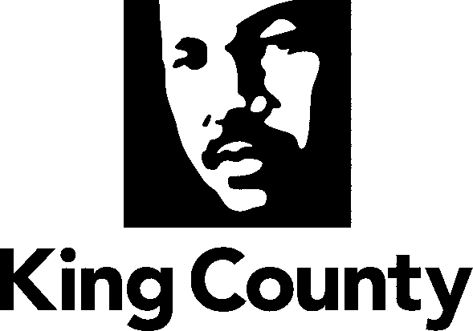

Checklist and Summary of Changes for the attached
Collective Bargaining Agreement

Name of Agreement
Public Safety Employees Union (Legal Administrative Specialists - Department of Judicial Administration) and Memorandum of Agreement

Labor Negotiator
Mary Beth Short

Prosecuting Attorney’s Review | Yes
Document Tracking System Routing Form; Motion or Ordinance | Yes
Executive Letter | Yes
Fiscal Note | Yes
Six Point Summary | Yes
King County Council Adopted Labor Policies Contract Summary | Yes
Ordinance | Yes
Original Signed Agreement(s) | Yes
Does transmittal include MOU/MOA? x1 | Yes

Six Point Summary of changes to the attached agreement:
1. The agreement provides standard cost-of-living increases for 2009 and 2010 based on 90% of the increase in the All Cities CPI-W Index (with a floor of 2% and a cap of 6%), and a re-opener to negotiate wages for a 2011 cost-of-living increase.

2. The agreement provides automatic step progression when an employee’s performance appraisal is 3.0 or higher and allows for a mechanism for employees who have scored lower than 3.0 to develop a plan to increase their score resulting in a step increase when the score is achieved.

3. The agreement provides for merit-based layoffs.

4. The agreement provides management the ability to maintain flexibility in the assignment of staff to ensure that the demands of the court are being met.

5. The agreement allows employees the ability to select an hourly or half-hourly lunch no more than monthly.

6. The agreement provides for telecommuting provisions during inclement weather as well as implementing the county’s Alternative Work Arrangements Guide.

