Lease Property Summary
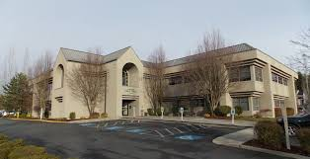

Property Owner: Apex Investment Group, LLP
Address: 13030 121st Way NE, Kirkland (the Evergreen Medical Center)
Cost Per Sq. Ft.: $24.00 per square foot per year
Operational Costs: $11.23 per square foot per year
Term: 10 year 3 months, with option to cancel after sixty three months and option to renew for one five year period.
Square Footage: 5,804
Council District: 6
Funding Source: Public Health Fund
Previous Location: Northshore Public Health
Landlord’s Offer
of Expiration: Approval of Ordinance by October 31, 2016

Lease Synopsis:
This legislation is a lease for a replacement location for the Northshore Public Health Clinic (PHC) currently located at 10808 NE 145th Street Southeast, in Bothell. This legislation is one of three ordinances related to Public Health’s Northshore Clinic. The second is an appropriation ordinance for the tenant improvements required for this lease and the third ordinance is related to the sale of the Northshore Clinic Building.

Context
Rationale for transaction: This lease is based on the Facilities Management Division's and Public Health’s recommendation to move the Public Health Center (PHC) staff from the current County-owned building to leased space. The Northshore PHC has shown that they can operate in a footprint of approximately 6,000 square feet of space and that the County’s current 16,691 square foot building is inefficient for their needs. Public Health desires this new lease to house Maternity Support Services (MSS) and Women, Infant and Children (WIC) programs. A strong offer for the purchase of the County’s Northshore property and an available leasehold in Public Health’s desired service area coupled to provide an opportunity that more closely meets the financial and facility needs of Public Health. The new Northshore Public Health Center has the additional advantages of being only 2.1 miles from the current facility; and in an area that is more accessible by public transit, as well as closer to other health and human service providers which promotes collaboration.

This location, per local City Code, includes 29 parking stalls, shared in common, based on Public Health’s total square footage in the building. Transit bus stops serving Metro Routes 236, 244, 252, 255, and 930 (DART) are located across the street at NE 132nd Street/121st Avenue NE; and the Totem Lake Transit Center serving Metro Routes 235, 236, 238, 252, 255, 277, 893, and 930 (DART) is located approximately one block away at 120th Avenue NE/NE 128th Street. In contrast, only Metro Route 238 (all day service to/from Bothell & Kirkland) and Metro Route 257 (express service only to/from downtown) are available within approximately one block of the Northshore property (Juanita-Woodinville Way NE/NE 145th Street).

Additionally, vacation and sale of the existing Northshore Public Health Center in Bothell is expected to contribute approximately $3.4 million to the Public Health fund.

Policy considerations: Given current and future anticipated operations, the County owned facility is no longer needed to support Public Health, or other King County operations and holding on to the facility results in additional liability as well as lost opportunity costs. Council previously expressed support for selling the facility and moving to a more central location as part of their review of the Northshore Public Health Center Proviso Response (Motion 14589); this issue was also considered in the report to council on the long-term sustainability of Public Health (2015-RPT0169). Council also approved capital funding to replace the HVAC Cooling System at this site (Ordinance #18110). Approval of this legislation supports the continued provision of medical services in the northeast section of King County.

Political considerations: The new location moves the Public Health Center from County Council District One to Council District Six. It is just across the district boundary, one block away from Council District One. Residents of Council District One will enjoy better access to Public Health services, because the new location offers better proximity to transit, highways, and other nearby services. In addition, Public Health will continue to offer services in Council District One at a satellite clinic in downtown Bothell located at 10414 Beardslee Boulevard.

Community considerations
or partnerships: No opposition is anticipated as a result of relocating the Northshore Public Health Center. Since most Public Health clients are pregnant women and new mothers, the main hospital for this region is a major source of referrals and a logical partner, as are other health care providers in the area.

Fiscal considerations: The base lease cost is $139,296 annually and runs for ten years and three months. The average market rent for this area is between $23.00 per square foot per year and $30.00 per square foot per year. The lease rate negotiated is $24.00 per square foot per year and at the lower end of the market. The lease contains one five-year extension and also includes an early termination option after sixty-three months at which time the County can decide whether to continue to provide these services at this location. The early termination option, if invoked, has a penalty of $211,345 (to repay the landlord for unamortized Tenant Improvements and Broker commissions). The underlying lease contains a tenant improvement allowance of $40 per square foot ($232,160) and five months of free rent ($58,040) for a total landlord contribution of $290,200. Total tenant improvements for the site are $1.1 million; the amount above the allowance will be funded by an appropriation request that is being submitted under separate cover. Tenant improvements planned for the site are detailed in the CIP/operating section of this document. Operating expenses are expected to be $65,178 annually.

Other considerations: The services provided at Northshore (WIC and MSS/First Steps) are income-based. A client who meets WIC eligibility will also qualify for MSS services. Therefore, the highest need for services is where there is a higher density of WIC-eligible residents.

Among clients who received services in 2013, the top five zip codes for clients who use the facility are:
1) 98034 (primarily north Kirkland, including Totem Lake), 35%
2) 98011 (Bothell), 22%
3) 98028 (Kenmore), 10%
4) 98052 (Redmond), 8%
5) 98072 (Woodinville), 7%

CIP/operational impacts: A leaseback opportunity is included as an option for the purchase and sale agreement for the current Northshore location. Given the leaseback opportunity as a result of the sale, Public Health will be able to minimize downtime associated with the move. The majority of work associated with the tenant improvements at this site are intended to update the appearance, functionality and provide for a more sustainable infrastructure, including energy efficient lighting and eco-friendly carpet and paint. Limited new construction activities are also proposed, this includes redesigning the waiting, reception and front office areas. This will provide for a more welcoming space for clients, while also providing more privacy for conversations at the reception counter.

King County Strategic Plan impact: This transaction supports the 2015 King County Strategic Plan Guiding Principle of Financial Sustainability and Goal of improving the health and well-being of all people in our community.

Equity and Social Justice impact: In accordance with Real Property Asset Management Plan (RAMP) Strategy 2.0 and 24.0, FMD and Public Health reviewed this legislation for Equity and Social Justice (ESJ) impacts. Public Health desires this new lease to provide Maternity Support Services (MSS) and Women, Infant and Children (WIC) programs in the Northshore area. This location is in the Totem Lake neighborhood of Kirkland and the predominant land uses within this neighborhood include a mixture of retail, industrial, multi-family, and low-rise medical office buildings. The northern sector, which is the location of the Evergreen Medical Center, is a neighborhood dominated by medical office buildings close to Evergreen Health Medical Center (hospital). By relocating the Northshore Public Health Center it will become more central to an expanded clientele draw area and thereby improving accessibility for our clients. In addition, the new location also offers direct access from I-405 and is accessible with more transit route options. While improving both the proximity and transportation options available to our clients, we are also improving our client’s options for seeking coordinated care with partner agencies, such as Evergreen Health and other local health care providers. This proposed site will help Public Health and its Community Health Services Division meet their triple aim goal of improving the patient experience, improving population health and reducing the per capita cost of health care.

Energy Efficiency impact: This site will have lower energy costs than the current Northshore Building. Transit connections are also superior to the previous location.

Lease Alternatives Analysis

There were several steps FMD and Public Health completed regarding the lease analysis for this project:

- Contacted and met with potential partner agencies regarding co-locating at either the current North Shore Public Health Center or a new location and discussed other alternatives, such as potential purchase and lease back opportunities.
- Analyzed the current and potential client base in northeast King County, to identify potential sites for relocation.
- Analyzed geographical proximity of transportation and community partners, overlaid onto the density of potential client base.
- Analyzed the current and future space needs, based on current staffing model.
- Analyzed the potential equity and social justice impact of reducing or relocating services in this portion of the county.

Summary: After completing these steps the Facilities Management Division determined the lease with Evergreen Medical Center to be a location that provides good value, is well located and consequently is recommending approval of the accompanying lease agreement.

Vicinity View Map
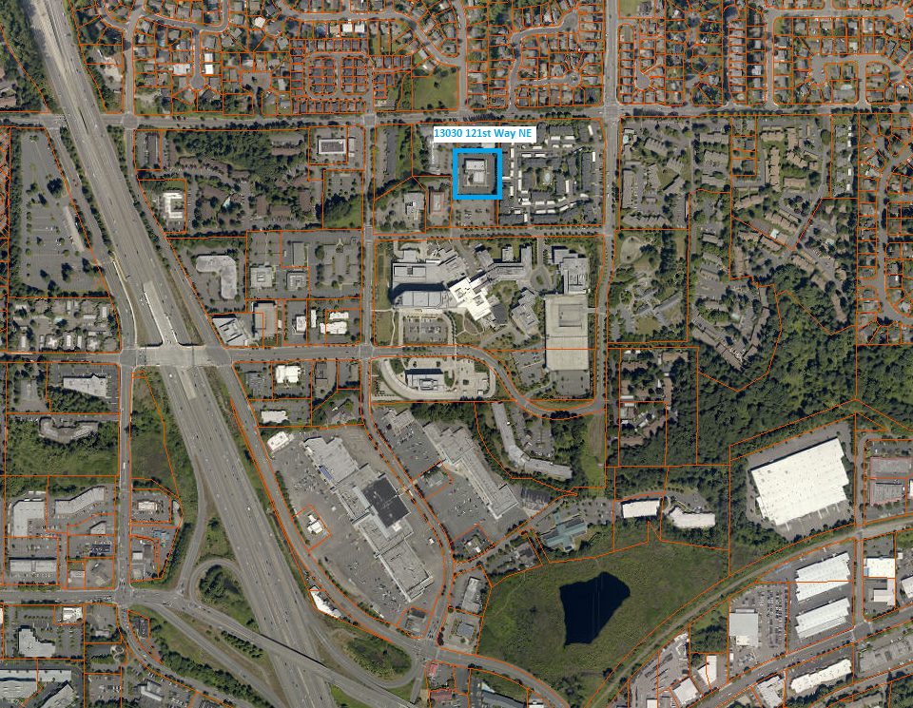

Parcel Map
