STAFF REPORT

Agenda Item: | 8 | Name: | Jenny Giambattista and Andy Micklow
Proposed No.: | 2025-0129 | Date: | May 28, 2025

SUBJECT

Proposed Ordinance 2025-0129 would increase the monthly sewer rate effective in 2026 to $62.66. The proposed ordinance would also set the monthly capacity charge for new connections to the regional system occurring in 2026 at $77.99.

SUMMARY

The sewer rate is the primary funding source of the Wastewater Treatment Division (WTD). The monthly sewer rate collected by the County goes to support all WTD expenses, including operating costs, debt service, and capital expenses. Proposed Ordinance 2025-0129 would increase the monthly sewer rate effective in 2026 by 7.5 percent from $58.28 to $62.66. This increase is 0.5 percent higher than what was projected as part of the forecast for the 2025 rate. The 2026 proposed sewer rate is projected to generate $592 million in revenue in 2026.

Beyond the 2026 rate, the proposed 10-year sewer rate forecast reflects substantive changes compared to the prior rate forecast. The 2026 10-year capital forecast is $3.1 billion greater than the prior 10-year forecast, and the rate projection reflects this increased capital forecast with higher than previously projected rates for 2027-2031. WTD reports that most of this increase compared to the prior forecast is due to the updated cost estimates and newly finalized completion dates for projects included in the Combined Sewer Overflow (CSO) Consent Decree as well as cost increases for other projects. With this new forecast, regulatory capital projects are projected to make up 52 percent of the 10-year capital forecast. A challenge for WTD as it implements this capital program is that many projects must be done concurrently and are costly and complex. The forecast also includes a revised approach to forecasting capital expenditures, which tries to take into consideration the complexity of the projects, the capacity to deliver the projects, and legally required timelines.

As part of the 2026 rate proposal process, WTD has extended the sewer rate forecast to 20 years through 2045, and this extended forecast shows annual increases ranging from 0.5 percent to 4.5 percent. WTD reports that this second decade of the forecast has significant uncertainty.

The proposed ordinance would also set the capacity charge for new connections to the regional system occurring in 2026 at $77.99 per Residential Customer Equivalent (RCE) per month, a 2.5 percent increase over the 2025 monthly charge of $76.09. The capacity charge is expected to generate approximately $105 million in revenue for 2026.

The schedule for Council consideration is listed below:
- Transmittal of Sewer Rate— April 24
- Budget and Fiscal Management Committee—Discussion only May 28 and Discussion/Possible Action —June 11
- Briefing only at Regional Water Quality Committee (RWQC)—May 7 and June 4
- Council consideration/action—June 17 or, if needed June 24 as emergency, assuming action by BFM on June 11
- Approval date requirement for sewer rate—June 30 (Prior to July 1)

Both RWQC and Metropolitan Water Pollution Abatement Advisory Committee (MWPAAC) have sent comment letters (Attachments 6 and 7) to the King County Council on the proposed rate.

Council staff analysis of Proposed Ordinance 2025-0129 is ongoing.

Links are provided below to the topics discussed in this staff report.
- Background
    - Sewer rate
    - Capacity charge
    - Combined Sewer Overflows (CSOs)
    - Required transmittal information
    - Recent RWQC and Council legislation related to sewer rate and capacity charge
- Analysis of the proposed sewer rate and 10-year forecast
  - Comparing 2025 and 2026 10-year forecasts
  - New, second decade forecast
  - Capital expenditure forecast
    - Updated approach to developing a capital forecast
    - Capital expenditures by category
    - Regulatory projects
        - CSO costs, including MDCSO
        - Nutrient reduction projects
    - Other large CIPs
    - Forecasted capital expenditures versus actual expenditures
    - Comparison of 2026 10-year capital forecast to prior capital forecast
    - Capital Improvement Program funding
  - Operating expenditures
  - Rate smoothing
- RWQC comment letter
- MWPAAC comment letter
- Contaminants of emerging concern-costs

BACKGROUND

The regional wastewater system is almost entirely funded by the monthly sewer rate and the capacity charge.

Monthly Sewer Rate Charged to Local Sewer Agencies. The sewer rate is WTD's primary funding source. The monthly sewer rate collected by the County goes to support all Wastewater Treatment Division (WTD) expenses, including operating costs, debt service, and capital expenses. The sewer rate is charged by the County to the utilities that deliver wastewater to the County for treatment and discharge. The monthly sewer rate charged by WTD is a wholesale rate and is billed to local sewer agencies, not ratepayers. The local utility providers, as direct service providers, set their own rates to recoup the payments required by the County plus their own "local" cost of service. The local agency sends the sewer customers the sewer utility bill.

Single-Family versus Volume-Based (Commercial, Multifamily, Industrial). Since the formation of Metro, and as directed in King County Code and all 34 local sewer contracts, King County has had a sewer rate structure that is based on two different classes of customers: single-family and volume-based. The fee structure, as specified in code and contract relies on a billing unit referred to as "Residential Customer Equivalent (RCE)" to charge the two customer classes and determine how costs are shared between the classes. One RCE unit is 750 cubic feet of wastewater and represents the assumed wastewater a single-family home would generate in a month based on flow data from 1989. Single-family homes are charged one RCE. Volume-based customers are converted to an RCE unit by taking the monthly volume of water used by the customer and dividing it by 750 cubic feet (cf) of wastewater (the "conversion factor"). This results in a usage amount for volume-based customers reported in RCEs.

Using the Number of RCEs to Calculate the Monthly Rate. WTD estimates the total number of RCEs for a given year and then divides the total projected amount of revenue required (from sewer rates) by the number of RCEs to get the cost per RCE. King County then charges local sewer agencies the monthly sewer rate for each RCE in their utility.

Allocating the Sewer Rate Cost Burden Between the Single-Family Sector and the Commercial/Industrial/Multifamily Sector. The 2021-2022 Adopted Biennial Budget Ordinance includes a proviso requesting a study on the shift of the sewer rate cost burden to the single-family sector from the commercial/industrial/multifamily sector. The report, Sewer Rate Cost Structure, concluded that since the water consumption assumption for the single-family home is fixed at the 1989 level, the current rate calculations likely attribute too much water flow to single-family residences, which, due to conservation efforts, have seen significant declines in water use over the years. As a result, single-family residences likely end up with a disproportionate share of the total cost. While the report does discuss updating the water consumption assumptions (RCE) for single-family homes, any change to the RCE calculations would require changes to the King County Code and amendments to each of the 34 local sewer contracts.

Historical Sewer Rate. Table 1 depicts the anticipated sewer rates through 2028. Historically, rates have been structured effectively as biennial rates, with rate adjustments in alternating years. In 2021, after engagement with cities and sewer districts through the Metropolitan Pollution Abatement Advisory Committee (MWPAAC), the Executive recommended annual rather than biennial adjustments to sewer rates.

Table 1.
Sewer Rate (2009-2025 Actual; 2026 Proposed; 2027-2029 Projected)

Year(s) | Rate  ($/RCE/ Month) | % Increase
2009 | $31.90 | 14.10%
2010 | $31.90 | 0.00%
2011 | $36.10 | 13.20%
2012 | $36.10 | 0.00%
2013 | $39.79 | 10.20%
2014 | $39.79 | 0.00%
2015 | $42.03 | 5.60%
2016 | $42.03 | 0.00%
2017 | $44.22 | 5.20%
2018 | $44.22 | 0.00%
2019 | $45.33 | 2.50%
2020 | $45.33 | 0.00%
2021 | $47.37 | 4.50%
2022 | $49.27 | 4.00%
2023 | $52.11 | 5.75%
2024 | $55.11 | 5.75%
2025 | $58.28 | 5.75%
2026 | $62.66 | 7.50%
2027 | $70.65 | 12.75%
2028 | $79.66 | 12.75%
2029 | $90.42 | 13.50%

Capacity Charge Billed to New Customers by King County. Since 1990, a capacity charge has been levied for new connections to the sewer system. The purpose of the capacity charge is to ensure that new customers pay the "growth" costs of expanding the wastewater system. The current version of the charge started with the Robinswood Agreement and the principle of "growth pays for growth."

County financial policies require new customers to pay their proportional share of these costs. Financial Policy 15 states: "The capacity charge shall be set such that each new customer shall pay an equal share of the costs of facilities allocated to new customers, regardless of what year the customer connects to the system."

The capacity charge is a one-time development charge, much like a new development fee or impact fee. However, state statute does not allow the County to require up-front payment of the capacity charge by the developer. Unless a developer voluntarily pays the capacity charge, it becomes an additional cost that buyers will encounter when purchasing properties with new sewer connections. It can be paid as a total payment up-front with a discount or as a monthly charge amortized over 15 years. If a buyer purchases property with an outstanding capacity charge, the new buyer becomes responsible for the capacity charge payments. Unlike the wholesale sewer rate, the capacity charge is billed directly to customers by King County.

Affordability Concerns with Capacity Charge. After hearing from many customers that the capacity charge can be unaffordable and impacts the extensive affordable housing challenges in King County, WTD initiated research to identify affordability challenges for its capacity charge customers and evaluate possible mitigating strategies. In 2019, WTD published a consultant report titled "Capacity Charge Affordability Analysis and Findings."

WTD implemented the following recommendations from this report:
- Expanded payment plan opportunities for customers with temporary financial hardship.
- Equity payment plan: expanded property lien opportunities for customers with ongoing inability to pay.
- Expanding discounts for long-term covenanted affordable housing projects.

Recent Changes to the Capacity Charge Rate Structure. Since the early 1990s, the County has established separate classifications of customers and charged those customers based on an RCE calculation. In 2017, WTD initiated a study of the capacity charge rate structure given the changes that are occurring in terms of types of development and housing stock. The Metropolitan Water Pollution Abatement Advisory Committee (MWPAAC) created a capacity charge rate structure workgroup to provide technical expertise to the County on the rate study and make any recommendations to WTD. A key recommendation of the workgroup was that capacity charge customer classifications should bear a close relationship with the average persons per household for each customer class.

In January 2021, the King County Council adopted Ordinance 19153, which revised the financial policies to restructure the capacity charge to align amounts charged according to size and type of housing as a proxy for the average number of persons accommodated by the housing type. Commercial connections continue to pay based on the number of fixtures, and discounts continue for low-income housing. These changes did not impact the methodology used to determine the total costs of growth.

Update to Projected Customer Numbers and Projected Capital Costs. The Regional Wastewater Services Plan (RWSP), which covers the period of 2003 through 2030, is the comprehensive plan for regional wastewater services and serves as the basis for projecting the number of customers, capital projects needed for capacity, and financial assumptions for the capacity charge. K.C.C. 28.86.160 requires an update of customer numbers and projected capital costs used to calculate the capacity charge every three years. The last update occurred in 2024 and covers the capacity charge calculations for 2025 and 2026. WTD reports that the required capacity charge update will not be possible after 2030 without an updated RWSP because the capacity charge methodology in code is tied to the life of the RWSP, which currently extends through 2030. WTD reports that an updated methodology is anticipated to be in place ahead of the next three-year update cycle.

Improving the Capacity Charge Methodology for Determining "Growth Pays for Growth." The policies to determine how growth costs should be determined and allocated are in King County Code (K.C.C. 28.86.160(C) FP-15(4)). Here's how it works at the simplest level:
- Growth-related costs are identified.
- Monthly sewer rate revenue from "new customers" is calculated.
- The capacity charge is set to cover any shortfall.

A 2016 Auditor's report found that the model that calculates the annual amount of the capacity charge is highly complex, not transparent, not independently verifiable, and susceptible to errors. Furthermore, the audit found that some of the financial policies related to the capacity charge need clarification. The Executive concurred with almost all the audit findings and recommendations and noted that the desire for a simpler capacity charge approach is a long-held goal of WTD.

In 2020, WTD engaged a consultant to develop a new model approach that is simpler and reflects current industry standards. In 2021, WTD briefed MWPACC on the consultant's findings in a series of meetings. Later that year, WTD paused work on the capacity charge methodology review. WTD reports that in 2024 it requested that the consultant resume its work on revising the methodology for the capacity charge. WTD has begun to engage with MWPAAC on this effort and has received feedback from MWPAAC on the initial analysis. WTD will now develop preliminary estimates for future system growth and related capacity needs and use these preliminary estimates to calculate a new capacity charge using the proposed methodology. The results will be reviewed with the MWPAAC workgroup sometime in 2025. In 2025, WTD will present the proposal to RWQC and draft policies to amend the code accordingly. Any changes to the capacity charge financial policies would have to be approved by the King County Council.

Combined Sewer Overflows. WTD has been implementing King County's Combined Sewer Overflow (CSO) program for over three decades to control the County's CSO outfalls to the Washington State standard of no more than one untreated CSO discharge per year on a 20-year average. WTD reports it has spent over $1 billion on CSO control since the early 1990s.

In 2013, King County entered into a federal consent decree to complete its CSO control projects in compliance with the federal Clean Water Act by December 31, 2030. In mid-2024, King County, Ecology, and the EPA reached an agreement in principle on the First Material Modification to 2013 Consent Decree on Combined Sewer Overflow (CSO), which extends the compliance milestones for the remaining CSO control projects and extends the overall compliance schedule from 2030 to 2037. WTD had assumed 2040 as a representative end date for CSO project completion since the 2022 sewer rate proposal.

With the adoption by Council of the modified consent decree in July 2024, WTD changed the CSO project completion date assumption in the rate forecasts to 2037. This means all but the final year of costs are now included in the ten-year forecast. The cost implications of this will be discussed later in the analysis section of the staff report.

Past CSO expenditures. Since the 2013 consent decree, the following completed CSO projects have cost an estimated $538 million:
- Ballard Siphon
- North Beach Wet Weather Storage
- Murray Pump Station Upgrade
- Barton Pump Station Upgrade and Green Stormwater Infrastructure
- South Magnolia
- Rainier Valley Storage
- Georgetown Wet Weather Storage

The following additional projects are under way with an estimated $206M spent to date:
- Ship Canal Water Quality Project
- West Duwamish Wet Weather Storage
- Elliot West Wet Weather Treatment Station Upgrade
- Mouth of Duwamish CSO Control Program

Required Transmittal Information. The financial policies listed below specify the contextual information that is to accompany the rate transmittal. WTD has prepared a technical memo (Attachment 4) with the required information that provides information on the revenues, expenditures, debt service, operations, and capital programs that inform the rate. Additionally, as required by Motion 16434, beginning with the 2025 sewer rate forecast, the technical memorandum submitted with the annual sewer rate needs to identify the cost of activities WTD has undertaken and plans to undertake to address contaminants.

Financial Policy-16: The executive shall prepare and submit to the council a report in support of the proposed monthly sewer rates for the next year, including the following information:

Key assumptions: key financial assumptions such as inflation, bond interest rates, investment income, size and timing of bond issues, and the considerations underlying the projection of future growth in residential customer equivalents.

Significant financial projections: all key projections, including the annual projection of operating and capital costs, debt service coverage, cash balances, revenue requirements, revenue projections and a discussion of significant factors that impact the degree of uncertainty associated with the projections.

Historical data: a discussion of the accuracy of the projections of costs and revenues from previous recent budgets, and

Policy options: calculations or analyses, or both, of the effect of certain policy options on the overall revenue requirement. These options should include alternative capital program accomplishment percentages (including a ninety percent, a ninety-five percent, and a one hundred percent accomplishment rate), and the rate shall be selected that most accurately matches historical performance in accomplishing the capital program and that shall not negatively impair the bond rating.

Timing of Rate Adoption. By contract with partner cities and sewer districts, the County is to complete its consideration of the sewer rate for the following year by July 1 of each year.

Recent RWQC and Council Legislation Related to Sewer Rate and Capacity Charge.
Motion 16410 Long-term Capital Forecast. The motion requests WTD research and identify methodologies to forecast the long-term costs of its capital improvement needs.
The motion requested that the recommended methodologies should allow for forecast periods of up to 75 years and should also allow for changes in various assumptions, including growth capacity and known and projected regulatory requirements, such that forecast scenarios can be compared using different assumptions. The report on the long-term methodology was completed by a firm specializing in providing financial and management consulting expertise to local utilities.

Motion 16449 Long-term Rate Forecast. In October 2023, the Council adopted Motion 16449, requesting WTD develop and maintain a long-term financial and sewer rate forecast. The motion specifies that the forecast should be based on revenue requirements needed for the operating and capital investment needs of the regional wastewater system and allow for forecasting periods of up to 75 years. The motion intended to allow for the comparison of forecast scenarios using different assumptions.
On June 4, 2025, RWQC will be briefed on the progress in developing a long-term financial and sewer rate forecast, and as requested by the motion, WTD will brief RWQC in July 2025 on the Division's long-term financial and sewer rate forecast.

RWQC Resolution 2024-01. In April 2024, RWQC adopted a resolution expressing RWQC's interest in the sewer rate and capacity charge and requesting the Metropolitan Water Pollution Abatement Advisory Committee continue performing a technical review of the annual sewer rate and capacity charge. The resolution states the RWQC may choose, upon its policy review of the proposed annual sewer rate and capacity charge and the Metropolitan Pollution Abatement Advisory Committee recommendations, to convey its policy recommendations on the proposed sewer rate and capacity charge to the King County council. (Please see Attachment 7 for RWQC's recommendation letter.)

ANALYSIS

Proposed Ordinance 2025-0129 (Attachment 1) would adopt the 2026 sewer rate and capacity charge. It would increase the monthly sewer rate effective in 2026 by 7.5 percent from $58.28 to $62.66. The proposed ordinance would also set the capacity charge for new connections to the regional system occurring in 2026 at $77.99 per Residential Customer Equivalent (RCE) per month, a 2.5 percent increase over the 2025 monthly charge of $76.09.

The first part of this analysis section will discuss the Sewer Rate and the key assumptions and changes influencing the proposed rate and the forecast. The Capacity Charge will be discussed in the next staff report.

Comparing 2025 and 2026 10-Year Sewer Rate Forecasts. As shown in Tables 2 and 3, the proposed 2026 rate is only .05 percent higher than was forecast in the prior forecast even though, as will be discussed later in the staff report, expenditures are increasing significantly over the forecast period. This relative consistency in the rate projection from the prior year reflects the Executive's policy decision to maintain predictability from the prior year's forecast. This is possible because WTD sets its cash revenue (rate) requirements based on a 10-year average over the forecast period, which allows WTD to make adjustments to the annual rates.

As shown in Tables 2 and 3, the 2026 rate forecast projects significantly larger rate increases when compared to the prior forecast for 2027 through 2031. In the final years of the 2026 10-year forecast, the rate increases are smaller than the prior forecast. As will be discussed later in this staff report, the projected sewer rate increases over the forecast period are primarily driven by the increasing capital portfolio of projects and the need for cash to fund capital projects and pay new and existing debt services.

Table 2.
Proposed 2026 Sewer Rate and Forecast

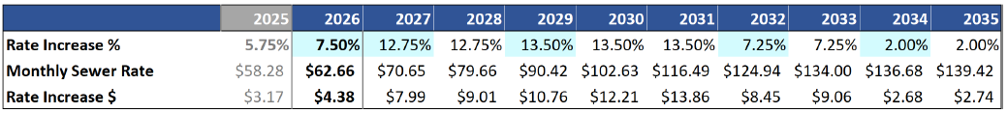

Table 3.
Adopted 2025 Sewer Rate and Forecast

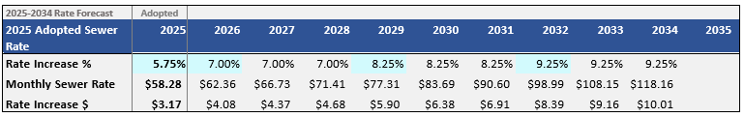

The increase in rates in the 2026 10-year forecast compared to the 2025 forecast are also shown in Figure 1, Sewer Rate Path.

Figure 1.
Sewer Rate Path

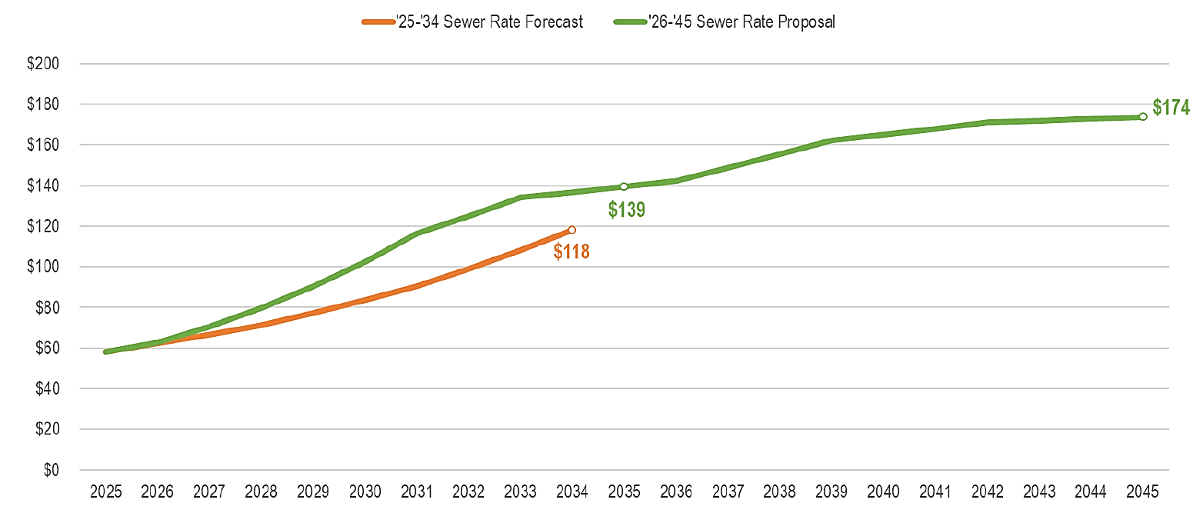

Second Decade Forecast. As shown in Figure 1 and Table 4, the 2026 sewer rate forecast includes, for the first time, an extension of the forecast period by an additional ten years. Motion 16449 requests WTD develop a rate forecast for up to 75 years and the final deliverable is due in July 2025. Since the development of the long-term forecast aligned with the 2026 rate transmittal, WTD has included the second decade of the forecast in this transmittal.

Table 4.
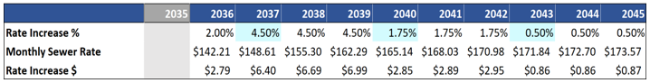
2036-2045 Rate Forecast

As shown in Figure 3, the second decade of the 2026 forecast reflects a reduction in capital expenditures expected in the second decade compared to the first ten years, including no regulatory expenditures projected beyond 2037. WTD reports that this second decade's forecast has significant uncertainty. There are currently no regulatory costs projected beyond 2037 or, as WTD notes, costs related to contaminants of emerging concern or nutrient removal costs beyond the first permit. Council staff analysis of this second decade of the forecast is ongoing.

Capital Forecast Continues to Project Significant Growth. With every rate proposal, WTD updates its 10-year forecast of capital expenditures. The 2026-2035 total capital forecast is $11.4 billion. As WTD reports, the CIP projection reflects the challenge of a "stacking" problem.

This section of the staff report discusses the approach to developing the capital forecast, categories of capital projects, comparisons to the prior 2025 10-year forecast, and cash funding for capital expenditures.

Updated Approach to Developing a Capital Forecast. Capital forecasts are necessary to determine the amount of funding (cash and debt) needed to pay for the CIP and directly impact the 10-year forecast. With this 2026 10-year rate forecast, WTD has updated its approach to forecasting capital expenditures. The new approach tries to take into consideration the complexity of the projects, the capacity to deliver concurrent projects, historical accomplishment rates, and legally required timelines. WTD reports that forecasting expenditures for a growing and complex capital program such as WTD's is a challenging endeavor. Council staff are reviewing additional information provided by WTD at the time of this staff report on the updated forecasting approach and any rate implications.

WTD reports that it will continue to evaluate the approach used to project capital expenditures. Given the size of the capital program and the complexity of developing a forecast with so many variables, Council may wish to encourage WTD to engage MWPAAC in an in-depth review of the method selected to forecast the amount of capital expenditures that will occur in each year of the forecast. While such a review would not be in time for the 2026 rate, it could help inform the 10-year capital forecast and the remaining years of the 10-year rate projection.

Categories of Capital Expenditures. Figure 2 shows the expenditure categories that make up the capital forecast in 2026-2035. Regulatory compliance and capacity improvement projects are the largest categories of projects. As shown in Figure 2, regulatory compliance expenditures are projected to make up a growing share of the capital expenditures in this forecast.

Figure 2.
CIP Components for 2026-2035 Financial Forecast

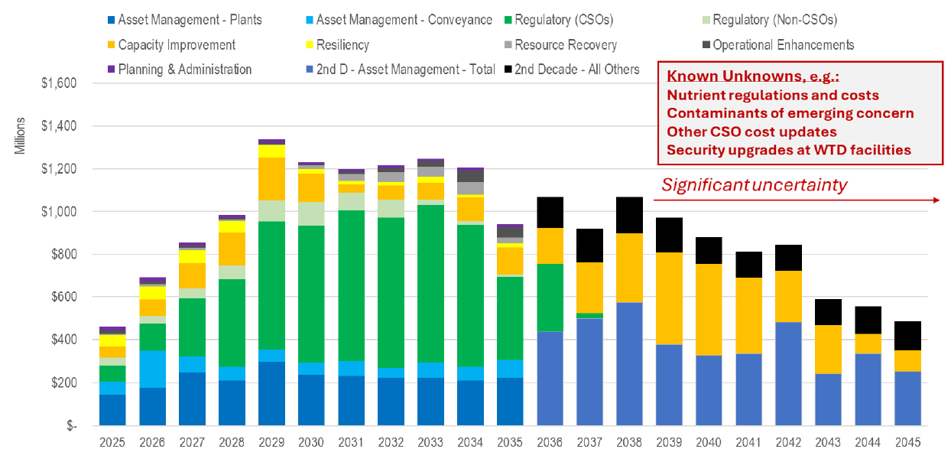

Regulatory Projects.

Modified Combined Sewer Overflow (CSO) Consent Decree Costs. When the Modified Consent Decree was adopted by the Council in July 2024 (Ordinance 19801), the total estimated cost range to complete the remaining projects was $1.7 billion and $4.9 billion. Now, with new cost estimates for the Mouth of Duwamish CSO, the completion date moved from 2040 to 2037 for other CSOs, and a new year in the forecast period (3035), cost estimates in this forecast period are $2 billion higher than in the 2025 sewer rate proposal with forecast years 2024-2034. Figure 3 shows the increasing CSO costs in the rate forecasts over the last five rate forecasts.

Figure 3.
Evolving CSO Costs in Rate Forecasts

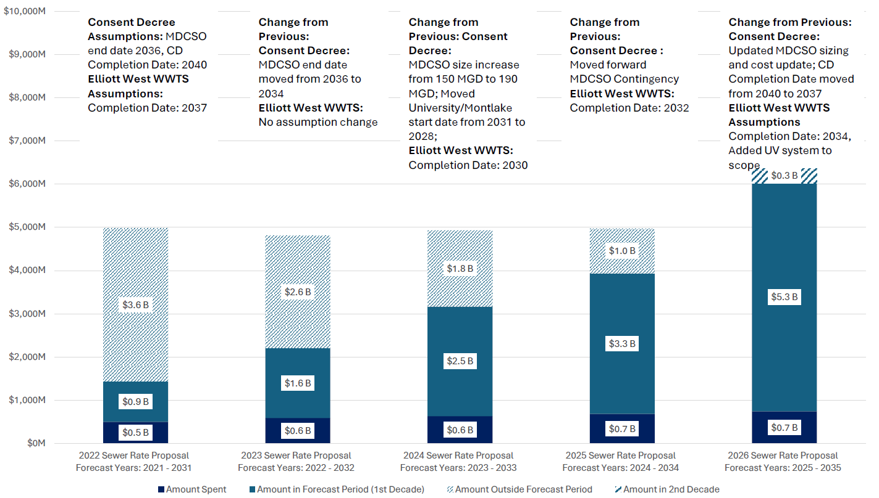

According to WTD, the 2026 Sewer Rate Forecast CIP includes $4 billion (escalated) to complete the four projects underway – Ship Canal Water Quality Project, West Duwamish, Mouth of Duwamish, and Elliott West. University and Montlake CSO control projects are not yet in delivery. Early planning activities are underway as WTD prepares to charter these projects in late 2026. Planning-level estimates for University and Montlake projects are $1.5 billion (escalated) in the 2026 Sewer Rate Forecast CIP. Council staff have asked for information on when those cost estimates were last updated beyond the standard inflation factor applied to all projects.

The Consent Decree additionally requires supplemental compliance activities for projects that were completed but have not brought an outfall into control. WTD currently has supplemental compliance plans for four uncontrolled outfalls. An estimated $75 million (escalated) is forecast in the 2026 Sewer Rate Forecast CIP to bring these outfalls into control by 2037 based on early planning-level estimates.

Increasing MDCSO Costs. As part of the 2026 rate review, Council staff asked for information as to why the costs for the MDCSO have significantly increased in this forecast when compared to the prior forecast and when compared to the information provided in the transmittal package the ordinance authorizing the modification of the CSO consent decree. WTD reports:
At the time of the Consent Decree modification process and the 2025 sewer rate process, only the earlier planning level estimates for MDCSO facilities were available. Prior to this year's rate development process, cost estimates for the set of MDCSO projects reflected high-level planning work initially completed in 2018 for the CSO Long Term Control Plan, a study that looks at the entire combined system and identifies regulatory compliance needs. In 2022 and 2023, these cost estimates were revised to incorporate updated planning assumptions that factored into scope of facilities at chartering.

In 2023, the WTD MDCSO program team initiated the pre-design process to update the planning level cost estimate and inform the MDCSO Wet Weather Facilities Engineering Report, a document specific to these facilities and required by King County's Consent Decree with regulatory agencies. The Engineering Report reflects the effects of climate change which means larger projected storm volumes, higher design flows and larger facilities. The current cost estimate, produced in January 2025, also incorporates the effects of market conditions and scope definition refinements. It was developed consistent with the Association for Advancement of Cost Engineering International (AACE) methodology.
- Construction materials have increased up to 25-40 percent since 2020. Materials make up about 60 percent of construction costs, and about 30-40 percent of overall program costs.
- Labor rates in the region increased by about 11 percent from 2022 to 2024. Conversations with contractors continue to reflect regional labor shortages for construction workers and engineering disciplines.
- The large number of other similar construction projects in our region (WSDOT, Port of Seattle, City of Seattle, Sound Transit and others) has created a 'contractor's market' where bidders can choose the most attractive projects, decreasing competition and exacerbating upward pressure on project costs.
- Ensuring regulatory compliance, including accounting for climate change, has led to a higher capacity treatment facility (190MGD to 240MGD) and larger storage volume for the Chelan tank (3MG to 7MG), compared to the earlier planning level estimate.

  - High Level of Uncertainty in Cost Projection for MDCSO Projects. According to WTD, a major capital program like MDCSO with multiple projects of this scale and at this early phase inherently has uncertainties and risks better understood as the design is advanced. WTD reports that the risks will be managed throughout the Program life cycle. The cost estimate has been prepared by consulting firms with expertise in large capital projects. The current cost estimate (January 2025) for the MDCSO is an AACE (Association for Advancement of Cost Engineering International) methodology Class 5 estimate, with an expected accuracy range of -50% to +100% at this stage.

- Given the significant cost of this project, WTD was asked by both MWPAAC and RWQC for additional information on steps WTD has taken to validate the cost estimate at this stage in the project. WTD reports:
A variety of double-checking steps have been taken (e.g., material cost benchmarking, quantity take-offs, historical comparisons, risk allocations and contingency) to validate the cost assumptions. The project team will also conduct a quantitative risk assessment in March 2025, to further refine risk and contingency allocations. Proceeding along the AACE method helps to further refine the cost estimate and improve certainty. The following examples of verification are undertaken during the cost estimation process:
- Internal QA/QC review: Ensures consistency with AACE methodology and incorporate WTD project development experience.
- Benchmarking against comparable projects: Includes construction benchmarks from current WTD construction projects, e.g., Georgetown Wet Weather Treatment Station and others. Indirect costs are consistent with peer agency wastewater treatment programs of similar scale.
- Market-based pricing validation: Utilizes contractor pricing models, quotes and commercially available cost data, and industry-specific cost trends.
- Estimate reconciliations: The MDCSO estimate is currently undergoing a reconciliation process where two cost independent estimates are compared by the project team and any differences discussed and reconciled for the selected alternative in the Engineering Report. As part of cost management best practices, additional independent review will occur as the program proceeds.

Expenditure Schedule for MDCSO. As discussed later in the staff report, the capital expenditure forecast for MDCSO reflects the policy decision to assume that 100 percent of the costs for regulatory projects will be expended as required by regulation. As such, the MDCSO Program schedule is based on legal obligations to meet the modified consent decree deadlines and avoid penalties. Council staff asked how realistic the spending plan is for this project. WTD reports that the spending projections are considered realistic per the current phase of the Program and WTD Capital Project delivery practices when the forecast was developed. The spending forecast is based on an AACEi Class 5 Estimate that has a scope definition of approximately 2 percent. WTD reports it has resourced the Program with internal staff and consultants to meet the schedule. WTD is preparing for some contractor procurements in 2026 to meet the schedule. Other critical early work to advance the MDSCO projects will be property acquisition.

  - Nutrient Reduction Projects. According to the Department of Ecology, discharges of excess nutrients, particularly nitrogen, to Puget Sound from wastewater treatment facilities are contributing to existing low oxygen levels in Puget Sound. In 2022, the Department of Ecology issued the Puget Sound Nutrient General Permit (PSNGP), which would have required additional capital investments to meet the permit requirement. In February 2025, the Pollution Control Hearings Board invalidated the permit and remanded it back to Ecology for further action.

  - The recent Pollution Controls Hearing Board decision to invalidate the PSNGP adds to WTD's regulatory uncertainty because it means the current permit requirements have not been set. However, the Department of Ecology has already stated that it will pursue a voluntary version of the permit. If agencies do not opt into the voluntary permit, then Ecology will pursue modifications of the National Pollutant Discharge Elimination System (NPDES) permit for each plant or take other actions to impose nutrient regulations. The Department of Ecology anticipates issuing a new decision in June 2025. WTD reports that some form of regulation appears likely, and therefore, it has included investments to address anticipated PSNGP requirements.

  - The 2026-2035 forecast includes about $390 million related to nutrient reduction. Of this amount, $350 million is for projects identified through the Nitrogen Removal Optimization planning effort. This study evaluated strategies to keep nutrient discharges below the "Action Level" established in the initial Puget Sound Nutrient General Permit (PSNGP). The recommended investments are intended to maintain compliance with that threshold over the next 10–15 years, support the permit's adaptive management framework, and align with broader treatment plant needs and planning efforts.

  - Most of these investments involve targeted upgrades to the secondary treatment process at South Plant, with one potential side stream treatment project at an as-yet-unspecified facility. In addition to helping manage nutrient discharges, these projects would offer other benefits, including reducing wear and tear on other assets and operability improvements.
  - Approximately $29 million in expenditures were assumed for 2026 through 2027.

Other Large CIP Projects. In addition to the regulatory projects described earlier in the staff report, there are other large projects in the 10-year forecast. Projected expenditures for individual projects are updated in the six-year CIP, which will be transmitted as part of the budget process.

West Point Electrical Improvements. ($400 million). This program will replace approximately 300 electrical assets, relocate nine additional electrical assets, and coordinate these efforts with other electrical and asset replacement projects at West Point Treatment Plant (WPTP) in Seattle.

West Point Treatment Plant (WPTP) Raw Sewage Pump Replacement. The existing raw sewage pump system was built in 1966, with a capacity of 440 million gallons of wastewater and stormwater per day. While the capacity remained at 440 million gallons per day, pumping untreated combined sewage over a long time has resulted in significant wear on the pumps. The purpose of this project is to replace the Raw Sewage Pump system and make seismic upgrades. In addition, the project will also replace the existing boiler system prior to completion of the RSP replacement to provide the heat necessary to maintain a stable treatment process.

West Point Treatment Plant (WPTP) Critical Gate Refurbishment. The objective of this program is to restore full functionality to critical treatment plant wastewater flow control gates and their support systems at the WPTP in Seattle.

Offsite Level Controls and Communication Upgrade. ($470 million). Council staff have asked for information on this project.

Asset Management Expenditures. The forecast for the asset management categories for the years 2025-2035 is $3.2 billion. As the system continues to age, the scope and cost of Tier 1 projects, the highest priority project, have continued to increase. In the 2026 10-year forecast, WTD intends to address 67 percent ($2.8 billion) of Tier 1 asset management projects and 33 percent ($1.4 billion) of Tier 1 projects in the second decade.

Conveyance System Improvement and I/I Projects Largely Deferred. For the 2026 forecast, the proposal largely continues the practice from the 2024 and 2025 forecasts of deferring the CSI-I/I projects with a lower risk of capacity-related overflows. This includes those projects that have not had a capacity-related overflow in the last 10 years.

Strategic Climate Action Plan Projects. The 2026-2035 forecast includes $261 million for SCAP projects for various initiatives, including significant upgrades to the biogas systems across all three regional plants. Additionally, funds are earmarked for investments in Class A biosolids production and numerous energy-saving projects, primarily focusing on replacing powered equipment such as pumps. The forecast also encompasses investments in the reclaimed water program at Brightwater, along with the installation of electric vehicle charging stations.

Complete Project List. Council staff have asked for a list of all the projects in the ten-year forecast. The project list represents a placeholder list of projects as the final list of projects to be funded is selected each year as part of the budget process and the development of the six-year CIP.

Forecasted Capital Expenditures Versus Actual Expenditures. The capital accomplishment rate is the amount of actual capital spending that occurs in the year compared with the amount of capital spending planned. WTD reports the actual 2024 accomplishment rate was lower than projected, largely because of significant underspend in 2024. Council staff have asked WTD to provide information on the target accomplishment rate for each year for the ten-year proposed rate forecast.

Table 5.
Historical Accomplishment Rates for the Capital Program ($ in millions)
Accomplishment Rate | 2015 | 2016 | 2017 | 2018 | 2019 | 2020 | 2021 | 2022 | 2023 | 2024
Capital Improvement Program | $191 | $207 | $211 | $246 | $262 | $247 | $291 | $360 | $386 | $401
Actual Annual CIP Spend | $160 | $168 | $188 | $231 | $211 | $199 | $201 | $259 | $351 | $313
Actual Accomplishment Rate | 84% | 81% | 89% | 94% | 81% | 81% | 69% | 72% | 91% | 78%

Comparison of 2006 Capital Forecast to Prior Ten-Year Forecast. As shown below in Figure 4, the capital forecast is increasing each year compared to the prior forecast.

  - WTD reports that looking across the ten-year forecast, the increased expenditures are largely due to:
- Cost increase for Mouth of Duwamish ($1.4 billion) for the increase.
- $800 million due to higher than projected cost increases. These costs would have removed with anticipated underspend, but are now carried forward for 3 years.
- $230 million added to this 10-year forecast because the University and Montlake projects are now in the forecast window.
- $610 million from 2024 coming out of the forecast window and 2035 coming on.

Figure 4.
Proposed 2026 Capital Forecast vs. Adopted 2025 Plan

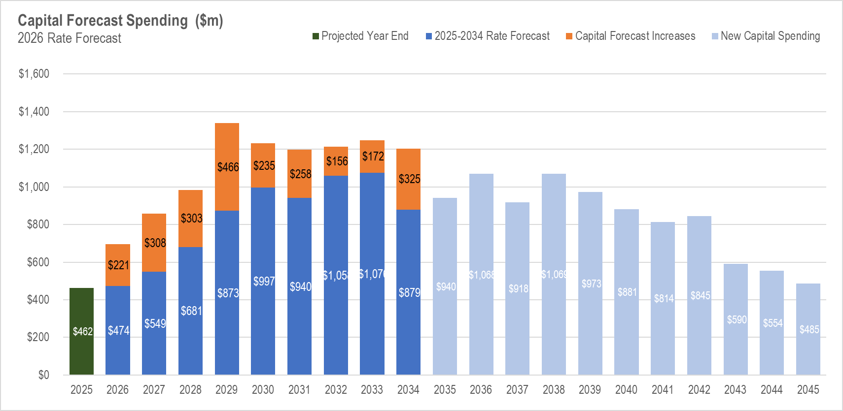

Differences Between 2025 and 2026 Annual Forecasts. The expenditures for 2025 and 2026 are expected to increase beyond what was projected in 2026. The 2025 forecast is about $64 million higher than projected in 2024 because the approach to forecasting capital expenditures has shifted to a more comprehensive view. Similarly, the 2026 forecast has increased by about $221 million, and the 2027 forecast by $307 million. WTD reports it is not possible to attribute the $221 million increase in 2026 and the $308 million increase in 2027 to projects with specificity due to the change in forecasting methodology. Under the approach used for this forecast, project team forecasts are used with minor adjustments made only for anticipated underspending due to schedule risk and carryforward of funds. These increases primarily reflect higher projected costs to deliver the current portfolio of active projects based on updated schedules and cost estimates. In contrast, the previous methodology assumed more of these projects would be delayed due to staffing constraints, which is no longer the case in this updated forecast. As noted earlier, Council staff have asked for additional clarification on the WTD's new approach to forecasting.

Additionally, as shown in Table 6, when compared to the prior forecast period, regulatory projects now make up 17 percent more of the ten-year capital forecast.

Table 6.
Categories of Capital Expenditures in 2025 vs. 2026 Forecast

Capital Improvement Program Funding. Two primary sources fund the capital improvement program: 1) cash generated from the sewer rate and capacity charge revenues and 2) debt financing from revenue bonds or low-interest state and federal loan programs. Figure 5 shows the amount and type of capital funding.

Cash Funding. Since 2023, WTD has used an original cost depreciation method for setting cash funding targets for its CIP. With this method, the average annual cash contribution is equivalent to the average annual depreciation in the forecast period. This means that WTD uses the total expected depreciation over the forecast period to determine the total cash contributions required in the next 10 years. Cash-funding requirements are averaged over the next 10 years of the forecast period, allowing WTD to smooth rate increases and produce a more stable rate path. According to WTD, this depreciation approach reduces the near-term rate spikes caused by large CIP investments in a particular year because the fiscal impact of the CIP investment is spread over the useful life of the asset.

According to the technical memo, the total forecasted depreciation over the next 10 years translates into approximately 28 percent of the total CIP.

Debt Financing. WTD uses debt financing to provide the remaining funds needed after the use of cash. Debt financing represents 72 percent of total project funding over the next 10 years. The main sources of debt available to WTD include state loans, federal Water Infrastructure Finance and Innovation Act (WIFIA) loans, and revenue bonds.
Figure 6 shows the capital funding forecast and capital funding sources.

Figure 5.
Capital Funding Sources

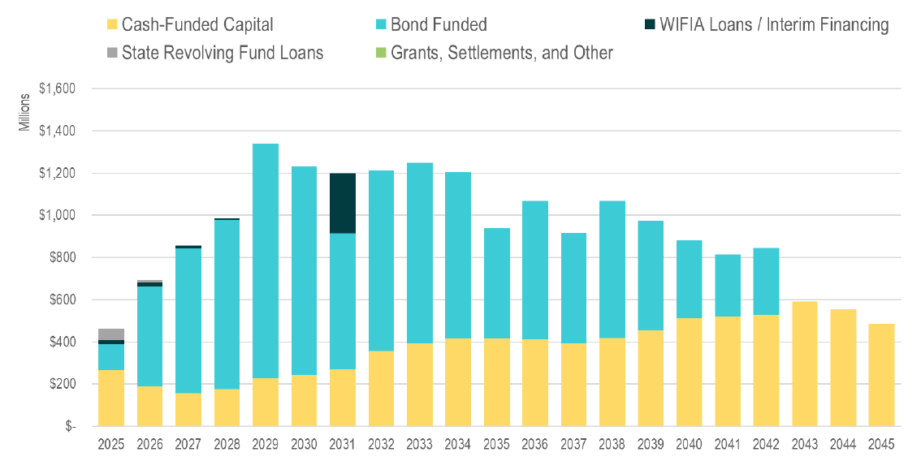
Note: Higher cash funding shown in 2025 is the result of a debt defeasance transaction postponed from November 2024 to February 2025.

Operating Expenditures. WTD's 2025 operating budget is the basis for forecasting operating costs for future years. The 2025 sewer rate and financial forecast included budgeted operating expenditures at $224 million. WTD's spending forecast assumes a budget amendment and includes base-year operating expenditures at $227.6 million.
According to the technical memo, the increase in operating expenditures for 2025 is due to a series of general wage increases for County staff, including a 5.5 percent increase for 2025.

Table 7.
Historical Annual Increase in WTD Operating Expenditures

Year | Operating  Expenses | Annual  Growth
2013 | 117,183 | 2.0%
2014 | 124,201 | 6.0%
2015 | 128,926 | 3.8%
2016 | 136,321 | 5.7%
2017 | 148,199 | 8.7%
2018 | 152,589 | 3.0%
2019 | 155,785 | 2.1%
2020 | 158,660 | 1.8%
2021 | 158,628 | 0.0%
2022 | 173,870 | 9.6%
2023 | 187,185 | 18.3%
2024 | 205,478 | 18.2%
 | Average | 6.6%

Forecasted Increase in Operating Expenditures. Operating expenditures are forecasted to account for 40 percent of the revenue requirements for the sewer rate in 2026. Operating expenditures are forecasted to increase by 9.5 percent from $227.6 million in 2025 to $249.3 million in 2026. The operating costs for WTD's base year (2026) forecast include adjustments for significant known increases, such as electricity and chemicals, in addition to updated prices where recent inflation exceeded previous forecast assumptions. According to WTD, the growth in the operating costs assumption reflects increased staffing levels to better meet industry standards and the growing needs of aging facilities, capital project participation, and higher costs of biosolids transportation. Operating costs are forecast to increase by approximately 7 percent from 2026 to 2027, approximately 6 percent from 2028 through 2030, and approximately 5 percent from 2031 through 2035.

The technical memo briefly describes the need for this additional operational staff on pages 11 and 12, but it does not include any estimate as to the number of additional staff that will be requested as part of future budget requests. The technical memo does note that a portion of the identified staffing needs will be requested in 2026, and the remainder of the requests will be spread over the following years.

Rate Smoothing. Over the forecast period, WTD aims to develop a "smooth" sewer rate forecast that provides for fewer steep spikes. According to the technical memo, a smoothed sewer rate forecast allows for the collection of revenues that exceed expenditures in a given year and are less than expenditures in subsequent years to fully fund the utility over the forecast period with less volatility.

Smoothing rates means moving from considering only the revenue needs in a particular year to considering the needs over a more extended period to smooth year-to-year increases. The first step in rate smoothing is setting the cash target for every year of the forecast to match the estimated annual depreciation. As shown in Table 8, using only the original cost depreciation method, the sewer rate would still have spikes within the forecast period. To smooth those spikes, WTD reviews the entire forecast period, and, when necessary, to create a gradual trajectory of rate increases, the projection anticipates transferring more cash to the capital fund than the cash-funding target for that year. The same amount is reduced from the transfer in a later year of the forecast. At the end of the 10-year forecast, total cumulative revenues and expenditures are balanced.

Table 8.
2026 Forecast Before and After Rate Smoothing

Table 8 shows the impact of rate smoothing on the sewer rate. The second row of the table shows that even after using the original cost depreciation method approach, the proposed rates would have steep ups and downs. The smoothed rate is shown in the fourth row. However, given the large rate "spike" projected from 2026 to 2027, Council staff have asked WTD what other rate "smoothing" options were considered that would have resulted in a more gradual increase. WTD’s response is below:

“Once the 2026 rate increase is fixed at 7.50%, as opposed to the pre-smoothing rate increase of 17.75%, the pre-smoothing rate for 2027 becomes 21.22%. The 12.75% increase in 2027 is meant to smooth that updated pre-smoothing increase of 21.22%. As discussed in prior meetings, rate smoothing is part science and part art. Part of this is balancing customer impact (avoiding “rate shock”) with financial risk. The financial risk comes from collecting revenues below cash-funding target in the first years, expecting to make up for it in the following years. Any stair stepping more gradual than the current proposal would either incur higher financial risk in the short term or require a higher rate increase peak in the middle of the forecast.”
With each new forecast, more information becomes available about the timing of future expenditures. WTD reports that the projected rate path may need to be re-smoothed by making adjustments from the prior forecast.

Capacity Charge. Council staff analysis is ongoing.

RWQC letter to King County Council and Executive. RWQC was briefed on WTD's rate forecast at the March and April RWQC meetings. Following the May RWQC meeting, RWQC sent a letter regarding the 2026 proposed sewer rate to the King County Council and the Executive. The letter is included as Attachment 7 to this staff report and is summarized below.

RWQC's letter begins with an acknowledgement of the work that WTD has done in making progress on rate methodologies, and the additional briefings WTD provided to both RWQC and the Metropolitan Water Pollution and Abatement Advisory Committee (MWPAAC) this year in support of the proposed 2026 sewer rate and capacity charge. The letter notes, "RWQC recognizes that rate increases are necessary to maintain and improve the system, but increases must be balanced with affordability for ratepayers. Our deepest concern is that the rates forecasted in the future, particularly in 2027, are untenable and unsustainable for our ratepayers."

The letter continues, "While the RWQC can support the 2026 rate based on relative consistency with the prior forecast, we are very concerned about the projected rate path. RWQC would likely not support the 2027 rate or the projected rate path without WTD providing better communication about the reason for the rate changes, various scenarios considered, efforts made to minimize the rate impacts to ratepayers, and more meaningful engagement by MWPAAC, RWQC, and the King County Council in the development of the 2027 rate."

The letter concludes by offering the following recommendations "to achieve more predictability, affordability, and transparency for the 2027 and future rates":
- Approach for 2027 Rate Development – ongoing discussions with MWPAAC, RWQC, and the King County Council on the factors driving the 2027 rate and future projections.
- Regulatory strategy – encouraging King County to develop and implement a strategy for renegotiating consent decrees or permit deadlines for major projects and investments to address affordability challenges while simultaneously achieving optimal water quality benefits to the region.
- Independent capital oversight – encouraging King County to develop a proposal for a third-party review of the capital program, including "mega" capital projects such as the Mouth of Duwamish Combined Sewer Overflow (CSO).
- Early visibility and transparency on large project planning - planning for large capital projects should include early opportunities to bring MWPAAC, RWQC, and other stakeholders into the process so that the benefits and tradeoffs of different alternatives can be examined and understood.
- Rate predictability for multiple years – encouraging WTD to explore a multi-year rate commitment, which would provide more time for a deeper review and understanding of costs, discussion of options and tradeoffs, and prioritization of investments.
- Long-term forecasting – WTD should continue strengthening its capital forecasting methodology to increase the reliability, predictability, and sustainability of the second decade of the rate forecast.
- Support the regional utilities affordability summit – expressing support for the Executive's plan to prepare a multi-jurisdictional summit to address affordability and access to essential utilities.
- Continued focus and timeliness on RWSP Update - encourage the Council to ensure the timelines are adhered to for this important planning effort.

Metropolitan Water Pollution Abatement Advisory Committee Comment Letter. The Metropolitan Water Pollution Abatement Advisory Committee (MWPAAC) advises the King County Council and Executive on matters related to water pollution abatement. It was created by state law (RCW 35.58.210) and consists of representatives from cities and local sewer utilities that operate sewer systems within King County's sewer service area. These cities and sewer utilities deliver their sewage to King County for treatment and disposal.

Although MWPAAC does not have a formal role in approving the rate, MWPAAC closely follows the rate development process each year and works closely with WTD on issues related to the regional wastewater system and the sewer and capacity charge. As noted in the attached letter (Attachment 6) to the King County Council from MWPAAC, "MWPAAC acknowledges the need for a sewer rate increase in 2026; however, we have not been given adequate time and information to responsibly understand the costs driving the rates for 2026 and beyond." The letter to the Council includes the following points for future discussion:
- Third-party oversight for the capital program – engaging a consultant to provide oversight of mega projects to provide greater transparency and understanding ahead of major decisions, given the magnitude of WTD's proposed capital spending over the next 10 years.
- Rate predictability for multiple years – committing to rates for a multi-year period to allow for better long-term planning and stability for WTD and MWPAAC member agencies.
- Long-term forecasting – continuing to refine long-term forecasts and early sharing of project alternatives and costs to allow MWPAAC to understand the drivers and provide early feedback.
- Deeper discussion on capital improvement program assumptions – having ample time for MWPAAC to fully understand projects and their planning to understand what contributes to the large cost buckets.
- Revisit regulatory timelines – encouraging WTD to pursue timeline extensions for regulatory requirements in areas requiring significant investment to allow for a more phased approach in implementing the required projects and to provide rate relief to local agencies.
- Policy effects on rate growth – clarifying how RWSP policies drive capital prioritization.

The letter concludes, "MWPAAC can support the proposed 2026 sewer rate; however, we urge the Council to work with the Executive and WTD to make meaningful progress on these issues summarized above before the next rate cycle begins."

Contaminants of Emerging Concern–Cost Tracking. Per Motion 16434: "Beginning with the 2025 sewer rate forecast, the wastewater treatment division shall include in its technical memorandum submitted with the annual sewer rate Ordinance a section identifying the cost of activities it has undertaken and plans to undertake to address contaminants of emerging concern, including PFAS."

The technical memo includes the following information on PFAS costs to date:
- Between 2019 and 2021, King County evaluated reclaimed water from the Brightwater Treatment Plant, analyzing its impact on soil, groundwater, and plant tissues for PFAS and other chemicals of emerging concern. PFAS compounds were found in river water, reclaimed water, soil, and plants irrigated with these water sources. The total cost for the PFAS-related work was approximately $93,750.
- In 2021-2022, King County investigated PFAS presence in wastewater effluent at three County treatment plants. The study cost around $24,990 for PFAS testing.
- In 2023, King County allocated $421,000 for a comprehensive investigation into PFAS in wastewater facilities and landfill leachate, expected to be completed by mid-2025. By mid-2024, tracking showed that staff had spent 300 hours and $27,300 on PFAS-related work.
- Additionally, the Nutrient Reduction Evaluation project (total estimated cost of approximately $8 million) includes an analysis of potential nitrogen-removal compounds of emerging concern and toxics removal, including PFAS chemicals. Approximately $63,500 has been spent on PFAS analysis as part of this project.
- Costs also include 2,090 documented staff hours spent on PFAS through the end of 2023, in addition to the 300 estimated hours in 2024.

The technical memo also includes information on future costs related to compliance with Ecology's draft NPDES permit for the West Point Treatment Plant. The cost estimate for this work is $1 million over five years. Other future unknown costs include monitoring for PFAS in stormwater, wastewater treatment plant influent and effluent, biosolids, and industrial waste.

Council Staff Analysis Is Ongoing. As noted in the staff report, Council staff have requested additional information on the following topics:
- Changes to the approach to develop the capital expenditure when compared with the prior forecast.
- Second decade of rate forecast.
- List of all the capital projects and their costs in the ten-year forecast.
- Cost estimates for Montlake and CSO Projects.
- Information on the target accomplishment rate for each year of the ten-year forecast.
- Capacity Charge.

INVITED

- Kamuron Gurol, Director, Wastewater Treatment Division
- Courtney Black, Financial Services Manager, Wastewater Treatment Division
- Crystal Fleet, Capital Portfolio Planning and Analysis Unit Manager, Wastewater Treatment Division

ATTACHMENTS

- Proposed Ordinance 2025-0129 (and its attachments)
- Transmittal Letter
- Fiscal Note
- Technical Memo Proposed 2026 Sewer Rate and Capacity Charge
- PowerPoint King County Wastewater Treatment Division 2026 Sewer Rate
- Metropolitan Water Pollution Abatement Advisory Committee 2026 Rate Recommendation Letter to Council
- Regional Water Quality Committee letter to King County Council

KCC 28.86.186 Financial Policy 15
Industrial users pay an additional fee beyond the monthly sewer rate. These fees help the King County Industrial Waste Program recover the costs associated with monitoring and administering the pretreatment program.
Ordinance 19210, Section 112, Proviso P3
See Attachment A to Motion 16006 Sewer Cost Structure Report
2025 Sewer Rate Technical Memo, page 30
In 1998, the King County Executive and RWQC held a retreat at the Robinswood Conference Center in Bellevue, Washington to discuss funding the Regional Wastewater Services Plan. The points of the agreement are collectively known as the “Robinswood Agreement.” The principle that “growth pays for growth” is the cornerstone of the Robinswood Agreement.
RCW 35.58.570
The RCEs assigned to single-family homes is based on size: small (<1,500 sq. ft. = 0.81 RCE), medium (1,500 – 2,999 sq. ft.= 1 RCE), and large (>3,000 sq. ft. = 1.16 RCE). Multi-family structures are billed by unit at 0.81 RCEs for two to four units and 0.64 RCEs for five or more units. Commercial structures are billed based on fixture counts and/or flows.
The commercial capacity charge structure also has an add-on category for non-fixture unit estimated flows where applicable to add the fixture unit RCE calculation.
See Subsection 3.a. of Financial Policy 15 in 28.86.160C.3(a)
Wastewater Capacity Charge: Unclear Whether Growth Is Paying for Growth
King County Code 28.86.160
2025 Sewer Rate Technical Memo, page 5
2025 Sewer Rate Technical Memo, page 5
WTD Presentation to MWPAAC Rates & Finance Subcommittee, March 6, 2025
2025 Sewer Rate Technical Memo, page 5
2025 Sewer Rate Technical Memo, page 17
Attachment 4: PowerPoint King County Wastewater Treatment Division 2026 Sewer Rate
WTD refers to the MDCSO as a Program because of its size and complexity.
2025 Sewer Rate Technical Memo, page 13
Attachment 4: PowerPoint King County Wastewater Treatment Division 2026 Sewer Rate
Provided by Wastewater Treatment Division
Depreciation is calculated by dividing an asset’s cost by its estimated useful life, representing how much that asset is expected to wear out or lose value every year. Original cost refers to the actual cost of an asset, rather than the cost adjusted for inflation.
2025 Sewer Rate Technical Memo, page 18
2025 Sewer Rate Technical Memo, page 11
Expenditures include depreciation-based cash transfers to capital
Provided by Wastewater Treatment Division
PFAS (Per- and Polyfluoroalkyl Substances) are a group of chemicals used to make fluoropolymer coatings and products that are widely used in consumer products. PFAS are a concern because they do not break down in the environment, are able to move through soils and water sources, and build up in fish and wildlife.

