

Metropolitan King County Council
Committee of the Whole

STAFF REPORT

Agenda Item: | 6 | Name: | Nick Wagner
Proposed No.: | 2014-B0186 | Date: | 20 October 2014

SUBJECT
Proposed adoption of a memorandum of agreement between King County and the King County Coalition of Labor Unions providing cost of living adjustments and modifying certain other terms of employment for county employees represented by the union members of the Coalition.

SUMMARY
Proposed Ordinance 2014-0391 (Att. 1) would adopt a memorandum of agreement (“the MOA”) between King County and the King County Coalition of Labor Unions (“the Coalition”) (Atts. 1-A and 1-B). Attachment 2 is a list of the unions participating in the MOA.

According to the Executive’s transmittal letter, the agreement covers about 5,800 employees, working in 17 county departments and agencies, covered by 59 different collective bargaining agreements.

The MOA provides in part, in the order listed in the MOA:

- COLAs. All covered employees would receive cost of living adjustments (“COLAs”) of 2.0% for 2015 and 2.25% for 2016, each effective on January 1 of the applicable year; the MOA provides that this “establish[es] no precedent” for the future;
- Extension of Longevity Pay MOA. An existing “Coalition ‘Administrative Support’ Memorandum” (Att. 1-B) (“the Longevity Pay MOA”) would be extended through January of 2016. This MOA was negotiated between the County and six unions representing employees in administrative support classifications in several county departments. Originally approved by the Council by Ordinance 17188 on 19 September 2011, the MOA provides premium pay of 1.5% above step 10 for employees with at least 15 years of county service and 3.0% above step 10 for employees with at least 20 years of service (the 3.0% would replace the 1.5%,
- not be added onto it, when an employee reaches 20 years of service), as long as the employee has a performance evaluation rating of at least 3.25.
- Rollover of Other Compensation, with Exceptions. All other “compensation elements” (defined as “wages, premiums, incentives, and other monetary payments; and all forms of leave and benefits” and also referred to in the MOA as “Total Compensation”) of current collective bargaining agreements (“CBAs”) are “rolled over” (i.e., neither increased nor decreased) through 2016 – except for CBAs “where the County and a union were already in the process of collective bargaining with respect to certain elements of ‘Total Compensation’ prior to June 27, 2014”; in the latter CBAs the MOA allows increases or decreases in “certain elements of ‘Total Compensation’”;
- Compensation Reopener. At the County’s request, all compensation elements of CBAs of covered employees will be reopened for coalition bargaining of possible changes to take effect in 2017 or later. The MOA notes that the Joint Labor Management Insurance Committee (“JLMIC”) benefits agreement “is already opened in 2016” and states that the MOA is not intended to modify the terms of that agreement.
- “Lump Sum Coalition Participation Premium Payment”. Each covered employee will receive a “lump sum coalition participation premium payment” of $500 by the end of 2014. The reason for this payment is explained in the Analysis section below. The MOA provides that this payment “establish[es] no precedent” for the future.
- Changes to King County Family and Medical Leave. Benefits under the King County Family Medical Leave (KCFML) ordinance will run concurrently with those provided under the federal Family Medical Leave Act (FMLA), instead of consecutively, subject to the following conditions: (a) the same changes being adopted and implemented by ordinance for non-represented employees; and (b) the changes not being implemented for represented employees before 1 July 2015. The parties agree to “work together to identify the King County Code language changes necessary to implement this change.”
BACKGROUND
The MOA is the latest in a series of agreements between King County and the King County Coalition of Labor Unions, which include many but not all of the unions that represent King County employees. Previous agreements have dealt with issues such as allowing unpaid furloughs, supporting a Lean process and implementation of Lean proposals (“the Lean MOA”), and providing cost of living adjustments, including the 2010 “Zero COLA” MOA.
The occasion for the new MOA, which would be approved by Proposed Ordinance 2014-0391, is the expiration of the 2010 “Zero COLA” MOA, which covered the years 2011 through 2014, providing a zero COLA for 2011, a COLA for 2012 that was set at 90% of the increase in the CPI-W, and COLAs for 2013 and 2014 that were set at 95% of the increase in the CPI-W. The new MOA would cover the calendar years 2015 and 2016.

ANALYSIS
The following analysis is organized by the substantive terms of the MOA, listed in the order in which they appear in the MOA:

- COLAs
The proposed new MOA would provide the covered employees with a 2.00% COLA for 2015 and a 2.25% COLA for 2016. This is a departure from both the 2010 Zero COLA MOA, which based the 2012-2014 COLAs on a percentage of the increase in the CPI-W, and from the County’s labor policy on compensation, which provides in part:
If a cost of living adjustment is determined to be warranted, it shall be linked to a specific Bureau of Labor Statistics Index, such as up to 90 percent of the calculated average of the 12 monthly percentage changes of the All-Cities CPI-W between July of the previous year and June of the current year.
The full text of the County’s labor policy on compensation is contained in Attachment 3.
The charts on the next page compare the proposed 2015-2016 COLAs with: (1) the percent increase in the CPI-W (for Seattle-Tacoma-Bremerton); and (2) the COLAs provided for under the Zero COLA MOA, including the COLAs that would have been provided in 2015 and 2016 if they had been calculated using the same formulas that were used to determine the COLAs for 2013 and 2014. The first chart shows the COLA and the CPI-W increase for each individual year. The second chart shows the cumulative increase since 2010.
Although the annual COLAs for 2015-2016 under the proposed new MOA are higher than the COLAs that would have been provided using the Zero-COLA-MOA formula for 2013-2014, the cumulative COLA increase since 2010 remains less than the cumulative percent increase in the CPI-W, as shown in the second chart.
According to the Executive’s Fiscal Note (Att. 8), the COLAs under the proposed new MOA would result in annual cost increases of $9,617,829 in 2015 and $11,036,458 in 2016.
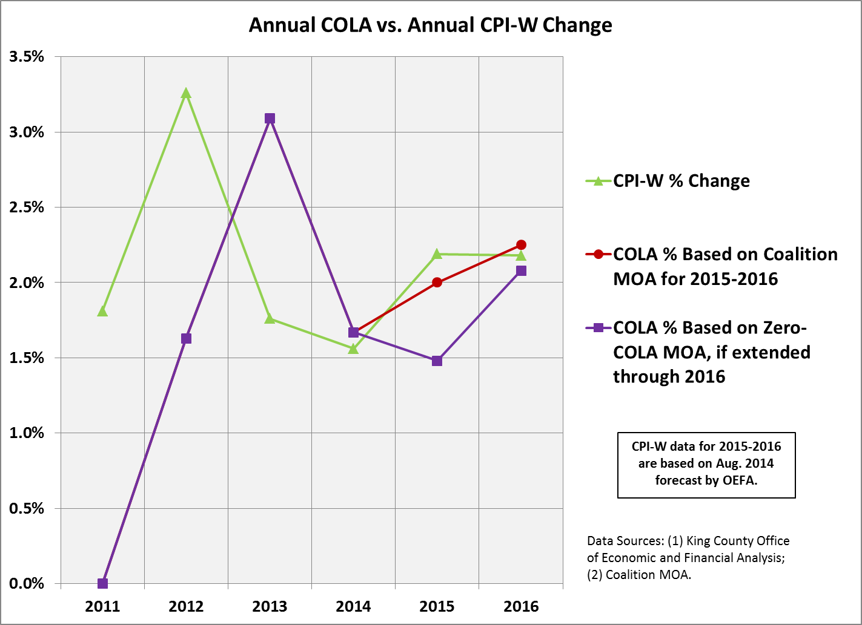
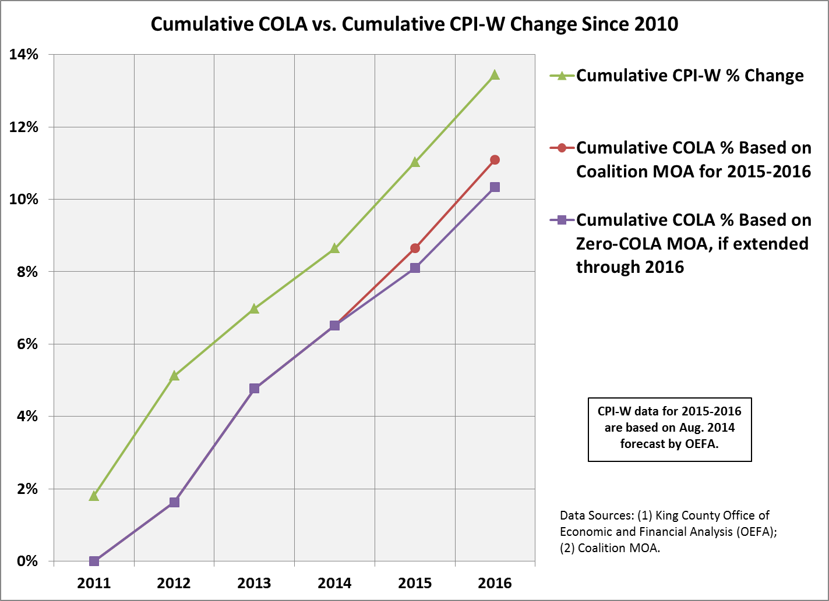

- Longevity Pay Extended
The proposed new MOA would extend the term of the Longevity Pay MOA for two more years, through 2016, at an annual cost of about $325,000, according to executive staff. Because this cost was already being incurred each year, it is not included in the Fiscal Note for the proposed new MOA.
- Rollover of Other Compensation, with Exceptions
The proposed new MOA provides that, except for the COLAs, the Longevity Pay extension, and the “lump sum coalition participation premium payment” (discussed below), all other “compensation elements” (defined as “wages, premiums, incentives, and other monetary payments; and all forms of leave and benefits”) of current CBAs are “rolled over” (i.e., neither increased nor decreased) through 2016 – except for CBAs “where the County and a union were already in the process of collective bargaining with respect to certain elements of ‘Total compensation’ prior to June 27, 2014,” in which there may be increases or decreases in “certain elements of ‘Total Compensation.’” The potential cost that might arise out of the exception is unknown and therefore is not included in the Fiscal Note. There are 14 CBAs, covering 1,884 employees, within the exception.
- Compensation Reopener
Under the proposed new MOA, all compensation terms in the CBAs of covered employees are subject to being reopened at the County’s request for coalition bargaining of possible changes to take effect in 2017 or later. It is unknown at this point what results that bargaining will yield; however, having those terms be subject to coalition bargaining is conducive to the County’s goal of standardizing labor contracts.
- “Lump Sum Coalition Participation Premium Payment”
The inclusion of a lump sum payment in a county collective bargaining agreement (excluding lump sum retroactive payments of compensation due under other terms of the agreements, such as COLAs) has been rare, at least in recent years. This includes coalition agreements. For example, neither the Zero COLA MOA, nor the Lean MOA, nor the Longevity MOA included such a payment. On the other hand, a lump sum payment has the advantage of not becoming part of base compensation (which can be used as a starting point for the next negotiation), especially where, as in the proposed new MOA, the parties explicitly agree that the payment “establish[es] no precedent” for the future.
The “lump sum coalition participation premium payment” in the proposed new MOA is described as being in exchange for:
  - “the agreement by participating unions to bargain economic issues with King County as a coalition rather than as individual bargaining units, resulting in process efficiencies and savings in administrative costs for King Count”; and
  - “the agreement by participating unions to open all compensation elements of CBAs on January 1,2015 or later, at the request of King County, for the purpose of bargaining a "Total Compensation" agreement in coalition.”
According to the Fiscal Note, the total cost of the payment is $3,232,348, which would be due in 2014. According to OLR, $442,941 of this cost will be recovered each year in efficiencies resulting from coalition bargaining:
As a result of the coalition bargaining agreement, OLR withdrew its [2015-2016 budget] request for a labor negotiator II and a Labor Analyst. Those positions were requested to support the employer of the future project. The annual cost would have been approximately $288,700. The Coalition agreement allows OLR to support EOF with its current staffing levels due to the significant reduction in staff devoted to individually negotiating each labor contract.
In addition, as noted in section 4 above, having compensation issues be subject to coalition bargaining is conducive to the County’s goal of standardizing labor contracts.
- Changes to King County Family and Medical Leave
The proposed new MOA provides that benefits under the King County Family Medical Leave (KCFML) ordinance will be treated as running concurrently with those provided under the federal Family Medical Leave Act (FMLA), instead of consecutively, subject to the following conditions:
- the same changes being adopted and implemented by ordinance for non-represented employees; and
- the changes not being implemented for represented employees before 1 July 2015.
The parties agree to “work together to identify the King County Code language changes necessary to implement this change.”
Under the County’s current practice, coverage under KCFML does not begin to run until the employee has exhausted all accrued, paid leave (e.g., sick leave and vacation). FMLA coverage, on the other hand, begins to run immediately. As a result, for long-term employees who have accrued a substantial amount of leave, KCFML does not overlap with FMLA, whereas for new employees who have accrued little leave there can be substantial overlap between the two. This inconsistency creates both potential unfairness to employees and an administrative burden on the County in tracking KCFML usage.
The chart in Attachment 4, which was prepared by executive staff, is intended to illustrate the difference between current practice and what would be required under the new MOA.
If KCFML and FMLA run concurrently, executive staff estimates the following ranges of potential annual savings:
- Cost of providing medical benefits: $45,534 - $76,692;
- Cost of overtime: $58,806 - $99,046;
- Cost of backfilling: $117,613 - $198,092.
- Total savings: $221,953 - $373,830.
Executive staff’s analysis underlying those numbers is contained in Attachment 5. A document prepared by executive staff that explains KCFML in a question-and-answer format is Attachment 6.
In addition to the direct savings described above, executive staff expects that having KCFML run concurrently with FMLA will result in a substantial reduction in the burden of administering KCFML, though that cost cannot be quantified.

FISCAL IMPACT
The fiscal impact of the COLAs and the lump sum payment is detailed in the Executive’s Fiscal Note (Att. 8), which is summarized in the table below. Other costs and savings, to the extent that they are ascertainable at this point, are described earlier in this staff report.
 | 2014 | 2015 | 2016
Increase over previous year | $ 3,232,348 | $ 9,617,829 | $ 11,036,458
Cumulative increase over 2014 |  | $ 9,617,829 | $ 20,654,287
The 2015 and 2016 COLAs are built into the Executive’s proposed budget. Twenty-six percent will be paid from the General Fund.
About 28% of the 2014 costs will be covered by a supplemental appropriation, the remainder being absorbed within existing agency budgets, as described below.
SUPPLEMENTAL APPROPRIATION
Adoption of the proposed new MOA will require a supplemental appropriation of $915,014 to help cover the “lump sum coalition participation premium payment,” which is due in 2014. The total estimated cost of the payment is about $3.2 million; however, a supplemental appropriation is requested only for agencies that require an additional appropriation to make the payments in 2014.
The request is being made in companion legislation, Proposed Ordinance 2014-0392, which has been referred to the Budget and Fiscal Management Committee. The Executive has requested Council action on the supplemental by November 17 in order to make the lump sum payment in 2014, as required by the MOA.
INVITED

- Patti Cole-Tindall, Director of Labor Relations, King County Executive Office
- James Johnson, Deputy Director of Labor Relations, King County Executive Office
- Dustin Frederick, Co-Chair, King County Coalition of Labor Unions
- Whitney Abrams, Co-Chair, King County Coalition of Labor Unions

ATTACHMENTS
- Proposed Ordinance 2014-0391
Att. A: MOA regarding COLAs, etc.
Att. B: MOA regarding longevity pay
- List of Unions Participating in the MOA
- County Labor Policy on Compensation
- Executive’s chart illustrating interplay between KCFML and FMLA
- Executive staff analysis of potential savings from KCFML and FMLA running consecutively.
- Executive staff’s KCFML Q&A
- Transmittal letter
- Fiscal Note

Specifically: “90% of the annual average growth rate of the bi-monthly Seattle-Tacoma-Bremerton Area Consumer Price Index for Urban Wage Earners and Clerical Workers (CPI-W, July of the previous year to June of the current year). Zero floor and no ceiling.”

