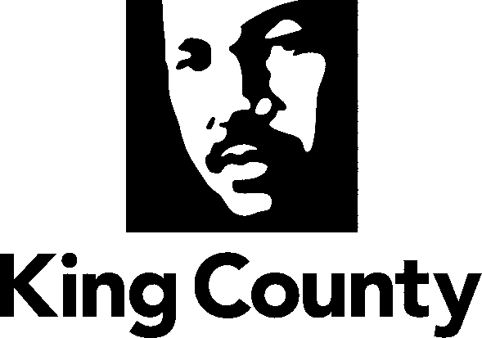

Metropolitan King County Council

Regional Water Quality Committee

Staff Report

Agenda Item No.: | 10 |  | Name: | Beth Mountsier
Briefing No.: | 2015-B0034 |  | Date: | March 4, 2015
Attending: | Stan Hummel, Capital Projects Managing Supervisor, Wastewater Treatment Division (WTD)  Mark Buscher, Capital Project Manager IV, WTD.

SUBJECT

A briefing and overview of the work plan and schedule for and Expert Review Panel to review combined sewer overflow (CSO) control projects - in response to 2015-16 King County Budget proviso.

SUMMARY

The United States Environmental Protection Agency (“EPA”) and the Washington State Department of Ecology (“Ecology”) alleged that the County violated Sections 301 and 402 of the Clean Water Act (“CWA”) and the conditions and limitations of the County’s National Pollutant Discharge Elimination system (“NPDES”) permit issued to the County by Ecology. These are violations related to the quality of the effluent released from combined sewer overflow (“CSO”) control facilities that act as satellite treatment plants to West Point Treatment Plant. In response, King County, without admitting any liability related to the alleged violations, negotiated a consent decree (Attachment A to PO 2012-0459) with EPA and Ecology that the Regional Water Quality Committee recommended and the Council approved via adoption of Proposed Ordinance 2012-0459 (Ordinance 17514) in the first quarter of 2013.

The consent decree obligates King County and its Wastewater Treatment Division (“WTD”) to implement the long-term CSO control plan that the Council approved in September 2012 (Ordinance 17413) for future projects per the proposed design criteria/specifications and schedule in the plan, including final completion of all projects in 2030. In addition, the consent decree provides direction for 1) implementation of CSO control projects currently in design 2) improvements in operations of existing CSO treatment plants to meet effluent standards, 3) various reporting requirements regarding progress towards these goals, post-construction monitoring, etc., 4) dispute resolution procedures and 5) penalties.

In October 2014 the committee was briefed on all of the CSO projects that are addressed in the consent decree with special attention and additional information regarding the Georgetown project provided by the King County Auditor’s Office and the WTD Director, Pam Elardo.

The Georgetown Project addresses the Brandon and Michigan basins that collect sewage and stormwater and convey the combined influent to the West Point Treatment Plant. Each basin currently has a combined sewer overflow pipe that discharges (more frequently than allowed by EPA and Ecology) exceeding the average of one discharge per year into the Duwamish River.

King County proposed in its updated 2012 CSO Control Plan – to meet the EPA and State of Washington’s CSO control standards for the Brandon and Michigan basins by building and operating a wet-weather treatment plant to handle the flows within both basins and treating the wastewater/influent during overflow conditions. Discharge of the treated wastewater to the Duwamish River is planned to occur at a new discharge location and the water discharged would meet certain standards as approved by EPA and Ecology. The current overflow pipes from each basin for Brandon and Michigan would also remain and would be required to not overflow more than once per year.

In December 2014, Wastewater Treatment Division staff reported on progress towards the milestones and ultimate completion of the Georgetown project, as required by the consent decree. In addition, Council staff briefed the committee on budget proviso for the 2015-16 Wastewater Treatment Division operating and capital budgets with regard to this project which required:

P3 PROVIDED FURTHER THAT:
Of this appropriation, $250,000 shall not be expended or encumbered until the executive transmits a detailed work plan for utilizing an expert review panel to provide review and recommendations regarding optimization, cost control measures, risk management and risk mitigation for combined sewer overflow ("CSO") control projects and the wastewater conveyance and treatment system and a motion approving the plan and the motion is passed by the council. The motion shall reference the subject matter, the proviso's ordinance, ordinance section and proviso number in both the title and body of the motion.

A. The expert review panel shall:
- Review and make technical recommendations to the executive and council
- regarding the Georgetown wet weather treatment plant project;
- Make its recommendations based on existing and new technical analyses that shall include:
- the October 10, 2014, Carollo Engineering, Inc., report and recommendations regarding the design and construction of the Georgetown wet weather treatment plant;
- potential redefinition of CSO basin boundaries to ensure optimization and correct sizing of treatment plants and storage throughout the combined system of wastewater and stormwater collection;
- the feasibility of isolating or separating the sanitary sewer system from the existing combined system where appropriate;
- additional consideration of upstream improvements to divert storm water 2075 flows from the CSO system; and
- Review King County's other pending CSO control projects to identify options for optimization, cost control, risk management and risk mitigation, noting which projects would be the highest priority for alternatives analysis;
- Consist of five to seven experts in the field of combined sewer overflow management and project design, construction and implementation; and Meet at least quarterly.

B. The work plan shall include:
1. The names and credentials of the expert review panel;
2. The schedule of deliverables, including those identified in subsection A.2. and 3. of this proviso, to the division, expert review panel and council for the technical analyses to support the expert review panel; and
3. The schedule of meetings and deadlines for recommendations for the expert review panel.

This briefing will provide an overview of the Expert Review Panel work plan and schedule for combined sewer overflow (CSO) control projects, in response to 2015-15 King County Budget proviso. The proposed legislation to approve the work plan has not reached the Clerk’s office at the writing of this staff report. It is due by March 1. Copies will be distributed electronically prior to the meeting – with hard copies distributed at the meeting.

The committee chair is interested in feedback from the RWQC members regarding the work plan.

BACKGROUND

At the committee’s October 2014 meeting there was a briefing and discussion of a September 2014 report from the King County Council’s Auditors Office (“Performance Audit of the Georgetown Combined Sewer Overflow Project, Sept 9, 2014”) regarding the planned wet weather treatment plant now called the Georgetown CSO Project – which will be handling the two CSO outfalls at Brandon and Michigan (distributed with Briefing 2014-B0192 in October). The Wastewater Treatment Division has concurred with the findings and recommendations of the Auditor’s Office.

The County Council has been concerned about the cost growth of the combined sewer overflow (CSO) program, as planning-level estimates provided to the County Council in the 2012 CSO Control Plan were double previous planning-level estimates. The purpose of this audit (that was added to the Auditor’s work program for 2014) was to focus on one of the first projects to be executed under the consent decree - the Georgetown CSO project and review how the Wastewater Treatment Division manages projects in the early development phase when significant cost growth has occurred on CSO projects in the past.

In advance of the Audit Report being released at the September 9, 2014 briefing on the report to the Council’s Government Accountability and Oversight (GAO) Committee – the Director of the Department of Natural Resources and Parks, Christie True suspended the Georgetown Project at the end of July 2014 and ordered an independent review of the project by consultants not previously associated with the project.

WTD selected Carollo Engineers, Inc. to conduct the evaluation and report back to the DNRP Director. Carollo submitted its final report to King County on October 10, 2014 during the middle of 2015-16 budget deliberation by the King County Council. Because of the concerns with regard to possible construction costs of the project in excess of the cost estimate ranges presented to the Council at the time that the CSO Control Plan was approved by the Council in 2012 – the Georgetown project was of particular interest as component of the 2015-16 capital budget for King County’s Wastewater Treatment Division.

A report from the consultants (Carollo Engineers, Inc.) was completed on October 10, 2014. A team of Council staff and Auditor’s Office staff reviewed the Carollo report. In addition, team members met with and interviewed Carollo engineers who had worked on the analysis and report.

Carollo advised that the proposed Georgetown WWTP is the least costly engineering solution and will best meet the scheduled deadlines for EPA’s consent decree. In making this judgment, Corolla used the materials provided to them by WTD supplemented by interviews with WTD and CH2M Hill staff. The Carollo analysis only considers the past work by King County and other consultants and did not consider any other engineering solutions which might have been analyzed in the early project planning phase.

Carollo’s report also identified some issues/concerns with WTD’s WWTP proposal and recommends some ways to potentially contain costs on the project as well as mitigate risk.
As predicted in the discussion of the first policy formation document/issue paper – of the three possible outcomes of the Carollo report – Carollo and sub-consultants have affirmed WTD’s initial decision to construct a wet weather treatment plant. The Council/Auditor’s Office staff team has identified issues with the Carollo report (see attached summary).

Based on WTD’s consultant report (Carollo and sub-consultants) the DNRP Director directed the Wastewater Treatment Division capital project team to proceed with the design and construction of a wet weather treatment plant, as approved by the Council in 2012 and incorporated into a consent decree with EPA/DOJ in 2013.

Council staff with assistance from a team of staff from the Auditor’s Office reviewed the Carollo report during budget deliberations and made recommendations to the Council via verbal and written briefings to Physical Environment Panel and the Council’s Budget Leadership Team (“BLT”).

Based on these briefings and interviews with WTD’s consultants/engineers on the Georgetown Project, CH2MHill – council staff and BLT recommended to the full Council the inclusion of a budget proviso (quoted above in the summary) to direct WTD’s engineers and consultants to include additional analysis of several aspects of the Georgetown project as recommended by Carollo Engineers.

The Council objectives of the proviso are to realize potential cost savings, risk mitigation and benefits to ‘downstream’ projects and provided additional Council oversight by retaining an ‘expert review panel’. To that end, they directed that an independent ‘expert review panel’ should be retained for at least the next two years to review the work of WTD with regard to these additional analyses for Georgetown in particular, but also to advise with regard to other pending CSO projects and the conveyance system with regard to potential to improve or revise project designs to optimize the investments in CSO Control projects.

BACKGROUND REGARDING CSO PROJECTS AND THE CONSENT DECREE

The overall goal of the consent decree and EPA’s compliance action is to ensure that combined sewer overflows at King County’s outfalls occur on average only once per year based on a rolling 20-year average and that the effluent discharged from CSO control treatment plants meet certain standards.

The consent decree contains some provisions for ‘flexibility’ with regard to the implementation of King County’s long term combined sewer overflow control plan. King County may propose changes to the design specifications for projects, the priority and sequencing of projects and may propose a supplemental ‘integrated plan’ that includes additional activities or refines the proposed CSO control projects to address other water pollution issues and thereby results in better water quality in the receiving waters where CSOs currently discharge.

The consent decree also includes payment of a civil penalty totaling $400,000 with half paid to EPA and half paid to Ecology. By agreeing to the consent decree and paying the penalty, all potential liabilities related to past violations of existing NPDES permits are discharged and King County is also held harmless from third party lawsuits, related to past or potential future violations. However, there are stipulated penalties (with payments to EPA and Ecology) should King County fail to comply with the consent decree with regard to completing the specified projects (including meeting various milestones), improving the operations of existing facilities, achieving effluent standards, and meeting reporting requirements.

Combined Sewer Overflows
Combined sewer overflows are discharges of untreated or partially treated sewage and stormwater released directly into marine waters, lakes and rivers during heavy rainfall, when the sewers have reached their capacity. Although the sewage in CSOs is greatly diluted by stormwater, both CSOs and stormwater may be harmful to public health and aquatic life because they carry chemicals and disease-causing pathogens.

From the late 1800s through the 1940s, engineers designed combined sewers (sewers that carry sewage and stormwater runoff in a single pipe) to convey sewage, horse manure, street and rooftop runoff, and garbage from city streets to the nearest receiving body of water. Around the 1950s, most sewer systems were built as separated systems (sewage in one pipe; stormwater in another pipe). In the late 1950s, treating wastewater became the standard. Interceptor pipes were built to transport all wastewater (from either combined or separated systems) to treatment plants.
Combined sewers exist in many parts of older cities, including Seattle. During heavy or long storms, the volume of the stormwater runoff may become too much for the combined sewers to handle. To protect treatment plants and avoid sewer backups into homes, businesses and streets, combined sewers sometimes overflow into Puget Sound, the Duwamish Waterway, Elliott Bay, the Lake Washington Ship Canal and Lake Washington.
Both King County and the City of Seattle manage CSOs within Seattle. King County's Wastewater Treatment Division manages 38 locations and Seattle Public Utilities manages more than 90. King County also has four CSO treatment plants, one in north Seattle (Carkeek Park CSO Treatment Plant) and one in West Seattle (Alki CSO Treatment Plant), and the new Mercer/Elliott West and Henderson/MLK facilities (see map below).
Clean Water Act and CSO Control Planning and Implementation in King County
The federal Clean Water Act was adopted in 1972. Its objective is to restore and maintain the integrity of the nation’s waters with two primary goals of eliminating discharges of pollutants into the nation’s waters and achieving/maintaining swimmable and fishable waters. The Clean Water Act requires all wastewater treatment facilities and industries that discharge effluent into surface waters to have a National Pollutant Discharge Elimination System (NPDES) permit. The Washington State Department of Ecology (Ecology) issues the permit as a vehicle for setting limits on the quality and quantity of effluent discharged from point sources such as treatment plants, CSOs, and industrial facilities. King County holds NPDES permits for the West Point, South, and Vashon Treatment Plant.

By 1979 King County (under the auspices of “Metro”, prior to the merger) was planning for CSO control projects. Metro’s CSO control program was first formalized with the development of the 1979 Combined Sewer Overflow Control program, which identified nine projects to control sewer overflows into fresh water areas of Lake Washington, Lake Union and the Ship Canal.
In 1984, Ecology introduced legislation requiring agencies with CSOs to develop plans for the “greatest reasonable reduction [of CSOs] at the earliest possible date.” In 1987 the greatest reasonable reduction was defined as “control of each CSO such that an average of one untreated discharge may occur per year.” In the following year, Metro published the “Final 1988 Combined Sewer Overflow Control Plan” which addressed control alternatives for the remaining CSOs discharging to the Ship Canal, Duwamish River and Elliott Bay. The County subsequently prepared an update/amendment of the 1988 Plan in 1995 that included an assessment of the effectiveness of CSO reduction efforts to date, a re-evaluation of priority for CSO control projects and a list of three projects the County intended to implement in the following five years.
In 1999 King County adopted the Regional Wastewater Services Plan (“RWSP) to update its policies and describe wastewater projects to be built to protect human health and the environment, provide sufficient wastewater treatment capacity and conveyance for anticipated population growth and meet regulatory requirements. It established policies for completing CSO control by 2030 and identified 21 projects, that when completed, were to bring all County CSOs into compliance.
In 2000, King County produced an update to the 1988 Plan entitled the Year 2000 CSO Control Plan Update. It summarized King County’s progress on its CSO projects and was approved by Ecology as amendment to the CSO reduction plan.
A CSO program review in 2005-2006 reaffirmed the RWSP priorities of protecting public health, the environment and endangered species that are the foundation of the CSO control program. The review also reinforced the environmental and operational benefits of transferring as many CSO flows as possible to regional treatment plants for best available treatment prior to discharge.
The 2008 CSO Control Plan Update described the county’s wastewater system and the control status of its CSOs, indicated how the county was meeting the EPA’s Nine Minimum Controls, and summarized the scientific studies that had shaped the control program over time. The update also described completed, in progress, and planned CSO control projects, available CSO control strategies, and how these strategies applied to county projects.
Most recently, King County adopted the 2012 CSO Control Plan Update and an amendment to its long term combined sewer overflow control plan (Ordinance 17413) to be submitted to Ecology with the next NPDES permit renewal for West Point. It was developed to provide the blueprint and updated schedule for construction of projects to address the remaining CSO outfalls that do not meet state standards. It was also understood that the approved 2012 CSO plan would become part of the consent decree with EPA and Ecology.
To date, out of the thirty-eight CSO sites in the regional wastewater system, sixteen of the sites are controlled to the Department of Ecology’s standard of no more than one overflow per year. Of the remaining CSO locations, three are being refined and adjusted to meet the control standard, five CSO control projects are currently in design. Fourteen sites remain uncontrolled and are addressed through nine projects (2 treatment plants and 7 storage facilities) in the 2012 Update and incorporated into the consent decree as Appendix B. An illustration of the remaining projects is below.
Significant progress has been made to meet federal and state CSO control standards. Thus far approximately $389 million has been spent to reduce untreated wastewater and CSO volumes from over 2 billion gallons per year in 1980 to 800 million gallons per year. Completion of the five projects currently in design is estimated to cost $100 million. The nine remaining projects have a very preliminary cost estimate of $711 million.
Environmental Protection Agency Policy Compliance and Enforcement
Based on a 2004 report to Congress noting the lack of progress in many communities, the U.S. Environmental Protection Agency (‘EPA’) stepped up its efforts in nearly all major metropolitan areas to ensure that long-term control plans were being implemented. EPA has been systematically auditing and then enforcing compliance across the country via consent decrees which mandate CSO control actions.
Though King County has successfully controlled about half of its 38 CSOs since the 1980s and was only slightly off its schedule to complete control of all CSOs by 2030, EPA began a compliance review of the County’s wet weather management programs in 2008. The County met with EPA and its contractors several times and by December 2010 the County presented an analysis of the Ecology performance or control standard to EPA’s presumptive standards for system control. WTD had also submitted an overview of the process and milestones of its CSO Program Review (that had started in 2009 and was scheduled to conclude with Council action in 2012). In mid-2011, EPA and the U.S. Department of Justice and the County began discussing potential elements of a consent decree as a start to negotiations. Conversations and technical meetings with EPA, its contractor and the Department of Justice (DOJ) continued to occur through 2012 with the understanding that the County’s proposed (now adopted) 2012 Long-term CSO Control Plan Amendment met EPA’s requirements and would be referenced as a part of a consent decree.
Consent Decree
A consent decree is a written agreement between all parties to a potential law suit or complaint that describes the actions that must be taken to resolve the alleged violations of law. In this case the parties are EPA and DOJ and the Washington State Department of Ecology (Ecology) and King County. A consent decree avoids the cost of litigation. Rather than disputing the alleged violations, the King County Executive and WTD chose to negotiate a settlement agreeing to implement a schedule for improvement of operations at existing CSO Treatment plants, construction of CSO control projects that were in design (the “Beach projects”) and design and construction of an additional nine projects to address 14 uncontrolled combined sewer overflow outfalls.

The decree had to be acceptable to the federal and state agencies involved. Once the terms were agreed to, the proposed decree was filed in federal court where a federal court judge reviewed the terms, allowed for interested parties to comment during a comment period, and issued the decree as final. Changes to the consent decree must be approved by the court.

ATTACHMENTS: none

Seattle and King County Combined Sewer Overflow Locations

King County's Approved Long-term CSO Control Plan Amendment

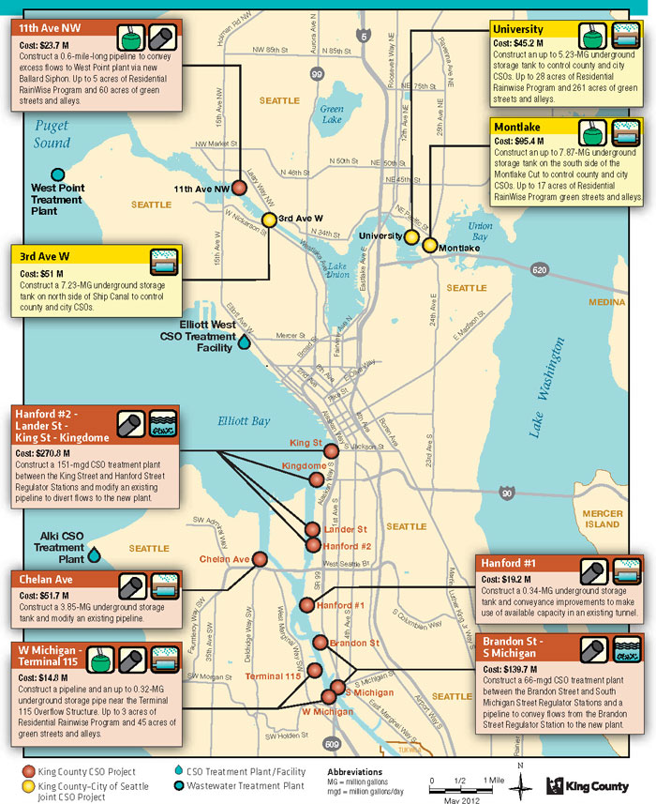

King County is one of the last jurisdictions (along with Seattle) with combined sewers to have negotiated a consent decree. EPA ‘s lawsuit related to violations of the Clean Water Act is part of a national enforcement strategy to compel completion of CSO control and water quality improvements across the country.
Given the schedule and the anticipated interests of regulators (EPA and Ecology) consideration of alternatives would have been nearly impossible, given the schedule.
The West Point NPDES permit includes the Alki and Carkeek CSO treatment plants, the CSO outfalls, and the recently constructed Mercer/Elliott West and Henderson/Norfolk CSO storage and treatment facilities. Department of Ecology’s CSO regulations (WAC 173-245) and King County’s RWSP policies require WTD to submit a CSO plan update to Ecology that coincides with each NPDES permit renewal for the West Point Treatment Plant. Updates are intended to describe WTD’s progress on its CSO program to date, identify its program for the next 5 years, and provide a vehicle for making changes in the overall long-term CSO control program.
King County’s predecessor agency was the Municipality of Metropolitan Seattle, also known as “Metro”, which was consolidated/merged with the County in 1994.
The standard of an average of one untreated discharge per year is now based on a 20-year moving or rolling average.
The consent decree has some provisions for flexibility with regard to design criteria/specifications, schedule and re-sequencing of projects and a supplemental integrated plan that might lead to refinements of CSO control projects. Some of the decision-making for these changes is proposed to be at the discretion of EPA and Ecology, beyond a certain threshold the court would need to approve the changes.

