STAFF REPORT

Agenda Item: | 6 | Name: | Amy Tsai
Proposed No.: | 2015-B0108 | Date: | June 2, 2015

SUBJECT

A continued look at Public Health services, in follow-up to the Public Health briefing presented on April 21, 2015.

SUMMARY

On April 21, 2015, the Health, Housing and Human Services Committee received a briefing on Public Health-Seattle & King County (Public Health) and its budget challenges, with a focus on its clinical services (2015-B0066).

Parent child health programs offered through public health clinics such as maternity support services (MSS), supplemental nutrition for women, infants and children (WIC), and Nurse Family Partnership (NFP), as well as family planning, were some of the programs spotlighted in the April 21 briefing. Public Health is one of the main providers of these services to needy populations in King County (for example, King County provides 94 percent of maternity support services in the county).

This staff report, as a preface to a presentation by Public Health staff, describes other programs and services provided within the Community Health Division with a particular focus on other clinical services. Recent financial projections indicate that Public Health continues to face fiscal challenges.

BACKGROUND

The Community Health Services Division (CHS) of Public Health provides a wide range of services to high risk populations, delivered through public health centers as well as through community-based facilities via contracts with community agencies. These services combine to promote public health and access to affordable, quality care. Some examples are discussed below.

Community Health Services Programs

Healthcare for the Homeless Network. The Healthcare for the Homeless Network, in collaboration with 12 community-based partner agencies, provides for health services for people who are homeless living in King County. Network providers visit over 60 sites throughout the county and provide medical, dental, mental health, substance abuse, case management, and health access services for the homeless. In addition to direct patient care, the Network provides training and consultation services for homeless agencies.

Navos Pilot. Public Health offers primary care at the Navos Mental Health and Wellness Center, which allows the public health clinic to integrate primary care with behavioral health care for severely and persistently mentally ill patients who need both medical and mental health services. With this innovative model of care, primary care providers and delivery systems are uniquely positioned to help patients with acute physical and mental health concerns and by doing so reduce health care costs.

Mobile Medical. CHS’s mobile medical program offers free medical care, dental care, and social services to homeless individuals and families in south King County. Clinics are held nearby free meal programs offered by non-profits and churches. There is a King County owned and operated medical van and a leased dental van with scheduled times and locations. Health care for the homeless raises particular challenges in improving and maintaining health, such as the impact of limited access to food and shelter and a lack of basic supporting elements like a refrigerator to store some medications.

School-Based Health Centers. School-based health centers offer a range of services including asthma care, immunizations, family planning, good nutrition education and mental health counseling. Public Health directly operates four school-based health centers and contracts for operations at 25 other schools. Over 6,000 elementary, middle and high school students are served each year across King County. Public Health coordinates health care services with community partners, including Group Health, Swedish Medical Center, Neighborcare Health, HealthPoint, International Community Health Services and Odessa Brown Children’s Clinic/Seattle Children’s.

Access and Outreach. The Access and Outreach program helps people apply for health insurance coverage under the Affordable Care Act and other programs these clients may qualify for like Transit’s Low Income Fare program. This program also coordinates a network of over 600 In-Person Assisters at partner organizations throughout the county and provides training and technical support to community partners.

Refugee Health Screening. Public Health provides interpreted basic health screening for newly arrived refugees and asylees out of the Downtown clinic. The health screening includes medical history review, acute triage, immunization assessment and update, and various health screenings for infectious disease. The program has a close working relationship with Harborview Medical Center’s international clinic and Lutheran International Counseling Services Northwest for follow up and care.

Travel Clinic. The travel clinic assists persons intending to travel outside the country with their health needs and offers information about health-related risks for those traveling abroad. Services include assessment, immunizations, and prescription medications for malaria prevention and other travel-related conditions.

Public Health Centers

King County operates ten public health centers. In addition, about 20 satellite operations situated throughout the county increase accessibility to maternity support services and WIC. Satellites serve anywhere from 40 to 2,000 clients depending on the site.

Figure 1 below shows the distribution of public health centers and satellites across the county. These clinics are part of the larger health care safety net that exists within the county, which includes hospitals and affiliated clinics, community health centers, school-based health centers, and tribal clinics.

Figure 1. Locations of Public Health Centers (P) and Satellite Programs
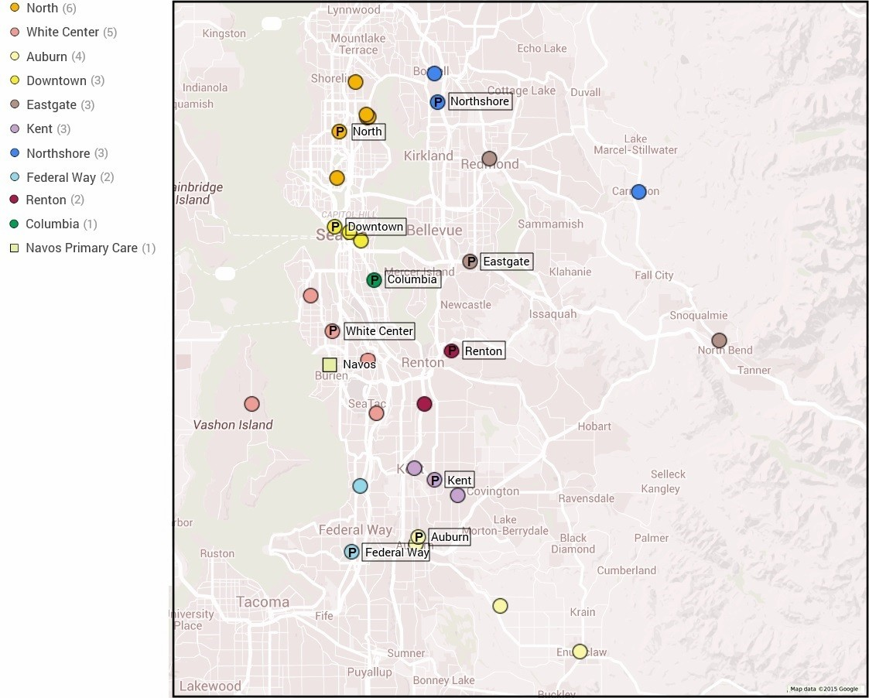

These clinics heavily serve the county’s most vulnerable populations (see Table 1 below). A large portion of the clients are also uninsured and/or have co-occurring chemical dependencies.

Table 1. 2013 Public Health Center Population Characteristics
 | 2013 PHC Clients¹ | 2014 PHC Clients | Income <200% Federal Poverty Level | People of  Color | Homeless | Interpretation provided at visit
Auburn | 10,700 | 10,184 | 97% | 59% | 11% | 9%
Columbia | 15,100 | 14,554 | 97% | 95% | 13% | 16%
Downtown | 14,200 | 13,486 | 88% | 59% | 41% | 17%
Eastgate | 15,100 | 15,391 | 95% | 70% | 8% | 20%
Federal Way | 13,700 | 12,155 | 92% | 69% | 7% | 10%
Kent | 11,400 | 11,112 | 92% | 74% | 13% | 7%
North | 15,000 | 14,023 | 89% | 68% | 10% | 9%
Northshore | 4,200 | 3,945 | 92% | 58% | 8% | 12%
Renton | 13,000 | 11,387 | 90% | 72% | 10% | 10%
White Center @ Greenbridge | 8,600 | 8,353 | 89% | 78% | 11% | 12%
Total | 121,000 | 114,590
^{[1]} Note: Some clients receive services from multiple programs, so there is some duplication of persons.

The briefing on April 21 highlighted family planning, maternity support services, WIC, and nurse family partnership as some of the signature programs offered at public health centers. Two other main services provided at some clinics include primary care and dental.

Primary Care. As of this year, primary care in public health clinics is provided at the Downtown and Eastgate locations. Services include pediatric and adolescent care and primary care for all ages. Public Health also hosts a residency practice, where residents and faculty from Swedish Family Practice Residency program and Advanced Registered Nurse Practitioners provide primary health care for adults and families at the Downtown Public Health Center. The Downtown clinic also provides obstetrical care.

Primary care is also offered through the program at Navos, school-based health centers, and the mobile medical van in south King County. (These programs were described above.)

Dental. Dental services are provided at five of the ten public health centers, including Columbia, Eastgate, North, Renton and Downtown. The Downtown clinic serves only homeless teens, ages 13-18, and homeless adults. Clients served at the other four clinics include children ages 1-18, low income pregnant women with Medicaid coverage, and low income parents of children established in the dental program.

Budget Outlook

2015-2016 Projections

As presented in the April 21 Public Health briefing, according to the 2015-2016 adopted financial plan (Attachment 1), the 2015-2016 biennium began with a projected deficit of almost $9 million and ended with a projected deficit of $2.9 million. The 2015 first quarter update now estimates a starting 2015-2016 deficit of $11.7 million and ending deficit of $7.9 million, or a $5 million greater deficit than previously projected (Attachment 2).

Three factors contributing to the increasing deficit were an increase in transfer to the Environmental Health Services division that had not been forecasted in 2014, program revenues coming in less than budgeted, and an adjustment to Medicaid Administrative Claiming that had been overstated in the budget. Decreases in revenues were offset slightly by salary savings from slower than expected hiring, leaving a greater net deficit of $5 million.

Collectively, the core public health clinic services (family planning, maternity support services, WIC, nurse family partnership, primary care, dental) are projected to operate at a net $3.7 million deficit in 2016. Revenues from federal and other sources continue to fall short of normal inflationary increases for operating costs (the “structural gap”). With current biennium issues extrapolated over time along with inflation rate adjustments, the projected deficit at the end of the 2017-2018 biennium has increased by $10.8 million to $22.6 million, but there are many issues and revenue streams to be resolved between now and then that are not yet reflected in the financial plan.

Public health and access to health care for the county’s most vulnerable populations continues to be a growing financial challenge.

ATTACHMENTS

- Adopted 2015-2016 Financial Plan
- 2015-2016 Financial Plan, 2015 Q1 Monitoring

INVITED

- Patty Hayes, Interim Director, Public Health – Seattle & King County (PHSKC)
- T.J. Cosgrove, Interim Division Director, Community Heath Services Division, PHSKC

As part of the realignment of Public Health’s services in the face of its financial difficulties last year, primary care at Columbia was transitioned to NeighborCare and University of Washington/Harborview Medical Center. Primary care at North was also transitioned to NeighborCare with the expectation that primary care providers could provide family planning as well. The collaboration with NeighborCare had been in the works previously but Public Health’s budget issues spurred an expedited timeline.

