STAFF REPORT

Agenda Item: | 8 | Name: | Beth Mountsier
Proposed No.: | 2015-B0089 | Date: | June 17, 2015

SUBJECT

This briefing will address drug trends in King County.

SUMMARY:

The briefing for the committee will review King County drug trends through 2014 based on a number of data sources including medical examiner reports, Washington State Department of Health statistics and police evidence sent to the crime labs as an indicator of what is available currently “on the street”. Review of publicly funded drug treatment admissions will provide a sense of the major drug addictions that are being treated locally. And, the briefing is also expected to detail drug overdose deaths across the county along with a discussion of current and possible improvements to overdose interventions.

Dr. Caleb Banta-Green is a senior researcher at the Alcohol and Drug Abuse Institute at the University of Washington. Since 2001 he has written semi-annual reports on drug trends in King County in collaboration with authors and representatives of county and state behavioral health and public health agencies as well as treatment programs, law enforcement, community outreach providers and others. He conducts research and provides technical assistance on drug overdose prevention and runs the website www.stopoverdose.org.

The University of Washington established the Alcohol and Drug Abuse Institute in October of 1973 as an interdisciplinary research center in the Warren G. Magnuson Health Sciences Center. From its beginning, the mission of the Institute has been to conduct and support substance abuse research at the University of Washington, and disseminate research findings in substance abuse. In 2013, the UW's Fetal Alcohol & Drug Unit (FADU) joined ADAI, adding their research and community-based services to the Institute's focal areas. Drug trend and other drug related research information are available at adai.uw.edu. Archives of drug trend reports can be found at: http://adai.uw.edu/pubs/publist.htm#trendsreports. The 2014 report is about to be released.

BACKGROUND

The National Institute on Drug Abuse (NIDA) reports that:

Estimates of the total overall costs of substance abuse in the United States, including productivity and health- and crime-related costs, exceed $600 billion annually. This includes approximately $193 billion for illicit drugs, $193 billion for tobacco, and $235 billion for alcohol. As staggering as these numbers are, they do not fully describe the breadth of destructive public health and safety implications of drug abuse and addiction, such as family disintegration, loss of employment, failure in school, domestic violence, and child abuse.

Addiction is a chronic, often relapsing brain disease that causes compulsive drug seeking and use, despite harmful consequences to the addicted individual and to those around him or her. Although the initial decision to take drugs is voluntary for most people, the brain changes that occur over time challenge an addicted person’s self-control and hamper his or her ability to resist intense impulses to take drugs.

Fortunately, treatments are available to help people counter addiction’s powerful disruptive effects. Research shows that combining addiction treatment medications with behavioral therapy is the best way to ensure success for most patients. Treatment approaches that are tailored to each patient’s drug abuse patterns and any co-occurring medical, psychiatric, and social problems can lead to sustained recovery and a life without drug abuse.

Similar to other chronic, relapsing diseases, such as diabetes, asthma, or heart disease, drug addiction can be managed successfully. And as with other chronic diseases, it is not uncommon for a person to relapse and begin abusing drugs again. Relapse, however, does not signal treatment failure—rather, it indicates that treatment should be reinstated or adjusted or that an alternative treatment is needed to help the individual regain control and recover.

No single factor can predict whether a person will become addicted to drugs. Risk for addiction is influenced by a combination of factors that include individual biology, social environment, and age or stage of development. The more risk factors an individual has, the greater the chance that taking drugs can lead to addiction.

However, drug addiction is a preventable disease. Results from NIDA-funded research have shown that prevention programs involving families, schools, communities, and the media are effective in reducing drug abuse. Although many events and cultural factors affect drug abuse trends, when youths perceive drug abuse as harmful, they reduce their drug taking. Thus, education and outreach are key in helping youth and the general public understand the risks of drug abuse. Teachers, parents, and medical and public health professionals must keep sending the message that drug addiction can be prevented if one never abuses drugs.

Unfortunately, many people with drug addictions are not able to access treatment or even with treatment, are unable to manage their disease. A chart produced by withdrawl.net (see next page) based on 2010 data from the Centers for Disease Control illustrates the number of Americans killed by various drugs with their average age at death. As the chart shows, drugs killed nearly 39,000 in the U.S. in 2010. This is more drug related fataities than those who died from traffic accidents, suicide, HIV and many types of cancer. And the people who die of drug overdoses are also relatively young with the average age at death 37.8 years old.

Similarly, deaths due to drug overdose now surpass deaths from traffic accidents in Washington State with an average of 14 deaths per 100,000 population across the state. And in King County, opioid deaths from heroin and/or pharmaceuticals such as hydrocodone (e.g., Vicodin), oxycodone (e.g., OxyContin, Percocet), and morphine surpass motor vehicle fatalities.

Increases in both heroin use and heroin-related deaths are seen in all regions of King County; the increase is also documented in local drug treatment admission and police evidence data tested by the state crime lab. Much of the increase is driven by greater useage among 18-29 year olds.

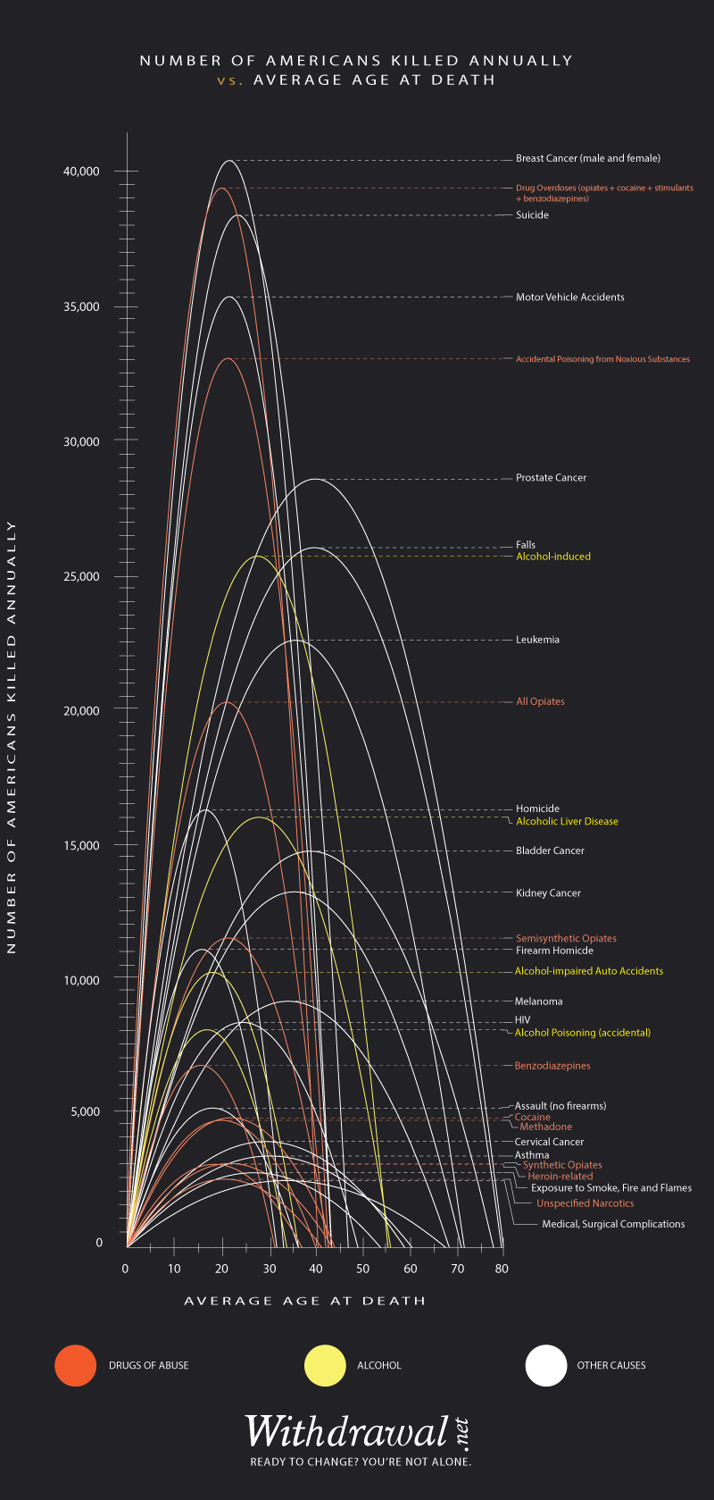

An animated version of this chart can be found at:
http://www.withdrawal.net/realize/drug-deaths-compared/#age
King County’s Community Health Indicators and data sets include the following information regarding all drug-induced deaths.

ATTACHMENTS:

- “Heroin Doesn’t Have to be a Killer”, Nicholas Kristof, New York Times, June 6, 2015
http://www.nytimes.com/2015/06/07/opinion/sunday/nicholas-kristof-heroin-doesnt-have-to-be-a-killer.html?_r=0

INVITED:

- Caleb Banta-Green, PhD, MPH, MSW, Senior Research Scientist, Alcohol and Drug Abuse Institute, University of Washington

