STAFF REPORT

Agenda Item: | 11 | Name: | Jake Tracy
Proposed No.: | 2022-0231 | Date: | September 15, 2022

SUBJECT

Proposed Ordinance 2022-0231 would update the inventory of high conservation value properties authorized by and in accordance with King County Charter Section 897.

SUMMARY

In July 2009, in response to a recommendation from the 2007-2008 Charter Review Commission, the Council approved Ordinance 16600, which placed a Charter amendment called the Open Space Protection Amendment on the November 2009 general election ballot. The purpose of the Open Space Protection Amendment was to provide enhanced protection for about 150,000 acres of “high conservation value” properties either owned by the County or on which the County held a conservation easement. Specifically, the amendment made it more difficult for the County to sell, develop, or otherwise change the use of properties identified as having high conservation value. Ordinance 16600 was adopted unanimously by the Council. The Open Space Protection Amendment was approved by the voters in November 2009.

Simultaneously with its adoption of Ordinance 16600, the Council adopted Ordinance 16601, which identified a list of 150,000 acres of high conservation value properties that would form the initial High Conservation Value Inventory following passage of the Open Space Protection Amendment.

In 2015, the Council passed Ordinance 18177, which added roughly 4,000 additional acres on 225 County-owned properties in natural areas in Districts 3, 7, 8 and 9.

The PO would add 243 parcels to the high conservation value property inventory in 60 discrete areas ("sites") around the County, constituting 2,116 acres in fee and 434 acres in easement. 20 of these sites are new to the inventory, whereas 40 are existing sites that are proposed for expansion by addition of new parcels.

There is an amendment, Amendment 1, which would make technical corrections to the ordinance.

BACKGROUND

2009 Open Space Protection Amendment. In July 2009, in response to a recommendation from the 2007-2008 Charter Review Commission, the Council approved Ordinance 16600, which placed a Charter amendment called the Open Space Protection Amendment on the November 2009 general election ballot.

The purpose of the Open Space Protection Amendment was to provide enhanced protection for about 150,000 acres of “high conservation value” properties either owned by the County or on which the County held a conservation easement. Specifically, the amendment made it more difficult for the County to sell, develop, or otherwise change the use of properties identified as having high conservation value.

As the ordinance was originally drafted, the list of high conservation value properties would have been included in the Charter amendment itself, and would have required an additional voter-approved Charter amendment to add or remove properties from this list. However, the Council amended the ordinance to change the method for creating and modifying the High Conservation Value Property Inventory:

- The initial inventory of properties to be protected was to be identified through a separate Council ordinance (adopted with at least seven votes) rather than through charter amendment; and
- Addition or removal or properties was to occur through a Council ordinance (adopted with at least seven votes) rather than through a new charter amendment. Such an ordinance would be required to include specific findings of fact about the reasons for the addition or removal. In addition, any legislation proposing a change to the list would require a time period of at least 28 days between introduction and a public hearing at Council, along with public meetings in the affected district(s).

Ordinance 16600 was adopted unanimously by the Council. The Open Space Protection Amendment was approved by the voters in November 2009.

Simultaneously with its adoption of Ordinance 16600, the Council adopted Ordinance 16601, which identified a list of 150,000 acres of high conservation value properties that would form the initial High Conservation Value Inventory following passage of the Open Space Protection Amendment.

2015 Additions to the High Conservation Value Property Inventory. Consistent with the process outlined above, in 2015, the Executive identified roughly 4,000 additional acres on 230 County-owned properties in natural areas in Districts 3, 7, 8 and 9 that were proposed to add to the inventory. During the legislative process, five of these properties in District 9 were removed due to flooding concerns. The remaining 225 properties were added to the inventory with passage of Ordinance 18177.

ANALYSIS

The PO would update the inventory of high conservation value properties authorized by and in accordance with King County Charter Section 897, for the second time since its original establishment in 2009. Attachment A to the PO is the updated High Conservation Value Property Inventory. The updated inventory would contain a total of 125 sites with 18,679 acres owned in fee and 143,011 protected via easement.

Proposed Additions. The PO would add 242 parcels to the high conservation value property inventory in 60 sites around the County, constituting 2,116 acres in fee and 434 acres in easement. 20 of these sites are new to the inventory, whereas 40 are existing sites that are proposed for expansion by addition of new parcels.

Supplemental Document 1 of the Executive's transmittal, which is Attachment 3 to this staff report, contains a redline version of the High Conservation Value Property Inventory. Pages 1 through 28 of that document list the parcel numbers and acreages proposed for addition to each site, and pages 29 through 70 show the parcels proposed for addition to the inventory in relation to existing parcels in the inventory.

Figure 1 below shows the location of the proposed additions in red. The large numbers in the boxes indicate which detail map that area can be found in within Supplemental Document 1.

Figure 1.
Map of Proposed High Conservation Value Property Additions
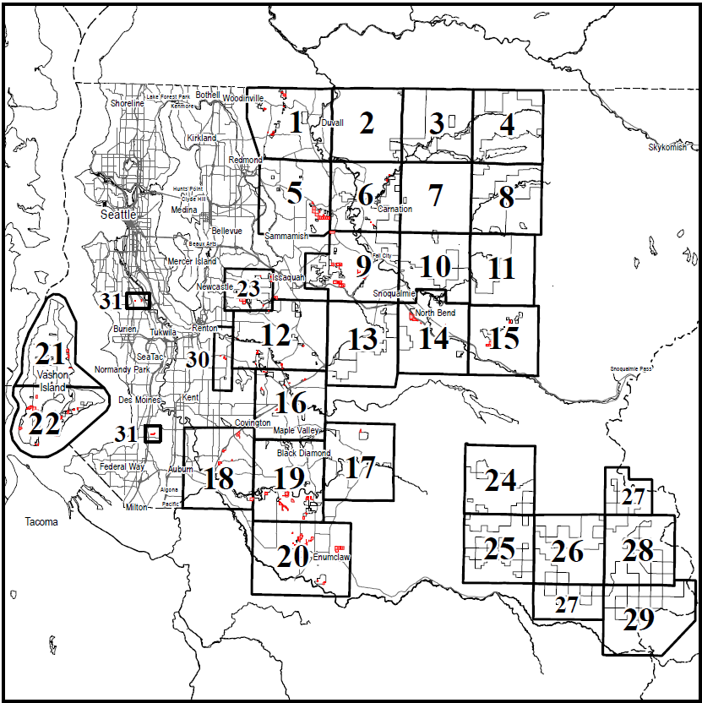

Table 1 below summarizes the proposed additions by Council District.

Table 1.
Proposed High Conservation Value Property Additions by Council District

Council District | Fee (acres) | Easement (acres) | Total (acres) | # of Parcels
1 | - | - | - | -
2 | - | - | - | -
3 | 856.50 | 293.91 | 1,150.41 | 75
4 | - | - | - | -
5 | - | - | - | -
6 | - | - | - | -
7 | 17.18 | 0.51 | 17.69 | 5
8 | 295.59 | 65.95 | 361.53 | 53
9 | 946.53 | 73.67 | 1,020.20 | 109
Total | 2,115.80 | 434.04 | 2,549.84 | 242

Technical Corrections. Supplemental Document 2 (Attachment 4 to this staff report) documents the technical corrections proposed to the High Conservation Value Property Inventory. Most of the changes are described as "map corrections," falling into one of the following five categories:

- Parcel Redraws – Parcel boundaries were redrawn during GIS shapefile updates by Assessor’s Office, affecting spatial depiction of a parcel in GIS but not changing legal description. The redrawn parcels better depict river shoreline, road edge, or correct a past error in parcel depiction. Only changes that resulted in >0.01 acre have been documented.
- Parcel Number Changes – Parcel number was changed by the Assessor’s Office.
- Ownership Interest Changes – Easement was listed on an earlier High Conservation Value Property Inventory; King County subsequently acquired fee title to the property.
- Site Name Changes – Site name was changed by King County Parks.
- Inventory List Errors – Inventory map contained parcels that were accidentally omitted from previous inventory update.
Additionally, there are two proposed "inventory error corrections," where a property not owned by the County was previously inadvertently added to the inventory. Both cases involve road right-of-way.

Consistency with Code and Charter Requirements. The proposed additions to the High Conservation Value Inventory appear to be consistent with King County Code and the King County Charter. The parcels that are proposed to be added are all owned by King County (either in fee or with an easement) and all are associated with natural areas that have been identified for conservation purposes.

To take effect, the proposed ordinance must meet the public notice requirements outlined in Code and Charter (see below) and must receive seven affirmative votes from the Council.

Public Notice Requirement. The King County Code requires that prior to adding parcels to or removing them from the inventory, the Council or Executive must hold a public meeting in the affected Council district(s) in which the parcels are located. As shown in Table 1 above, added properties are located in Council districts 3, 7, 8 and 9.

Supplemental Document 3 (Attachment 5 to this staff report) summarizes DNRP's outreach efforts. DNRP held a comment period from Sept. 1 through Oct. 15, and during that period held public information sessions in the affected areas, in Unincorporated Area Council (UAC) meetings and other community meetings. DNRP also shared written information with UACs that were not meeting during that time period. All meetings were held virtually due to the COVID-19 pandemic, with the exception of the Enumclaw Plateau Community Association meeting, which took place in person.

The King County Charter requires that at least 28 days after the introduction of an ordinance modifying the inventory, the Council must hold a public hearing after due notice. More than 28 days have passed since the proposed ordinance was introduced, and, if passed out of committee, notice would be given for the item to be on the agenda for the September 27th County Council meeting, which would fulfill this requirement.

INVITED

- Warren Jimenez, Parks Division Director, Department of Natural Resources and Parks
- Sarah Brandt, Environmental Policy and Initiatives Strategic Planning Manager, Department of Natural Resources and Parks

ATTACHMENTS

- Proposed Ordinance 2022-0231 (and its attachment)
- Amendment 1
- Supplemental Document 1
- Supplemental Document 2
- Supplemental Document 3
- Transmittal Letter
- Fiscal Note

The Open Space Protection Amendment is also called the Open Space Amendment or OSA in some documents.
The Open Space Protection Amendment is also called the Open Space Amendment or OSA in some documents.
Amendment 1 to Ordinance 18177.
KCC 26.14.010.B.
Charter Section 897

