Attachment A. — 2004-0546
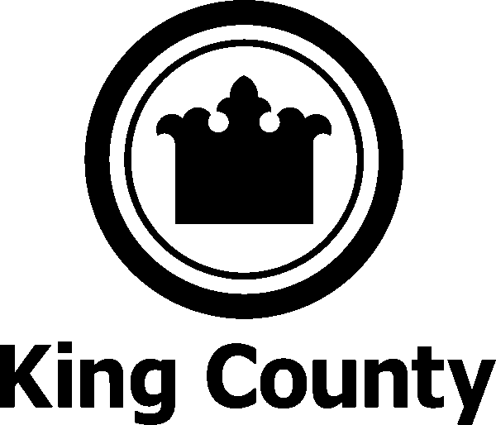 | KING COUNTY, WASHINGTON  2005 (FY 2006) FEDERAL AGENDA

 | PROJECT | DESCRIPTION OF REQUEST
1a | Transportation | Secure the following in the Transportation Appropriations bill:  - $3 million for County-wide Signal Synchronization Program;  - $5 million for Bus Radio Replacement Program;  - $2 million for Tolt River Bridge Replacement (Tolt/West Snoqualmie)  - $3.2 million for Vashon Island Passenger Only Ferry;  - $2 million for Transit Oriented Development ; and,  Secure the following in the reauthorization of the Transportation Equity Act:  - $60 million in New Starts Program for an arterial and corridor Bus Rapid Transit System.
1b | Transportation | Secure $10.73 million for Airport Runway Rehabilitation
2 | Workforce Training | Workforce Investment Act (WIA) Self-Sufficiency Initiative: Secure $1 million in the Labor-Health and Human Services-Education Appropriations bill to integrate workforce training services into other social services currently offered to ex-offenders transitioning back into the community. The requested funding will concentrate on providing jobs skills, training and job placement.
3a | Salmon Recovery | Secure the following in the Energy and Water Appropriations bill (Corps of Engineers):  - $4.5 million for the Green/Duwamish Ecosystem Restoration Program  - Funding for Salmon Habitat Restoration Studies, specifically:  - $995,000 for the Lake Washington/Ship Canal Ecosystem Study;  - $1.9 million for the Puget Sound Nearshore Marine Habitat Study; and $580,000 for the Puget Sound and Adjacent Waters Initiative.

3b | Salmon Recovery | Maintain Funding for the Pacific Coastal Salmon Recovery Program. Continued federal funding is crucial to WRIA plan projects. Continued support for the Salmon Recovery Funding Board at $34million level through the Commerce, State, Justice Appropriations Bill.
3c | Salmon Recovery | Snoqualmie Watershed Integrated Plan for Agricultural Lands and Fish Habitat. $500,000 to design, implement and maintain a series of on-the-ground restoration projects on private agricultural lands for salmon habitat restoration in the Snoqualmie watershed. Request line item in Interior Appropriations Bill particularly the U.S. Fish and Wildlife Service (3 separate accounts), Endangered species candidate conservation program, Habitat conservation program or Fisheries account
4 | Molten Fuel Cell Demonstration Project | Secure $2.5 million in the VA, HUD and Independent Agencies Appropriations bill (EPA-EPM). This project has received $8.3 million in federal funding from FY 1998 to FY 2002. A total of $5 million in federal funding is needed to complete this project.
5a | Growth Management/ Smart Growth | Maury Island Conservation Initiative: Secure $2 million in the Commerce, Justice, State Appropriations bill. The Initiative brings together a unique array of partners in an effort to preserve the significant ecological values of the Marine Island Aquatic Conservancy and associated uplands. The partners include the State of Washington, King County, the Cascade Land Conservancy and the Vashon/Maury Island Land Trust. The Conservancy protects critical nearshore salmon habitat, which has been identified as a top priority for preservation by the WRIA 9 watershed planning process.
5b | Growth Management/ Smart Growth | - Cedar Green Partnership (formerly known as Rock Creek Vision) -- Secure $5 million to leverage private and local funds to ensure long term forestry in the rapidly growing Eastern King and Pierce County Forest zones.  - Forest Legacy: Support funding for the forest legacy projects proposed by the State of Washington for the acquisition of development rights on forest parcels. The State proposal includes projects in King County worth $3 million.

6 | Emergency Management | Support federal legislation that provides revenue tools to local governments to fund the new infrastructure needed to provide effective e-911 services resulting from internet service providers offering Voice Over Internet Protocol (VOIP).
7 | Homeland Security/ Bioterrorism | - Support legislation to streamline funding to local first responders and provide them with greater control over how grant resources would be expended at the local level.  - Support increased funding for local governments to conduct security assessments for water treatment plants, drinking water distribution facilities, and transportation infrastructure, along with funding to support the implementation of security projects for such facilities.  - Support grant funds for regional law enforcement terrorism prevention.  - Support HS grant funding for a helicopter to fulfill regional anti-terrorism and response needs and for Urban Search & Rescue (USAR) air support responsibilities and to replace the MAST Unit (regional SAR/Medical extractions) that is being permanently redeployed from Ft. Lewis in `05.  - Support grant funds to develop and implement pre-incident emergency management planning to provide preparation for domestic terrorism and other issues where interagency coordination, cooperation and execution are critical to public safety.  - Support increased funding for city and county organizations to target major population centers providing regional services in response to weapons of mass destruction.  - Support funding to enhance the basic infrastructure of the public health system and its ability to prepare for and respond to acts of terrorism, especially bioterrorism.
8 | School Safety | Secure $350,000 to support School Resource Officer(s) in unincorporated King County.
9 | Medicaid | Support legislation to increase the Federal Medical Assistance Percentage (FMAP). King County mental health, drug and alcohol, and developmental disabilities services rely on Medicaid funding.

10 | Repeal Institutions for Mental Disease (IMD) Exclusion | Facilities of greater than 16 beds that are primarily devoted to the care of psychiatric patients are deemed to be Institutions for Mental Diseases (IMD). Persons in such a facility do not qualify for Medicaid and no Title XIX funding can be used for their care. The IMD Exclusion impacts over 400 individuals who reside in King County residential facilities.
11a | Health Care Reform | Encourage the Centers for Medicare & Medicaid Services (CMS) to speed up and significantly expand its current efforts to:  - make publicly available quantifiable measures of hospital and physician quality, clinical information system adoption, and clinical management capabilities; and  - prepare to implement promptly recommendations for CMS provider incentives, expected in 2005 from the Institute of Medicine.
11b | Heath Care Reform | Encourage CMS and the Agency of Health Research and Quality (AHRQ) to continue to:  - publicly support cost-effective evidence-based medicine and medical practices;  - advocate the importance of improving quality of health care delivered; and  - fund innovative pilot programs, demonstration projects and evaluations that focus on quality of care issues.
12 | Housing, Homeless and Community Development Funds | HUD Independent Agencies Appropriation –  - Increase appropriation for CDBG formula funds to $5 billion nation wide and ensure that King County’s formula share is maintained or increased.  - Adequately fund the Section 8 voucher program.  - Maintain or increase funding for Homeless Assistance (McKinney) and ensure the renewal of Shelter Plus Care funding.  - Maintain or increase funding for HOME program.
13 | Magnuson Act Amendment | Support proposed legislative language in the current reauthorization bill that would allow NOAA the discretionary authority to access and employ local law enforcement resources to fulfill certain duties mandated by the Magnuson Act.

