

Metropolitan King County Council

Regional Water Quality Committee

Staff Report

Agenda Item No.: | 7 |  | Name: | Beth Mountsier
Briefing No.: | 2011-B0038 |  | Date: | March 2, 2011
Attending: | Norm Alberg, Acting Project Planning and Delivery Manager, Wastewater Treatment Division
SUBJECT: A briefing and overview of Wastewater Treatment Division capital improvement projects.

SUMMARY:
When the Regional Water Quality Committee adopted its work plan for 2011 – it again identified or requested briefings on capital improvement projects within and outside the scope of the Regional Wastewater Services Plan (RWSP). Wastewater Treatment Division staff will provide an overview and highlight some of the types of projects currently underway or being planned in 2011.

BACKGROUND:
The RWSP outlines a number of important projects, programs, and policies for King County to implement through 2030. It calls for building a new treatment plant (Brightwater) to accommodate growth in the northern portion of the wastewater service area and also provide additional capacity throughout the system. The plan also calls for improvements to the regional conveyance system to meet the 20-year peak flow storm design standard and accommodate increased flows in general; improvements to reduce infiltration and inflow into local collection systems; and improvements to control Combined Sewer Overflows (CSOs) so that an average of no more than one untreated discharge occurs per year at each CSO site by 2030.

In addition to this ambitious capital plan – the Wastewater Treatment Division is responsible for maintaining the reliability and usefulness of its current assets which are valued at more than $4 billion. The condition of and performance of these assets are critical to protecting the health and safety of the public and environment. King County’s facilities and equipment must dependably collect and treat wastewater from 34 local sewer agencies, and function so that King County can meet the terms of its National Pollutant Discharge Elimination System (NPDES) permits. To fulfill these responsibilities, protect the investment in its existing wastewater system and ensure the system has the flexibility to meet future demands, the County must maintain and periodically update its wastewater assets.

It executes these responsibilities through a Capital Improvement Program that plans, manages and constructs a wide variety of capital projects. As noted, some of these improve processes and facilities – others are designed to just maintain the reliability and quality of the assets.

In 2003, King County’s Wastewater Treatment Division initiated a new process to prioritize its capital projects funding. The new process evaluates each capital project against specific criteria that reflect WTD’s mission and goals. Each project receives a score based on this evaluation, resulting in a ranking. The ranking, combined with the project costs estimates and other information helps WTD managers identify which projects to propose funding in upcoming years and budgets. Projects are prioritized within three project categories: Major Capital (projects that provide new capacity to the wastewater system – mostly RWSP projects); Asset Management (projects that rehabilitate or improve existing facilities, upgrade technologies, and improve processes or systems); and Planning (projects that are more diverse than a specific capital project – may involve planning, studies and collaboration with other agencies). The result of the ranking process is three lists of ranked projects, one for each category of projects. Each category has its own budget allocation, so only like projects compete against each other for available funding. WTD proposes projects to the Executive as part of the annual budget process. Projects are then recommended to the Council in the Executive’s proposed budget.
King County’s Wastewater Treatment Division (WTD) manages capital projects based on the international standards of the Project Management Institute (PMI) as described in part in the publication titled A Guide to the Project Management Body of Knowledge (PMBOK), Third Edition. These standards provide guidance through the five phases of a project: project development, pre-design, final design, implementation and closeout. King County moved to this standard in 2007 to improve project delivery within schedule and budget.
Project Life Cycle for a King County WTD capital project
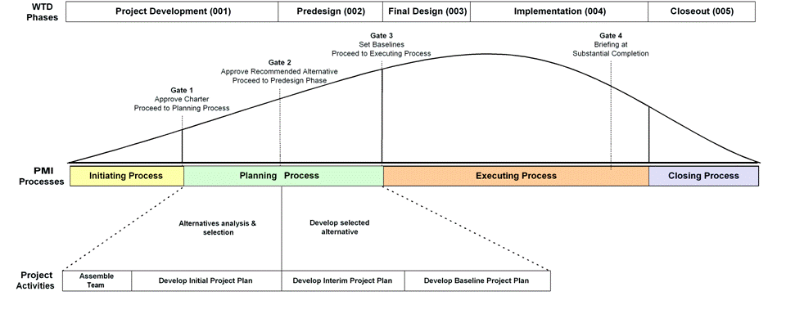
ATTACHMENTS: None

