2025 Bus Fare Enforcement and Fare Violation Program

April 1, 2026

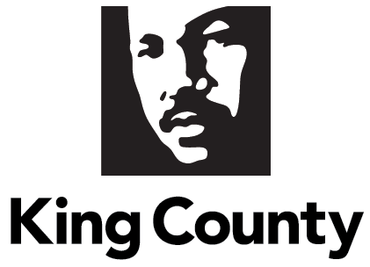
- Contents
II. King County Code 3
III. Executive Summary 4
IV. Background 5
A. Fare Enforcement Officers’ Role and Responsibilities 7
B. Safety, Security, and Fare Enforcement (SaFE) Reform Initiative and Fare Inspection 8
C. Fare enforcement operations 10
V. Report Requirements 11
A. Number of warnings issued for fare evasion 11
B. Number of citations issued for fare evasion 11
C. Number of citations resolved 12
D. Number of suspensions 12
E. Number of criminal trespass charges issued 12
F. Demographic data 12
G. Activities and effectiveness of program outreach 15
VI. Conclusion/Next Steps 15

List of Tables
Table 1: Routes and areas served by fare enforcement 10

List of Figures
Figure 1: Warnings issued by bus route 11
Figure 2: Citations issued by bus route 12
Figure 3: Race of riders issued citations 13
Figure 4: Age of Riders Issued Citations 14
Figure 5: Gender of Riders Issued Citations 14

- King County Code

The applicable portion of King County Code pertaining to this report requirement is as follows:

2.16.142 Report – Metro bus fare enforcement and new fare enforcement system.

The executive shall develop a reporting system for all Metro bus fare enforcement activities and the new fare enforcement system. The executive shall use the data from the reporting system to develop a report by April 1, 2019, and annually thereafter, that contains the following information:

A. For each RapidRide bus route, all other regular bus routes, and for total bus service the executive shall provide data on the following:

- The number of warnings issued for fare evasion and the number of people that have received warnings by bus route.
- The number of fare evasion citations issued and the number of those people that have received these citations by bus route, this should include identifying the number of individuals that receive multiple citations during the reporting period and how many citations they received;
- The number of citations resolved, showing the method used to resolve the citations;
- The number of people suspended as a result of fare evasion;
- The number of criminal trespass charges issued to individuals as a result of fare evasion violations;
- The report should also include data showing the demographics of persons issued citations, including but not limited to race, age, gender, income and housing status as available; and,
- The report should also include performance measures showing the activities and effectiveness of the program outreach manager.

B. The executive must file the report required by this section by April 1 of each year, starting in 2019, in the form of a paper original and an electronic copy with the clerk of the council, who shall retain the original and provide an electronic copy to all councilmembers, the council chief of staff, the policy staff director and the lead staff for the mobility committee, or its successor. (Ord. 18789 § 2, 2018).

- Executive Summary

This report provides background on the history and relaunch of bus fare enforcement in King County. Since 2010, fare enforcement has been in place to encourage and remind riders about the requirement to pay a fare to ride Metro services, especially with the onset of bus rapid transit service, also known as RapidRide, through the Third Avenue corridor. RapidRide lines, while efficient and customer-oriented, did not require customers to pay upon entry as all doors opened to allow passengers to enter and exit with fewer barriers and off-board fare payment was available at RapidRide stops and stations. Fare Enforcement Officers were hired through contracted security to bring awareness to riders and hold them accountable with citations for fare nonpayment.

In April 2018, Metro received an internal audit around fare enforcement’s efficiency and equitable practices on the six RapidRide lines. The audit highlighted the need to address systemic inequities around some of King County’s most vulnerable populations, including the unhoused. Metro convened a Fare Enforcement Workgroup comprised of community-based advocates and stakeholders to help develop more equitable ways of addressing fare nonpayment that would not perpetuate harm to historically, negatively impacted individuals. With collaboration from King County Council, Metro was able to remove citations for fare nonpayment from the court system and bring all citations into Metro’s administrative system.

The role of Fare Enforcement Officers has always been to check fares and educate the public about fares, while providing a safety presence and excellent customer service to all. As such, Fare Enforcement Officers undergo extensive training to serve King County customers, including but not limited to de-escalation, bias awareness, and customer service. To become a Fare Enforcement Officer, Transit Security Officers must complete and pass an additional 80 hours of training. Fare Enforcement Officers must balance their many roles while assessing what any given situation requires.

In March 2020, Metro suspended fare collection and fare enforcement functions due to the COVID-19 global pandemic. While fare collection resumed in October 2020, fare enforcement remained paused. Concurrently, Metro was launching the Safety, Security, and Fare Enforcement (SaFE) Reform Initiative, an enterprise-wide initiative that set out to reexamine and reimagine safety and security functions at Metro. Fare enforcement became part of the SaFE Reform effort that centers community voices to help guide Metro and Metro’s safety and security programs.

In 2022, Metro convened the SaFE Equity Workgroup, a workgroup comprised of nine community members, two coach operators, and one former fare enforcement officer supervisor. In June 2024, Metro received recommendations from this workgroup about how to bring back fare enforcement with community-centered actions. In January 2025, Fare Enforcement Officers were hired through a new security contract with PalAmerican, switching from the previous vendor, Securitas, after ten years. Fare Enforcement Officers were trained and began to inspect passengers for proof of fares in March 2025, on ten high ridership routes as well as Seattle Streetcar. During this period, Fare Enforcement Officers were educating passengers about how to pay fare, where to pay, and what was considered valid proof of payment. Starting in May 2025, Fare Enforcement Officers began to enforce their inspections with warnings and citations should passengers be unable to show valid proof of payment.

As required in King County Code, KCC 2.16.142, this report summarizes data for fare enforcement and fare violations for each RapidRide bus route, all other regular bus routes, and for total bus service by King County Metro. Fare enforcement and fare citations fully resumed in May 2025. Between May and December of 2025, a total of 2,186 warnings, eight citations, and zero suspensions were issued on buses. No citations were resolved and no criminal trespasses were issued. The overall demographics of riders who were unable to pay were non-specific to any trends.

Looking ahead, fare enforcement operations will continue to adjust deployment to high ridership routes with high rates of fare evasion to educate and encourage fare payment.

- Background

King County Metro is the Puget Sound region’s largest public transportation agency. Metro provides bus, paratransit, vanpool, and water taxi services, and operates Seattle Streetcar, Sound Transit Link light rail, and Sound Transit Express bus service. Metro is committed to providing safe, clean, and reliable transportation for all, as mobility is a human right. Metro works with regional partners to create and promote access to support livable communities, a thriving economy, and a sustainable environment.

In 2010, King County Metro began its Fare Enforcement Program when it established its first branded RapidRide bus route called the A Line. Metro’s rapid bus service initially utilized off-board fare payment to allow riders to board using any door on the bus, optimizing speed and reliability of service by reducing passenger boarding times at the curb. While off-board fare payment decreased the time buses spent loading and unloading passengers, it also increased the likelihood of riders boarding without paying fare. Metro began using fare enforcement to minimize fare nonpayment and increase fare payment awareness on RapidRide lines and on routes servicing the transit corridor through downtown Seattle along Third Avenue.

When fare enforcement began in the region, the utilization of law enforcement or uniformed security personnel to perform fare enforcement functions had become standard practice across the transit industry, consistent with authority outlined in the Revised Code of Washington (RCW). Transit Police personnel performed fare enforcement duties until 2012, at which time Metro transitioned to a private security contractor model to staff Fare Enforcement Officers. Pursuant to the same RCW authority permitting uniformed security personnel to conduct fare enforcement activities, Metro is authorized to refer fare evasion violations to the criminal legal system as civil infractions with a penalty of $124. Under this model, three or more civil infractions could amount to a misdemeanor charge to individuals, meaning that they would be subject to paying a large fine or serve jail time for up to 90 days.

In April 2018, the King County Auditor’s Office evaluated fare enforcement practices on RapidRide Lines A, B, C, D, E, and F. The audit found Metro had opportunities to improve and develop a more robust performance management framework for fare enforcement that could improve equitable outcomes for individuals experiencing homelessness, who were also disproportionately people of color. One of the findings found that one in four citations were issued to someone experiencing homelessness. The audit also found a lack of consistency or standardization in issuing warnings, citations, and misdemeanors, resulting in inequitable enforcement of fare penalties from one person to another. Based on these findings, Metro committed to realigning its fare enforcement practices to address systemic inequities with help from internal and external partners.

After receiving the audit findings in April 2018, Metro convened a Fare Enforcement Workgroup comprised of community-based advocates and stakeholders, including Transportation Choices Coalition, Transit Riders Union, Puget Sound Sage, Seattle/ King County Coalition on Homelessness, and OneAmerica, to develop a work plan to amend the existing rider suspension and violation resolution processes. The workgroup developed recommendations aimed to increase access to public transportation for underserved communities and to address disparate fare evasion impacts on low-income riders and riders experiencing homelessness.

From this work, Metro staff developed alternative resolution options to administer in lieu of penalty fees for fare evasion citations. To support and empower this work, King County Executive Constantine proposed an amendment to the King County Code that would allow Metro to utilize the alternative resolution system in replacement of the criminal legal system for administering fare evasion citations. In October 2018, the King County Council passed Ordinance 18789, authorizing Metro to administer these violations within Metro’s administration rather than through the criminal legal system, through a variety of resolution options. This action led to the launch of the Fare Violation Program in January 2019.

In March 2020, Metro suspended fare enforcement operations due to the COVID-19 global pandemic, where they remained suspended until May 2025. No fare warnings, violations, or suspensions were issued by Metro from February 2020 to May 2025. During this time, Metro repurposed fare enforcement teams to transit security functions to help maintain safety on routes that were experiencing the highest number of reports for assistance from operators. No additional training was required to do this as all Fare Enforcement Officers are given the same training as Transit Security Officers, in addition to Fare Enforcement Officer training.

Metro worked alongside several community-based organizations (CBOs) to communicate the resumption of fare enforcement in culturally and linguistically diverse ways. Metro began a phased reintroduction of fare enforcement in January 2025 with a public education campaign to inform riders about upcoming changes. In March 2025, Metro resumed partial fare enforcement operations, with Fare Enforcement Officers inspecting riders for valid proof of payment on ten routes and the Seattle Streetcar. From March through May, riders received fare education during inspections, providing a two-month acclimation period to become familiar with Fare Enforcement Officers and payment expectations. In May 2025, fare enforcement operations fully resumed with the issuance of warnings and citations. The phased approach was designed to reflect community recommendations and prioritize rider education during the reinstatement process.

Fare Enforcement Officers’ Role and Responsibilities
Fare Enforcement Officers are contracted King County employees. They are managed through a vendor identified through a competitive Request for Proposal (RFP) procurement process. From 2012 to 2024, Metro contracted with Securitas USA, Inc. to provide staffing for Transit Security Officers and Fare Enforcement Officers. A 2024 RFP resulted in a new contract with PalAmerican for staffing TSOs and FEOs effective in 2025.

Fare Enforcement Officers are responsible for fare enforcement through a standardized process designed to minimize bias. Their training, developed in collaboration with King County, includes cultural awareness, bias awareness, and fare enforcement protocols aligned with King County's True North principles and values. Officers are equipped to educate riders on proper fare payment, access to reduced fare programs, and safe navigation of the transit system. While officers primarily inspect fare payments, they also provide customer service and actively engage with Metro’s diverse community. As unarmed, uniformed personnel, they play a vital role in maintaining safety and fostering positive interactions on coaches, at terminals, and at bus stops.

While many riders are aware of bus fares and the role of Fare Enforcement Officers, some customers may react negatively when approached about fare payment. Fare Enforcement Officers are trained to manage conflict, such as verbal de-escalation techniques instead of requesting assistance from law enforcement, allowing law enforcement to focus on more serious incidents across the transit system. Fare Enforcement Officers are also certified in cardiopulmonary resuscitation (CPR), the use of automated external defibrillators (AEDs), and First Aid, which includes identifying opioid overdoses and administering Naloxone, commonly known as Narcan. This comprehensive training underscores their role as safety personnel for both riders and Metro employees, enhancing accountability and support for the transit system.

In 2019, Metro incorporated equity and social justice principles into the fare enforcement team’s operations and added three new trainings to support these principles. The trainings focused on three key areas: youth, individuals experiencing mental health crises, and recognizing human trafficking. Specifically, officers were required to complete the following:
- Strategies4Youth: Training aimed at enhancing law enforcement interactions with youth.
- Mental Health 101: Instruction on identifying and appropriately engaging individuals in mental health crises.
- Quarterly Equity and Social Justice Training: Sessions led by various experts and facilitated by King County Metro’s Equal Employment Opportunity (EEO) office.

These training courses were made mandatory for all officers as part of their onboarding process when joining Metro’s contract. In addition, officers must annually refresh and update their certification courses on de-escalation techniques, building on their initial de-escalation training.

With the new PalAmerican contract, the additional trainings listed above have been halted, as they’ve not yet been integrated into mandatory coursework due to operational constraints and need for reassessment. For example, Fare Enforcement Officers currently have limited interactions with youth riders since free transit for all youth 18 and younger was instituted on Metro in 2022, following the adoption of legislation by the passing of Washington State Legislature through the Transit Support Grant Program via the Climate Commitment Act and ultimately, King County Council.

Free youth transit is one of many new processes while fare enforcement operations were paused. By making youth transit free, Fare Enforcement Officers no longer needed to inspect youth for proof of payment which impacted training and resumption in 2025. This shift marked a transition from maintaining historical fare enforcement practices toward intentionally reassessing how fare enforcement functions within Metro’s broader safety, customer experience, and equity goals. As part of the SaFE Reform initiative, Metro has evaluated practices and training models that were in place prior to the enforcement pause and has worked to identify approaches that better reflect current operating conditions and community expectations.

Safety, Security, and Fare Enforcement (SaFE) Reform Initiative and Fare Inspection
As part of the ongoing SaFE Reform initiative, fare enforcement practices are re-examined by internal and external stakeholders. The SaFE Reform team, comprised of two project managers and a community engagement specialist, collaborates with and is guided by the SaFE Equity Workgroup. The Equity Workgroup members represent Villa Communitaria, White Center Community Development Association, Young Women Empowered, and Metro’s SaFE Reform Committee, the initial group of community members who helped define the SaFE Reform body of work.

In June 2024, the SaFE Equity Workgroup provided Metro with recommendations for fare enforcement policy and procedure, as well as the design and communications for the return of fare inspection and enforcement. While crafting these recommendations, the SaFE Equity Workgroup reviewed information on the previously instated Fare Violation Program and its past resolution processes. The overarching recommendation stated that the new iteration of fare inspection should closely align with the pre-pandemic policy while prioritizing fare education to foster positive interactions between riders and fare enforcement officers. Fare education would emphasize the various reduced fares products available through Metro, as well as information about where to get these products, how to resolve a fare nonpayment when issued a citation, and other pertinent information.

Finally, the SaFE Equity Workgroup recommended updates to the previously instated Fare Violation Program as per the following:

- Fine amounts should be reduced from the overarching $50 to $40 within 90 days, as well as reducing from $25 to $20 within 30 days of citation receipt.
- For second encounters within a 12-month span, flagged riders should be walked through the designated fine amount, with a focus on potential fine reductions and fine alternatives such as the following:
  - Pay the administrative fine of $40, reduced to $20 if paid within 30 days. (See prior point noting fine adjustment)
  - Load $20 to an existing One Regional Card for All (ORCA) card or $10 to an existing reduced fare program card.
  - Enroll in one of Metro’s reduced fare programs, such as ORCA LIFT or Reduced Regional Fare Product (RRFP) or register for and obtain a free Youth ORCA card. Load a minimum of $5 onto the new card with the exception of the Youth card.
  - Perform two (2) hours of community service.
  - Appeal the circumstances of the nonpayment to the Fare Adjudicator or request customized resolution.

For the design and communication recommendations, the SaFE Equity Workgroup recommended that Metro prioritize education to inform riders and encourage fare payment. These recommendations emphasize leading with community values, such as by framing fare payment within the broader concept of community, service frequency, and expanding bus access. The recommendations also highlighted the importance of accessible signage on bus doors, using images when possible so riders could rely less on language-driven information. Community engagement was also a key focus of the recommendations, with a call for Metro to work with community members and community-based organizations in messaging campaigns to promote fare inspection awareness and encourage fare payment.

In reinstating fare enforcement, the SaFE Reform team created an additional taskforce made up of members from both the SaFE Equity Workgroup and the Fares Cabinet, another Metro community workgroup brought in to speak on behalf of community about Metro’s fares initiative. The taskforce was intended to walk alongside and guide Metro in better understanding how to ensure community was centered in the fare enforcement reinstatement process, which Metro called the SaFE Fare Enforcement and Fare Education taskforce.

SaFE Fare Enforcement and Fare Education taskforce members met every two weeks to guide Metro on several actions:
- Public campaign for riders featured on buses, at transit centers, and at transit stops
- Fare Enforcement Officer-related work details, including:
  - Employee titles and uniforms
  - Deployment strategy and operational processes, such as which routes to deploy to and how to handle repeat, unpaid citations.

The SaFE Fare Enforcement and Fare Education taskforce’s feedback was submitted to Metro’s Leadership Team (MLT) for final approval, which, once made, was operationalized by the fare enforcement operations team.

Additionally, SaFE Reform formed a Partner Review Board upon the recommendation of the SaFE Equity Workgroup. The Partner Review Board is comprised of six community-based organizations (CBOs) who have worked with Metro in other capacities. The six CBOs include the Muslim American Youth Foundation, Freedom Project, Move Redmond, Kandelia, Meals Partnership Coalition, and Elizabeth Gregory House. The SaFE Equity Workgroup asked that Metro be updated through CBOs to ensure that the work was received by community the way it was intended.

From March 2025, the SaFE Reform team met with the Partner Review Board organizations every month to collect feedback and information on the campaign, rider feedback, and what was still needed from Metro. During this time, Metro established a toolkit for the CBOs and their members, including examples of the warnings and citations, brochures on how fare enforcement works in specific languages, updated brochure on transit security and law enforcement personnel, how to report, and where to get ORCA cards.

Once fare enforcement was reinstated with the community recommendations and guidance, SaFE Reform continued to update the SaFE Equity Workgroup members at the three-month and six-month marks. The same updates were given to the Partner Review Board and other Metro community workgroups, such as the Transit Advisory Commission (TAC) and the Equity Cabinet. The fare adjudication program manager also began attending community events, creating accessibility to riders who needed in-person information.

Fare enforcement operations
Community feedback and guidance were central to decisions about fare enforcement operations and how the program was reinstated. For the public campaign, the SaFE Fare Enforcement and Fare Education taskforce members were asked to review and guide Metro’s public campaign for tone and clarity. In the past, community members have asked Metro to rely less on language to convey messages and utilize imagery. In the public campaign, SaFE Fare Enforcement and Fare Education taskforce members proposed alternative images and wording to help riders better understand fare enforcement and what was expected of riders. Taskforce members were asked for preferences on Metro’s Ffare Enforcement Officer uniforms, as well as their formal title. SaFE Fare Enforcement and Fare Education taskforce members gave Metro helpful feedback around colors and labels that could help riders identify officers and better understand how they could assist riders.

In 2025, 30 Fare Enforcement Officers were deployed to ten routes with high ridership and high rates of fare evasion, including RapidRide lines A, B, C, D, E, and F, as well as routes 7, 36, 40, and 106. Below is a table that shows routes and their corresponding area served. Additionally, Metro’s Research and Innovation team conducted an onboard survey in October 2024, which included observation of fare payment behavior. The survey provided additional qualitative data and helped to shape fare enforcement redeployment based on observation of fare enforcement behavior.

Table 1: Routes and areas served by fare enforcement

Bus Route | Destinations | Regional King County
A Line | Tukwila to Federal Way | South King County
B Line | Downtown Redmond to Downtown Bellevue | East King County
C Line | White Center to Downtown | South King County/Central King County
D Line | Ballard to Downtown | Central King County
E Line | Shoreline to Downtown | North King County/ Central King County
F Line | Renton to Burien | South King County
7 | Rainier Beach to Downtown | South King County/Central King County
36 | Rainier Valley to Downtown | South King County/Central King County
40 | Northgate to Downtown | North King County/ Central King County
106 | Renton to Downtown | South King County/ Central King County

Metro relied on previous standard operating procedures to inform processes for fare enforcement going forward. Metro took several of these protocols to the taskforce members to engage them in the equity impacts of certain actions, such as how to create systems of accountability for riders who repeatedly were found to not have proof of payment. While many of the taskforce members understood the difficulty for many to be able to pay their fares, they also understood the need for accountability, especially for those who could pay for their fares and were not doing so.

Once Metro relaunched fare enforcement operations, they also began partnering closely with regional transportation agencies to bring awareness to fare inspection and enforcement efforts. This partnership and alignment with Sound Transit and Community Transit specifically, was critical in aligning contactless payment and will be key when the region hosts the FIFA Men’s World Cup in 2026.
- Report Requirements

A. Number of warnings issued for fare evasion
During May to December of 2025, a total of 2,186 warnings were issued across Metro buses to 2,103 riders. Figure 1 illustrates the distribution of warnings across each route during 2025. Routes 7, A, and E had the highest number of warnings issued while the 40, B, and 106 routes had the least number of warnings issued.

Figure 1: Warnings issued by bus route
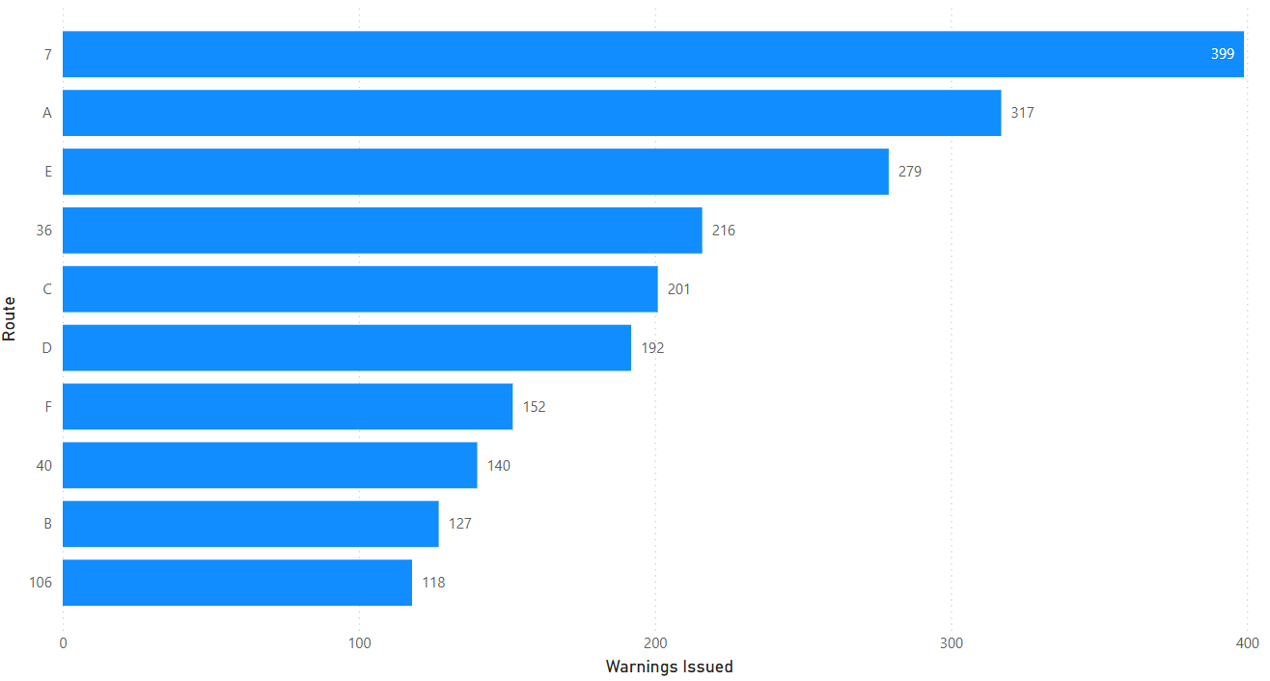
B. Number of citations issued for fare evasion
Metro issued eight citations to seven riders across 10 of Metro’s high ridership routes. One rider received two citations. Figure 3 shows citations issued across the routes, where the highest number of citations issued were on the A and E lines.

Figure 2: Citations issued by bus route
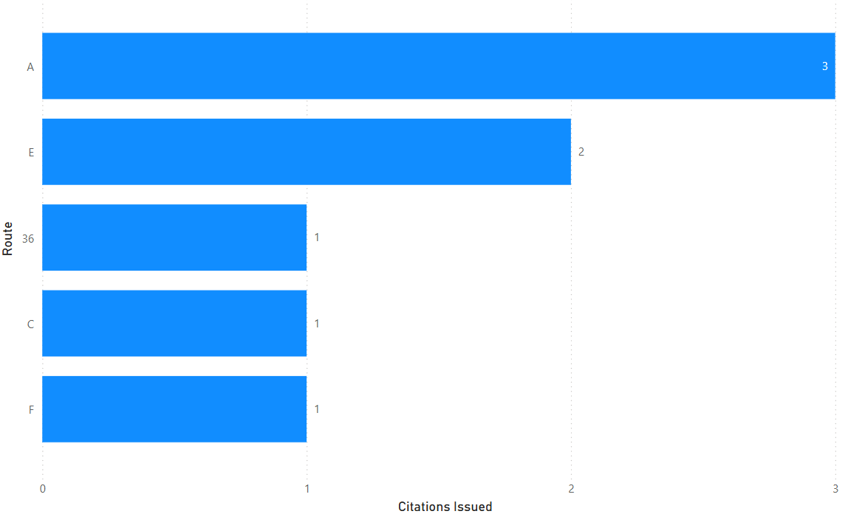

C. Number of citations resolved
In 2025, no citations were resolved. This is largely due to unreliable methods of communication, such as a rider giving an unspecific address, no phone number, or the address of a known shelter. Of the eight citations distributed, there were seven unique riders who received the citations. Of the seven riders who received these citations, four did not give a phone number and two gave a shelter address as their means of contact. Often, riders experiencing housing instability do not have reliable means of contact. This information suggests that several of the riders who received a citation in 2025 may have been experiencing housing instability.

Number of suspensions
In 2025, no suspensions were issued as a result of fare evasion.
E. Number of criminal trespass charges issued
In 2025, no individuals were charged with criminal trespass as a result of fare violation.

F. Demographic data
Figures 4 through 6 show the demographics of persons issued citations, approximating race, age, and gender. This information is largely collected through the riders’ state-issued identification if available and photo-identification when warnings and citations are issued. Fare Enforcement Officers collect age information from riders when possible, however, they will not ask someone for their racial identity. Fare Enforcement Officers will identify race through photos taken of the rider if available, which is standard operating procedure if no state-issued identification is presented. Photos taken help the Fare Adjudicator and Fare Enforcement Officers to identify riders who may be unable to present state-issued identification in the event of multiple engagements without valid proof of payment to ensure that warnings and citations are issued correctly. Income and housing status were not collected during this initial relaunch of fare enforcement, however, will be collected in 2026.

In Figure 3, this is information gathered by Fare enforcement officers through photo-identification. No specific trends were found in the first year of fare enforcement operations across seven months of operations.

Figure 3: Race of riders issued citations
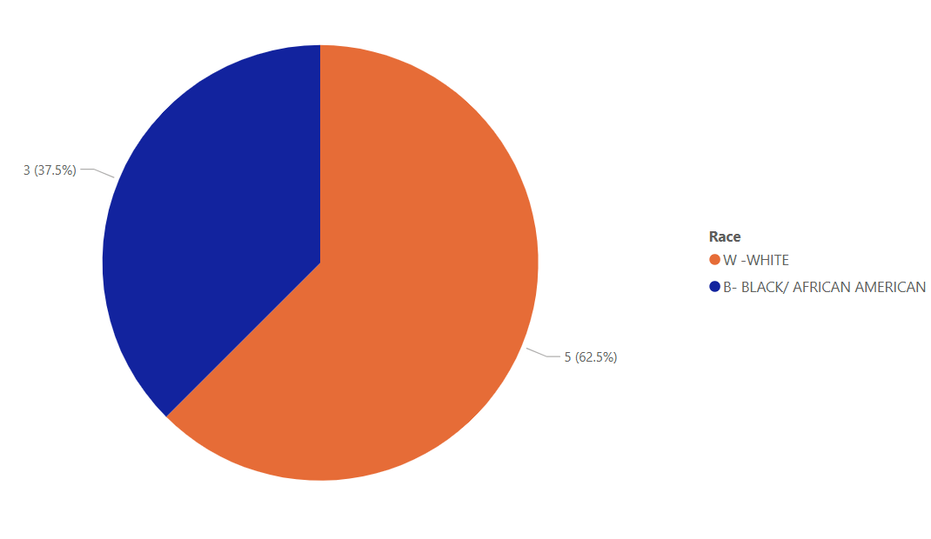

Figure 4 illustrates age of riders cited gathered through state-issued identification or photographic identification. Riders 18 and younger ride for free and therefore are not part of this data collection effort. Figure 5 shows the genders of the riders who received citations in 2025.
Figure 4: Age of Riders Issued Citations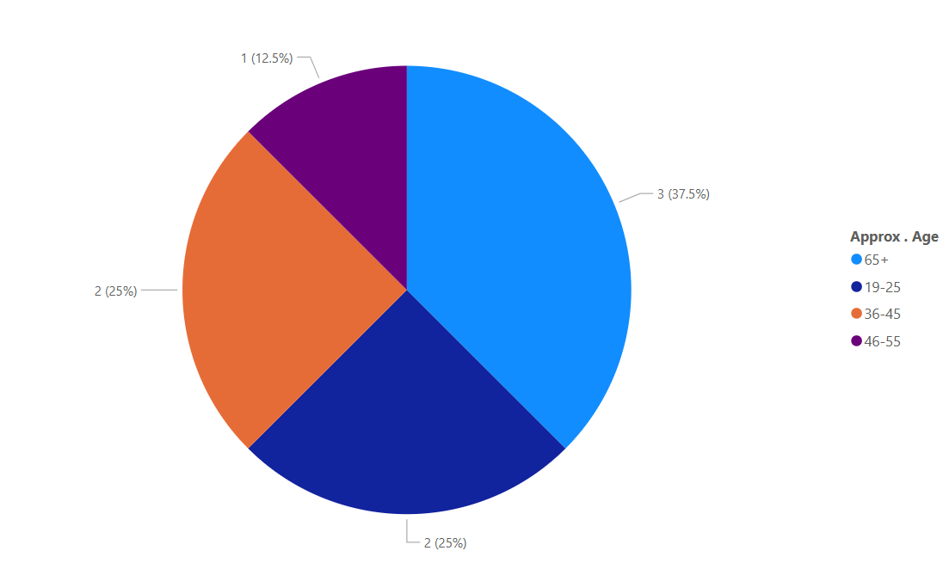 Figure 5: Gender of Riders Issued Citations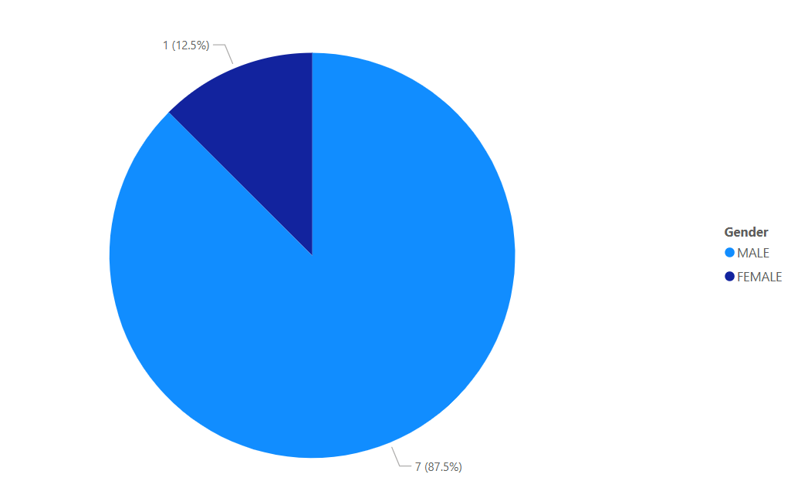

G. Activities and effectiveness of the program outreach manager
The Fare Adjudication Program, formerly known as the Fare Violation Program, was relaunched in March 2025. Program outreach includes the fare violation phone line, email, and website in addition to event facilitation. The website has an updated online payment portal. Metro staff attended two events hosted by Kandelia and have been working with two additional community-based organizations, Elizabeth Gregory House and Compass Housing. These events were meant to help connect riders to reduced fares information and enroll them in ORCA Lift and Youth rider programs. Outreach included, but was not limited to, referrals to Metro’s Pass Sales Office (PSO) to purchase and load ORCA cards with money; referrals to Department of Public Health for ORCA LIFT registrations (no current registrations from this channel); and the distribution of human service bus tickets (100 tickets distributed to community members).

- Conclusion/Next Steps
After a five-year pause of fare enforcement operations, Metro worked alongside several community members to ensure that it was brought back intentionally and with historically marginalized communities in mind. From the initial recommendations of a strong communications plan to walking alongside community in the process of relaunching, Metro is committed to addressing institutional harm that has been perpetuated towards vulnerable populations. Through the SaFE Reform effort, Metro continues to build upon its Mobility Framework to ensure safety and engage deliberately and transparently.

As Metro continues to build systems that support the safety of customers and employees in an equitable way in alignment with Metro’s Strategic Plan for Public Transportation, fare enforcement operations will continue to monitor its operations to ensure focus on the customer. Given that Metro relaunched fare enforcement operations after five years with a new security staffing contract, there are several operational opportunities for Metro to improve, such as better capturing customer demographic information and continuing to adapt training based on trends observed. In 2026, the Fare Enforcement team will also plan for an onboard survey to better understand the reasons for fare nonpayment by customers. Traditionally, this survey is used for this report and will serve as additional information for fare education concerning reduced fares and different fare products.

Metro brought back Fare Enforcement in 2025 and looking ahead to 2026, there are several business decisions that will impact the program. In early 2026, contactless payment for physical payment cards and mobile wallets launched as Tap to Pay. The technology to inspect the contactless payment types is limited and requires Fare Enforcement Officers to ask riders for the last four digits of the contactless payment type used. The One Regional Card for All (ORCA) organization is working with INIT, the company that owns the ORCA and payment card reader technology, to update the inspection application for the needs of regional transportation agencies. During this time, all-door boarding will also launch on all buses and at their discretion, operators will be able to open all doors to allow passengers to board.

With both operational changes, Metro will be ready to welcome global visitors to the FIFA Men’s World Cup games that the region will host for 45 days. During this time, it will be critical for Fare Enforcement Officers to provide fares information to global visitors and assist them with their wayfinding and fares information in a digestible, transparent manner.

Revised Code of Washington, 81.112.210, Fare payment – Fines and penalties established – Fare enforcement system – Enforcement, https://app.leg.wa.gov/rcw/default.aspx?cite=81.112.210.
Revised Code of Washington, 7.80.120, Monetary penalties – Restitution, https://app.leg.wa.gov/RCW/default.aspx?cite=7.80.120.
RCW, Chapter 9A.20, Classification of Crimes, https://app.leg.wa.gov/RCW/default.aspx?cite=9A.20.010.
King County, RapidRide Fare Enforcement: Efforts Needed to Ensure Efficiency and Address Equity Issues (Seattle: King County Auditor’s Office, 2018), https://www.documentcloud.org/documents/6426594-King-County-audit-of-Metro-Rapid-Ride-fare/.
https://lawfilesext.leg.wa.gov/biennium/2021-22/Pdf/Bills/Session%20Laws/Senate/5974-S.SL.pdf?q=20230711152724#page=95

