DES-BRC Report on Business Transformation-Ordinance 18409, Section 120, Proviso P1
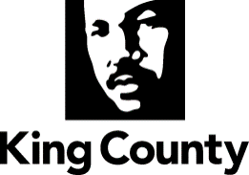

EXECUTIVE SERVICES - ADMINISTRATION

Caroline Whalen - County Administrative Officer

June 30, 2018

Table of Contents

Introduction and Purpose…………………………….…………....... | p. 3
Council Proviso………………….………………………………….. | p. 4
Executive Summary………………………………………………..... | p. 5
Summary of 2017-2018 Key Initiatives by Value Stream………...…. | p. 9
Addressing Remaining Pain Points Identified in 2016 Proviso…........ | p. 22
Standardization Metrics by Value Stream…………………………... | p. 25

INTRODUCTION AND PURPOSE
The purpose of this report is to respond to a proviso in Ordinance 18409 as part of the adopted 2017 and 2018 biennial budget. The report provides an assessment of the health of business processes and systems that were implemented as part of the countywide Accountable Business Transformation (ABT) project.

At the start of 2012, the ABT project replaced the County’s legacy financial, human resource/payroll, and budget systems with a modern integrated system. Currently, County agencies share an integrated system of three enabling technologies to help conduct business: Oracle E-Business Suite (Oracle EBS) for financial and procurement operations; PeopleSoft Human Capital Management (PeopleSoft) for human resources, employee benefits, and payroll operations; and Hyperion for budgeting.

Given the magnitude of technology and business process changes brought on by ABT, the County has viewed ABT implementation occurring in three overlapping phases: starting with stabilization in 2012 and 2013, with some carryover work in 2014; moving to standardization in 2014 through 2016; and further enhancing standardization and moving towards the optimization phase in 2017 and 2018. This three-phased continuum is referred to as a “maturity model” for new systems and their related business processes. While the enterprise software has been in place since 2012, many of the benefits and efficiencies mature over time as the County standardizes its business processes to best use the software.

In June 2013, the County provided the Council with a report documenting the initial stabilization phase of maturity both systems and business processes. The report concluded that the new systems were stable and business processes were functioning, but that there was a need for continued improvements and problem solving as part of the next phase of standardization. A follow-up report documenting the County’s progress in moving through the standardization phase, including a specific work plan and deliverables, was submitted in May 2014.

The 2015 preliminary report addressed sections A and B of the council’s 2015/2016 budget proviso which calls for key objectives and metrics for each value stream on March 31, 2015. In March 2016, a comprehensive report, addressing sections A through F of the previous proviso response, goes into more depth about the project initiatives related to the objectives, status updates, and the metrics used to chart the progress of standardization, as well as a status update of King County Enterprise Systems: Oracle EBS, Hyperion, and PeopleSoft.

COUNCIL PROVISO

For reference, the proviso in Council Ordinance 18409, Section 120, is excerpted below.

The report shall include, but not be limited to:
- A summary of the current status of each functional value stream, including procure-to-pay, billing-to-cash, hire-to-retire, budget-to-report and system security and controls. For the purposes of this proviso, "value stream" is defined in the King County Enterprise Systems 2016 Budget Proviso Report: Oracle EBS, Hyperion, and PeopleSoft Standardization Status, Metrics and Work Plan, adopted by Motion 14671.
- The summary shall include:
  - An assessment of the overall status of each value stream based on value stream maturity criteria, performance metrics and the outcome of completed initiatives; and
  - The progress made to date in meeting value stream objectives and moving towards "a high level of standardization or the beginning stages of optimization," as defined in the King County Enterprise Systems 2016 Budget Proviso Report: Oracle EBS, Hyperion, and PeopleSoft Standardization Status, Metrics and Work Plan; and
  - A summary of the future outlook for each value stream. The summary shall include:
    - A description of key factors that need to be addressed within each value stream in order to progress to a higher level of standardization or the beginning stages of optimization;
    - A description of key initiatives underway, estimated timeline and expected benefits; and
    - An update, as needed, of the value stream objectives and the metrics that will be used to assess the status of each value stream going forward.

The executive should file the report and a motion required by this proviso by June 30, 2018, in the form of a paper original and an electronic copy with the clerk of the council, who shall retain the original and provide an electronic copy to all councilmembers, the council chief of staff and the lead staff for the budget and fiscal management committee, or its successor.
EXECUTIVE SUMMARY

This report responds to a proviso in the 2017/2018 budget ordinance that requested identification of the key objectives for each value stream and whether King County is achieving these objectives. The proviso also requested a description of the key operational initiatives, including ongoing and proposed initiatives, to achieve the stated objectives for the 2017/2018 biennium.
This report examines the County’s enterprise systems via its business processes and systems using the constructs of “functional value streams” and a “maturity model” for each value stream. A value stream is a set of complete and coordinated work activities –involving multiple functional groups such as County agencies – that delivers clearly defined products or services to customers. For example, the value stream titled “Procure-to-Pay” is the coordinated set of work activities across County agencies that results in signed contracts with vendors and the payment of invoices to these vendors upon receipt of goods or services. The central procurement section within the Finance and Business Operations Division (FBOD) – along with other FBOD sections and multiple County departments—are responsible for the delivery of services within this functional value stream.

The County’s four functional value streams that are supported by enabling technology are commonly used in both the private and public sectors and are referred to in this report as: Budget-to-Report (Budgeting, Accounting, and Reporting), Procure-to-Pay (Procurement and Accounts Payable), Hire-to-Retire (Benefits, HR and Payroll), Billing-to-Cash (Grant Billing and Accounts Receivable). This report also includes the health of Systems Security and Controls that are managed by the Business Resource Center.
Within each value stream, there is a three phase “maturity model” for its enterprise systems and related business processes. The three phases are stabilization, standardization, and optimization. The County fully stabilized all systems and business processes by early 2014 and has made substantial progress in standardization, with many business process improvements, resulting in faster response times, greater reliability, and greater accuracy. The major factors in this success have been the completion of key initiatives and process improvements, as well as the development of “standard work” within each value stream. Standard work emphasizes documenting work flow, eliminating wasteful steps, and improving value for customers. Additionally, departments gained efficiencies, strengthened internal controls, and improved audit preparedness by reducing variations in business processes.
Moving into and progressing through the optimization phase, however, will require additional business and system enhancements in specific values streams. This report identifies business and system enhancements that are dependencies for optimization.

2017
2018
2019
2020
2021

2022
Jan 2012
Jan 2014
2013
2012
2014
2015
2016
Phase I
Stabilization

Phase III
Optimization
Jan 2016

Phase II
Standardization
Jan 2018

Jan 2020
Jan 2022

Standardization Status
The key factors of success in standardizing business processes include: (1) having end-to-end business process standards that are well defined and mapped; and (2) ensuring that senior leaders take full ownership for their department’s adherence to the new standards, with metrics used to report on variances from the standards; and (3) implementing the principles and practices of Lean continuous improvement to create efficiencies, solve problems, and add customer value within all value streams. Both business process and system standardization have reached a high (“green”) degree of standardization in almost every value stream, save for Systems Standardization. This is due to the security redesign modules still needing implementation.

Functional Value Stream Standardization Status
Area | Business Process Standardization | System Standardization
Procure-to-Pay Value Stream
Billing-to-Cash Value Stream
Hire-to-Retire Value Stream
Budget-to-Report Value Stream
System Security & Controls

To review, the County has defined the degrees of standardization that it will be continuing in the 2017/2018 biennium:

Standardization is the discipline of analyzing and standardizing business processes and their components in terms of effectiveness, efficiency, and added value contribution to the objectives of the business and includes these elements:
- Business processes and enabling systems are functioning without cumbersome or inefficient workarounds;
- Users are trained in standard work processes that were developed and being followed across County agencies;
- Agency and customers are engaged to help prioritize and address major issues and problems and feedback is obtained on their level of satisfaction;
- Standard protocols are being followed for system access and security; and
- The County is moving towards best practices as it leverages the capabilities of the enabling technologies.

Optimization Status
The ease of moving from a high degree of standardization into optimization varies from value stream to value stream, depending on certain barriers or opportunities. The chart below indicates whether the current trend for optimization is moving up, down, or remaining static. Two noteworthy trends to highlight are in the Procure-to-Pay and the Budget-to-Report value streams.

The Procure-to-Pay value stream is in a “static” mode because of technological limitations. For this value stream to move towards optimization, the County needs to leverage the use of current Oracle modules and replace outdated side systems with additional Oracle modules or other modern applications. In December 2017, FBOD hired a consultant with Oracle expertise to develop a Procurement Technology Modernization plan. The recommendations from this assessment highlight the technology required to bring the Procure-to-Pay value stream into early optimization. When this enhanced technology is combined with a continuing emphasis on standard work and trainings, the trend will shift to “up” for achieving optimization and sustaining service excellence.

The optimization trend for the Budget-to-Report value stream is moving “up” because of the new BI Insights project. As of April 2018, approximately 500 employees from various County agencies have received training on this new data analytics tool. As staff begin using this tool on a routine basis for financial monitoring and reporting, it will provide the foundation for making the jump from standardization to optimization. Over time, this should lead to improved financial reporting and decision making across the enterprise. It will also enhance transparency and financial management best practices, which are cornerstones for financial stewardship.

Functional Value Stream Optimization Status
Area | Optimization Trend | Trend Explanation
Procure-to-Pay Value Stream |  | Static: Need new technology identified in Procurement Technology Modernization plan. FBOD is preparing IT project proposal for 2019-2020 budget.
Billing-to-Cash Value Stream |  | Static: Increased electronic payments helping value stream move into optimization, but still limited by delays involving state and federal reimbursements.
Hire-to-Retire Value Stream |  | Up: With new Master Labor Agreement (MLA) and continued adoption of bi-weekly pay, value stream will be able to move into the optimization phase.
Budget-to-Report Value Stream |  | Up: With training and increasing use of BI Analytics, value stream can move into the optimization phase.
System Security & Controls |  | Up: After consultant’s assessment is completely addressed, this value stream will be able to move into the optimization phase.

As defined by the Business Resource Center (BRC) and FBOD, the degrees for optimization are highlighted below:

Optimization is the discipline of maximizing performance while minimizing inefficiencies under known constraints. Optimization requires that standards are upheld and improvements are made with both business and system agility. Optimization business objectives include the following elements:
- Business processes and enabling systems are functioning without unnecessary workarounds;
- Agencies work with customers to ensure that business functions operate in technologically challenging situations, ranging from high-risk to low-risk;
- Users are trained in developed standard work processes and updating them as necessary across County agencies;
- Customer feedback is valued and used to forward continuous improvement in a timely manner;
- Security risks are minimized and dealt with in a timely manner;
- Agencies use data and analytic tools (e.g. BI Insights) to assess the health of value streams, to identify opportunities for improvement project and to make better decisions; and
- The County utilizes established best practices across agencies.

SUMMARY OF 2017-2018 KEY INITIATIVES BY VALUE STREAM
Procure-to-Pay Key Initiatives and Completion Status

- Optimize Use of Requisitions and P-Cards
- Reduce the Cycle Time in the
Procurement Process
- Improve Visibility of Small Businesses
- Unclaimed Property (UCP) and General
Ledger Write-offs Automation Project
- Purchasing Inbound Interface Redesign
Completed

- Optimize use of Requisitions and P-Cards (“Requisition it Right” Initiative)
Standard work definitions were developed and implemented in 2015 and continue to be a critical part of training offered by Procurement and Payables (P&P) staff to purchasers across the County. Current system barriers are impacting the ability to monitor adherence to standards, but the Finance and Business Operations Division (FBOD) is collaborating with the Business Resource Center (BRC) to identify solutions to improve adherence to standards.

Part of this solution is included in the Procurement Technology Modernization plan (identified in “Pain Points” section on page 21), whereby retiring certain internal and external systems, FBOD could utilize the P-Card program more frequently than in the past. P-Card utilization is in part dependent on integrating contracts in iProcurement with their expenditures in iExpense. These are disparate EBS modules that were originally purchased in 2012. The iExpense module does not work well for P-Card and employee travel/expense reimbursements. We have also confirmed that this aspect of the Oracle EBS system is not a focus of attention for Oracle going into the future. Consequently, FBOD is looking to acquire other solutions (e.g., a product called Concur which easily integrates with Oracle EBS) to aid in optimizing and modernizing this element of the value stream.
Milestones: Q4 2017 – Received recommendations from consultant to leverage Oracle and supplement current functionality; Q1-Q4 2018 – Evaluating recommendations and receive approval for technology optimization and modernization; 2019-2020 – Implement Oracle optimizations and other solutions to better enable best business process and monitor adherence.

- Reduce the Cycle Time in the Procurement Process
To improve the procurement cycle time, P&P partnered with the Wastewater Treatment Division (WTD) for process improvement work in Architectural and Engineering (A&E) contract processes from 2015 to 2017. During this time, it was determined that the negotiation phase for contracts was still taking the same number of days in process. After this assessment, P&P and WTD were able to reduce the time for evaluating A&E contracts from six weeks to two weeks. P&P is now collaborating with other County agencies and the engineering consultant community to identify further process improvements specific to the negotiation phase of the A&E procurement process.

The Goods & Services team in P&P is working to improve its Request for Proposal (RFP) process and success through development of a “Stages of Procurement” tracking tool that is being used for all types of procurements to report on cycle time. The team that processes Construction and A&E contracts are using this tool and completing quarterly reports. The team that processes Goods & Services also started inputting data for the new tool. The data appears in the section of this report labeled “Standardization Metrics by Value Stream”.
Milestones: Q4 2016 – Conclusion of collaborative effort with WTD across the entire A&E procurement process; Q1 2017 – Kickoff of process improvement work in Goods & Services; Q2 2017 – Listening session with Goods & Services customers; Q3 2017 – Kickoff of negotiation phase process improvement work with additional County agencies and the Washington chapter of the American Council of Engineering Companies; 2019-2020 – RFP process evaluation and assessment completed.
- Improve Visibility of Small Businesses (Amazon Pilot Project)
P&P is working with Amazon Business to pilot functionality to allow certified small businesses to be more visible to County purchasers when buying through their marketplace. While the functionality was just launched in the Amazon Business platform to collect and identify Small Contractors and Suppliers (SCS) certified firms, the County is able to report that in the period from March 2017 through the end of February 2018, the County purchased approximately 7.5% ($63,000) of its total Amazon purchases from small businesses. Effective March 15, 2018, the County will be able to report on volume of purchases from SCS firms that have indicated themselves as such with Amazon Business.
During the same report period, the County also increased its outreach efforts to small businesses to apply for SCS certification. In the period from end of Q1 2017 through Q1 2018, the County certified 168 new SCS businesses. Of this number, 20 businesses (12%) of these newly certified SCS firms provide products.
The Business Development and Contract Compliance team is tracking the number of SCS certification applications received as a result of this Amazon pilot to identify the percentage of these submittals resulting directly from this initiative.
Milestones: Q1 2017 – Completed.

- Unclaimed Property (UCP) and General Ledger Write-offs Automation Project
The Unclaimed Property and General Ledger (GL) Write-offs Automation Project, referred to as the KCAP Outstanding Warrants Void Program, began in April 2016 and completed October 2017 by the Finance and Business Office Department (FBOD) and the Business Resources Center (BRC). This project was established to create an automated process, replacing the need for manual entries to void the approximate 2,500 unclaimed property warrants (uncashed checks), record the GL entries, and process the write-off transactions. The project also ensured that associated reports were updated and modified, making them more user-friendly. The project initially began as an automation of just the Accounts Payable (AP) processing. After reviewing the entire scope of work, the GL and Write-off processing was included to automate the entire end-to-end processing of UCP items.
The enhancement now automatically voids each warrant as specified through a system job that initiates the processing, updates the AP warrant description to UCP status and reporting year. Additionally, it creates offsetting GL journal entries and automatically performs the write-off accounting transaction for each. The process now requires minimal manual entries in AP and completes from end-to-end within two hours. There are some manual entries to be completed by Treasury for verification of the write-offs. This work is standard work for review and approval of Treasury validation of warrants.
Milestones: Q2 2016 – Project start date; Q3 2017 – Completed.
- Purchasing Inbound Interface Redesign
This project improved the communication between Oracle EBS and the side systems to bring it up to new standards of best practices within BRC. It also provided enhancements and features for the interface of inbound requisitions and receipts, which validates data prior to allowing it to move into Oracle EBS from a side system. Inbound requisitions and receipts are the initial purchase orders (PO) that P&P receives before they go into the system for payment. Inbound PO interfaces from customer systems worked correctly upon completion of this project to eliminate rework within both P&P Section and County agencies.
Milestones: Q3 2014 – Project identified as a low priority risk; Q4 2016 – Completed.

SUMMARY OF 2017-2018 KEY INITIATIVES BY VALUE STREAM
Billing-to-Cash Key Initiatives and Completion Status

- Dunning letters and aging reports
- US Bank Transaction Reports
- WTD Scanner Lockbox
Completed

- Dunning letters and Aging Reports
Accounts Receivable and BRC successfully worked to test and correct fixes to the dunning letter process. A dunning letter is a written reminder that is produced when the invoice ages longer than its set terms. Generally, an invoice is due within 30 days. The need to improve this process stemmed from the system not printing and mailing all available outstanding invoices, limited the ability of the County to forward outstanding debt to the contracted third party collection agency.
State Revised Code of Washington (RCW) requires the County to inform customers of outstanding debt to preserve the option for that debt to be forwarded to a third party collection company. To assure County agencies and Central AR has full transparency of outstanding debt, an enhanced electronic Aging Report was created to show the status, age, and location of the invoice in the Accounts Receivable/Collections process.
Upon further review of the report and dunning process, AR found identification errors for incorrectly flagged items selected for presentation to the agencies and to the third party collection company. In addition, the third party collection company was not receiving all necessary documents. The deficiencies in the process were corrected in early 2017 and resulted in a steady flow of approximately 900 dunning letters mailed monthly, up from 100 letters monthly. This increased the amount of payments directly to Central AR from the dunning letters and presented a more timely data feed to the third party collection company to start collection on unpaid invoices.
Milestones: Q1 2017 – Completed.
- US Bank Transaction Reports
US Bank contacted the County about a software platform change, specifically changing its then current file transmission system, which affected the reports that the County received. To tackle this project, FBOD’s Treasury, EBS Database Administrators (DBAs), and KCIT UNIX teams worked together to ensure a seamless transition to US Bank’s new software platform.
The County spent just over four months working in a test environment, establishing connectivity, updating its encryption, and developing its transition plan. During the testing phase, the County coordinated with US Bank to verify that all of its inbound and outbound bank files would continue to flow smoothly through the new software platform. The changes included the consolidation of six mailboxes into a single mailbox that uses the file name for routing, and improving the data encryption. The process proved to be much more complex than initially thought; however, the County was able to implement the changes with short notice and without post-implementation issues through collaboration amongst multiple agencies.
Milestones: Q3 2016 – US Bank informed County of changing platform; Q1 2017 – Completed.
- Wastewater Treatment Division (WTD) Scanner Lockbox
Through September 2016, AR was receiving 4,000 online bill payments monthly for WTD, which came directly from the customers’ banks. Coming directly from the customers’ bank accounts meant that there were no attached invoices, and the automated scanner process could not recognize and automatically apply cash to known accounts. Most customers had their Central Clearing Counterparty (CCP) customer account number on the payment that let AR know where to post but, approximately 10% of payments had irrelevant account information, such as property tax account numbers.
AR had to research these payments to manually post them until November 2016, when AR began using a US Bank scanner lockbox. With this system, payments come through as Automated Clearing House (ACH) payments, where all of the customer information is compiled into a standard file type to upload to EBS. In addition, the payments are posted the next day in EBS, versus a mailed check that takes nine days to process due to mailing and sorting. Finally, WTD and AR can send an email to US Bank to send any overpayments directly back to customers’ bank accounts using the Accounts Payable (AP) Smart spreadsheet (cloud-based collaborative work management product), instead of preparing paperwork and mailing the refund checks.
Milestones: Q3 2016 – Problem identified within AR; Q3 2016 – Completed.

SUMMARY OF 2017-2018 KEY INITIATIVES BY VALUE STREAM
Hire-to-Retire Key Initiatives and Completion Status

- Standardize Pay and Benefits Practices
- Family and Medical Leave Streamlined
- Reduce or Standardize the number of
Premium Pays
- Reduce the number of Work Week Types
- PeopleSoft Mobile Self-Service
- Master Labor Agreement
Completed

- Standardizing Pay and Benefits Practices
King County continually strives to reinvent how it approaches processes and practices to improve efficiency and effectiveness of County pay and benefits practices. The long-term goal is to have clear, consistent, and standardized policies and pay practices that (a) are fair and equitable across employees, (b) create sustainable and predictable financial obligations, (c) provide employees with choices to meet their individual needs, and (d) promote learning, growth and flexibility.
Several efforts are occurring to standardize County agencies. One effort is to transition the Emergency Medical Services (EMS) paramedics, in Seattle King County Public Health (SKCPH), from a Semi-Monthly to the Bi-Weekly Pay Cycle. Since 2015, analysis and discussions were used to communicate the benefit of changing pay cycles with EMS. Collective bargaining on this topic has been completed with the paramedics and deployment is now scheduled for October 2018.

The King County Sheriff Office (KCSO) is the remaining department that needs to transition to bi-weekly. However, other efforts have occurred to standardize KCSO pay and these efforts have been a higher priority due to recommendations in a King County Council Auditor report. We have eliminated a past pay practice called the enriched rate, which streamlines calculations on overtime premiums and makes paychecks easier to read (see initiative #3 below). We are also analyzing the capture of all work hours (actual hours) instead of using estimated pay that now occurs. This analysis would help eliminate potential issues identified by the audit such as roll call. When these commitments are completed, DES and KCSO will look to re-examine the priority to move to bi-weekly.
Milestones: Q2 2018 – Negotiation for bi-weekly pay cycle with Paramedics requirements identification for implementation; Q3 2018 – Deployment for Paramedics; Q4 2018 – Go Live for Paramedics; Q3 2018 – Analysis and discussion of move to actual hours for KCSO; Q1 2019 –Discussion with KCSO unions; Q1 2019 – Implementation planning; Q3 2019 – Complete system requirements; Q1 2020 – Deploy changes.

- Family and Medical Leave Streamlined
Creating standard leave administration practices is in response to a performance audit recommendation that will create efficiencies in the leave process for the administrator and reduce ambiguity for employees. King County approved the ordinance in December 2015, with agreement of the County Council, to implement the Family Medical Leave Act and King County Family Medical Leave (FMLA/KCFML) concurrency on August 1, 2016. Negotiations began with the unions to implement this change. The majority of unions agreed to a pilot to implement concurrency by August 2016 with a final acceptance of this model starting January 2017. There are still about five unions that are outliers and have not agreed to concurrency. This outcome was a collaborative effort across County functions amongst Office of Labor Relations (OLR), Business Resource Center (BRC), Finance Business Operations Division (FBOD), and Human Resources Division (HRD).
Milestone: Q3 2016 – Ordinance to streamline FMLA/KCFML standards approved; Q3 2016 – FMLA/KCFML standard leave agreement; Q1 2017 – Completed.

- Reducing or Standardizing the Number of Premium Pays
In 2017, as the result of a Council Auditor report, the County implemented a change in the PeopleSoft system to address issues with calculated overtime on premiums paid to KCSO deputies. Premium pays include educational incentives, longevity pay, detective pay, and others. To address the audit issues, the County used PeopleSoft functionality to integrate premium pays into a single hourly rate. This standard approach for paying overtime premiums, known as “multiple components of pay (MCOP),” enabled the County to eliminate a longstanding past practice known as the “enriched rate” for paying overtime premiums.
The elimination of the enriched rate practice has resulted in annual savings estimated at $162,600 per year. Other benefits include easy to understand paychecks for deputies, alignment with the current collective bargaining contract, no special customizations in PeopleSoft, and positioning the County to move the deputies from a semi-monthly to a bi-weekly payroll schedule.
Milestones: Q1 2018 – Legislation and full implementation of MCOP approach for overtime premiums in KCSO, based on 2017 project; Q4 2018 –Complete analysis to determine 7K schedule vs actual hours schedule to address remaining audit report issues.

- Reduce Number of Work Week Types
Reducing work weeks has not been a priority given the efforts directed to the negotiation of the Master Labor Agreement and the implementation of the KCSO multiple components of pay project. Rather than focusing on reducing work weeks, we have shifted our focus to maintaining the number of work weeks to the six currently identified. At least several times a year, FBOD is asked to add more work weeks to accommodate desires for telecommuting or alternative work schedules. Education is the key to addressing this issue because people need to understand the difference between a work schedule and a standard work week.
Milestones: Maintain status quo.
PeopleSoft Mobile Self-Service
BRC enhanced the Human Capital Management (HCM) self-service user experience by offering County employees the ability to review their paychecks and update personal details through their mobile phones by integrating Oracle’s delivered mobile features into the King County PeopleSoft system. New features included access to employee paycheck, paycheck analytics, time entry and approval, and leave balances through mobile devices. Other mobile updates allowed employees to change personal information including their addresses, email addresses, ethnicity, emergency contact information, and disability status. Through this initiative, the County hopes to see an increase in direct deposits.
Milestones: Q3 2017 – Completed paycheck access; Q4 2018 –Provide timesheet access.

- Master Labor Agreement (MLA)
In 2016, total compensation bargaining occurred as a joint labor management effort. The initial agreement was a large step towards setting up a process to standardize pay practices in King County. Last year, the first MLA was completed and has recently been adopted as an ordinance. This agreement aligns pay practices around bereavement, personal days, special duty, and many other practices. OLR is working with DES, including FBOD, BRC, and HRD to implement this agreement. Current negotiations are underway for further standardization and will also need further deployment.
Milestones: Q2 2018 – Agreement adopted; Q3 2018 – MLA implemented; Q4 2018 – Analysis of changes and contract preparation for Executive; Q1 2019 – MLA adoption and deployment of changes.

SUMMARY OF 2017-2018 KEY INITIATIVES BY VALUE STREAM
Budget-to-Report Key Initiatives and Completion Status

- Project/Award Data Element Management
- Reduce Complexity of Projects & Grants
Configuration
- Replace Enterprise Reporting tool
- AME to GL Journal Entry Approval
Completed

- Project/Award Data Element Management
Progress was made to monitor the set-up of federal and state awards in the Project Award Module in Oracle EBS. Initial work was completed during the first two quarters of 2015 to establish a baseline to identify errors in award set up. Next steps include using data analysis results for training purposes to inform the agencies on proper award set up. Going forward, the Financial Systems and Services team (FSS) will monitor the data to decrease the error rate in award set up.

In addition, detailed procedures on award setup were developed and agency staff trained in 2015. These procedures were enhanced in 2017 to include quick reference tools and additional award information. For example, detailed procedures for managing award installments and budgets were provided, as were instructions for how to leverage assistance from the Financial Systems and Services team when needing to open a new award in Oracle EBS. FBOD conducted site visits with agencies to review the specifics of award set up monitoring and introduced agencies to resources that will help reduce these errors further. In effect, award setup errors were reduced by more than 50 percent.
Milestones: Q1 2015 – Developed detailed Schedule of Expenditures of Federal Awards (SEFA) instructions; Q4 2015 – SEFA training and workshops; Q1 2015 - Q4 2016 – Site visits to help agencies develop SEFA; Q1 2017 – Implemented automated State Schedule of Financial Assistance (SSFA) Report and Instructions; Q4 2017 – Completed.
- Reducing Complexity of Projects and Grants Configuration
Standard definitions for cost center, project, and program are defined and socialized. Comments from surveys were incorporated into either the definitions, the new cost center request form, or on the Q&A companion document that accompanies the definitions. Efficiencies were achieved with the new tool for the Oracle EBS accrual processes. The new Project Accounting (PA) Accrual Smart Spreadsheets were introduced, with two enhanced levels of edits that significantly reduced errors, along with a new requisition process for actual expenses coming into Projects and Grants which greatly reduced the number of errors for the Schedule of Expenditures of Federal Awards (SEFA) associated with prior year payments.
In the effort to reconcile Project Accounting to the General Ledger (GL), FBOD created an offline tool to help the agencies reconcile the sub ledger to the GL. Workshops were originally conducted in 2014, with approximately 130 staff being trained with ongoing support provided by the Financial Systems and Services team (FSS), formerly the Financial Systems Unit (FSU). Workshops continued in 2016 with an emphasis to reconcile the sub ledger to the GL on a quarterly basis.
The PA to GL Reconciliation Process was revised and improved in 2017. The new tool is a dashboard in the new BI Insights that does much of the reconciliation process automatically and provides research drill down capabilities. This reduces cycle time by 40%. Another enhancement, not previously available, provides a solution for General Fund agencies to obtain their data easily through the BI hierarchy. Training and documentation provided to approximately 75 finance personnel.
Milestones: Q4 2015 – On Going Training provided; Q4 2017 – Process Revised/Improved.
- Replace Enterprise Reporting Tool
The Oracle Business Intelligence (BI) Proof of Concept, completed in Q1 2016, garnered accepted use of Oracle’s recommended BI solution, Oracle Business Intelligence/Oracle Business Intelligence Enterprise Edition (OBIA/OBIEE). Following the Proof of Concept, the County began its Software Acquisition and Implementation phase, including the acquisition and implementation of BI Solutions, and Oracle OBIA Financial Analytics and Human Capital Management (HCM) Analytics later in Q3. The scope of work included data unification of source system financial data from Oracle EBS, HCM data from PeopleSoft HRM, and Position Budget data from Hyperion Budget & Planning.
As of Q2 2018, the BI Analytics team developed approximately 145 Financial and HR Analytics that are available to all agencies across the County. There are approximately 400 casual users and 131 power users trained on the BI Analytics new service. In conjunction with rolling out BI, the County is also in the process of decommissioning the Oracle Discoverer reporting tool with a target completion of Q4 2018. Communications of the Discoverer Decommission timeline were transmitted during Q2 to all agencies across the County. The project team also successfully completed the Phase 1 Pilot that included agency participation of a critical financial year end task involving the Project Accounting to General Ledger Reconciliation.
Phase II of the Discoverer Decommission strategy includes Q2 – Q3 2018 workshops to ensure availability and replacement of all data elements used in custom Discoverer reports before the Q4 2018 decommission target date.
Milestones: Q1 2016— BI Proof of Concept completed; Q1 2018 – Phase I of Discoverer Decommission is completed; Q2-Q4 2018 – Phase II will be carried out, module by module until Discoverer is no longer needed.
- Strengthening internal control for GL Journal Entry
Over the past two years, auditors have found that up to 60% of manual General Ledger (GL) journal entries tested were not approved before the date they were posted in the financial system. In order to improve internal controls in financial reporting, FBOD has initiated a project focused on the approval of manual Journal Entries. The Approval Management Engine (AME) will be used to route journal entries electronically to a pre-determined approver group. This will provide an online audit trail for journal creation. The plan is to have 100% of manual journals reviewed and approved through AME.
Milestones: Q1 2018 – Requirements gathered; Q4 2018—Staged for completion. SUMMARY OF 2017-2018 KEY INITIATIVES BY VALUE STREAM
Security Systems and Controls Key Initiatives and Completion Status

- Improvements to security request process
- Security redesign pilot – AR module
- New security naming conventions
- Countywide EBS security self-audit
- Security redesign–remaining EBS modules
- Payroll Security Enhancements
Completed

- Improvements to security request process
This activity brought improvements to the forms and approval process for requesting EBS security access. In early 2017, BRC revised agency EBS request forms and added the ability to sign by electronic signature. In conjunction with the new naming conventions for EBS responsibilities, this clarified the purpose of each request form, which reduced the risk of awarding inappropriate security access. The project concluded when the County implemented the new EBS Security approver role for each County agency.

Milestones: Q1 2017 – Request forms revision; Q2 2017 – Completed.

- Security redesign pilot – Accounts Receivable module
This pilot focused on the Accounts Receivable (AR) module to redesign AR security responsibilities and structures (menus, functions, request sets, etc.) to remediate conflicts, reduce risk and standardize design. The pilot helped define an approach for the redesign work that could be repeated for the rest of the EBS modules. FBOD and BRC worked to address remaining risks, with the end result being a risk reduction of approximately 80 percent. The Security team conducted a “Lessons Learned” to help model future redesigns.

Milestones: Q1 2017 – Analyzed and identified cross module conflicts, designed prototype, and tested solutions; Q2 2017 –Completed.

- New security naming conventions
New naming conventions are integral to improving security and were adopted by all EBS users across the County. By revising responsibilities (defines user access), top menus (navigation paths), and request groups (report and batch job groups), the County avoided the risk of an Oracle patch introducing new functions without the systems team’s awareness, adding new security risk to the EBS system.
In early 2017, the County finalized security naming conventions and configured them in EBS, which included finalized testing, revision of documentation and access forms, and communications to all EBS users with cross-walks to facilitate smooth adoption and avoid confusion immediately after implementation.

Milestones: Q2 2017 – Completed.

- Countywide EBS security self-audit
FBOD and BRC collaborated to develop and implement a process to conduct a countywide review of EBS security access to confirm that EBS users in each agency have appropriate access. After an initial pilot group, six agencies followed with each cohort attending a workshop to prepare them for the task. All agencies received an EBS security report showing details of their organization’s EBS users’ security access and were asked to review permissions. Once the groups finalized their changes, BRC processed them and each agency reran the report to certify that the changes reflected the desired end state. The intent is to make this a regular annual process.

Milestones: Q2 2017 – Developed self-audit process, timeline, agency cohort groupings, and workshop materials and conducted pilot; Q3 2017 – Conducted workshops for Groups 1-6, supported audit process and made EBS security access changes as each agency completed its review; Q4 2017 – Completed final security changes and concluded audit.

- Security redesign – remaining EBS modules
After the completion of the security redesign pilot for the Accounts Receivable module, BRC began redesigns for remaining modules. Currently, BRC has completed redesign work of the General Ledger, EBS inquiry responsibilities Purchasing, iProcurement modules, Projects/Grants module (agency/BRC responsibilities), and EBS profiles. This work is still in progress for the remaining modules and is expected to continue through 2018.

Milestones: Q4 2017 – GL and EBS Inquiry responsibilities redesigns completed; Q1 2018 –Redesigns for Purchasing, iProcurement modules, Projects/Grants module (agency/BRC responsibilities), and EBS profiles completed; Q4 2018 – Target completion of remaining modules.

- Payroll Security Enhancements
In 2016, several security enhancements were made to strengthen the PeopleSoft system against phishing attacks focused on diverting employee pay through direct deposit account changes. These safeguards include automated notifications sent directly to the employee when suspicious activity is detected, alerts to administrators when patterns associated with phishing are detected, and audits which automatically alert payroll operations when direct deposit accounts are changed in a fashion that is indicative of phishing activity. As a final step, the system will not allow a change to a direct deposit without issuing a paper check prior to enacting the change. This is also intended to alert the employee of changes made to the direct deposit account.
In addition, sensitive employee data such as SSN and bank account number are being masked when displayed on a page. The BRC team has worked with KCIT to put in place geolocation tracking to limit access to PeopleSoft to prevent phishing attacks from outside of North America. The BRC PeopleSoft security team continues to work closely with KCIT to strengthen system security to ensure employees can access their information in PeopleSoft and feel confident that their information is protected from unauthorized access.
Milestones: Q4 2016 – Completed.

ADDRESSING REMAINING PAIN POINTS
In accordance with the 2017/2018 budget proviso, an update is provided on each pain point identified in the 2016 proviso response report, King County Enterprise Systems 2016 Budget Proviso Report: Oracle EBS, Hyperion, and PeopleSoft Standardization Status, Metrics and Work Plan, adopted by Motion 14228.

FBOD, PSB, HRD and BRC managers have addressed or are addressing the system or business process major “pain points” that remain. The business and system processes pain points addressed in the 2016 proviso response have been completed, as described below. The pain points for the 2017/2018 biennium are discussed under “Current Pain Points”.

Previous Pain Points
EBS System Design and Set-Up Decisions
Original EBS design decisions related to system setup of the Accounts Receivable and Projects modules have resulted in some business inefficiencies, unintended data growth, and an initial degree of frustration for agency customers, particularly for those who receive federal funds for specific programs and projects and/or use the Projects module for billing to other jurisdictions. The areas identified as pain points in the 2014 and 2016 report and progress have been completed:

- Methodology for capitalizing assets from the Oracle EBS Projects module to the Oracle EBS Fixed Asset module – Completed
- Level of labor detail utilized in the Oracle EBS Projects module – Completed
- Setup for awards in the Oracle EBS projects module – Completed
- Invoicing and billing choices that were made in the Oracle EBS Accounts Receivable and Projects modules – Completed

EBS System Defects and Release Set Strategy
Oracle EBS was upgraded from version 12.1.3 to version 12.2.5 in 2016 and outdated hardware was replaced in 2017 to ensure continuity of operations and Oracle support levels. In the summer of 2018, security and application patches will be implemented to update EBS to the current patch level 12.2.7 in accordance with Oracle’s recommendations. The Oracle EBS Defect and Release strategies encompass processes that have been standardized and operating effectively and efficiently over the last five years. Ongoing continuous improvement methodologies ensure refinements to improve customer service.

PeopleSoft Upgrade and Update Manager
The last upgrade of PeopleSoft was from version 9.0 to 9.2 that occurred in October 2014. The main driver for the PeopleSoft upgrade was that vendor support for the 9.0 release level was ending in 2015. This meant that payroll tax rates in the system would have become inaccurate, causing incorrect tax amounts to be withheld.

King County now is using a fully supported version of the system. Oracle’s stated direction regarding PeopleSoft Update Manager is to update version 9.2 continuously. Using the PeopleSoft Update Manager, the King County support team intends to apply a “full” release set and PeopleTools upgrade to the system at least annually, but not less than once every two years. This is in accordance with Oracle recommendations.

Current Pain Points
Procurement Technology Modernization
Within Procurement and Payables (P&P), there are several in-house developed applications, in addition to Oracle EBS, that assist in the procurement of goods and services. However, these outdated in-house applications (also called “side systems”) do not integrate with current Oracle modules and do not work well with one another. There are workarounds which have mitigated shortcomings. These in-house applications include the Online Vendor Request (OVR) system, the Service Request Module (SRM), databases, and the Contract and Apprenticeship Report Tracking System (CARTS). The County moved forward with an assessment on how to replace these in-house applications while leveraging the Oracle EBS investment. With the aid of an external consultant who reviewed current functionality of EBS and other systems, a team of County agencies (FBOD, BRC, and KCIT), were able to identify a technology roadmap to expand use of Oracle applications and to replace outdated side systems.

The plan includes implementation of Oracle iSupplier, Oracle Sourcing, Oracle Contracts, and adding Concur to manage purchasing card, travel, and employee reimbursement expenditures. Currently, vendors interested in doing business with the County need to register in more than one discreet system. These enhancements will allow vendors to self-register through a single portal to contract with the County, and continue to self-manage their accounts including obtaining purchase order information, submitting invoices, and maintaining information.

Currently, the County lacks the ability to accept electronic bid and proposal submissions due to technological shortcomings. In 2016, the County successfully obtained approval from State legislators to accept electronic submissions; this change however, has not yet been implemented. This project would enable vendors to provide electronic submissions to the County, saving over one million pieces of paper, along with the time and money associated with delivery. In addition, County staff would be able to evaluate submissions electronically in one single system.

The payables part of the process also will benefit from implementing iSupplier, which will work with Oracle’s Optical Character Recognition (OCR) and Earned Receipt Settlement (ERS) to allow electronic submission and processing of invoices within an integrated system. By adding in these technology components, Accounts Payable will be able to reduce manual invoice entry and users will have better visibility into electronic purchase orders, including requisitions, corresponding receipts, invoices, and payments.

Finally, the County will leverage Oracle’s Approval Management Engine (AME) and Oracle’s Business Intelligence Enterprise Edition (OBIEE) to ensure appropriate controls and provide better access to consolidated data. With leveraged and additional technology, the Procure-to-Pay value stream could move into the optimization phase.

State and Federal Funding Receipt and Distribution
King County agencies are responsible for applying for federal funding and awards as part of their budgeting process; however, when state and federal funding arrive at the County via Accounts Receivable (AR), the funding does not always have project numbers or information associated with County agencies’ programs and projects. Many of these invoices come in as ACH (Automated Clearing House) payments, checks, or cash. While ACH payments are paid electronically, they cannot be auto-applied to the correct account the same way as an online or credit card payment. Central AR has to research and apply the payment to the correct account for the funding to be utilized, keeping the process manual.

After the Electronics Payment Expansion project concludes, AR will be able to receive more electronic payments from its customers, but state and federal funding will remain manual. Being able to apply funding to the right agencies has been a known issue but because the County does not control how it receives its state and federal funding, the issue persists. It will be important for the County to see if it can leverage its state and federal partners in an improvement project that will help address the ongoing pain point in the value stream.

Ongoing Funding for Electronic Payments Program
In 2014, King County embarked on its journey to implement a countywide Electronic Payments Expansion project. The goal was to make it easier for citizens and firms to do business with King County by paying for services/products using credit cards and other forms of electronic payments. The County decided to move to a third party payment processor and to eliminate a legacy in-house “payment engine” to reduce risk associated with Payment Card Industry (PCI) compliance. The project also resulted in a new storefront (also called a “shopping cart”) for legacy payment applications, with the understanding that any new payment application requested by an agency could use either the new storefront or a vendor-supported storefront. The project has broad reach across the County, filling gaps in available electronic payment services that encompass 149 products and services offered by more than 40 agencies, to over 2.2 million customers.

Going forward, the County needs to evolve from the Electronic Payments Expansion project into an ongoing Electronic Payments program with sufficient funding for new agency applications. Many agencies do not explicitly budget for the design and implementation of electronic payment applications. With an estimated 8% growth projection for countywide electronic payment transactions per year, the Electronic Payments Expansion program will not be able to keep up with customer demand without proper funding,

In addition to agency funding, an Electronic Payments program needs to make PCI compliance a top priority. PCI compliance focuses on keeping user payment information protected, ensuring agency staff are trained and implementing proper controls, and monitoring systems and processes periodically for threats or risks. In the first half of 2018, FBOD and KCIT are partnering with County agencies to assess the County’s PCI risk. The PCI risk assessment should be an annual priority to ensure that the County is addressing the most urgent threats or risks. In the past, resources for conducting the PCI risk assessment have not been part of either FBOD’s budget or KCIT’s budget. As the volume of electronic payments grows, the level of PCI compliance becomes more stringent. FBOD and KCIT plan to make PCI compliance a top priority budget request for the 2019-2020 biennial budget.

STANDARDIZATION METRICS BY FUNCTIONAL VALUE STREAM

Functional Value Stream Standardization Status
Standardization is the discipline of analyzing and standardizing business processes and their components in terms of effectiveness, efficiency, and added value contribution to the objectives of the business. Standardization includes the following:
- Business processes and enabling systems function without cumbersome or inefficient workarounds;
- Standard work processes are developed and users are trained across County agencies to follow these standards;
- Agencies and customers are engaged to help prioritize and address major issues and problems, and feedback is obtained on levels of satisfaction;
- Standard protocols for system access and security are followed for system access and security; and
- The County moves towards best practices as it leverages the capabilities of the enabling technologies.

The following chart summarizes the current status of business process and system standardization for each of the business operations value streams, as well as the status of system security and controls.
Area | Business Process Standardization | System Standardization
Procure-to-Pay Value Stream
Billing-to-Cash Value Stream
Hire-to-Retire Value Stream
Budget-to-Report Value Stream
System Security & Controls

As mentioned previously, each value stream has been identified as achieving a high degree of Business Process standardization. Below are the criteria identified for the Standardization phases as the County continues into 2018.

Business Process Status Standardization Criteria
GREEN (HIGH STANDARDIZATION)
- Business process standards are fully mapped and well-defined
- Agency senior leaders have taken ownership of adopting business process standards
- Agency personnel understand and comply with standard business processes and report exceptions
- A complete set of online reference tools and guidance for business core processes are available and enable countywide standardization of processes
- Recurring process monitoring and continual process improvement initiatives are occurring on a recurring basis in most agencies
- Standard protocols are always being followed for systems access and security
- Agency feedback is used as a significant driver in issue prioritization
YELLOW (MEDIUM STANDARDIZATION)
- Business process standards are summarily mapped and defined
- Some agency senior leaders have taken ownership of adopting business process standards
- Some agency personnel understand and comply with standard business processes and report exceptions
- Online reference tools and guidance for most business core processes are available and enable countywide standardization of processes
- Recurring process monitoring and continual process improvement initiatives are occurring on a recurring basis in some agencies
- Standard protocols are being developed for systems access and security
- Agency feedback is used as a driver in issue prioritization
RED (LOW STANDARDIZATION OR NON-STANDARD)
- Business process standards are not mapped or defined
- Agency senior leaders have not taken ownership of adopting business process standards
- Most agency personnel do not understand or comply with standard business processes
- Online reference tools and guidance for a few business core processes are available
- Recurring process monitoring and continual process improvement initiatives are not occurring on a recurring basis in some agencies
- Standard protocols are not in place for systems access and security
- Agency feedback is not used as a driver in issue prioritization

System Process Status Standardization Criteria
GREEN (HIGH STANDARDIZATION)
- Standard business processes are established and enabled by delivered ERP system functionality
- Design choices optimize business processes, Oracle best practice recommendations and system capabilities
- Prioritization process engages customers to prioritize and implement system changes and enhancements to meet customer needs within a committed timeline
- Customization is minimal to support essential business process requirements and efficiencies
- Application is maintained to current Oracle support levels
- Best practice technical standards, processes and systems documentation are mature and consistently applied
YELLOW (MEDIUM STANDARDIZATION)
- Standard business processes are in place but fixes are needed to improve speed, accuracy and efficiency goals
- Design and system best practice choices need to be revisited to ensure optimal use of ERP system capabilities with the most efficient use of County resources
- Customer priorities are surpassed by competing business, regulatory and/or labor contract requirements. Some commitments to timelines for delivered changes and enhancements are missed
- Customizations exist that can be replaced by delivered system functionality
- Application release level is maintained but some delays are experienced maintaining to current Oracle support levels
- Best practice technical standards, processes and systems documentation are developed but not consistently applied
RED (LOW STANDARDIZATION)
- High level of customization is required because standard business processes or rules are not established
- BRC staff do not have the capacity to address design choices and have to devote a majority of time and resources to address critical issues in the application
- Customer priorities are not considered, or are overtaken by rework, or unanticipated regulatory and/or labor contract requirements
- Timelines to deliver changes and enhancements are frequently missed
- Application release level is maintained but frequent delays are experienced in maintaining to current Oracle support levels
- Best practice technical standards, processes and systems documentation are developed but not consistently applied
- System downtimes impact business performance and reliability

The County and Optimization
Below is the criteria identified by FBOD and BRC for the “Optimization” phase. These requirements will set the basis for the optimized value streams and each will be graded on its business and system processes. For the County to enter optimization, it will need to reconcile its technological shortcomings and manual risk mitigations with more agile systems, such as retiring outdated systems and acquiring the Oracle technologies previously discussed in the Pain Points section.
Business Process Status Optimization Criteria
GREEN (HIGH OPTIMIZATION)
- As we continue to improve processes, we always update standard work
- Best practices are established and utilized frequently
- Reporting and metrics for operational use are updated as operational processes change and evolve
- Customer feedback is valued and used to forward continuous improvement almost always
- Agencies work with customers to ensure that business functions can operate in technologically inhibited situations, ranging from high-risk to low-risk
YELLOW (MEDIUM OPTIMIZATION)
- As we continue to improve processes, we mostly update standard work documentation
- Best practices are established and utilized mostly
- Previously meaningful metrics are identified and reviewed, with planned updates as business processes change and evolve
- Customer feedback is valued and used to forward process improvement often
- Agencies work with customers to ensure that business functions can operate in most high-risk situations and some less than ideal conditions
RED (LOW OPTIMIZATION)
- As we continue to improve processes, we sometimes update standard work documentation
- Best practices are established and utilized with some frequency
- Meaningful metrics were identified and developed during standardization phase, but need to be reviewed and potentially realigned with new or changed metrics
- Customer feedback is valued and used to forward process improvement with some frequency
- Agencies work with customers to ensure that business functions can operate in some high-risk situations

System Process Status Optimization Criteria
GREEN (HIGH OPTIMIZATION)
- Error tracking and alerting is established for 90% or more of jobs and interfacing
- Customizations exist for regulatory requirements where standard functionality is not available
- Business and financial plan, strategy, and work plans with focus
- Security risks are minimized and dealt with in a timely manner
- Error handling and code standards meet regulations and code minimums
- System processes are considered agile and adaptable to business needs
- Standard business processes are established and enabled by delivered ERP system functionality
YELLOW (MEDIUM OPTIMIZATION)
- Error tracking and alerting is established for 50% jobs and interfacing
- 50% of customizations exist where standard functionality is available and a suitable alternative when paired with business process changes
- Business and financial plan, strategy, and work plans exist are regularly reviewed and updated with keeping technology current
- Security risks have been addressed
- Error handling and code standards meet regulations and code minimums
- System processes are agile but not as adaptable as needed
RED (LOW OPTIMIZATION)
- Error tracking and alerting is established for business critical jobs and interfacing
- More than 50% of customizations exist to override best practice processes
- Business and financial plan, strategy, and work plans exist yet, minimally align and focus on sustainability
- Security risks are continually problematic for both staff and customers
- Error handling and code standards meet regulations and code minimums
- System processes are adaptable but not agile
The table below highlights the objectives and specific metrics used for determining the health of each value stream. The last column indicates the status of each metric. A “completed” designation indicates that: (1) an initiative has been completed to meet the stated objective; or (2) the metric is now fully incorporated operationally as an ongoing dashboard metric for the value stream. New metrics added since the last proviso report are marked in Bold.

Value Stream | Objective | Metrics | Status
Procure to Pay | Use the lowest cost purchasing method (“Req. it Right”). | - Adherence to standard (best fit) purchasing methods for purchase type  - Dollar and transaction count using P-Cards | Completed  Completed
 | Reduce the cycle time of Construction, Architectural/Engineering and Goods/Services Contracts to reduce costs and increase productivity for customers, and correctly resource for contract volume and category. | - Elapsed time for each stage of procurement process  - “Pending contracts during each stage” was replaced with “Stages in Procurement”  - Increased productivity (e.g., more contracts completed annually) | Completed  Completed  Completed
 | Maintain a high usage of centrally negotiated contracts to ensure the best value/pricing for agency customers. | - On and off contract spend by agency  - Representative examples of how agencies have obtained the best value/pricing or comparisons to other benchmarks in the industry. | Completed  Completed
 | Improve contracting opportunities for small and disadvantaged businesses to sustain a growing and diverse economy. | - Number of certified small businesses  - Number and dollar amount of contracts awarded to certified small businesses and disadvantaged firms | Completed  Completed
Billing to Cash | Standardize use of Projects and Grants Module to administer grants and bill customers efficiently. | - Staff time required to prepare the Schedule of Expenditures of Federal Awards (SEFA)  - Audit findings and questioned costs | Completed  Completed
 | Reconfigure the Accounts Receivable setup in EBS to reduce delays in billing process and receipt of funds. | - Timely submission of grant billings  - Timely receipt of funds | Completed  Completed
 | Improve customer information with third party bill pay to apply payments to correct accounts efficiently. | - Dollar volume of unapplied cash (requiring research to manually apply to correct account)- Revised  - Average time required to apply payments to customer accounts | Completed  Completed
Hire to Retire | Standardize pay and benefits practices to reduce administrative complexity and costs. | - Agency adherence to payroll processing timelines  - Employees who opt for paperless electronic deposit  - Number of manual checks  - 2014 auditor’s recommendations addressed and the level of effort required to correctly administer family and medical leave benefits  - Reducing or standardizing the number of premium pays  - Reducing or maintaining a lower number of work week types offered to employees | Completed  Completed  Completed  In progress  In progress  Completed
Budget to Report | SEFA award set-up and errors by error type | - Proper award setup to match (restricted) revenue to expenditure- Moved from Billing-to-Cash | Completed
Budget to Report | Improve reporting in Hyperion, PIC and EBS so that managers obtain timely financial information for decision making. | - Customer surveys to determine level of effort required to obtain timely and accurate information in Hyperion, Project Information Center (PIC), and Oracle EBS | Completed
 | Reconfigure Projects and Grants to improve comparative reporting within and across agencies. | - Customer surveys to determine information quality and ease of reporting  - Dollar value of discrepancy between Projects and Grants and General Ledger needing to be reconciled- Needs revision  - Reporting system capacity to support year end closing as well as state and federal reporting | Completed  In progress  Completed
 | Replace custom reporting tool (Discoverer) to enhance financial reporting and decision making. | - Count of Discoverer reports that have been replaced by BI dashboards- New  - BI Analytics user count through conversion- New | Completed  Completed
Security Systems and Controls | Continue to implement Security Assessment recommendations. | - Internal control matrix established to support compliance with separation of duties  - Review process in place to remedy invalid/conflicting separation of duties  - Volume of EBS security configuration change requests  - Number of terminated employees with active accounts  - Average time to process security provisioning requests and changes | Completed  Completed  Completed  Completed  Completed

Standardization Metrics
PROCURE-TO-PAY VALUE STREAM

Procure-to-Pay Value Stream | Business Process | System
Standardization

Procure-to-Pay Value Stream Description
The Procure-to-Pay value stream is responsible for providing equitable and value driven sourcing in the administration of County contracts. These contracts should be administered in accordance with legal requirements and County policy, and vendors should be paid timely in the most cost effective manner.

County employees want to purchase goods and services as quickly, efficiently, and as equitably as possible. Purchasing efficiencies at King County can vary greatly depending upon which procurement tool is used. One objective of this value stream is to lower costs by using the ‘right’ procurement tool for any set of purchasing circumstances from one of the following purchasing methods: Purchasing Card (P-Card), EBS iProcurement ‘Store’, Direct Orders to the Vendor, and various contracting options.

Procure-to-Pay Value Stream Outlook
Based upon the criteria previously identified in the 2015/2016 Systems Proviso (pages 22-24), the Procure-to-Pay value stream has maintained a high level of standardization regarding business processes and continues to be highly standardized.
The Procure-to-Pay value stream is well understood and continues to evolve and improve. As part of the implementation of Oracle EBS, the iExpense module was chosen for reconciliation of P-Card expenses. As iExpense is primarily meant to report personal expenses for reimbursement, it does not integrate directly with Inventory and iProcurement. This has not allowed for accurate reporting within Oracle applications, imposing manual analysis of contract spend.
The Procurement and Payables (P&P) section hired an external consultant to evaluate current technological barriers where FBOD can transcend. Based on the external consultant’s suggestions, P&P will explore Oracle and other options that will further facilitate the P-Card process and reduce manual invoices for Accounts Payables, increasing transparency between vendors and the County.
In addition to refining the “Req it Right” initiative, P&P is working with Amazon Business to improve visibility of small businesses. The pilot was launched in the beginning of 2017, with reporting capabilities launched in March 2017. Small Contractors and Suppliers (SCS) certified firms can enroll in the Amazon Business pilot through King County’s Procurement and Payables website, where vendors also can submit questions and concerns. While P&P will collect data through September 2018 in order to assess the efficacy of the pilot, they will have information available by the end of Q3 2018.

Finally, P&P will need to replace other antiquated side systems, such as the Online Vendor Request (OVR) system, Service Request Module (SRM), Contract and Apprenticeship Report Tracking System (CARTS), and internal databases to start on its Optimization journey.

Procure-to-Pay Standardization Status and Metrics
EBS iExpense Module
In 2017, a total of 112,038 P-Card transactions were processed for King County with the dollar total for 2017 of $67,329,681. Using the P-Card saves over $70 per order when compared to the traditional requisition-to-check method. The County receives a rebate based on both the volume of purchases and the speed of payments. The rebates continue to increase year over year and a portion of the rebates fully funds staff who administer the County-wide program. The rebate in 2016 was $984,000 and in 2017 it was $1.1 million.

Procure-to-Pay Standardization Status and Metrics
EBS iProcurement and Purchasing Modules
To establish the baseline measure for Goods and Services contract cycle time, the Procurement and Payables team created the “Stages in Procurement” process. The chart below shows the average number of days for each stage of the procurement process, from Invitation to Bid (ITB) to Request for Proposal (RFP). The team worked with KCIT staff to develop and implement an electronic tracking system in October of 2017 to monitor progress.

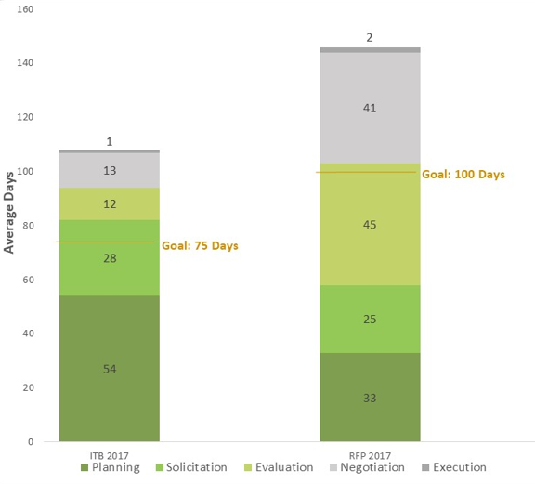
Average Cycle Time per Phase 2017 – Goods & Services Procurements

The Construction and A&E contracts measure average cycle time for the overall procurement process. The cycle time is measured from the procurement start date to the contract execution date. The procurement reform initiative in 2011 set a goal for total cycle time for these procurements. This chart below shows improvement in meeting or continuing to move towards the cycle time goal.

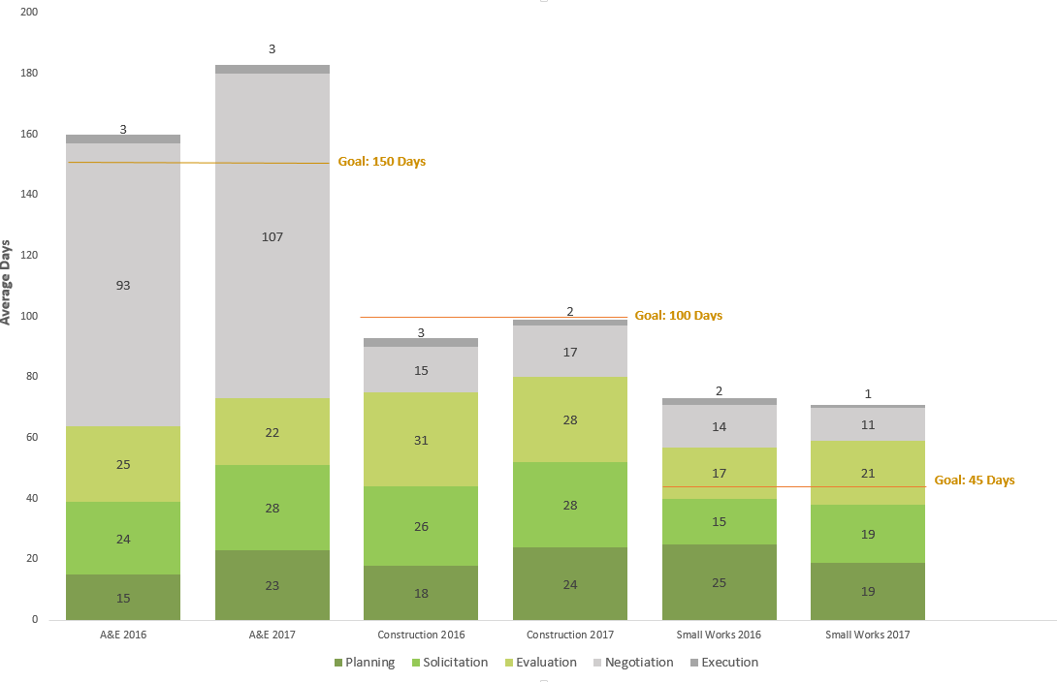
Average Cycle Time per Phase 2017 – A&E, Construction, and Small Works

Numbers of contracts FBOD executed in Construction and A&E are captured in the table below. The number of contracts is driven by the demand from the agencies and is affected by economic factors.

Construction and A&E Procurement Type | 2016 | 2017
Construction | 60 | 54
A&E | 55 | 43
Small Works Roster | 9 | 9
Total | 124 | 106

Goods & Services Procurement Type | 2016 | 2017
Invitations to Bid | 89 | 161
Requests for Proposals | 55 | 74
Others (RFI, waiver, RFQ, etc.) | 219 | 186
Total | 363 | 421

It is considered a best practice in the procurement industry to drive 75% or more of your organization’s spending from negotiated contracts with vendors (as opposed to having high levels of “off contract” spending with vendors that have not previously negotiated a formal contract with the County) allowing for faster processing.

As shown in the charts below, the County is achieving a very high rate of “On Contract” spend and continues to drive spend to negotiated contracts that offer best pricing. Most purchase orders are linked to contracts allowing for faster processing. However, it is important to note that P-card data is not integrated in this metric due to the information being in iExpense while this metric is pulled from iProcurement. When the P-Card program first began, manual reconciliation between the two systems did not have a high return on investment but as P&P continues to promote P-Card use, it would be beneficial to use systems that reconcile more easily as suggested in the Procurement Technology Modernization plan.

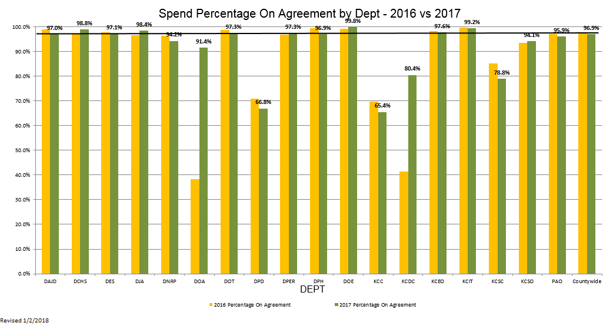

Procure-to-Pay Standardization Status and Metrics
Business Development and Contract Compliance
In 2017, the County achieved its seventh consecutive year of substantial growth in the number of certified Small Contractors and Suppliers (SCS). The chart below shows the number of small businesses certified monthly in 2016 and 2017. With the Amazon Business pilot, the County expects to see a continual increase in the number of SCS certified firms in 2018. The number of available certified SCS firms increased by 20% from 2016 to 2017. The County has existing partnerships with the Port of Seattle, Sound Transit and Seattle Colleges. A goal is to expand this “one-stop” regional service to other public entities.

The County established a triennial (three-year) goal for Disadvantaged Business Enterprise (DBE) participation on its USDOT assisted contracts to the Federal Transit Administration (FTA), and the Federal Aviation Administration (FAA). For the Federal Highway Administration (FHWA), the County is a sub-recipient of this spend from the WA State Department of Transportation’s (WSDOT) DBE program and as such, follows the WSDOT’s DBE Program Plan. For assisted contracts, divisions aim to award a certain amount to DBE certified firms. The assisted contracts shown below show the goals under each type of assisted contract. The Marine Division awarded nearly $27 million in FTA-assisted contracts, with 4.1 percent awarded to DBE certified firms as the majority of the Marine Division funds were sub-awarded to the Washington State Ferries (WSF) for construction of the Passenger Only Ferry Terminal (POF).
 | Actual | Goal
Transit (FTA) | 12.3% | 10.0%
Marine (FTA) | 4.1% | 10.0%
International Airport (FAA) | 12.0% | 2.5%

These federal programs mentioned above also support the inclusion of other certified firms. The chart below shows data on the County’s total dollar amount awarded to certified firms, broken out by types of business.

Note: A business may possess more than one type of certification. For example, a business certified by King County as a Small Contractor and Supplier (SCS) may also be certified by the state of Washington as a Women-owned Business Enterprise (WBE). The total dollars for each certification type is reported separately.

Standardization Metrics
BILLING-TO-CASH VALUE STREAM

Billing-to-Cash Value Stream | Business Process | System
Standardization

Billing-to-Cash Value Stream Description
The Billing-to-Cash value stream is responsible for presenting customers and grantors a timely and accurate accounting of goods received and services rendered. It also provides for the collection of payments to ensure continuation of County services funded through external revenue.

County agencies want to administer their grant and other revenue streams efficiently and effectively by billing their products and services as quickly and accurately as possible. Oracle EBS provides two types of billing methods, Cost Based Billing and Event Based Billing. Both methods are effective in providing billing details to external customers. Cost Based billing requires daily monitoring of expenditures and it can be difficult to make invoice adjustments. Event Based billing allows users more flexibility and control over the billing process. Billing for Federal Assistance uses Oracle EBS Event Based billing, which collects the details of both expenditures and revenues, making it easy to monitor and report financial activities, while some Contracts use Cost Based billing.

While it was originally thought that Cost Based was preferable, the merits of both processes allow King County personnel choose the option that best meets the business need. Both processes have been optimized over the past three years.

Billing-to-Cash Value Stream Outlook
Based upon the criteria identified in the 2015/2016 Systems Proviso (pages 22-24), the Billing-to-Cash value stream has reached a high level of standardization. While certain processes remain manual, many of the initiatives from the previous Proviso response are standardized and improved.

One of the initiatives that was improved in the Billing-to-Cash value stream, was the addition of a lockbox for the Wastewater Treatment Division (WTD) by Accounts Receivable (AR). This helped to reduce the number of manual payments overall, which in turn brought automatic capacity charges to its goal range of 95%, improving accuracy and reducing time spent trying to allocate funds to the correct accounts. This also reduced customer waiting time, as checks often got lost and once the check was received, it could take up to nine days to process. Now, once a customer posts payment, it is processed the next day.

Additionally, FBOD and BRC successfully worked to test and correct fixes to the dunning letter process, creating an enhanced electronic Aging Report to show the status, age, and location of invoices in the AR/Collections process. The deficiencies in the process were corrected in early 2017 and resulted in a steady flow of approximately 900 dunning letters mailed monthly, up from 100 in 2016. This increased the amount of payments directly to Central AR from the dunning letters and presented a more timely data feed to the third party collection company to start collection on unpaid invoices.

Finally, the County’s standardized processes allowed it to transition smoothly when US Bank went through a software platform change, specifically changing its file transmission system. The County spent just over four months working in a test environment, establishing connectivity, updating its encryption, and developing its cutover plan. While the change information provided by US Bank seemed straight forward, the actual process proved more complex than expected. The County has not had any issues to date with the new file transmission system.

These various process improvements and better leveraging of systems helped this value stream achieve its high degree of standardization.

Billing-to-Cash Standardization Status and Metrics
SEFA Awards and Audit
Metrics were established to quantify how many awards for which each agency against the number of SEFA submittals. Any use of federal funding requires documentation and it is part of County policy to report on federal award expenditures and non-cash assistance. Federal award expenditures can include transactions associated with the following:
- Grants
- Cost-reimbursement contracts
- Cooperative agreements and direct appropriations
- Indirect costs claimed for reimbursement
- Receipt of federal property
- Equipment, materials, or supplies and surplus property
- Receipt or use of program income
- County payments made to sub-recipients and
- Use of loan proceeds under loan and loan guarantee programs.

Non-cash assistance examples include food stamps, food commodities, vaccines, donated property (including surplus), and other non-cash items given to the County by a federal or state agency. In 2015, a baseline was established for SEFA submittals with the expectation that the number of submittals would decrease going forward. Other agencies include 13-14 smaller agencies.

Following the enhancement of the report with new fields expected to alleviate manual processes, agencies submitted their SEFA Report two times on average in 2016. The number of submittals continued to decrease in 2017 as shown in the graph below. Reduction in the number of submittals signifies that agencies understand the submission process and trainings were effective. Fewer errors and error types expedite the submittal process, which also helps FBOD report in a timely manner.

The chart below shows all agencies with SEFA submittals submitted more than twice in 2016 and 2017. In 2016, DCHS, DES-OEM, and DPH had the highest number of submittals per number of awards (5/39, 5/46, and 5/84, respectively). It also shows that PAO had the lowest number of awards of the seven agencies and had the largest number of submittals to number of awards (3/5). The optimal number of submittals is one and, three agencies achieved this goal in 2016 and 2017. Of the remaining agencies, thirteen had two submittals, while seven agencies submitted more than twice. These numbers are higher than they were in 2015 and only two agencies have improved between 2016 and 2017. The remaining agencies either remained the same in number of submittals or increased their number of submittals. This could indicate that FBOD should retrain agencies on how to submit award information.

The new SEFA report out of Oracle EBS Financials was in its first year of implementation for the FY14 report submission. Going forward, training will be targeted to help smaller agencies utilize the new report more effectively. FSS will continue to monitor this metric to prevent extra work and rework and to reduce errors.

In addition, FBOD embarked on a vigorous federal compliance requirements training program. This program included internal training by FSS and external training from a consultant who specializes in federal grant funding and compliance. Annually, the internal trainings are conducted monthly for over 28 training hours on federal compliance requirements. The consultant trained the program and fiscal personnel in the projects and grants community in compliance, sub-recipient monitoring, and other grant activities. Beginning in 2012, training was conducted twice a year, instructing six workshops (108 training hours per year) on the Monitoring of Federal Funds, Federal Grants Core Requirements and Sub-awarding.

Ideally, SEFA awards would only need to be submitted once, but twice is realistic. Additionally, the percentage of SEFA submittals to grant volume would be low, as seen below with the Department of Public Health (DPH). DPH had 49 awards and only two submittals and maintained this low submittal trend for the last two years. However, in 2016, the Department of Judicial Administration (DJA) had one Federal Award and submitted it three times, resulting in extra time and rework. Between 2016 and 2017, all but two agencies submitted their awards two times or less. The two agencies that submitted more than twice were WTD and Road Services Division (RSD). WTD had a disclaimed program with a major audit issue while RSD had no issues in 2016, but had three submittals in 2017.

FSS also collaborated with BRC to develop a standardized, automated SEFA report which also contributed to the reduction in audit findings around reporting. These trainings and report enhancements were instrumental in decreasing Audit Findings to one, with Questioned Costs being zero for the 2014 Single Audit, and Audit Findings continued to stay low entering 2016. The graph below shows a trend analysis from 2010 through 2016 for the Number of Single Audit Findings.

Target = 0 Findings

The following graph shows the related Questioned Costs for the Federal Single Audit Report. Both graphs demonstrate a significant improvement and reflect the work FBOD has done with agencies around SEFA reporting and award set-up and monitoring.

Target = 0 Audit Report Questions

Billing-to-Cash Standardization Status and Metrics
EBS Accounts Receivable Module
In 2015, a baseline was established to capture the number of invoices billed within the first 60 calendar days to determine timely billing and, FSS determined that the largest agencies with the most invoices also had the most invoices billed within 60 days. In 2016 and 2017, FSS noted that most agencies improved billing cycle time year over year. Bi-weekly payroll and year end competing activities continue to be factors which prevent agencies from reaching the goal set for this metric. The goal for each division is to bill 90% of invoices within 60 days.

The Accounts Receivable backlog represents payments not yet applied to an account, either because the payment is from an unknown source or because the payment is applied to a customer but not applied to an invoice. The spike in unapplied payments in December 2016 was due to year-end backlog, while the increases in April and August of 2017 were due to low staffing. There is also an ongoing issue with applying large payments from state and federal agencies. FBOD management set the target level of acceptable in-progress, month-end accounting transactions based on historical trends and professional experience.

Until September 2016, AR was receiving 4,000 online bill payments monthly for the Wastewater Treatment Division (WTD), which came directly from customers’ banks. This meant that invoices were not attached, and the automated scanner process could not recognize and automatically apply cash to known accounts. Most customers had their Central Clearing Counterparty (CCP) customer account number on the payment, which let AR know where to post payment. Approximately 10% of payments had irrelevant account information, such as property tax account numbers.

AR researched these payments for manual posting until November 2016, when AR began using a US Bank scanner lockbox. With this system, payments come through as Automated Clearing House (ACH) payments, where customer information is compiled into a standard file type to upload to EBS. Additionally, payments are posted the next day in EBS while previously, mailed checks took nine days to process due to mailing and sorting. For any overpayments, WTD and AR can send an email to US Bank to return extra money directly to customers’ bank accounts using the AP Smart Spreadsheet, instead of preparing paperwork and mailing refund checks.

In the 2015/2016 Proviso response, AR graphically showed the dollar volume of unapplied cash in terms of manual cash applications however, this metric was not meaningful to AR’s process. Instead, AR found it more informative to show the percentage of fully automated accounts, which supported the use of a scanner lockbox for WTD. In the graph below, the capacity charge increases from around 79% to the target range of 95%. This is due to automating the WTD payments. The unapplied cash that would have been manually applied to accounts is part of the AR Backlog value above.

In the graph above, Central AR’s goal of 75% has not been met due to various factors. First, Central AR receives around 50% of its payments from government funding, both federal and state. Many of these invoices come in as ACH payments without routing information, checks, or cash, all of which cannot be auto-applied like electronic payments. After the Electronics Payment Expansion project concludes, AR will be able to receive more electronic payments from its customers which will aid Central AR in reaching its target.
Standardization Metrics
HIRE-TO-RETIRE VALUE STREAM

Budget-to-Report Value Stream | Business Process | System
Standardization

Hire-to-Retire Value Stream Description
The Hire-to-Retire value stream encompasses all business functions necessary to plan, hire, develop, assign, and sustain personnel resources. Together, the Office of Labor Relations (OLR), FBOD, and the Human Resources Department (HRD) provide the foundation for agencies to recruit, engage and develop employees who reflect the communitites served by King County. FBOD and HRD are also responsible for the timely and accurate delivery of pay and benefits to County employees and their families.

County managers want to recruit, develop, and engage talented employees who are reflective of the communities that they serve. Agency administrative and finance staff want to provide accurate and timely pay and benefits efficiently to their employees and families. In the 2017/2018 biennium, key objectives in this value stream include moving toward a more standardized system for pay and benefits practices.

Hire-to-Retire Value Stream Outlook
Based upon the criteria identified in the 2015/2016 Systems Proviso (pages 22-24), the Hire-to-Retire value stream has reached a high level of standardization. HRD and FBOD have created standard work for this value stream to help adhere to best practices.

With the “Best Run Government: Employees project,” which HRD in collaboration with OLR, FBOD, PSB, BRC, and many other County agencies and stakeholders, will seek to create consistency across many of the County’s personnel policies and practices. These new standards and approaches will ultimately be implemented through collective bargaining agreements and enterprise systems. Standardization and consistency will improve business processes to meet quality workforce goals and will also increase system optimization and efficiency.

One of the key initiatives in 2016 was the push for paperless pay. Due to the large volume of bus drivers who were without access to their check stubs online, Benefits, Retirement, and Payroll Operations Section (BPROS) began to drive the mobile pay initiative. The Mobile Pay View was introduced in November 2017 and aims to drive higher mobile usage to help reduce the number of future pay warrants with proper promotion.

With the PeopleSoft Upgrade in 2014, the County is fully supported by Oracle. One of the benefits of this best practice is the addition of numerous PeopleSoft personnel tool updates. In addition to adding electronic absence requests and mobile pay for King County employees, FBOD and BRC are working to update the PERS add-on created via PeopleSoft to more effectively update retirement information reporting and better align with changing systems. The new add-on will be highly configurable, decreasing the need for complex and costly coding changes to the program. This change will enable the PeopleSoft team to be more agile.

Hire-to-Retire Standardization Status and Metrics
PeopleSoft – Payroll Deadlines
In 2016, payroll deadlines were met 58% of the time while in 2017, they were met 42% of the time. However, payroll deadlines were met within 10% of the target range of 90-95%, 82% being the lowest percentage achieved. As the Payroll department is responsible for all agencies across King County, it is important to better align initiatives with bi-weekly pay to achieve this target range.
Target: 90-95%

The target level set by FBOD management was based on PeopleSoft implementation and stabilization, in hopes of forwarding incremental improvements. Further refinement as process improvements are implemented will be examined with the completion of key initiatives.

Hire-to-Retire Stabilization and Standardization Status and Metrics
PeopleSoft – Paperless Payroll
The Paperless Payroll graph is measured by department and County employees who are paid electronically via direct deposit and who do not receive a printed advice (paystub) for their direct deposit. The Department of Assessors (DOA) has a lower percentage of paperless pay due to temporary and seasonal workers hired for property assessments. The Department of Transportation (DOT) realized a jump in paperless pay. At the end of 2015, DOT was at 49% paperless pay and at the end of 2017, DOT was up to 86% paperless pay. This was mostly due to BPROS coordinating with agency staff to go paperless, as seen below.

The Paychecks by Type metric below shows the percentage of paperless direct deposit, direct deposit with a paper paystub provided to the employee, paper pay warrant (printed check), and manual/off-cycle checks. The manual or off-cycle checks represent corrections to pay or an off-cycle settlement to an employee. The year to date percentage for 2017 was 0.19%, well below the goal of less than 1% and continued improvement from experience prior to ABT implementation.

Standardization Metrics
BUDGET-TO-REPORT VALUE STREAM

Budget-to-Report Value Stream | Business Process | System
Standardization

Budget-to-Report Value Stream Description
The purpose of the Budget-to-Report value stream is to align resource decisions with leadership and community priorities and the King County Strategic Plan. This includes accurate and timely reporting of the financial picture and performance of County operations to internal and external stakeholders in accordance with professional standards.

County managers want to obtain the financial information necessary to run their operations efficiently, and agency finance personnel want to know how to use the County’s financial systems effectively.

A key objective for this value stream is to improve user compliance with the enterprise systems, utilizing best practices for budget so that the County may accurately account and report on its financial activity. Reduction in tracking manual adjustments outside of the systems would mean less effort required to conduct ad hoc analysis such as budget versus reports and to create audited financial reports, including the Comprehensive Annual Financial Report (CAFR) and the Schedule of Expenditures of Federal Awards (SEFA). This enables finance and accounting staff to devote more time to monitoring compliance with County policies and external requirements, reducing the risk of audit findings, and questioned costs. This also gives operating managers confidence in current short and long term resource decisions.

The Budget to Report value stream is co-owned by the Office of Performance, Strategy and Budget (PSB) and the Finance and Business Operations Division (FBOD) of Executive Services. The value stream begins with the initial allocation of resources through the budget process and ends with the submission of audited financial reports that demonstrate the County’s financial position and how previously allocated funds were used.

Budget-to-Report Value Stream Outlook
Based upon the criteria identified in the 2015/2016 Systems Proviso (pages 22-24), the Budget-to-Report value stream reached a high level of standardization, progressing from medium in the 2015/2016 Systems Proviso. This is mainly due to the Business Intelligence (BI) Analytics tool and the Discoverer retirement plan.

For project award setup, detailed procedures were developed into trainings in 2015. These procedures were enhanced in 2017 to include quick reference tools and additional award information. FBOD held site visits with agencies to review the specifics of award set up monitoring and introduced agencies to resources to that would help reduce these errors further. In effect, award errors decreased by over 50%. The Financial Systems and Services team (FSS), formerly the Projects and Grants Unit (PGU), hopes to see further reduction by the end of 2018.

The BI Analytics tool and Discoverer retirement plan are meant to replace the aging Enterprise reporting tool, which will no longer be supported by Oracle. During the Discoverer retirement planning phase, BRC identified the reports and individuals who would need BI reports and training. This increased efficiencies by analyzing the actual number of users and reports needed for the conversion. The scope of work included data unification of source system financial data from Oracle EBS, HCM data from PeopleSoft HRM, and Position Budget data from Hyperion Budget & Planning.

Additionally, the County switched Hyperion from On Premise to the Oracle Cloud, where the County will not have to pay costly system upgrades every five years. In conjunction with this switch, PSB went forward with its “Small Improvements” project that prioritized system improvements based on their impact on usability and potential for process efficiency. Some of the system improvements included taxonomy cleanup, form improvement, adding smart tags, formatting templates, and debugging reports, which helped the team understand the system from administrative and development perspectives.

Budget-to-Report Standardization Status and Metrics
EBS Projects and Grants Accounting Module
In 2015, FBOD took a sample set of 67 awards to create a baseline expectation for award set-up. All error types with an error rate greater than 10% are graphed below by error type. “End Dates” and “Close Dates” had the most errors in 2015 and 2016, though both showed improvement over the year. In addition, FBOD requested that award documents be sent to the Grants Administration mailbox so that FBOD could assist agencies in accurate award set-up. Approximately 25% of the award documents were not submitted to FBOD from agencies, which the FSS concluded that the “Close Date” and “End Date” errors possibly could have been reduced by more than 50% if the award documents were submitted directly to FBOD. This hypothesis has shown to be true based on the graphical information below, showing a 54% decrease in “Close Date” and “End Date” errors in 2016.

Goal, 15%

Next, FSS graphed the number of errors per award by agency. The agency with the fewest number of errors per award was the Prosecuting Attorney’s Office (PAO). The Department of Natural Resources and Parks (DNRP) was new to setting up awards, but benefited from the training and documented standard work that FSS has created. Proper award set-up and assistance from FBOD—mentioned originally in the 2015 Proviso response—has shown that agencies benefit from FBOD training and onsite visits by FSS staff to aid in award document submittals. This addition of in-person training has resulted in a 21% decrease in award set-up errors. By continuing to send FBOD the award documents for award set-up, award errors should continue to decrease amongst agencies.

Goal, 2

Budget-to-Report Standardization Status and Metrics
BI Analytics
Oracle BI was Oracle’s recommended BI solution when the County was looking to replace the Discoverer reporting tool. Through the implementation process, BRC has identified unique users and targeted highly-used reports. To date, there have been 33 BI Power User Instructor-Led Trainings producing approximately 400 casual users and 131 power users for the BI Analytics new service. As March 2018, approximately 145 Financial Analytics and HR Analytics were developed and are available to all agencies across the County. This data can be seen in the chart below.

In conjunction with rolling out BI, the County is also working to decommission the Oracle Discoverer reporting tool by the end of 2018. Communications of the Discoverer Decommission timeline were also transmitted during Q2 to all agencies across the County, including the Communication Decommission Plan and a successfully completed Phase 1 Pilot. This included agency-wide participation of a financial year end task: the Project Accounting to General Ledger Reconciliation. The graph below shows the number of BI users in comparison to number of Discoverer users, represented by “Disco”.
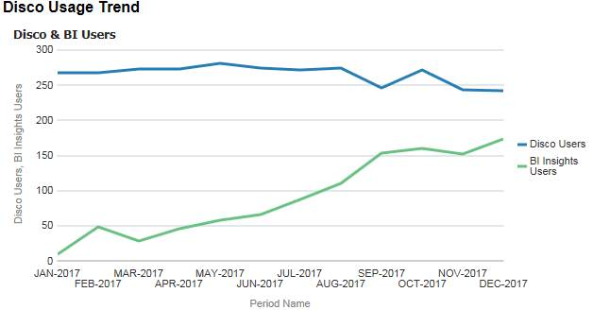

Budget-to-Report Standardization Status and Metrics
Hyperion
Budget Development Standardization efforts focus on improving the performance and reporting capabilities within the Hyperion system and the Project Information Center (PIC) application. PIC supports the County’s capital improvement program (CIP) processes (biennial budget development, capital portfolio management, monitoring and reporting, and budget revisions). This section briefly describes the standardization efforts and metrics related to the following areas: Hyperion Reporting, Hyperion’s conversion to Cloud, Hyperion Data Entry, and Project Information Center (PIC).
In Hyperion reporting, extracting information from Hyperion and PIC is often manual and time intensive. Although some standard reports exist, additional reports are in development to reduce the time necessary to respond to requests for management information. PSB and FBOD have surveyed agency finance and operational managers (primary customers) to measure the level of effort required to obtain timely and accurate information entered into the three systems. These surveys also measure customer satisfaction with reporting capabilities in Hyperion and PIC.
Switching from Hyperion on-Premise to Oracle Cloud (PBCS) simplified PSB’s support model and five year total cost of ownership. This allowed the County to avoid costly system upgrades which were scheduled every five years. Instead, the Cloud service from Oracle performs monthly patching and upgrades to ensure the system is always the most current version of the application. While this change affects numerous aspects of the business processes, PSB went forward with its “Small Improvements” project to help transition from on-Premise, which included updating folders, smart tagging, Smart View templates, batching reports, and data entry forms.
Hyperion data entry was previously non-intuitive. For this reason, PSB worked to improve and facilitate the process. With the PBCS implementation, PSB designed new Biennial and Supplemental Data Entry forms, including related business rules and menus, to provide more context for data entry. This made the system more intuitive, reduced the number of steps in entering data, and provided proposal clarity for the analysts. Implementing this improvement met a benefit listed in the Upgrade project Benefit Achievement Plan (BAP). Within the new system, utilizing user point of view (POV) means it is no longer necessary to press the Go arrow to refresh after making changes.
The charts below show baseline measurements of user satisfaction with Hyperion from the 2015/16 budget development process. In 2014, less than half of Hyperion users expressed satisfaction with Hyperion reports and position budgeting data entry. While “High Satisfaction” was still not as prevalent as desired in 2016, the trend is positive and PSB expects improvement in these metrics in 2018.

The Project Information Center (PIC), the County’s capital budgeting system, recently went through numerous updates, including administrative control for the budget screen, an agency project approval screen, IT project flags, and improved CAP detail view on the Detail Screen. PIC also updated its reporting by creating a new one percent for the Art Report, a new Red Yellow Green Quarterly comparison report, a Budget Approval report, and an Excel friendly Ordinance Attachment report. PIC also activated ordinance number parameters for its reporting. With these recent updates, customer satisfaction is expected to improve in the next survey. From the last survey in 2016, customer satisfaction with PIC is high, though there is room for a “high satisfaction” increase. Also in 2018, the PIC data is included as part of the rollout of the new BI Analytics project, which includes a data warehouse.

Budget-to-Report Standardization Status and Metrics
EBS Projects and Grants Module
To assess information quality and ease of reporting for EBS financials, especially for the Projects and Grants module, FBOD continues to conduct its customer survey biannually. The charts below show the 2017 survey results from 31 participants, down from 61 in 2015. One of the primary concerns for the FSS, formerly the Projects and Grants Unit (PGU), is reliable reporting and data accuracy. Customers’ confidence in the accuracy of reporting greatly improved, as seen in the charts below.

Budget-to-Report Standardization Status and Metrics
Projects Awards to General Ledger Reconciliations
In 2017, BRC worked with FBOD to replace the Project Awards (PA) to General Ledger (GL) Reconciliation Discoverer report, as the Discoverer reporting tool will be retired at the end of 2018. This BI Insights dashboard facilitated reconciliation of PA to GL and the time to reconcile the data vastly decreased. FBOD created a survey to show how these changes affected end users.

 | Before | After
Hours to complete Reconciliation | 28.5 | 16.5
Before the PA to GL BI dashboard, users needed to pull both the PA and GL reports and compare each report, line by line, to find discrepancies. With the new BI Insights dashboard, the dashboard reconciles the data automatically so that the user can analyze the differences without also having to find them. This improvement saved users eight hours, or one working day, when reconciling the Expenditure Sub Ledger to the General Ledger.

The expectation of FBOD is that reconciliations are performed at least quarterly, monthly being preferable. Nearly 50% of County agencies meet this expectation with a 19% improvement from 2015. This data was collected from users following the roll-out of the initial BI dashboard, so FBOD expects to see a steady increase in user frequency.

Standardization Metrics
SYSTEM SECURITY AND CONTROLS

System Security & Controls | Business Process | System
Standardization

System Security and Controls Description
Security systems and controls are the governance structures necessary to support the business processes and related systems. FBOD and BRC are jointly responsible for the business rules and controls embedded in the County’s accounting, budgeting, and payroll systems to ensure only authorized individuals can make changes in these systems. The following include the focus areas for system security and controls:

- Business processes, rules, and controls to govern who can access data and transaction processing in Oracle EBS
- System design and tools to manage and control EBS access privileges and permissions
- Security design and methods regulated in EBS to limit access to sensitive data to appropriate parties for job-related purposes
- Adoption of business and industry best practices in the design and management of EBS security rules, controls, and processes.

System Security and Controls Outlook
Based upon the criteria identified in the 2015/2016 Systems Proviso (pages 22-24), System Security and Controls have reached a high level of standardization for business processes and for systems. The best practice technical standards, processes, and system documentation are in place for new changes to security configuration. BRC and FBOD security work teams have strong working knowledge of EBS security control configuration and the implemented improvements and processes are expected to adapt to business and system changes.

The following is part of a multi-year project to establish security change control processes and implement security recommendations identified in a security assessment completed by consultant Jeffrey Hare, a well-regarded Oracle EBS security expert. Hare’s recommendations provided guidance in redesigning EBS security structures to reduce different types of risk (e.g., segregation of duties, sensitive data and possible fraud risk) and conform to security design best practices for EBS. The project also included the development of queries and reports used for the redesign work and for ongoing monitoring of EBS security health.
Improvements to the agency EBS security access request process include: revised security access request forms with option of electronic signatures; new naming conventions for EBS security responsibilities; and a new EBS security approver role for each KC agency, which strengthens the approval process and provides consistency in the assignment of security access roles to users. This need was clearly identified by agencies during the first annual EBS security self-audit workshops conducted in 2017.

The work to automate the request process and approval workflow has been put on hold to be addressed in a future project because it will require a new security provisioning automation tool not planned as part of this project.

Using best practice principles highlighted in the Jeffrey Hare security assessment and detailed risk conflicts identified in the security risk matrices, the security team began work on the Accounts Receivable (AR) module redesign its security responsibilities and structures to remediate conflicts and standardize design. During the pilot, all functions were reviewed for each AR responsibility. Where possible, update capability was replaced by view-only functions unless an update was required for all users with this responsibility to perform their job. In some cases, a new responsibility was created to allow two roles to co-exist with users needing higher privileges getting one responsibility and users not requiring the higher privileges put into a less privileged configuration. During the pilot, cross module risks (where an AR function is not compatible with non-AR function) were removed.

The initial redesign reduced AR risks by 40%. FBOD followed up to address remaining segregation of duty conflicts by moving the Create Customer function from the FBOD AR team to the Financial Systems Unit. This required BRC to create a new responsibility. This change reduced AR risks by an additional ≈40%, resulting in an overall risk reduction of ≈80%.

Lessons learned from the pilot helped format subsequent security redesigns. Key findings included focusing on high risks for redesigns due to the complexity of the Oracle EBS security design and the time required to redesign and lower risk items were lumped into improvements post-completion; agencies with fewer resources and a broad range of tasks faced more challenges, making it difficult to resolve conflicts, so implementing mitigating controls presented better option; and lastly, redesign work by analyzing functions that are needed to perform the jobs/tasks by the users who are assigned each responsibility for the module, then review the set of risks. This provides a more holistic view to inform the risk reduction work and is more effective than starting by reviewing risks first.

After the completion of the security redesign pilot for the AR module, the redesign work began on the remaining modules. This work is still in progress and is expected to continue through 2018.

As of March 2018 the following areas have been completed:
- All EBS inquiry responsibilities
- Advanced Collections module
- General Ledger module
- Project/Grants module – agency and BRC responsibilities
- Purchasing and iProcurement modules
- Profiles (method for enhancing EBS functionality without customization)

The security design for the following modules/area remain:
- Flexfields (used to configure EBS)
- Payables module
- iExpense module
- Project/Grants module – FBOD responsibilities
- Cash Management module
- Fixed Assets module
- Order Management module
- Inventory module

In 2017, FBOD and BRC developed and implemented a process to conduct a countywide review of EBS security to confirm that EBS users in each agency have appropriate access. This was the first time since EBS went into production in January 2012 that a review of this kind had taken place. After an initial pilot group, six agencies followed, with each cohort attending a workshop to prepare them for the task. All agencies received an EBS security report showing details of their organization’s EBS users’ security access. Agencies reviewed and requested changes to access privileges as appropriate for each employee. BRC processed the changes for each group, after which each agency reran the report and certified that the changes reflected the desired end state. The entire process took place from May–October of 2017 and was successful. The intent is to make this a regular annual process.
A review of the final report recommendations will be conducted to confirm if any items relevant and worthwhile for the County remain. If so, the high priority recommendations will be addressed and lower priority items will be documented and operations will complete them. The operational change management procedures for security controls as recommended in the Jeffrey Hare assessment have been in place now for the last few years and are well understood and integrated.

System Security and Controls Standardization Status and Metrics
Implemented Jeffrey Hare security recommendations
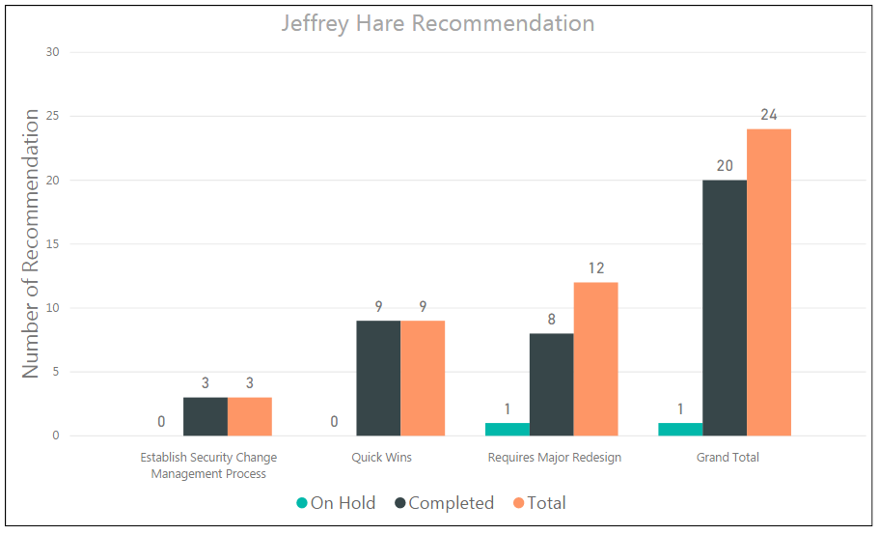
The chart above shows that as of March 2018, only major redesign work remains. Since the 2016 report, eight recommendations requiring major redesign were completed. Of the four that remain, one is on hold, and one is scheduled for implementation in April 2018. The other two items are part of the work plan for 2018. The item marked as “On Hold” relates to the recommendation to automate the EBS user provisioning process. This is a project in itself, which will require business process redesign, selection of an appropriate tool for the automation and workflow and implementation work that will be considered in a future project.

System Security and Controls Standardization Status and Metrics
Number of terminated employees with active accounts
Although County managers are encouraged to submit requests to revoke access when employees with EBS access leave the County (terminated status or “termed”), BRC created a process using PeopleSoft data to remove this access. This ensures accounts are closed if request forms are not received.
The two charts below show 2016 and 2017 data for account closures. The “To Be Processed” numbers are EBS terminated users in PeopleSoft for the month. The “Closed” row on the left shows the number of those accounts closed by BRC. There are cases where the completion of additional processes is needed prior to BRC closing the EBS account, for example if someone must be removed from approval workflow in EBS. If this delays closure to the next month, it will show as “Carry over – last period” as seen on the right. The “Closed” row on the bottom right indicates closure of the carry over group.
2016 Active EBS User Accounts to be Closed vs. Closed
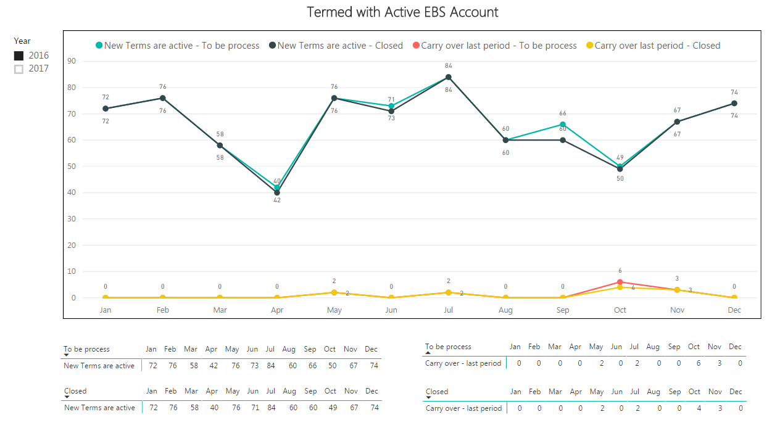

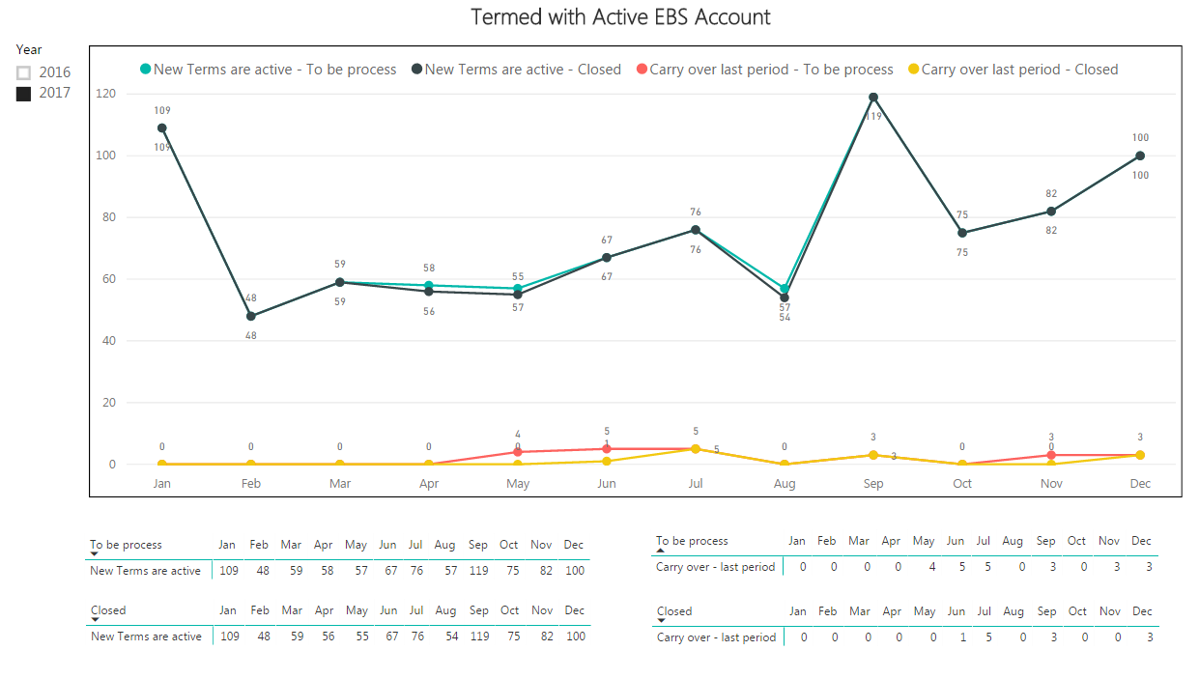
2017 Active EBS User Accounts to be Closed vs. Closed

System Security and Controls Standardization Status and Metrics
Average time to process security provisioning requests and changes
The following charts for 2016 and 2017 show a measure of timeliness in completing the EBS security access requests in the system following a valid request received by BRC. In June 2015, the measure began and showed a poor turn-around of 11 days. Request fulfillment reduced to about 8 days in July 2015. Since this baseline measurement, the average fulfillment rate has significantly improved to 1.6 days in 2016 and 2.1 days in 2017. The target fulfillment rate is 2 days however, a spike occurred in October 2017 that increased the average to 6.5 days. This was due to a few factors including but not limited, to a large volume request related to a special project to help implement new capabilities for an agency, coverage issues related to staff vacations and an overall spike in work associated with completion of the first annual EBS self-audit. The Security self-audit requests inspired a large volume of access change requests that impacted capacity and responsiveness in BRC. The countywide EBS security self-audit completed in November 2017.
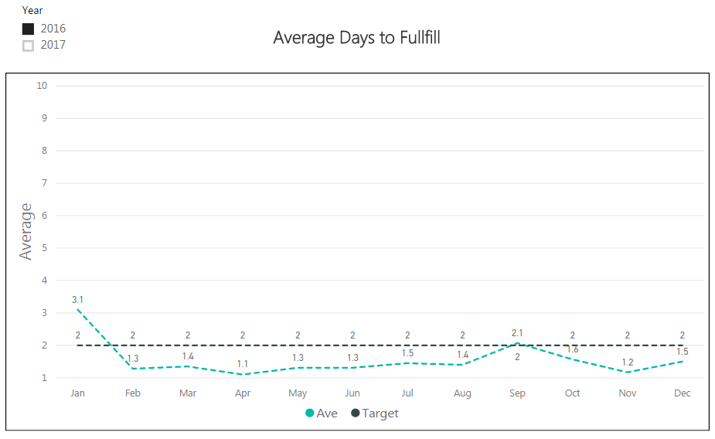

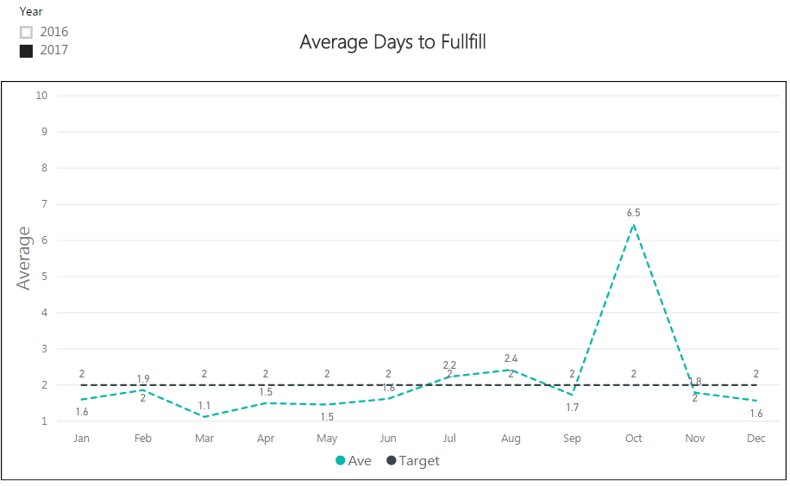
Measures days to complete security requests excluding subsequent security updates after training has occurred, proxy requests (can be up to 400 users included in a single proxy request), training administration and non-prod requests. It also excludes security request bundles associated with the annual EBS Security Self-Audit.

Accountable Business Transformation 2013 Budget Proviso Report, June 28, 2013.
King County Enterprise Systems 2014 Budget Proviso Report, May 30, 2014.
King County Enterprise Systems 2015 Preliminary Budget Proviso Report, Revised May 7, 2015.
King County Enterprise Systems 2016 Preliminary Budget Proviso Report, Revised May 5, 2016
PeopleSoft Update Manager Document 1641843.2, Best Practices / Maintenance Strategies
King County Enterprise Systems 2014 Budget Proviso Report, May 30, 2014.
https://www.kingcounty.gov/about/policies/aep/financeaep/fin161aep.aspx

